Janet T. Mills GOVERNOR
STATE OF MAINE
OFFICE OF THE GOVERNOR
1 STATE HOUSE STATION
AUGUSTA, MAINE
04333-0001

April 26, 2022

The 130th Legislature of the State of Maine State House
Augusta, Maine
Dear Honorable Members of the 130th Legislature:
By the authority conferred by Article IV, Part Third, Section 2 of the Constitution of the State of Maine, I am hereby vetoing L.D. 170, An Act Pertaining to Transmission Lines Not Needed for Reliability or Local Generation.
L.D. 170 would create inappropriate barriers to the development of transmission lines which could hinder the ability of the state and region to meet our critically important climate and clean energy goals. The bill would designate certain transmission lines as "non-essential" if those projects are not constructed primarily to provide electric reliability within the state, or to provide electricity to retail customers in the state. It would then impose additional requirements on the approval of “non­essential” transmission lines, some of which are vague, ill-considered, and unworkable.

As an initial matter, designating transmission line projects as "non-essential" because they provide substantial benefits beyond Maine's borders fails to recognize the regional nature of our electrical grid, and the global dimension of the climate crisis. If we are to meet the threat that global warming represents to our environment and our economy, and do so in a manner that keeps the cost of electricity affordable for our citizens, we must be willing to think and act on a regional and national level. However well-intentioned, it would be a serious mistake to penalize interstate transmission projects merely because of the benefits they would deliver to other jurisdictions.

Section 2 of the bill would require an entity seeking to develop a transmission line that cannot finance the project through the use of revenue bonds to make "a reasonable effort to negotiate ownership of the line by an entity that is authorized by charter or other law to own transmission facilities and that has the ability to finance the line through the use of revenue bonds." This provision is too vague to have regulatory meaning. It is unclear what is intended by the phrase "negotiate ownership." If this implies an obligation to negotiate the sale of the project, it is constitutionally suspect. Even assuming a project's owner can identify a negotiating partner, this bill attempts to compel a negotiation between two parties when neither may have independent interest in the transaction. If two parties exist with mutual interest in negotiating a sale, they will

PHONE: (207) 287-3531 (VOICE)

PRINTED ON RECYCLED PAPER

TTY USERS CALL 711
www. maine.gov

FAX: (207) 287-1034

do so on their own accord, but otherwise this requirement would only mandate a pointless regulatory exercise.
Maine has some of the most ambitious clean energy and climate targets in the country. As my Energy Office identified in the State of Maine Renewable Energy Goals Market Assessment, 1 electrical transmission is a key component of Maine's renewable energy future. To meet our climate goals, we will need to increase dramatically the deployment of electric vehicles and high efficiency heat pumps. This, in turn, will require new large- and small-scale renewable energy resources and will dramatically increase the capacity of our electric grid. The other New England states will need to undertake similar efforts, and the federal government has recently allocated more than $20 billion in federal financing tools to support new grid projects and the deployment of grid enhancement technologies.2 In order to succeed, it will be essential to work strategically on a regional level, and this bill would seriously interfere with those efforts.

For these reasons, I return L.D. 170 unsigned and vetoed and I urge the Legislature to sustain this veto.
Sincerely,
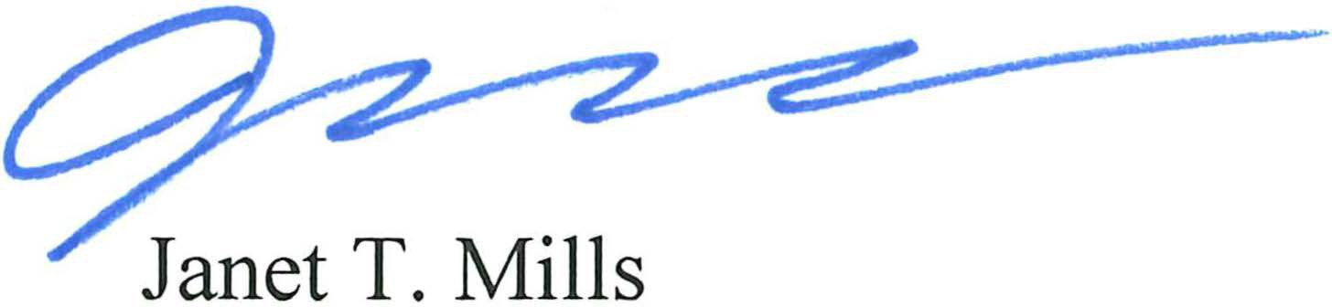
Governor

- Governor's Energy Office. State of Maine Renewable Energy Goals Market Assessment. February 2021. https://www.maine.gov/energy/sites/maine.gov.energy/files/inlinefiles/GEO_Renewable%20Energy%20Goals%20 Market%20Assessment_Feb%202021_1.pdf
- U.S. Department of Energy, Building a Better Grid initiative. January 2022. https://www.energy.gov/articles/doe­
launches-new-initiative-president-bidens-bipartisan-infrastructure-law-modernize

PRINTED ON RECYCLED PAPER

PHONE: (207) 287-3531 (VOICE)
TTY USERS CALL 711
www.maine.gov
FAX: (207) 287-1034

