Maine’s State Wildlife Grant Program
10 Years of Enhanced Wildlife Conservation
MAINE’S WILDLIFE ACTION PLAN
Congress instituted the State Wildlife Grant [SWG] program in 2001. State Wildlife Grants provide wildlife conservation funds to the 50 states. The states use the grants for the development and implementation of management programs that benefit wildlife and their habitat, including species that are not hunted or fished. To receive SWG funding, Maine must have a State Wildlife Action Plan. The U.S. Fish & Wildlife Service [USFWS] approved Maine’s wildlife action plan in the summer of 2005. The plan identified species and habitats in greatest conservation need, significant threats to wildlife and habitat, and the conservation actions needed to prevent endangered species listing and to spur the recovery of endangered species. http://www.maine.gov/ifw/wildlife/reports/wap.html
Maine’s 2005 Wildlife Action Plan is supported by two pillars. The first is wildlife conservation planning. Where adequate knowledge exists, the Maine Dept. of Inland Fisheries & Wildlife [MDIFW] and its conservation partners are able to develop species-specific management goals and objectives that lead to direct conservation actions. Where knowledge is inadequate, MDIFW must undertake survey, monitoring, and research.

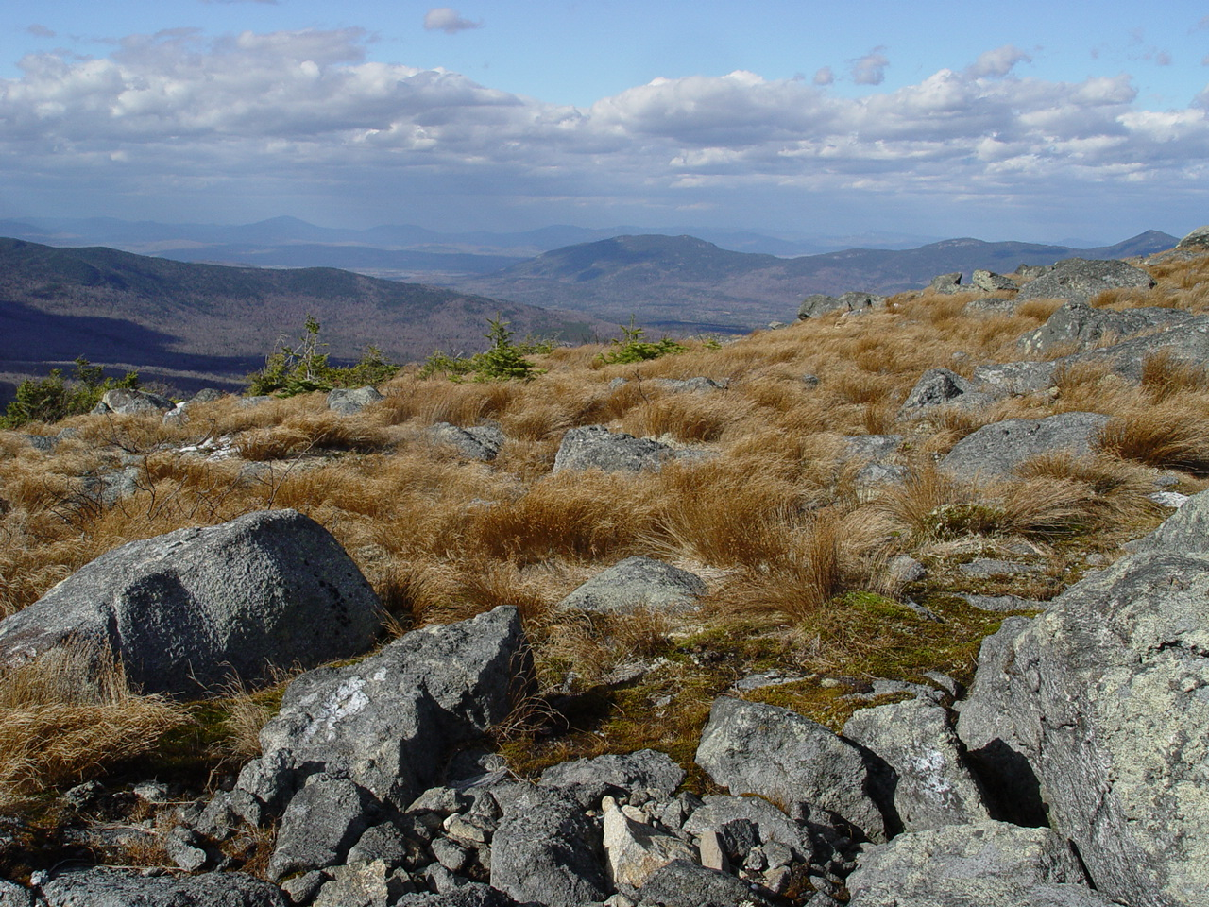
MDIFW has directed significant portions of SWG funding toward the monitoring, survey, and research required to fill knowledge gaps and to the development and maintenance of databases. Collected information must be accessible and stored in a logical format; and so, the construction and maintenance of databases is an extension of information gathering. Both are essential to species planning.

The second pillar is the various efforts of MDIFW and its conservation partners to conserve natural communities and habitat for wildlife and plants. Beginning with Habitat is Maine’s premier habitat conservation outreach program. The knowledge gained during monitoring, survey, and research is often sufficient to guide on-the-ground habitat conservation efforts, such as Beginning with Habitat. This is an important aspect of information gathering that is often overlooked.

Other conservation actions supported by information gathering include “focused” land acquisition, conservation easements, and cooperative habitat management agreements; environmental permit review; oil-spill preparedness and response, and responding to landowner inquiries for habitat information.

MDIFW also reviews the data gathered during monitoring, survey, and research to assess the status of wildlife populations and to determine appropriate conservation designations, such as the Species of Greatest Conservation Need [SGCN] list, which is basis for Maine’s wildlife action plan.

The SWG program requires that Maine update its wildlife action plan by October 2015. Ten years have passed since the state's conservation partners and MDIFW prepared Maine's first plan. Together, we have accomplished much for wildlife; and with your help, we hope to continue this success into the future. Maine's traditional "outdoor" values and its rural economy depend upon thriving wildlife populations. We know more remains to be accomplished. Continued habitat loss and fragmentation and the specter of a changing climate present a challenge to much that we value. Over the next 18 months, MDIFW, its conservation partners, and the public will update and revise Maine’s wildlife action plan. As we begin this process, we thought it would be helpful to review the accomplishments of the past decade.

STATE WILDLIFE GRANT ACCOMPLISHMENTS

BEGINNING WITH HABITAT

Beginning with Habitat: The premise of Beginning with Habitat [BwH] is that local planning undertaken with the knowledge of local natural resources will allow Maine’s towns and cities to grow and develop and conserve open space for fish, wildlife, and plant habitat. BwH provides habitat maps and assistance with open-space planning to municipalities, land trusts, and landowners. Its success depends upon voluntary land conservation efforts by landowners, particularly private landowners. BwH used SWG funds to compile data on water resources, riparian habitats, high value plant and animal habitats, focus areas of statewide ecological significance, undeveloped habitat blocks, and habitat connections. BwH made these data available in both printed and digital formats, including an interactive, on-line map service. BwH has assisted numerous regional conservation planning initiatives across Maine and more than 175 towns engaged in comprehensive or conservation planning. Recently, the program completed a climate change vulnerability assessment that is informing sea level rise adaptation plans in several communities and also the 2015 update of Maine’s wildlife action plan. http://www.beginningwithhabitat.com

SURVEY, INVENTORY, AND MONITORING
Ecoregional Surveys: From 1997-2007, MDIFW and the Maine Natural Areas Program [MNAP] conducted a systematic, statewide, ten-year survey on 9.7 million acres of wildlife habitats. The survey documented rare species status and distribution, and with this information, MDIFW developed conservation strategies for rare species, including Canada lynx, bats, small mammals, marsh birds, Bicknell’s thrush, Louisiana waterthrush, peregrine falcons, golden eagles, timber rattlesnakes, rare mayflies, freshwater mussels, White Mountain tiger beetles, spring salamander, Clayton’s copper butterfly, and rare butterflies, damselflies and dragonflies, among other species.
The Lake Habitat Inventory Program: SWG funds supported habitat surveys of the aquatic resources found in lakes and ponds. MDIFW staff surveyed approximately 3,800 ponds that had never been inventoried and also many waters with outdated surveys. MDIFW used SWG funding to conduct new pond surveys, wild brook trout pond surveys, hydroacoustic surveys to monitor forage fish populations, a lake trout spawning survey, a catchable trout study, lake contour mapping, a round whitefish telemetry study, winter creel surveys, management of illegally introduced fish populations, and sampling of white perch populations. The program updated and maintained the lake inventory database and the regulation database.

Status of the brook floater in Midcoast and central Maine: In 2009, a survey of state-threatened brook floaters in the Pleasant River revealed that a significant decline in numbers and habitat quality had occurred since biologists last visited the site in 2001. MDIFW used SWG funding to survey the Pleasant and Sheepscot rivers and document the brook floater’s distribution, population size and density, demographics, shell condition, habitat quality, and threats. Surveys confirmed the species’ presence and distribution in these two rivers.
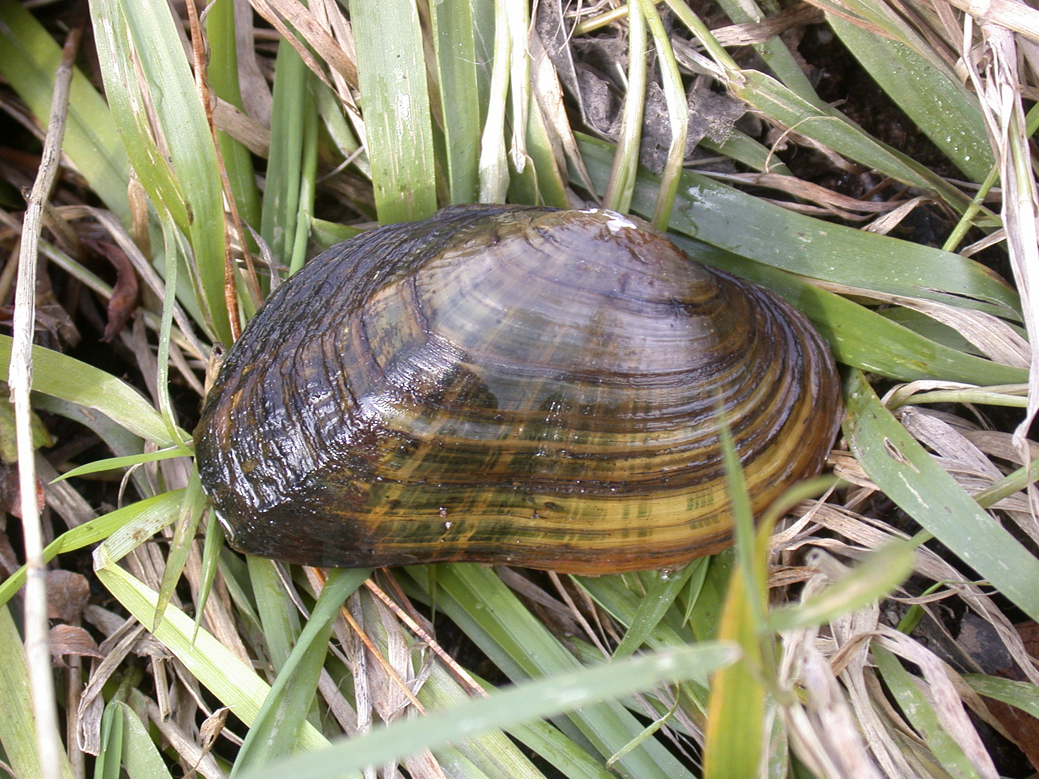
Status of the brook floater in the Denny’s and Sandy Rivers and Allen Stream: Biologists suspected the presence of the brook floater in the Denny’s River, Sandy River, and Allen Stream for several years. MDIFW used SWG funds to conduct surveys in all three to document the brook floater’s presence or absence, and if present, its distribution, population size and density, demographics, shell condition, habitat quality, and threats. The surveys did not find the species in the Sandy River; found one individual, despite several days of searching, in the Denny’s River; and found a viable population in Allen Stream.
Maine Butterfly Atlas: MDIFW currently recognizes 15 butterflies as SGCN. Many more require further assessment before MDIFW can assign conservation status. SWG funds supported the Maine Butterfly Atlas project, which documented the status and distribution of butterflies and assessed habitat conservation priorities. Professional and citizen scientists submitted thousands of Maine butterfly records, raising public awareness and concern for butterflies.
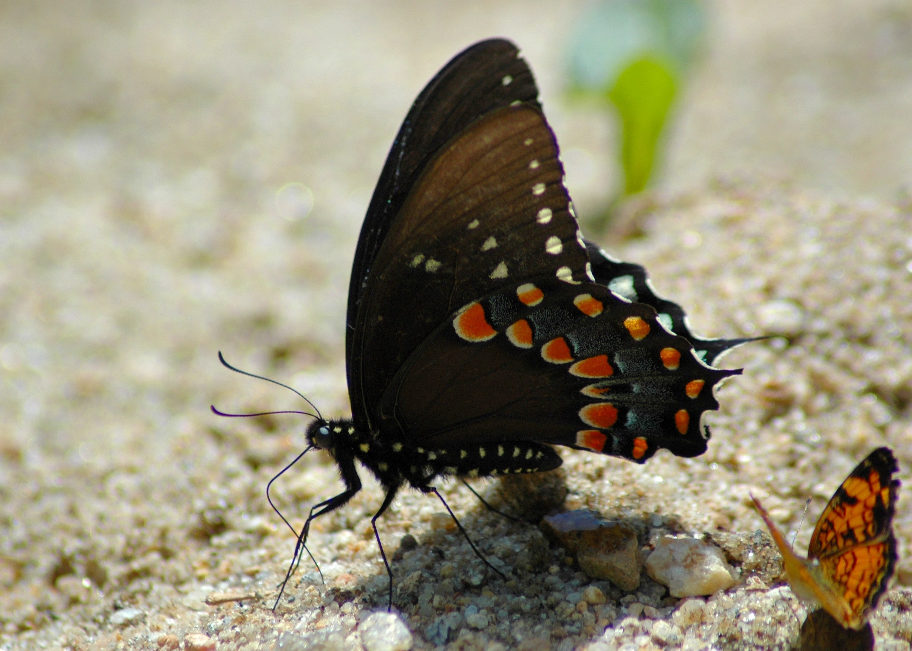
Status of the spicebush swallowtail butterfly in Maine: This butterfly reaches its most northeastern distribution in east-central New England, where the butterfly larvae’s rare host plants – sassafras and spicebush – also reach the northern edge of their range. The spicebush swallowtail inhabits a hardwood forest type that is threatened by habitat loss and fragmentation in the rapidly developing landscape of southern Maine. MDIFW used SWG funding to survey 28 high-priority host plant sites during the butterfly’s larval stage and documented spicebush swallowtail larvae at 15 localities in York County. MDIFW entered and mapped these new observations in MDIFW’s Endangered, Threatened, and Special Concern (ETSC) species database.
Status of the ringed boghaunter dragonfly in Maine: Biologists first discovered the ringed boghaunter dragronfly in Maine in 1995, but subsequent surveys have produced only ten confirmed breeding populations of this wetland species in York and southern Oxford counties. MDIFW used SWG funds to conduct boghaunter surveys and to monitor the dragonfly’s seasonal emergence. MDIFW plans additional surveys for 2014.
Cobblestone tiger beetle conservation in Maine: mapping standards and environmental review protocols: In 2009, MDIFW biologists working on the ecoregional survey in the central and western mountains discovered Maine’s first record of the cobblestone tiger beetle. Historically this species was likely found throughout the northeast, but due to habitat loss it is limited to a few free-flowing rivers. The newly discovered Maine population filled a distribution gap. MDIFW conducted surveys for the cobblestone tiger beetle from 2007-2012. It used SWG funds to synthesize survey data and to develop habitat mapping and ranking protocols, environmental review guidelines, and a factsheet for the beetle.
River surveys and analysis of wood turtle populations in Maine: Wood turtles are widely distributed, but localized and uncommon in Maine. They are considered a species of special concern due to habitat fragmentation and degradation, collisions with agricultural machinery and cars, and illegal collection for the pet trade. MDIFW funded wood turtle surveys along Maine’s rivers to determine its status. The survey produced observation records.
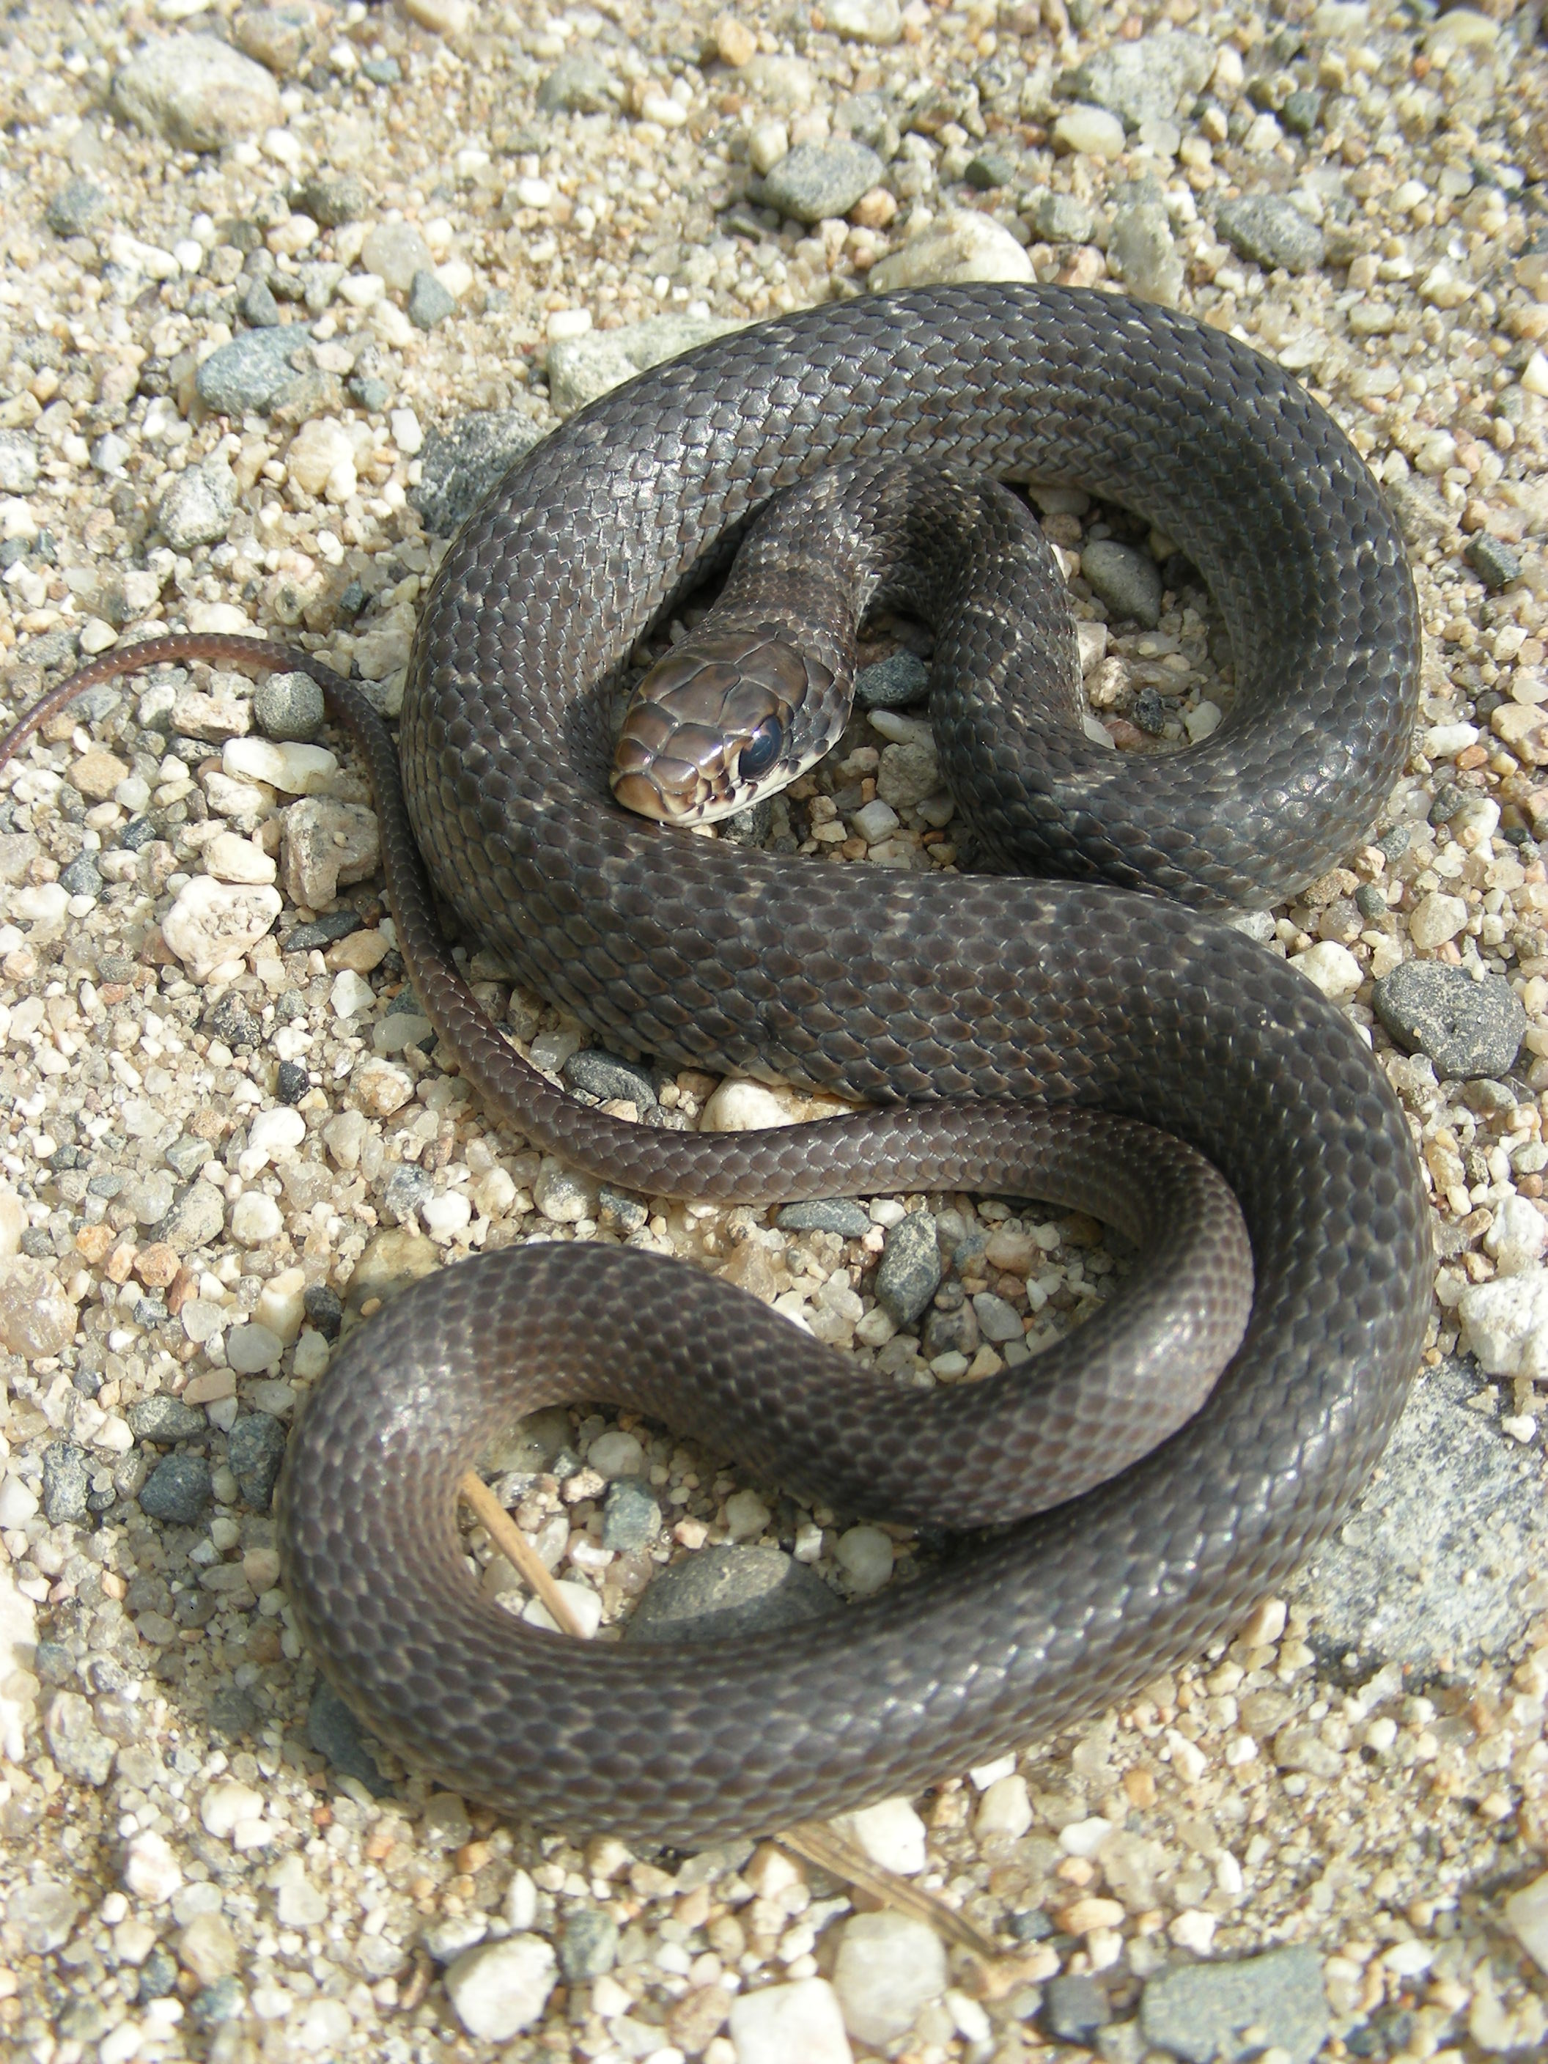
Northern black racer conservation in Maine: mapping standards and environmental review protocols: At present, less than 30 sites in Maine are known to host black racers, and less than six locations have persisting populations. The racer has a high risk of extirpation in Maine due to rarity at the northern edge of its range and habitat loss and fragmentation. MDIFW conducted surveys for the northern black racer from 2007-2012. It used SWG funds to review and synthesize survey data and to develop habitat mapping and ranking protocols, environmental review guidelines, and a factsheet for the black racer.
Timber rattlesnake habitat surveys: No rattlesnake sightings have been documented in Maine for over 100 years, but MDIFW receives many unconfirmed reports almost annually. The majority of these are misidentifications; nevertheless, some are suggestive. Biologists concluded that further investigation of the rattlesnake’s status was warranted due to its ability to remain undetected and to survive in fragmented landscapes. MDIFW funded multiple spring and fall surveys of potential mountain outcrop hibernacula. Although biologists observed no rattlesnakes, it appears that suitable habitat is still available over much of its historic Maine range.
New England cottontail: Maine listed the New England cottontail as an endangered species in 2007. MDIFW used SWG funds to support the salary of Maine’s New England cottontail restoration coordinator; conduct research on the geographic structure and landscape connectivity of New England cottontail populations; monitor the effectiveness of conservation actions; develop noninvasive genetic monitoring technique for population estimation; and develop a pellet count index.
Bald eagle monitoring and habitat conservation: Bald eagles continue their dramatic comeback. Presently, Maine is home to more than 630 nesting pairs, a remarkable increase from 30 nesting pairs in the mid-1970s. In order to minimize risks due to relentless pressures of land development and recreational disturbances on suitable nesting habitat (mature trees and wooded buffers in shorelands) MDIFW devised a statewide, long-term strategy for nesting habitat conservation. With support from SWG, survey emphasis shifted to guide and test the efficacy of those efforts. The following chart summarizes overall progress through the first 10 years of the SWG program in Maine:

Year | # Nesting Pairs | # Conserved Territories | #Partially Conserved Territories
2013 | 631 | 152 | 307
2008 | 477 | 97 | 220
2003 | 310 | 80

MDIFW has not expended SWG funds to purchase lands or easements for eagle nesting habitat, but partnered with > 50 land trusts to leverage projects of mutual interest. Periodic aerial surveys conducted by MDIFW not only track species recovery and safeguards, but provide the support for research by partners on subjects ranging from contaminant studies, productivity monitoring, habitat use and movement studies via telemetry, and identification of eagle foraging aggregations.

Peregrine falcon monitoring: Ground-based surveys are necessary to monitor peregrine nesting activity. MDIFW used SWG funds to survey 11 eyries in 2013, producing observations of eight resident pairs and fledglings at four locations. MDIFW opportunistically banded three nestlings at the Casco Bay Bridge in Portland the same year.
Status and monitoring of Maine owls: For several years, Maine Audubon and MDIFW worked in partnership with a group of more than 200 volunteers to survey owl populations. In 2002-2003, the partners conducted a two-year project to investigate new, volunteer-based survey approaches to more effectively evaluate the status and distribution of owls. MDIFW used SWG funds to complete data entry from this program, improve the efficiency of future surveys, and report the new monitoring approach to volunteers.
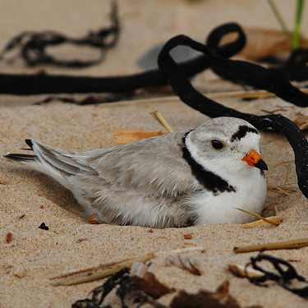
Piping plover and least tern management to monitor the effectiveness of predator control techniques: Piping plovers and least terns are Maine endangered species. They nest along the southern coast and require sand beaches free from human disturbance and predators to raise young successfully. SWG funding enabled MDIFW, working in cooperation with the Maine Audubon Society, to gather data necessary for the management of piping plovers and least terns, including the development of cooperative beach management agreements with municipalities.
Enhancing shorebird conservation in Casco Bay: Casco Bay supports several SGCN shorebirds; however, nearly 25% of Maine residents live within the Casco Bay watershed. Thus, shorebirds are confronted with habitat degradation from development, human disturbance, and contaminants. SWG funds supported a collaborative effort to develop a shorebird monitoring program in Casco Bay to determine shorebird trends and inform adaptive management.
Survey and mapping of important shorebird habitats: Arctic breeding populations of shorebirds have declined by as much as 50% over the past three decades. Habitat loss and degradation along migration routes and in wintering areas are major factors. The Gulf of Maine is a major flyway for many species of shorebirds. Its tidal mud flats provide a significant source of food that is critical to shorebird survival during their fall migration, which is thought to pose the greatest threat to annual survival. Understanding shorebird movements as they migrate through the Gulf of Maine is necessary to identify and preserve important stopover sites. SWG funding has supported shorebird tagging and tracking to determine important feeding areas and offshore roosts, which can subsequently be identified for conservation.
Enhancing the value of shorebird migration monitoring in Maine: Both the U.S. and Canada have identified the need for consistent monitoring of migratory shorebirds. Consequently, MDIFW participated in the development of a sampling plan that is compatible with existing survey protocols and data needs. SWG funds supported a volunteer coordinator to conduct surveys and recruit volunteers. MDIFW submitted survey results to the larger multi-agency program, and Maine will be a part of the long-term monitoring program. The project will improve the conservation of migratory shorebirds by estimating and monitoring population sizes, trends and causes for population declines.

Purple sandpiper research data analysis to identify important wintering areas: The U.S. Shorebird Conservation Council recognized the northeast Atlantic coast as an area important to the survival of wintering purple sandpipers in the Western Hemisphere. Maine supports a large percentage of the wintering population of these sandpipers. MDIFW used SWG funds to estimate abundance and distribution of purple sandpipers, assess movements and site fidelity of individuals at particular sites, and develop a protocol for monitoring purple sandpiper populations.

Development of a Maine seabird atlas: SWG funds allowed MDIFW to compile and publish the Maine Atlas of Breeding Seabird and Coastal Wading Bird Colonies 1960 – 2011. The atlas allows readers to quickly find information on specific seabird colonies or colonies in a particular region of the coast. The atlas includes colony name, Maine Coastal Island Registry number, survey date, observers, survey type, and an estimate of the number of breeding birds.

Inland-nesting seabird surveys: Small numbers of common terns nest on rocky islands in a few large freshwater lakes in northern and eastern Maine; however, their abundance and distribution is poorly understood. MDIFW used SWG funds to survey breeding activity by common terns at Portage Lake and at Long Lake in St. Agatha.

Monitoring roseate tern nesting activity on Maine islands managed by the National Audubon Society: In the Northeast, the federally-endangered nesting population of roseate terns is the focus of broad research. Audubon received SWG funds to conduct nest counts, productivity and growth studies, chick diet studies, and adult mark-recapture studies. Staff also constructed artificial nest boxes and shelters on Stratton Island; roseate terns used many of these throughout the chick-rearing period.
Island nesting tern and great cormorant monitoring in outer Penobscot and Jericho bays: In 2008, MDIFW used SWG funding to conduct a series of nest surveys for island-nesting terns and great cormorants off the coast of Maine. Staff conducted follow-up surveys in July and August to determine the number of fledglings.
Black tern surveys: Black terns nest in large, shallow, emergent marshes associated with lakes, impoundments, and slow-moving streams. Habitat loss and degradation on the breeding grounds are major contributors to the decline of black terns. Eighteen Maine wetlands have supported breeding black terns, and MDIFW has monitored these known breeding sites since 1989 to determine population status and trends. SWG-funded surveys during 2012-2013 determined that black tern numbers were down to 67 pairs in 2013 from 102 pairs in 2012.
Black tern and inland-nesting seabird surveys at historic breeding sites: Students from Nakomis Regional High School in Newport have conducted black tern surveys at breeding sites for many years. They also collect information about common terns, double-crested cormorants, Bonaparte’s gulls, and ring-billed gulls. SWG funds have supported this initiative.
Aerial survey of common loons in northern and Downeast Maine: Common loons are widely distributed across Maine, but are negatively impacted by shoreline development, boating, and lead ingestion. MDIFW used SWG funds to aerially survey approximately 100 lakes in northern and Downeast Maine, where loon surveys had not been conducted since 1996, to assess loon distribution and population trend data.
Aerial census of nesting great blue herons and other colonial wading birds: SWG funds have supported aerial surveys of more than 180 historic great blue heron nesting locations. MDIFW discovered 73 new sites during the surveys or as a result of information provided by the public or other biologists. MDIFW visited 38 colonies to verify locations and to count active nests. Additional on-the-ground efforts included surveys of two coastal islands for nesting black-crowned night-herons, a threatened species. MDIFW also initiated an adopt-a-colony program, called the Heron Observation Network (HERON) that enlists volunteers to monitor wading bird colonies. HERON identified nearly 40 new colonies.
Harlequin duck and purple sandpiper surveys in Outer Penobscot, Jericho, Blue Hill, and Frenchman’s bays: More than 90% of Maine’s wintering population of harlequin ducks is located at offshore ledges in Midcoast Maine. The Midcoast is also an important wintering area for purple sandpipers, which can be surveyed simultaneously with harlequins. MDIFW used SWG funds to support an annual boat survey of the wintering area to monitor changes in abundance and distribution of harlequin ducks and purple sandpipers.
Systematic surveys to determine the winter distribution of Barrow’s goldeneye. Barrow’s goldeneyes exhibit strong site fidelity to wintering areas, returning annually to the same open-water sites along the coast between Eastport and Kittery and between the Penobscot and Kennebec rivers. Systematic surveys of these sites are an efficient way to monitor distribution and population trends. MDIFW conducted surveys in 1999-2000 and repeated these surveys in 2008-2009. The number of Barrow’s goldeneye detected in 2008-2009 was 27% lower than the number in 1999-2000.
Conserving grassland birds in Maine: a comprehensive field survey for declining species in southern Maine: From 1997-1998, MDIFW surveyed nearly 300 grasslands and barrens to assess the presence of grassland birds. Following field surveys, the Department used GIS to map the extent of grassland habitat around the original survey sites. SWG funding allowed MDIFW to revisit many of the sites, adding additional survey points to better characterize grassland bird communities. Furthermore, MDIFW identified additional sites not previously surveyed to broaden the survey’s scope and expanded its intensity in six counties.

DATABASE DEVELOPMENT AND MAINTENANCE

Data conversion and management: This project converted data currently housed in the Biological Conservation Data System to the Biotics data management system. Following standard Heritage methodology, MDIFW used SWG funding to collect, transcribe, map, and process data on rare, threatened, and endangered animals, entering 257 records into Biotics. MDIFW provided data to NatureServe and The Nature Conservancy for biodiversity assessments. SWG funds also supported the development of MDIFW’s Endangered, Threatened, and Special Concern (ETSC) relational database. This system stores tabular observation data in Microsoft Access, which is linked to observation points and mapped habitat areas stored in a geodatabase. The system was designed specifically to meet MDIFW’s needs, especially for environmental reviews. It currently contains >6,500 observations.

Maine Aquatic Biodiversity Project: This project used SWG funds to compile freshwater biodiversity data on fish, macro-invertebrates, amphibians, reptiles, and aquatic plants into a centralized database containing over 200,000 geo-referenced records from across the state. It analyzed and synthesized these data to develop summaries of species distributions, patterns of species richness, associations among biodiversity and landscape-level variables, evaluation of data gaps, and an overview of key threats and stressors to freshwater ecosystem. The project re-designed and upgraded the University of Maine’s PEARL website to accommodate stream, wetland, and terrestrial data, providing on-line access to aquatic biodiversity data.
Stream survey database: MDIFW possesses extensive information on physical and biological stream characteristics; however, these data were in multiple formats and storage locations. MDIFW used SWG funding to compile existing stream habitat and fish community data into a GIS for easier use, analysis, and visualization. This project included field assessments of streams, the creation of a database to manage stream survey data, and the development of a reporting system that summarizes and displays data in a format useful to fishery managers. MDIFW also compiled a guide to Maine’s freshwater fish, created the Maine Stream Index, and conducted statewide mapping of ‘likely brook trout habitat.’ Ultimately, these efforts allow fisheries biologists to identify completed and future survey efforts.

Data entry and database management for Maine’s rare, threatened, and endangered reptiles, amphibians, and invertebrates: MDIFW used SWG funding to update the ETSC database by transcribing and entering recent and historic field notes and creating corresponding point locations in GIS.

Maine Amphibian and Reptile Atlas: MDIFW used SWG funds to enter nearly 1,200 reptile and amphibian records into the ETSC database. Additionally, it converted information from older, hard-copy reports to digital format and scanned and catalogued original documentation photographs. MDIFW contacted various museums in the Northeast to request confirmation of Maine specimens possessed and their catalog numbers. From the museum reports, the project gathered new records and updates for Blanding’s turtle, spotted turtle, wood turtle, and northern black racer, all of which are SGCN.

Documenting statewide survey efforts and results for Maine’s rare mayflies: Maine has two species of mayflies listed under Maine’s Endangered Species Act and more than a dozen species considered Special Concern. Surveys to document the occurrence, distribution, and status of the Tomah mayfly have been ongoing since the late 1970s, when researchers at the University of Maine rediscovered this globally rare insect once thought to be extinct. MDIFW has conducted extensive surveys for both the Tomah mayfly and Roaring Brook mayfly through its ecoregional survey over the past decade. It has also undertaken limited surveys for several other mayflies. In total, MDIFW has surveyed several hundred sites for rare mayflies. Using SWG funds, MDIFW transcribed its field records and those available from the University of Maine and independent sources into the ETSC database, creating a comprehensive, up-to-date record for these rare mayflies.
Data entry and database management for Maine’s rare, threatened, and endangered birds: MDIFW used SWG funding to transcribe field notes and reports into the ETSC database and create corresponding point locations in GIS.

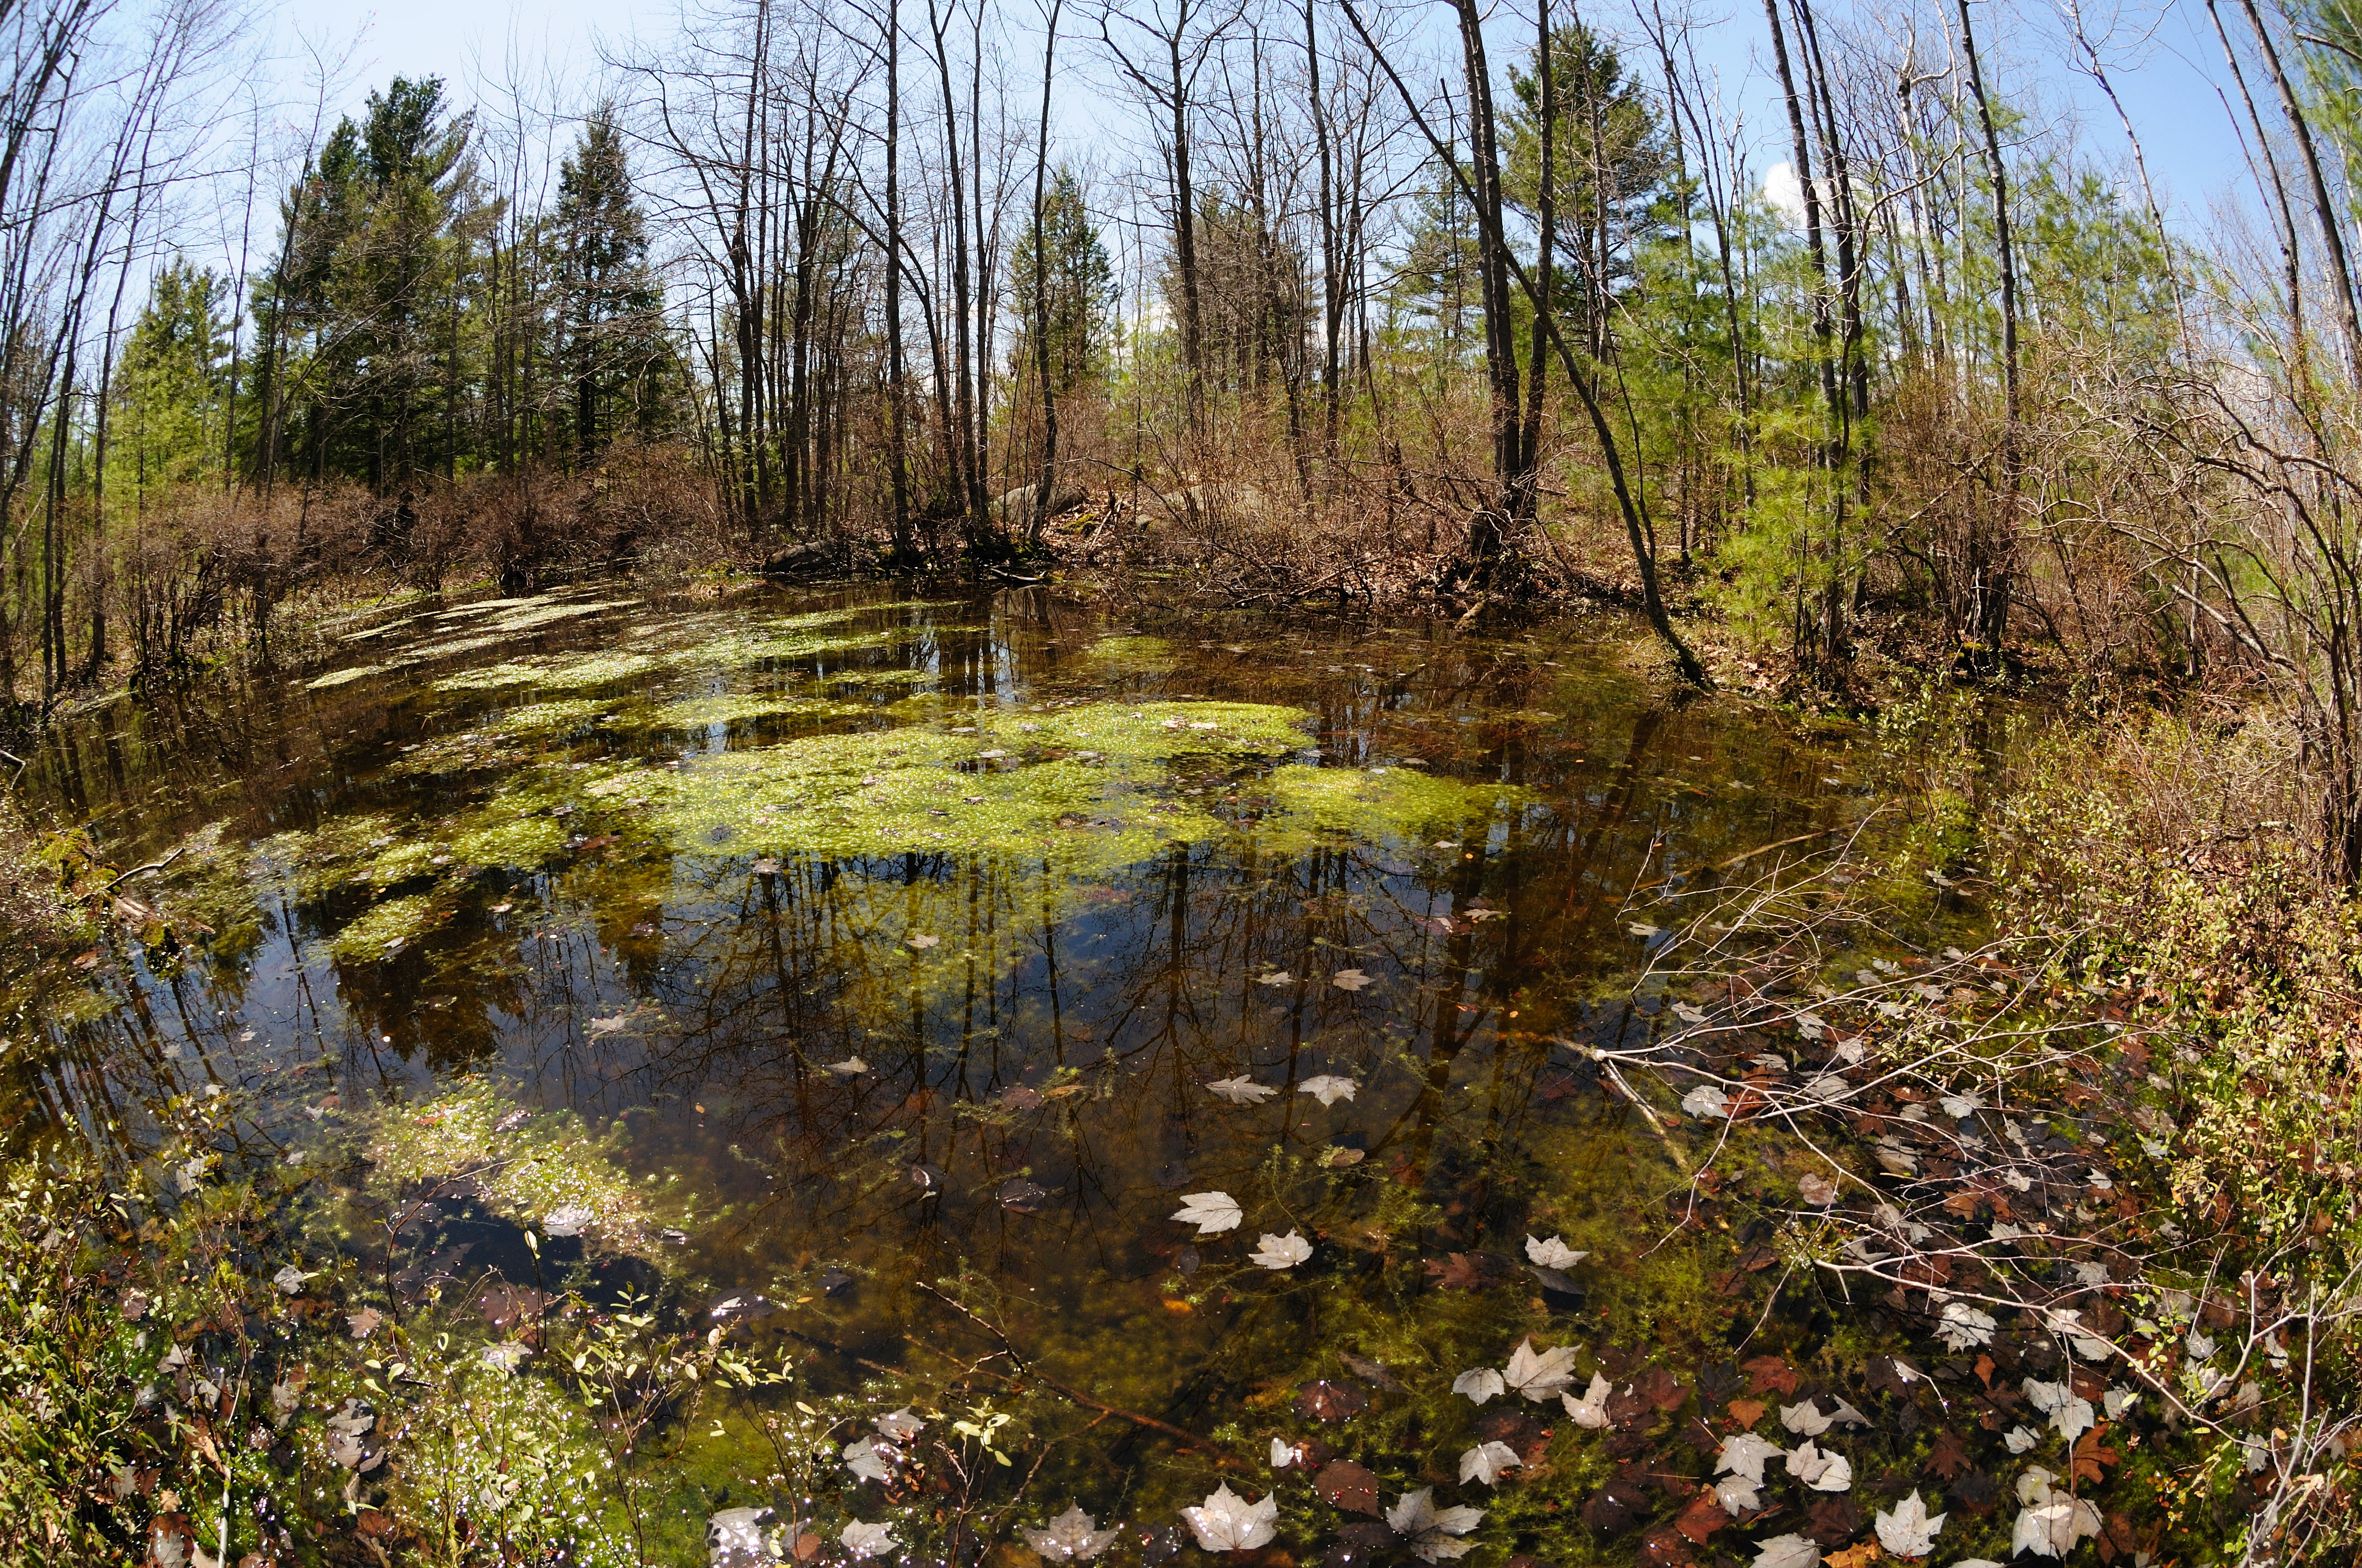
Planning for habitat management on MDIFW lands: Two-thirds of MDIFW’s Wildlife Management Areas (WMAs) provide habitat for rare, threatened, or endangered species. MDIFW used SWG funding to develop a statewide WMA database, which provides a summary of habitat types, physical features, stream layers, roads, natural communities, and property boundaries for MDIFW lands. SWG funds also supported the 2006 WMA plan update. Each updated plan contains a schedule of development and maintenance treatments and a schedule of habitat treatments to enhance wildlife diversity.

EDUCATION

Fish and wildlife education: Fish and wildlife conservation education at the elementary school level is important to establish ecological awareness in Maine’s citizens. MDIFW used SWG funding to assemble and mail a wildlife-conservation education packet to all 4th grade teachers in Maine. Each packet contained five MDIFW conservation posters, each linked to a Project WILD activity. MDIFW also developed Critters of Maine a full-color, 128-page pocket guide to wildlife that conforms to Maine’s State Learning Standards. MDIFW mailed 25 booklets to all 4th grade classrooms.
Seabird outreach: MDIFW used SWG funding to teach Maine students and the public about seabird biology and marine conservation. The program provided insight into the lives of Maine seabirds through a web-based school curriculum that featured live video from Eastern Egg Rock, a state-owned, seven-acre sanctuary managed by the National Audubon Society. The outreach effort also developed an interactive CD on tern biology and conservation and distributed them to upper elementary and middle school children.
Swan Island wildlife viewing area: Swan Island is a WMA located in the Kennebec River in the town of Richmond. Swan Island hosts almost 4,000 visitors annually, who come to hike, mountain bike, camp, participate in wildlife and conservation education tours, and photograph and view the abundant island wildlife. MDIFW used SWG funding to erect a wildlife viewing tower on the island and to renovate an existing boathouse to serve as an indoor classroom for its education programs.

RESEARCH

Studies of sea run brook trout in two Maine streams: Understanding the movements of brook trout in coastal streams is necessary to manage this important game fish and for the conservation of Atlantic salmon. This study used SWG funding to characterize brook trout movements in Stanley Brook and Cove Brook, both along the Maine coast. It used passive integrated transponder (PIT) technology to track individual brook trout movement in and out of these two systems; it also conducted stream-habitat surveys to complement life history and movement data. Data from this project contributed to the completion of a Master’s of Science thesis at the University of Maine, as well as two peer-reviewed publications.

Lake whitefish: This project identified factors contributing to the decline of Maine’s whitefish fishery. It focused research efforts on the relationship between the introduction of certain non-indigenous species, particularly the rainbow smelt, and the subsequent decline of lake whitefish populations. The project used SWG funding to search for information pertinent to competition and predation of rainbow smelt on lake whitefish. It conducted field studies on the movement of sub-adult and adult lake whitefish and potential interactions between lake whitefish and smelt. Next, the project consolidated the data and analyzed population trends for these two populations. Using this information, it developed a model predicting the likelihood of lake whitefish presence, based on physical characteristics of lakes and the presence of other fish species. Over the long term, this project is expected to prevent further decline and initiate the restoration of the lake whitefish sport fishery.
Environmental factors associated with unique lake communities in Maine: Widespread fish stocking has led to a worldwide decline in naturally fishless lakes and their associated communities. Little is known about the historic distribution and the native communities of these freshwater ecosystems. MDIFW has documented at least 30 fishless ponds; many ponds currently with fish are known to have been fishless prior to stocking. SWG funds allowed two University of Maine graduate students to develop a quantitative method to remotely detect naturally fishless lakes in Maine, conduct a landscape-scale assessment of unique attributes of fishless lake macroinvertebrate communities, identify macroinvertebrate bioindicators of fish absence, and assess effects of introduced fish on native macroinvertebrates. The study determined that stocked lakes supported dramatically reduced macroinvertebrate abundance and species richness than currently fishless lakes. These effects were more pronounced in headwater than kettle lakes, likely due to sparse littoral habitat and intense stocking. Maine’s naturally fishless lakes provide habitat for a unique suite of organisms that thrive in the absence of fish predation.

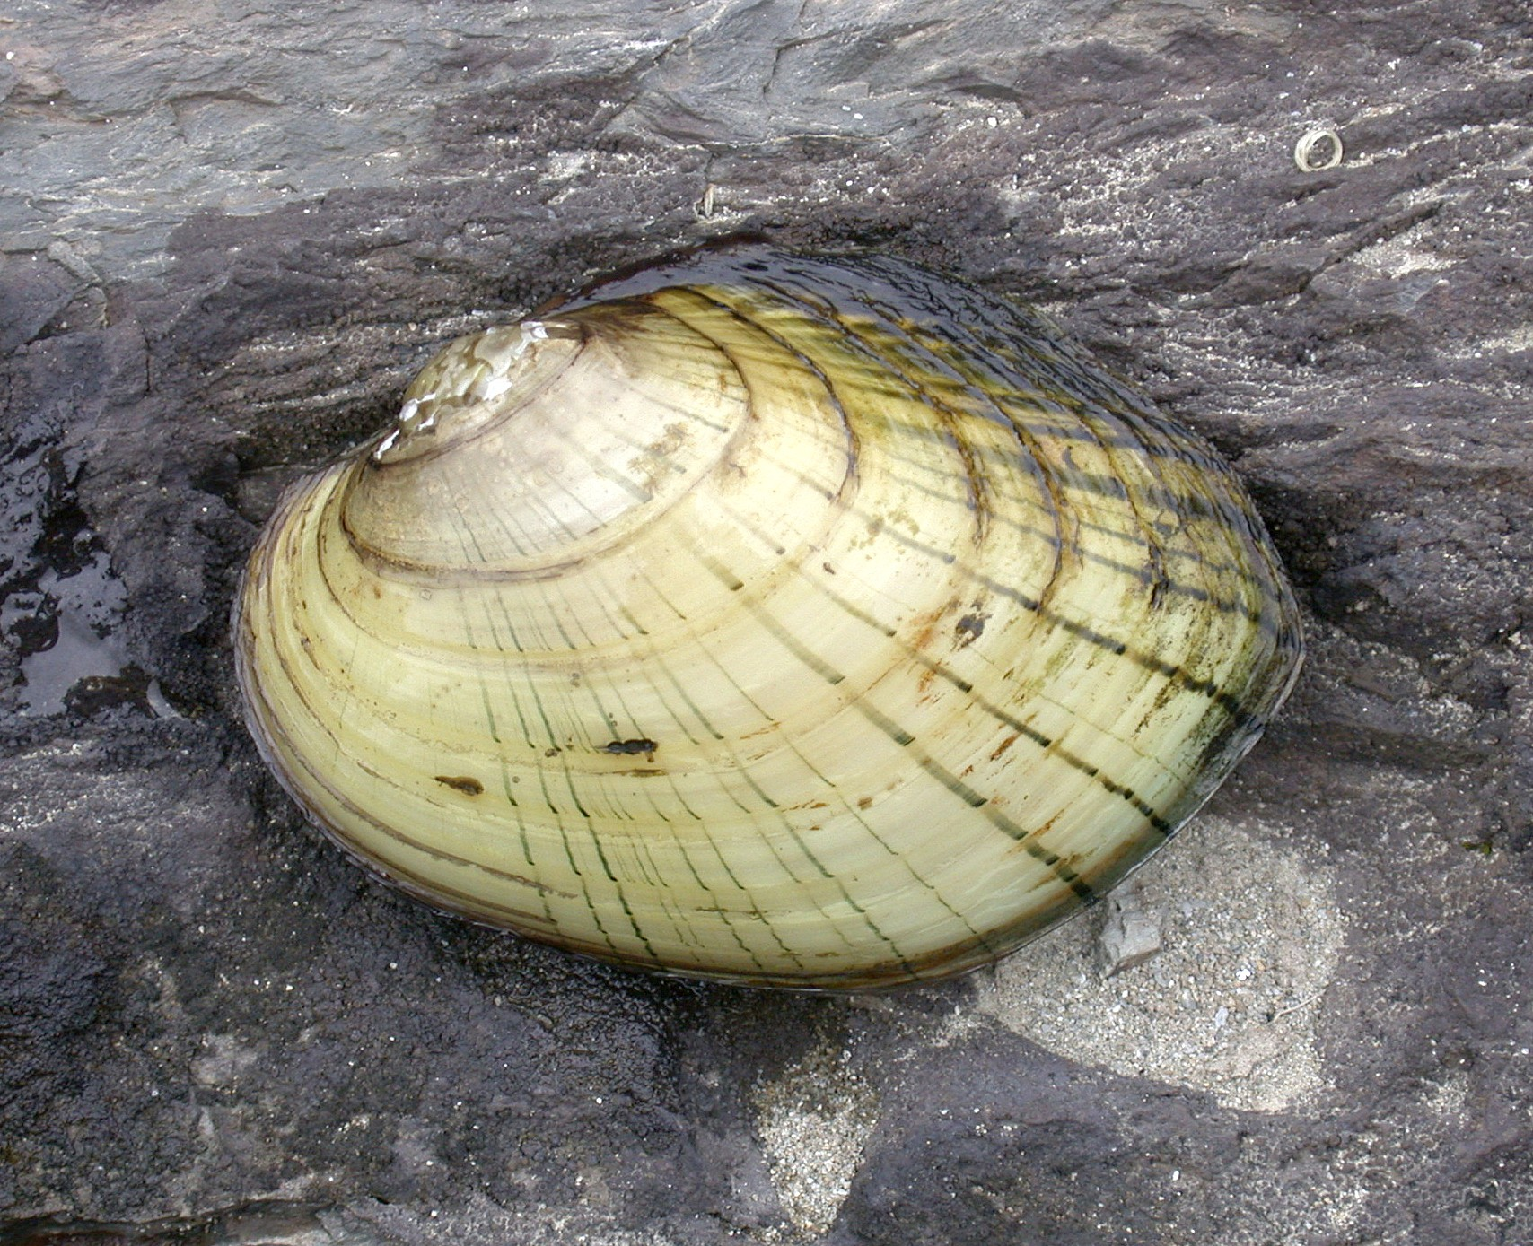
Effects of dam removal and relocation on yellow lampmussels and tidewater muckets: Dam removal could potentially jeopardize the state-threatened yellow lampmussel and tidewater mucket, as both inhabit impoundments, but the long-term effects were largely unknown. Two Masters’ of Science projects used SWG funding to investigate the status and distribution of these mussels, determine habitat selection, and evaluate relocation as a tool to minimize loss. The research indicated that both species are relatively flexible in their habitat needs and can persist in both flowing water and impounded areas. Therefore, the long-term persistence of the population is more likely limited by threats other than habitat loss, including mortality immediately following dam removal.
Genetic structure of Clayton’s copper butterfly metapopulation and assessment of environmental conditions in wetlands with and without Clayton’s copper: Investigators first discovered Clayton’s copper in Maine and described it as a distinct subspecies in 1940, disjunct and separate from the more widely distributed Dorcas copper. It is currently known from only ten sites in Maine and five just over the border near Woodstock, New Brunswick. Through cooperative efforts with the University of Maine, funded by SWG, MDIFW is using project information to estimate the levels of dispersal and isolation that contribute to butterfly population stability and to develop shrubby cinquefoil habitat management goals, as the butterfly species’ obligate host plant. These data also serve as a baseline for future cinquefoil monitoring and provide information for conservation planning and management of this endangered butterfly.
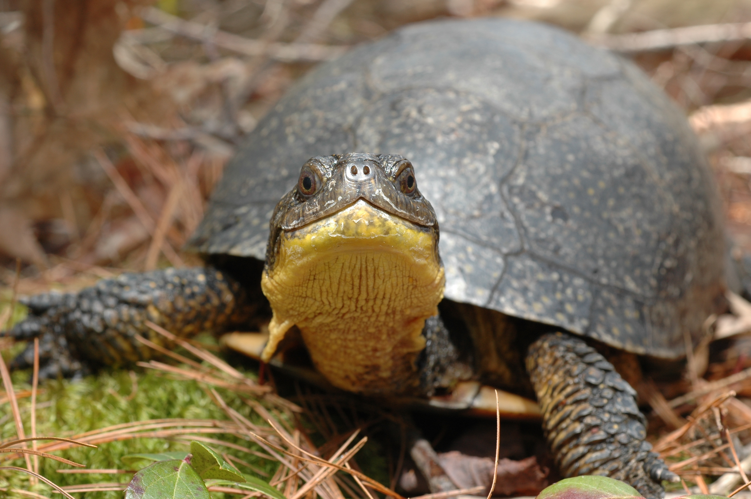
Habitat and distribution of the arrowhead spiketail dragonfly in Maine: The arrowhead spiketail dragonfly is found across much of the eastern U.S., but is generally rare in part due to the highly vulnerable nature of its breeding habitat. This species has been documented at nine sites in Maine, of which only a subset have likely breeding habitat. MDIFW used SWG funds to survey known and potential populations and habitats, characterize known breeding habitat in Maine, and assess the distribution and population status of the dragonfly statewide, including a conservation status recommendation. Researchers confirmed arrowhead spiketail populations at four new sites and located reproductive habitat at another. Analyses are currently in progress at the University of Maine to quantify both local and watershed scale characteristics of breeding habitat.
Blandings turtle road research: The Maine Department of Transportation (MDOT) and MDIFW initiated this project, using SWG funds, to support a University of Maine doctoral student in the development of a predictive model of endangered turtle road mortality rates for specific road segments throughout southern Maine. In addition, it produced a comprehensive review of road conservation mitigation options suitable for endangered turtles in southern Maine and also three peer-reviewed manuscripts advancing the science of turtle-road ecology.
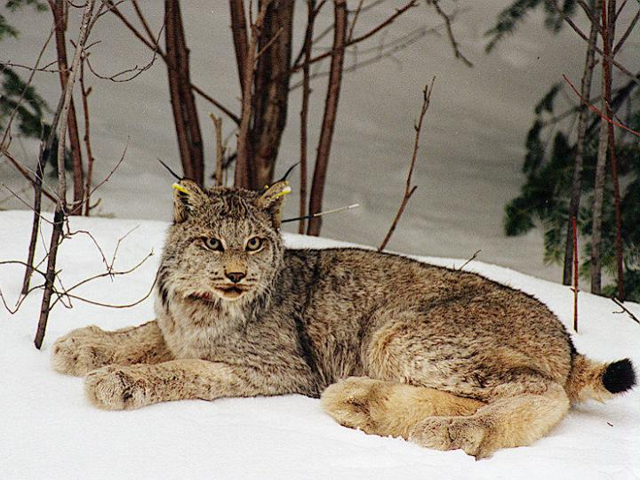
Canada lynx ecology: The U.S. Fish & Wildlife Service [USFWS] listed the Canada Lynx as threatened under the U.S. Endangered Species Act in 2000. Maine is the remaining stronghold for lynx in the east. MDIFW, in cooperation with the USFWS and the University of Maine, has been researching lynx population dynamics, habitat use, interactions with other carnivores, movements, and survey approaches since 1999. This effort has gathered some of the most detailed information on lynx ecology in the lower 48 states. Since 2005, biologists have used SWG to fund a significant portion of this research. Fieldwork has included capturing and fitting adult lynx with VHF and GPS radio collars to monitor survival rates, causes of mortality, reproduction, movements, and habitat use patterns; visiting den sites to determine litter sizes and tag kittens; conducting snow track surveys to assess the abundance of lynx and sympatric carnivores; and monitoring snowshoe hare pellet transects to determine hare density. This project has resulted in several peer-reviewed publications, guided the development of MDIFW’s lynx species assessment, and informed the federal designation of critical habitat for lynx in northern Maine.
Canada lynx diet and impact mitigation: SWG funds supported a Master’s of Science student at the University of Maine conducting research on the diet of Canada lynx. The student extracted DNA from “potential” lynx scats and used DNA to discriminate lynx scat from non-lynx species. If the scat sample came from a lynx, the student determined the gender of the animal. This project is ongoing, and will ultimately result in sex-specific evaluation of lynx diets in northern Maine. SWG funds have also been used to mobilize MDIFW wildlife biologists responding to lynx incidentally captured in foothold traps, so that the lynx may be assessed for injury and released unharmed. MDIFW is researching injury levels in relation to environmental factors and trapping techniques under the structured decision-making and adaptive management paradigms.
Risk assessment of saltmarsh passerines to mercury contamination: SWG funds supported a study to determine mercury exposure and assess risk to passerine birds breeding in Maine saltmarshes by determining the levels of mercury in the eggs and blood of tree swallows and saltmarsh sparrows and correlating these observed mercury levels with known impact levels from swallow dosing studies. This research effort concluded that blood is an appropriate tissue to evaluate the mercury exposure to insectivorous, saltmarsh birds and found that saltmarsh sparrows have elevated blood mercury levels across much of the Northeast. Tree swallows had significantly less mercury in blood than saltmarsh sparrows, indicating that aerial foragers, such as swallows, may not best represent mercury risk in estuaries.
Effects of tidal restriction on the breeding ecology of saltmarsh sparrows: Saltmarsh sparrows are migratory songbirds that breed exclusively in saltmarshes along the Atlantic coast. As a result of extensive industrial and urban development, saltmarshes have become increasingly rare. Roads, in particular, are known to restrict natural tidal flow and significantly alter marsh hydrology. Using SWG funding, MDIFW collaborated with the University of Maine to examine how roads crossing tidal marshes affect saltmarsh sparrow reproduction. This project confirmed that nests were more likely to succeed if they were initiated quickly after the lunar high tide flood cycles. In addition, nests located in marshes with tidal restrictions were more vulnerable to inundation from heavy rainfall compared to nests located in unrestricted marshes.
Productivity and dynamics of saltmarsh sparrow populations in a hybrid zone: Saltmarsh and Nelson’s sparrows commonly interbreed in an area of range overlap that includes approximately 170 km of the Maine coast. By evaluating hybrid fitness in relation to that of the parents and using microsatellite genotyping to determine the extent and direction of genetic introgression, MDIFW desires to gain a better understanding of the dynamics of the hybrid zone. MDIFW used SWG funding to evaluate the fitness (via nesting success and survival) of saltmarsh-Nelson’s hybrids in comparison to pure individuals. We collected genotypic data from nests containing chicks and their associated mothers to contribute to genetic studies of introgression and range-wide source-sink metapopulation dynamics. MDIFW incorporated the data collected for this project into a larger, collaborative, SWG funded Saltmarsh Habitat and Avian Research Project, contributing to regional analyses and a population model.

Determining the relationship between nest predation of rusty blackbirds and timber management: Rusty blackbirds of the northeastern U.S. have declined by an estimated 80-90% in the last 50 years. Despite increased research on this species, the causes are still unclear. Previous work in Maine indicated that this species may be suffering from an “ecological trap,” wherein they preferentially nest in regenerating clear cuts, experiencing higher nest predation and lower nest success than in -uncut areas. SWG funded an investigation of the relationship between habitat, nest site selection, and predation. Analysis is ongoing.
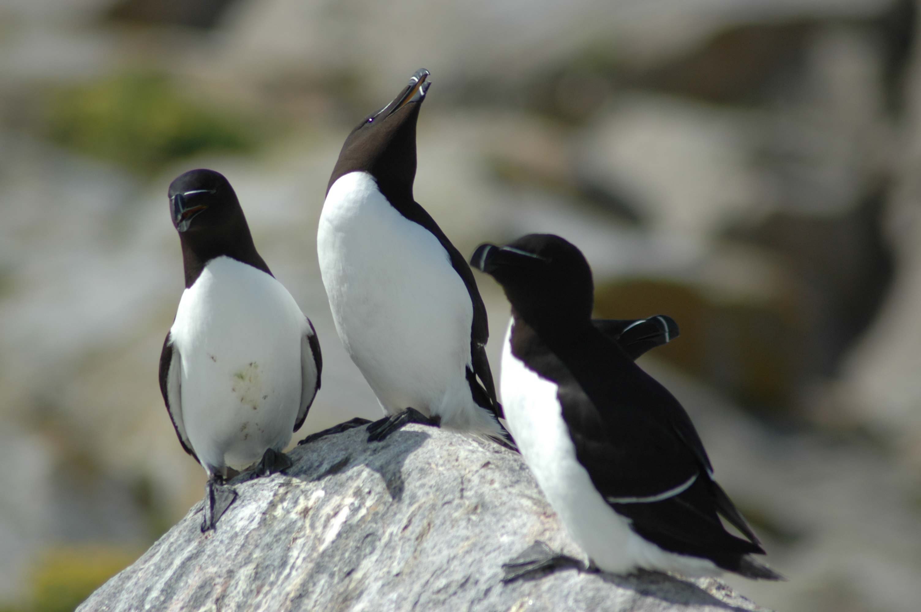
Foraging behavior of razorbills at the southern limit of their range in Maine: Razorbills were extirpated from the Gulf of Maine in the late 1800s, but have recolonized some nesting habitat during the past few decades. There are currently six colonies in Maine, which is the southern edge of this species’ breeding distribution. A Master’s of Science project at the University of Massachusetts used SWG funds to investigate adult foraging behavior, chick diet, and reproductive success of razorbills on Matinicus Rock. This project concluded that low prey availability was limiting population growth and that the success of this colony was likely due to immigration from other areas.

RESTORATION
Restoration work to facilitate nesting by terns, Atlantic puffins, and razorbills on Eastern Brothers Island: Eastern Brothers Island has historically served as an important nesting area for several sea bird species, but a variety of factors have recently resulted in low nesting activity. SWG funded several management actions to improve the attractiveness and security of Eastern Brothers Islands for nesting seabirds. These included placement of puffin and razorbill decoys, a sound system to imitate the sounds of an active tern colony, and active hazing to discourage gulls from nesting on the island.

BACKGROUND
Congress instituted the State Wildlife Grant program in 2001 via H.R. 2217, the Dept. of Interior and Related Agencies Appropriations Act, 2002, enacting the State and Tribal Wildlife Grants Program. This act provides wildlife conservation grants to U.S. States, the District of Columbia, and the territories of Puerto Rico, the U.S. Virgin Islands, the Northern Mariana Islands, American Samoa, and to federally-recognized Indian tribes. SWG supports the development and implementation of management programs that benefit wildlife and their habitat, including species that are not hunted or fished. Funds appropriated under the SWG program are allocated to states according to a formula that takes into account each state’s size and population.
To qualify for SWG funding, Maine must have a comprehensive wildlife conservation strategy, also known as the State Wildlife Action Plan. Maine submitted its first wildlife action plan to the USFWS in the summer of 2005. The plan identified species and habitats in greatest conservation need, including 213 SGCN; key threats to wildlife and habitat; and conservation actions needed to prevent endangered species listing or to spur recovery. http://www.maine.gov/ifw/wildlife/reports/wap.html
Since 2005, Maine has received $7,962,737 in SWG funds, of which $2,366,855 (30%) has been directed towards salaries. Projects have involved many species groups, all geographic areas of the state, and have ranged in scale from ecosystems to subspecies. Projects have varied in length from one year to five years and included baseline surveys and inventories, research, and habitat conservation. SWG funds support the equivalent of ten full-time positions at MDIFW.

The provisions of the SWG program require that each state update its wildlife action plan every 10 years. Maine's update is due in October 2015.

State Wildlife Grants are administered under the provision of the Fish & Wildlife Act of 1956 and the Fish & Wildlife Coordination Act.

