OTDR Traces
All fiber being tested should have a “Launch Cable”
The launch cable allows the OTDR trace to settle down after the test pulse is sent into the fiber so you can analyze the beginning of the cable you are testing. OTDR Launch Cables are designed to be used in conjunction with an OTDR to measure complete link loss of a fiber. A receive cable may be used on the far end to allow measurements of the connector on the end of the cable under test also.
Special PON OTDRs will test at 1310, 1490 and 1550 nm. Some also test “out of band” at 1650 nm, which is more sensitive to bending losses and allows in-service testing with a filter to remove signal wavelengths. Since PONs are short, the OTDR needs very high resolution, usually obtained by having the shortest test pulse that will give adequate range.

Testing PONs in the downstream direction is helped with launch and receive cables. The launch cable allows testing the initial connector on the link as well as allowing the initial overload of the OTDR to settle down as with any OTDR test. But on the receive end, if a cable of known length is used, say 100m or 500m, one can look back exactly that distance from the reflective end to see the loss of the end connector.
- Look at Length of Fiber tested. This should show and be documented the “A” & “B” locations. The fiber should be long enough to show splices, connectors, splitters and any other events associated with the fiber.

- Splice losses can range from very low (<0.05dB per splice) up to 0.3dB per splice, the maximum allowed by the IEC/TIA 568 standards.
- Connector loss - While TIA standards specify a maximum insertion loss for connectors of 0.75dB, most manufacturers' connectors have a typical insertion loss that ranges between 0.2 and 0.5dB. All splices within your cable plan also need to be calculated as part of your loss budget. .75dB would represent 2 connectors and a bulkhead.

- Reflectance and Optical Return Loss (ORL) Measurement and Testing - Opti Fiber. ... Return loss for the entire fiber under test, including fiber backscatter and reflections and relative to the source pulse, is called Optical Return Loss (ORL).

- Link Loss - The cable plant "loss budget" is a function of the losses of the components in the cable plant - fiber, connectors, and splices, plus any passive optical components like splitters in PONs. Thus, the loss budget of the cable plant is a major factor in the power budget of the fiber optic link and is what one calculates to compare against tested insertion loss (and even compares to OTDR loss measurements) to determine if the cable plant is properly installed.
For single mode fiber, the loss is about 0.5 dB per km for 1310 nm sources, 0.4 dB per km for 1550 nm. (1.0 dB/km for premises/0.5 dB/km at either wavelength for outside plant max per EIA/TIA 568). This roughly translates into a loss of 0.1 dB per 600 (200m) feet for 1310 nm, 0.1 dB per 750 feet (250m) for 1300 nm.
The power budget refers to the amount of fiber optic cable plant loss that a datalink (transmitter to receiver) can tolerate to operate properly. Sometimes the power budget has both a minimum and maximum value, which means it needs at least a minimum value of loss so that it does not overload the receiver and a maximum value of loss to ensure the receiver has sufficient signal to operate properly.
The loss budget is the amount of loss that a cable plant should have if it is installed properly. It is calculated by adding the estimated average losses of all the components used in the cable plant to get the estimated total end-to-end loss. The loss budget has two uses, 1) during the design stage it is used to ensure the cabling being designed will work with the links intended to be used over it and 2) after installation, the loss budget for the cabling is compared to the actual test results to ensure the cable plant is installed properly.
- Micro Bends - A microbend is a fiber imperfection. Microbends cause an increase in cable loss. This loss can result in an excessively large loss in excess of 100 dB/km in some cases. ... Microbend-induced loss is a function of mode-field diameter, cable design, and cable construction.

- Using an OTDR to test every fiber in an OSP link is traditional, as the OTDR provides a snapshot of the losses in the fiber, locates loss events (connectors, splices and bending losses from improper installation), aids installation troubleshooting and provides a trace which can be stored for later troubleshooting and restoration. On FTTH PON networks, the PON splitter causes some unusual traces on OTDRs, with the traces looking totally different when tested from each direction. Here are two traces from an actual system taken in two directions.

This trace is taken downstream from the CO to the subscriber:
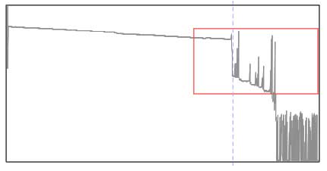

This trace is taken upstream from the subscriber toward the CO.
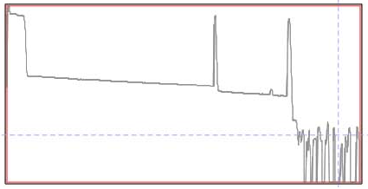

In both traces, you can see the large loss of the PON coupler, best seen in the upstream trace at the bottom, on the left side of the trace. On the downstream trace, it is the large loss preceding the multiple peaks of the subscriber fibers, marked with the dashed marker line. Below we will show a simpler coupler and explain what you are seeing here.

- OTDR Testing From CO
PON systems create problems for OTDRs. Shooting from the input of a PON splitter at the CO, the OTDR sees and adds together the backscatter traces from all the fibers. As a result, it becomes impossible to see detail on individual fibers, and an event (connector, splice of bending loss) cannot be easily assigned to any individual fiber unless the cable plant is carefully documented at installation.
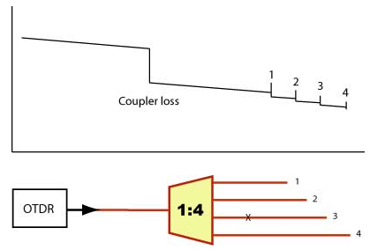
Consider the “X” shown in the network diagram below. If it was a loss or reflective event, it would show on the OTDR trace, but the operator would not know if were in fiber 1,2,3 or 4. The only unambiguous part of the OTDR trace shown is the end of fiber 4, the longest fiber, beyond the length of the next longest fiber, #3.

It should be noted that FTTH links, because of their short lengths and the use of some high-power transmitters, usually have APC connectors or fibers prepared to have minimal reflectance. That can make analyzing downstream OTDR traces very difficult when no reflective end is available to mark the fiber end and there are 32 fibers in the system.

- OTDR Testing from Subscriber
Testing from the subscriber end is easier. The fiber path will show events on just one fiber, like the “X” shown on fiber 3, and a high loss for the coupler. Here a 1:4 coupler will have 6 dB of splitting loss plus perhaps 1dB excess loss for a total of 7 dB loss.
Using launch and receive cables allow testing connectors on both ends and measuring end to end loss.
