Monitoring Site Visit Manual

Web: www.Maine.Gov/CSC
Email: MCSC@Maine.Gov

Adopted April 2019
Updated August 2021

Contents

 | Topic | pg
A | Site Visit Purpose | 3
B | Site Visit Frequency and Intensity | 3
C | End of Year Monitoring Visit Timeline | 5
D | End of Year Monitoring Visit Schedule | 5
E | Monitoring Visit Materials for the School | 5
F | Pre-Visit Phone Call | 5
G | Submission Requirements for the School | 6
H | Materials School Provides at Visit(s) | 6
I | Sample Visit Schedules | 6
J | Focus Group Participant Selection Guidance | 7
K | Focus Group and Interview Questions | 7
L | Materials list for MCSC Site Visit Team | 10
M | Discussion Topics for Site Visit Pre-Visit Meeting | 11
N | Classroom Observation Guidance | 11
O | Monitoring Site Visit Report | 12

- Site Visit Purpose

The primary purpose of site visits is to inform authorizer decisions, both imminent, such assessing a school’s readiness to open, and longitudinal, when a visit is undertaken mid-term as part of routine monitoring.

The purpose of monitoring visits is to gauge the overall progress a school is making toward the mission and goals outlined in its charter. In most cases, the authorizer will already possess some quantitative data about that progress – test scores, attendance rates, and other annual outcomes, so a monitoring visit can help explain the context behind that data and explore the school’s fidelity to its approved program.

Site visits are a mechanism for collecting additional evidence regarding a school’s performance against the expectations memorialized in its contract and contribute to the body of data authorizers utilize to ultimately make renewal recommendations. They also provide MCSC staff with the opportunity to review and analyze documentation that may be better understood on-site, such as factors impacting attendance, or rates of academic growth across subgroups. Site visits can also provide a basis for authorizer judgment or intervention where there is limited state assessment data yet available.

The Maine Charter School Commission’s Monitoring Site Visits are based on both the criteria set forth in the school’s performance framework and the school’s alignment with its mission. The categories in the performance framework are student achievement, school climate and family engagement, governance, and finance.

- Site Visit Frequency and Intensity

The MCSC has established a monitoring visit table for visit frequency and intensity (see page 4). At its discretion MCSC may opt to not conduct monitoring site visits in accordance with the Site Visit Table for schools that are performing well. Likewise, the MCSC may choose to visit a school that is not on a visit cycle for any reason.

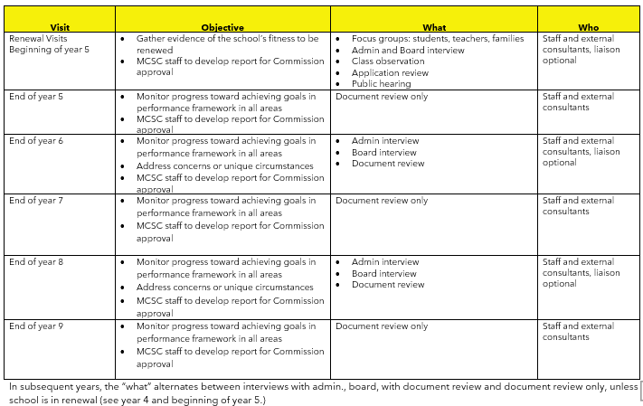
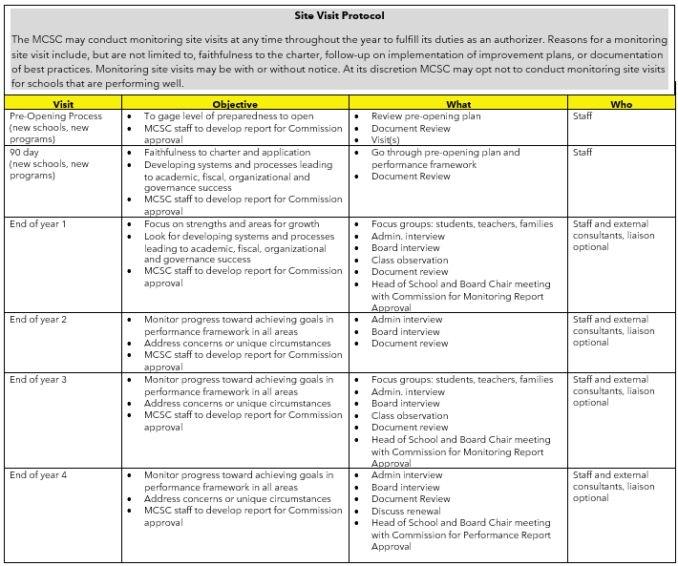

- End of Year Monitoring Visit Timeline

The following monitoring visit timeline will be followed as closely as possible to ensure sufficient notice to the school for planning purposes.

What | When
MCSC office contacts school to schedule visit date(s) | Approximately 6 weeks before visit
MCSC office sends schedule and any necessary materials to the school | Approximately 4 weeks before visit
MCSC office contacts school leader to go over the details of the visit and to answer any questions | Approximately 4 weeks before visit, a few days after materials are sent to the school
School completes all document submissions | Approximately 3-4 weeks before visit (due dates in Epicenter)
MCSC staff meet with Site Visit Team to review submitted materials and schedules. | Approximately 2 weeks before visit

- End of Year Monitoring Visit Scheduling

End of year visits may take one to two days, depending on the intensity of the visit. A visit for the purpose of classroom observations and for meeting with focus groups of students, families, and teachers/staff is typically scheduled for one day in late May/early June while school is in session. Visits with the school’s governing board and administration are typically scheduled for 1 day in late July/early August when school is out of session. There are circumstances when this schedule may not be suitable, such as during renewal, in these instances other scheduling arrangements will be made.

- Monitoring Visit Materials for the School

Approximately 4 weeks before the scheduled visit the MCSC office will send to the school a letter outlining the purpose of the visit with a confirmation of the date(s) and time, the number of people on the visiting team, visit schedule(s), focus group selection guidance (as applicable), focus group questions, a list of documents required for the day of the visit(s), and a lunch request. Additional materials may be included.

- Pre-Visit Phone Call

Shortly after the materials are sent to the school, the MCSC office will contact the school leader to review the purpose and schedule for the visit(s), confirm dates(s) and time(s), discuss required meeting space, answer any questions the school leader may have, and to discuss the procedure for reporting the Site Visit Team’s findings to the school.

- Submission Requirements for the School

Prior to the End of Year Monitoring Visit there will be submission requirements for the school due in Epicenter. The submissions may include, and will not be limited to:
- Current organizational chart
- Current strategic plan (if applicable)
- Current Education Service Provider Contract (if applicable)
- Professional Development calendar and agendas
- Staff evaluation tool
- Administration evaluation tool used by governing board
- Self-evaluation

- Materials School Provides at Visit(s)

On the day of the Monitoring Visit the school will provide copies of the following:
- Copies of current recruitment materials
- Student enrollment application
- School map
- Lunch menus for visit team (as applicable)
- Other items as requested

- Sample Visit Schedules

Late May/Early June Visit

 | Visitor 1 | Visitor 2 | Visitor 3 | Visitor 4
9:30-10:00 | Visiting Team arrival and orientation with School Leader
10:00-11:00 | Classroom Observations with School Leader |  | School walk through
11:00-11:45 | Teacher Focus Group 1 |  | Classroom Observations with School Leader
11:45-12:30 | Visiting Team working lunch
12:30-1:15 | Teacher Focus Group 2 |  | Parent Focus Group 1
1:15-1:30 | Break
1:30-2:15 | Student Focus Group |  | Parent Focus Group 2
2:15-3:00 | Visit Team Discussion

Late June/Early August Visit

 | Team
9:30-10:00 | Arrival and orientation with School Leader
10:00-11:15 | Administrative Team Interview
11:15-12:15 | School Leader Interview
12:15-1:00 | Visiting Team Working Lunch
1:00-2:45 | Governing Board Interview
2:45-3:30 | Visit Team Discussion

- Focus Group Participant Selection Guidance

Families, Students, Teachers/Staff

When the Commission’s Site Visit Team meets with focus groups representing students and parents, it is important to have a representative sampling of the population. The school should gather in good faith a representative group from each category through an open invitation, and inform each participant of the time, place, and purpose of the interview. The school is asked to publish the focus group dates and times in its newsletters and on its website to allow any student or parent wishing to participate an opportunity to sign up with the school.
Guidelines:
- Families: Whenever possible, the total number of families represented should a minimum of 6 (total of both sessions).
- Students: The student group should be approximately 2-3 students per grade level group (k-3, 4-8, 9-12), with no more than 10 students total.
- Teachers/Staff: All, or a majority of, teachers and staff is requested for the focus group sessions (between 2 sessions). This does not include administrators.

At each meeting the Site Visit Team will provide assurance that the information discussed in focus group sessions is not for personnel evaluation purposes, will not be reported in potentially identifying ways, and is being gathered to help the site visit team to better understand systems, processes, and trends at the school.

Governing Board

The Governing Board shall be represented by two members of the board, the Board Chairperson and one other member from the board.

Administration

The administration will be represented by the school leader (such as Executive Director, Superintendent, Head of School) and may be accompanied by building and/or academic administrators (such as principal, academic administrator, assistant principal).

- Focus Group and Interview Questions

The Site Visit Team will arrive prepared with questions for each focus group and interview. A standard set of questions will be asked, followed by questions developed specifically for the school. A list of questions for each group is provided below. This is not a comprehensive set of questions and may not include all questions that will be asked.

_____________________________________________________________________________________

Governing Board: Explore include Governance Team's monitoring and review of school leadership team and their role in governing the school.

1. What is your understanding of the school’s mission?
a. Describe your efforts in implementing these elements.
b. If implementing any part of the mission has been challenging, how is the board
addressing those challenges?
2. Reflect on the school’s performance on assessments- both state and internally administered.
a. What are the current areas or trends in strength and weakness?
b. What is the board’s plan of action to improve the latter?
3. Does the board receive summative information regularly from school leadership? If so, how often and what information is included?
4. Discuss board turnover this term.
a. Describe your process for recruiting and selecting board members.
b. Are there any identified gaps for which you are currently recruiting?
5. Have you engaged in any strategic planning in the past 12 months? Describe.
6. What oversight do you provide to the fiscal operations and progress toward meeting academic and other school goals?
7. Describe your process for evaluating school leadership.
a. What are the goals for the school leader for the current school year?
b. Is adequate progress towards these goals being made?
8. Describe your process for evaluating yourself as a board and any board development you engage in.
____________________________________________________________________________________

Leadership Team: Explore the school's successes and challenges and the leadership team's response to both and the adequacy of supports for students with learning exceptionalities, language acquisition needs, and those that are at-risk for academic failure.

1. What is your understanding of the school’s mission and vision, and how do you implement them?
a. What challenges have you experienced in implementing the mission?
b. How will/have you overcome these challenges?
2. How do you recruit and retain high-quality personnel?
3. Describe coaching and evaluation systems for teachers and staff.
4. How do you support teachers in strengthening their pedagogy? PD? Training? Coaching?
a. How do you support teachers who are struggling?
5. In what ways do you solicit teacher feedback and gauge teacher satisfaction?
6. How are Panorama Survey data used?
7. What are your internal and state assessments indicating about student achievement and
progress?
8. How do you use data to inform instruction? How do you support teachers in using data to
inform instruction?
9. Briefly explain the school’s overall approach to meeting the learning needs of all students.
10. How are the different subgroups performing? Be specific.
11. What interventions or intervention programs are used and how are students selected to participate in them?
a. Who administers them?
b. What percentage of students are currently receiving academic intervention supports?
c. How do you ensure that interventions are effective?
11. Describe the roles and responsibilities for all personnel who specialize in supporting special populations (special education, ELs, interventionists).
12. How does the school support the identification of students suspected of having a disability? Describe progress-monitoring that takes place to inform student interventions and supports.
13. Is the facility ADA compliant or programmatically accessible?
____________________________________________________________________________________

School Leader: Explore the school’s successes and challenges and the school leader’s response to both.

1. How do you share information and communicate with all staff members?
2. What opportunities do teachers have to collaborate on lesson planning, effective
instructional strategies, etc.?
3. How are you evaluated?
4. How are grade level promotion/retention decisions made?
5. How are graduation criteria determined and followed?
____________________________________________________________________________________
Teachers: Explore teacher satisfaction with academic program, the quality of the school climate, and the instructional support/coaching they receive.

1. What subject(s) and grade level(s) do you teach? How long have you been teaching? How long have you been at this school?
2. What drew you to work at this school?
3. Describe the school’s mission and vision.
a. How are they being implemented?
b. What is your role in implementing them?
4. How is the curriculum developed?
a. Is it aligned to the Maine Learning Results?
5. Who supports you in curriculum development? Are those supports effective/sufficient?
6. What assessments do you use to track student learning?
7. Describe how data is used at the school and in your classroom.
a. What kinds of PD are offered to ensure you are using data effectively?
8. What types of instructional supports, accommodations and modifications are being made in the regular education classroom for students with diverse learning needs?
9. How does school leadership evaluate your performance?
a. Do you receive coaching or any individual supports to grow as a teacher?
10. What professional development has been made available to you? How are PD topics determined?
11. How does the school solicit your input? How is input used?
12. What social/emotional supports are available for students?
13. What information do you provide to parents/families and how and how often?
14. Is there anything you wish you could change at this school?
_____________________________________________________________________________________

Students: Explore student satisfaction with the academic program and the quality of the school climate.

1. What do your teachers and principal expect of you as a student at this school? (What are their goals for you?)
2. Tell us about a few of the different types of learning activities you work on (refer to mission-specific programming or elements as applicable).
3. How well does your teacher understand your needs as a learner? (Who helps you if you need help?)
4. How do students get along with each other?
5. How do school staff prevent or address issues like bullying?
6. How safe do you feel at school? On the bus?
7. If you could change one thing at this school, what would that be?
_____________________________________________________________________________________

Parents: Explore satisfaction with academic program, the quality of the school climate, and the information they receive on their child's progress.

1. How many of your children attend this school? What grades are they in? How long have they attended?
2. Why did you decide to send your child(ren) here?
a. What about the school’s mission and programming appealed to you?
3. How does the school engage with families and community members?
4. Does the school ask you for input?
a. If so, how?
b. How is input used?
5. Do you know who to go to with questions? How responsive are staff to your concerns?
6. How do teachers share student academic achievement with you?
a. Format?
b. Frequency?
c. Is this sufficient?
7. How satisfied are you with your child’s rate of academic growth since they have attended this school?
8. What types of academic, social or behavioral supports are available to students?
9. Do you feel the school maintains a safe and positive school climate? Why/why not?
10.Would you recommend this school to friends or relatives? Why/why not?

- Materials List for MCSC Site Visit Team

Approximately 2 weeks prior to visiting the school the Site Visit Team will meet to review materials submitted by the school and information gathered by MCSC staff. Materials may include, and may not be limited to:
- Directions to the school
- Schedule for the day(s) of the visit(s)
- School calendar
- Current enrollment and demographics
- Staff roster
- Current organizational chart
- Board meeting minutes
- Board member meeting attendance
- School’s strategic plan
- Current Education Service Provider contract
- Professional Development calendar and agendas
- Staff evaluation tool
- Administrator evaluation tool used by governing board
- Panorama Survey results
- School’s self-assessment
- Previous year’s monitoring report
- School’s performance framework
- Standard focus group questions

- Discussion Topics for Site Visit Team Pre-Visit Meeting

When the Site Visit Team meets it will:
- Review and discuss the purpose of the site visit
- Review and discuss the school’s historical and current strengths and weaknesses
- Create school-specific focus group and interview topics/questions

- Classroom Observation Guidance

The purpose of classroom visits is to collect evidence and observe school-wide trends, not to evaluate individual teaching or teachers. Classroom observations will be conducted with a school leader. The Site Visit Team will decide which classrooms it will visit (visiting a variety of ages and subjects) and will spend approximately 20 minutes in each observation looking for the following:
- Is time used effectively?
- Are all students engaged in learning activities?
- Are objectives clearly posted?
- Do lessons and assignments align with the Maine Learning Results and grade level expectations?
- Is content differentiated to meet the needs of students with disabilities and English Learners?
- Are methods/lessons/activities aligned to the school’s mission?

After the observation the Visit Team will ask the school leader:
- Did you see the school’s mission reflected in that lesson? How/when?
- What feedback would you give that teacher based on our observation?

At some visits the Visit Team may walk through the school’s common areas (hallway, study hall, lunchroom, etc.) looking for the following (as applicable):
- Is time used effectively?
- Are all students engaged in learning activities?
- Are students safe and appropriately supervised?
- Are students interacting with each other and teachers in productive ways?
- Is the school to meeting the needs of students with disabilities and English Learners?
- Are methods/lessons/activities aligned to the school’s mission?

- Monitoring Site Visit Report

The Site Visit Team will report its findings to the school in writing approximately 4-6 weeks after completing the visit(s). The school will have an opportunity to preview the report and respond to factual inaccuracies prior to the report being finalized. The site visit report will become an attachment to the school’s annual monitoring report. (Report template on pages 12-14)

