STATE OF MAINE
Department of Labor
Bureau of Rehabilitation Services
Division of Vocational Rehabilitation
Division for the Blind and Visually Impaired

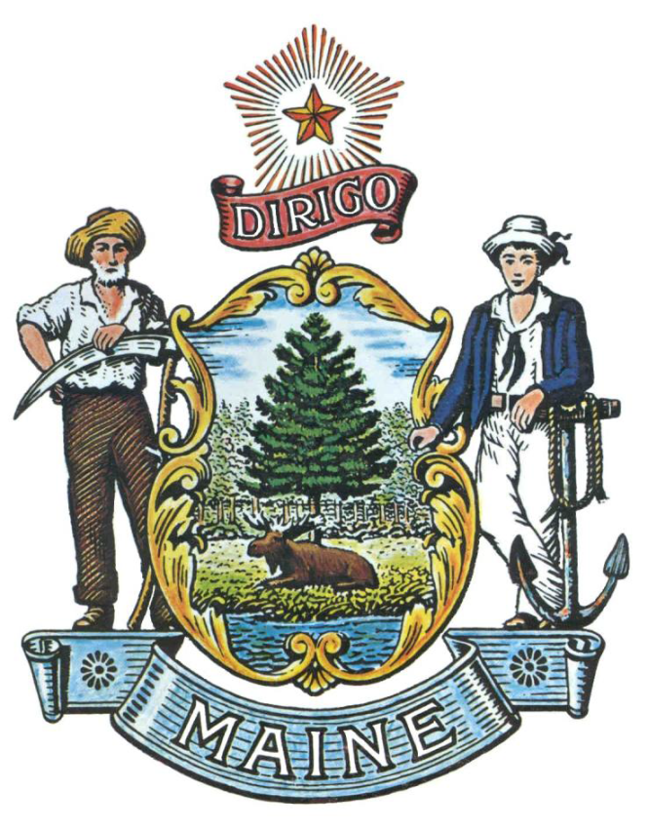

REQUEST FOR INFORMATION

RFI# 201909168

Client Assistance Services

RFI Coordinator | All communication regarding this RFI must be made through the RFI Coordinator identified below.  Name: Annette Stevens Title: Rehabilitation Consultant  Contact Information: Annette.M.Stevens@maine.gov
Submitted Questions Due | All questions must be submitted to the RFI Coordinator identified above by:  Date: October 09, 2019 no later than 4:00 p.m., local time
Response Submission | Submission Deadline: October 31,2019, no later than 4:00 p.m., local time  Submit to: Annette.M.Stevens@maine.gov
TABLE OF CONTENTS

PUBLIC NOTICE 3

RFI DEFINITIONS/ACRONYMS 4

PART I INTRODUCTION 5

- PURPOSE AND BACKGROUND
- CURENT CONDITIONS
- CHALLENGE STATEMENT
- GENERAL PROVISIONS

PART II INFORMATION SOUGHT 7

- GENERAL INFORMATION
- FEEDBACK REQUESTED

PART III KEY RFI EVENTS AND PROCESSES 8

- QUESTIONS
- SUBMITTING THE RESPONSE

PART IV REVIEW OF RESPONSES RECEIVED 9

RFI APPENDICES AND RELATED DOCUMENTS 10

RESPONSE COVER PAGE
SUBMITTED QUESTIONS FORM

PUBLIC NOTICE

*************************************************
State of Maine
Department of Labor
RFI# 201909168
Client Assistance Services

The State of Maine Department of Labor, Bureau of Rehabilitation Services is seeking information regarding the provision of statewide client assistance services that inform and advise applicants and clients of all available benefits of programs funded under the Rehabilitation Act of 1973, as amended; and when requested by applicants and clients, assist and advocate for them in their relationships with projects, programs, and community rehabilitation providers who offer services to them under the Act.

A copy of the RFI, as well as the Question & Answer Summary and all other related documents to this RFI, can be obtained at the following website: http://www.maine.gov/dafs/bbm/procurementservices/vendors/rfis

Responses must be submitted to: Annette Stevens at Annette.M.Stevens@Maine.gov and be submitted by 4:00 pm, local time, on October 31, 2019.

*************************************************
RFI DEFINITIONS/ACRONYMS

The following terms and acronyms shall have the meaning indicated below as referenced in this Request for Information:

Term/Acronym | Definition
RFI | Request for Information
RFP | Request for Proposal
State | State of Maine
Department | Department of Labor
FOAA | Maine Freedom of Access Act
Respondent | Any individual or organization submitting a response to this RFI.
BRS | Bureau of Rehabilitation Services
CAP | Client Assistance Program
DBVI | Division for the Blind and Visually Impaired
DVR | Division of Vocational Rehabilitation
VR | Vocational Rehabilitation

State of Maine - Department of Labor
RFI# 201909168
Client Assistance Services

PART I INTRODUCTION

A. Purpose and Background

This Request for Information (RFI) is an information gathering and market research tool, not a formal solicitation of a specific requirement (such as in a “Request for Proposals” document). The Maine Department of Labor (“Department”) is seeking information regarding the operation of a Client Assistance Program, which will provide client assistance services on a statewide basis to applicants and clients of programs funded under the Rehabilitation Act of 1973, as amended, from interested parties as defined in this RFI document.

The Client Assistance Program (CAP) is a federally mandated program (34 CFR §370), which advises and informs clients and client-applicants of all services and benefits available to them through state Vocational Rehabilitation (VR) programs authorized under the Rehabilitation Act of 1973, as amended. In Maine these VR programs are provided through the Department of Labor’s Division of Vocational Rehabilitation (DVR) and Division for the Blind and Visually Impaired (DBVI) within the Bureau of Rehabilitation Services (BRS).

The Client Assistance Program also provides assistance to the DVR State Rehabilitation Council (DVR/SRC) and DBVI State Rehabilitation Council (DBVI/SRC) through the membership of one staff person on each council. Client Assistance Program funds may be used for activities consistent with the purpose of this program, including the following:

- Help applicants and clients to understand rehabilitation services and independent living services under the Rehabilitation Act;

- Advise applicants and clients of all benefits available to them through rehabilitation and independent living programs authorized under the Rehabilitation Act and related federal and state assistance programs, their rights and responsibilities in connection with those benefits;

- Assist and advocate for applicants and clients in their relationships with projects, programs, and services providing rehabilitation and independent living services under the Rehabilitation Act;

- Assist applicants and clients by pursuing or assisting them in pursuing legal, administrative, and other available remedies when necessary to ensure the protection and rights under the Rehabilitation Act;

- Facilitate access to the services funded under the Rehabilitation Act through individual and systemic advocacy;

- Advise State and other agencies of identified problem areas in the delivery of rehabilitation services to persons with disabilities and suggesting methods and means of improving agency performance;

- Provide information on Title I of the Americans with Disabilities Act of 1990; and,

- Provide information to the public concerning the Client Assistance Program.

B. Current Conditions

The Client Assistance Program (CAP) is funded by the U.S. Department of Education’s Rehabilitation Services Administration (RSA) through an annual formula grant (CFDA 84.161A) of $131,917 to the current designated agency, Maine Department of Labor’s Division of Vocational Rehabilitation (MDOL DVR).

C.A.R.E.S, Inc., held the most recent CAP contract, which expired on September 30, 2019. C.A.R.E.S., Inc., informed the Department that they would not be seeking a contract renewal and the mandated services will be provided by a third party while this RFI is conducted.

Maine is one of only a few states in the country in which the State Vocational Rehabilitation agency is the designated agency for carrying out the CAP. Each state’s governor holds the authority for the designation of the agency responsible for operating the CAP in accordance with Section 112 of the Rehabilitation Act of 1973, as amended.

C. Challenge Statement

To gather pertinent information to assist the Governor in making the following determination: Which agency in Maine would be best designated to operate the Client Assistance Program under Section 112 of the Rehabilitation Act of 1973 as amended?

This is an opportunity for interested parties to help the Department better understand the marketplace and specific subject matter. The result of this RFI will be to provide information, that will accompany other sources of information, to the Governor for consideration in the State of Maine’s designation of an entity to operate the Client Assistance Program under Section 112 of the Rehabilitation Act of 1973, as amended (Act).

D. General Provisions

- All contact with the State regarding this RFI must be made through the aforementioned RFI Coordinator. No other person/ State employee is empowered to make binding statements regarding this RFI.
- This is a non-binding Request for Information.
- Issuance of this RFI does not commit the Department to pay any expenses incurred by a Respondent in the preparation of their response to this RFI. This includes attendance at personal interviews or other meetings and software or system demonstrations, where applicable.
- All responses should adhere to the instructions and format requests outlined in this RFI and all written supplements and amendments, such as the Summary of Questions and Answers, issued by the Department.
- All submissions in response to this RFI will be considered public records available for public inspection pursuant to the State of Maine Freedom of Access Act (FOAA) (1 M.R.S. §§ 401 et seq.): State of Maine Freedom of Access Act
- All applicable laws, whether or not herein contained, shall be included by this reference. It shall be Proposer’s/Vendor’s responsibility to determine the applicability and requirements of any such laws and to abide by them.
PART II INFORMATION SOUGHT

The Department seeks information regarding Client Assistance Services and welcomes responses to this RFI, including creative suggestions and feedback to enhance and expedite all future processes while providing efficient, reliable and high-quality outcomes. Respondents are not required to submit responses pertaining to every question, but the Department encourages interested parties to respond to any or all relevant aspects of the RFI.

The Department seeks detailed yet succinct responses that demonstrate the Respondent’s experience and/or familiarity with the subject matter.

- General Information

Provide a brief overview of yourself and your organization, if applicable.

  - Please identify yourself and any organization you represent in this RFI.
    - Name of respondent
    - Organization and affiliation
    - Address (organizational, if responding on behalf of an entity)
    - Contact information (phone number(s) and email address)

  - Please identify your experiences in providing Client Assistance Services

- Feedback Requested

Each state’s governor holds the authority for the designation of the agency responsible for operating the CAP in accordance with Section 112 of the Rehabilitation Act of 1973, as amended. Federal regulations, 34 CFR §370.2(c), indicate that this designation should be to an agency independent of any agency that provides treatment, services or rehabilitation to individuals with disabilities.

The department seeks feedback from all interested parties on which agency in Maine would be best designated by the Governor to operate the Client Assistance Program under Section 112 of the Rehabilitation Act of 1973 as amended. When making recommendations, respondents should specifically address the following assurances that the Governor must provide in the designation:

- The designated agency is independent of any agency that provides treatment, services, or rehabilitation to individuals under the Rehabilitation Act;
- The designated agency has the authority to pursue legal, administrative and other appropriate remedies to ensure the protection of the rights of individuals with disabilities in the state who are seeking or receiving treatment, services, or rehabilitation under the Act.

- The authority to pursue remedies described in paragraph two (2) includes the authority to pursue those remedies against the state vocational rehabilitation agency and other appropriate state agencies. The designated agency meets this requirement if it has the authority to pursue these remedies either on its own behalf or by obtaining necessary services, such as legal representation, from outside sources.

- The state will ensure that all entities conducting, administering, operating, or carrying out programs within the Section will advise all individuals seeking or receiving services under the Act of the existence of the CAP, the services provided by the CAP, and how to contact the CAP.

- The designated agency will submit to the secretary an annual report on the operation of the CAP during the previous year consistent with 34 CFR 370.44, including a summary of the work done and the uniform tabulation of all cases handled by the CAP in the format prescribed by RSA.

- Pursuant to Section 21 of the Act, the designated agency will address the needs of individuals with disabilities from minority backgrounds.
- The designated agency must be able to receive direct payment from the U.S. Department of Education and not be prohibited by or inconsistent with state law, regulation, or policy in receiving such.

The designated agency will meet each of the requirements set forth in Section 112 of the Act and 34 CFR Part 370 .
PART III KEY RFI EVENTS AND PROCESSES

- Questions

1. General Instructions
- It is the responsibility of each interested party to examine the entire RFI and to seek clarification, in writing, if they do not understand any information or instructions.
- Interested parties should use Appendix B – Submitted Questions Form – for submission of questions.
- The Submitted Questions Form must be submitted by e-mail and received by the RFI Coordinator, identified on the cover page of this RFI, as soon as possible but no later than the date and time specified on the RFI cover page.
- Submitted Questions must include the RFI Number and Title in the subject line of the e-mail. The Department assumes no liability for assuring accurate/complete/on time e-mail transmission and receipt.

2. Question & Answer Summary
Responses to all questions will be compiled in writing and posted on the following website: http://www.maine.gov/dafs/bbm/procurementservices/vendors/rfis. It is the responsibility of all interested parties to go to this website to obtain a copy of the Question & Answer Summary. Only those answers issued in writing on this website will be considered binding.

Submitting the Response

- Responses Due
Responses must be received no later than the date and time listed on the cover page of this RFI document.

- Delivery Instructions
Responses must be submitted to the RFI Coordinator, via e-mail, listed on the cover page of this RFI document.

- Response Format
Responses to this RFI may be developed in a manner that suits the respondent. A list of key questions is included within the RFI and all submissions, regardless of format will be reviewed. Respondents are asked to be brief and to respond to as many questions as possible within the RFI. Number each response to correspond to the relevant question or instruction of the RFI to allow comparison and clarity.

PART IV REVIEW OF RESPONSES RECEIVED

General Information

- The Department will review responses received for the purpose of gathering information and market research only.

- The Department reserves the right to communicate and/or schedule interviews/presentations with Respondents, if needed, to obtain clarification of information contained in the responses received and/or additional information to enhance information gathering efforts.

APPENDIX A

STATE OF MAINE
Department of Labor
RESPONSE COVER PAGE
RFI# 201909168
Client Assistance Services

Lead Point of Contact - Name/Title:
Organization Name (if applicable):
Tel: |  |  | Fax:
E-Mail: |  |  | Website:
Street Address:
City/State/Zip:

APPENDIX B

State of Maine
Department of Labor

SUBMITTED QUESTIONS FORM
RFI# 201909168
Client Assistance Services

Organization/Responder’s Name:

RFI Section & Page Number | Question

* If a question is not related to any section of the RFI, state “N/A” under “RFI Section & Page Number”.
** Add additional rows, if necessary.

