Farwell Dam Removal -Sabattus River

Technical Specifications
September 2023 (Progress Submittal)

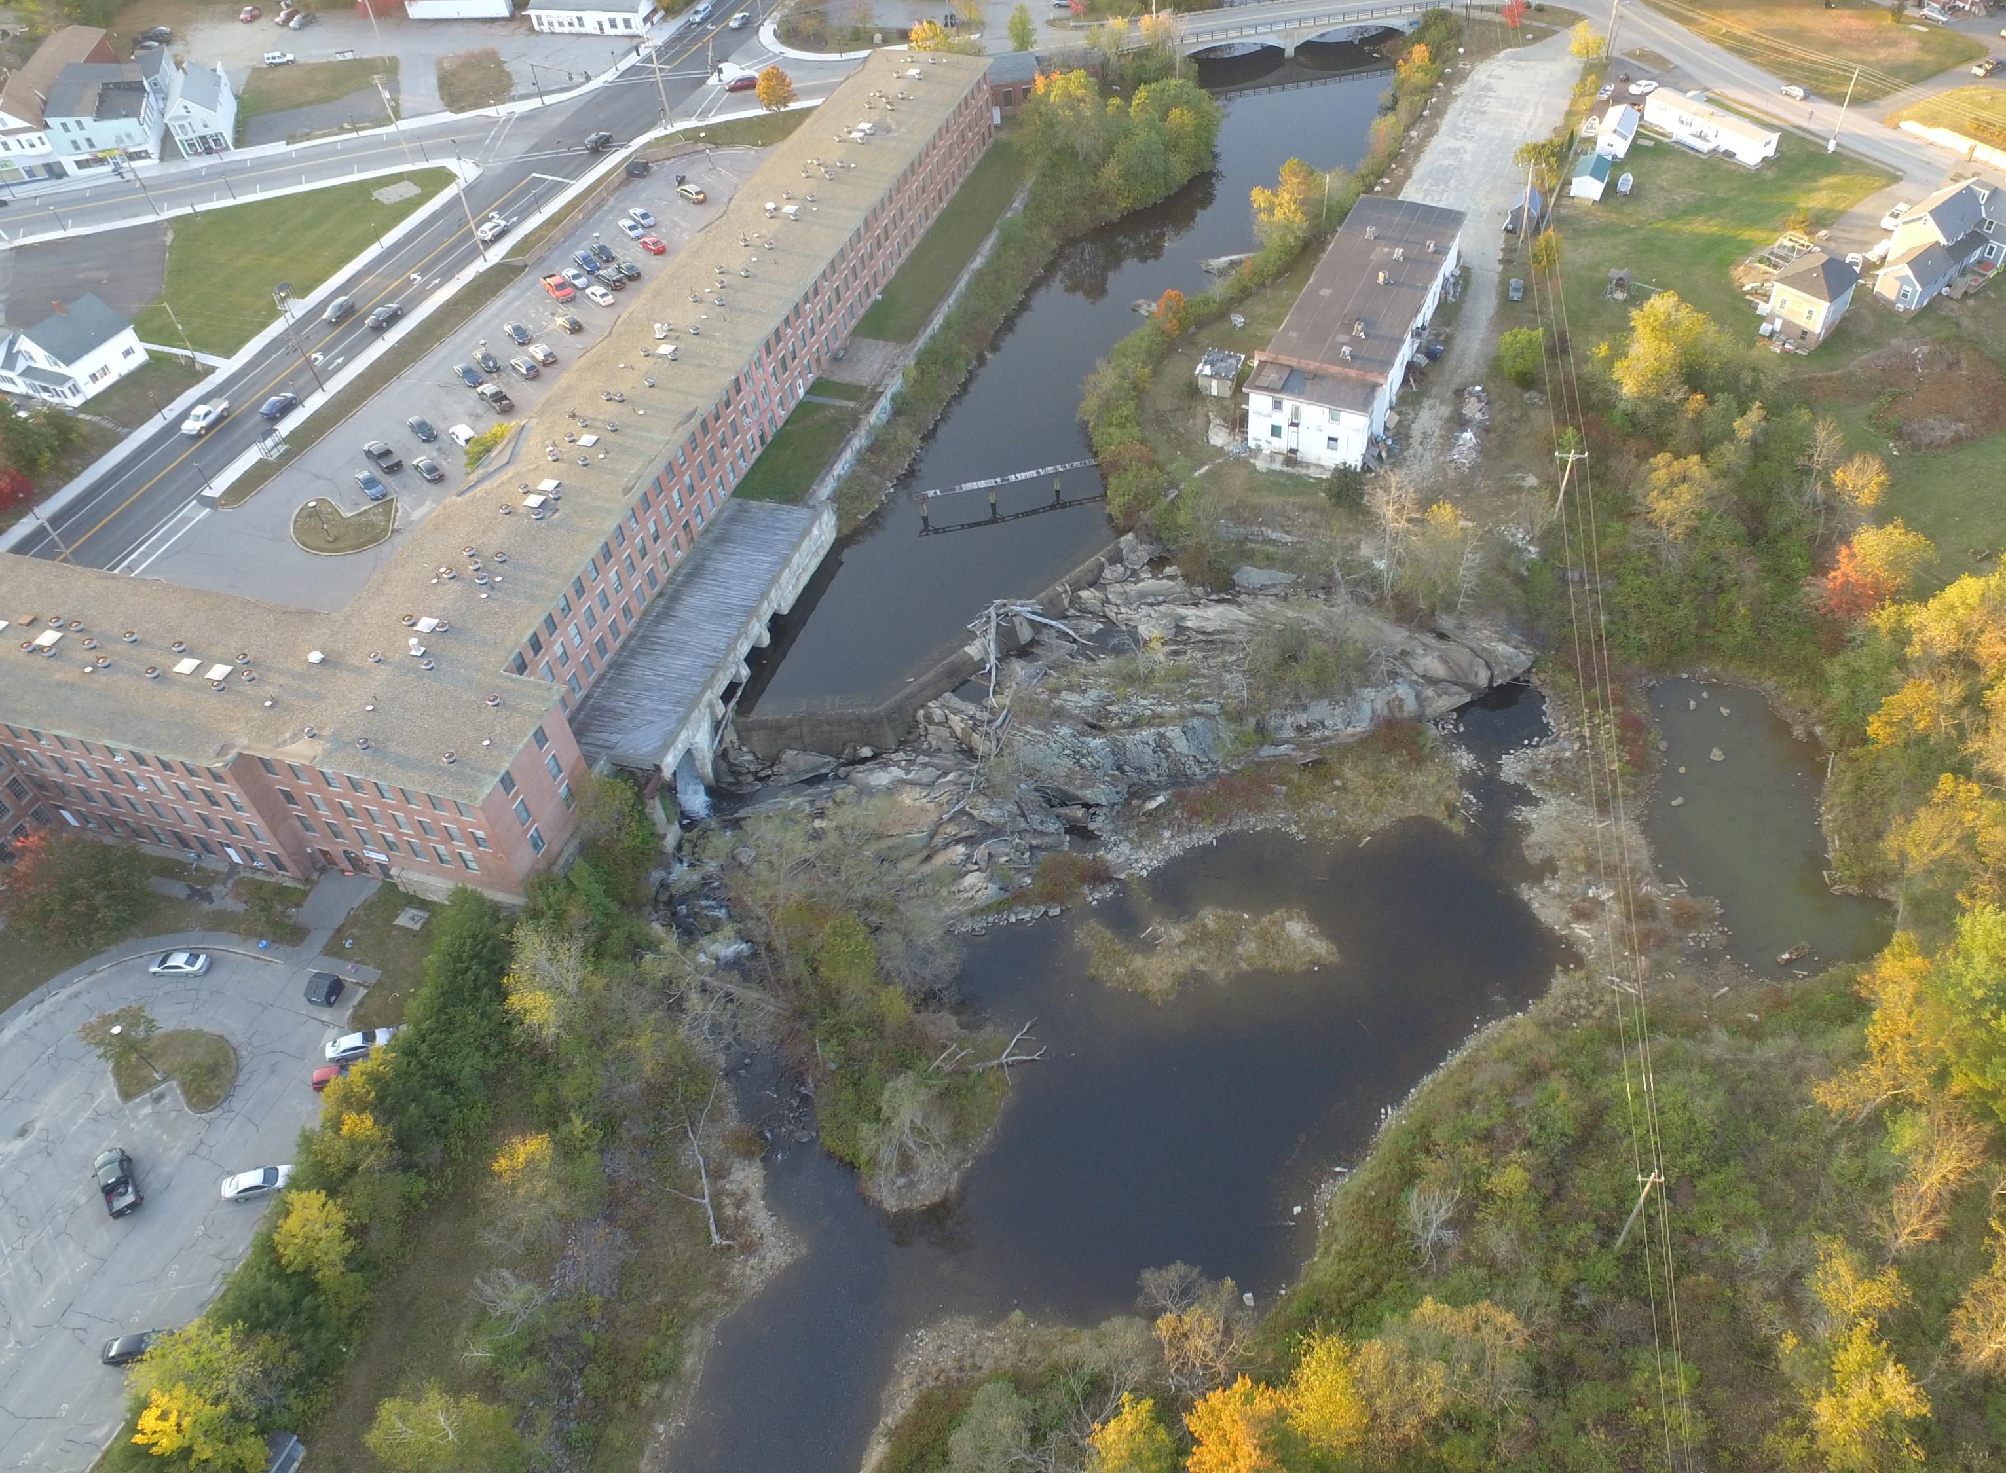

Prepared for:
Maine Department of Marine Resources
32 Blossom Lane
Augusta, ME 04330

Prepared by:
Inter-Fluve
P.O. Box 236
Damariscotta, ME 04543

Table of Contents

01 71 13 MOBILIZATION AND DEMOBILIZATION

02 41 00 STRUCTURE DEMOLITION

31 23 00 EARTHWORK

31 25 00 EROSION, POLLUTION, AND WATER CONTROL

31 36 00 STREAMBANK CONSTRUCTION

31 37 00 CHANNEL BED CONSTRUCTION

32 90 00 SITE PLANTINGS

