Mid-Atlantic/Northeast U.S. Visibility Data
2004-2020
(2nd RH SIP Metrics)

Prepared by
Maine Department of Environmental Protection (ME DEP)
for the
Mid-Atlantic/Northeast Visibility Union (MANE-VU)

Project Manager- Tom Downs (MEDEP)

DRAFT March XX, 2022 revision

Acknowledgments

This document is an update of the following report: Mid-Atlantic/Northeast U.S. Visibility Data 2004-2019 (2nd RH SIP Metrics) – January 21, 2021 Update (MANE-VU 2021).

We could not have completed this work without the IMPROVE (Interagency Monitoring of Protected Visual Environments) program and long-term commitment of the National Park Service and other state and federal partners to maintain visibility networks and the Federal Land Manager Environmental Database (FED). FED is hosted at the Colorado State University’s Cooperative Institute for Research in the Atmosphere (CIRA). IMPROVE is a collaborative association of state, tribal, and federal agencies, and international partners. US Environmental Protection Agency is the primary funding source, with contracting and research support from the National Park Service. The Air Quality Group at the University of California, Davis is the central analytical laboratory, with ion analysis provided by Research Triangle Institute, and carbon analysis provided by Desert Research Institute.

Special thanks to Scott Copeland, USDA Forest Service Air Data Analyst for all his efforts to complete data analyses used for this report, Rich Greves with the Maine Department of Environmental Protection for his help creating analysis plots and Martha Webster with the Maine Department of Environmental Protection for her help creating monitoring site maps.

i

TABLE OF CONTENTS

Acknowledgments.............................................................................................................. i

Executive Summary ......................................................................................................... vii
.
1. Introduction................................................................................................................ 1-1
1.1. Background ...................................................................................................... 1-1

2. Visibility Metrics ....................................................................................................... 2-1
2.1. IMPROVE Equation ......................................................................................... 2-2
2.2. Natural Visibility Metrics................................................................................. 2-3
2.3. Baseline, Current and Reasonable Progress Goal Visibility Metrics ............... 2-6
2.4. Visibility Metrics Trend Plots .......................................................................... 2-7

3. Visibility Species Light Extinction Trends................................................................. 3-1

4. Summary ..................................................................................................................... 4-1

5. References ................................................................................................................... 5-1

Appendix A: Tracking Progress Data for Current Active IMPROVE Monitoring Sites In and Adjacent to the MANE-VU Region

Appendix B: Species Light Extinction Data for Current Active IMPROVE Monitoring Sites In and Adjacent to the MANE-VU Region

Appendix C: Baseline and Current Visibility Species Trends Plots for Current Active IMPROVE Monitoring Sites In and Adjacent to the MANE-VU Region

Appendix D: Annual Visibility Species Trends Plots for Current Active IMPROVE Monitoring Sites In and Adjacent to the MANE-VU Region

Appendix E: Seasonal Trend Plots of 20 Percent Most Impaired Days for Current Active IMPROVE Monitoring Sites In and Adjacent to the MANE-VU Region

FIGURES

Figure 1-1. Class I Areas and IMPROVE Protocol Sites In and Adjacent to the
MANE-VU Region....................................................................................... 1-2
Figure 2-1. Visibility Metrics Levels at Acadia National Park....................................... 2-8
Figure 2-2. Visibility Metrics Levels at Moosehorn Wilderness Area ........................... 2-8
Figure 2-3. Visibility Metrics Levels at Great Gulf Wilderness Area ............................. 2-9
Figure 2-4. Visibility Metrics Levels at Lye Brook Wilderness Area ............................ 2-9
Figure 2-5. Visibility Metrics Levels at Brigantine Wilderness Area ........................... 2-10
Figure 2-6. Visibility Metrics Levels at Dolly Sods Wilderness Area .......................... 2-10
Figure 2-7. Visibility Metrics Levels at Shenandoah National Park ............................. 2-11
Figure 2-8. Visibility Metrics Levels at James River Face Wilderness Area ................ 2-11
Figure 3-1. Acadia National Park Species Percent Contribution to Baseline (2000-04)
and Current (2016-20) Haze Index Levels………………………….................... 3-3
Figure 3-2. Moosehorn Wilderness Area Species Percent Contribution to Baseline
(2000-04) and Current (2016-20) Haze Index Levels........................................... 3-4
Figure 3-3. Great Gulf Wilderness Area Species Percent Contribution to Baseline
(2000-04) and Current (2016-20) Haze Index Levels........................................... 3-5

ii

FIGURES (cont.)

Figure 3-4. Lye Brook Wilderness Area Species Percent Contribution to Baseline
(2000-04) and Current (2016-20) Haze Index Levels........................................... 3-6
Figure 3-5. Brigantine Wilderness Area Species Percent Contribution to Baseline
(2000-04) and Current (2016-20) Haze Index Levels........................................... 3-7
Figure 3-6. Dolly Sods Wilderness Area Species Percent Contribution to Baseline
(2000-04) and Current (2016-20) Haze Index Levels........................................... 3-8
Figure 3-7. Shenandoah National Park Species Percent Contribution to Baseline
(2000-04) and Current (2016-20) Haze Index Levels........................................... 3-9
Figure 3-8. James River Face Wilderness Area Species Percent Contribution to Baseline
(2000-04) and Current (2016-20) Haze Index Levels……..................................3-10
Figure 3-9. Current and Baseline 5-Year Average Light Extinction at Class I Sites on
20 Percent Clearest and 20 Percent Most Impaired Visibility Days.................... 3-11
Figure 3-10. Individual Species Contribution to Annual Haze Index Levels at Acadia
National Park on 20 Percent Clearest and Most Impaired Visibility Days ........... 3-12
Figure 3-11. Individual Species Contribution to Annual Haze Index Levels at Moosehorn
Wilderness Area on 20 Percent Clearest and Most Impaired Visibility Days ....... 3-12
Figure 3-12. Individual Species Contribution to Annual Haze Index Levels at Great Gulf
Wilderness Area on 20 Percent Clearest and Most Impaired Visibility Days ....... 3-13
Figure 3-13. Individual Species Contribution to Annual Haze Index Levels at Lye Brook
Wilderness Area on 20 Percent Clearest and Most Impaired Visibility Days ....... 3-13
Figure 3-14. Individual Species Contribution to Annual Haze Index Levels at Brigantine
Wilderness Area on 20 Percent Clearest and Most Impaired Visibility Day ........ 3-14
Figure 3-15. Individual Species Contribution to Annual Haze Index Levels at Dolly Sods
Wilderness Area on 20 Percent Clearest and Most Impaired Visibility Days ....... 3-14
Figure 3-16. Individual Species Contribution to Annual Haze Index Levels at Shenandoah
National Park on 20 Percent Clearest and Most Impaired Visibility Days ............ 3-15
Figure 3-17. Individual Species Contribution to Annual Haze Index Levels at James
River Face Wilderness Area on 20 Percent Clearest and Most Impaired Visibility Days …………………………………………………………………..................3-15
Figure 3-18. Range of Observed and Estimated Natural Light Extinction for
Select Individual Species at Acadia National Park on 20 Percent Clearest
and Most Impaired Visibility Days ....................................................................... 3-16
Figure 3-19. Range of Observed and Estimated Natural Light Extinction for Select
Individual Species at Moosehorn Wilderness Area on 20 Percent Clearest and
Most Impaired Visibility Days ............................................................................. 3-17
Figure 3-20. Range of Observed and Estimated Natural Light Extinction for
Select Individual Species at Great Gulf Wilderness Area on 20 Percent
Clearest and Most Impaired Visibility Days .......................................................... 3-18
Figure 3-21. Range of Observed and Estimated Natural Light Extinction for
Select Individual Species at Lye Brook Wilderness Area on 20 Percent
Clearest and Most Impaired Visibility Days .......................................................... 3-19
Figure 3-22. Range of Observed and Estimated Natural Light Extinction for
Select Individual Species at Brigantine Wilderness Area on 20 Percent
Clearest and Most Impaired Visibility Days .......................................................... 3-20
Figure 3-23. Range of Observed and Estimated Natural Light Extinction for
Select Individual Species at Dolly Sods Wilderness Area on 20 Percent
Clearest and Most Impaired Visibility Days .......................................................... 3-21

iii

FIGURES (cont.)

Figure 3-24. Range of Observed and Estimated Natural Light Extinction for
Select Individual Species at Shenandoah National Park on 20 Percent
Clearest and Most Impaired Visibility Days .......................................................... 3-22
Figure 3-25. Range of Observed and Estimated Natural Light Extinction for
Select Individual Species at James River Face Wilderness Area on 20 Percent
Percent Clearest and Most Impaired Visibility Days ............................................. 3-23
Figure 3-26. Seasonal Breakdown of 20 Percent Most Impaired Visibility Days for
New England Class I Areas ………………................................................................ 3-24
Figure 3-27. Seasonal Breakdown of 20 Percent Most Impaired Visibility Days for
New Jersey, West Virginia and Virginia Class I Areas.......................................... 3-25
Figure 3-28. 1997-2020 NO_{x} Trends by Month.............................................................. 3-26
Figure C-1. Presque Isle, ME Species Percent Contribution to Baseline (2002-04)
and Current (2016-20) Haze Index Levels........................................................... C-1
Figure C-2. Penobscot Nation, ME Species Percent Contribution to Baseline
(2006-08) and Current (2016-20) Haze Index Levels......................................... C-1
Figure C-3. Casco Bay, ME Species Percent Contribution to Baseline (2002-04)
and Current (2016-20) Haze Index Levels........................................................... C-2
Figure C-4. Proctor Maple R.F., VT Species Percent Contribution to Baseline
(2002-04) and Current (2016-20) Haze Index Levels......................................... C-2
Figure C-5. Londonderry, NH Species Percent Contribution to Baseline (2011-13)
and Current (2016-20) Haze Index Levels........................................................... C-3
Figure C-6. Pack Monadnock Summit, NH Species Percent Contribution to Baseline
(2008-10) and Current (2016-20) Haze Index Levels......................................... C-3
Figure C-7. Mohawk Mt., CT Species Percent Contribution to Baseline (2002-04)
and Current (2016-20) Haze Index Levels........................................................... C-4
Figure C-8. Cape Cod, MA Species Percent Contribution to Baseline (2002-04)
and Current (2016-20) Haze Index Levels........................................................... C-4
Figure C-9. Martha’s Vineyard, MA Species Percent Contribution to Baseline
(2003-05) and Current (2016-20) Haze Index Levels......................................... C-5
Figure C-10. Frostburg, MD Species Percent Contribution to Baseline (2005-07)
and Current (2016-20) Haze Index Levels........................................................... C-5
Figure C-11. Quaker City, OH Species Percent Contribution to Baseline (2002-04)
and Current (2016-20) Haze Index Levels........................................................... C-6
Figure D-1. Presque Isle, ME Individual Species Contribution to Annual Haze Index
Levels on 20 Percent Clearest and Most Impaired Visibility Days...................... D-1
Figure D-2. Penobscot Nation, ME Individual Species Contribution to Annual Haze
Index Levels on 20 Percent Clearest and Most Impaired Visibility Days............ D-1
Figure D-3. Casco Bay, ME Individual Species Contribution to Annual Haze Index
Levels on 20 Percent Clearest and Most Impaired Visibility Days...................... D-2
Figure D-4. Proctor Maple R.F., VT Individual Species Contribution to Annual Haze
Index Levels on 20 Percent Clearest and Most Impaired Visibility Days............ D-2
Figure D-5. Londonderry, NH Individual Species Contribution to Annual Haze
Index Levels on 20 Percent Clearest and Most Impaired Visibility Days............ D-3
Figure D-6. Pack Monadnock Summit, NH Individual Species Contribution to Annual
Haze Index Levels on 20 Percent Clearest and Most Impaired Visibility Days... D-3
Figure D-7. Mohawk Mt., CT Individual Species Contribution to Annual Haze Index
Levels on 20 Percent Clearest and Most Impaired Visibility Days…………….. D-4

iv

FIGURES (cont.)

Figure D-8. Cape Cod, MA Individual Species Contribution to Annual Haze Index
Levels on 20 Percent Clearest and Most Impaired Visibility Days...................... D-4
Figure D-9. Martha’s Vineyard, MA Individual Species Contribution to Annual Haze
Index Levels on 20 Percent Clearest and Most Impaired Visibility Days............ D-5
Figure D-10. Frostburg, MD Individual Species Contribution to Annual Haze Index
Levels on 20 Percent Clearest and Most Impaired Visibility Days...................... D-5
Figure D-11. Quaker City, OH Individual Species Contribution to Annual Haze Index
Levels on 20 Percent Clearest and Most Impaired Visibility Days...................... D-6
Figure E-1. Seasonal Breakdown of 20 Percent Most Impaired Visibility Days for
Maine and Vermont IMPROVE Protocol Sites................................................... E-1
Figure E-2. Seasonal Breakdown of 20 Percent Most Impaired Visibility Days for
Maryland, Ohio and Martha’s Vineyard, MA and Vermont IMPROVE
Protocol Sites......................................................................................................... E-2
Figure E-3. Seasonal Breakdown of 20 Percent Most Impaired Visibility Days for
Maryland, Ohio and Martha’s Vineyard, MA and Vermont IMPROVE
Protocol Sites......................................................................................................... E-3

TABLES

Table 1-1. Members of the Mid-Atlantic/Northeast Visibility Union (MANE-VU) ...... 1-2
Table 2-1. IMPROVE Monitoring Sites ………………….............................................. 2-1
Table 2-2. 20 Percent Clearest Days Natural Conditions for Class I and IMPROVE
Protocol Sites In and Adjacent to the MANE-VU Region …................................ 2-4
Table 2-3. 20 Percent Most Impaired Days Natural Conditions for Class I and IMPROVE
Protocol Sites In and Adjacent to the MANE-VU Region…................................. 2-5
Table 2-4. Baseline, Current and Reasonable Progress Goal Haze Index Levels for
Class I Areas In or Adjacent to the MANE-VU Region ........................................ 2-7
Table A-1. Tracking Progress Data for Acadia National Park (ME) and Brigantine
Wilderness (NJ) Class I Areas in the MANE-VU Region (dv)............................ A-1
Table A-2. Tracking Progress Data for Great Gulf Wilderness (NH) and Lye Brook
Wilderness (VT) Class I Areas in the MANE-VU Region (dv)........................... A-2
Table A-3. Tracking Progress Data for the Moosehorn Wilderness (ME) Class I Area
in the MANE-VU Region (dv)............................................................................. A-3
Table A-4. Tracking Progress Data for the Dolly Sods Wilderness (WV) Class I Area
Adjacent to the MANE-VU Region (dv).............................................................. A-3
Table A-5. Tracking Progress Data for James River Face Wilderness and Shenandoah
National Park (VA) Class I areas Adjacent to the MANE-VU Region (dv) ....... A-4
Table A-6. Tracking Progress Data for Addison Pinnacle (NY) and Arendtsville
(PA) IMPROVE Protocol Sites in the MANE-VU Region (dv).......................... A-5
Table A-7. Tracking Progress Data for Bridgton (ME) and Casco Bay (ME)
IMPROVE Protocol Sites in the MANE-VU Region (dv)................................... A-6
Table A-8. Tracking Progress Data for Cape Cod (MA) and Frostburg Reservoir
(MD) IMPROVE Protocol Sites in the MANE-VU Region (dv)......................... A-7

iv

TABLES (cont.)

Table A-9. Tracking Progress Data for Londonderry (NH) and Martha’s Vineyard
(MA) IMPROVE Protocol Sites in the MANE-VU Region (dv)......................... A-8
Table A-10. Tracking Progress Data for M.K. Goddard (PA) and Mohawk Mt. (CT)
IMPROVE Protocol Sites in the MANE-VU Region (dv)................................... A-9
Table A-11. Tracking Progress Data for New York City – IS52 and Pack Monadnock
Summit (NH) IMPROVE Protocol Sites in the MANE-VU Region (dv)........... A-10
Table A-12. Tracking Progress Data for Penobscot Nation (ME) and Proctor Maple
R.F. (VT) IMPROVE Protocol Sites in the MANE-VU Region (dv)................. A-11
Table A-13. Tracking Progress Data for Presque Isle (Me) and Quabbin Summit
(MA) IMPROVE Protocol Sites in the MANE-VU Region (dv)........................ A-12
Table A-14. Tracking Progress Data for Washington (DC) IMPROVE Protocol Site
in the MANE-VU Region (dv)............................................................................. A-13
Table A-15. Tracking Progress Data for the Quaker City (OH) IMPROVE Protocol
Site Adjacent to the MANE-VU Region (dv)...................................................... A-13
Table B-1. Observed Light Extinction Conditions for the Acadia National Park (ME)
MANE-VU Class I Area....................................................................................... B-1
Table B-2. Observed Light Extinction Conditions for the Brigantine Wilderness Area
(NJ) MANE-VU Class I Area............................................................................... B-2
Table B-3. Observed Light Extinction Conditions for the Great Gulf Wilderness Area
(NH) MANE-VU Class I Area.............................................................................. B-3
Table B-4. Observed Light Extinction Conditions for the Lye Brook Wilderness Area
(VT) MANE-VU Class I Area............................................................................... B-4
Table B-5. Observed Light Extinction Conditions for the Moosehorn Wilderness Area
(ME) MANE-VU Class I Area.............................................................................. B-5
Table B-6. Observed Light Extinction Conditions for the Dolly Sods Wilderness Area
(WV) Nearby Adjacent Class I Area..................................................................... B-6
Table B-7. Observed Light Extinction Conditions for the Shenandoah National Park
(VA) Nearby Adjacent Class I Area...................................................................... B-7
Table B-8. Observed Light Extinction Conditions for the James River Face
Wilderness Area (VA) Nearby Adjacent Class I Area.......................................... B-8
Table B-9. Observed Light Extinction Conditions for the Addison Pinnacle (NY)
MANE-VU IMPROVE Protocol Site.................................................................... B-9
Table B-10. Observed Light Extinction Conditions for the Arendtsville (PA)
MANE-VU IMPROVE Protocol Site.................................................................. B-10
Table B-11. Observed Light Extinction Conditions for the Bridgton (ME)
MANE-VU IMPROVE Protocol Site.................................................................. B-11
Table B-12. Observed Light Extinction Conditions for the Casco Bay (ME)
MANE-VU IMPROVE Protocol Site.................................................................. B-12
Table B-13. Observed Light Extinction Conditions for the Cape Cod (MA)
MANE-VU IMPROVE Protocol Site.................................................................. B-13
Table B-14. Observed Light Extinction Conditions for the Frostburg Reservoir (MD)
MANE-VU IMPROVE Protocol Site.................................................................. B-14
Table B-15. Observed Light Extinction Conditions for the Londonderry (NH)
MANE-VU IMPROVE Protocol Site................................................................... B-15
Table B-16. Observed Light Extinction Conditions for the Martha’s Vineyard (MA)
MANE-VU IMPROVE Protocol Site................................................................... B-16
Table B-17. Observed Light Extinction Conditions for the M.K. Goddard (PA)
MANE-VU IMPROVE Protocol Site.................................................................. B-17

v

TABLES (cont.)

Table B-18. Observed Light Extinction Conditions for the Mohawk Mt, (CT)
MANE-VU IMPROVE Protocol Site.................................................................. B-18
Table B-19. Observed Light Extinction Conditions for the New York City - IS52
MANE-VU IMPROVE Protocol Site.................................................................. B-19
Table B-20. Observed Light Extinction Conditions for the Pack Monadnock Summit
(NH) MANE-VU IMPROVE Protocol Site......................................................... B-20
Table B-21. Observed Light Extinction Conditions for the Penobscot Nation (ME)
MANE-VU IMPROVE Protocol Site.................................................................. B-21
Table B-22. Observed Light Extinction Conditions for the Proctor Maple R. F. (VT)
MANE-VU IMPROVE Protocol Site.................................................................. B-22
Table B-23. Observed Light Extinction Conditions for the Presque Isle (ME)
MANE-VU IMPROVE Protocol Site.................................................................. B-23
Table B-24. Observed Light Extinction Conditions for the Quabbin Summit (MA)
(NH) MANE-VU IMPROVE Protocol Site......................................................... B-24
Table B-25. Observed Light Extinction Conditions for the Washington (DC)
MANE-VU IMPROVE Protocol Site.................................................................. B-25
Table B-26. Observed Light Extinction Conditions for the Quaker City (OH)
Nearby Adjacent IMPROVE Protocol Site.......................................................... B-26

vi

Executive Summary

This technical document fulfills U.S. Environmental Protection Agency’s (USEPA’s) Regional Haze Rule (RHR) 51.308(f)(1) provision for the second implementation period (2018-28) to determine baseline, current and natural visibility conditions for the 20 percent most impaired days and the 20 percent clearest days, for each in-state and out-of-state Class I area for states in the Mid-Atlantic/Northeast Visibility Union (MANE-VU) region.

Visibility trends analyses in this document used USEPA recommended metrics in the December 2018 guidance (U.S. EPA 2018) at IMPROVE (Interagency Monitoring of Protected Visual Environments) monitoring sites at federal Class I areas in and adjacent to the MANE-VU region that are subject to USEPA’s RHR. Visibility trends analyses were also calculated for IMPROVE Protocol monitoring sites in and adjacent to the MANE-VU region. For visibility trends at IMPROVE Protocol monitoring sites February 15, 2022 data downloaded from the FED website were used.

This technical document provides an analysis of visibility data collected at the IMPROVE monitoring sites, starting in the baseline period of 2000-2004 through 2014-2020, the most recent five-year period with available data. The results of this analysis show the following:

- There continue to be definite downward trends in overall haze levels at all Class I areas in and adjacent to the MANE-VU region and at IMPROVE Protocol monitoring sites.

- Based on rolling five-year averages demonstrating progress since the 2000-2004 baseline period, all MANE-VU and nearby Class I area visibility conditions are currently better than the 2028 uniform rate of progress (URP) visibility condition for the 20 percent most impaired visibility days and below baseline conditions for the 20 percent clearest days.

- Modeled 2028 reasonable progress goals (RPGs) have already been achieved during the 2016-2020 data period at all except for the Acadia National Park Class I areas in the MANE-VU region. Further progress is needed to achieve modeled 2028 RPGs at Acadia National Park and nearby Class I areas in Virginia and West Virginia.

- Trends are mainly driven by large reductions in sulfate light extinction.

- Levels of organic carbon mass (OCM) and light absorbing carbon (LAC) appear to be approaching natural background levels at most of the MANE-VU Class I areas.

- The percent contribution of nitrate light extinction has been significantly increasing at some of the MANE-VU Class I areas not just due to lower sulfate contributions but due to more winter days and fewer summer days in the mix of 20 percent most impaired days.

vii

1. INTRODUCTION

  - Background

Haze, or reduced visibility, occurs when ambient particulate matter and gases scatter or absorb light (“light extinction”) that would otherwise reach an observer. Particles responsible for regional haze are produced naturally, from windblown dust, forest fires, and aerosolized sea salt; and by human-caused pollution from vehicles, power plants, and other combustion and dust-generating activities. Haze-forming particles can also cause serious health effects in the lungs and cardiopulmonary system, potentially leading to premature death. In addition, some particle species contribute to acidic deposition and other environmental harms.

In 1999, the US Environmental Protection Agency (USEPA) issued a rule under Section 169A of the Clean Air Act (Visibility Protection for the Federal Class I Areas) to address human-caused regional haze: Regional Haze Rule (RHR) [64 FR 35614 (July 1, 1999)]. The RHR is designed to improve visibility at certain national parks and wilderness areas (Class I areas) on the 20 percent haziest (‘worst’) days while not exacerbating haze on the 20 percent clearest (‘best’) days. The RHR requires states to submit state implementation plans (SIPs) to USEPA every ten years, setting interim progress goals and strategies consistent with the long-term national visibility goal of achieving natural conditions at Class I areas by 2064. States submitted their first haze SIPs to USEPA beginning in 2008. States additionally are required to track their progress against their historic baseline period¹ in achieving reductions in regional haze, submitting reports every five years, and to adjust their emissions management strategies accordingly.

In 2017, USEPA finalized revisions to the 1999 RHR [82 FR 3078 (January 10, 2017)] that will now require states to track progress of visibility for the 20 percent ‘most impaired’ days due to anthropogenic emissions instead of 20 percent worst visibility days as was done for the first planning period. The method for tracking progress for the 20 percent clearest days will not change from the first planning period. USEPA has recommended metrics for determining 20 percent most impaired days in a December 2018 guidance (U.S. EPA 2018). MANE-VU states have since decided to use those recommended metrics for the second implementation period. All analyses in this document use the most recent (20% most impaired natural conditions were updated in April 2020) recommended metrics.

The Mid-Atlantic/Northeast Visibility Union (MANE-VU) was formed to support visibility planning efforts in the mid-Atlantic and northeastern portion of the country, and includes the members listed in Table 1-1. The seven Class I areas in the MANE-VU region (black text) and four Class I areas adjacent to the MANE-VU region (blue text) are shown in Figure 1-1(a). This document also includes analyses for IMPROVE Protocol monitoring sites (see Figure 1-1(b)), with twenty monitors in the MANE-VU region (black text) and one adjacent to the MANE-VU region (blue text)). The purpose of this report is to support MANE-VU states to meet USEPA’s RHR 51.308(f)(1) provision for the second implementation period (2018-28) to determine baseline, current and natural visibility conditions for the 20 percent most impaired days and the 20 percent clearest days, for each in-state and out-of-state Class I area for states in the Mid-Atlantic/Northeast Visibility Union (MANE-VU) region.
_________________________
1 The title of this and earlier trends reports use 2004 as the base year because the trend is based on rolling averages of 5-year periods, and 2004 was the end of the initial 5-year period used as the baseline.

Page 1-1

Table 1-1. Members of the Mid-Atlantic/Northeast Visibility Union (MANE-VU)
Connecticut Pennsylvania
Delaware Penobscot Indian Nation
District of Columbia Rhode Island
Maine St. Regis Mohawk Tribe
Maryland Vermont Massachusetts National Park Service New Hampshire U.S. EPA
New Jersey U.S. Fish and Wildlife Service
New York U.S. Forest Service

Figure 1-1. Class I Areas and IMPROVE Protocol Monitoring Sites In and Adjacent to the MANE-VU Region

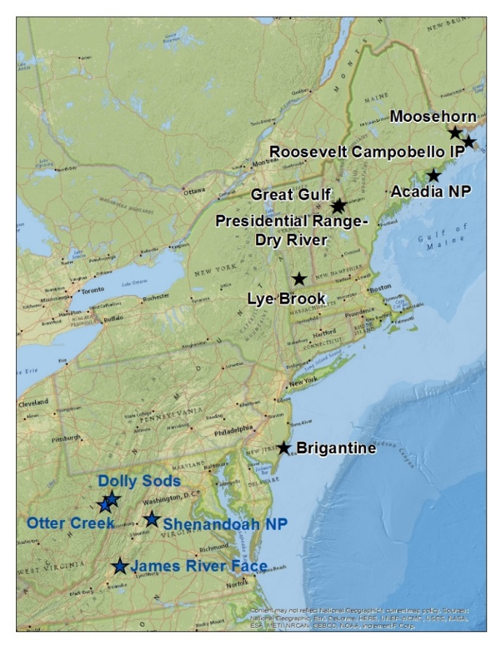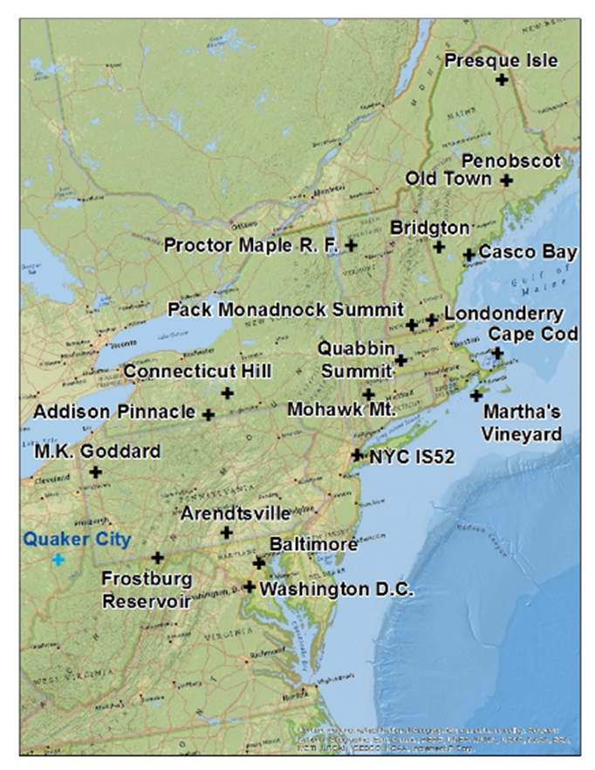
a) Class I Areas
b) IMPROVE Protocol
Monitoring Sites

While this report provides readers with a basic background on regional haze, it does not include in-depth discussions of topics covered in previous reports. For a broader understanding of these topics, readers can visit USEPA’s regional haze website: https://www.epa.gov/visibility, the IMPROVE technical documentation website: http://vista.cira.colostate.edu/improve/, the Publications section of the MANE-VU website: http://www.otcair.org/manevu/document.asp?Fview=Reports, the MARAMA regional haze website: http://www.marama.org/technical-center/regional-haze-planning and the NESCAUM regional haze documents archive, located at the following web address: http://www.nescaum.org/topics/regional-haze

Page 1-3

2. Visibility Metrics

IMPROVE is a collaborative association of state, tribal, and federal agencies, and international partners. USEPA is the primary funding source, with contracting and research support from the National Park Service. The Air Quality Group at the University of California, Davis is the central analytical laboratory, with ion analysis provided by Research Triangle Institute, and carbon analysis provided by Desert Research Institute. IMPROVE was initially established as a national visibility network in 1985 consisting of 30 monitoring sites primarily located in national parks, 20 of which began operation in 1987. IMPROVE has operated many sites within the MANE-VU and nearby regions with some sites (Acadia and Shenandoah National Parks) with data available since 1988. For this report, only available data for the period 2000-20 were analyzed. Table 2-1 lists all IMPROVE monitoring sites in the MANE-VU and nearby regions used in this report. Other IMPROVE Protocol monitoring sites [BALT (Baltimore, Maryland) and COHI (Connecticut Hills, New York), PITT (Lawrenceville, Pennsylvania) and OLTO (Old Town, Maine)] in the MANE-VU region were not included primarily because no impairment statistics were calculated for those sites.

Table 2-1. IMPROVE Monitoring Sites

Site Code | Class I Area or IMPROVE Protocol Site Name | State | Latitude | Longitude | Elevation (m AMSL) | Start Date | End Date
MANE-VU Class I Areas
ACAD | Acadia National Park | ME | 44.3771 | -68.261 | 157 | 3/1988 | Active
BRIG | Brigantine Wilderness | NJ | 39.465 | -74.4492 | 5 | 9/1991 | Active
GRGU | Great Gulf Wilderness | NH | 44.3082 | -71.2177 | 453 | 6/1995 | Active
LYBR | Lye Brook Wilderness | VT | 43.1482 | -73.1268 | 1015 | 9/1991 | 9/2012
LYEB | Lye Brook Wilderness | VT | 42.9561 | -72.9098 | 882 | 1/2012 | Active
MOOS | Moosehorn Wilderness | ME | 45.1259 | -67.2661 | 77 | 12/1994 | Active
Nearby Class I Areas
DOSO | Dolly Sods Wilderness | WV | 39.1053 | -79.4261 | 1182 | 9/1991 | Active
SHEN | Shenandoah National Park | VA | 38.5229 | -78.4348 | 1079 | 3/1988 | Active
JARI | James River Face Wilderness | VA | 37.6266 | -79.5125 | 289 | 6/2000 | Active
MANE-VU IMPROVE Protocol Sites
ADPI | Addison Pinnacle | NY | 42.0912 | -77.2099 | 512 | 4/2001 | 6/2010
AREN | Arendtsville | PA | 39.9232 | -77.3079 | 267 | 4/2001 | 12/2010
BRMA | Bridgton | ME | 44.1074 | -70.7292 | 233 | 3/2001 | 12/2015
CABA | Casco Bay | ME | 43.8325 | -70.0644 | 26 | 3/2001 | Active
CACO | Cape Cod | MA | 41.9758 | -70.0242 | 49 | 4/2001 | Active
FRRE | Frostburg Reservoir | MD | 39.7058 | -79.0122 | 767 | 4/2004 | Active
LOND | Londonderry | NH | 42.8624 | -71.3801 | 124 | 1/2011 | Active
MAVI | Martha’s Vineyard | MA | 41.3309 | -70.7846 | 2 | 1/2003 | Active
MKGO | M.K. Goddard | PA | 41.4269 | -80.1453 | 379 | 4/2001 | 12/2010
MOMO | Mohawk Mt. | CT | 41.8214 | -73.2973 | 521 | 9/2001 | Active
NEYO | New York City – IS52 | NY | 40.8161 | -73.9019 | 45 | 8/2004 | 6/2010
PACK | Pack Monadnock Summit | NH | 42.8619 | -71.8786 | 695 | 10/2007 | Active
PENO | Penobscot Nation | ME | 44.948 | -68.6479 | 45 | 1/2006 | Active
PMRF | Proctor Maple R. F. | VT | 44.5284 | -72.8688 | 401 | 12/1993 | Active
PRIS | Presque Isle | ME | 46.6964 | -68.0333 | 165 | 3/2001 | Active
QURE | Quabbin Summit | MA | 42.2985 | -72.3346 | 317 | 3/2001 | 12/2015
WASH | Washington D.C. | DC | 38.8762 | -77.0344 | 15 | 3/1988 | 12/2014
Nearby IMPROVE Protocol Site
QUCI | Quaker City | OH | 39.9428 | -81.3378 | 366 | 5/2001 | Active

Page 2-1

Figure 1-1(a) shows Class I areas in the MANE-VU and nearby regions. Monitoring data for the LYBR (2000-11) and LYEB (2012-20) sites at the Lye Brook Wilderness Class I area were merged with a new LYBR_RHTS site code. The Roosevelt Campobello International Park, Presidential Range-Dry River and Otter Creek Class I areas do not have an IMPROVE monitor. For those Class I sites without an IMPROVE monitor, monitoring data from a nearby representative Class I area was used to track visibility conditions. In addition to sites that are used to represent Class I areas, IMPROVE Protocol sites are in operation to provide expanded spatial coverage for the network. Protocol sites are separately sponsored by state, regional, tribal, and national organizations and use the same instrumentation, monitoring, and analysis protocols as IMPROVE. Figure 1-1(b) shows the IMPROVE Protocol sites in the MANE-VU and nearby regions with at least six years of valid data. Monitoring data and visibility metrics used for both the first and second implementation planning period are available on the Federal Land Manager Environmental Data Base (FED) website that is hosted at the Colorado State University’s Cooperative Institute for Research in the Atmosphere (CIRA).

2.1. IMPROVE Equation

MANE-VU states have agreed to use the revised IMPROVE equation (Pitchford et al., 2007) to calculate, from monitoring data, light extinction contributions from individual particle components for the first and second implementation period. The equation to estimate light extinction (b_{ext}) from the referenced literature is summarized below.

b_{ext} ≈ 2.2 × f_{S}(RH) × [Small Ammonium Sulfate] + 4.8 × f_{L}(RH) × [Large Ammonium Sulfate]
+ 2.4 × f_{S} (RH) × [Small Ammonium Nitrate] + 5.1 × f_{L}(RH) × [Large Ammonium Nitrate]
+ 2.8 × [Small Organic Mass] + 6.1 × [Large Organic Mass]
+ 10 × [Elemental Carbon]
+ 1 × [Fine Soil]
+ 1.7 × f_{SS}(RH) × [Sea Salt]
+ 0.6 × [Coarse Mass]
+ Rayleigh Scattering (Site Specific)
+ 0.33 (Mm⁻¹/ppb) × [Nitrogen Dioxide (ppb)]
Light extinction and Rayleigh scattering units are inverse megameters (Mm⁻¹), concentrations shown in brackets units are microgram per cubic meter (μg/m³), and the water growth terms, f (RH), do not have units. The nitrogen dioxide (NO₂) light absorption term will not be used for MANE-VU and nearby region sites due to no NO₂ concentration data being available at those sites. The organic compound mass (OM) to organic carbon mass (OC) ratio is 1.8 (OM=1.8*OC). Sulfate, nitrate and organics are split into small and large modes based

Page 2-2

on their mass. For masses less than 20 μg/m³, the fraction in the large mode is estimated by dividing the total concentration of the component by 20 μg/m³ with the remaining in the small mode. If the total concentration of a component exceeds 20 μg/m³, all of it is assumed to be in the large mode. The small and large modes of sulfate and nitrate have associated hygroscopicities, f _{S}(RH) and f _{L}(RH), respectively, while f _{SS}(RH) is for sea salt.

To convert light extinction to a haze index with units of deciviews (dv) the following equation is used:

Haze index (dv) = 10(ln(b_{ext}/10)

Not all visibility metrics used by MANE-VU states for the first implementation period can be used for the second implementation period. Recent amendments to the Regional Haze rule (USEPA, 2017) allow states to use the same metrics for the 20 percent clearest days however baseline and current haze metrics for the 20 percent most impaired days must now be calculated for the 20 percent most anthropogenically impaired days. USEPA has recommended metrics for determining 20 percent most impaired days in Chapter 2 of the December 2018 guidance (U.S. EPA 2018). MANE-VU states have agreed to use the recommended metrics for the second implementation period.

For all analyses in this report, the latest available (12/19/2020) data was downloaded from the Federal Land Manager Environmental Data Base (FED) website including daily calculated light extinction, deciview values (using the revised (new) IMPROVE algorithm including patched data) and other metrics needed in the determination of 20 percent clearest days and 20 percent most impaired days for 2000 through 2020. Natural conditions for 20 percent clearest days (IMPROVE Natural Haze Levels II version 2) and natural conditions for 20 percent most impaired days for Class I areas were downloaded from the IMPROVE website (http://vista.cira.colostate.edu/Improve/rhr-summary-data/).

2.2. Natural Visibility Metrics

Even in the absence of emissions from human activities, some level of light extinction occurs from natural causes. This “natural haze” represents the best expectation for long-term progress at Class I areas and is the goal for these areas by 2064.

For the first SIP planning period ending in 2018, USEPA has guidance (U.S. EPA 2003a) for calculating natural haze levels based on measurements of particulate species at Class I areas during a baseline period. States combine measurements of several parameters to calculate a “Haze Index” in deciview (dv) units based on estimates of light extinction. A fuller explanation of tracking progress procedures is presented in a 2003 USEPA guidance document for tracking progress (U.S. EPA 2003b). For the current SIP planning period ending in 2028, the December 2018 guidance (U.S. EPA 2018) contains final recommendations on methods for selecting 20 percent most impaired days to track visibility and determining natural visibility conditions.

Page 2-3

Natural haze levels are calculated for both 20 percent clearest days and 20 percent most impaired days, because changing natural processes lead to variability in natural visibility. MANE-VU states have agreed for the second implementation planning period to use 20 percent clearest days natural levels (IMPROVE Natural Haze Levels II version 2 (4/2020 update)) and derived 20 percent most impaired days natural levels in USEPA’s recent guidance (U.S.EPA 2018). Note: For IMPROVE Protocol sites, 20 percent most impaired days metrics were calculated if at least 6-years of data is available. Natural visibility levels for 20 percent clearest days for Class I and IMPROVE Protocol monitoring sites in the MANE-VU and adjacent Class I areas are presented in Table 2-2.

Table 2-2. 20 Percent Clearest Days Natural Conditions for Class I and IMPROVE Protocol Sites In and Adjacent to the MANE-VU Region

Site  Code | Deciview  (dv) | Extinction (Mm-1)
 |  | Sulfate | Nitrate | Organic Mass Carbon | Light Absorbing Carbon | Coarse Mass | Sea Salt | Soil
MANE-VU Class I Areas
ACAD | 4.66036 | 0.75945 | 0.02918 | 2.00049 | 0.08352 | 0.56367 | 0.18629 | 0.10431
BRIG | 5.51723 | 0.88119 | 0.04344 | 2.54476 | 0.11958 | 1.03972 | 0.22229 | 0.24231
GRGU | 3.73061 | 0.6705 | 0.04334 | 1.61155 | 0.08198 | 0.63134 | 0.10698 | 0.09615
LYBR_RHTS | 2.79447 | 0.39477 | 0.03257 | 1.02682 | 0.05891 | 0.3773 | 0.04617 | 0.08571
MOOS | 5.01796 | 0.83994 | 0.03792 | 2.24568 | 0.12446 | 0.75137 | 0.16123 | 0.11956
Nearby Class I Areas
DOSO | 3.63715 | 0.79949 | 0.04678 | 2.35139 | 0.10451 | 0.57496 | 0.06985 | 0.16779
SHEN | 3.14633 | 0.55701 | 0.07064 | 1.63632 | 0.08378 | 0.71779 | 0.07105 | 0.14487
JARI | 4.38931 | 0.81288 | 0.06061 | 2.07294 | 0.09621 | 0.83206 | 0.06385 | 0.19781
MANE-VU IMPROVE Protocol Sites
ADPI | 4.1197 | 0.66484 | 0.04448 | 2.05769 | 0.08995 | 0.61837 | 0.19171 | 0.12611
AREN | 4.23823 | 0.69604 | 0.03696 | 2.04036 | 0.09179 | 0.82225 | 0.17024 | 0.19266
BRMA | 4.64585 | 0.74476 | 0.03739 | 1.84437 | 0.07813 | 0.65535 | 0.21168 | 0.10856
CABA | 4.82768 | 0.72653 | 0.02964 | 1.99149 | 0.07961 | 0.86898 | 0.17602 | 0.16803
CACO | 5.95077 | 0.78033 | 0.05702 | 2.55505 | 0.11739 | 1.03772 | 1.1255 | 0.14441
FRRE | 4.48105 | 0.79186 | 0.0488 | 2.14043 | 0.10559 | 0.95432 | 0.11841 | 0.20139
LOND | 4.99519 | 0.84343 | 0.03054 | 2.1785 | 0.08201 | 0.8089 | 0.26277 | 0.1028
MAVI | 6.11041 | 0.8419 | 0.0454 | 2.53561 | 0.12299 | 0.9759 | 1.50675 | 0.14822
MKGO | 4.52286 | 0.79382 | 0.054 | 2.13868 | 0.08989 | 0.87227 | 0.20685 | 0.19927
MOMO | 3.67408 | 0.64117 | 0.03527 | 1.6037 | 0.07982 | 0.55116 | 0.15415 | 0.15967
NEYO | 5.52124 | 0.74 | 0.03033 | 2.59008 | 0.11492 | 0.94187 | 0.50003 | 0.28483
PACK | 3.17199 | 0.51903 | 0.0285 | 1.36239 | 0.07343 | 0.42529 | 0.09999 | 0.06772
PENO | 4.62004 | 0.67044 | 0.02716 | 1.80158 | 0.06975 | 0.73 | 0.28312 | 0.1328
PMRF | 3.85573 | 0.57006 | 0.03093 | 2.04162 | 0.08695 | 0.55555 | 0.14592 | 0.08835
PRIS | 4.90981 | 0.71974 | 0.0315 | 2.04509 | 0.11767 | 0.80764 | 0.20499 | 0.20713
QURE | 3.92289 | 0.62331 | 0.0276 | 1.8398 | 0.08 | 0.72058 | 0.2309 | 0.11885
WASH | 5.5175 | 0.86507 | 0.0512 | 2.34693 | 0.12815 | 1.19015 | 0.1747 | 0.28916
Nearby IMPROVE Protocol Site
QUCI | 4.95688 | 0.76891 | 0.0694 | 2.66763 | 0.11451 | 0.97224 | 0.12414 | 0.22298
Data Source: IMPROVE Natural Conditions (2064) downloaded 2/15/2022 from the on the FED website.
* Natural haze values are not calculated for areas without 2000-04 baseline monitoring data or nearby representative IMPROVE site values. Visibility for the Presidential Range/Dry River Wilderness Area, Roosevelt Campobello International Park and Otter Creek Wilderness are represented by the IMPROVE monitors for Great Gulf, Moosehorn and Dolly Sods, respectively.

Page 2-4

Per USEPA guidance (U.S. EPA 2018), other metrics needed to calculate natural (2064) deciview conditions for the 20 percent most impaired days include routine and episodic extinction levels. Table 2-3 shows the derived natural routine and episodic extinction levels and the final derived natural deciview levels for all MANE-VU and nearby Class I areas and IMPROVE Protocol sites.

Table 2-3. 20 Percent Most Impaired Days Natural Conditions for Class I and IMPROVE Protocol Sites In and Adjacent to the MANE-VU Region

 | Derived Natural Deciview (dv) | Routine Extinction (Mm-1) |  |  |  |  |  |  | Episodic Extinction (Mm-1)
*Site Code |  | Sulfate | Nitrate | Organic Mass Carbon | Light Absorbing Carbon | Coarse Mass | Sea Salt | Soil | Organic Mass Carbon | Light Absorbing Carbon | Soil | Coarse Mass
MANE-VU Class I Areas
ACAD | 10.39 | 5.1225 | 1.6127 | 5.6344 | 0.3375 | 1.3841 | 0.7715 | 0.2965 | 1.6554 | 0.5697 | 0.0344 | 0.1519
BRIG | 10.68 | 3.8860 | 1.2427 | 7.6581 | 0.2719 | 1.6719 | 0.6525 | 0.5491 | 1.3753 | 0.4494 | 0.0318 | 0.6238
GRGU | 9.78 | 4.7588 | 1.1049 | 6.3404 | 0.3247 | 1.7437 | 0.1307 | 0.2869 | 1.5853 | 0.4329 | 0.0491 | 0.3231
LYBR_RHTS | 10.24 | 5.0908 | 1.4947 | 6.2733 | 0.3583 | 1.3873 | 0.1694 | 0.3714 | 2.0988 | 0.7200 | 0.0573 | 0.2790
MOOS | 9.98 | 4.5338 | 1.3939 | 5.9851 | 0.2980 | 1.3072 | 0.6300 | 0.2532 | 1.3123 | 0.3876 | 0.0257 | 0.1743
Nearby Class I Areas
DOSO | 8.92 | 4.5229 | 0.5269 | 6.4175 | 0.2411 | 1.3120 | 0.1045 | 0.5479 | 1.0104 | 0.3069 | 0.0263 | 0.1024
SHEN | 9.52 | 4.3343 | 0.7651 | 7.1524 | 0.2750 | 1.8252 | 0.1984 | 0.4892 | 1.2562 | 0.3918 | 0.0412 | 0.1493
JARI | 9.47 | 3.7743 | 0.6904 | 6.6699 | 0.2373 | 1.8777 | 0.2130 | 0.4759 | 0.6733 | 0.2076 | 0.1103 | 0.4454
MANE-VU IMPROVE Protocol Sites
ADPI | 10.48 | 4.7466 | 0.8260 | 7.5189 | 0.2722 | 1.8009 | 0.1603 | 0.5579 | 1.8008 | 0.7248 | 0.0498 | 0.2153
AREN | 10.17 | 3.8109 | 1.1974 | 7.3847 | 0.2649 | 1.9374 | 0.7386 | 0.6202 | 1.0213 | 0.3431 | 0.0511 | 0.0995
BRMA | 10.46 | 4.4871 | 1.3354 | 7.1206 | 0.3068 | 1.2544 | 0.2344 | 0.3207 | 1.8027 | 0.6644 | 0.0389 | 0.1922
CABA | 10.93 | 4.1025 | 1.4243 | 7.9553 | 0.3003 | 1.8831 | 1.0234 | 0.3313 | 1.3535 | 0.4859 | 0.0327 | 0.1908
CACO | 11.00 | 4.2235 | 1.2289 | 6.9553 | 0.3471 | 1.7617 | 1.2958 | 0.4302 | 2.0194 | 0.6634 | 0.0245 | 0.1806
FRRE | 9.61 | 4.0620 | 0.8463 | 6.9401 | 0.2376 | 1.9033 | 0.1067 | 0.5028 | 0.7042 | 0.2469 | 0.0233 | 0.1176
LOND | 10.45 | 3.2309 | 1.7937 | 8.0721 | 0.3053 | 1.8540 | 0.6588 | 0.2498 | 0.5620 | 0.2114 | 0.0085 | 0.0849
MAVI | 11.11 | 4.2381 | 1.2957 | 6.5696 | 0.3272 | 1.7423 | 2.2013 | 0.4231 | 1.9719 | 0.5905 | 0.0191 | 0.3768
MKGO | 10.18 | 4.6325 | 1.2410 | 7.3525 | 0.2665 | 2.0299 | 0.3580 | 0.6558 | 0.4851 | 0.1811 | 0.0238 | 0.1025
MOMO | 10.90 | 4.5408 | 1.3803 | 8.1949 | 0.3168 | 1.6460 | 0.3685 | 0.4495 | 2.4354 | 0.7666 | 0.0508 | 0.2304
NEYO | 10.86 | 3.6153 | 1.2985 | 8.1825 | 0.2612 | 2.1042 | 1.2931 | 0.6963 | 0.4764 | 0.3415 | 0.0169 | 0.1270
PACK | 9.55 | 4.3606 | 1.4794 | 6.4355 | 0.3335 | 1.4150 | 0.1333 | 0.2988 | 0.9303 | 0.2470 | 0.0302 | 0.1981
PENO | 10.34 | 3.9756 | 1.3615 | 7.8991 | 0.2713 | 1.8770 | 0.5946 | 0.3302 | 0.4490 | 0.1667 | 0.0202 | 0.2140
PMRF | 10.29 | 4.8501 | 1.4571 | 7.4530 | 0.3164 | 1.3721 | 0.1518 | 0.3695 | 1.6648 | 0.5119 | 0.0263 | 0.0966
PRIS | 10.24 | 4.2311 | 1.4427 | 7.3465 | 0.2699 | 1.6332 | 0.3618 | 0.4082 | 1.0440 | 0.2928 | 0.0072 | 0.0545
QURE | 10.81 | 4.4516 | 1.3399 | 8.7940 | 0.3063 | 1.4830 | 0.2317 | 0.4516 | 2.0001 | 0.6754 | 0.0314 | 0.1296
WASH | 9.85 | 3.3849 | 0.9845 | 6.3415 | 0.2265 | 1.7642 | 0.5791 | 0.5931 | 1.0000 | 0.4976 | 0.0429 | 0.1311
Nearby IMPROVE Protocol Site
QUCI | 9.77 | 4.1207 | 1.1013 | 6.6323 | 0.2442 | 1.7604 | 0.2506 | 0.5690 | 0.8812 | 0.3799 | 0.0403 | 0.2091
Data Source: 2/15/2022 download of the 2064 Endpoint data on the FED website.
* Visibility for the Presidential Range/Dry River Wilderness Area, Roosevelt Campobello International Park and Otter Creek Wilderness are represented by the IMPROVE monitors for Great Gulf, Moosehorn and Dolly Sods, respectively.

Page 2-5

2.3. Baseline, Current and Reasonable Progress Goal Visibility Metrics

The RHR requires states to evaluate current regional haze conditions at Class I areas subject to the rule relative to conditions during a historic baseline period. The historic baseline
period is the five-year period from 2000 through 2004 and current five-year period is 2016 through 2020. Reasonable progress goals (RPGs) were established for the first implementation planning period for reduction of regional haze through 2018 for each Class I area and were established through 2028 in the second implementation planning period. States with Class I areas, in consultation with other states and federal land managers set 2028 RPGs (MANE-VU 2018a) for the 20 percent most impaired days and for the 20 percent clearest days as shown in Figure 2-5. Comparison between the five-year average Haze Index in 2028 (average of the 2024-2028 annual Haze Index values) and the baseline Haze Index will determine if states have met 2028 RPGs. The RPGs are designed to at least ensure no degradation from the baseline period for 20 percent clearest days visibility and achievement of reasonable progress toward natural conditions for 20 percent most impaired days visibility.

Haze indexes for baseline and current 20 percent clearest days are five-year averages of each year’s average 20 percent lowest daily haze index values. Results for each Class I area in the MANE-VU and nearby regions are in Table 2-4. For all Class I areas, current haze indexes for the 20 percent clearest days are below baseline levels showing no degradation.

Haze indexes for baseline and current 20 percent most impaired days are determined by starting with calculating daily haze index values and calculating anthropogenic impairment levels as specified in Chapter 2 of the guidance (U.S. EPA 2018). The resulting impairment values are then sorted to determine the 20 percent most impaired days for each ‘baseline’ and ‘current’ year. The final ‘baseline’ and ‘current’ haze index calculation is a five-year average of each year’s average 20 percent most impaired days daily haze index values. Results for each Class I area in the MANE-VU and nearby regions are in Table 2-4. The uniform rate of progress (URP) levels for 2020 and 2028 plus 2028 RPGs for each Class I area are also included in Table 2-5. Constant annual incremental improvement in the Haze Index (dv) such that natural conditions will be reached by 2064 is termed a “uniform rate of progress (URP)” (also referred to as the glide path). Results show that all Class I areas in the MANE-VU and nearby regions are currently between 5.00 dv and 8.00 dv below 2020 URP levels and between 2.77 dv and 5.49 dv below 2028 URP levels. Results also show that the Moosehorn, Lye Brook, Great Gulf and Brigantine Class I areas are below the respective modeled 2028 RPGs, the Acadia National Park Class I area needs a 0.40 dv improvement to reach the respective modeled 2028 RPG and Class I areas in Virginia and West Virginia need between 0.93 dv and 1.29 dv improvements to reach the respective modeled 2028 RPGs.

Appendix B contains 20 percent clearest days and 20 percent most impaired days annual and 5-year rolling average haze indexes for all MANE-VU and nearby region Class I and IMPROVE Protocol sites.

Page 2-6

Table 2-4. Baseline, Current and Reasonable Progress Goal Haze Index Levels for Class I Areas In or Adjacent to the MANE-VU Region

Class I Area | IMPROVE SITE DATA CODE(S) | State | CLEAREST DAYS |  |  | MOST IMPAIRED DAYS
 |  |  | Baseline (2000-04) (dv) | Current (2016-20) (dv) | RPG^ (2028)  (dv) | Baseline (2000-04) (dv) | Current (2016-20) (dv) | URP*  2020  (dv) | URP*  2028  (dv) | RPG^  (2028)  (dv)
Acadia National Park | ACAD | ME | 8.78 | 6.51 | 6.33 | 22.01 | 13.73 | 18.91 | 17.36 | 13.35
Moosehorn Wilderness Area | MOOS | ME NB | 9.16 | 6.43 | 6.45 | 20.65 | 12.60 | 17.81 | 16.38 | 13.12
Roosevelt Campobello International Park
Great Gulf Wilderness Area | GRGU | NH | 7.65 | 4.70 | 5.06 | 21.88 | 11.65 | 18.65 | 17.04 | 12.00
Presidential Range/Dry River Wilderness Area
Lye Brook Wilderness Area | LYBR_  RHTS | VT | 6.37 | 4.80 | 3.86 | 23.57 | 13.48 | 20.01 | 18.24 | 13.68
Brigantine Wilderness Area | BRIG | NJ | 14.33 | 10.66 | 10.47 | 27.43 | 17.96 | 22.96 | 20.73 | 17.97
Dolly Sods Wilderness Area† | DOSO | WV | 12.28 | 6.17 | 7.27 | 28.29 | 16.02 | 23.12 | 20.54 | 15.09
Otter Creek Wilderness Area†
James River Face Area† | JARI | VA | 14.21 | 8.52 | 9.36 | 28.08 | 16.60 | 23.12 | 20.64 | 15.31
Shenandoah National Park† | SHEN | VA | 10.96 | 6.31 | 6.83 | 28.32 | 15.31 | 23.31 | 20.80 | 14.25

† Class I area adjacent to the MANE-VU region;
* Uniform Rate of Progress;
^ Modeled Reasonable Progress Goal (MANE-VU 2018a)

2.4. Visibility Metrics Trend Plots

Figures 2-1 through Figure 2-8 present annual and 5-year average haze indexes on the 20 percent clearest days and 20 percent most impaired days at MANE-VU and adjacent Class I areas between 2000 and 2020 in the context of long-term visibility goals. Table A-1 through Table A-5 in Appendix A present haze index trends numerically. Table A-6 through Table A-11 in Appendix A presents haze index trends numerically for all IMPROVE Protocol sites in and adjacent to the MANE-VU Region. URPs and RPGs shown in the figures are the long-term visibility goals for each Class I area.

These figures show that haze levels on the 20 percent clearest and 20 percent most impaired days from 2000 through 2020 have dropped across the entire region. The grey region in the figures denotes the range of 20 percent clearest to 20 percent most impaired haze levels expected to occur under natural conditions. Thus, the URP line intersects with the highest portion of the grey area in 2064 for most sites. For the Brigantine, Dolly Sods, Shenandoah and James River Face Wilderness Areas, whose haze levels on the 20 percent clearest days during the 2000 to 2004 baseline period were higher than estimated natural conditions on the 20 percent most impaired days, the no degradation line (representing the long-term clearest-day goal) is higher than the URP at dates approaching 2064. This nonsensical situation by 2064 is an artifact of technical guidance and only represents stated haze level goals, not anticipated results.

Page 2-7

Figure 2-1. Visibility Metrics Levels at Acadia National Park

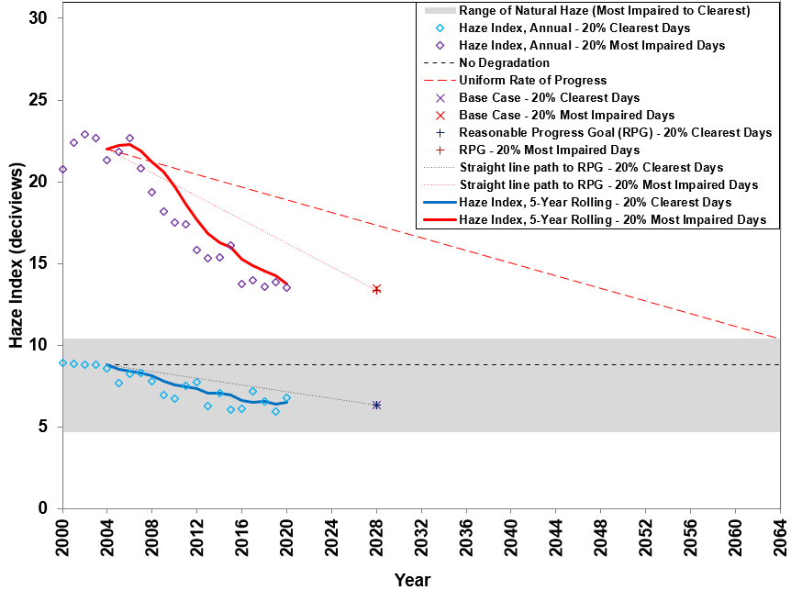

Figure 2-2. Visibility Metrics Levels at Moosehorn Wilderness Area

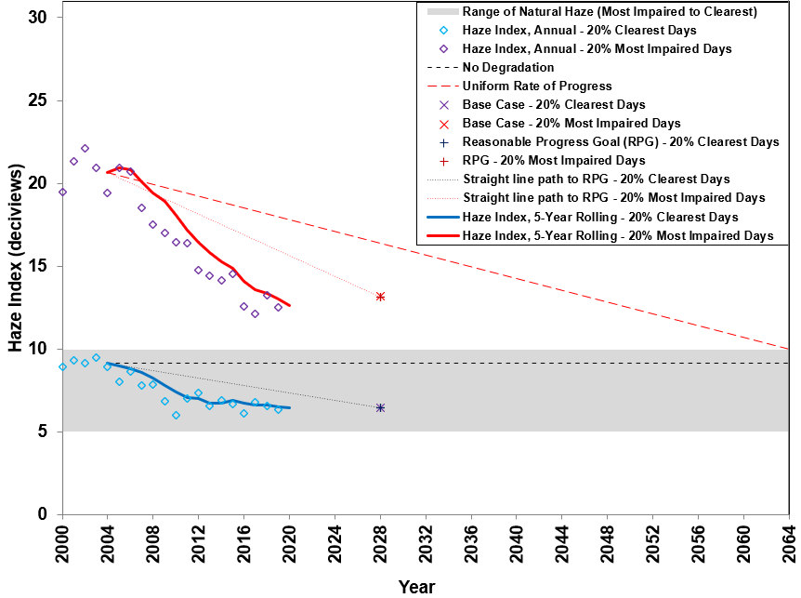

Page 2-8

Figure 2-3. Visibility Metrics Levels at Great Gulf Wilderness Area

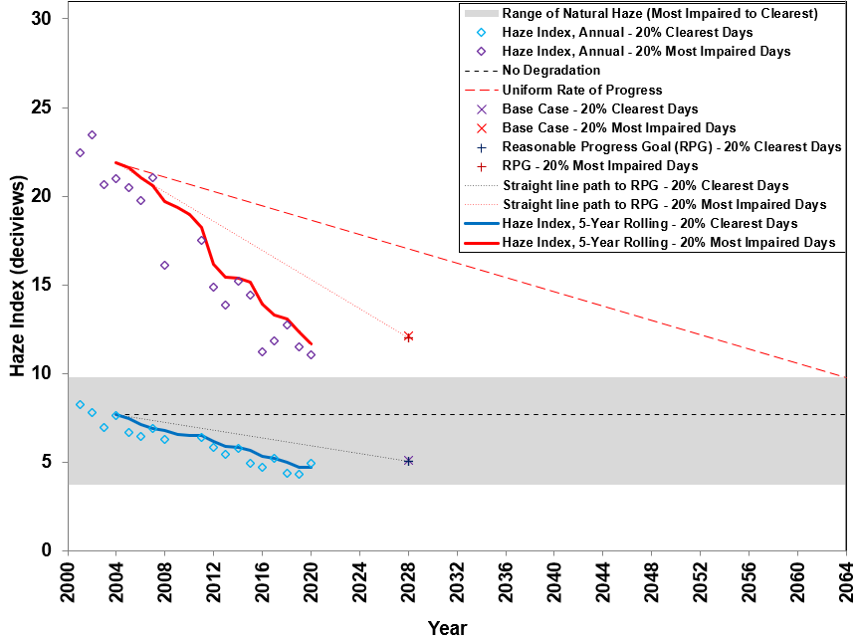

Figure 2-4. Visibility Metrics Levels at Lye Brook Wilderness Area

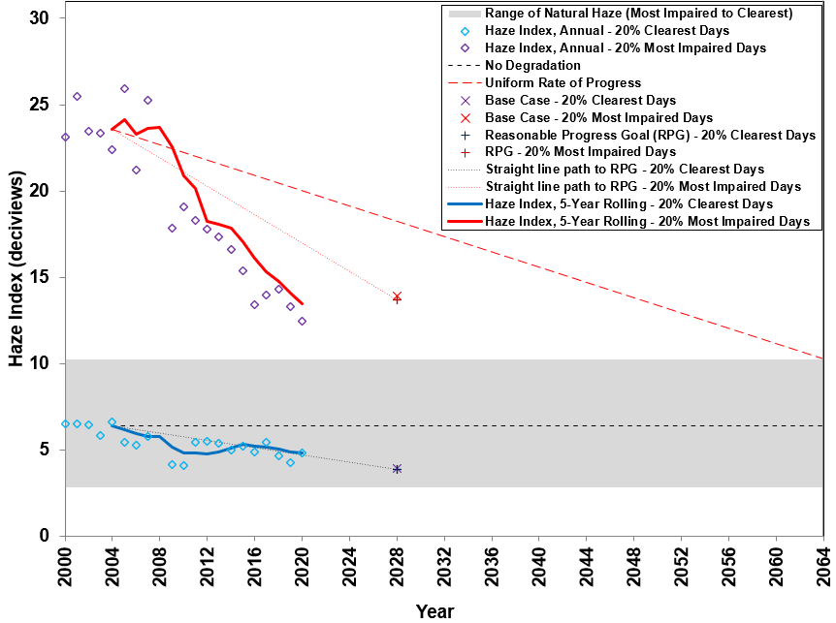

Page 2-9

Figure 2-5. Visibility Metrics Levels at Brigantine Wilderness Area

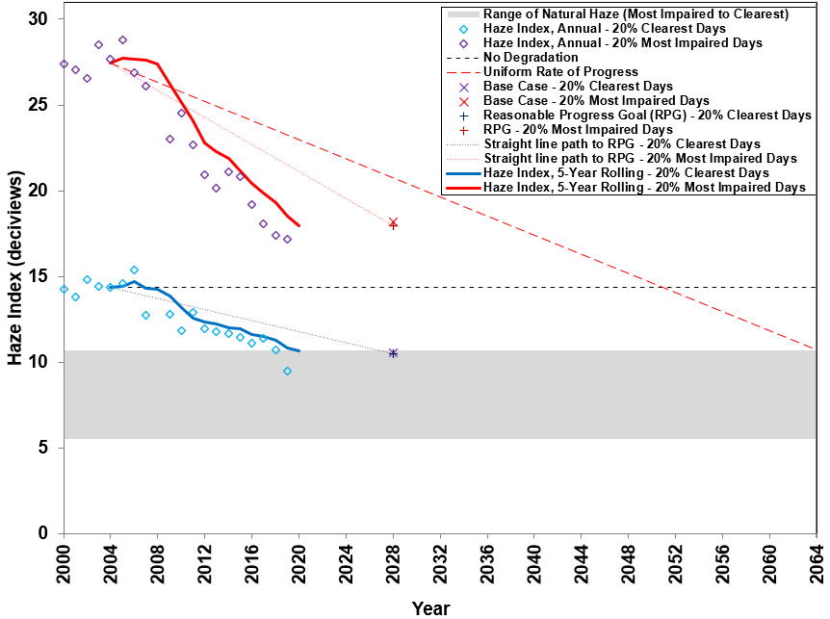

Figure 2-6. Visibility Metrics Levels at Dolly Sods Wilderness Area

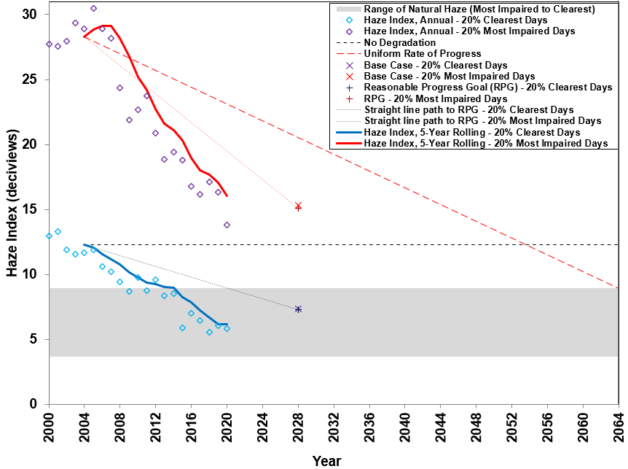

Page 2-10

Figure 2-7. Visibility Metrics Levels at Shenandoah National Park

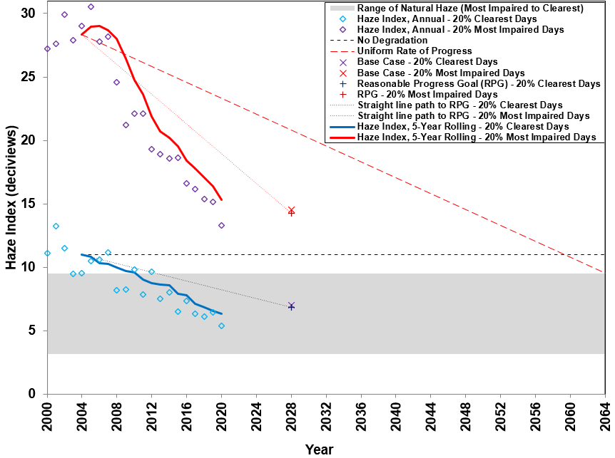

Figure 2-8. Visibility Metrics Levels at James River Face Wilderness

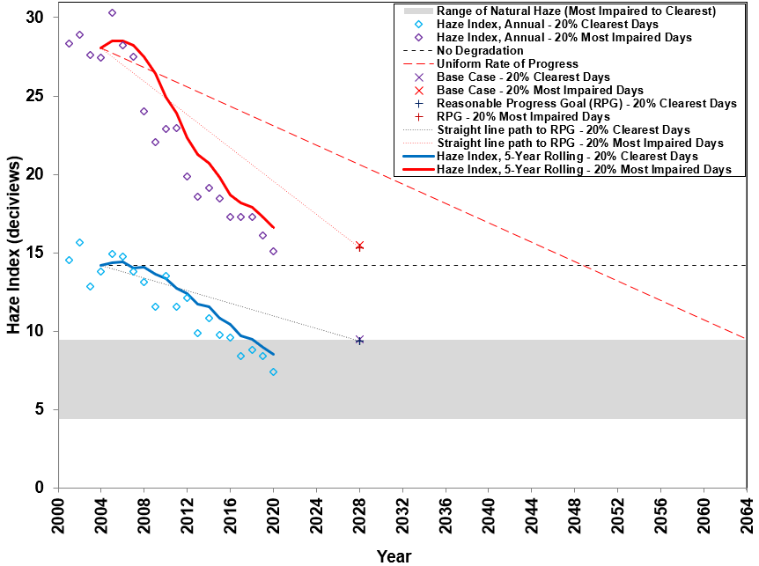

Page 2-11

3. Visibility Species Light Extinction Trends

In addition to analyzing trends in overall visibility changes at IMPROVE monitoring locations in the region, data for changes in individual PM species (constituents) contributions to visibility impairment were also examined. Both natural and anthropogenic species contributions will be included in the analyses. Rayleigh, sea salt and soil species are natural components of visibility. Sulfate, nitrate, organic carbon mass, light absorbing carbon (elemental carbon) and coarse mass species in the analyses are both natural and anthropogenic components of visibility. Table B-1 through Table B-28 in Appendix B present species contributions numerically for all Class I and IMPROVE Protocol sites in and adjacent to the MANE-VU region. Note that data for individual species in Appendix B are light extinction (units = inverse megameters (Mm⁻¹)).

Analyses of visibility by species helps policy decision makers determine what control strategies to consider for the second regional haze implementation planning period. The first set of analysis plots in Figure 3-1 through Figure 3-8 show 5-year baseline period vs. 5-year current period species average percent contributions for both 20 percent clearest and 20 percent most impaired days. Results clearly show a significant reduction in contributions at all Class I areas from sulfates for the 20 percent most impaired days with varying levels of increases for other species. Examples of increases include percent contribution from nitrates increasing at the Brigantine Wilderness and Lye Brook Wilderness Class I areas from 8% to 28% and from 7% to 24%, respectively. Similar plots for IMPROVE Protocol sites are in Appendix C.

Current and baseline 5-year average light extinction levels for the 20 percent best (see Figure 3-9(a)) and 20 percent worst (see Figure 3-9(b)) visibility days for all Class I IMPROVE sites are shown side by side. This is just another way to show reductions in the region and shows that reductions were primarily due to sulfate reductions with nitrate and OCM reductions more evident during the 20 percent best days. Because more winter days are in the current 20 percent worst days mix, the relative contribution of nitrates increased from the baseline especially at the Brigantine Wilderness Class I area.

The next set of analysis plots in Figure 3-10 to Figure 3-17 show individual species relative contributions [haze index*(species light extinction/total light extinction) (units = deciview (dv))] as stacked bar charts for sulfate, nitrate, organic carbon mass (OCM), light absorbing carbon (EC or LAC), soil, coarse mass, sea salt, and Rayleigh extinction levels on 20 percent clearest days (“a” plot) and 20 percent most impaired days (“b” plot). The total of the stacked bars represents annual Haze Index values and are marked by circles connected by a thin black line. The thick black line represents five-year back annual averages from 2004 to 2020. Two dashed lines descend from the 2004 five-year back average (i.e., the baseline value): the red dashed line represents the URP glide path to the 2064 natural visibility goal and the black dashed line represents the glide path to the modeled 2028 RPG. These figures confirm that large reductions in overall Haze Index values on the 20 percent most impaired days are primarily due to decreases in sulfate visibility impacts at MANE-VU and other nearby Class I areas. Significant decreases in sulfate contributions started in 2007 at Maine’s Class I areas and in 2008 at all other Class I areas analyzed. As the sulfate contributions declined, relative nitrate contributions have started to increase at many sites, especially at the Brigantine Wilderness monitoring site. This increase is primarily due to having more winter days in the 20 percent most impaired days mix during recent years. During the winter, relative nitrate contributions are much higher than during the summer (more discussion of winter nitrates is located at the end of this section). Steady decreases in

Page 3-1

sulfate contributions have reduced overall haze levels on the 20 percent clearest days. These decreases on the 20 percent clearest days started to occur after 2004 at most of the Class I areas. Sulfate remains the most significant contributor to light extinction at all Class I areas on the most impaired days in and adjacent to the MANE-VU region, followed by nitrate and OCM. For the Brigantine and Lye Brook Class I sites nitrate contributions are nearing the level of sulfate contributions. For the most part, light extinction from soil and sea salt, which help indicate the extent to which natural haze processes contribute to overall haze levels, are insignificant when compared to extinction from sulfate and nitrate. Based on these figures, continued progress in sulfate levels appears to be driving the trend in overall improvement in 20 percent most impaired days and 20 percent clearest days haze level reductions. Similar plots for IMPROVE Protocol sites are in Appendix D.

To examine the individual species trends more closely, the range of individual light extinction on 20 percent clearest days and 20 percent most impaired days from 2000 through 2020 at the Class I areas were plotted against the estimated light extinction under natural conditions in the next set of analysis plots. (See Table 2-2 for 20% clearest days natural extinction levels and Table 2-4 for 20% most impaired days routine and episodic natural extinction levels). Figure 3-18 through Figure 3-25 show the range of light extinction levels at MANE-VU and nearby Class I areas as compared to natural light extinction for selected species. IMPROVE Protocol sites are excluded from this analysis for simplicity and light extinction from soil and sea salt are excluded from this analysis as those contributions are small and are primarily natural. Estimated natural light extinction is represented in each chart by a purple line for 20 percent most impaired days and by a red line for 20 percent clearest days. For the carbonaceous species, OCM and LAC, the green band is observed OCM and the dark grey band is observed LAC. Note that the observations do not represent the range of the highest and lowest 20 percent light extinction levels for those species; rather, they represent the range of species light extinction levels on the 20 percent clearest and 20 percent most impaired visibility days.

It is clear from these charts that levels of extinction from sulfate have dropped significantly since the baseline period at all Class I areas, although remaining at levels much higher than the estimated natural range at all sites. Extinction due to nitrate is closer to natural levels than sulfates and is approaching natural levels on the clearest days, however, the range of nitrate extinction has expanded in recent years with the highest levels at southern Class I areas greater than the baseline period. At the Brigantine Wilderness Class I Area, extinction due to nitrate remains considerably higher than the natural baseline. At most Class I areas, levels of extinction due to carbonaceous species and coarse mass appear to be near or slightly above natural range levels. Prior peaks in carbonaceous matter extinction at most sites were driven by OCM levels. Carbonaceous matter and coarse mass light extinction levels at the Brigantine Wilderness Class I Area have started to decrease more into the natural range during more recent years.

The fourth set of analysis plots in Figure 3-26 for New England Class I areas and Figure 3-27 for other Class I areas show the mix of 20 percent most impaired days by season. Results clearly show that summer days no longer dominate the mix at all Class I areas. For many of the Class I areas there are now more winter days in the mix than in any other season. That trend is more evident at New Jersey, Virginia and West Virginia Class I areas. This helps to explain why nitrate extinction percent contributions are increasing and is consistent with the seasonality of nitrogen oxides (NO_{x}) emissions as shown in the Figure 3-28 monitoring data trends plot for sites located in or close to large cities (Boston, Philadelphia and Baltimore) in the region. Similar plots for IMPROVE Protocol sites are in Appendix E.
Page 3-2

BASELINE AND CURRENT VISIBILITY SPECIES TRENDS PLOTS

Figure 3-1. Acadia National Park Species Percent Contribution to
Baseline (2000-04) and Current (2016-20) Haze Index Levels

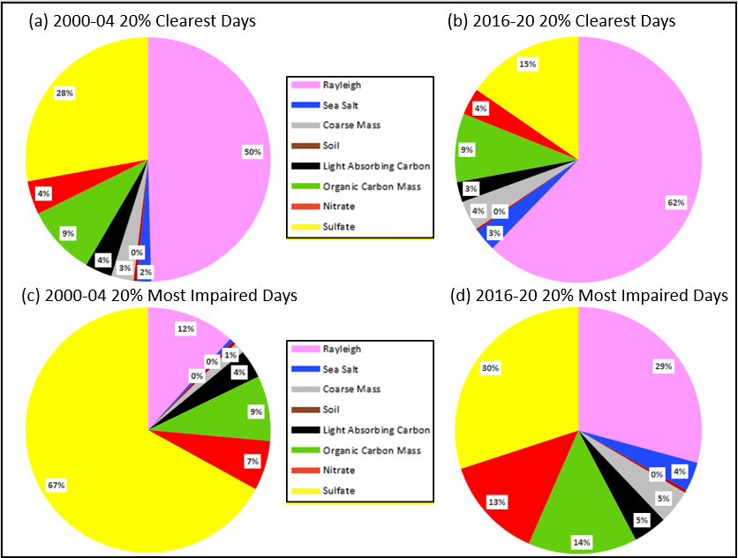

Page 3-3

Figure 3-2. Moosehorn Wilderness Area Species Percent Contribution to
Baseline (2000-04) and Current (2016-20) Haze Index Levels

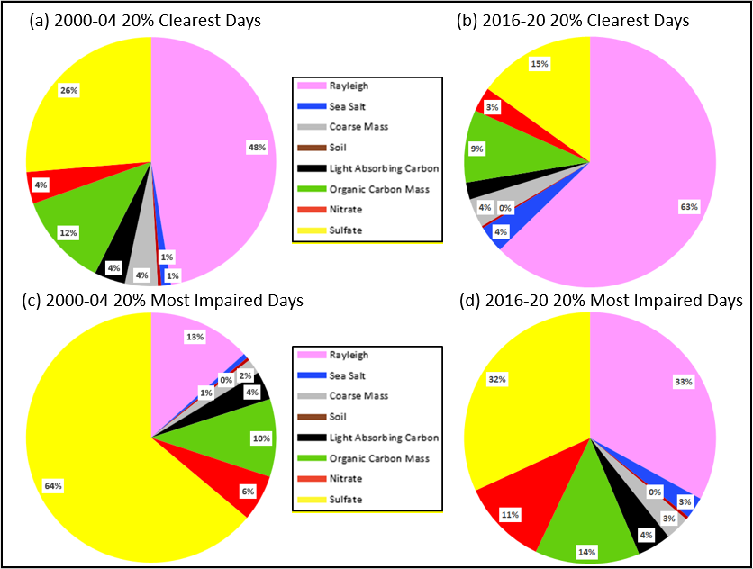

Page 3-4

Figure 3-3. Great Gulf Wilderness Area Species Percent Contribution to
Baseline (2000-04) and Current (2016-20) Haze Index Levels

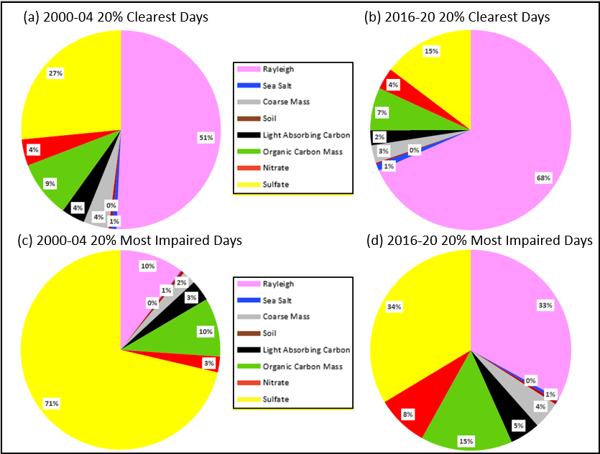

Page 3-5

Figure 3-4. Lye Brook Wilderness Area Species Percent Contribution to
Baseline (2000-04) and Current (2016-20) Haze Index Levels

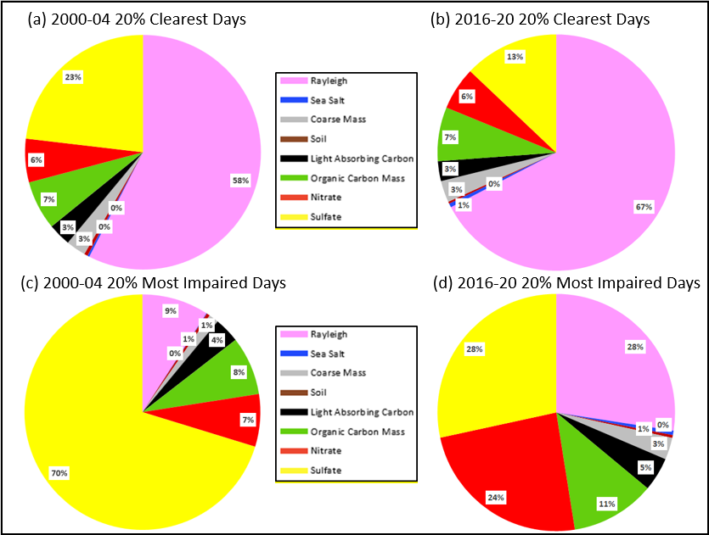

Page 3-6

Figure 3-5. Brigantine Wilderness Area Species Percent Contribution to
Baseline (2000-04) and Current (2016-20) Haze Index Levels

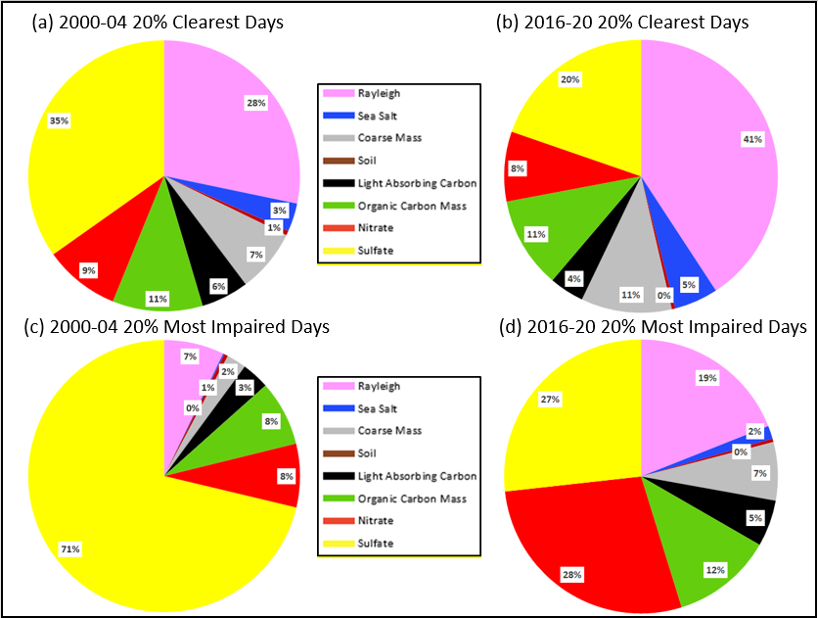

Page 3-7

Figure 3-6. Dolly Sods Wilderness Area Species Percent Contribution to
Baseline (2000-04) and Current (2016-20) Haze Index Levels

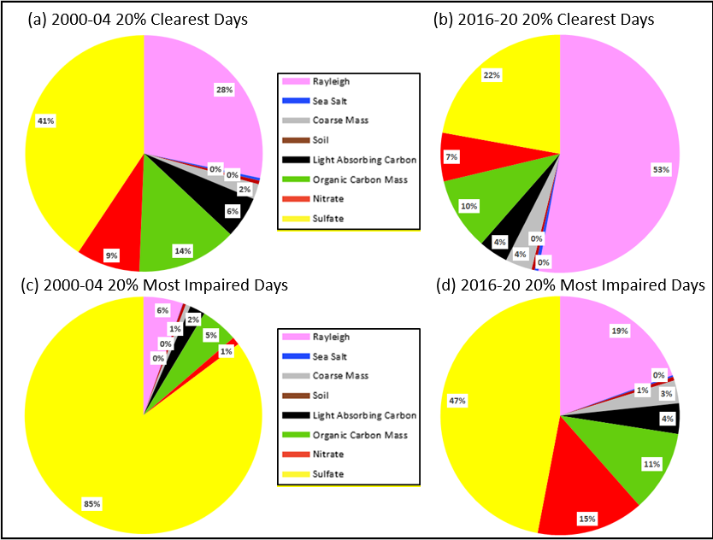

Page 3-8

Figure 3-7. Shenandoah National Park Species Percent Contribution to
Baseline (2000-04) and Current (2016-20) Haze Index Levels

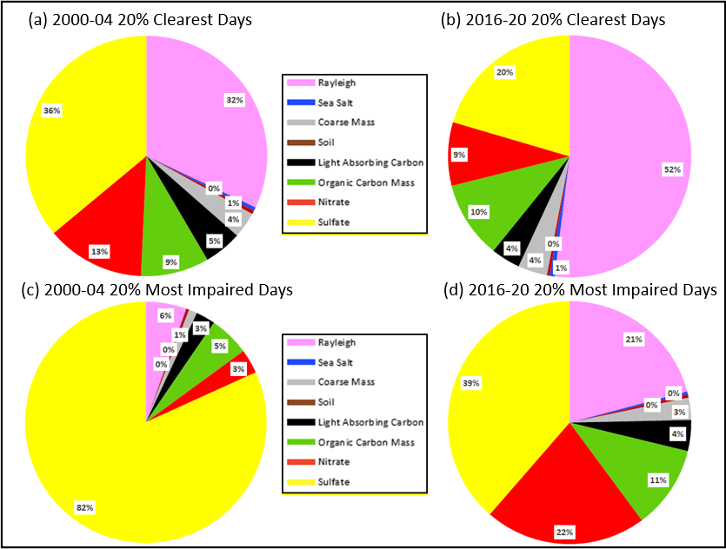

Page 3-9

Figure 3-8. James River Face Wilderness Area Species Percent Contribution to
Baseline (2000-04) and Current (2016-20) Haze Index Levels

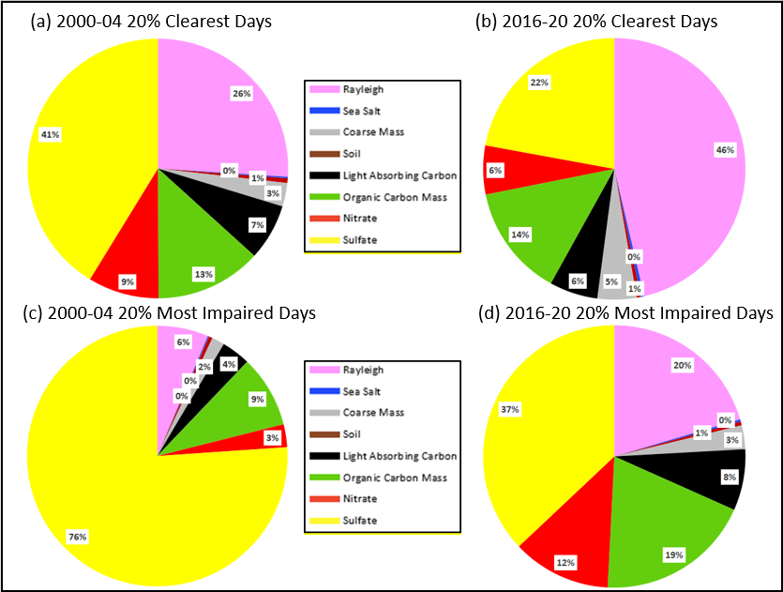

Page 3-10

Figure 3-9. Current and Baseline 5-Year Average Light Extinction at Class I Sites on 20 Percent Clearest and 20 Percent Most Impaired Visibility Days

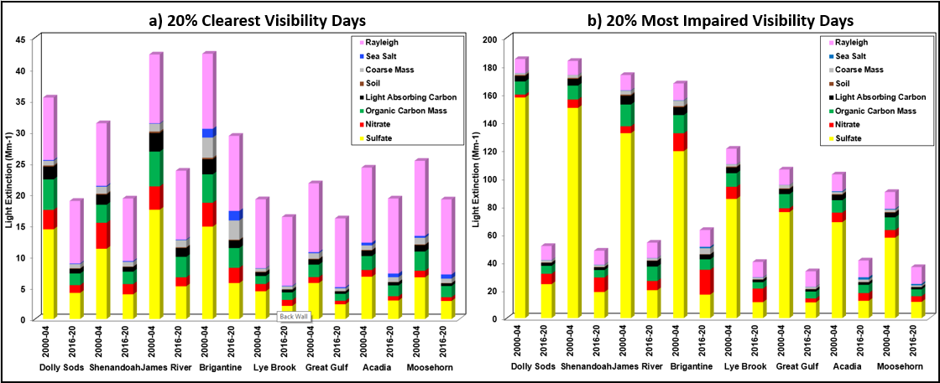

Page 3-11

ANNUAL VISIBILITY SPECIES TRENDS PLOTS
Figure 3-10. Individual Species Contribution to Annual Haze Index Levels at Acadia National Park on 20 Percent Clearest and Most Impaired Visibility Days
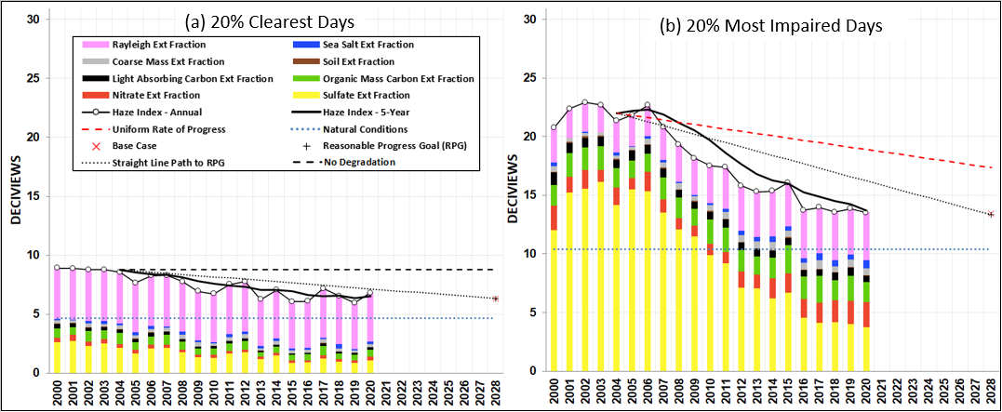

Figure 3-11. Individual Species Contribution to Annual Haze Index Levels at Moosehorn Wilderness Area on 20 Percent Clearest and Most Impaired Visibility Days
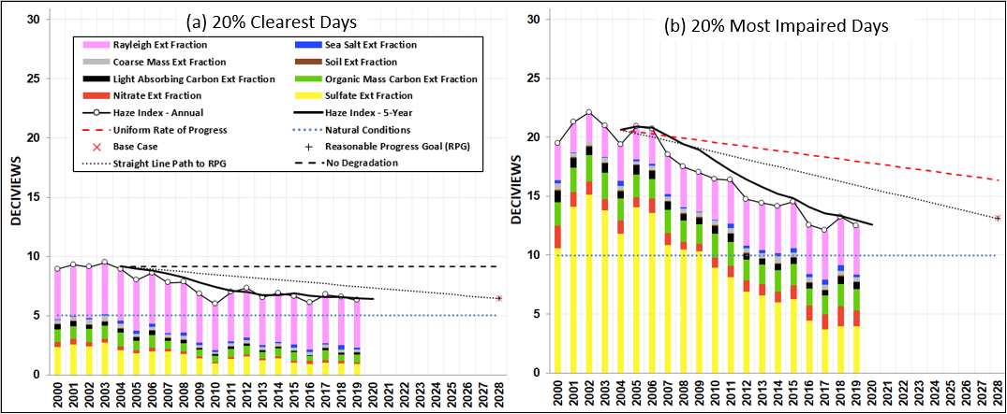
Page 3-12

Figure 3-12. Individual Species Contribution to Annual Haze Index Levels at Great Gulf Wilderness Area on 20 Percent Clearest and Most Impaired Visibility Days
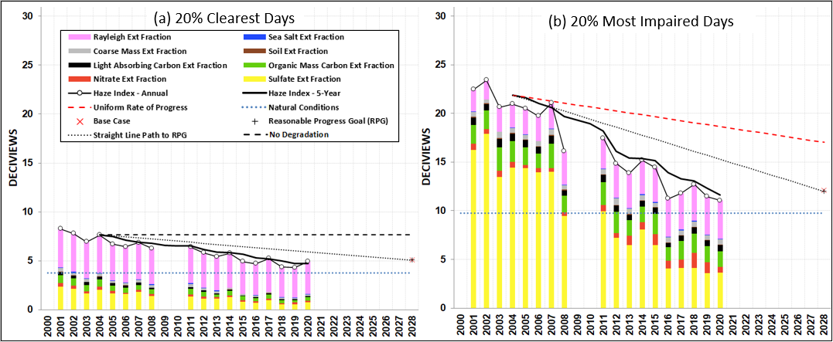

Figure 3-13. Individual Species Contribution to Annual Haze Index Levels at Lye Brook Wilderness Area on 20 Percent Clearest and Most Impaired Visibility Days
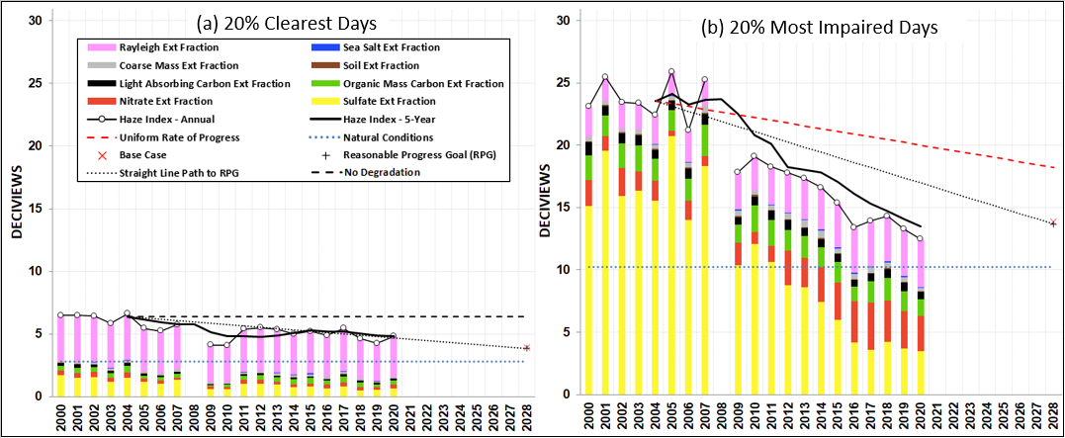
Page 3-13

Figure 3-14. Individual Species Contribution to Annual Haze Index Levels at Brigantine Wilderness Area on 20 Percent Clearest and Most Impaired Visibility Days
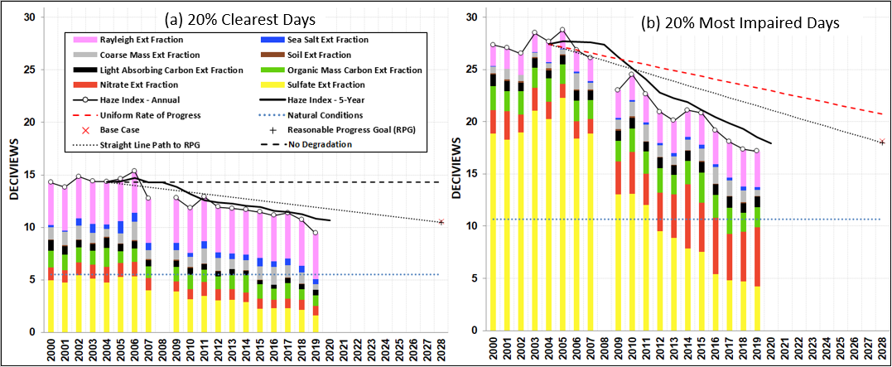

Figure 3-15. Individual Species Contribution to Annual Haze Index Levels at Dolly Sods Wilderness Area on 20 Percent Clearest and Most Impaired Visibility Days
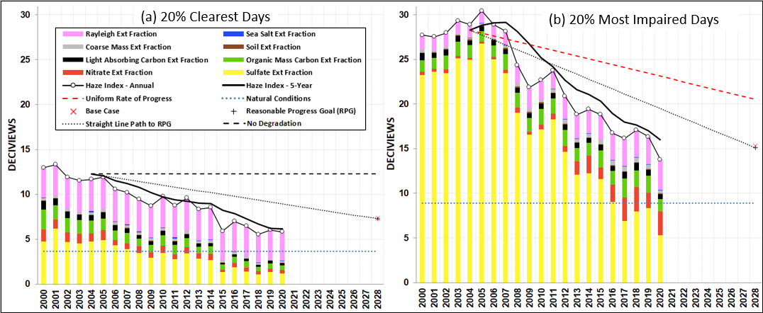
Page 3-14

Figure 3-16. Individual Species Contribution to Annual Haze Index Levels at Shenandoah National Park on 20 Percent Clearest and Most Impaired Visibility Days
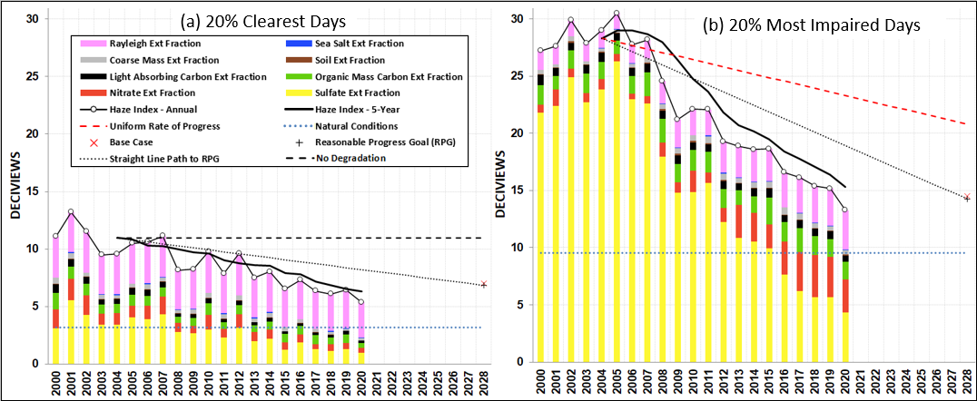

Figure 3-17. Individual Species Contribution to Annual Haze Index Levels at James River Face Wilderness Area on 20 Percent Clearest and Most Impaired Visibility Days
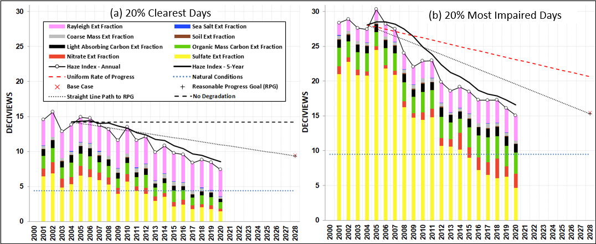
Page 3-15

RANGE OF OBSERVED VISIBILITY SPECIES TRENDS PLOTS

Figure 3-18. Range of Observed and Estimated Natural Light Extinction for Select Individual Species at Acadia National Park on 20 Percent Clearest and Most Impaired Visibility Days

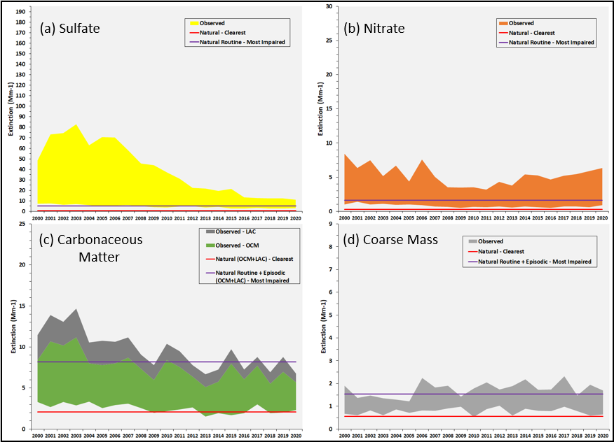
Notes: Light extinction from (a) sulfate, (b) nitrate, (c) carbonaceous matter (i.e., organic carbon mass or OCM and light absorbing carbon or LAC), and (d) coarse mass, alongside estimated natural light extinction from those species.

Page 3-16

Figure 3-19. Range of Observed and Estimated Natural Light Extinction for Select Individual Species at Moosehorn Wilderness Area on 20 Percent Clearest and Most Impaired Visibility Days

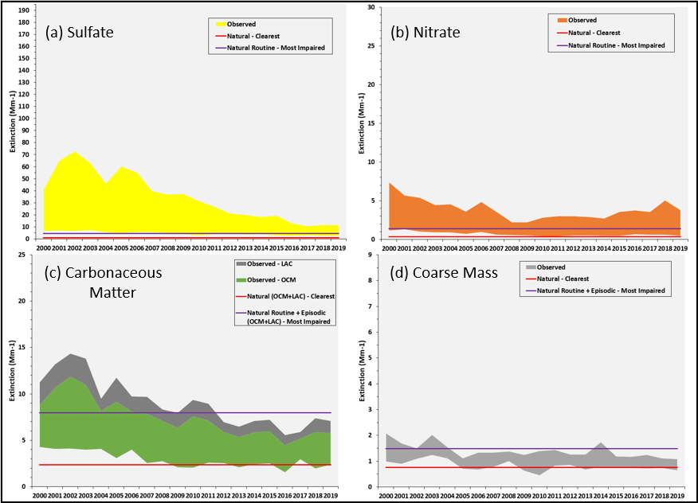
Notes: Light extinction from (a) sulfate, (b) nitrate, (c) carbonaceous matter (i.e., organic carbon mass or OCM and light absorbing carbon or LAC), and (d) coarse mass, alongside estimated natural light extinction from those species.

Page 3-17

Figure 3-20. Range of Observed and Estimated Natural Light Extinction for Select Individual Species at Great Gulf Wilderness Area on 20 Percent Clearest and Most Impaired Visibility Days

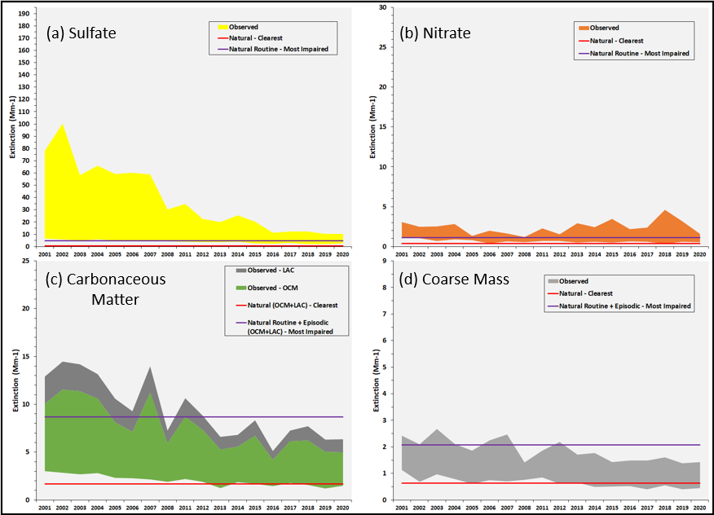
Notes: Light extinction from (a) sulfate, (b) nitrate, (c) carbonaceous matter (i.e., organic carbon mass or OCM and light absorbing carbon or LAC), and (d) coarse mass, alongside estimated natural light extinction from those species.

Page 3-18

Figure 3-21. Range of Observed and Estimated Natural Light Extinction for Select Individual Species at Lye Brook Wilderness Area on 20 Percent Clearest and Most Impaired Visibility Days

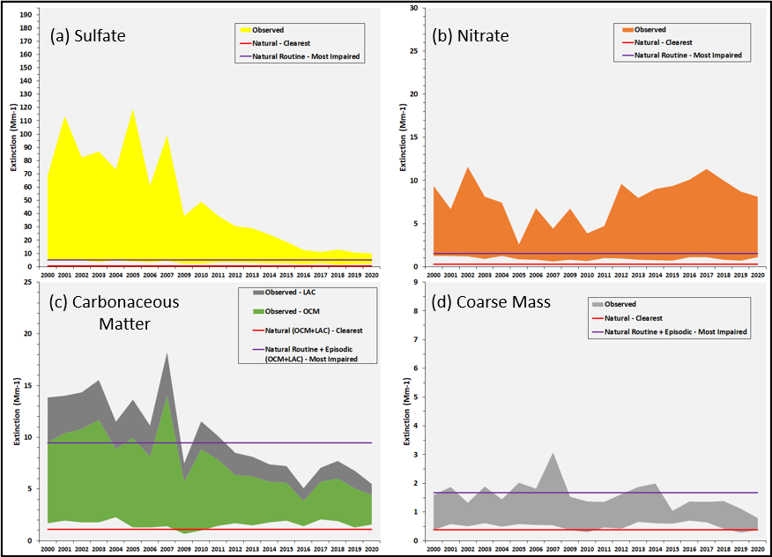
Notes: Light extinction from (a) sulfate, (b) nitrate, (c) carbonaceous matter (i.e., organic carbon mass or OCM and light absorbing carbon or LAC), and (d) coarse mass, alongside estimated natural light extinction from those species.

Page 3-19

Figure 3-22. Range of Observed and Estimated Natural Light Extinction for Select Individual Species at Brigantine Wilderness Area on 20 Percent Clearest and Most Impaired Visibility Days

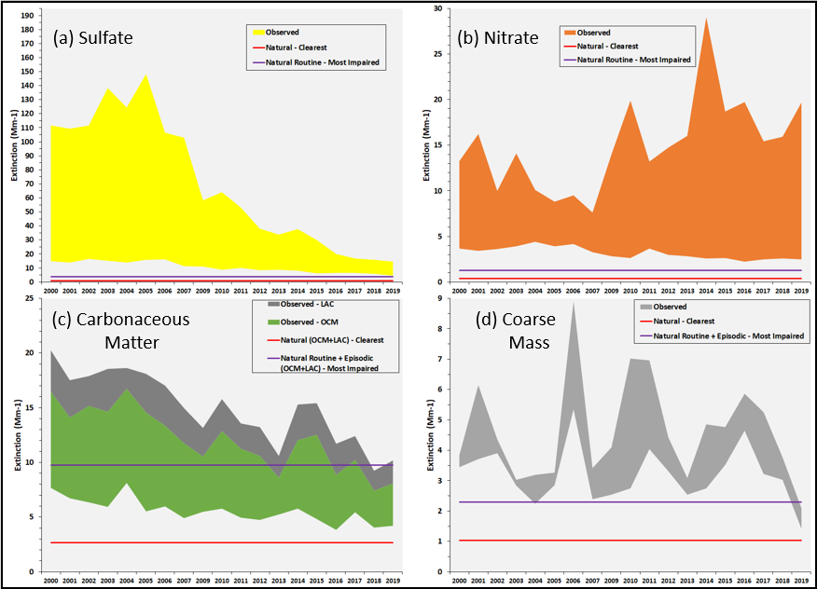
Notes: Light extinction from (a) sulfate, (b) nitrate, (c) carbonaceous matter (i.e., organic carbon mass or OCM and light absorbing carbon or LAC), and (d) coarse mass, alongside estimated natural light extinction from those species.

Page 3-20

Figure 3-23. Range of Observed and Estimated Natural Light Extinction for Select Individual Species at Dolly Sods Wilderness Area on 20 Percent Clearest and Most Impaired Visibility Days

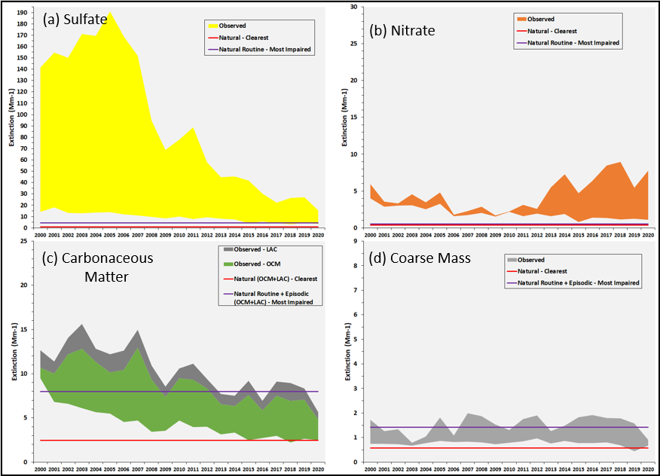
Notes: Light extinction from (a) sulfate, (b) nitrate, (c) carbonaceous matter (i.e., organic carbon mass or OCM and light absorbing carbon or LAC), and (d) coarse mass, alongside estimated natural light extinction from those species.

Page 3-21

Figure 3-24. Range of Observed and Estimated Natural Light Extinction for Select Individual Species at Shenandoah National Park on 20 Percent Clearest and Most Impaired Visibility Days

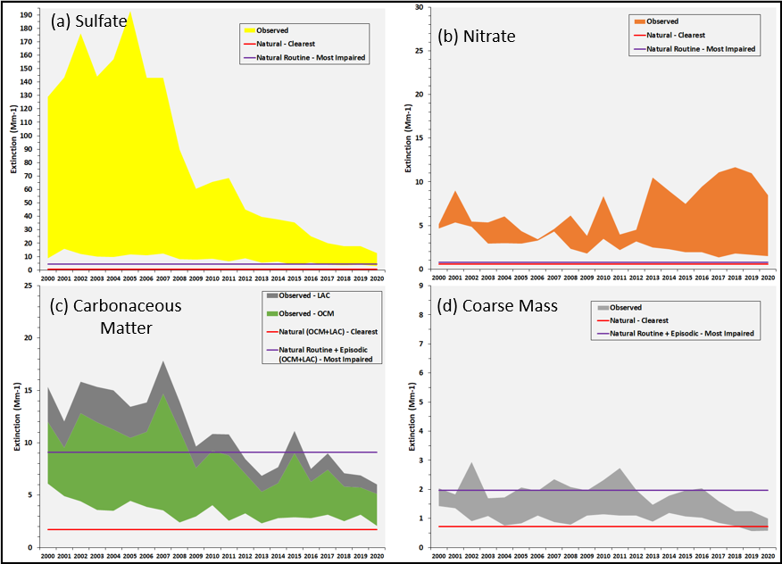
Notes: Light extinction from (a) sulfate, (b) nitrate, (c) carbonaceous matter (i.e., organic carbon mass or OCM and light absorbing carbon or LAC), and (d) coarse mass, alongside estimated natural light extinction from those species.

Page 3-22

Figure 3-25. Range of Observed and Estimated Natural Light Extinction for Select Individual Species at James River Face Wilderness Area on 20 Percent Clearest and Most Impaired Visibility Days

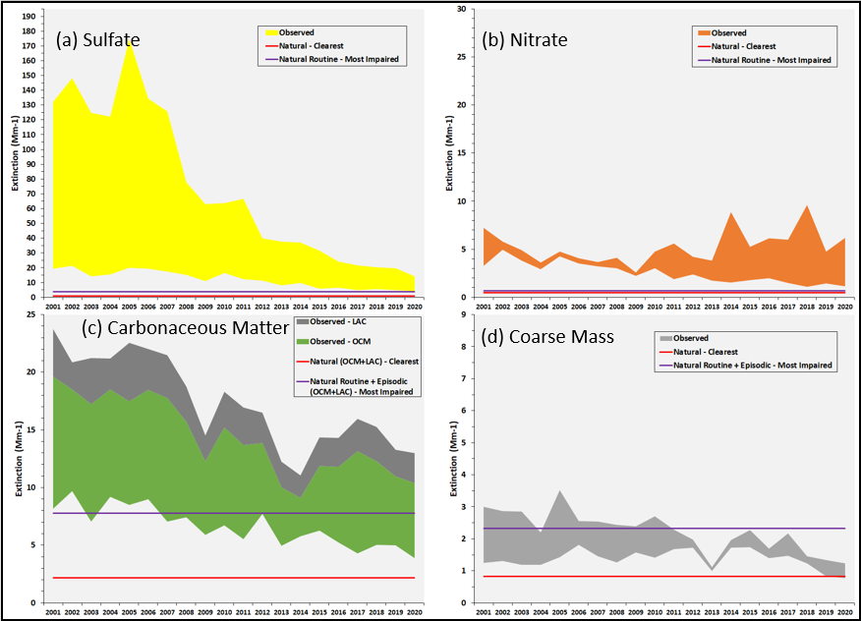
Notes: Light extinction from (a) sulfate, (b) nitrate, (c) carbonaceous matter (i.e., organic carbon mass or OCM and light absorbing carbon or LAC), and (d) coarse mass, alongside estimated natural light extinction from those species.

Page 3-23

SEASONAL TRENDS OF 20 PERCENT MOST IMPAIRED DAYS

Figure 3-26. Seasonal Breakdown of 20 Percent Most Impaired Visibility Days for New England Class I Areas

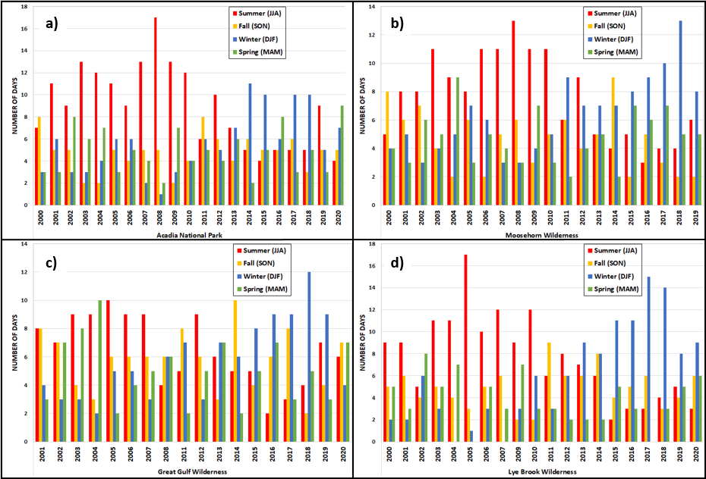

Page 3-24

Figure 3-27. Seasonal Breakdown of 20 Percent Most Impaired Visibility Days for New Jersey,
West Virginia and Virginia Class I Areas

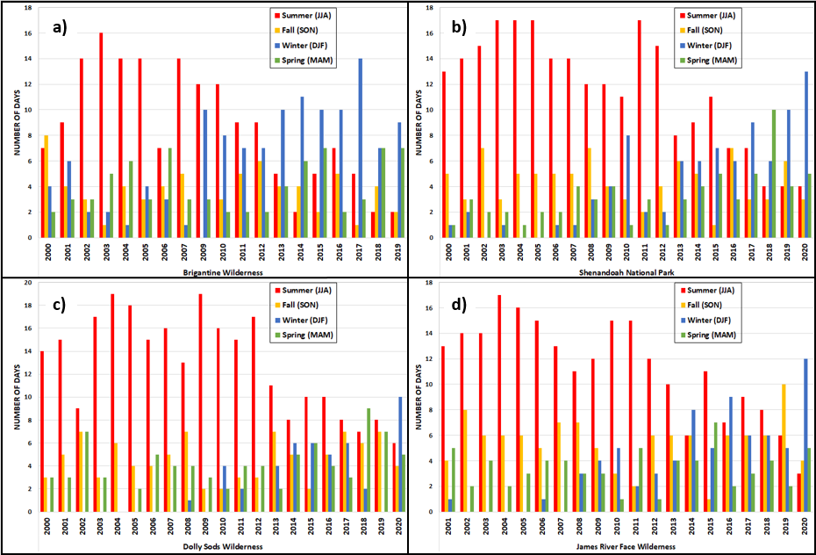

Page 3-25

Figure 3-28. 1997-2020 NO_{x} Trends by Month

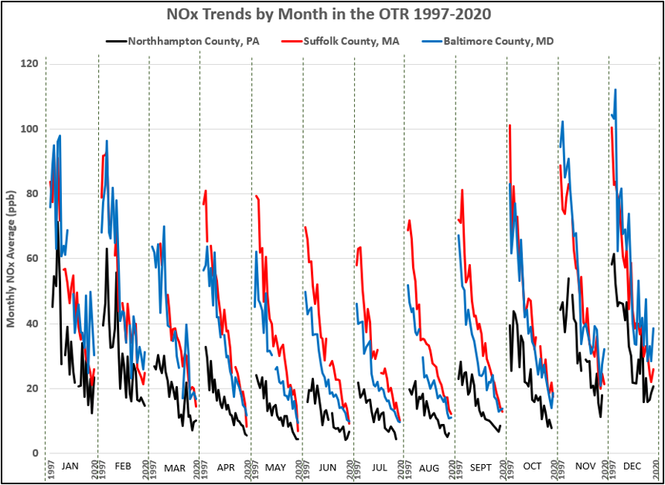
Source: USEPA Air Quality System (AQS) data

Page 3-26

4. Summary

There are definite downward trends in overall haze levels at Class I areas in and adjacent to the MANE-VU region. Based on rolling five-year averages demonstrating progress since the 2000-2004 baseline period, Class I areas are currently below the 2020 URP and baseline period levels for the 20 percent clearest visibility days. The trends are mainly driven by large reductions in sulfate light extinction. Levels of nitrate extinction are approaching natural conditions for the 20 percent clearest days; however, percent contribution levels are increasing for the 20 percent most impaired days in recent years as more winter days are in the 20 percent most impaired days mix, especially for the Brigantine and Lye Brook Class I areas. Levels of carbonaceous matter (OCM and LAC) appear to be approaching natural levels at most of the Class I areas. Though states are on track to be below 2028 URPs, current (2016-20) visibility levels are greater than modeled 2028 RPGs and the 2028 RPG is the metric states need to achieve for the second planning period. Continued sulfate and nitrate reductions are primary drivers in continuing to improve visibility.

Reductions in air pollution continue to bring down levels of fine particulate matter in the eastern United States, which in turn are leading to improved visibility at federally protected Class I areas in and adjacent to the MANE-VU region. Significant improvements in visibility at the MANE-VU Class I sites have been observed, and these changes have been largely driven by reductions in sulfate levels.

Large emission reductions of NO_{x} and sulfur dioxide (SO2) across the region in response to regional emission reduction requirements for power plants (i.e., NO_{x} SIP Call, NO_{x} Reasonably Available Control Technology (RACT), Cross State Air Pollution Rule (CSAPR), 2010 SO₂ National Ambient Air Quality Standard (NAAQS), etc.) is likely a principal driver for these visibility improvements. Reductions have occurred recently as the power sector continued to control or phase out coal plants across the eastern United States in response to competitive pressures from natural gas generation, overall reduced electricity demand, and more stringent requirements to reduce emissions of air toxics (i.e., 2011 Mercury and Air Toxics (MATS) rule).

In addition to addressing emissions from power plants, states across the Northeast have enacted or are in process of enacting low sulfur content requirements for fuel oils, which cover home heating oil (distillate) and residual oils (#4 and #6). At the federal level, USEPA finalized the Tier 3 motor vehicle program in 2014 that includes lowering sulfur content in gasoline. While gasoline combustion is a minor source of SO2 emissions, the Tier 3 fuel requirements will significantly reduce NO_{x} emissions from the existing fleet of on-road gasoline vehicles by reducing sulfur poisoning of the catalyst in catalytic converters, thus improving control technology performance. This would lead to lower nitrate levels, most notably during colder weather months when nitrates are more thermally stable. In warmer weather months, NO_{x} promotes ground-level ozone formation, which in turn can enhance formation of visibility-limiting secondary organic aerosols (Carleton et al. 2010). Therefore, lower levels of NO_{x} because of Tier 3 can also improve visibility by reducing ozone formation that leads to carbonaceous PM.

In summary, the visibility data examined using the 20 percent most impaired and 20 percent clearest days metrics in this report demonstrate that broad, regional efforts to reduce emissions of visibility-impairing pollutants have had a beneficial effect at the region’s Class I areas. IMPROVE data trends indicate that states continue to be on track keeping visibility levels significantly below the uniform rate of progress levels and some Class I areas have already achieved levels below the respective RPGs. However, further progress is needed at some Class I areas to achieve 2028 reasonable progress goals that have been established for the second regional haze implementation planning period.

Page 4-1

5. REFERENCES

Carleton, A.G., R.W. Pinder, P.V. Bhave, and G.A. Pouliot. 2010. To What Extent Can Biogenic SOA be Controlled? 44 Environ. Sci. Technol. 3376-3380, doi:10.1021/es903506b.

Copeland, S.A., Pitchford, M, and Ames, R. 2008. Regional Haze Rule Natural Level Estimates Using the Revised IMPROVE Aerosol Reconstructed Light Extinction Algorithm. Final Paper #48. Available at http://vista.cira.colostate.edu/improve/Publications/GrayLit/032_NaturalCondIIpaper/Copeland_etal_NaturalConditionsII_Description.pdf

Federal Land Manager Environmental Database (FED). 2018. IMPROVE and RHR Summary Data. Available at: http://views.cira.colostate.edu/fed/DataWizard/

MANE-VU. 2018a. Ozone Transport Commission/Mid-Atlantic Northeastern Visibility Union 2011 Based Modeling Platform Support Document - October 2018 Update. Available at https://otcair.org/manevu/document.asp?fview=Reports

MANE-VU. 2021. Mid-Atlantic/Northeast U.S. Visibility Data 2004-2019 (2nd RH SIP Metrics) – January 21, 2021 Update. Available at https://otcair.org/manevu/document.asp?fview=Reports

NESCAUM. 2010. Tracking Visibility Progress, 2004-2008 (2010). MANE-VU Technical Memorandum, May 12, 2010. Available at http://www.nescaum.org/topics/regional-haze/regional-haze-documents

NESCAUM. 2013. Tracking Visibility Progress, 2004-2011 (2013). MANE-VU Technical Memorandum, May 24, 2013. Available at http://www.nescaum.org/topics/regional-haze/regional-haze-documents

Pitchford, Mark, William Malm, Bret Schichtel, Naresh Kumar, Douglas Lowenthal & Jenny Hand (2007) Revised Algorithm for Estimating Light Extinction from IMPROVE Particle Speciation Data, Journal of the Air & Waste Management Association, 57:11, 1326-1336, DOI: 10.3155/1047-3289.57.11.1326

US Environmental Protection Agency (U.S. EPA). 2003a. Guidance for Estimating Natural Visibility Conditions Under the Regional Haze Rule. Research Triangle Park: Office of Air Quality Planning and Standards, September 2003. EPA-454/B-03-005.

US Environmental Protection Agency (U.S. EPA). 2003b. Guidance for Tracking Progress Under the Regional Haze Rule. Research Triangle Park: Office of Air Quality Planning and Standards, September 2003. EPA-454/B-03-004.

US Environmental Protection Agency (U.S. EPA). 2017. Protection of Visibility: Amendments to Requirements for State Plans. Final Rule. 82 FR 3078, January 10, 2017, https://www.gpo.gov/fdsys/pkg/FR-2017-01-10/pdf/2017-00268.pdf

US Environmental Protection Agency (U.S. EPA). 2018. Technical Guidance on Tracking Visibility Progress for the Second Implementation Period of the Regional Haze Program. Research Triangle Park: Office of Air Quality Planning and Standards, December 2018. EPA-454/R-18-010.

Page 5-1

Appendix A: Tracking Progress Data for Current Active IMPROVE Monitoring Sites In and Adjacent to the MANE-VU Region

Table A-1. Tracking Progress Data for Acadia National Park (ME) and Brigantine Wilderness (NJ) Class I Areas in the MANE-VU Region (dv)

 |  | 20 Percent Clearest Days |  | 20 Percent Most Impaired Days
Class I Area | Year | Haze Index,  Annual | Haze Index, 5-  Year Rolling | Haze Index,  Annual | Haze Index,  Year Rolling
Acadia National Park (ACAD) | 2000 | 8.90 | - | 20.75 | -
 | 2001 | 8.87 | - | 22.37 | -
 | 2002 | 8.77 | - | 22.91 | -
 | 2003 | 8.77 | - | 22.70 | -
 | 2004 | 8.56 | 8.78 | 21.34 | 22.01
 | 2005 | 7.66 | 8.53 | 21.85 | 22.23
 | 2006 | 8.25 | 8.40 | 22.69 | 22.30
 | 2007 | 8.28 | 8.30 | 20.84 | 21.88
 | 2008 | 7.76 | 8.10 | 19.35 | 21.21
 | 2009 | 6.92 | 7.77 | 18.17 | 20.58
 | 2010 | 6.71 | 7.58 | 17.52 | 19.71
 | 2011 | 7.51 | 7.44 | 17.39 | 18.65
 | 2012 | 7.75 | 7.33 | 15.81 | 17.65
 | 2013 | 6.25 | 7.03 | 15.31 | 16.84
 | 2014 | 7.03 | 7.05 | 15.36 | 16.28
 | 2015 | 6.05 | 6.92 | 16.07 | 15.99
 | 2016 | 6.08 | 6.63 | 13.72 | 15.26
 | 2018 | 7.18 | 6.52 | 13.97 | 14.89
 | 2018 | 6.53 | 6.58 | 13.58 | 14.54
 | 2019 | 5.95 | 6.36 | 13.85 | 14.24
 | 2020 | 6.80 | 6.51 | 13.52 | 13.73
 | 2028 RPG |  | 6.33 RPG |  | 13.35 RPG
 | 2064 NAT |  | 4.66 NAT |  | 10.39 ER NAT
Brigantine Wilderness  (BRIG) | 2000 | 14.26 | - | 27.37 | -
 | 2001 | 13.80 | - | 27.07 | -
 | 2002 | 14.83 | - | 26.53 | -
 | 2003 | 14.39 | - | 28.49 | -
 | 2004 | 14.36 | 14.33 | 27.69 | 27.43
 | 2005 | 14.61 | 14.40 | 28.81 | 27.72
 | 2006 | 15.35 | 14.71 | 26.88 | 27.68
 | 2007 | 12.74 | 14.29 | 26.10 | 27.60
 | 2008 | * | 14.26 | * | 27.37
 | 2009 | 12.78 | 13.87 | 23.03 | 26.21
 | 2010 | 11.82 | 13.17 | 24.51 | 25.13
 | 2011 | 12.92 | 12.56 | 22.66 | 24.08
 | 2012 | 11.93 | 12.36 | 20.95 | 22.79
 | 2013 | 11.80 | 12.25 | 20.12 | 22.25
 | 2014 | 11.66 | 12.03 | 21.09 | 21.87
 | 2015 | 11.44 | 11.95 | 20.84 | 21.13
 | 2016 | 11.12 | 11.59 | 19.18 | 20.44
 | 2017 | 11.36 | 11.48 | 18.09 | 19.86
 | 2018 | 10.70 | 11.26 | 17.37 | 19.31
 | 2019 | 9.44 | 10.81 | 17.19 | 18.53
 | 2020 | * | 10.66 | * | 17.96
 | 2028 RPG |  | 10.47 RPG |  | 17.97 RPG
 | 2064 NAT |  | 5.52 NAT |  | 10.68 ER NAT
“-” = not applicable; “*” = no data available; “RPG” = Reasonable Progress Goal; “NAT” = Natural Conditions; ”ER” = episodic routine

Page A-1

Table A-2. Tracking Progress Data for Great Gulf Wilderness (NH) and Lye Brook Wilderness (VT) Class I Areas in the MANE-VU Region (dv)

 |  | 20 Percent Clearest Days |  | 20 Percent Most Impaired Days
Class I Area | Year | Haze Index,  Annual | Haze Index, 5-  Year Rolling | Haze Index,  Annual | Haze Index,  Year Rolling
Great Gulf Wilderness Area  (GRGU) | 2000 | * | - | * | -
 | 2001 | 8.26 | - | 22.47 | -
 | 2002 | 7.77 | - | 23.43 | -
 | 2003 | 6.94 | - | 20.65 | -
 | 2004 | 7.61 | 7.65 | 20.97 | 21.88
 | 2005 | 6.69 | 7.46 | 20.51 | 21.61
 | 2006 | 6.43 | 7.09 | 19.74 | 21.06
 | 2007 | 6.86 | 6.91 | 21.06 | 20.59
 | 2008 | 6.26 | 6.77 | 16.10 | 19.67
 | 2009 | * | 6.56 | * | 19.35
 | 2010 | * | 6.52 | * | 18.96
 | 2011 | 6.39 | 6.50 | 17.48 | 18.21
 | 2012 | 5.81 | 6.16 | 14.86 | 16.14
 | 2013 | 5.41 | 5.87 | 13.87 | 15.40
 | 2014 | 5.75 | 5.84 | 15.19 | 15.35
 | 2015 | 4.92 | 5.66 | 14.44 | 15.17
 | 2016 | 4.69 | 5.32 | 11.23 | 13.92
 | 2017 | 5.22 | 5.20 | 11.81 | 13.31
 | 2018 | 4.37 | 4.99 | 12.70 | 13.07
 | 2019 | 4.30 | 4.70 | 11.47 | 12.33
 | 2020 | 4.92 | 4.70 | 11.04 | 11.65
 | 2028 RPG |  | 5.06 RPG |  | 12.00 RPG
 | 2064 NAT |  | 3.73 NAT |  | 9.78 ER NAT
Lye Brook Wilderness Area  (LYBR 2000-2011)  (LYEB 2012-current) | 2000 | 6.49 | - | 23.10 | -
 | 2001 | 6.47 | - | 25.48 | -
 | 2002 | 6.43 | - | 23.46 | -
 | 2003 | 5.83 | - | 23.37 | -
 | 2004 | 6.61 | 6.37 | 22.41 | 23.57
 | 2005 | 5.45 | 6.16 | 25.92 | 24.13
 | 2006 | 5.24 | 5.91 | 21.19 | 23.27
 | 2007 | 5.74 | 5.78 | 25.26 | 23.63
 | 2008 | * | 5.76 | * | 23.69
 | 2009 | 4.11 | 5.14 | 17.85 | 22.55
 | 2010 | 4.08 | 4.80 | 19.09 | 20.85
 | 2011 | 5.40 | 4.83 | 18.27 | 20.12
 | 2012 | 5.49 | 4.77 | 17.78 | 18.25
 | 2013 | 5.35 | 4.89 | 17.32 | 18.06
 | 2014 | 5.00 | 5.07 | 16.61 | 17.81
 | 2015 | 5.20 | 5.29 | 15.36 | 17.07
 | 2016 | 4.88 | 5.19 | 13.42 | 16.10
 | 2017 | 5.43 | 5.17 | 13.95 | 15.33
 | 2018 | 4.62 | 5.03 | 14.31 | 14.73
 | 2019 | 4.25 | 4.88 | 13.28 | 14.06
 | 2020 | 4.82 | 4.80 | 12.46 | 13.48
 | 2028 RPG |  | 3.86 RPG |  | 13.68 RPG
 | 2064 NAT |  | 2.79 NAT |  | 10.24 ER NAT
“-” = not applicable; “*” = no data available; “RPG” = Reasonable Progress Goal; “NAT” = Natural Conditions; ”ER” = episodic routine

Page A-2

Table A-3. Tracking Progress Data for the Moosehorn Wilderness (ME) Class I Area in the MANE-VU Region (dv)
 |  | 20 Percent Clearest Days |  | 20 Percent Most Impaired Days
Class I Area | Year | Haze Index,  Annual | Haze Index, 5-  Year Rolling | Haze Index,  Annual | Haze Index,  Year Rolling
Moosehorn Wilderness Area  (MOOS) | 2000 | 8.94 | - | 19.48 | -
 | 2001 | 9.31 | - | 21.30 | -
 | 2002 | 9.12 | - | 22.12 | -
 | 2003 | 9.48 | - | 20.96 | -
 | 2004 | 8.93 | 9.16 | 19.40 | 20.65
 | 2005 | 7.99 | 8.97 | 20.92 | 20.94
 | 2006 | 8.60 | 8.82 | 20.72 | 20.82
 | 2007 | 7.79 | 8.56 | 18.50 | 20.10
 | 2008 | 7.82 | 8.23 | 17.51 | 19.41
 | 2009 | 6.83 | 7.81 | 17.01 | 18.93
 | 2010 | 5.98 | 7.41 | 16.45 | 18.04
 | 2011 | 6.97 | 7.08 | 16.38 | 17.17
 | 2012 | 7.32 | 6.99 | 14.74 | 16.42
 | 2013 | 6.55 | 6.73 | 14.42 | 15.80
 | 2014 | 6.90 | 6.74 | 14.15 | 15.23
 | 2015 | 6.64 | 6.88 | 14.53 | 14.85
 | 2016 | 6.09 | 6.70 | 12.56 | 14.08
 | 2017 | 6.77 | 6.59 | 12.13 | 13.56
 | 2018 | 6.57 | 6.59 | 13.23 | 13.32
 | 2019 | 6.31 | 6.48 | 12.49 | 12.99
 | 2020 | * | 6.43 | * | 12.60
 | 2028 RPG |  | 6.45 RPG |  | 13.12 RPG
 | 2064 NAT |  | 5.02 NAT |  | 9.98 ER NAT
“-” = not applicable; “*” = no data available; “RPG” = Reasonable Progress Goal; “NAT” = Natural Conditions; ”ER” = episodic routine

Page A-3

Table A-4. Tracking Progress Data for the Dolly Sods Wilderness (WV) Class I Area Adjacent to the MANE-VU Region (dv)
 |  | 20 Percent Clearest Days |  | 20 Percent Most Impaired Days
Class I Area | Year | Haze Index,  Annual | Haze Index, 5-  Year Rolling | Haze Index,  Annual | Haze Index,  Year Rolling
Dolly Sods Wilderness (DOSO) | 2000 | 12.96 | - | 27.72 | -
 | 2001 | 13.30 | - | 27.53 | -
 | 2002 | 11.91 | - | 27.96 | -
 | 2003 | 11.54 | - | 29.33 | -
 | 2004 | 11.67 | 12.28 | 28.91 | 28.29
 | 2005 | 11.91 | 12.07 | 30.45 | 28.84
 | 2006 | 10.57 | 11.52 | 28.91 | 29.11
 | 2007 | 10.20 | 11.18 | 28.15 | 29.15
 | 2008 | 9.44 | 10.76 | 24.37 | 28.16
 | 2009 | 8.70 | 10.16 | 21.89 | 26.75
 | 2010 | 9.74 | 9.73 | 22.68 | 25.20
 | 2011 | 8.75 | 9.37 | 23.75 | 24.17
 | 2012 | 9.59 | 9.25 | 20.88 | 22.71
 | 2013 | 8.34 | 9.03 | 18.83 | 21.61
 | 2014 | 8.52 | 8.99 | 19.41 | 21.11
 | 2015 | 5.88 | 8.22 | 18.82 | 20.34
 | 2016 | 7.00 | 7.87 | 16.76 | 18.94
 | 2017 | 6.47 | 7.24 | 16.15 | 17.99
 | 2018 | 5.52 | 6.68 | 17.10 | 17.65
 | 2019 | 6.04 | 6.18 | 16.34 | 17.03
 | 2020 | 5.82 | 6.17 | 13.77 | 16.02
 | 2028 RPG |  | 7.27 RPG |  | 15.09 RPG
 | 2064 NAT |  | 3.64 NAT |  | 8.92 ER NAT
“-” = not applicable; “*” = no data available; “RPG” = Reasonable Progress Goal; “NAT” = Natural Conditions; ”ER” = episodic routine

Page A-4

Table A-5. Tracking Progress Data for James River Face Wilderness and Shenandoah National Park (VA) Class I Areas Adjacent to the MANE-VU Region (dv)

 |  | 20 Percent Clearest Days |  | 20 Percent Most Impaired Days
Class I Area | Year | Haze Index,  Annual | Haze Index, 5-  Year Rolling | Haze Index,  Annual | Haze Index,  Year Rolling
James River Face  (JARI) | 2000 | * | - | * | -
 | 2001 | 14.54 | - | 28.36 | -
 | 2002 | 15.65 | - | 28.91 | -
 | 2003 | 12.85 | - | 27.61 | -
 | 2004 | 13.80 | 14.21 | 27.45 | 28.08
 | 2005 | 14.92 | 14.35 | 30.32 | 28.53
 | 2006 | 14.75 | 14.39 | 28.21 | 28.50
 | 2007 | 13.78 | 14.02 | 27.49 | 28.22
 | 2008 | 13.15 | 14.08 | 24.01 | 27.50
 | 2009 | 11.55 | 13.63 | 22.07 | 26.42
 | 2010 | 13.51 | 13.35 | 22.88 | 24.94
 | 2011 | 11.57 | 12.71 | 22.93 | 23.88
 | 2012 | 12.12 | 12.38 | 19.84 | 22.35
 | 2013 | 9.86 | 11.72 | 18.59 | 21.27
 | 2014 | 10.81 | 11.58 | 19.14 | 20.68
 | 2015 | 9.76 | 10.83 | 18.47 | 19.80
 | 2016 | 9.57 | 10.42 | 17.28 | 18.67
 | 2017 | 8.38 | 9.68 | 17.26 | 18.15
 | 2018 | 8.82 | 9.47 | 17.28 | 17.89
 | 2019 | 8.41 | 8.99 | 16.11 | 17.28
 | 2020 | 7.41 | 8.52 | 15.08 | 16.60
 | 2028 RPG |  | 9.36 RPG |  | 15.31 RPG
 | 2064 NAT |  | 4.39 NAT |  | 9.47 ER NAT
Shenandoah National Park  (SHEN) | 2000 | 11.08 | - | 27.23 | -
 | 2001 | 13.21 | - | 27.62 | -
 | 2002 | 11.49 | - | 29.89 | -
 | 2003 | 9.48 | - | 27.87 | -
 | 2004 | 9.55 | 10.96 | 29.00 | 28.32
 | 2005 | 10.48 | 10.84 | 30.51 | 28.98
 | 2006 | 10.59 | 10.32 | 27.75 | 29.01
 | 2007 | 11.13 | 10.25 | 28.17 | 28.66
 | 2008 | 8.16 | 9.98 | 24.59 | 28.00
 | 2009 | 8.23 | 9.72 | 21.20 | 26.44
 | 2010 | 9.79 | 9.58 | 22.12 | 24.77
 | 2011 | 7.87 | 9.04 | 22.10 | 23.64
 | 2012 | 9.63 | 8.73 | 19.30 | 21.86
 | 2013 | 7.50 | 8.60 | 18.88 | 20.72
 | 2014 | 8.02 | 8.56 | 18.58 | 20.20
 | 2015 | 6.50 | 7.90 | 18.65 | 19.50
 | 2016 | 7.32 | 7.79 | 16.59 | 18.40
 | 2017 | 6.35 | 7.14 | 16.14 | 17.77
 | 2018 | 6.09 | 6.85 | 15.37 | 17.07
 | 2019 | 6.44 | 6.54 | 15.16 | 16.38
 | 2020 | 5.35 | 6.31 | 13.27 | 15.31
 | 2028 RPG |  | 6.83 RPG |  | 14.25 RPG
 | 2064 NAT |  | 3.15 NAT |  | 9.52 ER NAT
“-” = not applicable; “*” = no data available; “RPG” = Reasonable Progress Goal; “NAT” = Natural Conditions; ”ER” = episodic routine

Page A-5

Table A-6. Tracking Progress Data for Addison Pinnacle (NY) and Arendtsville (PA) IMPROVE Protocol Sites in the MANE-VU Region (dv)

 |  | 20 Percent Clearest Days |  | 20 Percent Most Impaired Days
Class I Area | Year | Haze Index,  Annual | Haze Index, 5-  Year Rolling | Haze Index,  Annual | Haze Index,  Year Rolling
Addison Pinnacle  (ADPI) | 2000 | * | - | * | -
 | 2001 | * | - | * | -
 | 2002 | 12.38 | - | 28.45 | -
 | 2003 | 11.79 | - | 27.37 | -
 | 2004 | 11.18 | 11.78 | 26.46 | 27.43
 | 2005 | 11.63 | 11.75 | 29.64 | 27.98
 | 2006 | 10.27 | 11.45 | 25.79 | 27.54
 | 2007 | 10.65 | 11.11 | 26.79 | 27.21
 | 2008 | 10.99 | 10.94 | 24.74 | 26.69
 | 2009 | 9.57 | 10.62 | 21.94 | 25.78
 | 2010 | * | * | * | *
 | 2011 | * | * | * | *
 | 2012 | * | * | * | *
 | 2013 | * | * | * | *
 | 2014 | * | * | * | *
 | 2015 | * | * | * | *
 | 2016 | * | * | * | *
 | 2017 | * | * | * | *
 | 2018 | * | * | * | *
 | 2019 | * | * | * | *
 | 2020 | * | * | * | *
 | 2064 NAT |  | 4.12 NAT |  | 10.48 ER NAT
Arendtsville  (AREN) | 2000 | * | - | * | -
 | 2001 | * | - | * | -
 | 2002 | 15.49 | - | 29.19 | -
 | 2003 | 14.32 | - | 28.68 | -
 | 2004 | 12.87 | 14.23 | 29.44 | 29.10
 | 2005 | 14.41 | 14.27 | 30.99 | 29.58
 | 2006 | 13.29 | 14.08 | 28.84 | 29.43
 | 2007 | 13.22 | 13.62 | 27.51 | 29.09
 | 2008 | 13.69 | 13.50 | 26.33 | 28.62
 | 2009 | 11.70 | 13.26 | 24.97 | 27.73
 | 2010 | 11.74 | 12.73 | 24.25 | 26.38
 | 2011 | * | * | * | *
 | 2012 | * | * | * | *
 | 2013 | * | * | * | *
 | 2014 | * | * | * | *
 | 2015 | * | * | * | *
 | 2016 | * | * | * | *
 | 2017 | * | * | * | *
 | 2018 | * | * | * | *
 | 2019 | * | * | * | *
 | 2020 | * | * | * | *
 | 2064 NAT |  | 4.24 NAT |  | 10.17 ER NAT
“-” = not applicable; “*” = no data available; “NAT” = Natural Conditions; ”ER” = episodic routine

Page A-6

Table A-7. Tracking Progress Data for Bridgton (ME) and Casco Bay (ME) IMPROVE Protocol Sites in the MANE-VU Region (dv)

 |  | 20 Percent Clearest Days |  | 20 Percent Most Impaired Days
Class I Area | Year | Haze Index,  Annual | Haze Index, 5-  Year Rolling | Haze Index,  Annual | Haze Index,  Year Rolling
Bridgton  (BRMA) | 2000 | * | - | * | -
 | 2001 | * | - | * | -
 | 2002 | 9.34 | - | 22.10 | -
 | 2003 | 8.92 | - | 21.92 | -
 | 2004 | 9.19 | 9.15 | 22.31 | 22.11
 | 2005 | 7.77 | 8.81 | 21.01 | 21.84
 | 2006 | 8.15 | 8.67 | 22.21 | 21.91
 | 2007 | 7.71 | 8.35 | 20.64 | 21.62
 | 2008 | 7.88 | 8.14 | 18.17 | 20.87
 | 2009 | 6.64 | 7.63 | 17.78 | 19.96
 | 2010 | 6.30 | 7.33 | 17.15 | 19.19
 | 2011 | 7.33 | 7.17 | 17.72 | 18.29
 | 2012 | 7.44 | 7.12 | 16.08 | 17.38
 | 2013 | 6.71 | 6.89 | 15.60 | 16.87
 | 2014 | 6.93 | 6.94 | 15.60 | 16.43
 | 2015 | 6.22 | 6.93 | 15.66 | 16.13
 | 2016 | * | * | * | *
 | 2017 | * | * | * | *
 | 2018 | * | * | * | *
 | 2019 | * | * | * | *
 | 2020 | * | * | * | *
 | 2064 NAT |  | 4.65 NAT |  | 10.46 ER NAT
Casco Bay  (CABA) | 2000 | * | - | * | -
 | 2001 | * | - | * | -
 | 2002 | 9.84 | - | 23.58 | -
 | 2003 | 9.52 | - | 22.24 | -
 | 2004 | 10.12 | 9.82 | 21.96 | 22.59
 | 2005 | 8.88 | 9.59 | 22.15 | 22.48
 | 2006 | 8.98 | 9.47 | 22.55 | 22.49
 | 2007 | 8.77 | 9.25 | 21.15 | 22.01
 | 2008 | 9.65 | 9.28 | 20.34 | 21.63
 | 2009 | 7.75 | 8.80 | 19.23 | 21.08
 | 2010 | 7.47 | 8.52 | 17.80 | 20.21
 | 2011 | 8.75 | 8.48 | 18.19 | 19.34
 | 2012 | 9.17 | 8.56 | 17.23 | 18.56
 | 2013 | 7.68 | 8.16 | 16.86 | 17.86
 | 2014 | 7.81 | 8.18 | 16.65 | 17.35
 | 2015 | 7.67 | 8.22 | 17.30 | 17.25
 | 2016 | 7.35 | 7.94 | 14.20 | 16.45
 | 2017 | 8.01 | 7.70 | 14.81 | 15.96
 | 2018 | 7.41 | 7.65 | 15.78 | 15.75
 | 2019 | 7.08 | 7.50 | 13.66 | 15.15
 | 2020 | 7.65 | 7.50 | 13.74 | 14.44
 | 2064 NAT |  | 4.83 NAT |  | 10.93 ER NAT
“-” = not applicable; “*” = no data available; “NAT” = Natural Conditions; ”ER” = episodic routine

Page A-7

Table A-8. Tracking Progress Data for Cape Cod (MA) and Frostburg Reservoir (MD) IMPROVE Protocol Sites in the MANE-VU Region (dv)

 |  | 20 Percent Clearest Days |  | 20 Percent Most Impaired Days
Class I Area | Year | Haze Index,  Annual | Haze Index, 5-  Year Rolling | Haze Index,  Annual | Haze Index,  Year Rolling
Cape Cod  (CACO) | 2000 | * | - | * | -
 | 2001 | * | - | * | -
 | 2002 | 11.18 | - | 23.59 | -
 | 2003 | 10.94 | - | 25.59 | -
 | 2004 | 11.97 | 11.36 | 23.74 | 24.31
 | 2005 | 12.12 | 11.55 | 24.78 | 24.43
 | 2006 | 10.87 | 11.42 | 23.64 | 24.27
 | 2007 | 10.02 | 11.19 | 24.71 | 24.49
 | 2008 | 10.82 | 11.16 | 20.91 | 23.56
 | 2009 | 9.89 | 10.74 | 21.06 | 23.02
 | 2010 | 9.86 | 10.29 | 19.64 | 21.99
 | 2011 | 10.35 | 10.19 | 19.22 | 21.11
 | 2012 | 9.74 | 10.13 | 18.48 | 19.86
 | 2013 | 9.49 | 9.87 | 16.93 | 19.07
 | 2014 | 9.12 | 9.71 | 16.79 | 18.21
 | 2015 | 8.74 | 9.49 | 17.04 | 17.69
 | 2016 | 8.33 | 9.09 | 15.09 | 16.86
 | 2017 | 9.59 | 9.05 | 15.45 | 16.26
 | 2018 | 9.35 | 9.03 | 16.26 | 16.13
 | 2019 | 8.53 | 8.91 | 15.74 | 15.92
 | 2020 | 8.57 | 8.87 | 14.11 | 15.33
 | 2064 NAT |  | 5.95 NAT |  | 11.00 ER NAT
Frostburg Reservoir  (FRRE) | 2000 | * | - | * | -
 | 2001 | * | - | * | -
 | 2002 | * | - | * | -
 | 2003 | * | - | * | -
 | 2004 | * | * | * | *
 | 2005 | 14.49 | * | 31.80 | *
 | 2006 | 13.69 | * | 29.72 | *
 | 2007 | 12.82 | 13.67 | 27.90 | 29.81
 | 2008 | 12.74 | 13.44 | 24.91 | 28.58
 | 2009 | 10.85 | 12.92 | 23.68 | 27.60
 | 2010 | 11.81 | 12.38 | 24.00 | 26.04
 | 2011 | 11.11 | 11.87 | 23.86 | 24.87
 | 2012 | 11.76 | 11.66 | 21.04 | 23.50
 | 2013 | 10.57 | 11.22 | 21.04 | 22.73
 | 2014 | 10.94 | 11.24 | 21.22 | 22.23
 | 2015 | 9.44 | 10.77 | 19.84 | 21.40
 | 2016 | 9.46 | 10.44 | 17.75 | 20.18
 | 2017 | 9.53 | 9.99 | 18.21 | 19.61
 | 2018 | 9.03 | 9.68 | 17.67 | 18.94
 | 2019 | 8.98 | 9.29 | 17.82 | 18.26
 | 2020 | 8.32 | 9.07 | 15.77 | 17.44
 | 2064 NAT |  | 4.48^ NAT |  | 9.61 ER NAT
“-” = not applicable; “*” = no data available; “NAT” = Natural Conditions; “^” = 2005 NAT first year; ”ER” = episodic routine

Page A-8

Table A-9. Tracking Progress Data for Londonderry (NH) and Martha’s Vineyard (MA) IMPROVE Protocol Sites in the MANE-VU Region (dv)

 |  | 20 Percent Clearest Days |  | 20 Percent Most Impaired Days
Class I Area | Year | Haze Index,  Annual | Haze Index, 5-  Year Rolling | Haze Index,  Annual | Haze Index,  Year Rolling
Londonderry  (LOND) | 2000 | * | - | * | -
 | 2001 | * | - | * | -
 | 2002 | * | - | * | -
 | 2003 | * | - | * | -
 | 2004 | * | * | * | *
 | 2005 | * | * | * | *
 | 2006 | * | * | * | *
 | 2007 | * | * | * | *
 | 2008 | * | * | * | *
 | 2009 | * | * | * | *
 | 2010 | * | * | * | *
 | 2011 | 9.84 | * | 19.79 | *
 | 2012 | 9.34 | * | 18.39 | *
 | 2013 | 8.17 | 9.12 | 18.28 | 18.82
 | 2014 | 8.33 | 8.92 | 17.82 | 18.57
 | 2015 | 7.98 | 8.73 | 17.99 | 18.45
 | 2016 | 7.79 | 8.32 | 16.02 | 17.70
 | 2017 | 8.72 | 8.20 | 16.88 | 17.40
 | 2018 | 7.87 | 8.14 | 16.50 | 17.04
 | 2019 | 7.61 | 8.00 | 15.26 | 16.53
 | 2020 | 7.79 | 7.96 | 15.30 | 15.99
 | 2064 NAT |  | 5.00^ NAT |  | 10.45^ ER NAT
Martha’s Vineyard  (MAVI) | 2000 | * | - | * | -
 | 2001 | * | - | * | -
 | 2002 | * | - | * | -
 | 2003 | 11.83 | - | 26.56 | -
 | 2004 | 12.25 | * | 24.38 | *
 | 2005 | 12.31 | 12.13 | 25.70 | 25.55
 | 2006 | 11.22 | 11.90 | 24.90 | 25.38
 | 2007 | 10.46 | 11.62 | 23.66 | 25.04
 | 2008 | 10.77 | 11.40 | 22.55 | 24.24
 | 2009 | 9.94 | 10.94 | 22.00 | 23.76
 | 2010 | 9.98 | 10.48 | 21.05 | 22.83
 | 2011 | 11.29 | 10.49 | 20.86 | 22.02
 | 2012 | 9.93 | 10.38 | 18.54 | 21.00
 | 2013 | 8.92 | 10.01 | 19.41 | 20.37
 | 2014 | 10.23 | 10.07 | 17.74 | 19.52
 | 2015 | 10.14 | 10.10 | 19.06 | 19.12
 | 2016 | 9.42 | 9.73 | 16.45 | 18.24
 | 2017 | 10.03 | 9.75 | 16.74 | 17.88
 | 2018 | 8.73 | 9.71 | 16.43 | 17.29
 | 2019 | 8.65 | 9.39 | 16.01 | 16.94
 | 2020 | 8.99 | 9.16 | 15.25 | 16.18
 | 2064 NAT |  | 6.11~ NAT |  | 11.11~ ER NAT
“-” = not applicable; “*” = no data available; “NAT” = Natural Conditions; “^” = 2011 NAT first year; “~” = 2003 NAT first year; ”ER” = episodic routine

Page A-9

Table A-10. Tracking Progress Data for M.K. Goddard (PA) and Mohawk Mt. (CT) IMPROVE Protocol Sites in the MANE-VU Region (dv)

 |  | 20 Percent Clearest Days |  | 20 Percent Most Impaired Days
Class I Area | Year | Haze Index,  Annual | Haze Index, 5-  Year Rolling | Haze Index,  Annual | Haze Index,  Year Rolling
M.K. Goddard.  (MKGO) | 2000 | * | - | * | -
 | 2001 | * | - | * | -
 | 2002 | 14.75 | - | 28.74 | -
 | 2003 | 13.76 | - | 27.76 | -
 | 2004 | 13.76 | 14.09 | 27.85 | 28.11
 | 2005 | 14.78 | 14.26 | 31.11 | 28.86
 | 2006 | 13.02 | 14.01 | 27.83 | 28.66
 | 2007 | 12.91 | 13.65 | 28.07 | 28.52
 | 2008 | 13.30 | 13.55 | 25.70 | 28.11
 | 2009 | 11.81 | 13.16 | 25.50 | 27.64
 | 2010 | 11.54 | 12.52 | 25.82 | 26.58
 | 2011 | * | * | * | *
 | 2012 | * | * | * | *
 | 2013 | * | * | * | *
 | 2014 | * | * | * | *
 | 2015 | * | * | * | *
 | 2016 | * | * | * | *
 | 2017 | * | * | * | *
 | 2018 | * | * | * | *
 | 2019 | * | * | * | *
 | 2020 | * | * | * | *
 | 2064 NAT |  | 4.52 NAT |  | 10.18 ER NAT
Mohawk Mt.  (MOMO) | 2000 | * | - | * | -
 | 2001 | * | - | * | -
 | 2002 | 10.34 | - | 25.59 | -
 | 2003 | 9.31 | - | 25.53 | -
 | 2004 | 9.85 | 9.83 | 25.96 | 25.69
 | 2005 | 8.87 | 9.59 | 27.24 | 26.08
 | 2006 | 8.39 | 9.35 | 24.93 | 25.85
 | 2007 | 7.88 | 8.86 | 26.69 | 26.07
 | 2008 | * | 8.75 | * | 26.21
 | 2009 | 6.97 | 8.03 | 20.56 | 24.86
 | 2010 | 6.71 | 7.49 | 20.64 | 23.20
 | 2011 | 8.06 | 7.40 | 20.37 | 22.06
 | 2012 | 7.50 | 7.31 | 19.08 | 20.16
 | 2013 | 6.70 | 7.19 | 18.01 | 19.73
 | 2014 | 7.35 | 7.26 | 16.60 | 18.94
 | 2015 | 6.08 | 7.14 | 17.45 | 18.30
 | 2016 | 6.30 | 6.79 | 14.75 | 17.18
 | 2017 | 6.19 | 6.53 | 15.06 | 16.37
 | 2018 | 6.03 | 6.39 | 14.92 | 15.76
 | 2019 | 5.46 | 6.01 | 14.44 | 15.33
 | 2020 | 5.83 | 5.96 | 13.70 | 14.58
 | 2064 NAT |  | 3.67 NAT |  | 10.90 ER NAT
“-” = not applicable; “*” = no data available; “NAT” = Natural Conditions; ”ER” = episodic routine

Page A-10

Table A-11. Tracking Progress Data for New York City - IS52 and Pack Monadnock Summit (NH) IMPROVE Protocol Sites in the MANE-VU Region (dv)

 |  | 20 Percent Clearest Days |  | 20 Percent Most Impaired Days
Class I Area | Year | Haze Index,  Annual | Haze Index, 5-  Year Rolling | Haze Index,  Annual | Haze Index,  Year Rolling
New York City - IS52 (NEYO) | 2000 | * | - | * | -
 | 2001 | * | - | * | -
 | 2002 | * | - | * | -
 | 2003 | * | - | * | -
 | 2004 | * | * | * | *
 | 2005 | 16.53 | * | 30.15 | *
 | 2006 | 14.94 | * | 29.44 | *
 | 2007 | 15.27 | 15.58 | 29.88 | 29.82
 | 2008 | 15.79 | 15.63 | 26.46 | 28.98
 | 2009 | 14.47 | 15.40 | 26.52 | 28.49
 | 2010 | * | * | * | *
 | 2011 | * | * | * | *
 | 2012 | * | * | * | *
 | 2013 | * | * | * | *
 | 2014 | * | * | * | *
 | 2015 | * | * | * | *
 | 2016 | * | * | * | *
 | 2017 | * | * | * | *
 | 2018 | * | * | * | *
 | 2019 | * | * | * | *
 | 2020 | * | * | * | *
 | 2064 NAT |  | 5.52^ NAT |  | 10.86 ER NAT
Pack Monadnock Summit  (PACK) | 2000 | * | - | * | -
 | 2001 | * | - | * | -
 | 2002 | * | - | * | -
 | 2003 | * | - | * | -
 | 2004 | * | * | * | *
 | 2005 | * | * | * | *
 | 2006 | * | * | * | *
 | 2007 | * | * | * | *
 | 2008 | 6.56 | * | 18.81 | *
 | 2009 | 4.82 | * | 18.20 | *
 | 2010 | 5.14 | 5.51 | 18.79 | 18.60
 | 2011 | 5.63 | 5.54 | 17.87 | 18.42
 | 2012 | 5.55 | 5.54 | 17.24 | 18.18
 | 2013 | 5.12 | 5.25 | 15.95 | 17.61
 | 2014 | 4.88 | 5.26 | 16.25 | 17.22
 | 2015 | 4.57 | 5.15 | 15.66 | 16.60
 | 2016 | 4.57 | 4.94 | 12.87 | 15.60
 | 2017 | 5.27 | 4.88 | 12.71 | 14.69
 | 2018 | 4.21 | 4.70 | 13.28 | 14.15
 | 2019 | 3.99 | 4.52 | 12.87 | 13.48
 | 2020 | 4.48 | 4.51 | 12.47 | 12.84
 | 2064 NAT |  | 3.17~ NAT |  | 9.55 ER NAT
“-” = not applicable; “*” = no data available; “NAT” = Natural Conditions; “^” = 2005 NAT first year; “~” = 2008 NAT first year; ”ER” = episodic routine

Page A-11

Table A-12. Tracking Progress Data for Penobscot Nation (ME) and Proctor Maple R. F. (VT) IMPROVE Protocol Sites in the MANE-VU Region (dv)

 |  | 20 Percent Clearest Days |  | 20 Percent Most Impaired Days
Class I Area | Year | Haze Index,  Annual | Haze Index, 5-  Year Rolling | Haze Index,  Annual | Haze Index,  Year Rolling
Penobscot Nation  (PENO 2006-current) | 2000 | * | - | * | -
 | 2001 | * | - | * | -
 | 2002 | * | - | * | -
 | 2003 | * | - | * | -
 | 2004 | * | - | * | -
 | 2005 | * | - | * | -
 | 2006 | 9.18 | - | 21.63 | -
 | 2007 | 8.37 | - | 20.41 | -
 | 2008 | 8.52 | 8.69 | 19.23 | 20.42
 | 2009 | 7.55 | 8.41 | 19.25 | 20.13
 | 2010 | 7.24 | 8.17 | 17.75 | 19.65
 | 2011 | 8.38 | 8.01 | 17.97 | 18.92
 | 2012 | 8.50 | 8.04 | 16.35 | 18.11
 | 2013 | 8.19 | 7.97 | 16.20 | 17.50
 | 2014 | 7.77 | 8.02 | 15.97 | 16.85
 | 2015 | 6.96 | 7.96 | 17.73 | 16.84
 | 2016 | 6.74 | 7.63 | 15.22 | 16.29
 | 2017 | 8.11 | 7.55 | 14.55 | 15.93
 | 2018 | 7.45 | 7.41 | 15.80 | 15.85
 | 2019 | 6.75 | 7.20 | 14.33 | 15.53
 | 2020 | * | 7.26 | * | 14.97
 | 2064 NAT |  | 4.62^ NAT |  | 10.34 ER NAT
Proctor Maple R.F. (PMRF) | 2000 | * | - | * | -
 | 2001 | * | - | * | -
 | 2002 | 8.67 | - | 25.34 | -
 | 2003 | 7.82 | - | 23.25 | -
 | 2004 | 8.26 | 8.25 | 24.13 | 24.24
 | 2005 | 7.94 | 8.17 | 25.36 | 24.52
 | 2006 | 7.97 | 8.13 | 21.36 | 23.89
 | 2007 | 7.71 | 7.94 | 23.56 | 23.53
 | 2008 | 7.58 | 7.89 | 19.63 | 22.81
 | 2009 | 6.27 | 7.49 | 18.61 | 21.70
 | 2010 | 6.77 | 7.26 | 18.90 | 20.41
 | 2011 | 7.82 | 7.23 | 19.57 | 20.06
 | 2012 | 6.40 | 6.97 | 17.14 | 18.77
 | 2013 | 6.48 | 6.75 | 16.16 | 18.08
 | 2014 | 6.54 | 6.80 | 16.78 | 17.71
 | 2015 | 5.72 | 6.59 | 16.69 | 17.27
 | 2016 | 5.65 | 6.15 | 13.18 | 15.99
 | 2017 | 6.07 | 6.09 | 13.10 | 15.18
 | 2018 | 5.56 | 5.91 | 14.66 | 14.88
 | 2019 | 5.31 | 5.66 | 13.17 | 14.16
 | 2020 | 6.14 | 5.74 | 12.60 | 13.34
 | 2064 NAT |  | 3.86 NAT |  | 10.29 ER NAT
“-” = not applicable; “*” = no data available; “NAT” = Natural Conditions; “^” = 2006 NAT first year; ”ER” = episodic routine

Page A-12

Table A-13. Tracking Progress Data for Presque Isle (ME) and Quabbin Summit (MA) IMPROVE Protocol Sites in the MANE-VU Region (dv)

 |  | 20 Percent Clearest Days |  | 20 Percent Most Impaired Days
Class I Area | Year | Haze Index,  Annual | Haze Index, 5-  Year Rolling | Haze Index,  Annual | Haze Index,  Year Rolling
Presque Isle  (PRIS) | 2000 | * | - | * | -
 | 2001 | * | - | * | -
 | 2002 | 9.39 | - | 21.95 | -
 | 2003 | 9.53 | - | 19.49 | -
 | 2004 | 9.52 | 9.48 | 20.04 | 20.49
 | 2005 | 8.80 | 9.31 | 19.33 | 20.20
 | 2006 | 9.37 | 9.32 | 20.47 | 20.26
 | 2007 | 8.24 | 9.09 | 17.53 | 19.37
 | 2008 | 8.21 | 8.83 | 17.75 | 19.03
 | 2009 | 8.40 | 8.61 | 17.58 | 18.53
 | 2010 | 6.81 | 8.21 | 16.16 | 17.90
 | 2011 | 8.25 | 7.99 | 16.65 | 17.14
 | 2012 | 7.85 | 7.91 | 15.00 | 16.63
 | 2013 | 7.20 | 7.70 | 15.02 | 16.08
 | 2014 | 8.39 | 7.70 | 15.28 | 15.62
 | 2015 | 6.66 | 7.67 | 15.34 | 15.46
 | 2016 | 7.26 | 7.47 | 14.23 | 14.97
 | 2017 | 7.68 | 7.44 | 13.44 | 14.66
 | 2018 | 6.33 | 7.26 | 14.69 | 14.60
 | 2019 | 6.72 | 6.93 | 13.36 | 14.21
 | 2020 | 7.55 | 7.11 | 13.53 | 13.85
 | 2064 NAT |  | 4.91 NAT |  | 10.24 ER NAT
Quabbin Summit  (QURE) | 2000 | * | - | * | -
 | 2001 | * | - | * | -
 | 2002 | 9.83 | - | 24.91 | -
 | 2003 | 9.51 | - | 24.70 | -
 | 2004 | 10.06 | 9.80 | 24.51 | 24.71
 | 2005 | 9.11 | 9.63 | 26.40 | 25.13
 | 2006 | 8.50 | 9.40 | 24.71 | 25.05
 | 2007 | 8.32 | 9.10 | 25.06 | 25.08
 | 2008 | * | 9.00 | * | 25.17
 | 2009 | 7.46 | 8.35 | 20.44 | 24.15
 | 2010 | 6.82 | 7.77 | 20.67 | 22.72
 | 2011 | 7.74 | 7.58 | 19.51 | 21.42
 | 2012 | 7.45 | 7.37 | 18.74 | 19.84
 | 2013 | 6.41 | 7.17 | 17.75 | 19.42
 | 2014 | 6.64 | 7.01 | 16.81 | 18.69
 | 2015 | 6.41 | 6.93 | 17.89 | 18.14
 | 2016 | * | * | * | *
 | 2017 | * | * | * | *
 | 2018 | * | * | * | *
 | 2019 | * | * | * | *
 | 2020 | * | * | * | *
 | 2064 NAT |  | 3.92 NAT |  | 10.81 ER NAT
“-” = not applicable; “*” = no data available; “NAT” = Natural Conditions; ”ER” = episodic routine

Page A-13

Table A-14. Tracking Progress Data for the Washington (DC) IMPROVE Protocol Site Adjacent to the MANE-VU Region (dv)
 |  | 20 Percent Clearest Days |  | 20 Percent Most Impaired Days
Class I Area | Year | Haze Index,  Annual | Haze Index, 5-  Year Rolling | Haze Index,  Annual | Haze Index,  Year Rolling
Washington D.C.  (WASH) | 2000 | 17.83 | - | 27.48 | -
 | 2001 | 17.10 | - | 28.36 | -
 | 2002 | 17.92 | - | 28.87 | -
 | 2003 | 16.79 | - | 28.27 | -
 | 2004 | 16.29 | 17.19 | 28.97 | 28.39
 | 2005 | 17.71 | 17.16 | 31.24 | 29.14
 | 2006 | 17.29 | 17.20 | 27.68 | 29.01
 | 2007 | 16.80 | 16.98 | 28.68 | 28.97
 | 2008 | 16.30 | 16.88 | 26.86 | 28.69
 | 2009 | 15.01 | 16.62 | 24.08 | 27.71
 | 2010 | * | 16.35 | * | 26.83
 | 2011 | 14.29 | 15.60 | 22.86 | 25.62
 | 2012 | 13.25 | 14.71 | 21.71 | 23.88
 | 2013 | * | 14.18 | * | 22.88
 | 2014 | 12.69 | 13.41 | 22.54 | 22.37
 | 2015 | * | * | * | *
 | 2016 | * | * | * | *
 | 2017 | * | * | * | *
 | 2018 | * | * | * | *
 | 2019 | * | * | * | *
 | 2020 | * | * | * | *
 | 2064 NAT |  | 5.52 NAT |  | 9.85 ER NAT
“-” = not applicable; “*” = no data available; “NAT” = Natural Conditions; ”ER” = episodic routine

Page A-14

Table A-15. Tracking Progress Data for the Quaker City (OH) IMPROVE Protocol Site Adjacent to the MANE-VU Region (dv)
 |  | 20 Percent Clearest Days |  | 20 Percent Most Impaired Days
Class I Area | Year | Haze Index,  Annual | Haze Index, 5-  Year Rolling | Haze Index,  Annual | Haze Index,  Year Rolling
Quaker City  (QUCI) | 2000 | * | - | * | -
 | 2001 | * | - | * | -
 | 2002 | 15.59 | - | 29.77 | -
 | 2003 | 15.30 | - | 29.55 | -
 | 2004 | 14.67 | 15.19 | 30.12 | 29.81
 | 2005 | 16.09 | 15.41 | 31.57 | 30.25
 | 2006 | 14.75 | 15.28 | 28.86 | 29.97
 | 2007 | 14.71 | 15.10 | 29.24 | 29.87
 | 2008 | 14.04 | 14.85 | 25.81 | 29.12
 | 2009 | 13.02 | 14.52 | 24.82 | 28.06
 | 2010 | 13.99 | 14.10 | 26.38 | 27.02
 | 2011 | 12.80 | 13.71 | 25.11 | 26.27
 | 2012 | 12.24 | 13.22 | 22.22 | 24.87
 | 2013 | 12.12 | 12.83 | 22.66 | 24.24
 | 2014 | 12.47 | 12.72 | 23.11 | 23.90
 | 2015 | 11.53 | 12.23 | 22.13 | 23.05
 | 2016 | 10.51 | 11.77 | 19.85 | 22.00
 | 2017 | 10.17 | 11.36 | 19.52 | 21.46
 | 2018 | 11.07 | 11.15 | 18.95 | 20.71
 | 2019 | 10.33 | 10.72 | 19.06 | 19.90
 | 2020 | 9.58 | 10.33 | 17.51 | 18.98
 | 2064 NAT |  | 4.96 NAT |  | 9.77 ER NAT
“-” = not applicable; “*” = no data available; “NAT” = Natural Conditions; ”ER” = episodic routine

Page A-15

Appendix B: Species Light Extinction Data for Current Active IMPROVE Monitoring Sites In and Adjacent to the MANE-VU Region

Table B-1. Observed Light Extinction Conditions for the Acadia National Park (ME) MANE-VU Class I Area

Year | Sulfate  (Mm⁻¹) | Nitrate  (Mm⁻¹)) | Organic Mass Carbon  (Mm⁻¹) | Light Absorbing Carbon (LAC or EC)  (Mm⁻¹) | Coarse Mass  (Mm⁻¹) | Sea Salt  (Mm⁻¹) | Soil  (Mm⁻¹) | Total PM@  (Mm⁻¹)
20 PERCENT CLEAREST DAYS
2000 | 7.2439 | 0.9890 | 2.2073 | 1.0977 | 0.6710 | 0.2676 | 0.0982 | 12.5746
2001 | 7.5656 | 1.3663 | 1.8168 | 0.8588 | 0.6108 | 0.1218 | 0.1346 | 12.4748
2002 | 6.2921 | 1.0140 | 2.4590 | 0.8563 | 0.8157 | 0.6305 | 0.0969 | 12.1646
2003 | 6.8416 | 1.0701 | 2.0937 | 0.7825 | 0.6141 | 0.6702 | 0.1005 | 12.1727
2004 | 5.8580 | 0.9467 | 2.6046 | 0.7523 | 0.8663 | 0.5067 | 0.1235 | 11.6581
2005 | 4.7447 | 0.9704 | 1.8038 | 0.7750 | 0.7140 | 0.8166 | 0.0732 | 9.8977
2006 | 5.7911 | 0.9134 | 2.0078 | 0.9063 | 0.8187 | 0.6178 | 0.0758 | 11.1310
2007 | 5.9094 | 0.7130 | 2.3377 | 0.7633 | 0.7959 | 0.3754 | 0.1028 | 10.9975
2008 | 4.9094 | 0.6604 | 1.9764 | 0.5716 | 0.9105 | 0.8242 | 0.0898 | 9.9423
2009 | 3.9262 | 0.5181 | 1.5387 | 0.4616 | 0.9874 | 0.5966 | 0.0904 | 8.1191
2010 | 3.8472 | 0.6466 | 1.6922 | 0.5004 | 0.5350 | 0.4318 | 0.0746 | 7.7278
2011 | 4.6437 | 0.5931 | 1.8658 | 0.5420 | 0.8809 | 0.7508 | 0.0495 | 9.3258
2012 | 4.9138 | 0.6765 | 2.0322 | 0.6118 | 1.0204 | 0.5447 | 0.0951 | 9.8945
2013 | 3.5974 | 0.5339 | 1.2331 | 0.3073 | 0.5955 | 0.5328 | 0.0421 | 6.8422
2014 | 4.3119 | 0.6779 | 1.5715 | 0.3670 | 0.8943 | 0.5999 | 0.0466 | 8.4690
2015 | 2.6593 | 0.5998 | 1.4613 | 0.2484 | 0.8013 | 0.6041 | 0.0331 | 6.4073
2016 | 2.7208 | 0.5094 | 1.5919 | 0.3522 | 0.7841 | 0.4607 | 0.0391 | 6.4582
2017 | 3.5016 | 0.7208 | 2.3469 | 0.6753 | 0.9776 | 0.3367 | 0.0581 | 8.6169
2018 | 2.7723 | 0.6757 | 1.4215 | 0.5064 | 0.7853 | 1.0822 | 0.0491 | 7.2925
2019 | 2.6318 | 0.5760 | 1.5758 | 0.4333 | 0.6015 | 0.3350 | 0.0312 | 6.1846
2020 | 3.1589 | 0.9173 | 1.7290 | 0.5785 | 0.6379 | 0.7175 | 0.0559 | 7.7949
20 PERCENT MOST IMPAIRED DAYS
2000 | 48.4979 | 8.4336 | 7.2967 | 4.1520 | 1.9028 | 1.2459 | 0.2887 | 71.8176
2001 | 73.2714 | 6.3115 | 9.8357 | 4.0405 | 1.3606 | 0.0236 | 0.5719 | 95.4153
2002 | 74.4633 | 7.4757 | 9.3296 | 3.7231 | 1.4681 | 0.3109 | 0.7489 | 97.5196
2003 | 82.8832 | 5.1382 | 10.3711 | 4.2866 | 1.3472 | 0.0646 | 0.4282 | 104.5190
2004 | 62.9697 | 6.6607 | 7.2555 | 3.2798 | 1.2953 | 1.0110 | 0.3848 | 82.8569
2005 | 70.5598 | 4.3467 | 7.0237 | 3.7250 | 1.2205 | 0.4651 | 0.2172 | 87.5579
2006 | 70.2979 | 7.5744 | 7.0839 | 3.5330 | 2.2396 | 1.0120 | 0.3092 | 92.0501
2007 | 57.9373 | 5.0296 | 7.9271 | 3.2620 | 1.8317 | 1.1123 | 0.3166 | 77.4166
2008 | 45.5628 | 3.5388 | 6.7849 | 2.2689 | 1.9068 | 0.5328 | 0.3039 | 60.8989
2009 | 43.8824 | 3.4504 | 5.5392 | 2.2404 | 1.4246 | 0.4638 | 0.3398 | 57.3407
2010 | 37.0754 | 3.5319 | 7.8980 | 2.4852 | 1.7852 | 0.4855 | 0.3996 | 53.6609
2011 | 31.1686 | 3.1597 | 7.0250 | 2.4614 | 2.0424 | 0.8137 | 0.1557 | 46.8265
2012 | 22.4020 | 4.3239 | 5.7956 | 2.0093 | 1.7397 | 1.3158 | 0.2204 | 37.8066
2013 | 21.8019 | 3.7479 | 4.7924 | 1.9000 | 1.8805 | 1.1469 | 0.1791 | 35.4487
2014 | 19.3692 | 5.4096 | 5.3878 | 1.8853 | 2.1834 | 1.5683 | 0.1777 | 35.9814
2015 | 21.4853 | 5.2711 | 7.6988 | 2.0343 | 1.7263 | 1.2249 | 0.2076 | 39.6482
2016 | 13.3955 | 4.6563 | 5.7005 | 1.5548 | 1.7320 | 1.1553 | 0.1437 | 28.3381
2017 | 12.6150 | 5.1885 | 7.0210 | 1.7494 | 2.3115 | 1.7149 | 0.1777 | 30.7780
2018 | 12.2702 | 5.4425 | 5.0004 | 1.9403 | 1.4664 | 1.6080 | 0.1572 | 27.8850
2019 | 12.3636 | 5.9139 | 6.5420 | 2.2294 | 1.9484 | 1.1959 | 0.1817 | 30.3749
2020 | 11.0590 | 6.3215 | 5.1135 | 1.6402 | 1.6924 | 2.0623 | 0.1911 | 28.0800
“@” = does not include Rayleigh (12 Mm⁻¹)

Page B-1

Table B-2. Observed Light Extinction Conditions for the Brigantine Wilderness Area (NJ) MANE-VU Class I Area

Year | Sulfate  (Mm⁻¹) | Nitrate  (Mm⁻¹)) | Organic Mass Carbon  (Mm⁻¹) | Light Absorbing Carbon (LAC or EC)  (Mm⁻¹) | Coarse Mass  (Mm⁻¹) | Sea Salt  (Mm⁻¹) | Soil  (Mm⁻¹) | Total PM@  (Mm⁻¹)
20 PERCENT CLEAREST DAYS
2000 | 14.8238 | 3.6542 | 4.6951 | 2.9656 | 3.4484 | 0.7103 | 0.2252 | 30.5226
2001 | 13.7510 | 3.4354 | 4.3173 | 2.3960 | 3.7181 | 0.4069 | 0.2474 | 28.2721
2002 | 16.3451 | 3.6267 | 4.3113 | 2.0506 | 3.9049 | 2.0065 | 0.2334 | 32.4786
2003 | 15.1058 | 3.9268 | 4.0418 | 1.9022 | 2.8311 | 2.6278 | 0.1906 | 30.6260
2004 | 13.8696 | 4.4112 | 5.3658 | 2.7658 | 2.2370 | 1.2595 | 0.2807 | 30.1895
2005 | 15.7543 | 3.9352 | 3.3387 | 2.1872 | 2.8512 | 3.4870 | 0.1678 | 31.7215
2006 | 16.1510 | 4.1794 | 3.9553 | 2.0306 | 5.3474 | 2.6397 | 0.2519 | 34.5552
2007 | 11.2823 | 3.2614 | 3.2743 | 1.6435 | 2.3860 | 1.9732 | 0.2112 | 24.0319
2008 | * | * | * | * | * | * | * | *
2009 | 10.9321 | 2.8349 | 3.8262 | 1.6765 | 2.5362 | 2.0940 | 0.2574 | 24.1573
2010 | 8.8392 | 2.6038 | 3.8829 | 1.8747 | 2.7450 | 0.9082 | 0.2386 | 21.0923
2011 | 9.9082 | 3.6809 | 3.3135 | 1.6273 | 4.0391 | 1.9930 | 0.1506 | 24.7126
2012 | 8.4524 | 2.9757 | 3.3331 | 1.3942 | 3.3176 | 1.5212 | 0.1470 | 21.1413
2013 | 8.5972 | 2.8276 | 3.6730 | 1.5700 | 2.5344 | 1.4887 | 0.1325 | 20.8234
2014 | 8.0833 | 2.5614 | 4.5244 | 1.2381 | 2.7491 | 1.3747 | 0.1385 | 20.6695
2015 | 6.2453 | 2.6372 | 3.6758 | 1.1527 | 3.5153 | 2.1706 | 0.1648 | 19.5617
2016 | 6.3094 | 2.2466 | 2.9277 | 0.8905 | 4.6521 | 1.4024 | 0.1265 | 18.5552
2017 | 6.3476 | 2.5019 | 4.1128 | 1.3472 | 3.2181 | 1.7228 | 0.1425 | 19.3928
2018 | 5.9055 | 2.5561 | 2.7823 | 1.2534 | 3.0266 | 1.6183 | 0.1200 | 17.2621
2019 | 4.4244 | 2.4699 | 2.8084 | 1.3795 | 1.4058 | 1.3539 | 0.0937 | 13.9356
2020 | * | * | * | * | * | * | * | *
20 PERCENT MOST IMPAIRED DAYS
2000 | 111.7086 | 13.2827 | 13.5226 | 6.7326 | 3.8412 | 0.3462 | 0.5193 | 149.9532
2001 | 109.3284 | 16.2179 | 11.6909 | 5.8471 | 6.1491 | 0.0272 | 0.6750 | 149.9355
2002 | 111.5146 | 9.9718 | 13.1074 | 4.7817 | 3.4526 | 0.0049 | 0.9796 | 143.8127
2003 | 138.1686 | 14.1055 | 12.7253 | 5.8170 | 3.0298 | 0.1735 | 0.6977 | 174.7173
2004 | 124.4343 | 10.0838 | 13.9639 | 4.6505 | 3.1954 | 0.7008 | 1.0301 | 158.0589
2005 | 148.1647 | 8.8207 | 12.3468 | 5.7592 | 3.2587 | 0.4506 | 0.6081 | 179.4088
2006 | 106.3302 | 9.4834 | 11.3070 | 5.7187 | 8.9091 | 0.9038 | 0.6277 | 143.2799
2007 | 102.9291 | 7.6154 | 10.0880 | 4.8659 | 3.4114 | 0.9830 | 0.6211 | 130.5139
2008 | * | * | * | * | * | * | * | *
2009 | 58.3008 | 14.0115 | 8.8714 | 4.2879 | 4.0958 | 0.5384 | 0.6764 | 90.7822
2010 | 64.1135 | 19.8793 | 10.9749 | 4.8308 | 7.0200 | 0.6283 | 0.7222 | 108.1690
2011 | 53.1299 | 13.2064 | 9.6229 | 3.9417 | 6.9547 | 1.1175 | 0.2801 | 88.2533
2012 | 38.0020 | 14.7369 | 9.2022 | 4.0501 | 4.4206 | 0.8079 | 0.3397 | 71.5594
2013 | 33.8086 | 16.0339 | 7.0515 | 3.5416 | 3.0877 | 1.0351 | 0.2369 | 64.7952
2014 | 37.5657 | 29.0515 | 10.8042 | 4.4723 | 4.8486 | 1.4178 | 0.2801 | 88.4403
2015 | 29.7893 | 18.7241 | 11.3917 | 4.0414 | 4.7592 | 1.4490 | 0.3801 | 70.5349
2016 | 19.9051 | 19.7135 | 7.9937 | 3.7230 | 5.8627 | 0.8746 | 0.3208 | 58.3934
2017 | 16.7380 | 15.4306 | 8.8659 | 3.5555 | 5.2505 | 0.9267 | 0.1911 | 50.9582
2018 | 15.7846 | 15.9544 | 6.1791 | 3.0416 | 3.7680 | 1.3227 | 0.2358 | 46.2863
2019 | 14.5921 | 19.6939 | 6.7020 | 3.4653 | 2.0893 | 0.8191 | 0.2528 | 47.6145
2020 | * | * | * | * | * | * | * | *
“*” = no data available; “@” = does not include Rayleigh (12 Mm⁻¹)

Page B-2

Table B-3. Observed Light Extinction Conditions for the Great Gulf Wilderness Area (NH) MANE-VU Class I Area

Year | Sulfate  (Mm⁻¹) | Nitrate  (Mm⁻¹)) | Organic Mass Carbon  (Mm⁻¹) | Light Absorbing Carbon (LAC or EC)  (Mm⁻¹) | Coarse Mass  (Mm⁻¹) | Sea Salt  (Mm⁻¹) | Soil  (Mm⁻¹) | Total PM@  (Mm⁻¹)
20 PERCENT CLEAREST DAYS
2000 | * | * | * | * | * | * | * | *
2001 | 6.4643 | 1.1261 | 2.1295 | 0.8689 | 1.1306 | 0.0493 | 0.1617 | 11.9304
2002 | 5.9630 | 1.0314 | 2.0081 | 0.8356 | 0.6854 | 0.3935 | 0.0607 | 10.9777
2003 | 4.8105 | 0.6938 | 1.8576 | 0.8166 | 0.9618 | 0.0462 | 0.0691 | 9.2556
2004 | 5.8231 | 0.8862 | 2.0356 | 0.7826 | 0.7848 | 0.1797 | 0.1227 | 10.6146
2005 | 4.9606 | 0.7958 | 1.5668 | 0.7495 | 0.6082 | 0.1230 | 0.0505 | 8.8543
2006 | 4.7361 | 0.4188 | 1.5973 | 0.6683 | 0.7403 | 0.0730 | 0.0818 | 8.3155
2007 | 5.2079 | 0.6450 | 1.4722 | 0.6859 | 0.7000 | 0.1614 | 0.0980 | 8.9704
2008 | 4.1777 | 0.5729 | 1.4414 | 0.4709 | 0.7601 | 0.2762 | 0.0868 | 7.7861
2009 | * | * | * | * | * | * | * | *
2010 | * | * | * | * | * | * | * | *
2011 | 3.9855 | 0.6828 | 1.6364 | 0.5368 | 0.8527 | 0.3130 | 0.0472 | 8.0544
2012 | 3.5133 | 0.6748 | 1.4012 | 0.4949 | 0.6135 | 0.1974 | 0.0656 | 6.9606
2013 | 3.5433 | 0.5099 | 0.9524 | 0.3053 | 0.6614 | 0.3016 | 0.0431 | 6.3168
2014 | 3.9499 | 0.6105 | 1.3963 | 0.4815 | 0.4897 | 0.0938 | 0.0459 | 7.0676
2015 | 2.6693 | 0.5148 | 1.4270 | 0.2617 | 0.5017 | 0.0420 | 0.0264 | 5.4429
2016 | 2.3030 | 0.6382 | 1.1407 | 0.2984 | 0.5188 | 0.1261 | 0.0327 | 5.0579
2017 | 3.0619 | 0.6171 | 1.3255 | 0.4418 | 0.4000 | 0.1018 | 0.0386 | 5.9866
2018 | 1.9074 | 0.3547 | 1.1808 | 0.3911 | 0.5545 | 0.1205 | 0.0252 | 4.5343
2019 | 1.9963 | 0.6121 | 0.7960 | 0.4195 | 0.4074 | 0.1890 | 0.0391 | 4.4594
2020 | 2.5470 | 0.5657 | 1.1168 | 0.3766 | 0.4419 | 0.3176 | 0.0432 | 5.4088
20 PERCENT MOST IMPAIRED DAYS
2000 | * | * | * | * | * | * | * | *
2001 | 78.2944 | 3.0570 | 9.1867 | 3.7371 | 2.4170 | 0.0227 | 0.4523 | 97.1673
2002 | 100.1793 | 2.4723 | 10.7277 | 3.7306 | 2.0905 | 0.0711 | 0.6003 | 119.8719
2003 | 58.1345 | 2.5496 | 10.5478 | 3.6373 | 2.6763 | 0.0035 | 0.3945 | 77.9433
2004 | 65.7948 | 2.8332 | 9.8118 | 3.3510 | 2.1133 | 0.3024 | 0.5231 | 84.7297
2005 | 59.0981 | 1.3483 | 7.3579 | 3.2399 | 1.8591 | 0.1350 | 0.2231 | 73.2613
2006 | 60.0020 | 1.9604 | 6.4616 | 2.8349 | 2.2355 | 0.0866 | 0.3374 | 73.9183
2007 | 58.9391 | 1.6376 | 10.5126 | 3.4490 | 2.4657 | 0.1926 | 0.4336 | 77.6301
2008 | 30.2044 | 1.1744 | 5.4478 | 1.8138 | 1.4153 | 0.0276 | 0.2960 | 40.3795
2009 | * | * | * | * | * | * | * | *
2010 | * | * | * | * | * | * | * | *
2011 | 34.7101 | 2.2661 | 8.1632 | 2.4865 | 1.8618 | 0.2278 | 0.1653 | 49.8808
2012 | 22.5650 | 1.5174 | 6.8358 | 1.9920 | 2.1838 | 0.1123 | 0.2317 | 35.4380
2013 | 19.8868 | 2.9073 | 4.9679 | 1.6316 | 1.7137 | 0.1683 | 0.2204 | 31.4960
2014 | 25.3918 | 2.4169 | 5.0876 | 1.7147 | 1.7690 | 0.2179 | 0.1899 | 36.7877
2015 | 20.1602 | 3.4500 | 6.4735 | 1.8760 | 1.4266 | 0.2133 | 0.1866 | 33.7861
2016 | 11.3886 | 2.1854 | 3.9049 | 1.1997 | 1.4883 | 0.1432 | 0.1630 | 20.4730
2017 | 12.1416 | 2.3728 | 5.7004 | 1.5520 | 1.4882 | 0.1781 | 0.1454 | 23.5784
2018 | 12.1842 | 4.5896 | 5.8376 | 1.8922 | 1.6028 | 0.2371 | 0.1750 | 26.5186
2019 | 10.1775 | 3.1769 | 4.5950 | 1.7120 | 1.3764 | 0.1871 | 0.1336 | 21.3585
2020 | 10.1963 | 1.6108 | 4.5985 | 1.7513 | 1.4200 | 0.1688 | 0.2050 | 19.9506
“*” = no data available; “@” = does not include Rayleigh (11 Mm⁻¹)

Page B-3

Table B-4. Observed Light Extinction Conditions for the Lye Brook Wilderness Area^ (VT) MANE-VU Class I Area

Year | Sulfate  (Mm⁻¹) | Nitrate  (Mm⁻¹)) | Organic Mass Carbon  (Mm⁻¹) | Light Absorbing Carbon (LAC or EC)  (Mm⁻¹) | Coarse Mass  (Mm⁻¹) | Sea Salt  (Mm⁻¹) | Soil  (Mm⁻¹) | Total PM@  (Mm⁻¹)
20 PERCENT CLEAREST DAYS
2000 | 5.0730 | 1.2224 | 1.1102 | 0.5864 | 0.3690 | 0.0141 | 0.0787 | 8.4537
2001 | 4.3964 | 1.2348 | 1.2440 | 0.6783 | 0.5800 | 0.0107 | 0.1613 | 8.3056
2002 | 4.6585 | 1.1722 | 1.2096 | 0.5562 | 0.5116 | 0.0731 | 0.0579 | 8.2390
2003 | 3.6867 | 0.8746 | 1.1944 | 0.5886 | 0.6148 | 0.0541 | 0.0549 | 7.0682
2004 | 4.3933 | 1.2637 | 1.6766 | 0.5782 | 0.4973 | 0.1027 | 0.1148 | 8.6265
2005 | 3.7873 | 0.8479 | 0.7910 | 0.4881 | 0.5808 | 0.0300 | 0.0557 | 6.5808
2006 | 3.3859 | 0.7785 | 0.8306 | 0.4587 | 0.5574 | 0.0733 | 0.0629 | 6.1473
2007 | 4.1401 | 0.5893 | 0.9304 | 0.4850 | 0.5311 | 0.1317 | 0.0712 | 6.8789
2008 | * | * | * | * | * | * | * | *
2009 | 2.2098 | 0.7777 | 0.3783 | 0.2772 | 0.3799 | 0.1260 | 0.0578 | 4.2067
2010 | 2.1616 | 0.6283 | 0.7178 | 0.2853 | 0.3021 | 0.0485 | 0.0643 | 4.2080
2011 | 3.3050 | 0.9908 | 1.0028 | 0.4270 | 0.4547 | 0.1268 | 0.0433 | 6.3502
2012 | 3.2847 | 0.9485 | 1.1227 | 0.5641 | 0.4243 | 0.0964 | 0.0511 | 6.4919
2013 | 3.0485 | 0.7958 | 1.1521 | 0.3481 | 0.6484 | 0.2108 | 0.0478 | 6.2515
2014 | 2.5889 | 0.7431 | 1.3781 | 0.3925 | 0.6074 | 0.1360 | 0.0369 | 5.8830
2015 | 2.5698 | 0.7208 | 1.5549 | 0.3717 | 0.5963 | 0.2239 | 0.0590 | 6.0963
2016 | 2.1129 | 1.0996 | 1.0990 | 0.3044 | 0.6968 | 0.0952 | 0.0437 | 5.4515
2017 | 2.5184 | 1.0784 | 1.6167 | 0.4661 | 0.6342 | 0.0818 | 0.0805 | 6.4761
2018 | 1.7638 | 0.7862 | 1.4058 | 0.4796 | 0.4175 | 0.0774 | 0.0381 | 4.9685
2019 | 1.9748 | 0.7051 | 0.8306 | 0.4342 | 0.2900 | 0.0949 | 0.0358 | 4.3654
2020 | 2.1513 | 1.1182 | 1.0353 | 0.5283 | 0.3681 | 0.0848 | 0.0305 | 5.3165
20 PERCENT MOST IMPAIRED DAYS
2000 | 68.7784 | 9.3691 | 8.9556 | 4.8968 | 1.5933 | 0.0209 | 0.3470 | 93.9611
2001 | 113.5720 | 6.6982 | 9.7213 | 4.3009 | 1.8725 | 0.0291 | 0.6378 | 136.8317
2002 | 82.3920 | 11.5951 | 10.2339 | 4.0980 | 1.3150 | 0.0442 | 0.6132 | 110.2914
2003 | 86.8995 | 8.1352 | 11.0648 | 4.4938 | 1.8842 | 0.1923 | 0.4617 | 113.1314
2004 | 73.3012 | 7.4419 | 8.2774 | 3.2225 | 1.4424 | 0.1721 | 0.6564 | 94.5139
2005 | 119.1209 | 2.5625 | 9.4428 | 4.1880 | 2.0173 | 0.2031 | 0.3828 | 137.9173
2006 | 61.1557 | 6.7590 | 7.6585 | 3.4686 | 1.8053 | 0.1588 | 0.3959 | 81.4018
2007 | 99.1510 | 4.3900 | 13.4957 | 4.7442 | 3.0736 | 0.1345 | 0.6583 | 125.6473
2008 | * | * | * | * | * | * | * | *
2009 | 38.3424 | 6.7383 | 5.4013 | 2.0802 | 1.5245 | 0.5294 | 0.4336 | 55.0498
2010 | 48.9262 | 3.8690 | 8.5482 | 3.0050 | 1.3671 | 0.0675 | 0.4620 | 66.2449
2011 | 38.4088 | 4.6949 | 7.4059 | 2.6808 | 1.3462 | 0.1505 | 0.2222 | 54.9093
2012 | 30.5210 | 9.6101 | 5.7988 | 2.6883 | 1.6259 | 0.2118 | 0.2668 | 50.7226
2013 | 28.9599 | 7.9744 | 5.8887 | 2.2408 | 1.8681 | 0.2242 | 0.2551 | 47.4111
2014 | 24.2942 | 9.0156 | 5.3153 | 2.0819 | 1.9914 | 0.2328 | 0.2585 | 43.1897
2015 | 18.5534 | 9.3539 | 5.2495 | 1.9788 | 1.0403 | 0.3941 | 0.1819 | 36.7520
2016 | 12.5572 | 10.1097 | 3.5438 | 1.5143 | 1.3625 | 0.2643 | 0.1812 | 29.5329
2017 | 10.8510 | 11.3285 | 5.2294 | 1.8197 | 1.3505 | 0.2528 | 0.1361 | 30.9680
2018 | 12.9088 | 9.9879 | 5.5527 | 2.1473 | 1.3879 | 0.2830 | 0.1696 | 32.4370
2019 | 10.7641 | 8.7040 | 4.6302 | 2.1205 | 1.1162 | 0.2257 | 0.1423 | 27.7028
2020 | 9.8752 | 8.1111 | 3.8962 | 1.6004 | 0.7921 | 0.1734 | 0.1550 | 24.6033
“*” = no data available; “@” = does not include Rayleigh (11 Mm⁻¹);
“^” = merged LYBR (2000-2011) and LYEB (2012-current) data

Page B-4

Table B-5. Observed Light Extinction Conditions for the Moosehorn Wilderness Area (ME) MANE-VU Class I Area

Year | Sulfate  (Mm⁻¹) | Nitrate  (Mm⁻¹)) | Organic Mass Carbon  (Mm⁻¹) | Light Absorbing Carbon (LAC or EC)  (Mm⁻¹) | Coarse Mass  (Mm⁻¹) | Sea Salt  (Mm⁻¹) | Soil  (Mm⁻¹) | Total PM@  (Mm⁻¹)
20 PERCENT CLEAREST DAYS
2000 | 6.6094 | 1.1516 | 3.0241 | 1.2397 | 0.9853 | 0.0436 | 0.0933 | 13.1471
2001 | 7.0210 | 1.2883 | 3.0124 | 1.0359 | 0.9001 | 0.1404 | 0.1360 | 13.5341
2002 | 6.5543 | 1.0383 | 3.0820 | 1.0036 | 1.0919 | 0.2597 | 0.1245 | 13.1543
2003 | 7.3850 | 0.9131 | 3.0920 | 0.9067 | 1.2369 | 0.3470 | 0.1041 | 13.9848
2004 | 5.7625 | 0.9065 | 3.1237 | 0.9300 | 1.1010 | 0.7105 | 0.1144 | 12.6485
2005 | 5.1411 | 0.7229 | 2.2331 | 0.8519 | 0.7050 | 0.8046 | 0.0784 | 10.5369
2006 | 5.4998 | 0.9418 | 2.8619 | 1.1318 | 0.6747 | 0.7096 | 0.1060 | 11.9256
2007 | 5.5015 | 0.6425 | 1.9018 | 0.6390 | 0.7789 | 0.3474 | 0.1051 | 9.9162
2008 | 4.9058 | 0.5831 | 2.0750 | 0.6781 | 0.9991 | 0.6877 | 0.1256 | 10.0546
2009 | 4.0301 | 0.5086 | 1.6421 | 0.4299 | 0.6257 | 0.6457 | 0.0794 | 7.9616
2010 | 2.9271 | 0.4116 | 1.5581 | 0.4693 | 0.4481 | 0.4170 | 0.0802 | 6.3114
2011 | 3.9249 | 0.3987 | 2.0636 | 0.5066 | 0.8260 | 0.4426 | 0.0325 | 8.1948
2012 | 4.4018 | 0.5129 | 2.0315 | 0.5243 | 0.8596 | 0.5161 | 0.0943 | 8.9404
2013 | 3.5665 | 0.5318 | 1.6561 | 0.4143 | 0.6694 | 0.5175 | 0.0448 | 7.4003
2014 | 4.0176 | 0.4524 | 2.0136 | 0.4123 | 0.7870 | 0.3383 | 0.0606 | 8.0817
2015 | 2.9793 | 0.4800 | 2.1457 | 0.3508 | 0.7836 | 0.7284 | 0.0397 | 7.5075
2016 | 2.8048 | 0.6860 | 1.3279 | 0.2047 | 0.7386 | 0.6593 | 0.0433 | 6.4646
2017 | 3.0473 | 0.6140 | 2.4057 | 0.5582 | 0.7249 | 0.3768 | 0.0754 | 7.8024
2018 | 2.8920 | 0.6387 | 1.5495 | 0.4286 | 0.7352 | 1.0528 | 0.0540 | 7.3508
2019 | 2.7834 | 0.4937 | 1.8790 | 0.4789 | 0.6408 | 0.5700 | 0.0374 | 6.8832
2020 | * | * | * | * | * | * | * | *
20 PERCENT MOST IMPAIRED DAYS
2000 | 40.6148 | 7.3681 | 7.5082 | 3.7488 | 2.0787 | 1.0254 | 0.2444 | 62.5885
2001 | 64.7383 | 5.6566 | 9.6352 | 3.5389 | 1.6920 | 0.0234 | 0.4239 | 85.7083
2002 | 72.6980 | 5.3515 | 10.8759 | 3.4497 | 1.4912 | 0.0695 | 0.4568 | 94.3925
2003 | 62.8914 | 4.4503 | 10.0547 | 3.7341 | 2.0093 | 0.1218 | 0.2876 | 83.5492
2004 | 45.7411 | 4.5381 | 7.2289 | 2.2583 | 1.5301 | 1.5701 | 0.3805 | 63.2471
2005 | 60.0160 | 3.5937 | 8.3036 | 3.4497 | 1.1093 | 0.6235 | 0.2168 | 77.3125
2006 | 55.3450 | 4.8091 | 6.9353 | 2.7994 | 1.3327 | 0.8269 | 0.2530 | 72.3014
2007 | 39.4883 | 3.5534 | 7.2203 | 2.4658 | 1.3275 | 0.8751 | 0.2594 | 55.1897
2008 | 36.7279 | 2.2045 | 6.4084 | 1.9022 | 1.3762 | 0.4464 | 0.2597 | 49.3253
2009 | 37.1510 | 2.2145 | 5.8883 | 2.0699 | 1.2384 | 0.2041 | 0.3682 | 49.1345
2010 | 31.2618 | 2.8187 | 7.1016 | 2.2234 | 1.3960 | 0.2501 | 0.3697 | 45.4213
2011 | 26.4268 | 3.0111 | 6.5973 | 2.3142 | 1.4287 | 1.1761 | 0.1463 | 41.1004
2012 | 21.0786 | 2.9904 | 5.3479 | 1.6203 | 1.2499 | 0.6737 | 0.1881 | 33.1489
2013 | 19.7829 | 2.9134 | 4.9315 | 1.5250 | 1.2490 | 0.8278 | 0.1750 | 31.4045
2014 | 18.0345 | 2.7000 | 5.4235 | 1.6450 | 1.7365 | 0.7363 | 0.1536 | 30.4295
2015 | 19.0876 | 3.5576 | 5.5928 | 1.6121 | 1.1762 | 1.1180 | 0.2080 | 32.3524
2016 | 12.7132 | 3.7279 | 4.2231 | 1.3392 | 1.1608 | 0.8114 | 0.1402 | 24.1160
2017 | 10.5651 | 3.5222 | 4.6255 | 1.2530 | 1.2337 | 1.1486 | 0.1325 | 22.4806
2018 | 11.5664 | 5.0154 | 5.4448 | 1.9072 | 1.1105 | 1.3821 | 0.1665 | 26.5929
2019 | 11.5130 | 3.8086 | 5.2917 | 1.7687 | 1.0800 | 0.6359 | 0.1446 | 24.2425
2020 | * | * | * | * | * | * | * | *
“@” = does not include Rayleigh (12 Mm⁻¹)

Page B-5

Table B-6. Observed Light Extinction Conditions for the Dolly Sods Wilderness Area (WV) Nearby Adjacent Class I Area

Year | Sulfate  (Mm⁻¹) | Nitrate  (Mm⁻¹)) | Organic Mass Carbon  (Mm⁻¹) | Light Absorbing Carbon (LAC or EC)  (Mm⁻¹) | Coarse Mass  (Mm⁻¹) | Sea Salt  (Mm⁻¹) | Soil  (Mm⁻¹) | Total PM@  (Mm⁻¹)
20 PERCENT CLEAREST DAYS
2000 | 14.1466 | 4.0176 | 6.5973 | 2.8846 | 0.7419 | 0.1281 | 0.2106 | 28.7267
2001 | 17.9991 | 2.8831 | 4.6931 | 2.1210 | 0.7378 | 0.0141 | 0.1950 | 28.6431
2002 | 13.1993 | 2.9989 | 4.6255 | 1.9693 | 0.7351 | 0.0028 | 0.1443 | 23.6752
2003 | 12.9810 | 3.0857 | 4.4461 | 1.6669 | 0.6758 | 0.0656 | 0.1626 | 23.0838
2004 | 13.4115 | 2.5299 | 4.0154 | 1.6233 | 0.7774 | 0.4166 | 0.1786 | 22.9527
2005 | 13.7662 | 3.2482 | 3.5989 | 1.8871 | 0.8640 | 0.1212 | 0.1588 | 23.6444
2006 | 12.0237 | 1.6111 | 2.9423 | 1.5956 | 0.8240 | 0.1772 | 0.1714 | 19.3452
2007 | 10.9418 | 1.7498 | 3.2278 | 1.4795 | 0.8306 | 0.2100 | 0.1889 | 18.6285
2008 | 9.7196 | 2.0432 | 2.3644 | 1.0493 | 0.7962 | 0.3067 | 0.1588 | 16.4381
2009 | 8.3081 | 1.5507 | 2.4941 | 1.0434 | 0.7285 | 0.1285 | 0.2595 | 14.5128
2010 | 10.0016 | 2.1692 | 3.4043 | 1.3171 | 0.7944 | 0.0642 | 0.2051 | 17.9559
2011 | 7.7774 | 1.5901 | 2.8769 | 1.0764 | 0.8510 | 0.3453 | 0.1047 | 14.6219
2012 | 9.3727 | 1.9137 | 2.7927 | 1.2251 | 0.9676 | 0.0776 | 0.1834 | 16.5328
2013 | 8.0718 | 1.5874 | 2.2204 | 0.9367 | 0.7561 | 0.0835 | 0.0959 | 13.7516
2014 | 7.4931 | 1.8611 | 2.3603 | 0.9700 | 0.8653 | 0.1416 | 0.1192 | 13.8107
2015 | 4.1304 | 0.8187 | 1.8949 | 0.5658 | 0.7754 | 0.1075 | 0.0884 | 8.3811
2016 | 5.5703 | 1.3965 | 2.0647 | 0.6652 | 0.7795 | 0.0845 | 0.0947 | 10.6555
2017 | 4.1534 | 1.3632 | 2.1916 | 0.7762 | 0.8081 | 0.0619 | 0.0817 | 9.4361
2018 | 3.3867 | 1.1409 | 1.5782 | 0.6440 | 0.6778 | 0.1009 | 0.0503 | 7.5788
2019 | 4.0730 | 1.2365 | 1.7522 | 0.9073 | 0.4516 | 0.0905 | 0.0499 | 8.5609
2020 | 3.6931 | 1.0863 | 1.6937 | 0.7884 | 0.6681 | 0.1507 | 0.0997 | 8.1800
20 PERCENT MOST IMPAIRED DAYS
2000 | 141.5192 | 2.1099 | 7.8060 | 4.8605 | 1.7264 | 0.0271 | 0.4600 | 158.5091
2001 | 154.5992 | 2.1851 | 7.8786 | 3.5032 | 1.2588 | 0.0284 | 0.7117 | 170.1650
2002 | 150.0593 | 2.6829 | 10.2265 | 3.8450 | 1.3325 | 0.0055 | 0.7638 | 168.9155
2003 | 171.0568 | 1.6116 | 11.1697 | 4.4499 | 0.7911 | 0.0045 | 0.5357 | 189.6192
2004 | 169.3490 | 1.5754 | 9.7011 | 3.1170 | 1.0405 | 0.2883 | 1.0374 | 186.1087
2005 | 190.9884 | 1.6732 | 8.2384 | 3.9760 | 1.8064 | 0.1128 | 0.5083 | 207.3035
2006 | 168.7131 | 1.7941 | 8.8231 | 3.7962 | 1.0891 | 0.1492 | 0.6420 | 185.0067
2007 | 151.8244 | 2.2808 | 11.4575 | 3.5240 | 1.9955 | 0.0670 | 0.8320 | 171.9812
2008 | 94.4189 | 2.8867 | 8.3019 | 2.6324 | 1.8719 | 0.0825 | 0.7432 | 110.9375
2009 | 68.9218 | 1.3986 | 6.3392 | 2.2077 | 1.5237 | 0.0071 | 0.6529 | 81.0510
2010 | 77.8422 | 2.2409 | 8.1699 | 2.4250 | 1.3044 | 0.0094 | 0.7305 | 92.7223
2011 | 88.6493 | 3.1410 | 8.2432 | 2.8790 | 1.7493 | 0.2489 | 0.3625 | 105.2732
2012 | 57.9241 | 2.5758 | 7.0945 | 2.3103 | 1.9001 | 0.2145 | 0.4910 | 72.5102
2013 | 44.6409 | 5.5172 | 5.6007 | 2.1222 | 1.2681 | 0.1556 | 0.2406 | 59.5453
2014 | 45.4693 | 7.2939 | 5.3741 | 2.1244 | 1.4915 | 0.1668 | 0.2355 | 62.1554
2015 | 41.8182 | 4.7027 | 7.0139 | 2.1832 | 1.8248 | 0.1247 | 0.3119 | 57.9794
2016 | 30.1309 | 6.3747 | 5.2023 | 1.7298 | 1.9187 | 0.1482 | 0.2416 | 45.7463
2017 | 22.0722 | 8.4504 | 6.7183 | 2.4042 | 1.7919 | 0.0597 | 0.2137 | 41.7105
2018 | 26.2649 | 8.9698 | 6.2841 | 2.6593 | 1.7892 | 0.1365 | 0.2974 | 46.4011
2019 | 26.9976 | 5.4644 | 6.1639 | 2.1832 | 1.5735 | 0.1262 | 0.2450 | 42.7537
2020 | 15.5931 | 7.7880 | 4.0418 | 1.6247 | 0.9129 | 0.1087 | 0.2876 | 30.3567
“@” = does not include Rayleigh (10 Mm⁻¹)

Page B-6

Table B-7. Observed Light Extinction Conditions for the Shenandoah National Park (VA) Nearby Adjacent Class I Area

Year | Sulfate  (Mm⁻¹) | Nitrate  (Mm⁻¹)) | Organic Mass Carbon  (Mm⁻¹) | Light Absorbing Carbon (LAC or EC)  (Mm⁻¹) | Coarse Mass  (Mm⁻¹) | Sea Salt  (Mm⁻¹) | Soil  (Mm⁻¹) | Total PM@  (Mm⁻¹)
20 PERCENT CLEAREST DAYS
2000 | 8.7478 | 4.6604 | 4.0378 | 2.0622 | 1.4201 | 0.0906 | 0.1602 | 21.1790
2001 | 15.7978 | 5.3540 | 3.1117 | 1.7873 | 1.3521 | 0.2586 | 0.2044 | 27.8660
2002 | 11.9042 | 4.8729 | 2.7816 | 1.6172 | 0.9004 | 0.0029 | 0.1368 | 22.2160
2003 | 10.0164 | 2.9020 | 2.2700 | 1.3118 | 1.0800 | 0.1302 | 0.1665 | 17.8768
2004 | 9.7242 | 2.9751 | 2.2549 | 1.2500 | 0.7637 | 0.2556 | 0.1252 | 17.3488
2005 | 11.5988 | 2.9367 | 2.7523 | 1.6925 | 0.8282 | 0.1313 | 0.1311 | 20.0708
2006 | 10.8099 | 3.2486 | 2.3501 | 1.5255 | 1.1004 | 0.2713 | 0.2052 | 19.5111
2007 | 12.1544 | 4.3317 | 2.1840 | 1.3783 | 0.8723 | 0.1863 | 0.1395 | 21.2465
2008 | 8.0929 | 2.3305 | 1.5283 | 0.8868 | 0.7935 | 0.1485 | 0.1268 | 13.9073
2009 | 7.7142 | 1.7652 | 1.9921 | 0.9887 | 1.0924 | 0.0972 | 0.1407 | 13.7905
2010 | 8.3517 | 3.4914 | 2.7915 | 1.2714 | 1.1434 | 0.0751 | 0.1637 | 17.2882
2011 | 6.5673 | 2.1707 | 1.7210 | 0.8535 | 1.0937 | 0.2929 | 0.0727 | 12.7718
2012 | 8.6585 | 3.1769 | 2.2517 | 1.0074 | 1.0954 | 0.1083 | 0.1496 | 16.4479
2013 | 5.6372 | 2.4554 | 1.6530 | 0.6622 | 0.8900 | 0.2996 | 0.1150 | 11.7124
2014 | 6.2681 | 2.2664 | 1.9677 | 0.8285 | 1.1921 | 0.1635 | 0.1031 | 12.7893
2015 | 3.8239 | 1.9364 | 2.2123 | 0.6580 | 1.0629 | 0.0848 | 0.0534 | 9.8318
2016 | 5.5528 | 1.9586 | 2.1164 | 0.6997 | 1.0231 | 0.0488 | 0.0932 | 11.4926
2017 | 3.8136 | 1.3365 | 2.3997 | 0.7464 | 0.8401 | 0.0676 | 0.0598 | 9.2636
2018 | 3.5086 | 1.7945 | 1.8406 | 0.6840 | 0.7503 | 0.1823 | 0.0678 | 8.8282
2019 | 3.8257 | 1.6176 | 2.2284 | 0.9154 | 0.5669 | 0.1720 | 0.0539 | 9.3799
2020 | 3.0468 | 1.4827 | 1.3535 | 0.7010 | 0.5775 | 0.1630 | 0.0768 | 7.4013
20 PERCENT MOST IMPAIRED DAYS
2000 | 128.8990 | 4.1850 | 9.9459 | 5.3869 | 2.0290 | 0.0284 | 0.3600 | 150.8343
2001 | 143.4537 | 9.0001 | 7.7466 | 4.2740 | 1.8318 | 0.0304 | 0.4454 | 166.7820
2002 | 176.1417 | 5.4536 | 11.2035 | 4.6183 | 2.9405 | 0.0055 | 1.1210 | 201.4840
2003 | 143.9188 | 5.3701 | 10.6380 | 4.7023 | 1.6874 | 0.0043 | 0.4480 | 166.7688
2004 | 156.8712 | 6.0322 | 10.0209 | 4.9937 | 1.7256 | 0.3596 | 0.9235 | 180.9266
2005 | 192.8233 | 4.3379 | 8.7925 | 4.6373 | 2.0647 | 0.3389 | 0.5038 | 213.4984
2006 | 143.1303 | 3.0866 | 9.5239 | 4.3166 | 1.9407 | 0.3166 | 0.6003 | 162.9150
2007 | 143.0214 | 4.0684 | 13.2888 | 4.5619 | 2.3397 | 0.2650 | 0.7244 | 168.2697
2008 | 89.6640 | 6.1538 | 10.3181 | 3.6208 | 2.0745 | 0.2069 | 0.7028 | 112.7409
2009 | 60.3784 | 3.8315 | 6.5886 | 3.0711 | 1.9642 | 0.2288 | 0.5177 | 76.5802
2010 | 65.4576 | 8.3506 | 7.9447 | 2.9117 | 2.3196 | 0.0023 | 0.5464 | 87.5328
2011 | 68.3673 | 3.9443 | 7.9373 | 2.8746 | 2.7379 | 0.2975 | 0.3384 | 86.4972
2012 | 45.0159 | 4.5070 | 6.0342 | 2.4316 | 1.9784 | 0.4315 | 0.4152 | 60.8138
2013 | 39.4577 | 10.4940 | 4.6677 | 2.1982 | 1.4645 | 0.2447 | 0.1881 | 58.7150
2014 | 37.7059 | 8.9706 | 5.2984 | 2.3515 | 1.7870 | 0.2155 | 0.2264 | 56.5552
2015 | 35.3857 | 7.4756 | 8.3309 | 2.7946 | 1.9578 | 0.1964 | 0.2586 | 56.3996
2016 | 25.1219 | 9.4588 | 5.5815 | 1.9341 | 2.0337 | 0.1534 | 0.1871 | 44.4705
2017 | 19.9275 | 11.0874 | 6.6848 | 2.3080 | 1.5854 | 0.2021 | 0.1781 | 41.9733
2018 | 17.6990 | 11.6624 | 5.1310 | 1.9663 | 1.2511 | 0.2042 | 0.2439 | 38.1579
2019 | 17.7215 | 10.9684 | 4.7996 | 2.0774 | 1.2452 | 0.2064 | 0.1828 | 37.2012
2020 | 12.5469 | 8.4846 | 4.4311 | 1.6070 | 0.9980 | 0.1633 | 0.2806 | 28.5115
“@” = does not include Rayleigh (10 Mm⁻¹)

Page B-7

Table B-8. Observed Light Extinction Conditions for the James River Face Wilderness Area (VA) Nearby Adjacent Class I Area

Year | Sulfate  (Mm⁻¹) | Nitrate  (Mm⁻¹)) | Organic Mass Carbon  (Mm⁻¹) | Light Absorbing Carbon (LAC or EC)  (Mm⁻¹) | Coarse Mass  (Mm⁻¹) | Sea Salt  (Mm⁻¹) | Soil  (Mm⁻¹) | Total PM@  (Mm⁻¹)
20 PERCENT CLEAREST DAYS
2000 | * | * | * | * | * | * | * | *
2001 | 19.1849 | 3.2609 | 5.3709 | 2.8101 | 1.2455 | 0.0531 | 0.2245 | 32.1499
2002 | 21.1568 | 4.9388 | 6.2412 | 3.4439 | 1.3101 | 0.0039 | 0.2379 | 37.3326
2003 | 14.0850 | 3.8128 | 4.5797 | 2.4597 | 1.1918 | 0.0287 | 0.2739 | 26.4316
2004 | 15.4764 | 2.9258 | 6.0497 | 3.1613 | 1.1898 | 0.2229 | 0.2445 | 29.2706
2005 | 19.9807 | 4.2811 | 5.2626 | 3.2265 | 1.4257 | 0.1126 | 0.2319 | 34.5212
2006 | 19.2788 | 3.4986 | 5.5706 | 3.4102 | 1.8087 | 0.1551 | 0.2657 | 33.9877
2007 | 17.3316 | 3.2157 | 4.3385 | 2.7048 | 1.4582 | 0.2023 | 0.2249 | 29.4760
2008 | 15.3003 | 3.0229 | 4.7469 | 2.6927 | 1.2672 | 0.1033 | 0.2097 | 27.3430
2009 | 10.9888 | 2.2523 | 3.8284 | 2.0831 | 1.5694 | 0.1648 | 0.2033 | 21.0900
2010 | 16.4704 | 3.0192 | 4.5629 | 2.1453 | 1.4140 | 0.0464 | 0.3205 | 27.9787
2011 | 12.3627 | 1.8692 | 3.7655 | 1.7429 | 1.6762 | 0.2397 | 0.1593 | 21.8155
2012 | 11.2247 | 2.3930 | 5.3282 | 2.3958 | 1.7214 | 0.1250 | 0.2383 | 23.4263
2013 | 8.0644 | 1.7259 | 3.5406 | 1.4275 | 0.9973 | 0.2212 | 0.1725 | 16.1496
2014 | 9.6828 | 1.5492 | 4.0243 | 1.7648 | 1.7273 | 0.1115 | 0.1411 | 19.0011
2015 | 5.8387 | 1.7649 | 4.5823 | 1.7035 | 1.7368 | 0.1577 | 0.1371 | 15.9209
2016 | 6.6056 | 1.9722 | 3.8130 | 1.4122 | 1.3947 | 0.0954 | 0.1169 | 15.4099
2017 | 4.9494 | 1.4940 | 3.0558 | 1.2448 | 1.4754 | 0.0561 | 0.1301 | 12.4057
2018 | 5.5900 | 1.1057 | 3.5380 | 1.4845 | 1.2259 | 0.1670 | 0.1311 | 13.2422
2019 | 4.9313 | 1.4294 | 3.2676 | 1.7417 | 0.8344 | 0.0618 | 0.1240 | 12.3902
2020 | 4.0923 | 1.1486 | 2.6895 | 1.2075 | 0.7670 | 0.1110 | 0.1031 | 10.1189
20 PERCENT MOST IMPAIRED DAYS
2000 | * | * | * | * | * | * | * | *
2001 | 132.2904 | 7.2127 | 16.8323 | 6.9203 | 2.9931 | 0.5025 | 0.7988 | 167.5500
2002 | 148.0798 | 4.0817 | 15.0645 | 5.7830 | 2.8611 | 0.1352 | 1.0157 | 177.0209
2003 | 124.7295 | 4.8802 | 14.7736 | 6.4411 | 2.8455 | 0.0041 | 0.4914 | 154.1654
2004 | 122.2393 | 3.6224 | 15.3622 | 5.8388 | 2.1932 | 0.3523 | 0.9054 | 150.5136
2005 | 174.5107 | 3.7972 | 14.2471 | 8.2945 | 3.5191 | 0.1969 | 0.4817 | 205.0473
2006 | 134.4870 | 2.9221 | 15.0747 | 6.9537 | 2.5464 | 0.2995 | 0.6027 | 162.8861
2007 | 125.5670 | 3.6713 | 15.0670 | 6.3978 | 2.5319 | 0.2789 | 0.7232 | 154.2371
2008 | 77.6731 | 4.1059 | 13.0174 | 5.7342 | 2.4304 | 0.2376 | 0.6638 | 103.8623
2009 | 63.0029 | 2.5947 | 10.2159 | 4.2880 | 2.3932 | 0.1162 | 0.5421 | 83.1530
2010 | 63.8056 | 4.7471 | 13.0557 | 5.2532 | 2.6968 | 0.0144 | 0.6889 | 90.2616
2011 | 66.4581 | 5.5837 | 11.9324 | 5.0031 | 2.2932 | 0.3106 | 0.3567 | 91.9379
2012 | 40.0424 | 4.2036 | 11.4557 | 5.0445 | 1.9707 | 0.1656 | 0.4609 | 63.3435
2013 | 37.5307 | 3.8115 | 8.6118 | 3.6434 | 0.8789 | 0.1950 | 0.2939 | 54.9652
2014 | 36.9775 | 8.8556 | 7.3489 | 3.6913 | 1.4973 | 0.1731 | 0.1957 | 58.7394
2015 | 31.4050 | 5.2430 | 10.1810 | 4.1842 | 2.2657 | 0.1426 | 0.2614 | 53.6831
2016 | 24.0117 | 6.1615 | 10.3791 | 3.9140 | 1.6937 | 0.1437 | 0.2418 | 46.5456
2017 | 21.5483 | 5.9999 | 11.8928 | 4.0705 | 2.1686 | 0.0999 | 0.2612 | 46.0413
2018 | 20.2305 | 9.5833 | 10.7866 | 4.4612 | 1.4543 | 0.2043 | 0.3008 | 47.0210
2019 | 19.5729 | 4.7328 | 9.2179 | 4.0741 | 1.3377 | 0.1722 | 0.2862 | 39.3937
2020 | 14.2543 | 6.1919 | 9.1768 | 3.8108 | 1.2282 | 0.1108 | 0.1837 | 34.9565
“*” = no data available; “@” = does not include Rayleigh (11 Mm⁻¹)

Page B-8

Table B-9. Observed Light Extinction Conditions for the Addison Pinnacle (NY) MANE-VU IMPROVE Protocol Site

Year | Sulfate  (Mm⁻¹) | Nitrate  (Mm⁻¹)) | Organic Mass Carbon  (Mm⁻¹) | Light Absorbing Carbon (LAC or EC)  (Mm⁻¹) | Coarse Mass  (Mm⁻¹) | Sea Salt  (Mm⁻¹) | Soil  (Mm⁻¹) | Total PM@  (Mm⁻¹)
20 PERCENT CLEAREST DAYS
2000 | * | * | * | * | * | * | * | *
2001 | * | * | * | * | * | * | * | *
2002 | 14.3098 | 3.2439 | 3.2420 | 1.6765 | 1.1586 | 0.0475 | 0.1581 | 23.8365
2003 | 12.0673 | 3.5573 | 3.5365 | 1.6258 | 0.8857 | 0.1424 | 0.1445 | 21.9594
2004 | 10.3916 | 3.0171 | 3.3263 | 1.6408 | 0.9852 | 0.4677 | 0.1308 | 19.9594
2005 | 12.9827 | 3.2517 | 2.6764 | 1.8089 | 0.9346 | 0.1856 | 0.1189 | 21.9587
2006 | 9.0989 | 1.7265 | 3.2227 | 1.5076 | 1.2961 | 0.2365 | 0.2099 | 17.2982
2007 | 9.6633 | 2.5217 | 2.9100 | 1.4816 | 1.2204 | 0.1937 | 0.1669 | 18.1576
2008 | 10.1652 | 2.6421 | 3.5225 | 1.5237 | 1.2474 | 0.1716 | 0.2107 | 19.4831
2009 | 8.8203 | 1.4799 | 2.3712 | 1.0268 | 1.2121 | 0.1999 | 0.1353 | 15.2455
2010 | * | * | * | * | * | * | * | *
2011 | * | * | * | * | * | * | * | *
2012 | * | * | * | * | * | * | * | *
2013 | * | * | * | * | * | * | * | *
2014 | * | * | * | * | * | * | * | *
2015 | * | * | * | * | * | * | * | *
2016 | * | * | * | * | * | * | * | *
2017 | * | * | * | * | * | * | * | *
2018 | * | * | * | * | * | * | * | *
2019 | * | * | * | * | * | * | * | *
2020 | * | * | * | * | * | * | * | *
20 PERCENT MOST IMPAIRED DAYS
2000 | * | * | * | * | * | * | * | *
2001 | * | * | * | * | * | * | * | *
2002 | 147.2118 | 10.2574 | 12.4725 | 5.7629 | 2.1695 | 0.0054 | 0.8373 | 178.7168
2003 | 131.6619 | 8.4282 | 11.4617 | 5.0231 | 1.9470 | 0.0545 | 0.5337 | 159.1101
2004 | 120.6700 | 5.7827 | 8.9527 | 4.6278 | 1.6514 | 0.2745 | 0.6340 | 142.5931
2005 | 170.1929 | 9.0535 | 9.2288 | 5.5677 | 1.8844 | 0.3189 | 0.4781 | 196.7243
2006 | 108.4861 | 5.3583 | 8.9684 | 4.5444 | 2.0983 | 0.1980 | 0.5306 | 130.1843
2007 | 120.4900 | 6.4069 | 11.7953 | 5.5383 | 2.9194 | 0.1520 | 0.7114 | 148.0134
2008 | 89.3493 | 8.7862 | 9.1523 | 4.4104 | 2.1151 | 0.1321 | 0.6253 | 114.5707
2009 | 61.6627 | 10.7476 | 6.4110 | 3.2622 | 1.8475 | 0.1468 | 0.5140 | 84.5919
2010 | * | * | * | * | * | * | * | *
2011 | * | * | * | * | * | * | * | *
2012 | * | * | * | * | * | * | * | *
2013 | * | * | * | * | * | * | * | *
2014 | * | * | * | * | * | * | * | *
2015 | * | * | * | * | * | * | * | *
2016 | * | * | * | * | * | * | * | *
2017 | * | * | * | * | * | * | * | *
2018 | * | * | * | * | * | * | * | *
2019 | * | * | * | * | * | * | * | *
2020 | * | * | * | * | * | * | * | *
“*” = no data available; “@” = does not include Rayleigh (11 Mm⁻¹)

Page B-9

Table B-10. Observed Light Extinction Conditions for the Arendtsville (PA)
MANE-VU IMPROVE Protocol Site

Year | Sulfate  (Mm⁻¹) | Nitrate  (Mm⁻¹)) | Organic Mass Carbon  (Mm⁻¹) | Light Absorbing Carbon (LAC or EC)  (Mm⁻¹) | Coarse Mass  (Mm⁻¹) | Sea Salt  (Mm⁻¹) | Soil  (Mm⁻¹) | Total PM@  (Mm⁻¹)
20 PERCENT CLEAREST DAYS
2000 | * | * | * | * | * | * | * | *
2001 | * | * | * | * | * | * | * | *
2002 | 22.0022 | 6.4678 | 4.5852 | 2.4352 | 1.3356 | 0.0395 | 0.2230 | 37.0884
2003 | 16.1986 | 6.2926 | 4.8707 | 2.3333 | 1.5366 | 0.0830 | 0.2085 | 31.5232
2004 | 12.0715 | 5.0880 | 4.4856 | 2.1399 | 1.4076 | 0.4677 | 0.1880 | 25.8484
2005 | 17.9307 | 6.9589 | 3.6971 | 2.7031 | 1.5183 | 0.5123 | 0.1592 | 33.4796
2006 | 15.0883 | 3.6052 | 3.6534 | 2.2960 | 2.0266 | 0.3328 | 0.3637 | 27.3660
2007 | 14.0387 | 4.4303 | 3.8319 | 2.2713 | 2.0327 | 0.4273 | 0.1952 | 27.2274
2008 | 16.3690 | 4.6788 | 3.9762 | 1.9267 | 1.5260 | 0.4150 | 0.2849 | 29.1767
2009 | 11.9705 | 2.5735 | 3.4752 | 1.5925 | 1.4796 | 0.3480 | 0.2354 | 21.6748
2010 | 11.1675 | 3.0761 | 3.5510 | 1.6060 | 1.8222 | 0.1833 | 0.2213 | 21.6273
2011 | * | * | * | * | * | * | * | *
2012 | * | * | * | * | * | * | * | *
2013 | * | * | * | * | * | * | * | *
2014 | * | * | * | * | * | * | * | *
2015 | * | * | * | * | * | * | * | *
2016 | * | * | * | * | * | * | * | *
2017 | * | * | * | * | * | * | * | *
2018 | * | * | * | * | * | * | * | *
2019 | * | * | * | * | * | * | * | *
2020 | * | * | * | * | * | * | * | *
20 PERCENT MOST IMPAIRED DAYS
2000 | * | * | * | * | * | * | * | *
2001 | * | * | * | * | * | * | * | *
2002 | 153.4380 | 15.3681 | 15.1674 | 5.7473 | 2.8931 | 0.3890 | 1.2543 | 194.2572
2003 | 126.3764 | 29.2450 | 12.3877 | 6.1613 | 2.7975 | 0.6718 | 0.5454 | 178.1851
2004 | 139.8009 | 25.8959 | 13.7780 | 6.2432 | 2.8723 | 1.0920 | 0.7680 | 190.4503
2005 | 167.7738 | 27.4705 | 11.2578 | 6.5765 | 3.4616 | 0.9172 | 0.6263 | 218.0837
2006 | 129.2889 | 22.5271 | 13.3141 | 6.8782 | 2.7275 | 0.9273 | 0.5206 | 176.1837
2007 | 114.5123 | 16.4667 | 12.6944 | 5.9311 | 3.2036 | 0.5699 | 0.5886 | 153.9665
2008 | 84.6370 | 28.9720 | 10.4722 | 5.4979 | 2.7605 | 1.0262 | 0.6206 | 133.9864
2009 | 68.0285 | 30.3833 | 8.8085 | 4.8030 | 2.1924 | 0.6942 | 0.5800 | 115.4898
2010 | 64.7452 | 23.1160 | 10.7114 | 4.5343 | 3.2007 | 0.3598 | 0.6412 | 107.3086
2011 | * | * | * | * | * | * | * | *
2012 | * | * | * | * | * | * | * | *
2013 | * | * | * | * | * | * | * | *
2014 | * | * | * | * | * | * | * | *
2015 | * | * | * | * | * | * | * | *
2016 | * | * | * | * | * | * | * | *
2017 | * | * | * | * | * | * | * | *
2018 | * | * | * | * | * | * | * | *
2019 | * | * | * | * | * | * | * | *
2020 | * | * | * | * | * | * | * | *
“*” = no data available; “@” = does not include Rayleigh (11 Mm⁻¹)

Page B-10

Table B-11. Observed Light Extinction Conditions for the Bridgton (ME) MANE-VU IMPROVE Protocol Site

Year | Sulfate  (Mm⁻¹) | Nitrate  (Mm⁻¹)) | Organic Mass Carbon  (Mm⁻¹) | Light Absorbing Carbon (LAC or EC)  (Mm⁻¹) | Coarse Mass  (Mm⁻¹) | Sea Salt  (Mm⁻¹) | Soil  (Mm⁻¹) | Total PM@  (Mm⁻¹)
20 PERCENT CLEAREST DAYS
2000 | * | * | * | * | * | * | * | *
2001 | * | * | * | * | * | * | * | *
2002 | 6.5068 | 1.1147 | 3.3996 | 1.3354 | 0.9291 | 0.2309 | 0.0941 | 13.6107
2003 | 6.4513 | 0.9757 | 2.5871 | 1.0466 | 0.8844 | 0.5976 | 0.1004 | 12.6430
2004 | 6.4566 | 1.3435 | 2.9691 | 1.1354 | 0.7100 | 0.4664 | 0.1437 | 13.2247
2005 | 5.3204 | 0.8802 | 1.9260 | 0.9305 | 0.6332 | 0.2303 | 0.0673 | 9.9879
2006 | 5.9962 | 0.7028 | 2.0918 | 0.8815 | 0.8410 | 0.2012 | 0.1347 | 10.8493
2007 | 5.2315 | 0.6149 | 1.8749 | 0.8460 | 0.8070 | 0.2139 | 0.1307 | 9.7189
2008 | 4.8453 | 0.7733 | 2.3597 | 0.8825 | 0.8528 | 0.2418 | 0.1466 | 10.1022
2009 | 3.3433 | 0.5732 | 1.9008 | 0.7066 | 0.7854 | 0.1462 | 0.0558 | 7.5112
2010 | 3.2480 | 0.4166 | 1.8345 | 0.6461 | 0.5718 | 0.0909 | 0.0893 | 6.8972
2011 | 4.2680 | 0.4760 | 2.4528 | 0.7117 | 0.7644 | 0.1871 | 0.0491 | 8.9091
2012 | 4.4539 | 0.6537 | 2.2453 | 0.7930 | 0.8536 | 0.1320 | 0.0927 | 9.2241
2013 | 3.8550 | 0.5873 | 1.7434 | 0.5043 | 0.6199 | 0.3390 | 0.0412 | 7.6900
2014 | 4.1292 | 0.4561 | 2.3145 | 0.5896 | 0.6553 | 0.0670 | 0.0715 | 8.2832
2015 | 3.0030 | 0.4985 | 1.9250 | 0.4655 | 0.7191 | 0.0961 | 0.0490 | 6.7562
2016 | * | * | * | * | * | * | * | *
2017 | * | * | * | * | * | * | * | *
2018 | * | * | * | * | * | * | * | *
2019 | * | * | * | * | * | * | * | *
2020 | * | * | * | * | * | * | * | *
20 PERCENT MOST IMPAIRED DAYS
2000 | * | * | * | * | * | * | * | *
2001 | * | * | * | * | * | * | * | *
2002 | 75.9993 | 4.6227 | 10.3022 | 4.2093 | 1.2230 | 0.0045 | 0.5019 | 96.8629
2003 | 66.1309 | 6.3634 | 12.9541 | 5.2657 | 1.7869 | 0.0033 | 0.3822 | 92.8865
2004 | 75.5098 | 5.3729 | 9.7986 | 3.7952 | 1.4997 | 0.4360 | 0.6473 | 97.0594
2005 | 56.1510 | 3.5421 | 9.3708 | 4.4523 | 1.1666 | 0.2547 | 0.2688 | 75.2064
2006 | 67.8324 | 4.6819 | 11.2145 | 5.6335 | 1.5411 | 0.2219 | 0.3744 | 91.4997
2007 | 50.7814 | 4.2968 | 9.8587 | 4.0063 | 2.2934 | 0.3049 | 0.3600 | 71.9015
2008 | 37.4506 | 2.2429 | 7.3768 | 3.1380 | 1.6719 | 0.1206 | 0.4236 | 52.4244
2009 | 37.8962 | 3.3005 | 6.9534 | 3.1104 | 1.4412 | 0.1219 | 0.4170 | 53.2407
2010 | 34.1361 | 1.6121 | 8.2309 | 2.7274 | 1.5370 | 0.0379 | 0.4545 | 48.7359
2011 | 32.0726 | 2.8399 | 8.5669 | 2.9070 | 1.5154 | 0.2808 | 0.1833 | 48.3659
2012 | 22.5613 | 2.8876 | 8.2610 | 3.1499 | 1.5317 | 0.3435 | 0.2514 | 38.9864
2013 | 21.4136 | 5.5048 | 7.0842 | 2.7930 | 0.7902 | 0.5277 | 0.2440 | 38.3575
2014 | 21.8151 | 4.3202 | 6.6720 | 2.7339 | 0.9275 | 0.3897 | 0.1780 | 37.0364
2015 | 19.2372 | 5.5637 | 8.2345 | 2.5014 | 1.6630 | 0.3806 | 0.2191 | 37.7994
2016 | * | * | * | * | * | * | * | *
2017 | * | * | * | * | * | * | * | *
2018 | * | * | * | * | * | * | * | *
2019 | * | * | * | * | * | * | * | *
2020 | * | * | * | * | * | * | * | *
“*” = no data available; “@” = does not include Rayleigh (12 Mm⁻¹)

Page B-11

Table B-12. Observed Light Extinction Conditions for the Casco Bay (ME) MANE-VU IMPROVE Protocol Site

Year | Sulfate  (Mm⁻¹) | Nitrate  (Mm⁻¹)) | Organic Mass Carbon  (Mm⁻¹) | Light Absorbing Carbon (LAC or EC)  (Mm⁻¹) | Coarse Mass  (Mm⁻¹) | Sea Salt  (Mm⁻¹) | Soil  (Mm⁻¹) | Total PM@  (Mm⁻¹)
20 PERCENT CLEAREST DAYS
2000 | * | * | * | * | * | * | * | *
2001 | * | * | * | * | * | * | * | *
2002 | 6.9717 | 1.3286 | 3.3737 | 1.4910 | 1.1093 | 0.4593 | 0.2577 | 14.9912
2003 | 7.0204 | 1.0527 | 3.0516 | 1.3818 | 1.0457 | 0.4674 | 0.1226 | 14.1422
2004 | 7.2197 | 1.2592 | 3.5968 | 1.4790 | 1.1877 | 0.8551 | 0.1411 | 15.7387
2005 | 6.3643 | 0.9904 | 2.6444 | 1.4617 | 0.7411 | 0.4118 | 0.1010 | 12.7146
2006 | 5.9500 | 0.9737 | 2.7449 | 1.4267 | 1.1580 | 0.4858 | 0.1161 | 12.8552
2007 | 6.0368 | 0.8225 | 2.6782 | 1.1812 | 0.9444 | 0.4763 | 0.0981 | 12.2376
2008 | 6.6669 | 1.2631 | 3.1171 | 1.2708 | 1.1315 | 0.9036 | 0.1327 | 14.4858
2009 | 3.7985 | 0.8163 | 2.6830 | 1.0390 | 0.9768 | 0.4165 | 0.0829 | 9.8129
2010 | 3.7638 | 0.4194 | 2.6770 | 0.9572 | 0.9017 | 0.3750 | 0.1072 | 9.2011
2011 | 5.6074 | 0.6563 | 2.7696 | 1.1589 | 1.2815 | 0.5014 | 0.0765 | 12.0515
2012 | 5.4883 | 0.9129 | 3.3724 | 1.3128 | 1.5722 | 0.4018 | 0.1052 | 13.1656
2013 | 4.1198 | 0.8417 | 2.4618 | 0.8302 | 0.9247 | 0.4673 | 0.0450 | 9.6906
2014 | 4.6067 | 0.6526 | 2.6086 | 0.7785 | 1.0936 | 0.3798 | 0.0845 | 10.2041
2015 | 3.6036 | 0.6904 | 2.6868 | 0.8427 | 1.2129 | 0.5999 | 0.0736 | 9.7100
2016 | 3.3965 | 0.7968 | 2.3699 | 0.7629 | 1.0312 | 0.5289 | 0.0506 | 8.9366
2017 | 4.0325 | 0.9554 | 2.7486 | 0.9078 | 1.0970 | 0.6043 | 0.0944 | 10.4400
2018 | 2.9129 | 1.0379 | 2.2403 | 1.0662 | 1.0722 | 0.7452 | 0.0711 | 9.1458
2019 | 2.9283 | 0.7743 | 2.2982 | 0.8868 | 0.6831 | 0.7598 | 0.0501 | 8.3807
2020 | 3.3108 | 0.7838 | 2.5201 | 1.0843 | 0.9002 | 0.8417 | 0.0971 | 9.5379
20 PERCENT MOST IMPAIRED DAYS
2000 | * | * | * | * | * | * | * | *
2001 | * | * | * | * | * | * | * | *
2002 | 69.2842 | 8.8081 | 15.9070 | 6.2515 | 2.6307 | 0.8533 | 0.7234 | 104.4582
2003 | 63.8771 | 6.6185 | 13.8836 | 6.1549 | 2.3605 | 0.3447 | 0.4605 | 93.6999
2004 | 55.8988 | 10.6492 | 10.6811 | 5.1528 | 2.2638 | 1.3565 | 0.6218 | 86.6239
2005 | 58.8241 | 8.0369 | 8.9060 | 5.5807 | 1.4236 | 1.5530 | 0.2471 | 84.5714
2006 | 67.2244 | 6.2489 | 9.2800 | 5.2440 | 1.9696 | 0.9007 | 0.3554 | 91.2229
2007 | 50.8797 | 7.0599 | 11.0686 | 4.9112 | 2.2263 | 1.3366 | 0.3433 | 77.8256
2008 | 45.8481 | 4.3289 | 9.5686 | 4.2622 | 2.3503 | 0.7397 | 0.3481 | 67.4459
2009 | 42.3892 | 4.2860 | 8.4970 | 3.8310 | 1.6904 | 0.9254 | 0.4635 | 62.0826
2010 | 34.0139 | 3.3665 | 9.6907 | 4.2010 | 2.2984 | 0.4011 | 0.5065 | 54.4781
2011 | 28.7485 | 3.7704 | 10.6488 | 4.2323 | 2.8348 | 0.8661 | 0.1521 | 51.2529
2012 | 20.2141 | 7.1320 | 9.6302 | 3.9995 | 2.7225 | 1.5139 | 0.1934 | 45.4056
2013 | 21.5208 | 6.8882 | 9.4878 | 4.0167 | 1.4140 | 1.2256 | 0.1893 | 44.7422
2014 | 18.3033 | 7.0615 | 9.1231 | 3.9035 | 2.2854 | 1.2878 | 0.1762 | 42.1407
2015 | 19.6484 | 7.6407 | 11.5699 | 4.2706 | 1.9182 | 0.9283 | 0.1974 | 46.1735
2016 | 10.8934 | 6.0665 | 7.8178 | 3.1584 | 1.9723 | 0.9847 | 0.1597 | 31.0528
2017 | 11.3610 | 6.2870 | 9.0874 | 3.2891 | 1.7264 | 1.5419 | 0.1776 | 33.4704
2018 | 11.1586 | 8.8717 | 9.8376 | 4.2489 | 2.3050 | 1.3567 | 0.1649 | 37.9434
2019 | 9.8909 | 3.9494 | 8.6214 | 3.9807 | 1.5145 | 0.8218 | 0.1629 | 28.9416
2020 | 9.0500 | 5.1016 | 7.9527 | 3.1732 | 1.4972 | 1.9372 | 0.1718 | 28.8837
“*” = no data available; “@” = does not include Rayleigh (12 Mm⁻¹)

Page B-12

Table B-13. Observed Light Extinction Conditions for the Cape Cod (MA) MANE-VU IMPROVE Protocol Site

Year | Sulfate  (Mm⁻¹) | Nitrate  (Mm⁻¹)) | Organic Mass Carbon  (Mm⁻¹) | Light Absorbing Carbon (LAC or EC)  (Mm⁻¹) | Coarse Mass  (Mm⁻¹) | Sea Salt  (Mm⁻¹) | Soil  (Mm⁻¹) | Total PM@  (Mm⁻¹)
20 PERCENT CLEAREST DAYS
2000 | * | * | * | * | * | * | * | *
2001 | * | * | * | * | * | * | * | *
2002 | 8.7183 | 2.1123 | 2.7332 | 1.0693 | 2.1392 | 1.7875 | 0.1288 | 18.6888
2003 | 7.9934 | 1.8886 | 2.6160 | 0.9503 | 2.4574 | 2.0636 | 0.1029 | 18.0722
2004 | 9.3367 | 2.1563 | 3.1652 | 1.1716 | 2.2252 | 3.0661 | 0.1319 | 21.2530
2005 | 9.0531 | 2.0156 | 3.0087 | 1.1159 | 2.6698 | 3.8321 | 0.1087 | 21.8038
2006 | 8.2121 | 1.4494 | 2.4948 | 0.8715 | 2.0135 | 2.5928 | 0.1341 | 17.7680
2007 | 6.4979 | 1.5679 | 2.3042 | 0.6978 | 1.6533 | 2.5264 | 0.0759 | 15.3235
2008 | 7.3679 | 1.8205 | 3.1270 | 0.9675 | 2.1612 | 2.0988 | 0.1357 | 17.6786
2009 | 6.3511 | 1.5907 | 2.0891 | 0.6154 | 1.4596 | 2.9063 | 0.0988 | 15.1110
2010 | 5.2692 | 1.2610 | 2.6414 | 0.8289 | 2.0712 | 2.8219 | 0.1077 | 15.0012
2011 | 6.5535 | 1.4917 | 2.5496 | 0.8673 | 1.9673 | 2.7183 | 0.1103 | 16.2580
2012 | 5.5078 | 1.5293 | 2.7486 | 0.7840 | 1.8231 | 2.1637 | 0.0718 | 14.6283
2013 | 4.6562 | 1.3485 | 2.4598 | 0.7863 | 2.2242 | 2.4919 | 0.0898 | 14.0566
2014 | 4.7730 | 1.1507 | 2.3014 | 0.5282 | 1.9366 | 2.2738 | 0.0768 | 13.0405
2015 | 4.2916 | 1.1158 | 2.2686 | 0.4204 | 1.9361 | 2.0517 | 0.0575 | 12.1417
2016 | 3.6306 | 1.2773 | 1.6470 | 0.4767 | 1.6836 | 2.3156 | 0.0596 | 11.0903
2017 | 4.4140 | 1.8383 | 2.6438 | 0.7300 | 2.1798 | 2.2958 | 0.0753 | 14.1769
2018 | 4.4035 | 1.3435 | 2.3138 | 0.8130 | 2.5469 | 2.0698 | 0.0839 | 13.5745
2019 | 3.4045 | 1.4681 | 2.0156 | 0.5899 | 1.6761 | 2.3154 | 0.0647 | 11.5343
2020 | 3.5919 | 1.3620 | 1.9808 | 0.7167 | 1.7580 | 2.1480 | 0.0733 | 11.6308
20 PERCENT MOST IMPAIRED DAYS
2000 | * | * | * | * | * | * | * | *
2001 | * | * | * | * | * | * | * | *
2002 | 73.2399 | 10.0071 | 9.5210 | 3.7644 | 3.2254 | 0.4950 | 0.5689 | 100.8217
2003 | 108.1193 | 5.9113 | 13.5769 | 4.8970 | 3.5191 | 0.9021 | 0.6221 | 137.5478
2004 | 81.3048 | 4.9970 | 9.6704 | 3.7600 | 3.3094 | 0.9293 | 0.7269 | 104.6977
2005 | 102.4779 | 4.9417 | 9.3678 | 4.3730 | 2.5936 | 1.0497 | 0.4102 | 125.2139
2006 | 74.8545 | 6.3326 | 10.4942 | 4.5837 | 2.7414 | 1.1746 | 0.4423 | 100.6235
2007 | 90.6716 | 6.7007 | 9.5946 | 4.2273 | 2.6075 | 0.7524 | 0.5214 | 115.0756
2008 | 50.7998 | 6.0937 | 7.7092 | 2.5787 | 2.6986 | 1.7387 | 0.4788 | 72.0976
2009 | 54.6003 | 6.1389 | 6.8661 | 3.0727 | 1.9646 | 1.2261 | 0.5746 | 74.4434
2010 | 41.6831 | 6.8354 | 9.2487 | 2.8273 | 3.2183 | 1.5315 | 0.5190 | 65.8633
2011 | 35.2372 | 5.4837 | 9.4345 | 3.2965 | 2.8684 | 1.7919 | 0.2128 | 58.3250
2012 | 30.8188 | 7.0575 | 8.5350 | 3.1935 | 2.3216 | 1.2936 | 0.2866 | 53.5067
2013 | 24.4594 | 5.7499 | 6.5457 | 2.2643 | 2.7331 | 1.8551 | 0.3440 | 43.9514
2014 | 20.6290 | 8.0132 | 6.1066 | 2.4060 | 3.4617 | 2.1057 | 0.2038 | 42.9261
2015 | 22.5081 | 7.7088 | 7.1359 | 2.2879 | 2.6067 | 1.7823 | 0.4237 | 44.4534
2016 | 15.5484 | 5.8914 | 6.5655 | 2.0725 | 3.2928 | 1.8171 | 0.2110 | 35.3986
2017 | 15.4223 | 5.6156 | 7.3429 | 2.1609 | 3.2469 | 2.3151 | 0.1751 | 36.2789
2018 | 16.3759 | 6.8511 | 9.3192 | 2.8217 | 3.8885 | 1.6296 | 0.2485 | 41.1346
2019 | 14.8456 | 6.4738 | 9.1148 | 2.8239 | 2.8605 | 1.7609 | 0.2695 | 38.1490
2020 | 11.7495 | 4.9981 | 6.7405 | 2.4026 | 2.2342 | 1.5371 | 0.1693 | 29.8314
“*” = no data available; “@” = does not include Rayleigh (12 Mm⁻¹)

Page B-13

Table B-14. Observed Light Extinction Conditions for the Frostburg Reservoir (MD) MANE-VU IMPROVE Protocol Site

Year | Sulfate  (Mm⁻¹) | Nitrate  (Mm⁻¹)) | Organic Mass Carbon  (Mm⁻¹) | Light Absorbing Carbon (LAC or EC)  (Mm⁻¹) | Coarse Mass  (Mm⁻¹) | Sea Salt  (Mm⁻¹) | Soil  (Mm⁻¹) | Total PM@  (Mm⁻¹)
20 PERCENT CLEAREST DAYS
2000 | * | * | * | * | * | * | * | *
2001 | * | * | * | * | * | * | * | *
2002 | * | * | * | * | * | * | * | *
2003 | * | * | * | * | * | * | * | *
2004 | * | * | * | * | * | * | * | *
2005 | 19.5307 | 4.6939 | 3.8228 | 2.7718 | 1.4485 | 0.1692 | 0.2050 | 32.6420
2006 | 16.6169 | 3.4710 | 3.8400 | 2.5899 | 1.7274 | 0.1224 | 0.3124 | 28.6799
2007 | 15.7978 | 2.4874 | 3.3963 | 2.2525 | 1.5201 | 0.1794 | 0.2561 | 25.8895
2008 | 15.2038 | 3.3614 | 3.4822 | 1.9813 | 1.4243 | 0.0867 | 0.2515 | 25.7913
2009 | 12.4382 | 1.8374 | 2.1476 | 1.3663 | 1.0161 | 0.0913 | 0.1622 | 19.0590
2010 | 13.3502 | 2.7730 | 3.0765 | 1.7378 | 1.5518 | 0.1217 | 0.2502 | 22.8612
2011 | 11.5495 | 2.4756 | 2.9537 | 1.4885 | 1.1988 | 0.3958 | 0.1254 | 20.1872
2012 | 11.2503 | 2.9650 | 3.4149 | 1.8485 | 2.1214 | 0.1353 | 0.2560 | 21.9914
2013 | 9.8060 | 2.4969 | 2.3486 | 1.1689 | 1.9725 | 0.2133 | 0.1410 | 18.1471
2014 | 10.0682 | 2.6941 | 2.9209 | 1.4022 | 1.9191 | 0.2274 | 0.1654 | 19.3973
2015 | 7.3375 | 2.3083 | 3.1229 | 1.4135 | 1.0481 | 0.0730 | 0.1190 | 15.4223
2016 | 7.0219 | 2.1840 | 3.0797 | 1.2238 | 1.6037 | 0.1125 | 0.1258 | 15.3514
2017 | 7.2708 | 2.3975 | 2.9038 | 1.1779 | 1.2158 | 0.0879 | 0.0997 | 15.1535
2018 | 6.0902 | 2.4698 | 2.5948 | 1.3251 | 1.0301 | 0.2306 | 0.1241 | 13.8646
2019 | 6.3612 | 1.7088 | 2.8446 | 1.4271 | 1.2500 | 0.1240 | 0.1143 | 13.8301
2020 | 5.1645 | 1.7898 | 2.6985 | 1.4735 | 0.8556 | 0.1943 | 0.1347 | 12.3108
20 PERCENT MOST IMPAIRED DAYS
2000 | * | * | * | * | * | * | * | *
2001 | * | * | * | * | * | * | * | *
2002 | * | * | * | * | * | * | * | *
2003 | * | * | * | * | * | * | * | *
2004 | * | * | * | * | * | * | * | *
2005 | 218.6769 | 2.2453 | 9.4548 | 4.9361 | 2.0187 | 0.0245 | 0.6899 | 238.0461
2006 | 172.8702 | 2.4451 | 10.3833 | 4.4489 | 2.2564 | 0.0502 | 0.7350 | 193.1891
2007 | 143.4868 | 2.7350 | 10.8874 | 4.4373 | 2.5379 | 0.0835 | 0.6873 | 164.8552
2008 | 93.0224 | 4.4962 | 9.0923 | 3.6639 | 2.3965 | 0.0576 | 0.7588 | 113.4876
2009 | 78.9589 | 7.4247 | 7.2391 | 3.4051 | 1.9697 | 0.0632 | 0.5959 | 99.6566
2010 | 82.8160 | 5.7517 | 9.0004 | 3.4297 | 2.1124 | 0.0166 | 0.6817 | 103.8085
2011 | 88.3061 | 3.9633 | 8.9770 | 3.2757 | 2.4857 | 0.1679 | 0.2922 | 107.4678
2012 | 52.0661 | 6.8132 | 6.7866 | 3.3068 | 2.8818 | 0.2161 | 0.4164 | 72.4870
2013 | 48.9757 | 10.4874 | 6.6976 | 3.2476 | 3.0203 | 0.2165 | 0.2340 | 72.8790
2014 | 46.1406 | 16.3683 | 5.3425 | 3.3970 | 2.4002 | 0.1714 | 0.2649 | 74.0850
2015 | 41.5633 | 7.9025 | 7.9334 | 3.3281 | 2.1576 | 0.1647 | 0.2880 | 63.3374
2016 | 29.6051 | 9.1957 | 5.5015 | 2.3814 | 2.1103 | 0.1558 | 0.2037 | 49.1535
2017 | 26.0703 | 13.8708 | 7.4232 | 3.2851 | 2.1588 | 0.1754 | 0.2177 | 53.2013
2018 | 25.2100 | 11.8123 | 6.3574 | 3.4087 | 2.0830 | 0.1979 | 0.2157 | 49.2850
2019 | 26.1313 | 13.1462 | 5.8778 | 2.9393 | 1.5902 | 0.2507 | 0.2103 | 50.1457
2020 | 18.6281 | 11.2899 | 4.8146 | 2.4255 | 1.2097 | 0.2065 | 0.2969 | 38.8712
“*” = no data available; “@” = does not include Rayleigh (11 Mm⁻¹)

Page B-14

Table B-15. Observed Light Extinction Conditions for the Londonderry (NH)
MANE-VU IMPROVE Protocol Site

Year | Sulfate  (Mm⁻¹) | Nitrate  (Mm⁻¹)) | Organic Mass Carbon  (Mm⁻¹) | Light Absorbing Carbon (LAC or EC)  (Mm⁻¹) | Coarse Mass  (Mm⁻¹) | Sea Salt  (Mm⁻¹) | Soil  (Mm⁻¹) | Total PM@  (Mm⁻¹)
20 PERCENT CLEAREST DAYS
2000 | * | * | * | * | * | * | * | *
2001 | * | * | * | * | * | * | * | *
2002 | * | * | * | * | * | * | * | *
2003 | * | * | * | * | * | * | * | *
2004 | * | * | * | * | * | * | * | *
2005 | * | * | * | * | * | * | * | *
2006 | * | * | * | * | * | * | * | *
2007 | * | * | * | * | * | * | * | *
2008 | * | * | * | * | * | * | * | *
2009 | * | * | * | * | * | * | * | *
2010 | * | * | * | * | * | * | * | *
2011 | 6.2645 | 1.1709 | 4.0150 | 1.7625 | 1.2097 | 0.3493 | 0.1037 | 14.8757
2012 | 5.4793 | 1.2984 | 3.5015 | 1.4822 | 1.4031 | 0.3723 | 0.1040 | 13.6407
2013 | 4.3779 | 0.9793 | 2.6627 | 1.0693 | 1.0926 | 0.5664 | 0.0834 | 10.8316
2014 | 4.6697 | 0.8976 | 3.2118 | 1.1417 | 1.2596 | 0.3351 | 0.1018 | 11.6173
2015 | 4.1106 | 0.8347 | 2.8049 | 0.9961 | 1.1157 | 0.3105 | 0.1129 | 10.2853
2016 | 3.6141 | 0.9369 | 2.5247 | 0.9780 | 1.4608 | 0.3658 | 0.0859 | 9.9662
2017 | 4.0964 | 1.4122 | 3.3031 | 1.2478 | 1.4828 | 0.3975 | 0.0903 | 12.0300
2018 | 3.2567 | 1.1490 | 2.6598 | 1.2755 | 1.1608 | 0.5961 | 0.0702 | 10.1682
2019 | 2.7970 | 1.1362 | 2.6764 | 1.3056 | 1.0993 | 0.4594 | 0.0655 | 9.5394
2020 | 3.1936 | 1.0304 | 2.7898 | 1.3764 | 1.0264 | 0.4979 | 0.0957 | 10.0102
20 PERCENT MOST IMPAIRED DAYS
2000 | * | * | * | * | * | * | * | *
2001 | * | * | * | * | * | * | * | *
2002 | * | * | * | * | * | * | * | *
2003 | * | * | * | * | * | * | * | *
2004 | * | * | * | * | * | * | * | *
2005 | * | * | * | * | * | * | * | *
2006 | * | * | * | * | * | * | * | *
2007 | * | * | * | * | * | * | * | *
2008 | * | * | * | * | * | * | * | *
2009 | * | * | * | * | * | * | * | *
2010 | * | * | * | * | * | * | * | *
2011 | 36.8751 | 4.5089 | 13.6368 | 4.4680 | 2.1720 | 0.4805 | 0.2494 | 62.3907
2012 | 26.4690 | 6.7072 | 11.3191 | 4.4694 | 2.2691 | 0.6138 | 0.3828 | 52.2306
2013 | 26.6229 | 8.7824 | 9.9717 | 4.1445 | 1.9351 | 0.5319 | 0.2373 | 52.2258
2014 | 21.8842 | 10.0899 | 9.4488 | 4.5110 | 2.0099 | 0.5356 | 0.2746 | 48.7539
2015 | 21.4511 | 11.1478 | 10.5983 | 4.2550 | 2.1171 | 0.5301 | 0.3321 | 50.4316
2016 | 13.4719 | 8.5233 | 10.4587 | 4.4889 | 1.8319 | 0.6106 | 0.2105 | 39.5959
2017 | 12.7247 | 10.4952 | 11.8638 | 4.7629 | 2.3379 | 0.9828 | 0.1981 | 43.3653
2018 | 11.2977 | 12.2384 | 10.0658 | 4.8137 | 2.2880 | 0.9919 | 0.1944 | 41.8898
2019 | 10.2199 | 8.0677 | 9.2241 | 4.4135 | 2.0308 | 0.6953 | 0.2214 | 34.8726
2020 | 9.8385 | 7.9344 | 10.2250 | 5.2954 | 1.9238 | 0.6074 | 0.2245 | 36.0489
“*” = no data available; “@” = does not include Rayleigh (12 Mm⁻¹)

Page B-15

Table B-16. Observed Light Extinction Conditions for the Martha’s Vineyard (MA) MANE-VU IMPROVE Protocol Site

Year | Sulfate  (Mm⁻¹) | Nitrate  (Mm⁻¹)) | Organic Mass Carbon  (Mm⁻¹) | Light Absorbing Carbon (LAC or EC)  (Mm⁻¹) | Coarse Mass  (Mm⁻¹) | Sea Salt  (Mm⁻¹) | Soil  (Mm⁻¹) | Total PM@  (Mm⁻¹)
20 PERCENT CLEAREST DAYS
2000 | * | * | * | * | * | * | * | *
2001 | * | * | * | * | * | * | * | *
2002 | * | * | * | * | * | * | * | *
2003 | 10.8222 | 2.0740 | 3.7599 | 1.2498 | 1.9621 | 1.1291 | 0.1424 | 21.1395
2004 | 9.3018 | 2.4877 | 3.4634 | 1.4371 | 2.3856 | 2.9856 | 0.1487 | 22.2098
2005 | 10.8933 | 2.3023 | 2.3525 | 1.2992 | 2.0316 | 3.5102 | 0.1185 | 22.5076
2006 | 8.8065 | 1.8137 | 2.6572 | 1.2203 | 2.0339 | 2.2347 | 0.1251 | 18.8913
2007 | 6.9478 | 1.8565 | 2.1894 | 0.8402 | 2.3056 | 2.2860 | 0.1126 | 16.5380
2008 | 8.0043 | 1.9408 | 2.3850 | 0.9749 | 2.0102 | 2.1225 | 0.1534 | 17.5911
2009 | 6.3300 | 1.4967 | 2.1481 | 0.8140 | 2.0975 | 2.1173 | 0.1216 | 15.1251
2010 | 5.4134 | 1.3882 | 2.6449 | 0.8812 | 2.1720 | 2.6969 | 0.1266 | 15.3232
2011 | 7.2447 | 1.8620 | 3.0244 | 0.8444 | 2.8517 | 3.2222 | 0.1170 | 19.1664
2012 | 5.7813 | 1.5651 | 2.7404 | 0.8143 | 2.2629 | 1.8954 | 0.1025 | 15.1619
2013 | 4.0052 | 1.3179 | 1.9339 | 0.6963 | 3.0522 | 2.0821 | 0.0828 | 13.1703
2014 | 5.6109 | 1.9058 | 2.3256 | 0.7689 | 2.8817 | 2.3271 | 0.1140 | 15.9340
2015 | 4.6062 | 1.2953 | 2.2204 | 0.5726 | 4.5833 | 2.3162 | 0.0879 | 15.6819
2016 | 4.2220 | 1.5061 | 1.8954 | 0.5895 | 3.6326 | 1.8536 | 0.0767 | 13.7759
2017 | 5.0410 | 1.9351 | 2.5496 | 0.7648 | 2.5959 | 2.3530 | 0.0841 | 15.3236
2018 | 3.6614 | 1.4187 | 1.8624 | 0.7916 | 1.8117 | 2.4686 | 0.0816 | 12.0962
2019 | 3.4493 | 1.6408 | 1.7239 | 0.6868 | 1.7498 | 2.5624 | 0.0605 | 11.8734
2020 | 3.9755 | 1.4635 | 1.9957 | 0.8605 | 2.2019 | 2.0987 | 0.0911 | 12.6869
20 PERCENT MOST IMPAIRED DAYS
2000 | * | * | * | * | * | * | * | *
2001 | * | * | * | * | * | * | * | *
2002 | * | * | * | * | * | * | * | *
2003 | 120.2975 | 7.3178 | 12.5998 | 4.7506 | 1.2200 | 0.0041 | 0.4570 | 146.6469
2004 | 87.7116 | 7.7489 | 8.7028 | 2.9345 | 2.7427 | 1.4765 | 0.7323 | 112.0492
2005 | 110.1817 | 7.2776 | 6.9393 | 4.2756 | 3.2671 | 1.9928 | 0.4428 | 134.3769
2006 | 89.9496 | 8.9973 | 9.6157 | 3.3616 | 3.6038 | 3.9033 | 0.5283 | 119.9595
2007 | 77.4298 | 7.0162 | 6.8309 | 3.3648 | 3.7850 | 1.4439 | 0.4881 | 100.3585
2008 | 60.4868 | 7.7358 | 10.0101 | 3.1372 | 3.3516 | 2.0663 | 0.5264 | 87.3141
2009 | 57.4253 | 8.6667 | 7.8092 | 3.1878 | 3.0916 | 2.3927 | 0.6340 | 83.2074
2010 | 45.8534 | 10.8577 | 9.3774 | 3.3440 | 3.6400 | 2.1978 | 0.6899 | 75.9602
2011 | 50.1773 | 7.4570 | 10.9220 | 2.9341 | 4.3905 | 3.1288 | 0.2688 | 79.2784
2012 | 29.6598 | 9.0649 | 7.1249 | 2.5529 | 3.8045 | 2.1061 | 0.3039 | 54.6169
2013 | 30.7035 | 10.4202 | 7.6676 | 2.8394 | 4.9670 | 2.8485 | 0.3710 | 59.8172
2014 | 21.4909 | 9.5212 | 5.7282 | 2.1990 | 6.7941 | 2.8552 | 0.2383 | 48.8269
2015 | 27.9163 | 11.3054 | 8.7854 | 2.4459 | 5.1995 | 2.4494 | 0.2853 | 58.3871
2016 | 15.2560 | 8.2512 | 6.2948 | 1.9496 | 6.9511 | 3.5886 | 0.2223 | 42.5137
2017 | 16.4017 | 8.0259 | 7.5927 | 2.0761 | 5.7839 | 3.8699 | 0.1996 | 43.9499
2018 | 16.8400 | 8.6023 | 7.6507 | 2.6359 | 4.0877 | 2.9993 | 0.2338 | 43.0496
2019 | 15.7592 | 8.8639 | 7.3764 | 2.4264 | 3.1873 | 2.7464 | 0.2689 | 40.6284
2020 | 13.0274 | 7.2574 | 5.8101 | 2.1220 | 2.9868 | 3.5384 | 0.2314 | 34.9735
“*” = no data available; “@” = does not include Rayleigh (12 Mm⁻¹)

Page B-16

Table B-17. Observed Light Extinction Conditions for the M.K. Goddard (PA)
MANE-VU IMPROVE Protocol Site

Year | Sulfate  (Mm⁻¹) | Nitrate  (Mm⁻¹)) | Organic Mass Carbon  (Mm⁻¹) | Light Absorbing Carbon (LAC or EC)  (Mm⁻¹) | Coarse Mass  (Mm⁻¹) | Sea Salt  (Mm⁻¹) | Soil  (Mm⁻¹) | Total PM@  (Mm⁻¹)
20 PERCENT CLEAREST DAYS
2000 | * | * | * | * | * | * | * | *
2001 | * | * | * | * | * | * | * | *
2002 | 17.7122 | 6.0997 | 5.2179 | 2.7078 | 1.2241 | 0.0033 | 0.1928 | 33.1580
2003 | 13.3865 | 6.1889 | 5.4603 | 2.6730 | 1.3967 | 0.2096 | 0.2142 | 29.5292
2004 | 14.3822 | 5.4775 | 5.1188 | 2.5964 | 1.1767 | 0.4740 | 0.1987 | 29.4243
2005 | 18.4982 | 5.3294 | 5.2542 | 2.9640 | 1.7132 | 0.3384 | 0.1862 | 34.2836
2006 | 13.1529 | 3.5211 | 4.4659 | 2.9140 | 1.5649 | 0.4755 | 0.2693 | 26.3636
2007 | 12.3619 | 4.4558 | 4.4874 | 2.6555 | 1.3001 | 0.4348 | 0.1908 | 25.8862
2008 | 13.6642 | 4.5931 | 5.0039 | 2.4250 | 1.1841 | 0.2529 | 0.2546 | 27.3777
2009 | 11.1118 | 2.4858 | 4.3083 | 2.0400 | 1.3470 | 0.2770 | 0.1891 | 21.7589
2010 | 9.4091 | 2.7387 | 4.7290 | 2.4187 | 1.2865 | 0.3600 | 0.2448 | 21.1867
2011 | * | * | * | * | * | * | * | *
2012 | * | * | * | * | * | * | * | *
2013 | * | * | * | * | * | * | * | *
2014 | * | * | * | * | * | * | * | *
2015 | * | * | * | * | * | * | * | *
2016 | * | * | * | * | * | * | * | *
2017 | * | * | * | * | * | * | * | *
2018 | * | * | * | * | * | * | * | *
2019 | * | * | * | * | * | * | * | *
2020 | * | * | * | * | * | * | * | *
20 PERCENT MOST IMPAIRED DAYS
2000 | * | * | * | * | * | * | * | *
2001 | * | * | * | * | * | * | * | *
2002 | 129.8110 | 22.3573 | 13.8993 | 6.4218 | 2.9646 | 0.1019 | 0.7833 | 176.3393
2003 | 114.3294 | 17.8439 | 15.1810 | 7.2518 | 2.3014 | 0.2166 | 0.5042 | 157.6283
2004 | 120.9804 | 12.8055 | 15.5130 | 7.5364 | 2.4426 | 0.6810 | 0.8159 | 160.7748
2005 | 188.5080 | 8.6301 | 14.9874 | 8.2395 | 2.9933 | 0.3292 | 0.6331 | 224.3205
2006 | 125.5225 | 11.6779 | 12.2245 | 6.8135 | 2.3211 | 0.4571 | 0.6365 | 159.6531
2007 | 123.1580 | 13.7453 | 13.6989 | 7.6191 | 2.6344 | 0.3726 | 0.8732 | 162.1015
2008 | 83.6967 | 21.0123 | 12.8935 | 6.0036 | 2.1773 | 0.3635 | 0.6744 | 126.8214
2009 | 76.7694 | 25.9253 | 10.9102 | 5.4190 | 2.0997 | 0.3851 | 0.6125 | 122.1211
2010 | 84.5229 | 16.9171 | 14.9315 | 5.7700 | 1.9958 | 0.3151 | 0.6972 | 125.1497
2011 | * | * | * | * | * | * | * | *
2012 | * | * | * | * | * | * | * | *
2013 | * | * | * | * | * | * | * | *
2014 | * | * | * | * | * | * | * | *
2015 | * | * | * | * | * | * | * | *
2016 | * | * | * | * | * | * | * | *
2017 | * | * | * | * | * | * | * | *
2018 | * | * | * | * | * | * | * | *
2019 | * | * | * | * | * | * | * | *
2020 | * | * | * | * | * | * | * | *
“*” = no data available; “@” = does not include Rayleigh (11 Mm⁻¹)

Page B-17

Table B-18. Observed Light Extinction Conditions for the Mohawk Mt. (CT)
MANE-VU IMPROVE Protocol Site

Year | Sulfate  (Mm⁻¹) | Nitrate  (Mm⁻¹)) | Organic Mass Carbon  (Mm⁻¹) | Light Absorbing Carbon (LAC or EC)  (Mm⁻¹) | Coarse Mass  (Mm⁻¹) | Sea Salt  (Mm⁻¹) | Soil  (Mm⁻¹) | Total PM@  (Mm⁻¹)
20 PERCENT CLEAREST DAYS
2000 | * | * | * | * | * | * | * | *
2001 | * | * | * | * | * | * | * | *
2002 | 9.3532 | 2.3162 | 2.8952 | 1.4436 | 1.2737 | 0.0992 | 0.1617 | 17.5429
2003 | 8.0144 | 1.5965 | 2.7895 | 1.2836 | 0.7407 | 0.0873 | 0.1418 | 14.6537
2004 | 8.1904 | 2.1376 | 2.9937 | 1.2570 | 0.8491 | 0.4916 | 0.1467 | 16.0660
2005 | 7.5203 | 1.5636 | 2.3574 | 1.2520 | 0.9531 | 0.2256 | 0.1157 | 13.9876
2006 | 6.5565 | 1.3116 | 2.4017 | 1.1065 | 0.9348 | 0.1889 | 0.1432 | 12.6431
2007 | 6.2404 | 0.9544 | 1.9199 | 0.9959 | 0.8145 | 0.2144 | 0.1082 | 11.2477
2008 | * | * | * | * | * | * | * | *
2009 | 4.1491 | 1.0581 | 1.7300 | 0.8088 | 1.1085 | 0.3136 | 0.0724 | 9.2406
2010 | 3.9627 | 1.1592 | 1.8881 | 0.7093 | 0.7556 | 0.1923 | 0.1383 | 8.8055
2011 | 5.5822 | 1.6276 | 2.2673 | 0.9437 | 0.9948 | 0.2398 | 0.0714 | 11.7268
2012 | 5.1647 | 1.5193 | 1.8940 | 0.7863 | 0.7572 | 0.2612 | 0.0963 | 10.4791
2013 | 4.2424 | 1.1461 | 1.7616 | 0.6410 | 0.7125 | 0.2032 | 0.0626 | 8.7695
2014 | 4.6490 | 1.4651 | 2.1135 | 0.7509 | 1.2191 | 0.1324 | 0.0607 | 10.3906
2015 | 3.0929 | 1.0114 | 1.8668 | 0.6171 | 0.7940 | 0.1185 | 0.0733 | 7.5740
2016 | 3.1386 | 1.1654 | 1.9228 | 0.6367 | 0.8212 | 0.1955 | 0.0683 | 7.9485
2017 | 3.2054 | 1.2010 | 1.7936 | 0.6363 | 0.7471 | 0.0984 | 0.0599 | 7.7416
2018 | 2.6493 | 1.1174 | 1.8794 | 0.7766 | 0.7000 | 0.2174 | 0.0561 | 7.3961
2019 | 2.5231 | 1.0199 | 1.5570 | 0.7353 | 0.3364 | 0.2338 | 0.0398 | 6.4453
2020 | 2.8055 | 1.1524 | 1.6750 | 0.7828 | 0.4106 | 0.2286 | 0.0611 | 7.1159
20 PERCENT MOST IMPAIRED DAYS
2000 | * | * | * | * | * | * | * | *
2001 | * | * | * | * | * | * | * | *
2002 | 103.2350 | 10.7503 | 12.9688 | 5.3793 | 1.9452 | 0.2029 | 0.6463 | 135.1277
2003 | 97.5035 | 12.8803 | 13.3995 | 6.0738 | 1.9694 | 1.7684 | 0.6417 | 134.2367
2004 | 113.1590 | 5.7663 | 18.7812 | 4.2017 | 1.2830 | 0.1861 | 0.9481 | 144.3253
2005 | 139.6234 | 5.4332 | 10.8384 | 5.6316 | 1.7436 | 0.2100 | 0.4968 | 163.9770
2006 | 97.1985 | 6.7073 | 13.0157 | 5.5117 | 2.0676 | 0.1991 | 0.5624 | 125.2623
2007 | 119.5890 | 5.0466 | 13.8510 | 5.0686 | 2.7964 | 0.1488 | 0.6771 | 147.1776
2008 | * | * | * | * | * | * | * | *
2009 | 51.4179 | 8.6118 | 8.2499 | 3.2522 | 1.5945 | 0.0924 | 0.5494 | 73.7682
2010 | 48.2256 | 7.5110 | 10.5350 | 4.2409 | 2.1052 | 0.1055 | 0.4898 | 73.2129
2011 | 42.4310 | 9.9903 | 8.8258 | 3.8366 | 2.5608 | 0.5142 | 0.2496 | 68.4083
2012 | 32.7642 | 12.1586 | 7.7623 | 3.6010 | 1.7111 | 0.3630 | 0.2891 | 58.6492
2013 | 29.6422 | 9.1534 | 6.8698 | 3.0807 | 1.6771 | 0.3101 | 0.2035 | 50.9369
2014 | 22.5380 | 9.9614 | 5.4641 | 2.6257 | 1.9128 | 0.3220 | 0.2680 | 43.0921
2015 | 23.1169 | 12.4729 | 7.3603 | 3.0285 | 1.6005 | 0.2052 | 0.2590 | 48.0433
2016 | 14.8916 | 9.8774 | 5.8499 | 2.3449 | 1.5072 | 0.2266 | 0.2266 | 34.9243
2017 | 13.0906 | 10.4739 | 7.0073 | 2.5747 | 1.5889 | 0.3014 | 0.1761 | 35.2129
2018 | 13.0432 | 10.2438 | 6.7802 | 3.1292 | 1.1828 | 0.2905 | 0.1982 | 34.8678
2019 | 13.0575 | 9.8299 | 5.6924 | 2.5640 | 0.7483 | 0.2518 | 0.2080 | 32.3520
2020 | 10.8143 | 9.2574 | 6.0146 | 2.3315 | 0.8405 | 0.3668 | 0.2150 | 29.8401
“*” = no data available; “@” = does not include Rayleigh (11 Mm⁻¹)

Page B-18

Table B-19. Observed Light Extinction Conditions for the New York City - IS52
MANE-VU IMPROVE Protocol Site

Year | Sulfate  (Mm⁻¹) | Nitrate  (Mm⁻¹)) | Organic Mass Carbon  (Mm⁻¹) | Light Absorbing Carbon (LAC or EC)  (Mm⁻¹) | Coarse Mass  (Mm⁻¹) | Sea Salt  (Mm⁻¹) | Soil  (Mm⁻¹) | Total PM@  (Mm⁻¹)
20 PERCENT CLEAREST DAYS
2000 | * | * | * | * | * | * | * | *
2001 | * | * | * | * | * | * | * | *
2002 | * | * | * | * | * | * | * | *
2003 | * | * | * | * | * | * | * | *
2004 | * | * | * | * | * | * | * | *
2005 | 16.9244 | 5.5845 | 5.5949 | 8.9965 | 3.0185 | 0.8983 | 0.4210 | 41.4381
2006 | 13.2596 | 2.6846 | 5.7483 | 6.9929 | 3.2383 | 0.6564 | 0.4800 | 33.0599
2007 | 12.5377 | 4.0225 | 5.5480 | 7.5357 | 3.8317 | 0.6193 | 0.4388 | 34.5337
2008 | 13.7515 | 5.0618 | 5.6993 | 8.5164 | 2.7126 | 0.7443 | 0.5144 | 37.0003
2009 | 11.6988 | 2.7621 | 5.3155 | 6.9155 | 2.9724 | 0.7023 | 0.4660 | 30.8326
2010 | * | * | * | * | * | * | * | *
2011 | * | * | * | * | * | * | * | *
2012 | * | * | * | * | * | * | * | *
2013 | * | * | * | * | * | * | * | *
2014 | * | * | * | * | * | * | * | *
2015 | * | * | * | * | * | * | * | *
2016 | * | * | * | * | * | * | * | *
2017 | * | * | * | * | * | * | * | *
2018 | * | * | * | * | * | * | * | *
2019 | * | * | * | * | * | * | * | *
2020 | * | * | * | * | * | * | * | *
20 PERCENT MOST IMPAIRED DAYS
2000 | * | * | * | * | * | * | * | *
2001 | * | * | * | * | * | * | * | *
2002 | * | * | * | * | * | * | * | *
2003 | * | * | * | * | * | * | * | *
2004 | * | * | * | * | * | * | * | *
2005 | 129.8135 | 30.5782 | 16.5392 | 19.5396 | 6.0493 | 1.3022 | 1.0386 | 204.8606
2006 | 108.5090 | 32.7655 | 18.8468 | 20.5385 | 6.0325 | 1.3506 | 1.2369 | 189.2798
2007 | 112.1046 | 33.7063 | 22.1802 | 17.6117 | 6.1403 | 1.1367 | 1.1768 | 194.0567
2008 | 63.7089 | 28.6829 | 15.9758 | 17.9593 | 4.8101 | 1.1140 | 1.0550 | 133.3060
2009 | 58.3701 | 34.7332 | 15.6586 | 17.8630 | 5.7128 | 1.5618 | 1.2219 | 135.1214
2010 | * | * | * | * | * | * | * | *
2011 | * | * | * | * | * | * | * | *
2012 | * | * | * | * | * | * | * | *
2013 | * | * | * | * | * | * | * | *
2014 | * | * | * | * | * | * | * | *
2015 | * | * | * | * | * | * | * | *
2016 | * | * | * | * | * | * | * | *
2017 | * | * | * | * | * | * | * | *
2018 | * | * | * | * | * | * | * | *
2019 | * | * | * | * | * | * | * | *
2020 | * | * | * | * | * | * | * | *
“*” = no data available; “@” = does not include Rayleigh (12 Mm⁻¹)

Page B-19

Table B-20. Observed Light Extinction Conditions for the Pack Monadnock Summit (NY) MANE-VU IMPROVE Protocol Site

Year | Sulfate  (Mm⁻¹) | Nitrate  (Mm⁻¹)) | Organic Mass Carbon  (Mm⁻¹) | Light Absorbing Carbon (LAC or EC)  (Mm⁻¹) | Coarse Mass  (Mm⁻¹) | Sea Salt  (Mm⁻¹) | Soil  (Mm⁻¹) | Total PM@  (Mm⁻¹)
20 PERCENT CLEAREST DAYS
2000 | * | * | * | * | * | * | * | *
2001 | * | * | * | * | * | * | * | *
2002 | * | * | * | * | * | * | * | *
2003 | * | * | * | * | * | * | * | *
2004 | * | * | * | * | * | * | * | *
2005 | * | * | * | * | * | * | * | *
2006 | * | * | * | * | * | * | * | *
2007 | * | * | * | * | * | * | * | *
2008 | 4.3131 | 0.8160 | 1.6656 | 0.6319 | 0.8070 | 0.1731 | 0.0897 | 8.4963
2009 | 2.3170 | 0.4759 | 1.4107 | 0.4830 | 0.4112 | 0.1952 | 0.0639 | 5.3569
2010 | 2.7436 | 0.5448 | 1.5079 | 0.4668 | 0.4713 | 0.1038 | 0.0716 | 5.9098
2011 | 3.1593 | 0.4990 | 1.8138 | 0.6292 | 0.6312 | 0.0588 | 0.0587 | 6.8498
2012 | 3.4098 | 0.6552 | 1.2654 | 0.5682 | 0.4384 | 0.1979 | 0.0604 | 6.5952
2013 | 3.0724 | 0.5540 | 1.1161 | 0.4599 | 0.4193 | 0.2254 | 0.0392 | 5.8863
2014 | 2.7088 | 0.5690 | 1.3191 | 0.3650 | 0.3930 | 0.2808 | 0.0300 | 5.6655
2015 | 2.2442 | 0.4814 | 1.3628 | 0.3782 | 0.4183 | 0.0606 | 0.0335 | 4.9790
2016 | 1.8194 | 0.5932 | 1.3948 | 0.4004 | 0.6169 | 0.1107 | 0.0341 | 4.9693
2017 | 2.3033 | 0.8320 | 1.6444 | 0.6696 | 0.4862 | 0.0822 | 0.0443 | 6.0619
2018 | 1.7448 | 0.5221 | 1.1231 | 0.4814 | 0.3540 | 0.1016 | 0.0226 | 4.3496
2019 | 1.5126 | 0.4746 | 1.0503 | 0.5491 | 0.3336 | 0.0888 | 0.0227 | 4.0317
2020 | 1.8079 | 0.5249 | 1.1518 | 0.5202 | 0.5560 | 0.1623 | 0.0325 | 4.7554
20 PERCENT MOST IMPAIRED DAYS
2000 | * | * | * | * | * | * | * | *
2001 | * | * | * | * | * | * | * | *
2002 | * | * | * | * | * | * | * | *
2003 | * | * | * | * | * | * | * | *
2004 | * | * | * | * | * | * | * | *
2005 | * | * | * | * | * | * | * | *
2006 | * | * | * | * | * | * | * | *
2007 | * | * | * | * | * | * | * | *
2008 | 45.6744 | 2.2798 | 7.6391 | 2.6080 | 1.9859 | 0.1071 | 0.4340 | 60.7284
2009 | 41.0632 | 4.3599 | 6.8705 | 2.4180 | 1.2633 | 0.0502 | 0.4680 | 56.4931
2010 | 42.6229 | 2.8880 | 9.6986 | 2.7737 | 1.6214 | 0.0121 | 0.4556 | 60.0723
2011 | 34.7469 | 3.7279 | 7.9896 | 2.5159 | 1.8217 | 0.1841 | 0.1988 | 51.1849
2012 | 28.7522 | 6.3031 | 7.3021 | 2.9854 | 1.6094 | 0.1769 | 0.3262 | 47.4554
2013 | 25.0046 | 5.6610 | 5.7007 | 2.0013 | 1.5955 | 0.1832 | 0.2720 | 40.4182
2014 | 23.3051 | 6.7493 | 6.3602 | 2.5225 | 1.3944 | 0.2197 | 0.2525 | 40.8038
2015 | 20.5674 | 7.8123 | 7.2712 | 2.2022 | 0.7914 | 0.2907 | 0.2180 | 39.1532
2016 | 11.4898 | 6.8528 | 4.8263 | 1.7434 | 1.0864 | 0.3050 | 0.1608 | 26.4645
2017 | 10.7531 | 5.8733 | 5.5644 | 1.8492 | 1.4027 | 0.2246 | 0.1479 | 25.8150
2018 | 10.3652 | 8.3139 | 5.5022 | 2.2869 | 1.4957 | 0.3305 | 0.2086 | 28.5031
2019 | 11.0020 | 5.9188 | 5.6641 | 2.3711 | 0.9203 | 0.2712 | 0.1557 | 26.3031
2020 | 9.6437 | 6.4648 | 5.2024 | 2.0795 | 1.0535 | 0.1932 | 0.1760 | 24.8131
“*” = no data available; “@” = does not include Rayleigh (11 Mm⁻¹)

Page B-20

Table B-21. Observed Light Extinction Conditions for the Penobscot Nation (ME) MANE-VU IMPROVE Protocol Site

Year | Sulfate  (Mm⁻¹) | Nitrate  (Mm⁻¹)) | Organic Mass Carbon  (Mm⁻¹) | Light Absorbing Carbon (LAC or EC)  (Mm⁻¹) | Coarse Mass  (Mm⁻¹) | Sea Salt  (Mm⁻¹) | Soil  (Mm⁻¹) | Total PM@  (Mm⁻¹)
20 PERCENT CLEAREST DAYS
2000 | * | * | * | * | * | * | * | *
2001 | * | * | * | * | * | * | * | *
2002 | * | * | * | * | * | * | * | *
2003 | * | * | * | * | * | * | * | *
2004 | * | * | * | * | * | * | * | *
2005 | * | * | * | * | * | * | * | *
2006 | 6.3117 | 0.9210 | 2.6610 | 1.4045 | 1.3422 | 0.5202 | 0.1660 | 13.3264
2007 | 5.4866 | 0.6090 | 2.7115 | 1.1489 | 0.7900 | 0.4125 | 0.1342 | 11.2927
2008 | 5.2648 | 0.7396 | 2.6271 | 1.2742 | 1.1349 | 0.5205 | 0.1387 | 11.6998
2009 | 3.8265 | 0.6526 | 2.3481 | 0.9930 | 1.2474 | 0.2427 | 0.1308 | 9.4410
2010 | 3.8102 | 0.4320 | 2.2784 | 0.8915 | 0.9777 | 0.3284 | 0.1058 | 8.8240
2011 | 5.1089 | 0.5069 | 2.7476 | 1.0301 | 1.5062 | 0.3117 | 0.0849 | 11.2962
2012 | 4.6924 | 0.7005 | 2.6865 | 1.0140 | 1.4501 | 0.9624 | 0.1152 | 11.6211
2013 | 4.4052 | 0.7072 | 2.3957 | 0.9256 | 2.0916 | 0.3450 | 0.1286 | 10.9990
2014 | 4.3162 | 0.5338 | 2.6455 | 0.8321 | 1.5159 | 0.1684 | 0.0628 | 10.0746
2015 | 2.8211 | 0.5757 | 2.4916 | 0.6927 | 1.2763 | 0.3106 | 0.0742 | 8.2422
2016 | 2.9048 | 0.6724 | 1.9979 | 0.6864 | 1.0099 | 0.4040 | 0.0748 | 7.7503
2017 | 3.9128 | 0.7030 | 2.9301 | 0.9145 | 1.8129 | 0.2182 | 0.1365 | 10.6281
2018 | 2.7058 | 0.8160 | 2.3286 | 1.0555 | 1.2940 | 0.8356 | 0.1082 | 9.1437
2019 | 2.6590 | 0.5239 | 2.1095 | 0.8009 | 1.1006 | 0.4957 | 0.0683 | 7.7580
2020 | * | * | * | * | * | * | * | *
20 PERCENT MOST IMPAIRED DAYS
2000 | * | * | * | * | * | * | * | *
2001 | * | * | * | * | * | * | * | *
2002 | * | * | * | * | * | * | * | *
2003 | * | * | * | * | * | * | * | *
2004 | * | * | * | * | * | * | * | *
2005 | * | * | * | * | * | * | * | *
2006 | 54.2902 | 6.1871 | 12.0260 | 5.1180 | 2.5701 | 0.4812 | 0.3503 | 81.0229
2007 | 45.0437 | 4.7104 | 11.5241 | 4.6615 | 2.0867 | 0.5693 | 0.4162 | 69.0119
2008 | 41.8376 | 3.6042 | 9.1363 | 3.5124 | 1.8692 | 0.4160 | 0.4026 | 60.7782
2009 | 42.9295 | 2.8994 | 9.2038 | 3.8523 | 2.5998 | 0.3168 | 0.4614 | 62.2631
2010 | 32.2375 | 2.6895 | 9.4570 | 3.5303 | 3.0941 | 0.4451 | 0.5589 | 52.0124
2011 | 28.3054 | 4.3608 | 10.3519 | 3.6923 | 3.1311 | 0.9585 | 0.1951 | 50.9951
2012 | 22.2367 | 4.1332 | 8.2475 | 3.3043 | 2.1857 | 0.5449 | 0.2418 | 40.8941
2013 | 20.2761 | 5.0171 | 8.0937 | 3.3028 | 3.3908 | 0.8357 | 0.3129 | 41.2291
2014 | 18.5569 | 5.1216 | 8.8551 | 3.5798 | 2.7076 | 0.7840 | 0.2139 | 39.8189
2015 | 21.0195 | 6.8324 | 12.1692 | 4.5952 | 3.5474 | 0.6117 | 0.3022 | 49.0776
2016 | 13.4935 | 6.0678 | 9.5284 | 4.4487 | 2.6923 | 0.9024 | 0.2787 | 37.4117
2017 | 11.3638 | 4.5102 | 8.8266 | 3.9176 | 2.6212 | 0.7811 | 0.2438 | 32.2643
2018 | 13.4989 | 7.0044 | 9.4979 | 4.5984 | 2.5127 | 0.8806 | 0.1714 | 38.1643
2019 | 10.2384 | 5.4813 | 9.1679 | 4.8008 | 1.8311 | 0.6248 | 0.1952 | 32.3395
2020 | * | * | * | * | * | * | * | *
“*” = no data available; “@” = does not include Rayleigh (12 Mm⁻¹)

Page B-21

Table B-22. Observed Light Extinction Conditions for the Proctor Maple R.F. (VT) MANE-VU IMPROVE Protocol Site

Year | Sulfate  (Mm⁻¹) | Nitrate  (Mm⁻¹)) | Organic Mass Carbon  (Mm⁻¹) | Light Absorbing Carbon (LAC or EC)  (Mm⁻¹) | Coarse Mass  (Mm⁻¹) | Sea Salt  (Mm⁻¹) | Soil  (Mm⁻¹) | Total PM@  (Mm⁻¹)
20 PERCENT CLEAREST DAYS
2000 | * | * | * | * | * | * | * | *
2001 | * | * | * | * | * | * | * | *
2002 | 5.9488 | 1.4018 | 3.0953 | 1.1501 | 1.1571 | 0.1783 | 0.1033 | 13.0348
2003 | 5.3978 | 0.9670 | 2.7246 | 1.0366 | 0.6116 | 0.2143 | 0.0839 | 11.0358
2004 | 5.6241 | 1.3382 | 2.7812 | 1.0793 | 0.7034 | 0.3640 | 0.1134 | 12.0037
2005 | 5.4871 | 1.2700 | 2.4577 | 1.2398 | 0.8252 | 0.1872 | 0.0779 | 11.5449
2006 | 5.0904 | 0.9190 | 2.7036 | 1.1789 | 1.1897 | 0.2374 | 0.1095 | 11.4285
2007 | 5.1846 | 1.3521 | 2.2895 | 0.9050 | 0.5334 | 0.3441 | 0.1075 | 10.7161
2008 | 5.0932 | 1.0848 | 2.2435 | 0.6846 | 1.0269 | 0.2432 | 0.1113 | 10.4876
2009 | 3.6918 | 0.6024 | 1.9927 | 0.6681 | 0.7540 | 0.1458 | 0.0734 | 7.9282
2010 | 3.9128 | 0.9372 | 2.2889 | 0.7910 | 0.5350 | 0.2666 | 0.1139 | 8.8452
2011 | 5.3599 | 0.8719 | 2.5922 | 0.7943 | 1.0853 | 0.2028 | 0.0720 | 10.9783
2012 | 3.6687 | 0.7775 | 1.8291 | 0.5613 | 0.8108 | 0.3887 | 0.0748 | 8.1110
2013 | 4.0806 | 0.8304 | 1.7347 | 0.6038 | 0.7588 | 0.2549 | 0.0606 | 8.3238
2014 | 4.1222 | 0.7259 | 1.8746 | 0.6909 | 0.7842 | 0.1444 | 0.0656 | 8.4078
2015 | 3.0275 | 0.7021 | 1.9620 | 0.3982 | 0.6255 | 0.0920 | 0.0433 | 6.8508
2016 | 2.6504 | 0.9036 | 1.6867 | 0.4434 | 0.7424 | 0.2113 | 0.0489 | 6.6867
2017 | 3.1405 | 0.9037 | 2.0984 | 0.6265 | 0.6749 | 0.0460 | 0.0542 | 7.5442
2018 | 2.6437 | 0.7774 | 1.7149 | 0.6749 | 0.5140 | 0.1448 | 0.0421 | 6.5118
2019 | 2.4596 | 0.6706 | 1.6640 | 0.5543 | 0.5234 | 0.1895 | 0.0408 | 6.1022
2020 | 3.1169 | 0.9294 | 1.9975 | 0.7553 | 0.4892 | 0.1859 | 0.0454 | 7.5195
20 PERCENT MOST IMPAIRED DAYS
2000 | * | * | * | * | * | * | * | *
2001 | * | * | * | * | * | * | * | *
2002 | 104.8198 | 11.5481 | 11.8546 | 4.7046 | 1.8691 | 0.1002 | 0.6445 | 135.5408
2003 | 78.4745 | 7.0667 | 12.4771 | 4.4437 | 1.6196 | 0.0036 | 0.4369 | 104.5221
2004 | 89.4194 | 10.2047 | 10.5420 | 4.2480 | 1.5028 | 0.2338 | 0.6930 | 116.8438
2005 | 111.4801 | 2.5834 | 10.8225 | 4.5692 | 1.4637 | 0.1580 | 0.3496 | 131.4265
2006 | 60.9977 | 6.2781 | 8.1045 | 3.6542 | 1.5455 | 0.2338 | 0.3676 | 81.1814
2007 | 80.1652 | 6.7358 | 11.3978 | 4.4210 | 0.8979 | 0.1461 | 0.5172 | 104.2810
2008 | 49.4072 | 3.5024 | 7.9083 | 2.8364 | 1.6318 | 0.0417 | 0.4539 | 65.7817
2009 | 42.4721 | 5.5101 | 7.1810 | 2.6571 | 1.5976 | 0.1242 | 0.3963 | 59.9384
2010 | 41.4445 | 4.2640 | 9.6326 | 3.1345 | 0.8242 | 0.0539 | 0.4324 | 59.7860
2011 | 38.7429 | 10.8606 | 10.3541 | 3.2674 | 1.6970 | 0.3583 | 0.2304 | 65.5108
2012 | 28.2410 | 5.8490 | 6.7864 | 2.7267 | 1.7321 | 0.1910 | 0.2374 | 45.7635
2013 | 24.6318 | 6.5487 | 6.1294 | 2.1358 | 1.4845 | 0.1438 | 0.1854 | 41.2594
2014 | 28.3320 | 6.5607 | 6.0054 | 2.2980 | 1.6692 | 0.1854 | 0.2025 | 45.2532
2015 | 23.8389 | 8.0092 | 7.6172 | 2.3635 | 1.3712 | 0.4130 | 0.2085 | 43.8214
2016 | 13.7575 | 5.4084 | 4.6847 | 1.8682 | 1.3822 | 0.1444 | 0.1836 | 27.4291
2017 | 11.0288 | 7.2261 | 5.9499 | 2.0340 | 1.3384 | 0.1673 | 0.1528 | 27.8973
2018 | 13.3450 | 11.9288 | 5.8180 | 2.5046 | 0.9469 | 0.2983 | 0.1485 | 34.9901
2019 | 10.6217 | 9.0287 | 4.7384 | 2.0514 | 0.9338 | 0.2415 | 0.1136 | 27.7290
2020 | 9.7688 | 6.4042 | 5.3083 | 2.0325 | 0.9658 | 0.1799 | 0.1154 | 24.7749
“*” = no data available; “@” = does not include Rayleigh (11 Mm⁻¹)

Page B-22

Table B-23. Observed Light Extinction Conditions for the Presque Isle (ME) MANE-VU IMPROVE Protocol Site

Year | Sulfate  (Mm⁻¹) | Nitrate  (Mm⁻¹)) | Organic Mass Carbon  (Mm⁻¹) | Light Absorbing Carbon (LAC or EC)  (Mm⁻¹) | Coarse Mass  (Mm⁻¹) | Sea Salt  (Mm⁻¹) | Soil  (Mm⁻¹) | Total PM@  (Mm⁻¹)
20 PERCENT CLEAREST DAYS
2000 | * | * | * | * | * | * | * | *
2001 | * | * | * | * | * | * | * | *
2002 | 6.0901 | 0.7359 | 3.2724 | 1.4467 | 1.8093 | 0.0368 | 0.3474 | 13.7386
2003 | 5.3617 | 0.6920 | 3.4593 | 1.9003 | 2.1466 | 0.2825 | 0.2750 | 14.1174
2004 | 5.9751 | 0.8713 | 3.0309 | 1.8203 | 1.8130 | 0.4302 | 0.2017 | 14.1424
2005 | 5.5373 | 0.6303 | 2.6188 | 1.6274 | 1.3859 | 0.4887 | 0.1444 | 12.4329
2006 | 5.9251 | 0.6172 | 3.1068 | 1.6328 | 2.0148 | 0.2532 | 0.2110 | 13.7609
2007 | 5.3524 | 0.4205 | 2.2781 | 1.0287 | 1.4070 | 0.3224 | 0.1541 | 10.9632
2008 | 4.8733 | 0.4654 | 2.3033 | 0.9115 | 1.8232 | 0.2663 | 0.1988 | 10.8420
2009 | 4.9813 | 0.8105 | 2.2257 | 1.1078 | 1.5624 | 0.3810 | 0.1772 | 11.2459
2010 | 3.2246 | 0.3181 | 1.9121 | 0.6511 | 1.3050 | 0.3750 | 0.1558 | 7.9417
2011 | 4.9538 | 0.5305 | 2.5015 | 0.8497 | 1.6678 | 0.3191 | 0.1139 | 10.9362
2012 | 4.2667 | 0.5303 | 2.3279 | 0.9150 | 1.5563 | 0.3455 | 0.1403 | 10.0820
2013 | 3.4235 | 0.4123 | 2.0976 | 0.6348 | 1.5787 | 0.4709 | 0.0874 | 8.7052
2014 | 4.7842 | 0.6336 | 2.4693 | 0.9183 | 1.8361 | 0.4225 | 0.1376 | 11.2014
2015 | 2.5756 | 0.4277 | 2.1263 | 0.5518 | 1.5566 | 0.2870 | 0.1027 | 7.6277
2016 | 2.8498 | 0.5620 | 2.3831 | 0.8328 | 1.7029 | 0.3653 | 0.1041 | 8.7999
2017 | 3.0695 | 0.6813 | 2.6322 | 0.9161 | 1.9994 | 0.2201 | 0.2000 | 9.7186
2018 | 2.2955 | 0.3979 | 1.6334 | 0.9825 | 1.0238 | 0.5156 | 0.0967 | 6.9454
2019 | 2.5165 | 0.4812 | 1.9277 | 0.9994 | 1.4065 | 0.2784 | 0.0997 | 7.7095
2020 | 3.6455 | 0.5251 | 2.0236 | 0.9677 | 1.4575 | 0.5535 | 0.1554 | 9.3283
20 PERCENT MOST IMPAIRED DAYS
2000 | * | * | * | * | * | * | * | *
2001 | * | * | * | * | * | * | * | *
2002 | 64.0137 | 8.5786 | 13.8518 | 4.7774 | 2.3260 | 0.3196 | 0.6348 | 94.5019
2003 | 39.0918 | 4.0396 | 12.1778 | 4.5100 | 2.8718 | 0.0536 | 0.4769 | 63.2215
2004 | 49.7447 | 4.6336 | 9.6007 | 4.2843 | 3.0337 | 0.3795 | 0.5872 | 72.2636
2005 | 44.7608 | 4.2051 | 8.5332 | 4.2178 | 2.2284 | 0.2958 | 0.3398 | 64.5810
2006 | 50.4603 | 4.8491 | 10.5366 | 4.4455 | 2.6688 | 0.2545 | 0.3547 | 73.5696
2007 | 28.7081 | 3.7584 | 7.7462 | 3.3510 | 2.8901 | 0.4123 | 0.4485 | 47.3147
2008 | 33.6567 | 3.1295 | 8.7899 | 3.6653 | 2.8253 | 0.1368 | 0.4211 | 52.6246
2009 | 33.7238 | 2.8002 | 7.3336 | 2.6634 | 3.4513 | 0.3525 | 0.4861 | 50.8111
2010 | 25.5356 | 2.8443 | 8.4364 | 2.4975 | 2.6212 | 0.3421 | 0.5356 | 42.8127
2011 | 24.0169 | 3.5503 | 8.1989 | 2.9378 | 2.8120 | 0.7784 | 0.2446 | 42.5389
2012 | 17.1378 | 3.2180 | 6.7956 | 2.5305 | 3.4225 | 0.4228 | 0.3526 | 33.8798
2013 | 17.3155 | 4.0673 | 6.8311 | 2.9541 | 2.8665 | 0.4179 | 0.2929 | 34.7454
2014 | 19.4462 | 3.4689 | 5.9225 | 3.0727 | 2.6671 | 0.5378 | 0.2430 | 35.3581
2015 | 18.0160 | 4.1418 | 6.8330 | 2.3292 | 3.6389 | 0.5180 | 0.2959 | 35.7728
2016 | 12.6632 | 4.6483 | 5.8637 | 2.5892 | 3.8842 | 0.6259 | 0.3514 | 30.6259
2017 | 10.2545 | 3.7968 | 6.0526 | 2.8590 | 3.3117 | 0.7195 | 0.3024 | 27.2965
2018 | 11.7671 | 5.9081 | 7.5026 | 3.8421 | 2.5564 | 0.4774 | 0.2943 | 32.3480
2019 | 8.9149 | 5.9650 | 5.9164 | 3.8187 | 1.9755 | 0.6883 | 0.2272 | 27.5060
2020 | 10.0352 | 4.2899 | 5.7110 | 3.3268 | 2.7393 | 0.7025 | 0.3222 | 27.1269
“*” = no data available; “@” = does not include Rayleigh (12 Mm⁻¹)

Page B-23

Table B-24. Observed Light Extinction Conditions for the Quabbin Summit (MA) MANE-VU IMPROVE Protocol Site

Year | Sulfate  (Mm⁻¹) | Nitrate  (Mm⁻¹)) | Organic Mass Carbon  (Mm⁻¹) | Light Absorbing Carbon (LAC or EC)  (Mm⁻¹) | Coarse Mass  (Mm⁻¹) | Sea Salt  (Mm⁻¹) | Soil  (Mm⁻¹) | Total PM@  (Mm⁻¹)
20 PERCENT CLEAREST DAYS
2000 | * | * | * | * | * | * | * | *
2001 | * | * | * | * | * | * | * | *
2002 | 8.7360 | 1.4980 | 3.1423 | 1.4287 | 1.0350 | 0.0682 | 0.1367 | 16.0449
2003 | 8.1240 | 1.3764 | 2.7190 | 1.3321 | 1.0553 | 0.4162 | 0.1203 | 15.1433
2004 | 8.4933 | 2.0595 | 3.1251 | 1.1864 | 0.8605 | 0.6640 | 0.1592 | 16.5479
2005 | 8.1678 | 1.4947 | 2.5061 | 1.3084 | 0.7654 | 0.3605 | 0.0996 | 14.7023
2006 | 6.8134 | 0.9413 | 2.4860 | 1.1023 | 1.0471 | 0.3127 | 0.1578 | 12.8606
2007 | 6.3782 | 0.8752 | 2.5085 | 1.1659 | 0.8128 | 0.3377 | 0.1115 | 12.1898
2008 | * | * | * | * | * | * | * | *
2009 | 4.4180 | 1.1751 | 2.5844 | 0.9510 | 0.7106 | 0.3178 | 0.0958 | 10.2527
2010 | 4.4277 | 0.8346 | 2.0701 | 0.8020 | 0.5855 | 0.1490 | 0.1004 | 8.9692
2011 | 4.9204 | 0.9940 | 2.6365 | 0.9750 | 0.9782 | 0.2626 | 0.0770 | 10.8437
2012 | 4.9341 | 1.0878 | 2.2377 | 0.8340 | 0.7773 | 0.2506 | 0.0777 | 10.1993
2013 | 3.6430 | 0.8781 | 1.8449 | 0.6616 | 0.6905 | 0.3824 | 0.0608 | 8.1614
2014 | 3.6155 | 0.7482 | 2.6904 | 0.8088 | 0.7503 | 0.1924 | 0.0674 | 8.8730
2015 | 3.2001 | 0.7587 | 2.4806 | 0.6919 | 0.7758 | 0.1779 | 0.0547 | 8.1397
2016 | * | * | * | * | * | * | * | *
2017 | * | * | * | * | * | * | * | *
2018 | * | * | * | * | * | * | * | *
2019 | * | * | * | * | * | * | * | *
2020 | * | * | * | * | * | * | * | *
20 PERCENT MOST IMPAIRED DAYS
2000 | * | * | * | * | * | * | * | *
2001 | * | * | * | * | * | * | * | *
2002 | 87.5615 | 13.5877 | 13.5346 | 5.8099 | 2.0144 | 0.3988 | 0.6542 | 123.5613
2003 | 95.9812 | 8.6454 | 14.3193 | 5.6276 | 1.8462 | 0.0036 | 0.5139 | 126.9373
2004 | 99.2982 | 6.1668 | 11.7721 | 4.6397 | 1.3856 | 0.3633 | 0.8338 | 124.4595
2005 | 123.9746 | 5.4925 | 12.7811 | 5.5915 | 1.0014 | 0.1662 | 0.5204 | 149.5277
2006 | 89.3196 | 7.1143 | 14.2509 | 5.5725 | 1.9501 | 0.2324 | 0.5624 | 119.0022
2007 | 96.5809 | 5.0212 | 13.0335 | 5.5507 | 2.0740 | 0.1952 | 0.6265 | 123.0821
2008 | * | * | * | * | * | * | * | *
2009 | 51.1634 | 7.4767 | 9.0318 | 3.7350 | 1.3693 | 0.0305 | 0.5207 | 73.3275
2010 | 50.5061 | 7.4740 | 11.8326 | 4.3023 | 1.2107 | 0.0678 | 0.5802 | 75.9738
2011 | 38.3809 | 5.3707 | 11.0617 | 3.8056 | 1.9313 | 0.2922 | 0.2500 | 61.0924
2012 | 30.5335 | 10.1828 | 9.0695 | 3.9060 | 1.8711 | 0.3922 | 0.2695 | 56.2245
2013 | 26.5061 | 9.1901 | 9.1149 | 3.3680 | 1.1220 | 0.3286 | 0.2333 | 49.8631
2014 | 21.9011 | 9.1925 | 7.2063 | 3.2608 | 1.5754 | 0.3099 | 0.2563 | 43.7023
2015 | 23.5191 | 12.8911 | 9.8819 | 3.4958 | 1.5852 | 0.2679 | 0.2317 | 51.8728
2016 | * | * | * | * | * | * | * | *
2017 | * | * | * | * | * | * | * | *
2018 | * | * | * | * | * | * | * | *
2019 | * | * | * | * | * | * | * | *
2020 | * | * | * | * | * | * | * | *
“*” = no data available; “@” = does not include Rayleigh (11 Mm⁻¹)

Page B-24

Table B-25. Observed Light Extinction Conditions for the Washington (DC)
MANE-VU IMPROVE Protocol Site

Year | Sulfate  (Mm⁻¹) | Nitrate  (Mm⁻¹)) | Organic Mass Carbon  (Mm⁻¹) | Light Absorbing Carbon (LAC or EC)  (Mm⁻¹) | Coarse Mass  (Mm⁻¹) | Sea Salt  (Mm⁻¹) | Soil  (Mm⁻¹) | Total PM@  (Mm⁻¹)
20 PERCENT CLEAREST DAYS
2000 | 20.2290 | 8.3613 | 8.1563 | 7.8486 | 2.9868 | 0.2903 | 0.4916 | 48.3639
2001 | 21.8856 | 6.4138 | 6.9678 | 5.2682 | 2.5693 | 0.4244 | 0.4576 | 43.9868
2002 | 24.7875 | 7.7029 | 7.3664 | 5.3982 | 2.3853 | 0.4245 | 0.4397 | 48.5045
2003 | 18.7825 | 8.9710 | 6.6378 | 5.2137 | 2.3440 | 0.1197 | 0.4276 | 42.4963
2004 | 15.9874 | 6.9398 | 6.7776 | 5.1714 | 3.2455 | 0.9924 | 0.4796 | 39.5935
2005 | 21.0992 | 7.5743 | 6.4890 | 7.3366 | 3.6654 | 1.0452 | 0.4160 | 47.6257
2006 | 16.8418 | 6.3650 | 8.2168 | 9.2784 | 3.4092 | 0.7547 | 0.5817 | 45.4476
2007 | 18.7606 | 5.7842 | 6.3020 | 7.1679 | 2.9891 | 0.5558 | 0.4960 | 42.0557
2008 | 16.5293 | 6.2891 | 6.4253 | 6.3233 | 2.7337 | 0.8000 | 0.6174 | 39.7181
2009 | 16.1941 | 3.3231 | 4.7106 | 5.8078 | 2.4292 | 0.4784 | 0.4419 | 33.3851
2010 | * | * | * | * | * | * | * | *
2011 | 11.9330 | 3.9007 | 5.5201 | 5.0175 | 2.9507 | 0.7124 | 0.3664 | 30.4009
2012 | 11.8355 | 2.8581 | 4.1455 | 3.6473 | 2.8459 | 0.4337 | 0.3679 | 26.1339
2013 | * | * | * | * | * | * | * | *
2014 | 9.4982 | 2.9110 | 5.4467 | 3.2020 | 2.1887 | 0.5367 | 0.3278 | 24.1112
2015 | * | * | * | * | * | * | * | *
2016 | * | * | * | * | * | * | * | *
2017 | * | * | * | * | * | * | * | *
2018 | * | * | * | * | * | * | * | *
2019 | * | * | * | * | * | * | * | *
2020 | * | * | * | * | * | * | * | *
20 PERCENT MOST IMPAIRED DAYS
2000 | 101.8412 | 19.3286 | 15.1918 | 10.2366 | 2.4995 | 0.3616 | 0.6862 | 150.1454
2001 | 112.1808 | 22.1919 | 15.8360 | 10.8048 | 2.9061 | 0.1285 | 0.6833 | 164.7314
2002 | 138.3024 | 8.0661 | 19.2023 | 7.7938 | 3.5035 | 0.0094 | 1.3091 | 178.1866
2003 | 122.8629 | 16.7564 | 17.2556 | 8.9322 | 2.4289 | 0.0811 | 0.8751 | 169.1922
2004 | 127.1481 | 20.8400 | 17.8102 | 7.9071 | 3.7415 | 1.0427 | 1.2851 | 179.7747
2005 | 173.6003 | 19.9834 | 14.6740 | 12.6823 | 4.1659 | 0.6717 | 0.8080 | 226.5856
2006 | 112.5069 | 12.1191 | 14.0867 | 12.5614 | 4.0453 | 0.8565 | 0.8573 | 157.0333
2007 | 134.2265 | 10.9336 | 15.5780 | 11.1395 | 3.3508 | 0.5042 | 0.9441 | 176.6768
2008 | 95.1768 | 13.1989 | 14.8612 | 11.4457 | 4.2110 | 0.6096 | 1.2040 | 140.7072
2009 | 65.1122 | 12.0976 | 9.9592 | 9.4338 | 3.4932 | 0.6374 | 0.8232 | 101.5566
2010 | * | * | * | * | * | * | * | *
2011 | 47.2417 | 15.5062 | 12.0078 | 9.9480 | 3.4113 | 0.5644 | 0.5456 | 89.2249
2012 | 33.6438 | 22.0119 | 9.2653 | 8.1660 | 3.0924 | 0.9071 | 0.5153 | 77.6019
2013 | * | * | * | * | * | * | * | *
2014 | 35.1024 | 30.6659 | 9.9955 | 6.8273 | 2.8687 | 1.1537 | 0.5077 | 87.1213
2015 | * | * | * | * | * | * | * | *
2016 | * | * | * | * | * | * | * | *
2017 | * | * | * | * | * | * | * | *
2018 | * | * | * | * | * | * | * | *
2019 | * | * | * | * | * | * | * | *
2020 | * | * | * | * | * | * | * | *
“*” = no data available; “@” = does not include Rayleigh (12 Mm⁻¹)

Page B-25

Table B-26. Observed Light Extinction Conditions for the Quaker City (OH) Nearby Adjacent IMPROVE Protocol Site

Year | Sulfate  (Mm⁻¹) | Nitrate  (Mm⁻¹)) | Organic Mass Carbon  (Mm⁻¹) | Light Absorbing Carbon (LAC or EC)  (Mm⁻¹) | Coarse Mass  (Mm⁻¹) | Sea Salt  (Mm⁻¹) | Soil  (Mm⁻¹) | Total PM@  (Mm⁻¹)
20 PERCENT CLEAREST DAYS
2000 | * | * | * | * | * | * | * | *
2001 | * | * | * | * | * | * | * | *
2002 | 20.5021 | 6.5356 | 5.1468 | 2.7708 | 1.6979 | 0.1220 | 0.2376 | 37.0128
2003 | 17.6515 | 7.5608 | 5.5429 | 2.8919 | 2.0305 | 0.0030 | 0.2955 | 35.9762
2004 | 17.1741 | 6.7031 | 4.4364 | 2.2990 | 1.7848 | 0.3877 | 0.2755 | 33.0607
2005 | 23.3790 | 5.9021 | 4.4962 | 3.0408 | 2.1995 | 0.2783 | 0.2602 | 39.5560
2006 | 19.4179 | 4.3872 | 4.2179 | 2.6986 | 2.1460 | 0.2141 | 0.2285 | 33.3102
2007 | 18.1715 | 5.3346 | 4.3119 | 2.5535 | 2.0699 | 0.3296 | 0.2729 | 33.0439
2008 | 17.1187 | 3.6323 | 4.3403 | 2.1668 | 2.4037 | 0.1282 | 0.3142 | 30.1041
2009 | 15.3529 | 2.8048 | 3.2733 | 1.7114 | 2.5106 | 0.1752 | 0.2954 | 26.1237
2010 | 15.8395 | 3.1055 | 4.6230 | 2.3837 | 3.3120 | 0.2014 | 0.3712 | 29.8364
2011 | 12.0258 | 3.8813 | 4.1104 | 2.1617 | 2.5419 | 0.5807 | 0.1825 | 25.4842
2012 | 12.0549 | 3.0941 | 3.6715 | 1.8241 | 2.6965 | 0.1402 | 0.2874 | 23.7686
2013 | 12.0585 | 3.0855 | 3.0215 | 1.6305 | 2.7867 | 0.1984 | 0.2033 | 22.9844
2014 | 12.0703 | 3.7801 | 3.3463 | 1.9473 | 2.4510 | 0.1887 | 0.2086 | 23.9924
2015 | 9.4963 | 2.5841 | 4.4384 | 1.9158 | 2.3409 | 0.1248 | 0.2370 | 21.1371
2016 | 8.2828 | 2.5227 | 3.1935 | 1.3246 | 2.5283 | 0.1005 | 0.1318 | 18.0842
2017 | 7.2834 | 2.6762 | 3.3910 | 1.5753 | 1.9262 | 0.0667 | 0.1337 | 17.0525
2018 | 8.2044 | 3.0168 | 4.0251 | 2.0282 | 1.8785 | 0.1455 | 0.1914 | 19.4899
2019 | 6.8427 | 2.3064 | 3.8247 | 2.0517 | 1.8751 | 0.1212 | 0.2049 | 17.2268
2020 | 6.3552 | 2.7020 | 3.1398 | 1.5306 | 1.2224 | 0.1062 | 0.1463 | 15.2025
20 PERCENT MOST IMPAIRED DAYS
2000 | * | * | * | * | * | * | * | *
2001 | * | * | * | * | * | * | * | *
2002 | 174.6730 | 7.9584 | 11.2093 | 5.0152 | 1.9320 | 0.0056 | 0.9305 | 201.7239
2003 | 165.8683 | 6.4209 | 10.7639 | 5.9894 | 1.9306 | 0.6483 | 0.5785 | 192.1999
2004 | 181.6486 | 3.1243 | 12.1142 | 5.6321 | 2.6744 | 0.2931 | 1.2210 | 206.7077
2005 | 208.8227 | 5.5600 | 9.0612 | 5.9709 | 3.6493 | 0.1465 | 0.6316 | 233.8422
2006 | 155.3690 | 3.6090 | 10.8931 | 5.4906 | 3.0936 | 0.1042 | 0.6713 | 179.2308
2007 | 159.5456 | 4.9584 | 10.5730 | 5.5973 | 4.1370 | 0.1145 | 1.0374 | 185.9632
2008 | 100.2149 | 10.7560 | 10.1620 | 4.8675 | 3.4314 | 0.1683 | 0.7921 | 130.3922
2009 | 80.3296 | 17.5275 | 8.1141 | 4.4812 | 2.6654 | 0.1453 | 0.6228 | 113.8858
2010 | 94.1996 | 22.7671 | 9.1139 | 4.5689 | 2.9586 | 0.0998 | 0.6599 | 134.3678
2011 | 90.5283 | 11.2599 | 7.7036 | 3.8591 | 3.2474 | 0.2704 | 0.3223 | 117.1910
2012 | 56.1394 | 11.7765 | 7.0154 | 4.0644 | 3.4367 | 0.3290 | 0.4387 | 83.2001
2013 | 51.2245 | 25.6599 | 6.2777 | 3.5775 | 2.6427 | 0.4484 | 0.2872 | 90.1178
2014 | 46.6566 | 30.8552 | 7.0661 | 4.4335 | 2.6618 | 0.4846 | 0.3386 | 92.4964
2015 | 45.9649 | 20.6321 | 9.0459 | 4.6403 | 3.0543 | 0.3390 | 0.3691 | 84.0457
2016 | 27.9322 | 23.1119 | 6.2211 | 3.0956 | 2.6071 | 0.2519 | 0.2140 | 63.4337
2017 | 26.6334 | 20.4893 | 8.0184 | 4.0430 | 2.4108 | 0.1671 | 0.2628 | 62.0248
2018 | 21.8111 | 24.1239 | 6.0530 | 3.7373 | 2.1138 | 0.3905 | 0.2207 | 58.4503
2019 | 19.7012 | 26.2278 | 5.9964 | 3.6004 | 1.5845 | 0.4609 | 0.2096 | 57.7807
2020 | 15.7004 | 21.9721 | 5.8725 | 3.0962 | 1.2822 | 0.2440 | 0.2704 | 48.4378
“*” = no data available; “@” = does not include Rayleigh (11 Mm⁻¹)

Page B-26

Appendix C: Baseline and Current Visibility Species Trends Plots for Current Active IMPROVE Monitoring Sites In and Adjacent to the MANE-VU Region

Figure C-1. Presque Isle, ME Species Percent Contribution to
Baseline (2002-04) and Current (2016-20) Haze Index Levels

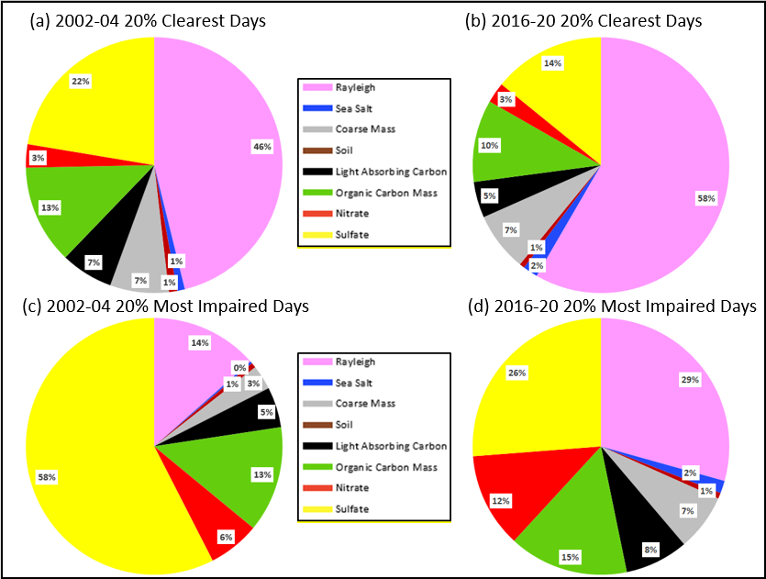

Figure C-2. Penobscot Nation, ME Species Percent Contribution to
Baseline (2006-08) and Current (2016-20) Haze Index Levels

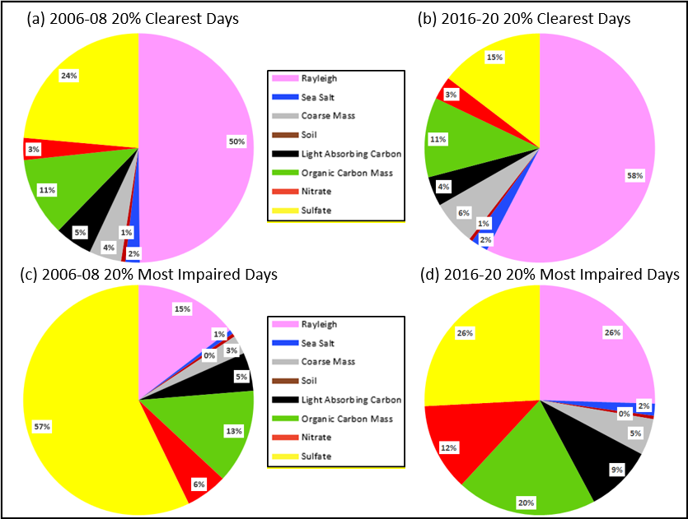

Page C-1

Figure C-3. Casco Bay, ME Species Percent Contribution to
Baseline (2002-04) and Current (2016-20) Haze Index Levels

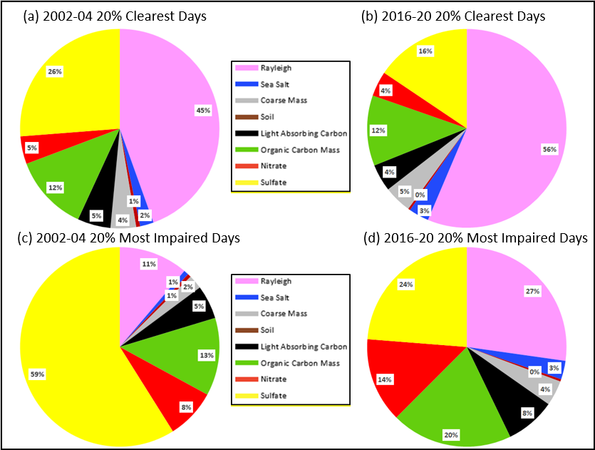

Figure C-4. Proctor Maple R.F., VT Species Percent Contribution to
Baseline (2002-04) and Current (2016-20) Haze Index Levels

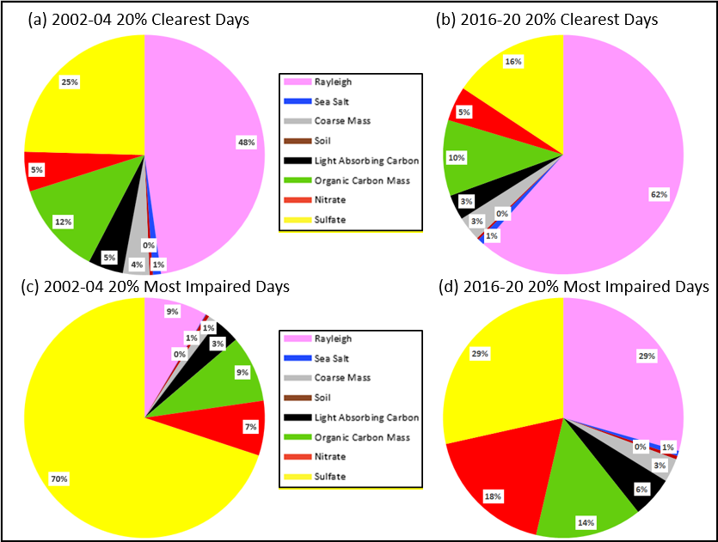

Page C-2

Figure C-5. Londonderry, NH Species Percent Contribution to
Baseline (2011-13) and Current (2016-20) Haze Index Levels

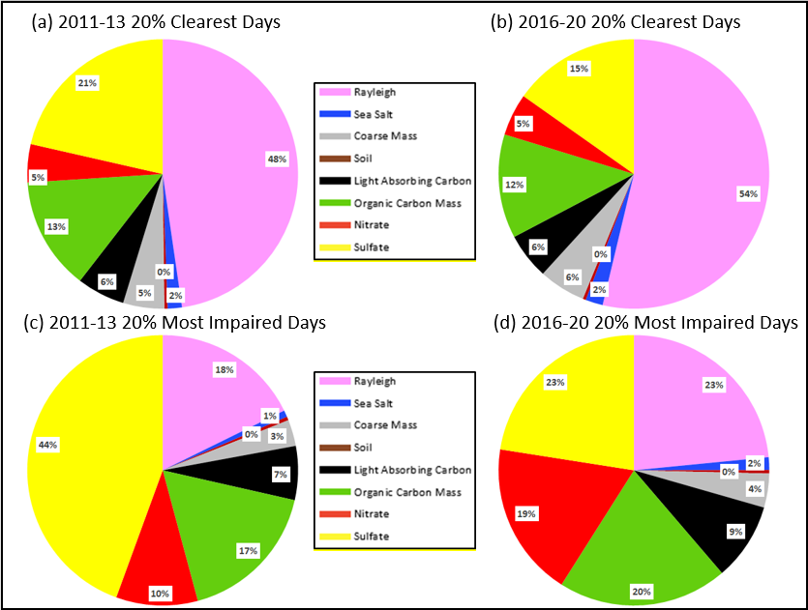

Figure C-6. Pack Monadnock Summit, NH Species Percent Contribution to
Baseline (2008-10) and Current (2016-20) Haze Index Levels

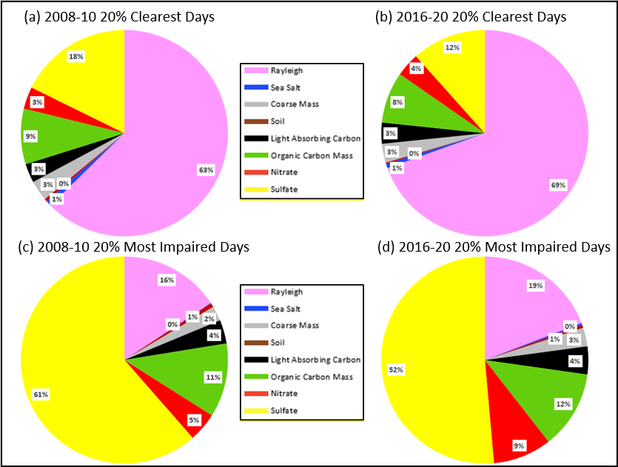

Page C-3

Figure C-7. Mohawk Mt., CT Species Percent Contribution to
Baseline (2002-04) and Current (2016-20) Haze Index Levels

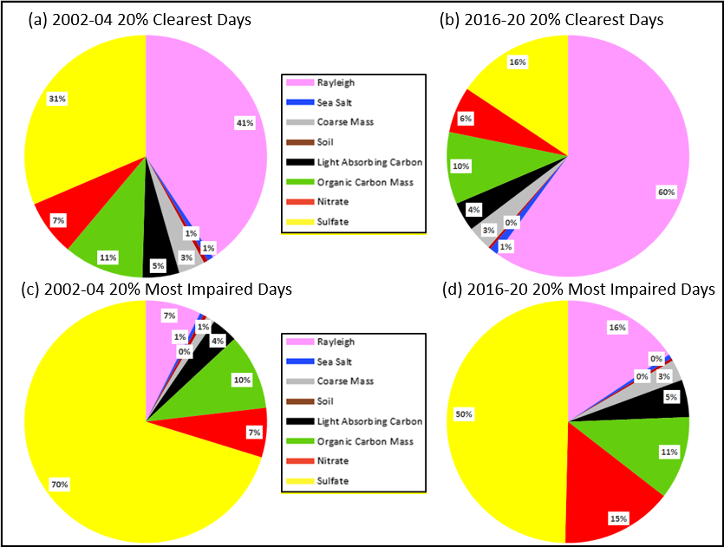

Figure C-8. Cape Cod, MA Species Percent Contribution to
Baseline (2002-04) and Current (2016-20) Haze Index Levels

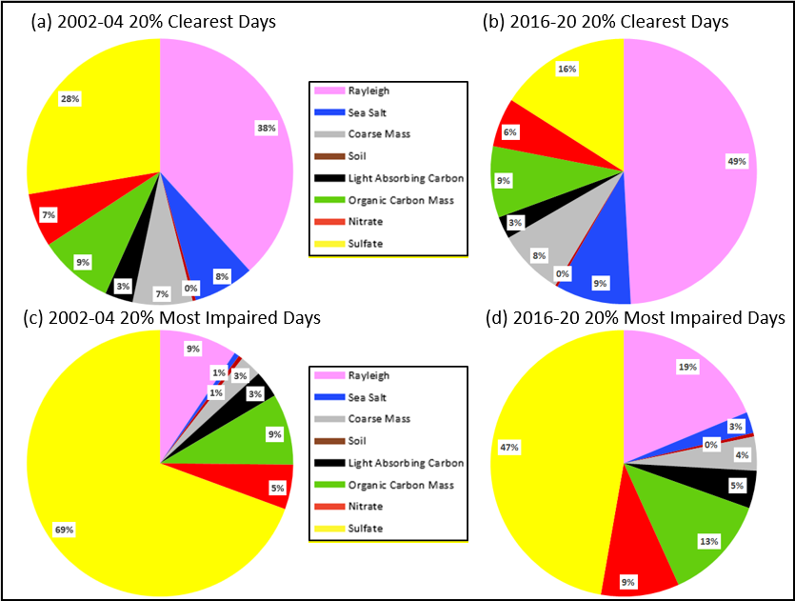

Page C-4

Figure C-9. Martha’s Vineyard, MA Species Percent Contribution to
Baseline (2003-05) and Current (2016-20) Haze Index Levels

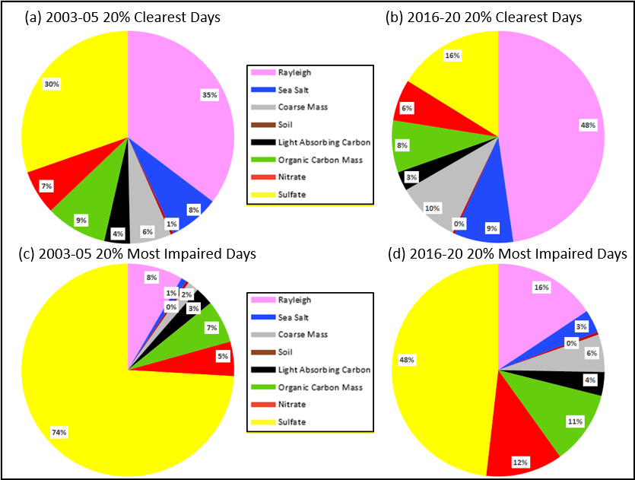

Figure C-10. Frostburg Reservoir, MD Species Percent Contribution to
Baseline (2005-07) and Current (2016-20) Haze Index Levels

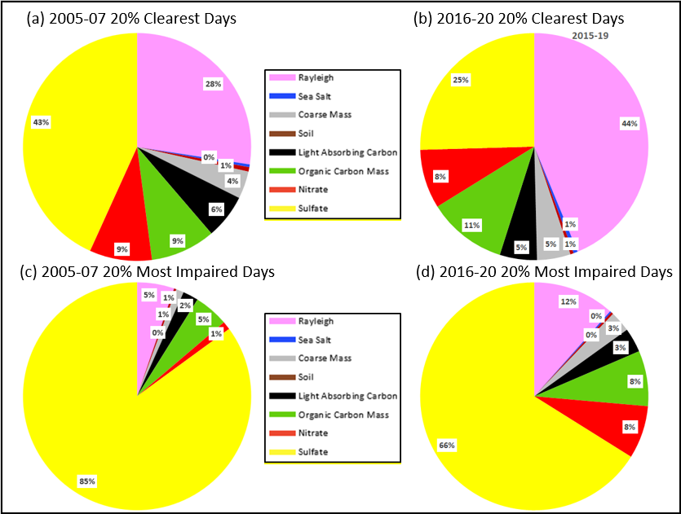

Page C-5

Figure C-11. Quaker City, OH Species Percent Contribution to
Baseline (2002-04) and Current (2016-20) Haze Index Levels

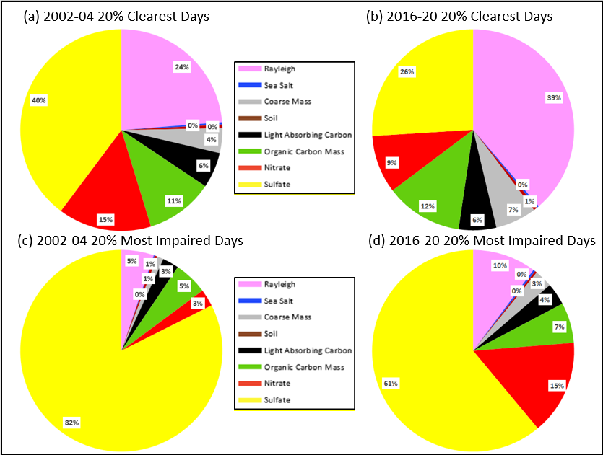

Page C-6

Appendix D: Annual Visibility Species Trends Plots for Current Active IMPROVE Monitoring Sites In and Adjacent to the MANE-VU Region

Figure D-1. Presque Isle, ME Individual Species Contribution to Annual Haze Index Levels on 20 Percent Clearest and Most Impaired Visibility Days

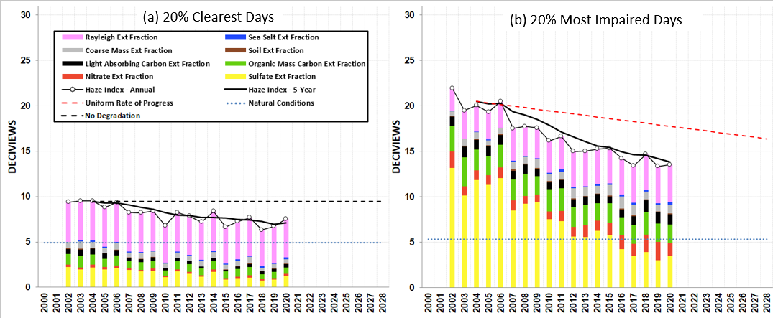

Figure D-2. Penobscot Nation, ME Individual Species Contribution to Annual Haze Index Levels on 20 Percent Clearest and Most Impaired Visibility Days

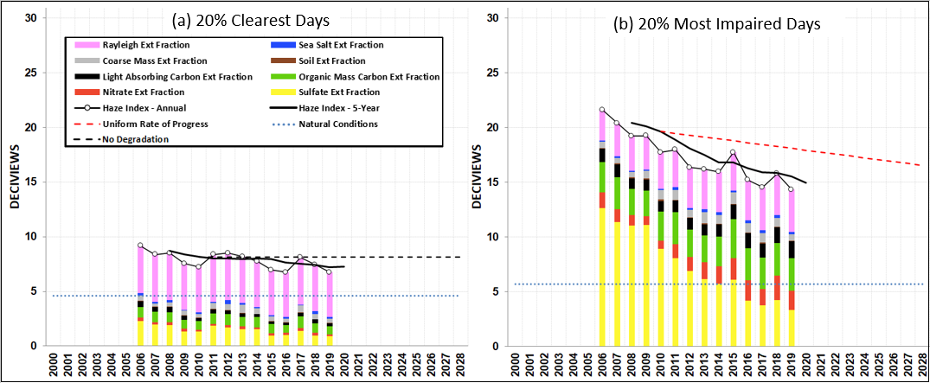

Page D-1

Figure D-3. Casco Bay, ME Individual Species Contribution to Annual Haze Index Levels on 20 Percent Clearest and Most Impaired Visibility Days

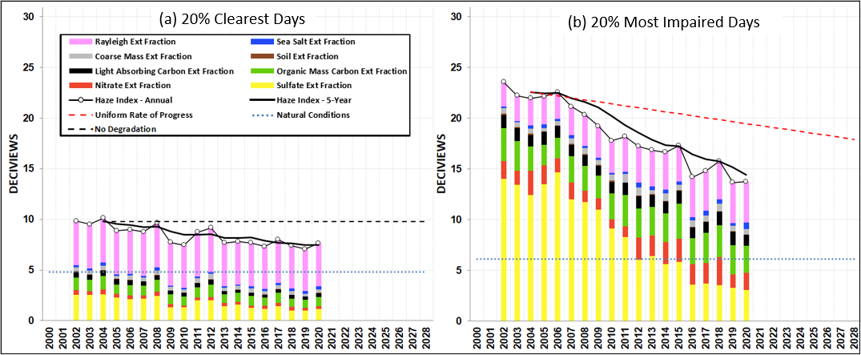

Figure D-4. Proctor Maple R.F., VT Individual Species Contribution to Annual Haze Index Levels on 20 Percent Clearest and Most Impaired Visibility Days

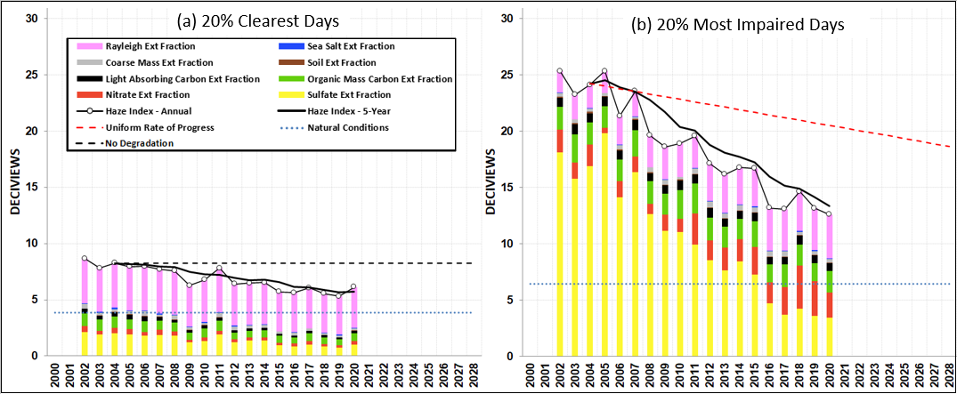

Page D-2

Figure D-5. Londonderry, NH Individual Species Contribution to Annual Haze Index Levels on 20 Percent Clearest and Most Impaired Visibility Days

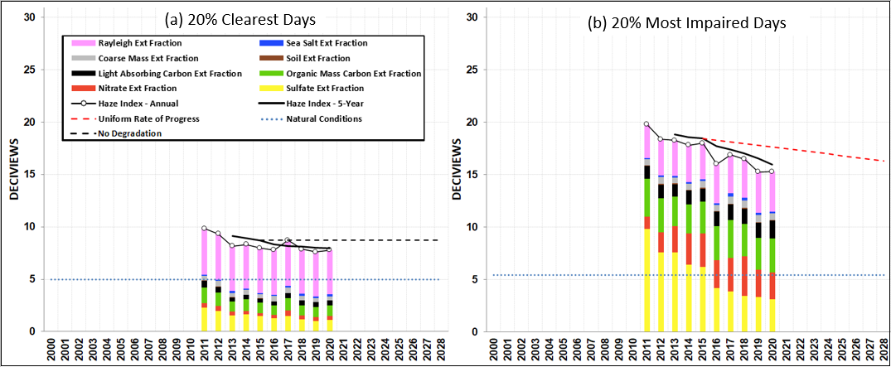

Figure D-6. Pack Monadnock Summit, NH Individual Species Contribution to Annual Haze Index Levels on 20 Percent Clearest and Most Impaired Visibility Days

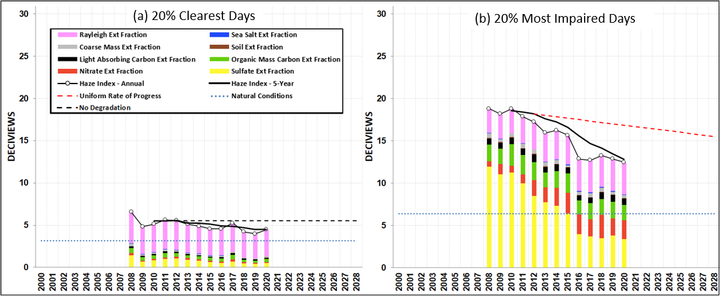

Page D-3

Figure D-7. Mohawk Mt., CT Individual Species Contribution to Annual Haze Index Levels on 20 Percent Clearest and Most Impaired Visibility Days

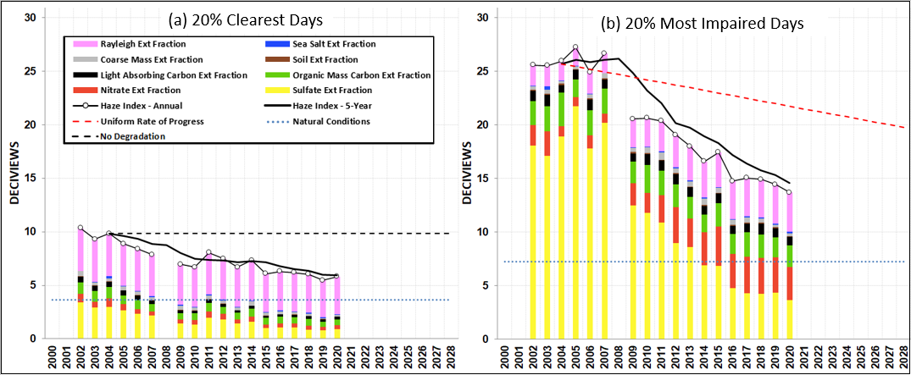

Figure D-8. Cape Cod, MA Individual Species Contribution to Annual Haze Index Levels on 20 Percent Clearest and Most Impaired Visibility Days

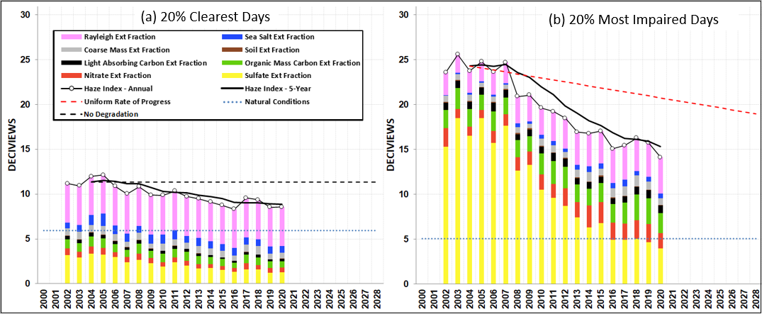

Page D-4

Figure D-9. Martha’s Vineyard, MA Individual Species Contribution to Annual Haze Index Levels on 20 Percent Clearest and Most Impaired Visibility Days

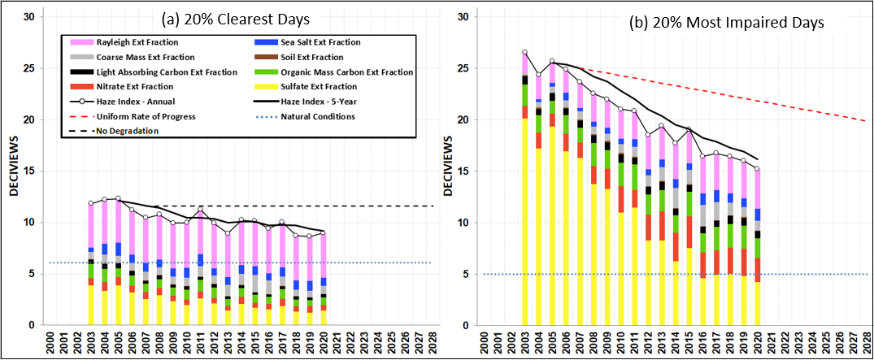

Figure D-10. Frostburg Reservoir, MD Individual Species Contribution to Annual Haze Index Levels on 20 Percent Clearest and Most Impaired Visibility Days

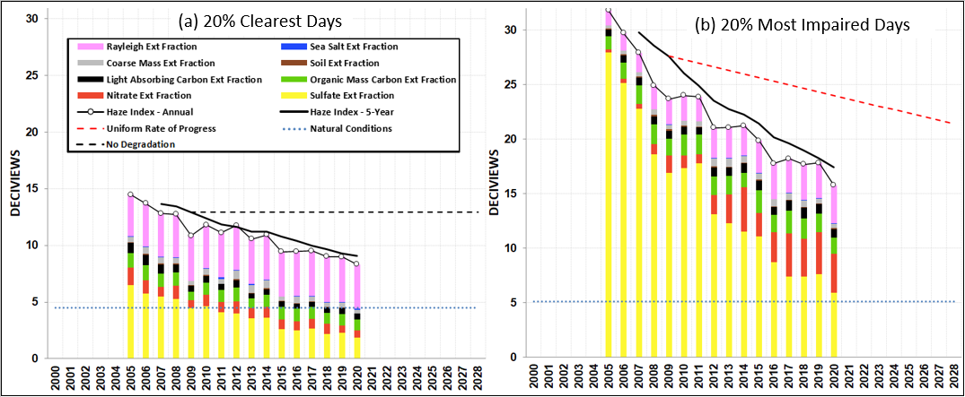

Page D-5

Figure D-11. Quaker City, OH Individual Species Contribution to Annual Haze Index Levels on 20 Percent Clearest and Most Impaired Visibility Days

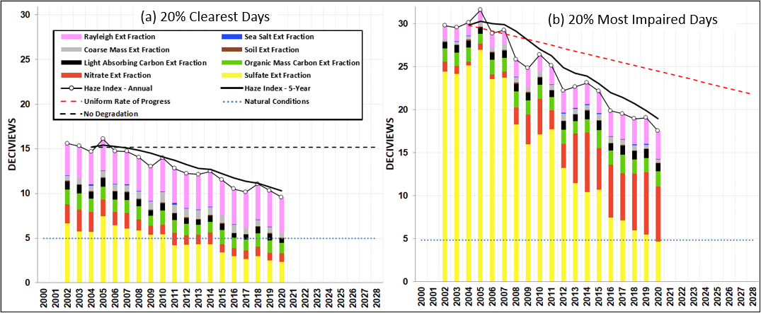

Page D-6

Appendix E: Seasonal Trend Plots of 20 Percent Most Impaired Days for Current Active IMPROVE Monitoring Sites In and Adjacent to the MANE-VU Region

Figure E-1. Seasonal Breakdown of 20 Percent Most Impaired Visibility Days for Maine and Vermont IMPROVE Protocol Sites

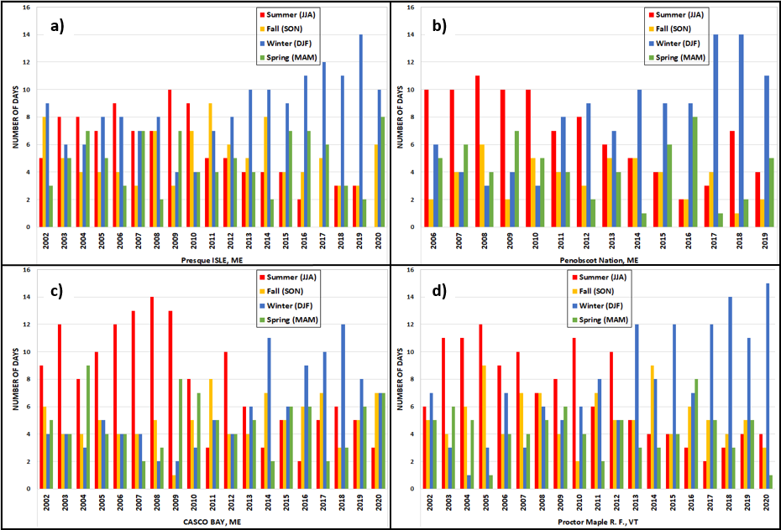

Page E-1

Figure E-2. Seasonal Breakdown of 20 Percent Most Impaired Visibility Days for New Hampshire, Connecticut and Cape Cod, MA IMPROVE Protocol Sites

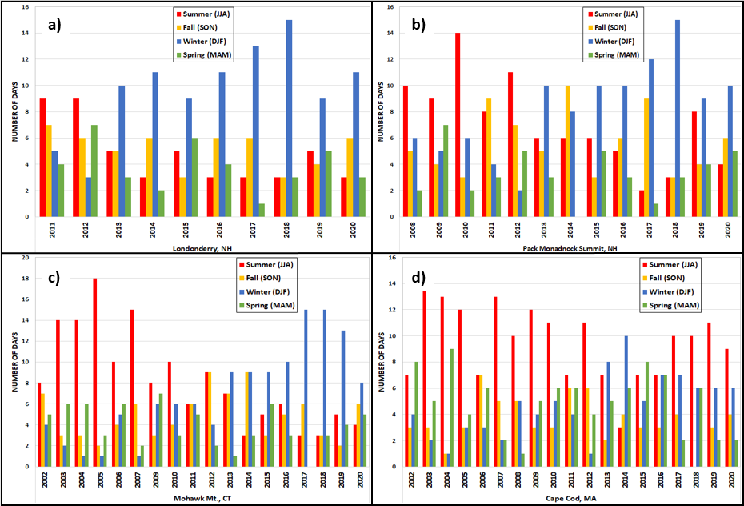

Page E-2

Figure E-3. Seasonal Breakdown of 20 Percent Most Impaired Visibility Days for Maryland, Ohio and Martha’s Vineyard, MA and Vermont IMPROVE Protocol Sites

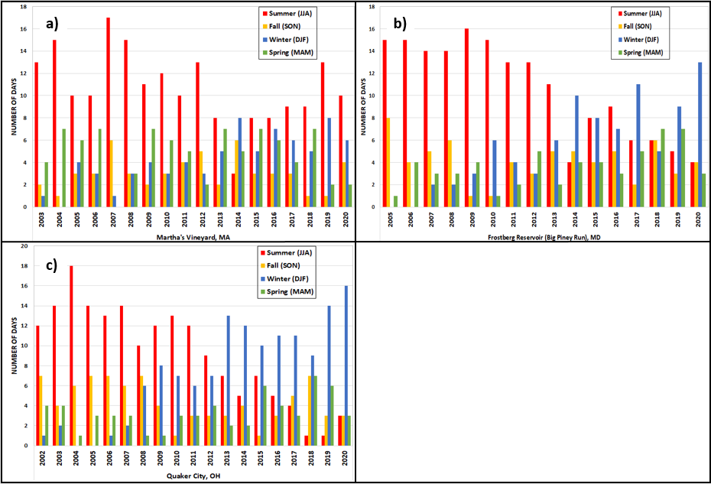

Page E-3

