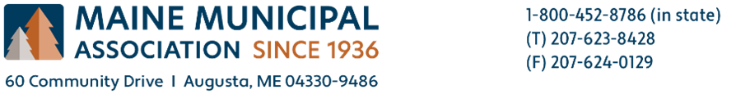

To: Susanne Miller, Director, Bureau of Remediation and Waste Management, DEP
Fr: Rebecca Graham, Senior Legislative Advocate, MMA Advocacy & Communications
Re: Solid Waste Management and Recycling Plan
Date: September 1, 2023

We appreciate the way the department has held listening sessions across the state and particularly the effort to listen to officials and residents from the jurisdictions far away from Augusta. This work provided opportunities for input for the stakeholders that are not as fortunate to have capacity to spend time in Augusta in the same way other stakeholders do.
Maine Municipal Association represents the interests of all municipalities across the state, regardless of size or local capacity. Many communities are facing challenges with staffing at all levels of public service and the more rural communities are struggling to find volunteers who have traditionally formed the backbone of municipal government and provide the vast majority of required duties. As the department embarks on this required update to the five-year Solid Waste Management and Recycling Plan, we ask that you consider how proposed changes to processes may impact local government with the smallest and least capable communities in mind.
Municipalities have developed locally natural processes for waste management that are geographically appropriate, and sometimes dependent on mutually beneficial international partnerships that are in line with the existing waste hierarchy system, but not measurable in the same way. MMA feels this is vital to protect and understand these relationships as future policy is developed.
Locally developed collection and transportation relationships are key to meeting climate goals particularly in areas of the state that do not generate a marketable level of recyclable material or waste for use in a processing and incineration facility. It’s important that the department view alternative waste to energy and recycling capture processes in broad ways that also meet other vital climate goals and contain environmental risks locally.
As partners in government services, we hope the department will focus more on ways to support and promote waste processing change instead of punitive measures that disadvantage existing small businesses in favor of larger corporations with capacity to change processes quickly or ones that favor views of waste management processes in large communities over needs in small communities. All stakeholders play a vital role and collaboration between them is better incentivized at the state level.
Similarly, MMA hopes the department will explore the reality that landfills, and waste to energy processes are equally important and necessary waste management keystones that can benefit from the repurposing of waste in different ways. The reuse of waste in the energy generation can be environmentally improved through technology and provide a tangible benefit for material that will always lack an alternative reuse. All waste to energy and recycling processes are reliant upon landfills and landfills provide an opportunity to generate energy.
MMA supports ways the department can leverage and connect existing regional processes to achieve Maine’s waste goals and use these relationships to collect data that will be necessary to implement the Extended Producer Responsibility (EPR) program. MMA believes that to be successful, there will need to be state investment to improve those processes, particularly for rural communities, where marketable material for the program will be collected at lower levels than other areas. In rural Maine, transportation and collection pose a far greater burden on operations proportional to the material they will contribute, and participation will be reduced if collection and transportation coupled with reporting burdens outstrip the value of the effort. It’s important that policy around participation be shaped to not require local expenditure simply due to a community’s rural location.
Many municipalities feel it is equally important to be honest with their residents who are passionate about separating material, believing it will be reused when the market for many materials is non-existent. While the separation effort is vital to continue as a practice, this process is one that deserves greater honest public education, and allowance for the growth of new and innovative ways sorting can occur. The educational role that is required and expected from municipal solid waste managers is one that should be better supported with a statewide campaign to explain the EPR program, and how the end user can be a better participant in their local program.
MMA appreciates the opportunity to comment on the Solid Waste Management and Recycling Plan, and thanks staff for all their efforts to date. We continue to hope the department will consider MMA a partner in communicating with municipal officials and facilitating feedback opportunities to achieve all of Maine’s environmental goals.

