Share tables can help reduce food waste and encourage consumption of foods served at schools. However, reservice of food can create a potential health hazard if appropriate precautions are not taken. These guidelines are intended to assist school staff who implement share tables. The Department is exercising its authority per 8-103.10 10-144 CMR Ch. 200 to grant a variance to the Maine Food Code per 3-306.14 to allow for reservice of fruit and cold perishable food under the following procedures for share tables. Health Inspectors will review compliance with this variance during their inspections.
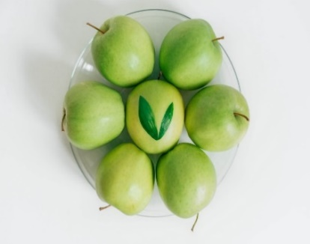

Foods Not Allowed
Foods Allowed
- Food not provided by School Meal Program. (e.g., foods brought from home)
- Perishable foods that have not been kept at 41$°$F or lower or that must be held hot
- Opened or unpackaged food items, such as:
- An opened bag of baby carrots
- A salad bowl without a lid
- Whole fruit with an edible peel if not wrapped.
- Packaged items that can be opened and resealed.
- Only food served by the school nutrition program may be placed on the share table.
- Intact packaged items (i.e., prepackaged crackers, fruit snacks, juices, etc.) or whole fruits with thick skins that can be peeled such as oranges, bananas or tangerines.
- Whole thin-skinned fruits if wrapped.
- Temperature-controlled cold intact packaged foods (i.e., milk and yogurt) must be held at 41$°$F or lower. Students may place milk, etc., in a small refrigerator, cooler or drained ice bath (provided by school nutrition program) to maintain 41$°$F or below.

Share tables should be used in combination with Offer Versus Serve and careful portion control to combat excess waste on trays. For more information about Offer Versus Serve visit www.fns.usda.gov/school-meals/guidance-and-resources

Food Safety Practices for Share Tables
- Prior to sitting down, students or staff may place unwanted food on the share table, so that another student may select the food item.
- Monitor the table to ensure that unallowable foods are not put on the share table and allowable foods are maintained properly to prevent any potential contamination.
- Ensure perishable foods which require temperature control for safety are stored at or below 41$°$F. This can be done by providing an insulated bin, such as a cooler, filled with ice or frozen gel packs.
- Monitor and record the temperature inside the cooler to verify that food is being maintained at safe temperatures.
- Be familiar with safe food-handling practices. See resources below for more information.
- Practice good personal hygiene
- Clean and sanitize food collection containers as appropriate
- Display signage outlining share table rules.
Re-service/Donation
- Unused, sealed prepackaged food may be re-served by cafeteria staff to students for another meal or may be donated rather than thrown away. USDA regulations allow donations such as packaged foods, whole fruits and vegetables, and milk near expiration to 501c3 non-profit organizations.
- Unwrapped whole fruit must be rewashed and thoroughly dried.

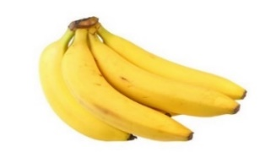

Other Resources
1. Maine Health Inspection Program Home Page: http://www.maine.gov/healthinspection
2. The USDA guidance for food recovery: The Use of Share Tables in Child Nutrition Programs: www.fns.usda.gov/use-share-tables-child-nutrition-programs
3. The 2013 Maine Food Code: 3-201.11A, 3-306.11, 3-501.16, 3-306.14

