MAINE



Department of Health &
Human Services

Health & Environmental

Testing Laboratory

NEWSLETTER


In Memory of Rejeanne Gilbert

11/21/1943 – 09/03/2004

WHAT YOU WILL FIND IN THIS ISSUE:
- Maine Sentinel Laboratories 2
- Forensic Chemistry 3
- Organic Chemistry 3
- Bio-Monitoring 4
- Quality Assurance 4
- Chlamydia and Gonorrhoeae: Nucleic Acid Amplification Testing 5
- Select Agents 7
- In Memoriam 9

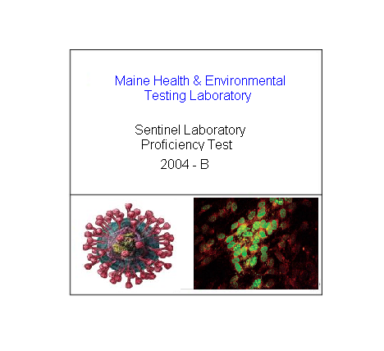

Maine Sentinel Laboratories
by Rick Danforth, SM (ASCP)
Laboratory Program Advisor
_________________________

Five years have passed since the Laboratory Response Network became operational. The Centers for Disease Control and Prevention established the LRN after President Clinton issued Presidential Decision Directive 39. Its objective was to ensure an effective laboratory response to bioterrorism by helping to improve the nation's public health laboratory infrastructure, which had limited ability to respond to bioterrorism. Today, the LRN is charged with the task of maintaining an integrated network of state and local public health, federal, military, and international laboratories that can respond to both bioterrorism and chemical terrorism.

The objective of the LRN rests on the foundation of sentinel laboratories ability to rule in or rule out potential bioterrorism agents. The Health and Environmental Testing Laboratory (HETL) distributed protocols designed to assist clinical (sentinel) laboratories with information and techniques to identify organisms that might be suspected as bioterrorism (BT) agents. During the distribution process an assessment of each laboratory was performed. Examples of data collected were: physical description of each lab, staffing, contact information, training needs, types of media on hand, automated blood culture systems and automated identification systems. The data collected will be used to create training programs to further aid the sentinel laboratories expand and fine tune their ability to rule in or rule out potential BT agents.

In order to remain in contact with the sentinel laboratories and monitor their progress in ruling in or ruling out potential BT agents, HETL provides an educational proficiency exam twice a year. Five case histories with test results and pictures depicting various organisms are copied to a CD-ROM and mailed to each laboratory. The sentinel laboratory reviews the histories and identifies the causative agent. A response sheet is completed and returned to the HETL. Subsequently a final critique is sent to the sentinel laboratory.

In the near future, workshops will be presented throughout the state to allow sentinel laboratories to send their personnel to receive hands on training. These workshops will be located strategically in different regions around the state to minimize travel time for the participants. Updates will include information on emerging infectious diseases (potential BT agents), packaging/shipping and bio-safety.

The next round of on-site visits is planned for mid 2005. At that time the 5th edition of the Bio-safety in Microbiological and Biomedical Laboratories will be distributed to all the sentinel laboratories in the state. The new edition will include protocols on dealing with laboratory safety in the era of bioterrorism.

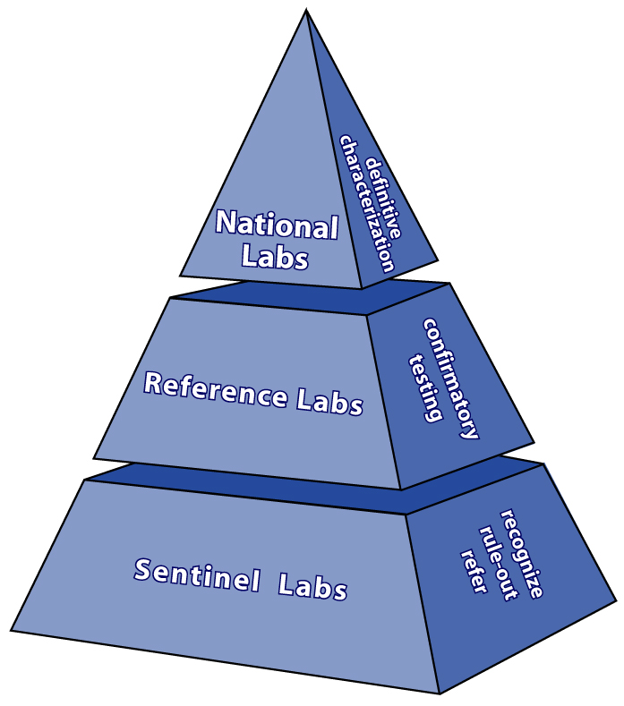

Forensic Chemistry
Christopher P. Montagna, Chemist III

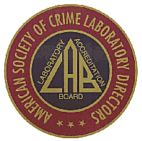
After five years of hard work and preparation, the Maine Health and Environmental Testing Laboratory was inspected by the American Society of Laboratory Director’s/Laboratory Accreditation Board (ASCLD/LAB) in the areas of Controlled Substances and Toxicology. In summary, the auditing inspectors stated there were no deficiencies related to analytical testing. They also complimented the staff on the excellent job regarding case data and analytical procedures. In their words, "the section’s attention to detail and following established protocols is one of the finest examples they have seen in a laboratory seeking accreditation." It is rare for auditors to find no deficiencies in analytical testing.

The American Society of Crime Laboratory Directors/Laboratory Accreditation Board (ASCLD/LAB) offers accreditation to forensic laboratories that exhibit strict compliance to a large number of rigorous quality standards. The accreditation program is voluntary and open to any crime laboratory. The program’s criteria address all areas of the laboratory’s operations including management, personnel training and qualifications, technical operations, evidence handling, proficiency testing, lab security, and health and safety. Compliance to these standards is assessed through a comprehensive and thorough inspection performed by an external team of ASCLD/LAB trained inspectors. There are 145 standards that are rated as Essential, Important or Desirable. In order to be granted accreditation, a laboratory must meet 100% of the 78 Essential criteria, 75% of the 47 important criteria and 50% of the 20 Desirable criteria. The HETL successfully met the requirements classified as Desirable (100%) and Important (86%). The auditor’s findings indicated 83% of the Essential criteria were met by the HETL. The inspectors stated the steps necessary for remediation of the deficiencies are relatively easy, mostly administrative documentation. A follow-up inspection is expected within the next several months to assure the few remedial corrections have been made.

The Health and Environmental Testing Laboratory Forensic Chemistry Section provides professional forensic services including unbiased scientific examination and analysis of evidentiary material and property, supervision and management of specific technical programs, assistance in scientific investigations, expert testimony concerning the analyses performed, the interpretation of technical data and laboratory findings, and other related forensic services and activities to all criminal justice agencies throughout the State of Maine.

News From The Organic Section
By: Jim Curlett (Organic Supervisor)

The Health and Environmental Testing Lab has been working diligently on preparing for a chemical incident that would impact the population, be this an accidental release or a terrorist attack. The following measures are in place:

Using a grant from the Center for Disease Control the HETL has acquired and installed a gas chromatograph/mass spectrometer (GC/MS) equipped with cryo-focusing and chemical ionization and electron impact sources. Two staff members have attended the CDC training course and are proficient in the analyses of cyanide in blood. Jim Eaton has adapted the CDC Cyanide Method as a 10-minute screen for cyanide in water with an MDL of 0.017μg/ml. Jim has also been appointed to serve on the Proficiency Testing Committee at the CDC for the anti-Chemical Terrorism Methods. In the next few months the HETL will also acquire a new gas chromatograph/mass spectrometer equipped for use for Nerve Agent detection. In addition, the HETL will acquire an Inductively Coupled Argon Plasma Mass Spectrometer equipped with a dynamic reaction cell (ICP/DRC/MS) for metals in blood and urine. The dynamic reaction cell eliminates interferences that cause difficulties in the analysis of arsenic, selenium and other toxic metals.

Funding from the Maine Emergency Management Agency has allowed the lab to acquire a Fourier Transform Infra-Red Microscope. This optical microscope provides an optical view of a powder, which allows differentiation of crystal structures that can then be individually analyzed by infrared its built-in infrared spectroscopy. The infrared spectra can then be compared to a computerized library for identification. When further confirmation is required the sample can be more efficiently processed in the lab based upon this information.

The HETL’s Coordinator for Chemical Terrorism (CT), Jim Curlett, has attended a training session with the other CT Coordinators of the Northeastern States on CDC sample collection and shipping of specimens in the case of an event. Training involved defining respective roles to enhance coordination within the NE region and with the CDC.

Upcoming plans:
1. A national CT Conference in November with an emphasis on new analytical techniques.
2. Installation of the new GC/MS and ICP/DRC/MS and operator training on these instruments.

Bio-monitoring
By: Jim Curlett (Organic Supervisor)

The Health and Environmental Testing Laboratory (HETL) is increasing its expertise in bio-monitoring. Bio-monitoring is the assessment of internal dose exposure by measuring a toxicant (or metabolite or reaction product) in human blood, urine, saliva or tissue. This method of direct measurement is superior to the practice of trying to predict the level of toxicants in people by using environmental monitoring and the associated assumptions used to model exposure.

HETL has for years been analyzing children’s blood for the presence of lead. There are plans to develop a more comprehensive panel of work to include other toxic metals such as mercury, cadmium, and arsenic. The instrumentation to develop this analytical panel should arrive at the lab early this winter. Once the new instruments and techniques are established we can perform a parallel study with our current blood lead method. This opens future opportunities to get involved in other studies such as metals in urine, the speciation of arsenic in groundwater and body fluids to name a few.

Metals whether naturally occurring, like arsenic and uranium in Maine, or released into the environment by man are certainly not the only toxicants that pose health threats. The whole list of industrially created organic compounds also pose potential threats. Compound types such as pesticides, herbicides, solvents, plasticizers, flame retardants, over the counter products, and pharmaceuticals also present dangers to humans and the environment. As the awareness of potential negative impacts become known the HETL will do what we can to contribute to the knowledge base to keep the people of the State of Maine healthy.

Quality Assurance

By: Richard French

Quality Assurance Officer

Matt Sica is the new Environmental Laboratory Certification Program Quality Assurance Officer (QAO) at the Bureau of Health. You may have talked with Matt in person at AMEL meetings or on the phone about laboratory certification issues. Matt comes to BOH from New Jersey were he worked in the environmental field. He has 15 years experience in water, wastewater and hazardous waste fields and has dealt with laboratory certification as a QAO and laboratory manager. He has recently successfully completed both the Microbiology and Chemistry Laboratory Certification Courses offered by the USEPA in Cincinnati You can contact Matt by phone at (207) 287-1929 or by e-mail at matthew.sica @maine.gov.

The QA Office, environmental, and chemistry sections went through three major audits this past summer. The EPA audited the Radiochemistry section in May. This audit occurred just after the supervisor of the section, Cheryl Baker, retired after 25 years of service. Pat Boudreau, the new supervisor, was instrumental in the positive outcome of the audit. The auditor found only minor deficiencies in the program. The final report from the auditor is pending. In June the environmental section of HETL was audited by New Hampshire NELAC accreditating authority. The audit was very positive. The section staff prepared the required documentation and received invaluable assistance from Kathy Irminger, a consultant with GovConnect. Only a few deficiencies were found in the quality system and laboratory operation. A corrective action plan addressing the deviations has been submitted and is awaiting final approval. The last audit was the Chemistry section in July. This was the first time the laboratory applied for ASCLD accreditation for forensics. Most of the credit for the success of the audit goes to Chris Montagna, the section supervisor, who wrote the documents required for accreditation. This included the QAM and procedure manuals. The final report has been received and a corrective action plan is in the process of being written.

Clinical QA
The clinical section of HETL will be audited next year under the new CLIA standards. This will be the first time the “laboratory will be evaluated as a “quality system”. The last quarter of 2003 the HETL sent out the following text of the letter on a QA issue to a number of providers.
Dear Laboratory Supervisor:
One important piece of information that is required for all samples is the “specimen date of collection”. Section 493.1105-d of the CLIA regulations requires it to be included on the test requisition and it is also, a requirement for sample acceptability. The specimen collection date is used to determine if the holding times for specific tests are met and for proper preservation of samples that may not be analyzed immediately when received. “Name of provider” has been identified as to submitting a number of specimens to the HETL for testing that have not included the specimen date of collection on the lab slip. This technically causes the sample to be unsatisfactory and requires that the laboratory personnel acquire this information from you or not analyze the sample. In the future, to save time, would you please check each specimen for proper labeling and that the information on the lab slip is complete before sending them to the HETL for testing.

As the HETL Quality Assurance Officer, it is my responsibility to see that samples received by the laboratory are analyzed and reported as quickly and accurately as possible. Your cooperation in this matter is an important step in achieving this goal. Thank you for attending to this.

A review of the data from the past two quarters of this year indicated that specimens continue to be sent to the HETL at an increasing rate without the date of collection filled in. This includes some of the providers who received the first mailing of the letter. The date of collection is essential information and required for processing a specimen. Those of you that are responsible for sending out specimens for testing, please check the lab slips for completeness before it is sent. The HETL staff thanks you for your cooperation in this matter.

Chlamydia trachomatis and Neisseria gonorrhoeae
Nucleic Acid Amplification Testing
Jim Martin (Microbiology Supervisor)

Since July 2002, the Health and Environmental Testing Laboratory has offered the GEN-PROBE APTIMA Combo 2 Assay for the qualitative detection of Chlamydia trachomatis and Neisseria gonorrhoeae in endocervical and male urethral swab specimens, and in female and male urine specimens. The assay may be used to test specimens from symptomatic and asymptomatic individuals to aid in the diagnosis of gonococcal and/or chlamydia urogenital disease.

Chlamydia trachomatis (CT) and Neisseria gonorrhoeae (GC) infections are two of the most common sexually transmitted infections worldwide. In 2002, 834,555 cases of genital of C. trachomatis infection and 351,852 new cases of N. gonorrhoeae infections were reported to the Centers for Disease Control and Prevention (1).

The C. trachomatis species is comprised of eighteen recognized serovars of which fifteen can cause disease in humans. The serovars D through K are the major cause of genital chlamydial infections in men and women (2). Chlamydiae are nonmotile, gram-negative, obligate intracellular bacteria. C. trachomatis infections may be asymptomatic in both males and females. C. trachomatis may cause non-gonococcal urethritis, epididymitis, Reiter’s syndrome, ectopic pregnancy, pelvic inflammatory disease (PID), and infertility (3).

N. gonorrhoeae are non-motile, gram-negative diplococci. Most N. gonorrhoeae infections among men produce symptoms that cause them to seek curative treatment soon enough to prevent serious sequelae, but this may not be soon enough to prevent transmission to others. Among women, many infections do not produce recognizable symptoms until complications (e.g., PID) have occurred. Both symptomatic and asymptomatic cases of PID can result in tubal scarring that can lead to infertility or ectopic pregnancy. Because gonococcal infections among women often are asymptomatic, an important component of gonorrhea control in the United States continues to be the screening of women at high risk for STDs (3).

The GEN-PROBE APTIMA Combo 2 Assay is a second generation Nucleic Acid Amplification Test (NAAT). It is an amplification probe test that utilizes target capture, Transcription-Mediated Amplification, and Dual Kinetic Assay technologies to improve upon specimen processing, amplify target rRNA, and amplicon detection. Swab or urine specimens are collected and transferred into their respective specimen transport tubes. The transport solutions in these tubes release the rRNA targets and protect them from degradation during storage. When the APTIMA Combo 2 Assay is performed in the laboratory, the target rRNA molecules are isolated from the urine and swab samples by the use of capture oligomers in a method called target capture; magnetic micro particles are another key feature of target capture. The capture oligomers contain sequences complementary to specific regions of the target molecules as well as a string of deoxyadenosine residues. A separate capture oligomer is used for each target. During the hybridization step, the sequence specific regions of the capture oligomers bind to specific regions of the target molecules. The capture oligomer:target complex is then captured out of solution by decreasing the temperature of the reaction to room temperature. This temperature reduction allows hybridization to occur between the deoxyadenosine region on the capture oligomer and the poly-deoxythymidine molecules that are covalently
attached to the magnetic particles. The micro particles, including the captured target molecules bound to them, are pulled to the side of the reaction vessel using magnets and the supernatant is aspirated. The particles are washed to remove residual specimen matrix that may contain amplification reaction inhibitors. After the target capture steps are completed, the specimens are ready for amplification. Target amplification assays are based on the ability of complementary oligonucleotide primers to specifically anneal and allow enzymatic amplification of the target nucleic acid strands. The Gen-Probe APTIMA Combo 2 Assay reaction replicates a specific region of the 23S rRNA from C. trachomatis and a specific region of the 16S rRNA from N. gonorrhoeae via DNA intermediates. A unique set of primers is used for each target molecule. Detection of the rRNA amplification product sequences (amplicon) is achieved using nucleic acid hybridization. Single-stranded chemi-luminescent DNA probes, which are complementary to a region of each target amplicon, are labeled with different acridinium ester molecules. The labeled DNA probes combine with amplicon to form stable RNA: DNA hybrids. The Selection Reagent differentiates hybridized from unhybridized probe, eliminating the generation of signal from unhybridized probe. During the detection step, light emitted from the labeled RNA: DNA hybrids is measured as photon signals in a luminometer, and are reported as Relative Light Units (RLU). In DKA, differences in the kinetic profiles of the C. trachomatis and N. gonorrhoeae labeled probes allow for the differentiation of signal; kinetic profiles are derived from measurements of photon output during the detection read time. The chemi-luminescent detection reaction for C. trachomatis signal has very rapid kinetics and has the “flasher” kinetic type. The chemi-luminescent detection reaction for N. gonorrhoeae signal is relatively slower and has the “glower” kinetic type. Assay results are determined by a cut-off based on the total RLU and the kinetic curve type (4).

ASSAY FEATURES
- Improved specimen collection, handling and hold times for both swab and urine specimens.
- Swab and urine specimens from symptomatic and asymptomatic males and females.
- Both diseases are tested for from a single specimen – urine or swab.
- Amplified assay to test urine and swab specimens for chlamydia and gonorrhoeae.

URINE:
- Noninvasive and more acceptable to males and adolescent females versus swab.
- 30 day hold time between collection and testing without loss of sensitivity.
- Ambient specimen shipping temperature - no need to pack and send cold.
- A bulb pipettor is used to transfer 2 ml of urine to a color-coded transport tube similar to the swab tube.
SWABS:
- 60 day hold time between collection and testing without loss of sensitivity.
- Unisex with no need to have separate male and female collection kits.

BIBLIOGRAPHY
1. Centers for Disease Control and Prevention. 2003. Sexually Transmitted Disease, Surveillance 2002
2. Mahoney, J.B., B.K. Coombes, and M.A. Chernesky 2003. Chlamydia and Chlamydophila, p. 991-1004. In E. H. Murray, et al. (ed.), Manual of Clinical Microbiology, 8th ed. American Society for Microbiology, Washington, D.C.
3. Centers for Disease Control and Prevention. 2002. United States Morbid. and Mortal. Weekly Rep. 51 (RR-6:1-80).
4. GEN-PROBE Inc. 2004. Gen-Probe® Aptima Combo 2® Assay

Select Agent Rules
Jim Martin (Microbiology Supervisor)
The following is a brief overview of the Select Agent Regulation. The regulation and additional information may be found at the following Centers for Disease Control (CDC) website: http://www.cdc.gov/od/sap/42cfr72.htm.

What is the Select Agent Regulation?
The Select Agent Regulation establishes requirements regarding possession and use in
The United States, receipt from outside the United States, and transfer within the United States, of select biological agents and toxins. This includes requirements concerning registration, security risk assessments, safety plans, security plans, emergency response plans, training, transfers, record keeping, inspections, and notifications. The regulation also contains delegations of authority to the Office of Inspector General concerning civil money penalties. The regulation implements provisions of the “Public Health Security and Bioterrorism Preparedness and Response Act of 2002” and is designed to provide protection against misuse of select agents and toxins whether inadvertent or the result of terrorist acts against the United States homeland or other criminal acts.

What are Select Agents and Toxins?
Select agents and toxins are those biological agents and toxins that have been determined to have the potential to pose a severe threat to both human and animal health, to plant health, or to animal and plant products. A table listing currently regulated biological agents and toxins may be seen at this end of this discussion. Periodic review of the CDC website for any future changes is advisable.

Who may possess or have access to Select Agents and Toxins?
An entity (i.e. laboratory) may not possess or use in the United States, receive from outside the United States, or transfer within the United States, any select agent or toxin unless the entity has been granted a certificate of registration by HHS or USDA. The entity must have submitted an application to HHS or USDA and provided the required information to determine whether it is eligible for a certificate of registration. The certificate of registration will be valid only for the specific select agents and toxins and the specified activities and locations consistent with the information upon which the certificate of registration or amendment was granted.

The certificate of registration will cover activities at only one general physical location (a building or a complex of buildings at a single mailing address). This is designed to ensure that the Responsible Official is not over-extended and will be able to perform the required activities. The certificate of registration will be valid for up to three years.
An entity may not possess or use in the United States, receive from outside the United States, or transfer within the United States, any select agent or toxin unless the entity and any individual who owns or controls the entity are approved by the HHS Secretary or the USDA Secretary based on security risk assessments by the Attorney General (FBI). An employee of the entity may not have access to a select agent or toxin unless approved by the HHS Secretary or the USDA Secretary based on a security risk assessment by the Attorney General (FBI).

Who may not possess or have access to Select Agents and Toxins?
Restricted persons, as defined in 18 U.S.C. 175b, may not be granted access to select agents and toxins (42 U.S.C. 262a (e)). A restricted person is a person who:
- Is under indictment for a crime punishable by imprisonment for a term exceeding 1 year;
- Has been convicted in any court of a crime punishable by imprisonment for a term exceeding 1 year;
- Is a fugitive from justice;
- Is an unlawful user of any controlled substance (as defined in section 102 of the Controlled Substances Act (21 U.S.C. 802));
- Is an alien illegally or unlawfully in the United States;
- Has been adjudicated as a mental defective or has been committed to any mental institution;
- Is an alien (other than an alien lawfully admitted for permanent residence) who is a national of a country as to which the Secretary of State has made a determination (that remains in effect) that such country has repeatedly provided support for acts of international terrorism; or
- Has been discharged from the Armed Services of the United States under dishonorable conditions.

Additionally, the HHS Secretary may deny or limit access if the individual is reasonably suspected by any Federal law enforcement or intelligence agency of: Committing a crime set forth in section 2332b(g)(5) of title 18 U.S.C.; knowing involvement with an organization that engages in domestic or international terrorism (as defined in section 2331of such title18) or with any other organization that engages in intentional crimes of violence; or being an agent of a foreign power (as defined in section 1801 of title 50 U.S.C.

Requirements for a Responsible Official
To conduct regulated activities, the entity must identify and authorize an individual as the Responsible Official. The regulations also provides for the designation of Alternate Responsible Officials to conduct the duties of the Responsible Official. The Responsible Official and the Alternate Responsible Official must meet all of the qualifications for a Responsible Official.

The Responsible Official must:
- Be approved for access to biological agents and toxins under Sec. 73.8
- Be familiar with the requirements of the part 73 regulations
- Have authority and responsibility to ensure that the requirements of the part 73 are met, on behalf of the entity

The Responsible Official is responsible for ensuring compliance with the regulations including:
- Developing and implementing safety, security and emergency response plans
- Allowing only approved individuals to have access to select agents or toxins
- Providing appropriate training for safety, security, and emergency response
- Transferring select agents or toxins
- Providing timely notice of any theft, loss or release of a select agent or toxin
- Maintaining detailed records of information necessary to give a complete accounting of all activities related to select agents or toxins
- Reporting the identification of a select agent or toxin as a result of diagnosis, verification or proficiency testing

The Responsible Official of an agency must get prior approval by promptly notifying the HHS Secretary in writing if any change occurs in any information submitted in the application for the certificate of registration or amendments. This includes modifications to the list of individuals, to add select agents or toxins, changes in area of work, to change specified activities or locations, changes in protocols or objectives of studies.

These requirements regarding a Responsible Official are necessary to ensure management oversight of the implementation of the part 73 regulations and to establish a point of contact.

The RO must conduct regular inspections, at least annually, of the laboratory where select agents or toxins are stored or used to ensure compliance with all procedures and protocols of the safety plan. The results of these inspections must be documented and any deficiencies must be corrected.

Exemptions
Paragraph (a) of § 73.6 states that an entity is exempt from the provisions of this part, other than § 73.14 (transfer), if all of the following apply:
- The only activities conducted by the entity that are subject to the part 73 regulations concerns select agents or toxins that are contained in specimens or in isolates from the specimens presented for diagnosis, verification, or proficiency testing;
- Upon identification as the result of diagnosis or verification, the entity immediately reports to HHS any of the following: Variola major virus (Smallpox virus) and Variola minor (Alastrim), Bacillus anthracis, Yersinia pestis, Botulinum neurotoxins, Francisella tularensis, Ebola viruses,
Marburg virus, Lassa fever virus, and South American Haemorrhagic Fever viruses (Junin, Machupo, Sabia, Flexal, Guanarito);
- The entity reports as required under Federal, State, or local law, to appropriate authorities;
- After diagnosis, verification, or proficiency testing, the entity either transfers the specimens or isolates from the specimens to a facility eligible for receiving them, or destroys them on-site by autoclaving, incineration, or by means of a sterilization or neutralization process sufficient to cause inactivation;
- The entity transfers or destroys those select agents or toxins used for diagnosis or verification within seven calendar days after identification, unless directed otherwise by the Federal Bureau of Investigation or other law enforcement entity after consultation with the HHS Secretary;
- The entity transfers or destroys those select agents or toxins used for proficiency testing within 90 calendar days after receipt; and
- The entity prepares a record of the identification and transfer or destruction on CDC Form 0.1318, submits the completed form to the HHS Secretary within seven calendar days after the transfer or destruction, and maintains a copy of the record for a period of three years.

NOTE: Retention of any select agent as a positive control or reference sample is no longer exempt for any reason.

When and how will inspections take place?
Inspectors from the CDC Select Agent Program will conduct inspections of registered entities. Such inspections may be conducted without prior notification and will include a review of all safety and security aspects, as well as record keeping requirements, covered by 42 CFR Part 73.

There are criminal and civil penalties for not being in compliance with the regulation.
Violation of the Public Health and Bioterrorism Preparedness Response Act of 2002 can result in substantial fines or imprisonment of up to five years, or both. In addition, violation of the law can result in a civil money penalty of up to $250,000.00 for individuals and $500,000.00 for an entity.

In Memoriam

Rejeanne Gilbert worked at HETL for almost 25 years. She was a warm, beautiful and compassionate person with a special gift for life that she shared unselfishly. Each night as we close the door to her old workspace we may shed a tear as we remember a particular occurrence from the past. Rejeanne will always be in our fondest memories.

SELECT AGENTS AND TOXINS LIST

HHS NON-OVERLAP SELECT AGENTS/TOXINS
Crimean-Congo hemorrhagic fever virus
Coccidiodes posadasii
Ebola viruses
Cercopithecine herpesvirus 1 (Herpes B virus)
Lassa fever virus
Marburg virus
Monkeypox virus
Rickettsia prowazekii
Rickettsia rickettsii

South American Haemmorrhagic fever viruses

Junin
Machupo
Sabia
Flexal
Guanarito

Tick-borne Encephalitis Complex (flavi) viruses

Central European tick-borne encephalitis
Far Eastern tick-borne encephalitis
Russian spring and summer encephalitis
Kyasanur forest disease
Omsk hemorrhagic fever

Variola major virus (Smallpox virus)
Variola minor virus (Alastrim)
Yersinia pestis
Abrin
Conotoxins
Diacetoxycirpenol
Ricin
Saxitoxin
Shiga-like ribosome inactivating proteins
Tetrodotoxin

HIGH CONSEQUENCE LIVESTOCK PATHOGENS AND TOXINS/SELECT AGENTS (OVERLAP AGENTS)

Bacillus anthracis
Brucella abortus
Brucella melitensis
Brucella suis
Burkholderia mallei (formerly Psuedomonas mallei)
Burkholderia pseudomallei
Botulinum neurotoxin producing species of Clostridium
Coccidiodes immitis
Coxiella burnetii
Eastern equine encephalitis virus
Hendra virus
Francisella tularensis
Nipah Virus
Rift Valley fever virus
Venezuelan equine encephalitis virus
Boutlinum neurotoxin
Clostridium perfringens epsilon toxin
Shigatoxin
Staphlyococcal enterotoxin
T-2 toxin

USDA HIGH CONSEQUENCE LIVESTOCK PATHOGENS & TOXINS (NON-OVERLAP AGENTS AND TOXINS)

Akabane virus
African swine fever virus
African horse sickness virus
Avian influenza virus (highly pathogenic)
Blue tongue virus (Exotic)
Bovine spongiform encephalopathy agent
Camel pox virus
Classical swine fever virus
Cowdria ruminantium (Heartwater)
Foot and mouth disease virus
Goat pox virus
Lumpy skin disease virus
Malignant catarrhal fever virus (Exotic)
Menangle virus
Mycoplasma capricolum/M.F38/M.mycoides Capri
Mycoplasma mycoides mycoides
Newcastle disease virus (VVND)
Peste Des Petits Ruminants virus
Rinderpest virus
Sheep pox virus
Swine vesicular disease virus
Vesicular stomatitis (Exotic)

LISTED PLANT PATHOGENS

Liberobacter africanus
Liberobacter asiaticus
Peronosclerospora philippinensis
Phakospora pachyrhizi
Plum Pox Potyvirus
Ralstonia solanacearum race 3, biovar 2
Schlerophthora rayssiae var zeae
Synchytrium endobioticum
Xanthomonas oryzae
Xytella fastidiosa (citrus variegated chlorosis strain)

Health & Environmental Testing Laboratory

221 State Street •12 State House Station Telephone: (207) 287-2727
Augusta, Maine 04333 Fax: (207) 287-6832

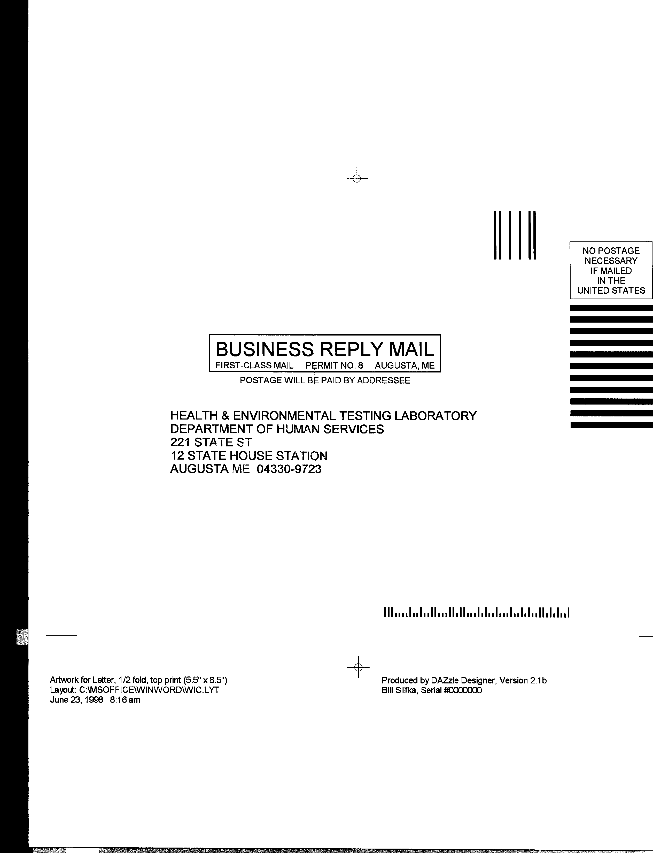

MAINE HEALTH & ENVIRONMENTAL LABORATORY NEWS
Division of Health & Environmental Testing Laboratory
Bureau of Health
Maine Department of Human Services
State House Station 12, Augusta ME 04333
Telephone: (207) 287-2727 Fax: (207) 287-6832

Governor – John Baldacci
Commissioner – John Nicholas
Director, Bureau of Health - Dora A. Mills, MD, MPH
Deputy Director, Bureau of Health - Philip W. Haines, Dr. P.H.
Chief, Laboratory Services, HETL - John A. Krueger, MS, CHE
Editors –Richard Danforth, BA, Tsun K. Lee, Dr. P. H., and Kenneth G. Pote, BS, MS, PhD
PRSRT STD
U.S. POSTAGE
PAID
PERMIT NO.8.
AUGUSTA, MAINE

---------------------------------------------------------------------------------------------------------------------------------
 cut along dotted line

PLEASE FILL OUT THIS FORM FOR:
•Change of address •Removal from our mailing list •Additions to our mailing list •Questions/Comments
When you are finished simply cut this half of the page off (along the dotted line) and drop into any mailbox.
If mailing address below is incorrect, cross off the what is wrong and print the correct information in the spaces to the right.

Name/Company/Organization:
Address:
Address:
City: State: ZIP
If you no longer want to be on our Newsletter mailing list, please check the box below.
- Please remove me from the mailing list.
If you would like to add an address to our mailing list, please write it below.

This space is provided for anyone who wants to speak his or her mind. All suggestions, questions, comments welcome!!!

