Certifying Quarterly Behavior Reporting in NEO
- This data will need to be Certified by the Superintendent each reporting quarter according to the following schedule:
  - Q1 Jul-Sep: Due 10/15
  - Q2 Oct-Dec: Due 1/15
  - Q3 Jan-Mar: Due 4/15
  - Q4 Apr-Jun: Due 6/30
- Only the designated Superintendent of Schools in NEO will be able to Certify the dataset in NEO.
- Only behavior incidents that have been entered into the State Synergy student information system will appear on the report.

- To access the report you will need to login to NEO and got into Student Data:
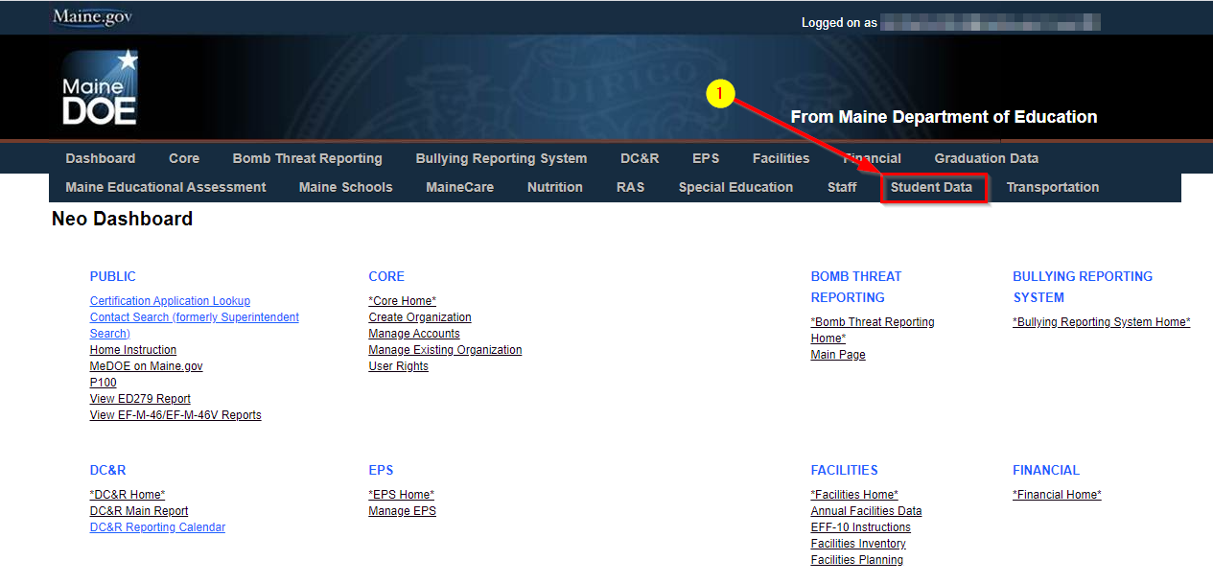

- Then go into Student Reports: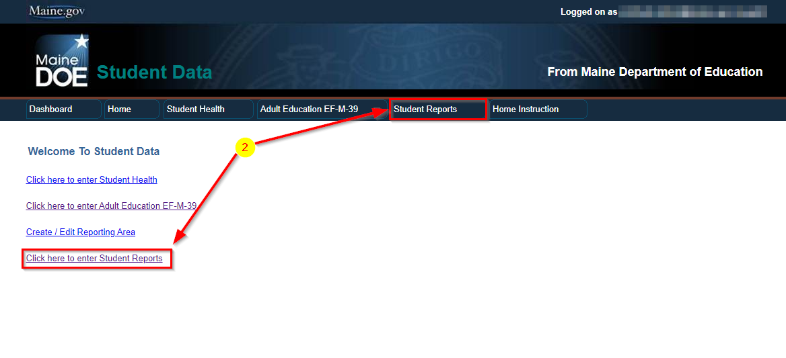

- Locate the ‘Behavior Certification Report’ in the report list, click View Report:
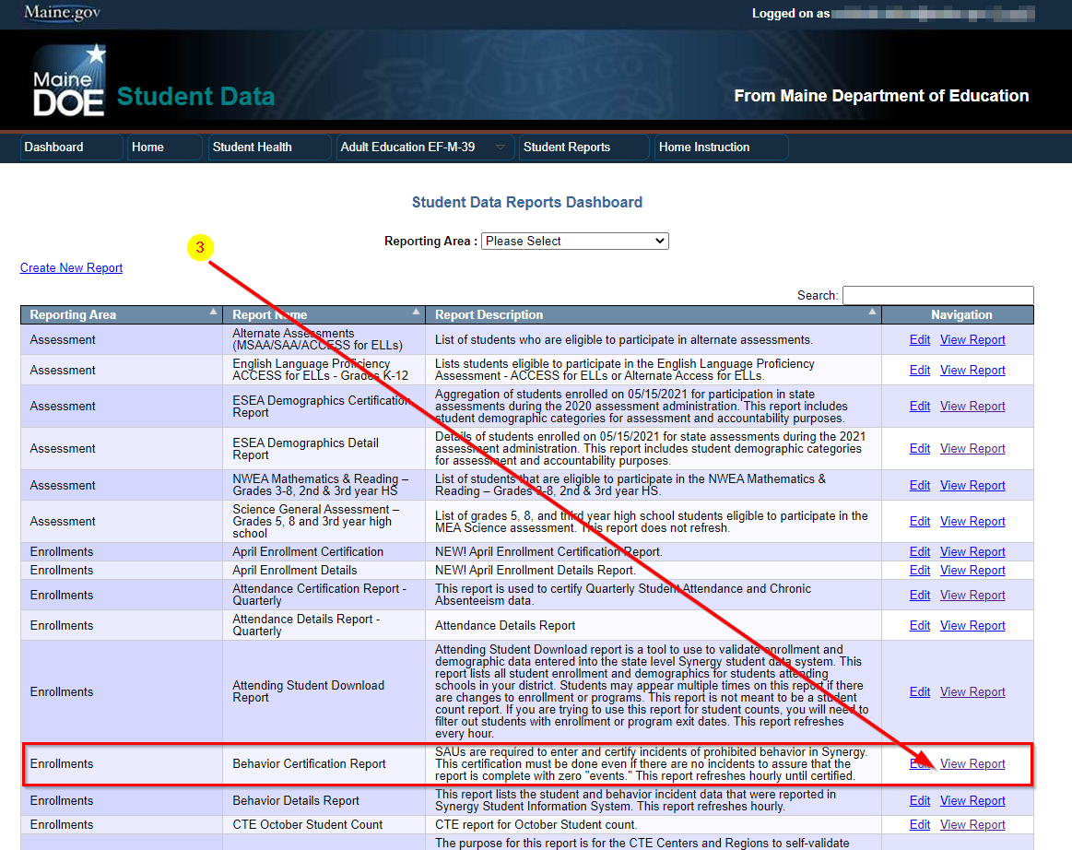
- Once the report loads, please ensure you are viewing the correct reporting period by setting the dropdown boxes for Year and Submission Due Date to view the data. To certify the report, simply click Certify and Submit to DOE at the bottom (Superintendent Only).
- You may click the View Details link in the far-right column under Navigation to see the student level data if desired:

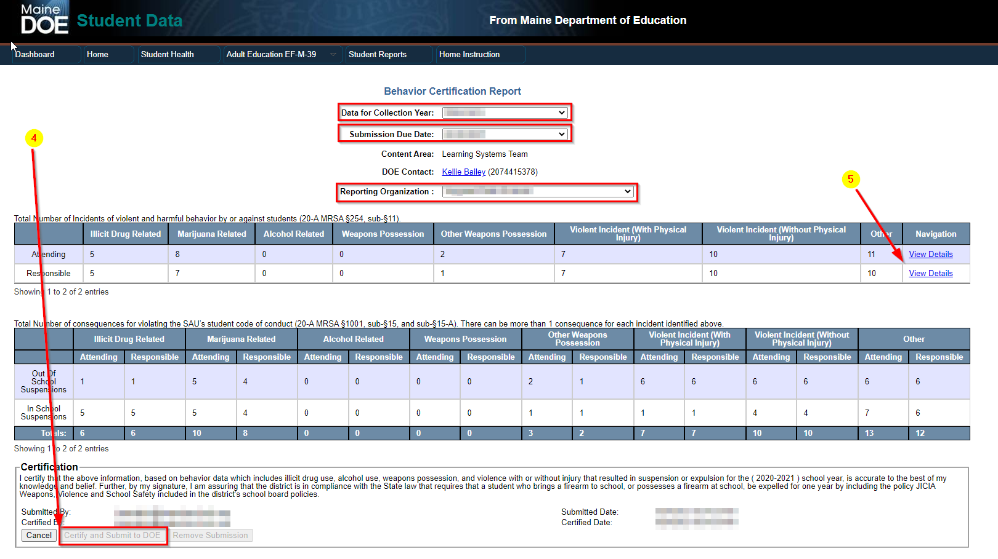

If the data on the report does not look correct, please contact your school Synergy Data Specialist to ensure all incidents have been upload/entered to the State.

If there are incidents on here that were entered in error, for example under the wrong student, or if there are any general questions please contact the MEDMS Helpdesk by phone or email and we can happily assist: MEDMS.Helpdesk@Maine.Gov or 207.624.6896, M-F 8AM-4PM.

