The purpose of this report is to provide the data required to calculate the maximum allowable tuition per Title 20-A, §5805 and §5806.
INSTRUCTIONS:
Report number of pupils from prior school year:
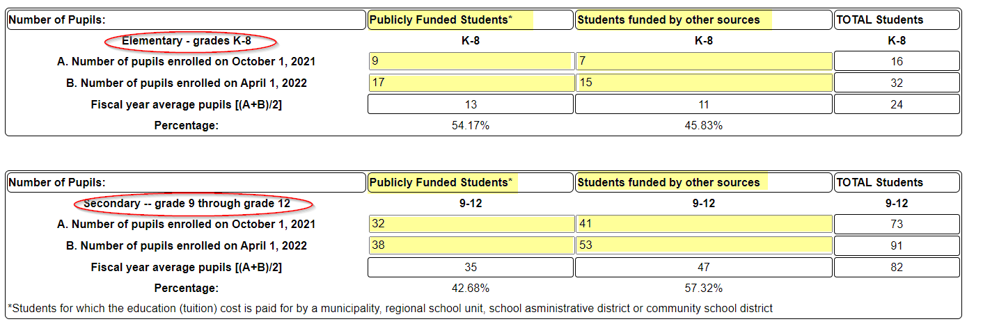
Report Expenditures from prior school year:
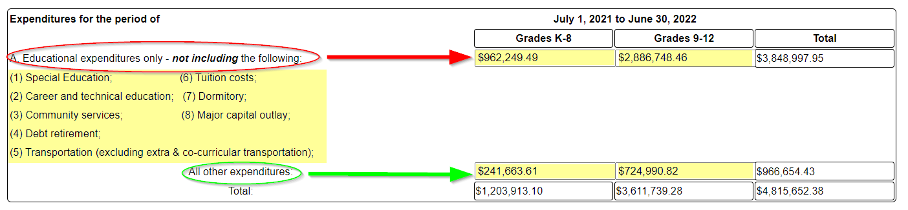
For Maine Secondary Schools Only: Report Insured Value of School Buildings & Equipment:
Superintendent or Headmaster will then Certify that the information is correct:
The maximum allowable tuition calculation cannot be completed until all the final audited financial data for the previous school year has been submitted to the State for every School Administrative Unit; once that data is received the tuition rates for the upcoming/current school year will be calculated and posted after December 1st.
The maximum tuition rate calculated for the previous year can be used as an estimate for the current year until the new calculation is available.

