Fresh Fruit and Vegetable Program (FFVP)
Budgeting Guide
Child Nutrition
Maine Department of Education

Grant Cycle

FFVP funding aligns with the federal fiscal year- October 1st through September 30th.
The funds are split into two allocations: 1) July-September and 2) October- June
- The first allocation for July-September must be used during those months. Any excess funds must be returned to USDA. *Note: this money is from the prior school year
- The second allocation for October- June is the amount the school was awarded for the current school year.

Budgeting Needs

- Create a monthly or weekly budget to ensure funds are being used timely.
  - For October- June allocation divide by 9 to allow adequate monthly spending.
  - Example: $9,000 allocation/9 months= $1,000 average monthly spending
*Note: districts may opt to save money for September of the following school year
- Save ~10% of grant award for September of the following school year (if plan to save)

Resources

FFVP budgeting tool: https://www.maine.gov/doe/schools/nutrition/programs/ffvp.

USDA FFVP Handbook: https://www.maine.gov/doe/schools/nutrition/programs/ffvp

FFVP usage report in NEO: https://neo.maine.gov/doe/neo/nutrition/ReportDashboard.
- The report has three columns: Amount, Balance and Usage (separated for July- Sept and Oct-June).
  - Amount = grant amount allocated to that school
  - Balance = funds remaining, based on the most recent claim that has been paid.
  - Usage = percent of funds used to date, based on the most recent claim that has been paid.

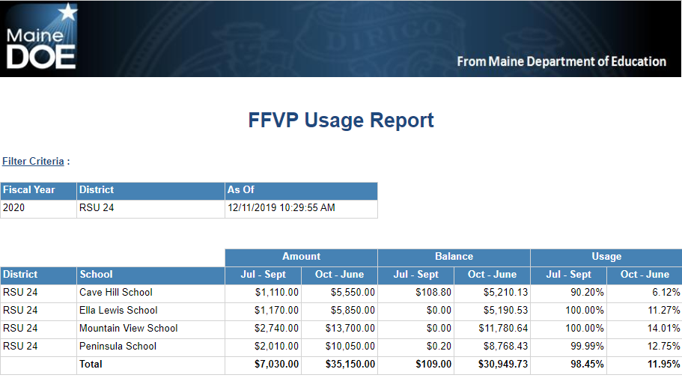

Budgeting Tips & Best Practices

- Develop a budget for each school and monitor throughout the year
- Conduct a mid-year evaluation of spending (refer to FFVP usage report) and adjust accordingly
- Reallocate funds as needed- send requests to the FFVP coordinator
- Use funds for labor and equipment expenses, keeping in mind these should be kept minimal and administrative costs are no more than 10% of the total grant.
- Increase the number of serving days if underspending
- Communicate frequently with school staff to avoid over or under spending.

For questions, please contact:

Stephanie Stambach MS, RD, SNS
Child Nutrition Consultant
Stephanie.stambach@maine.gov
207-215-9437

