[Print on School district Letterhead]

Dear Parent/Guardian:

Our school participates in the Special Milk Program (SMP). The SMP provides milk to children in schools, child care institutions, and summer camps that do not participate in other Federal child nutrition meal service programs. Students may qualify for free milk or may buy milk for _______ cents.

To apply for free milk benefits, complete, sign and return the attached application to the school. Within 10 days of receiving your application, you will be notified of your child’s eligibility. If your child is not able to consume milk due to a dietary disability, an approved substitution may be provided.

Who can qualify for free milk under the Special Milk Program? Children in households receiving SNAP, TANF or, FDPIR benefits, and foster, homeless, and migrant children are eligible for free meals without reporting household income. Alternatively, children may receive free or reduced-price meals if their household’s income is within the limits on the Federal Income Eligibility Guidelines.
Will information on my form be kept confidential? We will use the information on your form to decide if your child is eligible for free milk. We may inform officials connected with other child nutrition, health and education programs of the information on your form to determine benefits for those programs or for funding and/or evaluation purposes.

How do I know if my children qualify as homeless, migrant, or runaway? Do the members of your household lack a permanent address? Are you staying together in a shelter, hotel, or other temporary housing arrangement? Does your family relocate on a seasonal basis? Are any children living with you who have chosen to leave their prior family or household? If you believe children in your household meet these descriptions and haven’t been told your children will get free milk, please call or e-mail [school, homeless liaison or migrant coordinator].
Do I need to fill out an application for each child? No. Use one application for all students in your household. We cannot approve an application that is not complete, so be sure to fill out all required information.
Should I fill out an application if I received a letter this school year saying my children are already approved for free milk? No, but please read the letter you got carefully and follow the instructions.
My child’s application was approved last year. Do I need to fill out a new one? Yes. A new application must be submitted each school year unless the school told you that your child is eligible for the new school year. If you do not send in a new application that is approved by the school or you have not been notified that your child is eligible, your child will be charged the full price for milk.
Will the form be verified? Your eligibility may be checked at any time during the school year. School officials may ask you to send written evidence.

Can I apply for free milk later? Yes. Please complete an application at any time including if your income decreases, household size increases, or you start getting SNAP, TANF or benefits from FDPIR.
What if I disagree with the school’s decision about my application? You should talk to school officials. You also may ask for a hearing by calling or writing to: [name, address, phone number, e-mail].
May I apply if someone in my household is not A U.S. citizen? Yes. You, your children, or other household members do not have to be U.S. citizens to apply.
What if my income is not always the same? List the amount that you normally receive. For example, if you normally make $1000 each month, but you missed some work last month and only made $900, put down that you made $1000 per month. If you normally get overtime, include it, but do not include it if you only work overtime sometimes. If you have lost a job or had your hours or wages reduced, use your current income.
What if some household members have no income to report? Household members may not receive some types of income we ask you to report on the application or may not receive income at all. Whenever this happens, please write a 0 in the field. However, if any income fields are left empty or blank, those will also be counted as zeroes. Please be careful when leaving income fields blank, as we will assume you meant to do so.
We are in the military. Do we report our income differently? Your basic pay and cash bonuses must be reported as income. If you get any cash value allowances for off-base housing, food, or clothing, it must also be included as income. However, if your housing is part of the Military Housing Privatization Initiative, do not include your housing allowance as income. Any additional combat pay resulting from deployment is also excluded from income.
What if there isn’t enough space on the application for my family? List any additional household members on a separate piece of paper and attach it to your application.
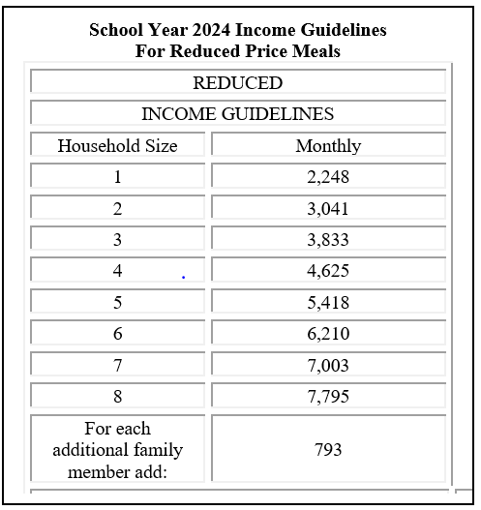
My family needs more help. Are there other programs we might apply for? For information about Food Supplement, Health Care, Cash Assistance and/or apply for Maine's Child Care Subsidy, go to My Maine Connection found online at https://www1.maine.gov/benefits/account/login.html. For low cost health insurance information, contact Consumers for Affordable Health Care (CAHC) at 1-800-965-7476.
If you have other questions or need help, call [phone number].

Sincerely,
[signature]

In accordance with federal civil rights law and U.S. Department of Agriculture (USDA) civil rights regulations and policies, this institution is prohibited from discriminating on the basis of race, color, national origin, sex (including gender identity and sexual orientation), disability, age, or reprisal or retaliation for prior civil rights activity. Program information may be made available in languages other than English. Persons with disabilities who require alternative means of communication to obtain program information (e.g., Braille, large print, audiotape, American Sign Language), should contact the responsible State or local Agency that administers the program or USDA’s TARGET Center at (202) 720-2600 (voice and TTY) or contact USDA through the Federal Relay Service at (800) 877-8339.To file a program discrimination complaint, a Complainant should complete a Form AD-3027, USDA Program Discrimination Complaint Form which can be obtained online at: https://www.usda.gov/sites/default/files/documents/USDA-OASCR%20P-Complaint-Form-0508-0002-508-11-28-17Fax2Mail.pdf, from any USDA office, by calling (866) 632-9992, or by writing a letter addressed to USDA. The letter must contain the complainant’s name, address, telephone number, and a written description of the alleged discriminatory action in sufficient detail to inform the Assistant Secretary for Civil Rights (ASCR) about the nature and date of an alleged civil rights violation. The completed AD-3027 form or letter must be submitted to USDA by:
(1) mail:
U.S. Department of Agriculture
Office of the Assistant Secretary for Civil Rights
1400 Independence Avenue, SW
Washington, D.C. 20250-9410; or
(2) fax: (833) 256-1665 or (202) 690-7442; or
(3) email: program.intake@usda.gov
This institution is an equal opportunity provider

The Maine Human Rights Act prohibits discrimination because of race, color, sex, sexual orientation, age, physical or mental disability, genetic information, religion, ancestry or national origin.
Complaints of discrimination must be filed at the office of the Maine Human Rights Commission, 51 State House Station, Augusta, Maine 04333-0051. If you wish to file a discrimination complaint electronically, visit the Human Rights Commission website at https://www.maine.gov/mhrc/file/instructions and complete an intake questionnaire. Maine is an equal opportunity provider and employer.
(Federal Statement Revised 5/2022)

