Board of Trustees

MAINE CRIMINAL JUSTICE ACADEMY

SHELLFISH WARDEN CERTIFICATION

Specification S-16

The following requirements are specified for certification of Shellfish Wardens as required by 25 M.R.S. §§2803-A(7) and 2804-I, and authorized to make arrest under 12 M.R.S. §6671(8) and the Maine Department of Marine Resources Rules, Chapter 4, relevant to their duties as Shellfish Warden.

Purpose:

The purpose of this certification empowers Shellfish Warden to perform related law enforcement duties only; no general law enforcement authority outside this limited scope of duty is intended nor granted.

Requirements:

- Be employed as a Shellfish Warden, and;

- Successfully complete the Law Enforcement Pre-service (LEPS) training as required by 25 M.R.S. §§2804-B(1) and 2804-I, and;

- Within a year of employment successfully complete the Municipal Shellfish Warden Training Course, as prescribed by the Maine Department of Marine Resources of not less than 16 hours.

- Only Shellfish Wardens who have met the requirements of Specification S-XX or that otherwise hold a Certificate of Eligibility by the Board as a full-time law enforcement officer or a part-time law enforcement officer shall possess sworn powers to arrest and authority to carry a firearm.

Certification:

- All Shellfish Wardens must successfully complete the LEPS Training Program with a passing grade of 75% at the conclusion of Phase I and Phase II.

- After the MCJA Background form, the MCJA Firearms form and the MCJA Notice of Employment form is received, the Shellfish Warden will be issued a Provisional Shellfish Warden Certificate of Eligibility to work as a Shellfish Warden. The employing agency must provide documentation that the Shellfish Warden has successfully completed eighty (80) hours of supervision as a Shellfish Warden (Phase III) within one (1) year of their hire date.

- Once Phase III is completed and the MCJA Phase III form is received, a Shellfish Warden Certificate of Eligibility will be issued. A Shellfish Warden may receive an extension by the Board in extenuating circumstances if more time is needed to complete Phase III.

- Certification as a Shellfish Warden will remain in effect, if the individual maintains employment in this capacity.

Recertification:

- To maintain a Certificate of Eligibility to act as a Shellfish Warden in the State of Maine, a Shellfish Warden must complete the annual mandatory in-service training, per 25 M.R.S. §§2804-E and 2804-I by December 31st of each calendar year.

Adopted: 09/13/2019
Revised:
Review Date: 09/13/2022

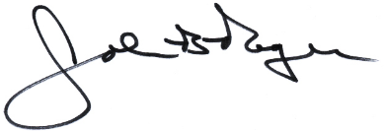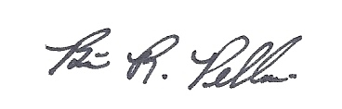
____________________________ __________________________
John B. Rogers, Director Brian R. Pellerin, Chair
Maine Criminal Justice Academy MCJA Board of Trustees

