Board of Trustees
MAINE CRIMINAL JUSTICE ACADEMY

FEDERAL OFFICERS LIMITED AUTHORITY TO ENFORCE MAINE LAW CERTIFICATION

Specification S-32

The purpose of this specification is to set guidelines and to establish parameters for the training and use of the statutory authority to enforce Maine State law granted to certain federal officers to enforce certain Maine laws in accordance with 25 M.R.S., $§$1502-A.

Applicability:

A. This specification is limited to the following persons who are authorized to carry firearms in the performance of their duties as federal law enforcement employees or officers.
1. Special Agents of the United States Secret Service (USSS) of the Department of Homeland Security
2. U.S. Border Patrol (USBP) Agents when on official duty or when traveling to or from their home to their official scheduled duty
3. U.S. Immigration & Customs Enforcement: Homeland Security Investigations (ICE / HSI) Special Agents when on official duty or when traveling to or from their home to their official scheduled duty
4. U.S. Customs and Border Protection (CBP) Officers when on official duty or when traveling to or from their home to their scheduled duty port-of-entry
5. An officer of an agency of the United States Department of Homeland Security that has administrative and enforcement jurisdiction over immigration, customs, or border security matters that is not specifically named above

B. This specification is not intended to limit the authority to enforce state law of any other federally employed, federal law enforcement officer or law enforcement officer of another state who, with the written consent of the Attorney General, has been sworn or otherwise cross-designated or cross-deputized as a state law enforcement officer.

Situational Extended Use of Authority:

All federal officers as defined by 25 M.R.S., §1502-A, may, but are not required to, enforce state law. This section is not intended to limit the existing authority of federal officers under federal law or to interfere with the performance of federal duties by federal officers. A federal officer as defined above has the power to enforce state law:

- In situations where there is a potentially life-threatening danger to the public or another law enforcement officer to ensure the safety of any victims or potential victims and to secure and stabilize the situation until a state, county, or municipal law enforcement officer arrives.

B. In situations where there is a request by a state, county, or municipal law enforcement officer to provide assistance in an emergency to ensure the safety of any victims or potential victims and to secure and stabilize the situation until a state, county, or municipal law enforcement officer arrives.

C. To make vehicle stops by mobile units of the U.S. Border Patrol (USBP), special agents within the U.S. Immigration and Customs Enforcement / Homeland Security Investigations (ICE / HSI), and officers of the U.S. Customs and Border Protection (CBP), where:
1. This authority shall not be used to circumvent the requirement of legal authority to initiate an immigration stop.
2. This authority is not intended to make USBP agents, ICE / HSI special agents, or CBP officers traffic enforcement officers, but to ensure their authority to act when a life-threatening situation evolves in their presence.

D. In situations regarding arrests under 25 M.R.S., §1502-A, where it is necessary to detain the individual(s) and / or to hold evidence until a state, county, or municipal law enforcement officer arrives and takes custody thereof.
1. It is expected that the arrest(s) will be made by a state, county, or municipal law enforcement officer that has jurisdiction over the place and / or type of crime.

Requirements:

A. Be recognized by the United States or an agency thereof as being duly sworn and / or having the authority to enforce federal law and make arrests, as defined under Title of the United States Code.

B. Be currently employed by one of the applicable federal agencies listed above.

C. Successfully complete a training program approved by the Board of Trustees to include,
at a minimum, Criminal Law and Use of Force.

D. The federal law enforcement agency listed above in Applicability section A, must develop policies governing their employees, including training and limitations of using the Federal Offices Limited Authority to Enforce Maine Law granted by the Board of Trustees. These policies and training must be approved by, and the policies filed with the Board of the Maine Criminal Justice Academy as required by 25 M.R.S. §1502-A(5)(B-1).

Procedures:

A. The employing agency must submit proper documentation to the Maine Criminal Justice Academy that the federal officer is employed by that agency.

B. The employing agency must submit proper documentation to the Maine Criminal Justice Academy to show successful completion of a training program in Criminal Law and Use of Force established by the Board of Trustees.

C. The Academy Director will review the submitted documentation and make a recommendation to the Board of Trustees.

Adopted: 06/13/2003
Amended: 11/08/2019
Review Date: 11/08/2022

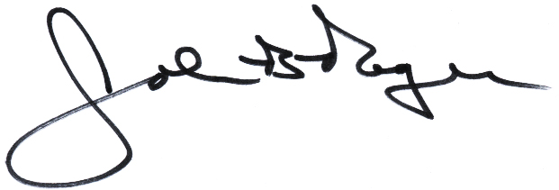 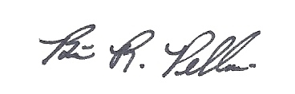____________________________ __________________________
John B. Rogers, Director Brian R. Pellerin, Chair
Maine Criminal Justice Academy MCJA Board of Trustees

