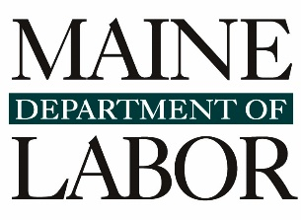

Employment of Minors
  - Observations as of February 2023
As employers in Maine and throughout the country are increasingly challenged to find employees, they rely more heavily on younger workers to meet that need. Not surprisingly, this is reflected in a steep rise in number of work permits processed by the Maine Department of Labor in recent years.
With the help of the Department, almost all Maine employers comply with the nearly identical state and federal legal restrictions designed to protect the health, safety, and education of our minors. However, MDOL has also recently observed a marked increase in the numbers of work permits denied, violations of child-protective labor laws, and most disturbingly, in reported injuries to minors in Maine’s workplaces. This report attempts to assess the extent of the problem.

Three sets of data
We reviewed three separate data sources.
- Work Permit applications and denials.
In order to work every child under age 16 is required to have a work permit, applied for through their school superintendent’s office and issued by MDOL. Denial of a permit may indicate application for work in an occupation or industry considered hazardous for that age group. We analyzed the applications, denials, and reasons for denial over the past several years.

- Wage and Hour complaints and violations.
Records from the Bureau of Labor Standards provide information on violations of Maine employment law discovered through investigations, usually in response to complaints. We extracted data on violations of child labor laws to detect recent trends.

- Workers Compensation data.
Injuries that occur in Maine workplaces involving a half day or more of lost work time require the employer to complete and submit an Employer’s First Report of Injury or Illness to their insurance carrier or the Maine Workers’ Compensation Board. The data is augmented by coding from the Maine Department of Labor, enabling us to analyze data regarding minors in the workplace.
Below is a summary of the information we reviewed. More detailed data is available on request.

Work Permit Applications and Denials
Applications for Work Permits increased nearly 75% between 2017 and 2022, from 4,260 to 7,441.
- The number processed have increased steadily at about 10% per year from 2017-2022
(with the notable exception of pandemic year 2020).
- Last year’s increase continued the recent trend at over 9%.

The number and percent of permits denied has also increased during that period.
- The number initially denied has increased steadily in recent years, and
by 68% between 2021 and 2022 (see table below)
- The number finally denied (after discussion with the applicant) in the same period also rose,
from 306 to 443, or 45%, between 2021 and 2022
- The rate of final denial increased from 1% in 2017 to 4.5% in 2021 and 6% in 2022
- Permits denied for reasons related to occupation or industry rose dramatically as well
(indicated in red below)

Initial Denials 2017-2022
Applications/ Reason denied | 2017 | 2018 | 2019 | 2020 | 2021 | 2022 | Totals
Permit Applications | 4,260 | 4,732 | 4,828 | 3,531 | 6,817 | 7,441 | 31,609
Employer Denied Job Offer | 1 |  | 1 |  |  |  | 2
Employer Out of State |  | 2 |  | 3 | 2 | 5 | 12
Exceeds Number of Permits |  |  | 3 | 3 | 31 | 158 | 195
Information Lacking | 6 | 14 | 9 | 11 | 245 | 298 | 583
Other | 4 | 2 | 1 | 2 | 106 | 217 | 332
Too Hazardous for Age | 45 | 80 | 136 | 111 | 171 | 253 | 796
Total Denials | 56 | 98 | 150 | 130 | 555 | 931 | 1,920

- Denials within certain industries last year were especially concerning:
    - Manufacturing, where 17% (28 out of 164 applications) were denied
    - Construction, where over half (51/99) were denied

Violations of Employment Laws Protecting Minors
Complaints and violations have increased together with permits from 2017 to 2022.
- Formal complaints regarding child labor received by the Wage and Hour Division have doubled, from 6 in 2017 to 12 in 2022. In addition, one case in 2022 resulted from a focused inspection.
- The number per year of statutes cited after investigation has increased during that period from 10 to 28, including these specific types of violations:
    - Hours minors are permitted to work (total of 47 minors affected)
    - Minors working in hazardous occupations or industries (18 minors affected)
    - Minors under 16 working without required work permit (22 minors affected)
- 240 separate violations were cited in 2020, including
  - 2 cases potentially exposing minors to recognized hazards, and
  - 33 failures to secure or produce a work permit.
- 515 separate violations were cited in n 2021, including
  - 7 cases potentially exposing minors to recognized hazards, and
  - 22 failures to secure or produce a work permit.
- 870 separate violations were cited in 2022, including
  - 37 minors under 14 years of age working, and
  - 138 failures to secure or produce a work permit.
Statute violated/ Number of Cases | 2017 | 2018 | 2019 | 2020 | 2021 | 2022 | Total
26 MRS §702 Minors - Daily Time Records (rpld) | 1 |  |  |  |  |  | 1
26 MRS §771 Minors Under 14 Years of Age |  |  |  |  |  | 5 | 5
26 MRS §772 Hazardous Occupations | 2 |  | 2 | 2 | 6 |  | 12
26 MRS §773-A (1) Minors Under 16 years of age –  Prohibited Businesses |  |  |  |  | 1 |  | 1
26 MRS §774 (1) Restricted Hours –  Minors 16 & 17 years of Age | 3 | 1 | 2 | 3 | 5 | 4 | 18
26 MRS §774 (1)(E) No More Than 6 Days –  16 & 17 years of Age | 1 | 1 |  |  | 1 | 1 | 4
26 MRS §774 (2) Restricted Hours –  Minors Under 16 years of Age |  | 1 | 1 | 1 | 4 | 5 | 12
26 MRS §774 (2)(E) No More Than 6 Days –  Under 16 years of Age |  | 1 |  |  | 1 | 1 | 3
26 MRS §774 (3) Work During School Hours | 1 |  |  |  | 2 | 1 | 4
26 MRS §774 (7) Record of work hours of minors. |  |  | 2 | 1 | 3 | 4 | 10
26 MRS §775 Work Permit | 2 | 1 | 3 | 2 | 7 | 7 | 22
Total Number of Cases Investigated | 6 | 2 | 6 | 5 | 14 | 13 | 46
Statutory sections highlighted in yellow indicate violations that might endanger minors.
(Most cases discovered multiple violations)

Reports of Injuries to Minors at Work
Reports of injuries to minors at work have doubled over the past decade.

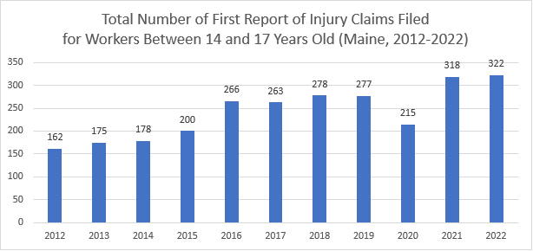
(We expect to receive several additional reports for 2022)
In the same period (2017 through 2022) during which work permit applications for minors increased by approximately 10% per year, reported injuries to minors in the workplace increased by over 22%, from 263 in 2017 to 322 in 2022.
- The vast majority (92%) of those injuries were to 16- and 17-year-olds, who
  - do not require work permits and
  - are allowed to work in more occupations and industries than younger workers.
- Of the 640 injuries reported in 2021 and 2022, only 29 were to minors aged 14 and 15
(who were presumably permitted and thus shielded from hazardous work).

Conclusion
As shown in the above data sources, employment of minors, and consequently violations of child labor law and workplace injuries, have been on the rise in Maine. The Department wants to work with employers and young job seekers to ensure that legal restrictions designed to protect the health, safety, and education of minors are being followed. Employers or workers who have questions about child labor law, or would like to report violations, should view our webpage or contact MDOL’s Wage & Hour Division at 207-623-7900 or bls.mdol@maine.gov.

