2013 Annual Census of
Maine’s Fatal Occupational Injuries*
A Report Provided to the US Department of Labor:
Statistical Factors Regarding Maine’s 2013 Work Related Fatalities

Nineteen Maine Workers Died from

Occupational/Work-Related Injuries in 2013.

The Bureau of Labor Standards of the Maine Department of Labor annually participates in the Census of Fatal Occupational Injuries (CFOI) conducted by the Bureau of Labor Statistics of the U.S. Department of Labor (US DOL). This informational report provides statistical data and charts derived from the 2013 census. It also presents key data points pertaining to Maine’s fatalities.
Maine’s participation in the CFOI is funded by the U.S. Bureau of Labor Statistics and the Safety Education and Training Fund (SETF) in Maine.

States collect data through conducting research, verifying occupational fatalities with supporting documentation and submitting case data to the Bureau of Labor Statistics for review and compilation.

The CFOI program limits counting occupational fatalities to those which result from injuries; the latency period of many occupational illnesses and the resulting difficulty of linking illnesses to work make it difficult to compile a complete account of all fatal illnesses in a given year.

2005 – 2013 Occupational Fatalities
Table 1 lists Maine’s annual totals of occupational fatalities for the years 2005 to 2013. There were 180 occupational fatalities in that period, averaging 20 fatalities per year. The largest annual total of fatalities during this period, 26, occurred in 2011.

Table 1: Maine’s Occupational Fatalities from 2005 – 2013
Year | 2013 | 2012 | 2011 | 2010 | 2009 | 2008 | 2007 | 2006 | 2005
Total  Fatalities | 19 | 19 | 26 | 20 | 16 | 24 | 21 | 20 | 15

Fatalities within Occupational Categories
Figure 1 illustrates reportable data for Maine’s 2013 occupational fatalities in three occupational categories. In Transportation and Material Moving, there were five fatalities, or 26 percent of 2013’s occupational fatalities. Installation, Maintenance and Repairs and Construction and Extraction occupations each incurred four fatalities, each accounting for 21 percent. Six additional fatalities occurred within a diverse range of occupational categories or were not reportable.

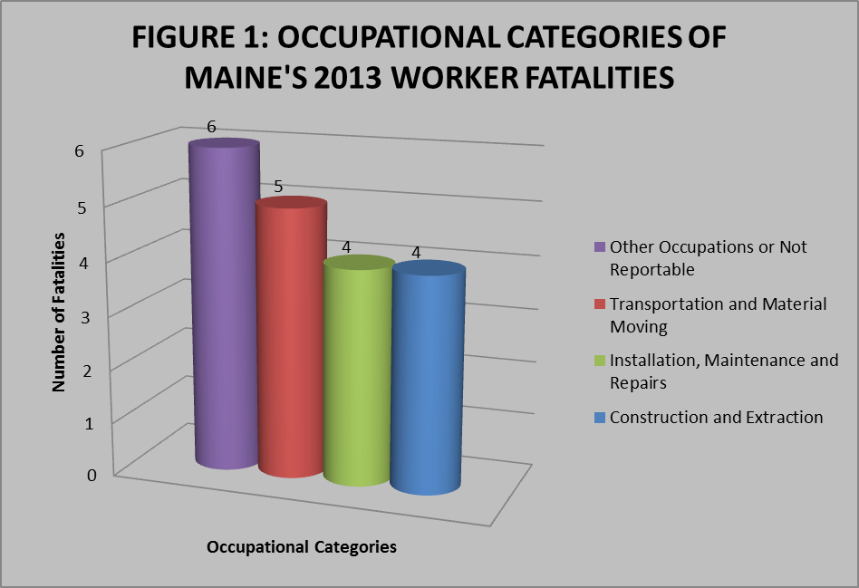

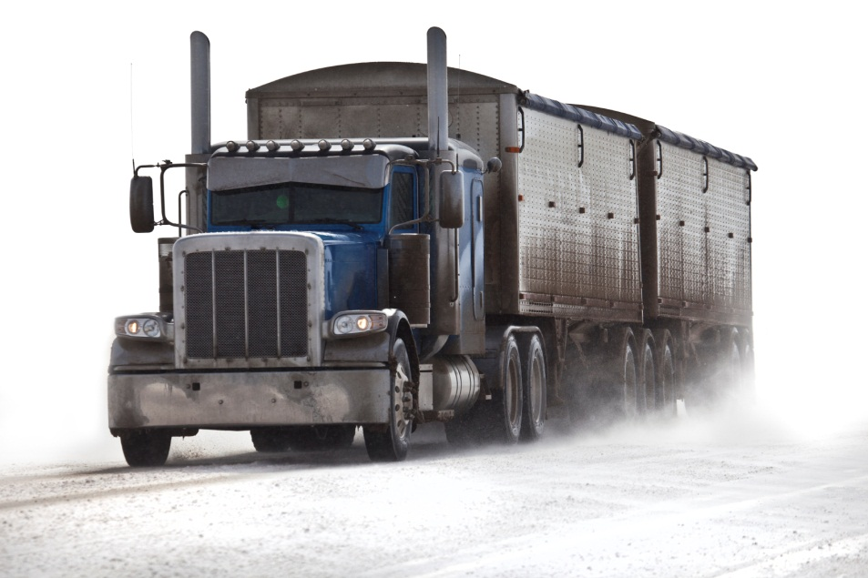

Types of Fatal Events
Figure 2 provides reportable data from Maine’s 2013 types of fatal events. Transportation Incidents accounted for six fatalities, 32 percent of all 2013 occupational fatalities. Falls, Slips and Trips as well as Contact with Objects and Equipment accounted for four fatalities in each category (21 percent) and five fatalities fell under the fatal event category of Other or were Not Reportable.

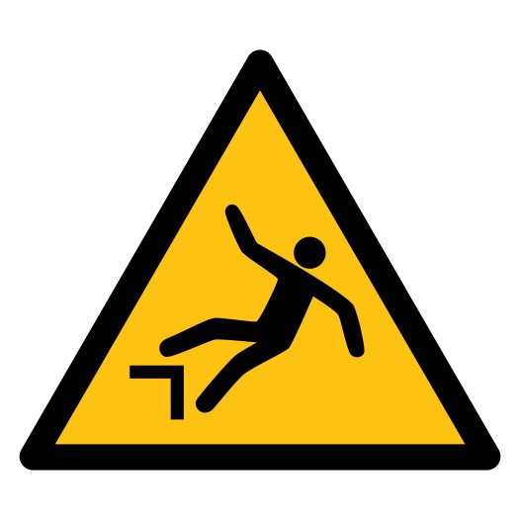

Primary Sources Causing Fatalities
Figure 3 provides reportable data for three primary sources that contributed to Maine’s 2013 occupational fatalities. Vehicles were involved in eight fatalities, 42 percent of all 2013 fatalities. Persons, Plants, Animals and Minerals were involved in three fatalities and Parts and Materials were involved in two. These 13 fatalities accounted for 68 percent of all 2013 occupational fatalities.

Secondary Sources
Tools, Instruments, and Equipment were secondary sources involved in three occupational fatalities. This includes firearms, such as pistols, handguns, revolvers, rifles and shotguns.

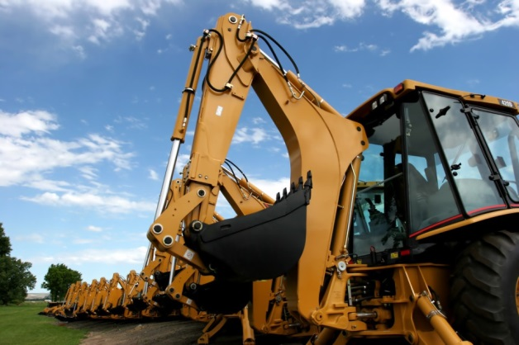

Age Categories
Figure 4 provides reportable data regarding age categories for Maine’s 2013 occupational fatalities. Seventeen fatalities, 89 percent, involved workers who were age 35 or older. Of those 17 workers, 41 percent were in the age 55–64 range; five, 29 percent, were in the 65-years-and-older range; and four, 24 percent, were between 35 and 44 years old.

U.S. 2013 occupational fatality age data reflects that 56 percent were over age 45 with 24 percent in the age 45-to-54 range, 20 percent in the age 55-to-64 range and 12 percent were age 65 and older.¹

Other Key Points:
- Five of the fatalities that were Transportation Incidents involved workers that were employed in industries classified as Service Providing.
- Maine’s 2013 fatalities in the occupational category of Natural Resources, Construction, and Maintenance occupations accounted for 53 percent of total fatalities. U.S. occupational fatalities in this category accounted for 39 percent of national fatalities.
- All 19 of the workers who died in Maine as a result occupational fatalities in 2013 were men.
- Ten of the fatalities in 2013 involved employees working for wage or salary.

Sources:
Except for numbered references, data for this report was extracted from the Census of Fatal Occupational Injuries (CFOI), Maine Department of Labor, 2013. CFOI is a federal program that, in most cases, is administered by the states.

- See the national CFOI website: http://www.bls.gov/news.release/cfoi.t04.htm .

For more information on fatal occupational injuries, contact
Eliza Galella, Statistician II
207-623-7907
TTY users call Maine Relay 711.

Research and Statistics Unit, Division of Technical Services
Bureau of Labor Standards
Maine State Department of Labor

Maine Department of Labor provides equal opportunity in employment and programs.
Auxiliary aids and services are available to individuals with disabilities upon request.

