Central York County Connections Study
Steering Committee Meeting
March 28, 2012, 2:45 – 5:00 PM
Central York County Connections Study

Attendees: Jon Carter, Wells Manager; Judy Bernstein, Kennebunk; Mike Livingston, Wells; Charles Andreson, Sanford; John Sylvester, Alfred; Dwayne Morin, North Berwick; Brad Littlefield, Sanford; Myranda McGowan, SMRPC; Sara Devlin, MTA; Gerry Audibert, MaineDOT; Uri Avin, Parsons Brinckerhoff; Steve Rolle, Parsons Brinckerhoff; Carol Morris, Morris Communications; Ben Ettelman, Morris Communications.

Meeting began at 2:45pm

Gerry Audibert: Hello and thank you for coming to this Steering Committee Meeting for the Central York County Connections Study. Today we are going to review what we have accomplished to date in the study. MTA and MaineDOT have spent some time talking about what the next steps will be and we will share that with you a little later in the meeting. We will also talk about what the study intends to accomplish in Phase III. Carol will now share the meeting agenda.

Carol Morris: The agenda for today’s meeting is as follows:

- Welcome
- Study Overview To-Date
  - Refresher on Study Purpose and Context
  - Brief Review of Large-scale Transportation Strategies and Previous Comments
  - Additional Discussion
- Revisit Purpose and Need Statement
- Potential Areas of Study for Phase III
- Phase III Timeframe and Meeting Format

Uri Avin: Thank you, Carol. I am going to provide a quick update on what we have accomplished in the study to date.

Uri Avin presents a slide titled Population and Jobs Will Continue to Grow

As you can see from this slide, the growth in this part of the state is growing approximately 1% a year and is one of the faster growing areas in the state, we project 17% population growth out to 2035. Jobs will continue to grow in this region as well; we project 35% job growth out to 2035.

Uri Avin presents a slide showing traffic growth by corridor in 2010 and 2035

In this slide you can see that the job and population growth will lead to increased traffic:

- Total Vehicle-Miles Traveled (VMT) increase by 29%
- A projected 30% increase in traffic on Rte. 111 near the Arundel/Biddeford town line
- A 56% increase in traffic on Rte. 109

Steve Rolle: I wanted to point out that while 56% sounds like a large increase for Route 109, it is based on the volume that was measured near the Sanford-Wells town line where volumes are relatively modest today.

Uri Avin: Thanks, Steve. This is the existing purpose statement that we developed early in the process:

The purpose of the Central York County Connections Study is to identify and evaluate feasible transportation and related land use strategies that will enhance regional economic growth, increase regional transportation interconnectivity, improve traffic safety, direct expected travel demand through a strong mix of multimodal strategies and preserve and improve existing infrastructure while maintaining the visual, cultural and historic character of village centers and rural areas.

We wanted to share this and we will come back and revisit this later in the meeting.

Uri Avin presents slide showing Regional Strategies

This slide shows the regional strategies that we looked at.

Uri Avin presents a slide showing Local Strategies

This slide shows the local strategies that we have looked at; we haven’t focused on these local strategies as much so far. We have focused on the larger scale strategies and tested them in detail to see if they met purpose and need.

The following are a refresher of MOEs and their measures:
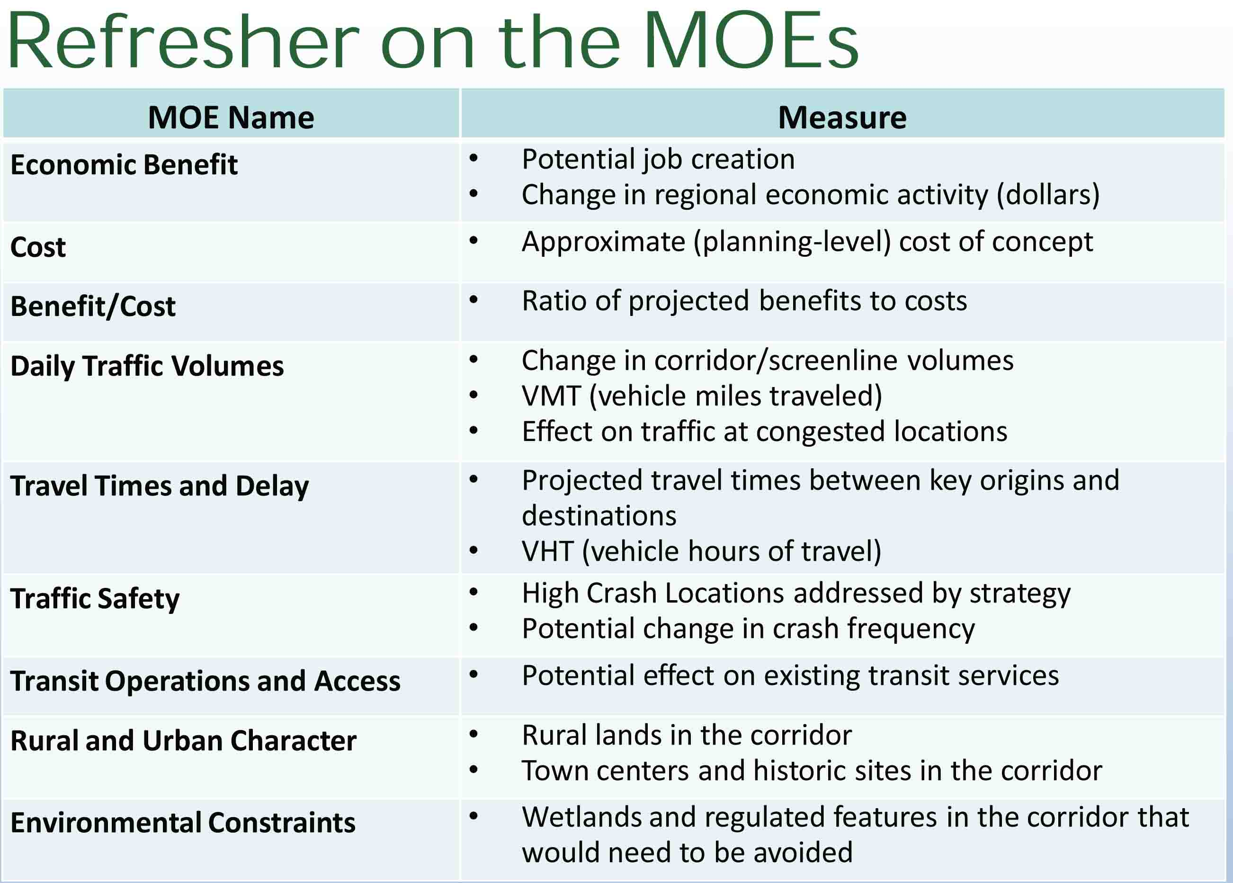

Uri Avin presents a slide showing a Summary of MOEs
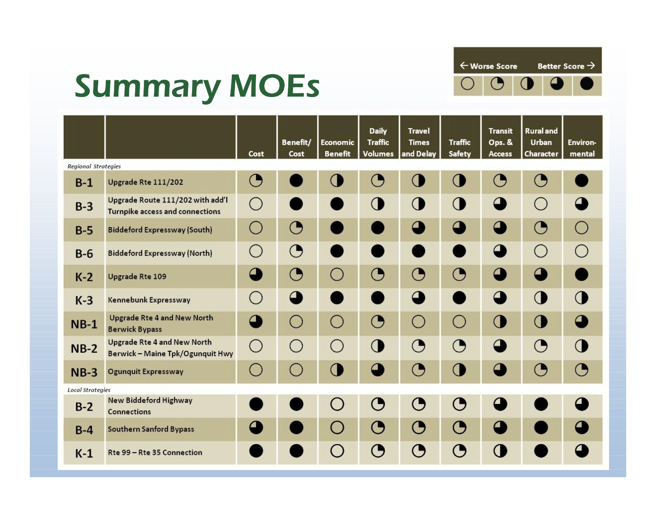

This slide shows how the nine MOEs stack up against the 12 strategies we looked at.

Uri Avin presents a slide showing a map of Rural and Urban Character Impacts

This slide shows a map of each strategy and the impact to Urban and Rural Character. The darker the color of the line on the map represents a strategy that has more conflicts.

Uri Avin presents a slide showing a map of Environmental Constraints

This map shows each strategy and the environmental constraints and estimated how much of the road was going through sensitive environmental areas. The lines that are darker represent strategies that have more conflicts with environmentally sensitive areas.

Uri Avin presents a slide showing Benefit Cost Analysis

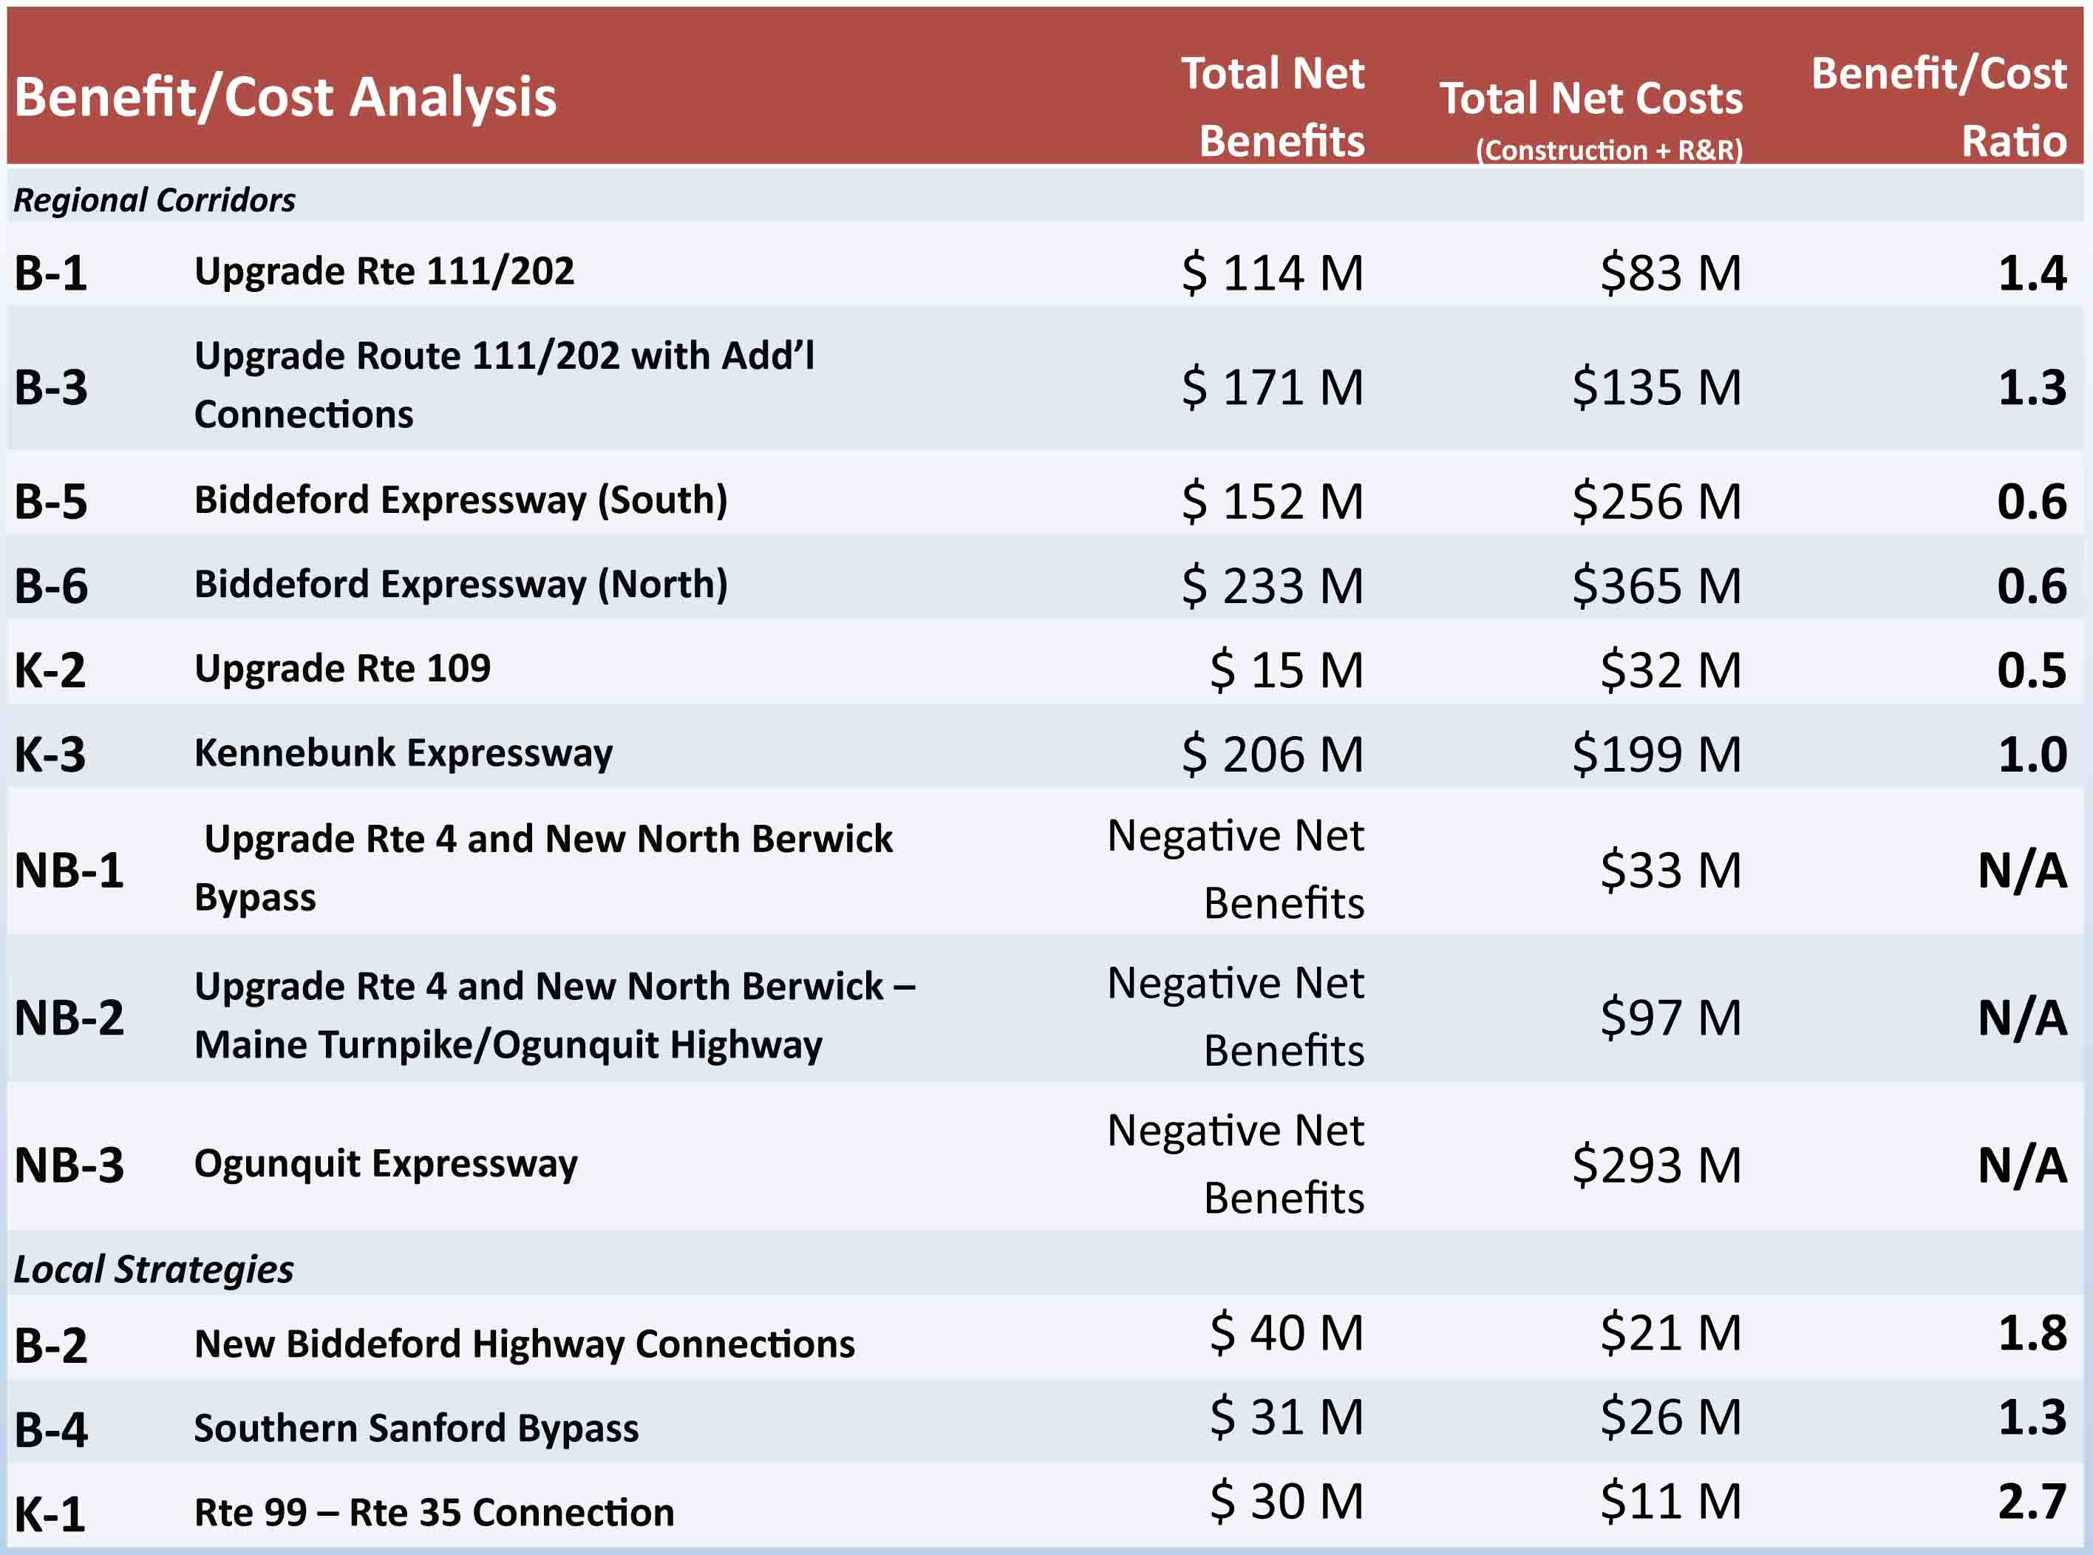

This slide shows each strategy with the respective benefit/cost ratio. The benefit is calculated by looking at time savings, accidents, safety savings, etc. Anything above 1 is generally considered worth thinking about moving forward.

Brad Littlefield: These numbers seem different from previous meetings. The Kennebunk Expressway was $185 million last time.

Steve Rolle: The construction costs are $185 million; in the cost benefit ratio we include the annualized cost of maintenance in the total cost, which is why this number is higher.

Carol Morris: The following are comments that we received at the September meeting from the Advisory Committee regarding the strategies and previously stated analysis:

- B-1 and B-3: Concerned about feasibility of four lanes on Rte. 111, but thought B-3 or some variation thereof makes the most sense of the “B” strategies.
- B5 and B6: Majority agreed that Strategies B5 and B6 are far too costly, have too many negative impacts, offer limited benefits and should not be pursued.
- K2: The Advisory Committee believed this should not be pursued since analysis didn’t demonstrate need for major improvements.
- K3: Concerned about cost, environmental impacts and mixed response on usefulness, but most of the AC was willing to keep K3 on the table.
- NB1, NB2 and NB3: The majority of the AC indicated that NB2 and NB3 are too costly, and all NB options offered very limited benefits and should not be pursued.

The following are comments made by the Steering Committee regarding the strategies:

- B1 and B-3: Consensus was that these should remain under consideration because upgrading an existing corridor is less impactful than a new road.
- B5 and B6: Majority agreed that Strategies B5 and B6 are far too costly, have too many negative impacts, offer limited benefits and should not be pursued.
- K2: The Steering Committee believed this should not be pursued due to limited benefits.
- K3: Very mixed reactions in terms of environmental impacts, but most SC members felt K3 was the best of the new road strategies and should not yet be eliminated.
- NB1, NB2 and NB3: The majority of the SC indicated that NB1, NB2 and NB3 are economically infeasible, though there was some support for NB3.

I am now going to turn the floor over to Gerry so he can talk about how MTA and MaineDOT have decided to move forward.

Gerry Audibert: Thanks, Carol. MaineDOT has to look at the fiscal realities of these strategies. The days of receiving federal earmarks for road projects are over. We expect to maintain the level of funding we have received in the past few years, it may be slightly more, but nothing substantial. So, from a MaineDOT perspective, the days of $100 million plus highways are over. There may be some tolling opportunities in the state, but this area would not be one of them. One of the reasons is that there is a statutory limitation on how far MTA can build a toll road from the turnpike, which is five miles.

Brad Littlefield: Wasn’t that changed this year? According to the majority leader, MTA adjusted the charter and can go wherever they want to now.

Sara Devlin: The limit is five miles. We can make improvements and upgrades within 5 miles only. The only thing that was adjusted in the charter this year was the requirement for MTA to have a commuter discount program, which was lifted.
Brad Littlefield: Your executive director said that MTA could now go anywhere they want to the economic subcommittee of Sanford.

Carol Morris: When was that?

Brad Littlefield: January.

Sara Devlin: If that is the case then he misspoke or was misunderstood. I would be happy to provide you with the current legislation and the statute that states that we can only make improvements or upgrades within five miles.

(POST-MEETING COMMENT: Below is clarification on the legislation that defines how MTA revenues will be spent:

Enabling Act Restrictions and Requirements on Expenditure of MTA Revenue
23 MRSA § 1974 restricts the use of MTA revenue to the following categories of expenditure:

(1) Turnpike operations, maintenance and construction
(2) Payment of MTA debt, including sinking funds for payment of that debt
(3) Construction of new interchanges
(4) State Police Services
(5) Payment of debt issued by MTA for MaineDOT projects^{[1]}

There is no geographic limit specifically mentioned, but all categories of allowed expenditure except for #5 are linked to operation or reconstruction of the Turnpike (as it exists now and presumably as it may in the future be expanded). This would include interchanges and access roads considered important to the operation of the Turnpike.

23 MRSA § 1961(7) requires the MTA to expend (either directly or through transfer to MaineDOT) approximately 5% of its annual operating revenues on MaineDOT projects. The projects must bear “a sufficient relationship to the public’s use of the turnpike” as defined by a list of factors in Section 1974. The projects are not limited by a geographic area but proximity to the Turnpike and the number of vehicles which use both the MaineDOT project and the Turnpike are factors in the determination.

A copy of 23 MRSA § 1974 is attached.

Bond Resolution Restrictions
The Bond Resolution is a legally enforceable contract between the MTA and its bondholders. The Bond Resolution sets out restrictions on the way in which the MTA may spend its revenue. Revenue raised by the sale of bonds must be spent on a capital project on the Maine Turnpike. Revenue raised through tolls and other means must be spent first on MTA operations, then on the funding of several debt service funds and the MTA’s Reserve Maintenance Fund, which is used to pay for capital projects. After these various funding requirements have been satisfied, the MTA may spend any excess revenue for “any lawful purpose” which would include, for instance, the annual 5% transfer to MaineDOT described above.

The Bond Resolution contains a specific geographical restriction stating that the MTA shall not “acquire, construct, reconstruct, operate or maintain any road or highway as a part of the Turnpike which is not part of the Turnpike as of the effective date of this Resolution if such highway is in excess of five miles in length” unless either: (a) the MTA is legally authorized to collect tolls on that highway sufficient to pay for its operation and maintenance, (b) an independent revenue study shows that even with acquisition of such a road the MTA would have revenue sufficient for five years, without a toll increase, to meet the required revenue to debt service tests contained in the Bond Resolution or (3) on a unanimous vote of the board provided that the Authority is not in default under the Bond Resolution and an independent consultant’s report states that the Authority is likely to remain in compliance for the following five years.)

Charles Andreson: One of the things that we have trouble with is being encumbered with existing legislation. All across the country governments are selling highways to private corporations and drastic changes are happening in the way business is being done. If you are throwing an option out just because legislation says you can’t do it even though it may be viable, is that shortsighted? If there is a need for it, it seems that folks will get the legislation changed.

Gerry Audibert: From a MaineDOT perceptive, we have gone down this path before. The Wiscasset bypass is an example. We spent millions of dollars on a study that ended up being infeasible. MaineDOT has a new culture of cost containment and making sure our studies lead to recommendations that are viable. Where it stands now we do not see a new highway as a viable alternative. That’s not to say we won’t look at other improvements in this area.

We also looked at benefit to cost ratio and those with ratios at one or under are not considered feasible. In terms of public support, there was some support from the Advisory and Steering Committees for Strategy B1 and B3. When we were looking at these strategies initially, they were four-lane highways. In looking at the traffic projections through 2035, we don’t see a capacity need for a four-lane highway. What we are proposing moving forward is keeping those two on the table, but in a more pragmatic way. We will identify trouble spots for safety, environmental impacts and gauge public support and fundability. For example on Route 111 we would look at passing lanes, improved intersections and perhaps shoulder widening. We have also done a lot of work on the Route 109 corridor as well and have addressed safety and capacity issues. The local strategies would also stay on the table. We know there are environmental limitations so we do not know if they will be feasible, but that’s what Phase III analysis will tell us.

Brad Littlefield: Sanford was the only community in Maine that wanted a Wal-Mart or Lowes. Wiscasset doesn’t want development, but Sanford does. The executive director has said that we have a chokepoint in Southern Maine and if something happens on the I-95 Bridge, there is no economy in Maine. We should be looking at a strategic need for evacuation.

Gerry Audibert: We are looking at those types of scenarios with the Kittery/Portsmouth bridges.

Brad Littlefield: If you had a connector through Sanford over to the Spaulding Turnpike you would be eliminating all traffic coming west from Albany and Worcester.

Gerry Audibert: SMRPC has been working with Lebanon and Rochester and we met with them last week. We have identified that there are no capacity issues on Route 202, either now or 20 years from now.

Brad Littlefield: What do you do if you shut down the choke point at the Maine/New Hampshire border?

Gerry Audibert: I-95 is the primary route, Route 1A is the alternate route; Memorial Bridge is there to service the two communities of Portsmouth and Kittery. The issue we have is that the Sarah Long Bridge is load limited and needs serious work. Those bridges need major investment of $100 + million on the Sarah Long, plus $100 million on Memorial plus tens of millions on the I-95 bridge as well. So we have existing infrastructure that need attention.

Myranda McGowan: There are also plans in place for major detours if certain roads or bridges are closed. So SMRPC is planning for emergency scenarios like that.

Brad Littlefield: Have you been in Sanford when they close down any exit south of exit 32? There will be a ton of trucks in Sanford and the economy will be hurting if we cannot get goods and services to the rest of the state. We need to look at this as a strategic way to have travel alternatives in case of emergency.

Gerry Audibert: I understand what you are saying but that is not in the scope of this study. This study is specifically looking at capacity and safety concerns in the area as well as whether a new east-west connector would improve the regional economy, and we found that the regional economy will do just fine if we don’t do anything, and if a new highway were to be built the return on that investment would be very limited. You raise a good point regarding the strategic concerns but that should be discussed outside of this study.

John Sylvester: Last week MaineDOT was in Alfred talking about the new federal mandate regarding posting of bridges in relation to floods. There were a number of strategies regarding detours discussed. In Alfred we went and looked where the markers were placed on the abutments, and the marker on Route 4 was eight feet below the bottom of the bridge. A 2-inch rainstorm would close that bridge. This will be problematic as there will be a lot of bridges that close if we get a rainstorm. That needs to be considered.

Gerry Audibert: I do not know much about that but I believe it is based on the FEMA flood maps.

Dwayne Morin: TY Lin went and looked at the bridges in York County through the scour program and there are two bridges on Route 4 that fall below that scour program. If those bridges went down, that would cause significant transportation problems in York County.

Gerry Audibert: I will look into that. I am not sure why they are using a 10-year incident timeframe. (POST MEETING NOTE: The markings indicate the stream level when scour becomes a concern. The markings have nothing to do with high water levels).

Dwayne Morin: The primary reason is the soil under those bridges is erodible and sitting on silty soils.

Gerry Audibert: There is an interagency group looking at incident management and detouring if Route 1 or the turnpike shut down.

Myranda McGowan: Yes, we are still active, in fact we have a meeting this Friday and the municipalities are involved in that.

Brad Littlefield: I’m not sure that rerouting traffic on Route 1A on a Saturday afternoon is going to resolve the problems. If you have a bridge out, people will not come here.

Carol Morris: I think that it is fair to say that discussions about money drive almost everything these days. Even if there was a lot of extra money in the MTA and MaineDOT coffers, there are some significant environmental issues on the Strategy K3, so even if it made sense, was fundable and we moved forward, there is still a strong possibility that that this alignment would not be permittable.

Judy Bernstein: I would suggest that it would be extremely difficult to get across the water supply.

Carol Morris: We had a representative from the water district at the Advisory Committee meeting earlier and he was adamant about that as well.

Gerry Audibert: We look at three aspects when deciding whether or not to move forward with these types of projects: cost, environmental impacts and public support. If we were to build a new highway we would need to get environmental permitting. We have been consistently reminded about the potential impacts in that K3 area. Our philosophy is to conduct a study with implementable recommendations.

Brad Littlefield: No matter what road you build, there are environmental impacts. Interstate I-70 that was built in the 70s and 80s went though some of the most environmentally sensitive land in the United States, but they still built it. We should not dismiss the project out of hand because we think there are environmental concerns that we think we can’t overcome.

Gerry Audibert: Quite frankly we don’t see a need for it, which is the bottom line.

Brad Littlefield: I do not agree with the economic analysis. At 1% growth, you have significant numbers of people travelling out of this area to the turnpike.

Gerry Audibert: I think there is a disconnect between distance and travel time. The issue with Sanford is that, geographically, it is distant from the turnpike. If we put in a 50 or 60 mph highway, it only cuts a few minutes of travel time. We don’t see that as a major economic inducer. A couple of minutes is not going to make a difference to a Wal-Mart distribution center.

Brad Littlefield: But it did make a difference, Sanford lost 1,000 jobs to Raymond, NH because we did not have a direct connection to the turnpike.

Gerry Audibert: They put one in Lewiston because it is right next to the turnpike, but not South Portland or Portland. All I can say is that we can’t support a $100-200 investment when we cannot find the funding and we cannot support the need for it.

John Sylvester: It is interesting to look at the unintended consequences of these things. We have seen a significant increase of traffic in Stone Road because of the development in Sanford.

Gerry Audibert: Looking at the economic analysis and the traffic analysis, you will see growth in this area, and the current transportation system has some locations that need attention, but overall it works pretty well. In Phase III we are going to take a close look at that.
Carol Morris: Okay, we are going to look at the purpose statement again:

The purpose of the Central York County Connections Study is to identify and evaluate feasible transportation and related land use strategies that will enhance regional economic growth, increase regional transportation interconnectivity, improve traffic safety, direct expected travel demand through a strong mix of multimodal strategies and preserve and improve existing infrastructure while maintaining the visual, cultural and historic character of village centers and rural areas.

Does anyone have any comments or suggested changes to this as we move forward into Phase III?

None of the members of the Steering Committee had any suggestions.

Carol noted that the Advisory Committee wanted to add minor recommendations to the statement.

Charles Andreson: My issues are that if we are not going to improve the infrastructure by adding to the transportation system, how do we preserve it for the long term? I’m a little skeptical about promises being made to fix roads when in my community I have not seen anything happen more than a skim coat in 10 years. I am troubled by MaineDOT's lack of awareness towards the Sanford region.

Gerry Audibert: I can say that we have done almost all of the work that was identified in the Route 111 study. But you are right; we are continually facing funding shortfalls where we can’t address all of the need. In the long term it doesn’t look any better. This study helps elevate the items that the Steering Committee feels are critical. Getting regional and local support really brings the need to our attention. This study will be able to identify what strategies are actionable. There are no-cost solutions that are based at the local level that will also be helpful. The economic development districts identified the priorities by corridor and MaineDOT included those in the long-range plan. These will all be revisited again in this study. We would like to start planning on these in the next six year plan so we will start identifying fiscally viable projects. It takes time to get projects on the table.

Charles Andreson: It is crucial that there is a plan and a program with funding mechanisms in place so we can establish priorities.

Gerry Audibert: On the local level we will expect a local match, which may be increasing. So this is to the municipalities’ benefit as well, so they can be prepared to pay their share.

Brad Littlefield: It does seem that the state does not pay attention to Sanford. We are fixing five miles of road, and the state is going to kick in but not as much as they should. We can come up with all the plans that we want but I’m wondering how long it is going to take to get the infrastructure the state owns to be repaired in Sanford.

Gerry Audibert: To address your concerns, we sent a request to the regional planning commissions to have them ask their members to submit their capital investment needs. We will have those lists after the RPCs prioritize them and those will be the basis of our next bi-annual plan.

Myranda McGowan: I’m not sure whether they are to be prioritized by the RPCs.

Gerry Audibert: I will double-check that for you. (POST MEETING CORRECTION: The RPCs have not been asked to prioritize the candidate project requests).

John Sylvester: The $7 million Municipal Partnership Initiative that was made available over the last several months for state roads and connectors, is that plan likely to continue in the future?

Gerry Audibert: I am not sure about that; I will double check and follow up with you.

John Sylvester: You said that the local match is part of the planning for any of these strategies?

Gerry Audibert: Traditionally that is an 80-20 split; safety projects are usually completely funded on all public roads, not just state roads. The other programs address state and federal highways. Those communities who are willing to pay more may receive priority.

Mike Livingston: Getting back to the purpose statement, after the word maintaining, should the word environmental be in there?
Gerry Audibert: It falls under cultural but it should be added.

Brad Littlefield: If you put in a new road, you can’t maintain that environment. Sometimes you have to mitigate those impacts. If you make a new road into Sanford there will be some environmental impact, it should say striving to maintain the environment.

Gerry Audibert: I agree.

Uri Avin: We could add minimizing environmental impacts at the end.

The members of the Steering Committee agreed on adding the previous suggestions to the end of the Purpose Statement

Steve Rolle: We are going to talk about what to expect in Phase III of the study. The additional analysis that will occur in Phase III is as follows:

- Update and investigate safety issues
- Level of Service (LOS) analysis for major segments and intersections
- Input from SC, AC and public.

The following are the potential focus areas for strategies in Phase III:

- Intersection improvements
- Passing lanes or other capacity improvements
- Safety projects
- Local strategies initially investigated in Phase II
- Land use and access management approaches
- Transportation Systems Management (TSM)
- Traffic signal upgrades, roundabouts, improved signage
- Multimodal, Travel Demand Management (TDM) and Transit Improvements to support and enhance transit service
- Opportunities to leverage rideshare and TDM programs
- Improve walkability/bikability through design

Steve Rolle presented a slide showing a map of Potential Focus Areas – Safety

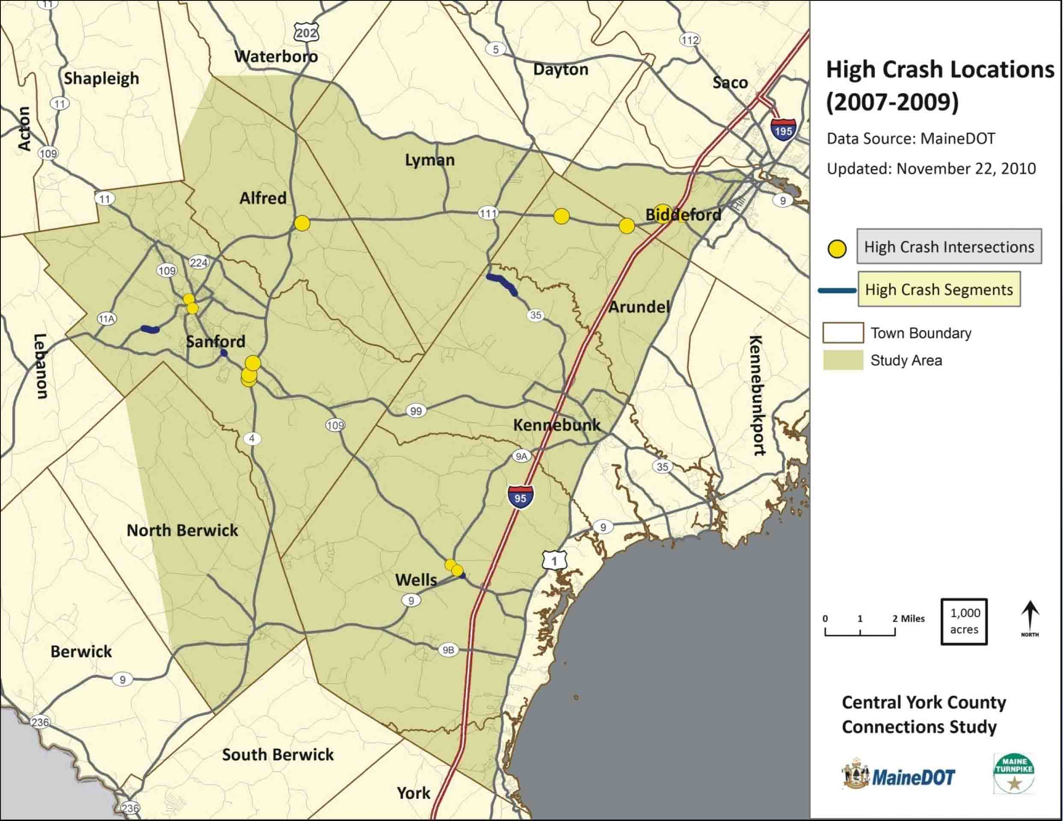

This map shows the High Crash Locations in the study area and this is where we will focus on safety projects. Can anyone think of anything that we missed?

John Sylvester: Scotts Hill Road in Alfred is dangerous. The pitch drags you to the middle and over the centerline. It is about a mile from the Sanford line. Going up the hill is not the issue, coming down you get pushed over.

Brad Littlefield: Route 109 and Washington, as well as Route 109 and winter can be dangerous.

Dwayne Morin: Scarborough Bridge by the intersection of Route 111 and Route 4 is dangerous and needs to be rebuilt. It needs alignment and scour control.

John Sylvester: That bridge needs to be a half a lane wider in order for you to drive straight. It’s an alignment issue.

Judy Bernstein: In the past Route 99 and Mill Street was a HCL and is still a bad intersection.

Dwayne Morin: The HCL location in Biddeford is the highway intersection?

Steve Rolle: The smaller circle (lower rate) is. The larger one is in front of Home Depot.

Dwayne Morin: I know that B2 addresses this but the intersection getting off of the highway is a nightmare.

Sara Devlin: That exit is built to capacity and we will look at this more closely in Phase III. There is talk about an exit to South Street, though there are environmental constraints. We will also look at signalization options.

Steve Rolle presented a slide showing a map of Potential Focus Areas – High Traffic Areas

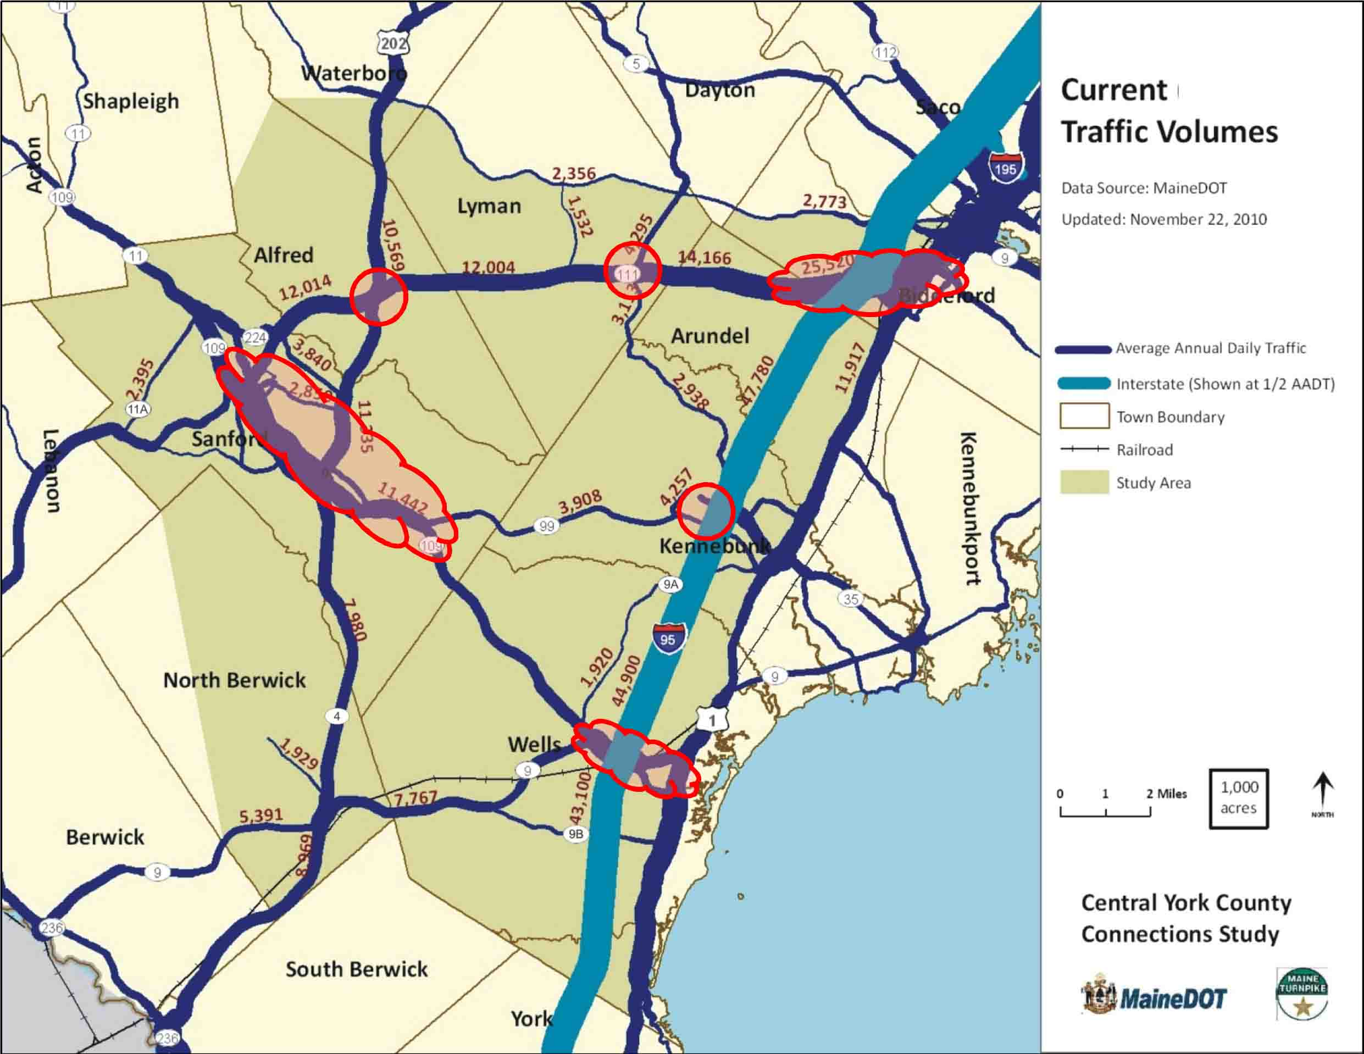

This map shows where in the study area there are high traffic volumes. We are going to pinpoint where these locations are.

John Sylvester: What do you have for traffic counts in downtown Sanford compared to the Sanford-Wells line?

Steve Rolle: In Sanford it gets quite a bit higher, it gets into the 18,000 range. The projected growth is not as high as 56% in relative terms. We’ll look at specific segments in Phase III.

Brad Littlefield: When we did the roundabout, the traffic count was 22,000.

Charles Andreson: Dennis Emity did a simulation of the traffic there and that may be helpful to you.

Steve Rolle: I believe that is the highest volume segment along Route 109. That could be in the low 20s.

Charles Andreson: When you do these studies do you get the LOS for every section?
Steve Rolle: We expect to do major signalized intersections and then break the highways down into segments.

Gerry Audibert: Would you be looking at downtown Sanford as well?

Steve Rolle: We will have to finalize the list of what we are going to look at, but likely major intersections and segments on Routes 109 and 202.

John Sylvester: Are there any thoughts regarding changes to the intersection of Route 4 and Route 202?

Steve Rolle: At this point, until we do LOS analysis, and look at crash records, it seems to be working pretty well.

John Sylvester: I agree.

Brad Littlefield: Did you look at Route 202 and Route 224? Or Grammar Road?

Steve Rolle: No but we will. The intersection at Grammar Road was recently improved, it was signalized and a turn lane was added. That is in the tech memo that is posted on the website.

Uri Avin: Okay, now we are going to talk about potential land use and access management strategies, which are all local decisions. We have looked at all of the zoning, subdivision and site development plans of all of the towns and analyzed what towns can be doing differently to protect the investments made on the major roads. The following are options for towns to consider:

- Through zoning regulations, reduce the number of new trips generated
- Provide direct access to streets other than the primary highway
- Improve parcel interconnectivity and local circulation
- Manage the number and operation of commercial and residential driveways

I want to point out that Sanford has done a good job of addressing issues of access by inserting a Major Thoroughfare Plan into their comprehensive plan. The potential strategies utilized in a Major Thoroughfare Plan are as follows:

- Limited use in Maine but powerful tool
- Community identifies where new roads are needed
- To provide access or connect network
- Community lays out general location
- Developments required to:
  - Protect the right-of-way
  - Build the segment of the road

These strategies and tools help preserve the existing infrastructure and right of ways and by including it in a town’s comprehensive plan it provides legal force. This is used throughout the country to preserve capacity and movements on major arterial roads. We will look at these as part of Phase III to provide ideas and recommendations for municipalities to consider.

Charles Andreson: I was at the meeting last Monday with Lebanon. Access management was discussed. If it’s optional it won’t happen in many of the communities.

Judy Bernstein: It’s too bad because we have been using this in Route 1 in Kennebunk and people are very pleased with it.

Carol Morris: Is there any opportunity to talk to people about this? Route 111 will have capacity issues in the future if access issues are not addressed.

Judy Bernstein: Is there a way to show communities in a simple way that it could work?
Steve Rolle: Yeah, maybe we need to think about an education piece.

Uri Avin: This will be on the table in Phase III. So will a closer look at transit, park and ride locations as well as multimodal opportunities.

Carol Morris: In order to look at the smaller strategies we are going to follow the same process as when we looked at the bigger strategies. The Study Team will look at these in much more detail moving forward and we will come back at our next meeting and share what we found.

So the next steps for Phase III are as follows:
- Complete Phase III by end of June
- SC/AC Meetings in May and June/July
- Public Meeting in July
- Final Report Completed by mid-August

Carol Morris: In addition, we have been talking about how best to structure these upcoming meetings, since we will be looking in some cases at more local situations, and not everyone may be interested in hearing all of it. What are your thoughts?

(Discussion ensued that indicated members would like to at least know when each segment was being discussed so they would have the option of attending some or all of the meeting. They were open to changes in format.)

Carol Morris: Thank you very much for coming today.

Meeting adjourned at 4:37

