How To Training
For
Comment on Case

Comment on Case

Public Comments module will facilitate the MPUC in receiving the public comments from external users regarding cases before the Commission and to publish the same for internal and external (public) viewing. Public Comments are case-specific, and are generally submitted by users who are not active parties/participants to the case.

Objective:

- Submit Public Comment on Case

Step | Action
From the External Registered User Home Page, click on Submit a Comment in a Case hyperlink
- Enter valid Case Number in text box and click on GO Button

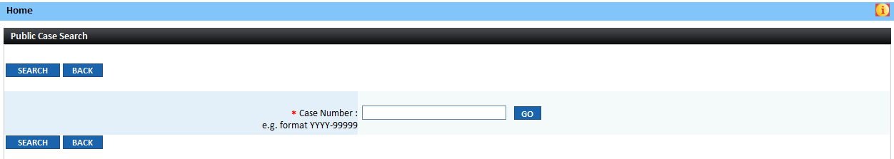

- Comment form will be displayed

Case Details will be displayed in the top sections of the screen

- Logged in External Registered User’s contact information will be system populated

- Enter all required information indicated by a red asterisk ( * )
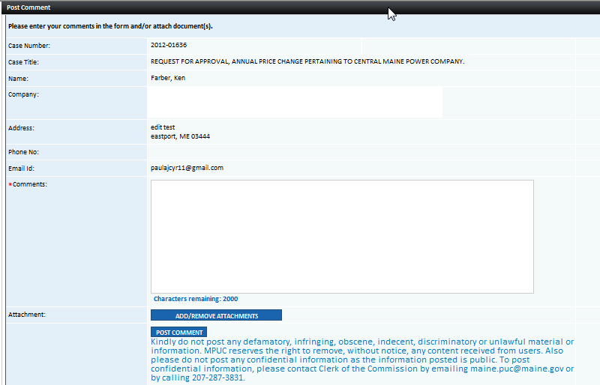
 | - To append a document, click on Add/Remove Attachments Button
 | - Click on Post Comment Button
 | - Public Comments will be posted in the Case File Screen under the Public Comments Tab for the specified case.

