MSWord Setting Modification to allow Copy and Paste
into PUC CMS System – December 2012
Fix for Copy and Pasting Text from MSWord into the PUC CMS system and getting ? in place of your quotes. This happens because your MSWord is set to use Smart Quotes. The fix is to turn this setting off.
What are SmartQuotes?
The Smart Quotes setting is used for publishing in HTML format. If you need to leave your Smart Quotes on, then you will have to either change the ? to " or ' after you paste the text, or paste the text into Notepad first and then paste it into CMS.
Turning SmartQuotes Off in MSWord 2007 and 2010:
The easiest way to get rid of smart quotes is to disable the option as follows:
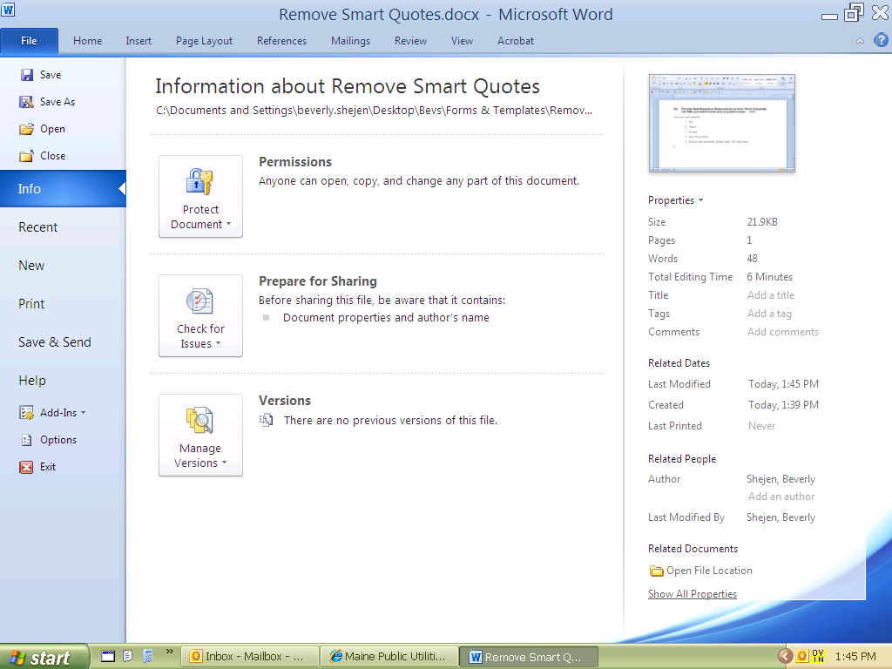
F
- Open your "Word" document,
- Go to
File then Options

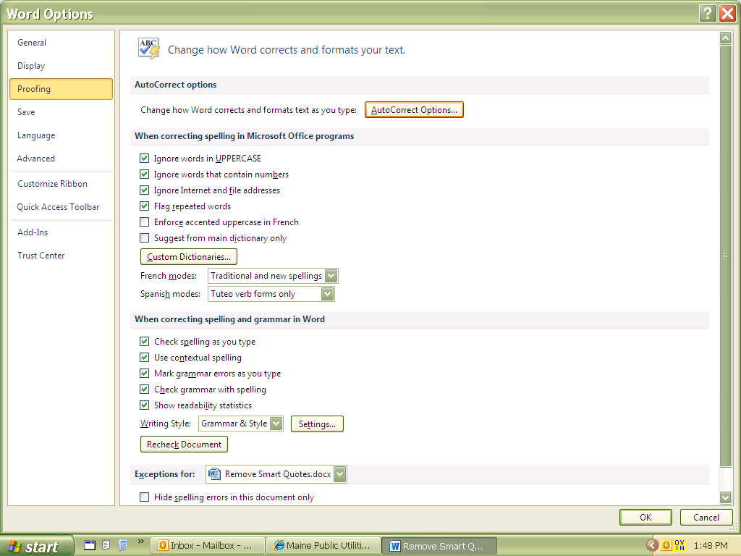
- Proofing and Auto Correct Options
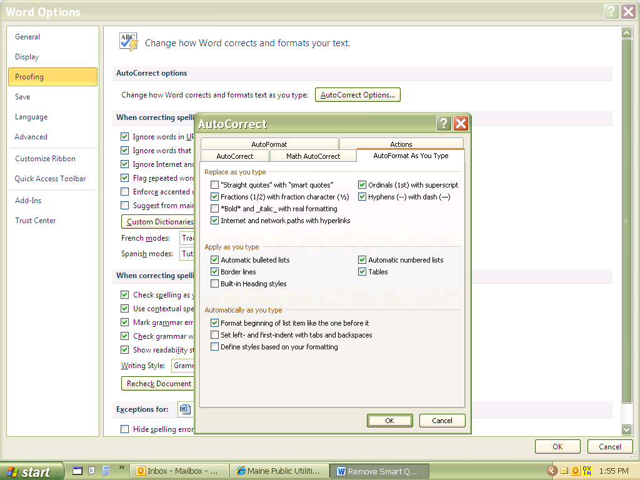
- Remove check mark beside
"Straight quotes" with "smart quotes"
then click OK

For earlier versions of MSWord this should work:
- From the Tools menu, select Auto Correct Options.
- Click the AutoFormat As You Type tab.
- Deselect the Straight Quotes With Smart Quotes option in the Replace As You Type section.
- Click OK.
