How To Training
For
Submit New Case or Filing
The Case Filing module enables users to submit new cases and documents in electronic form for various types of matters to a document repository. New cases and document filings can be filed by authorized MPUC Staff and External Users with specifically applied access rights. To access the Case Filing Screen, authorized users should click on the Case File link on the Application Level Access Menu and select Submit New Case or Filing.

The user should enter the Case Filing details for processing a New Case filing. Some of the fields on this screen are mandatory entry fields as denoted by the red (*) asterisk; others fields are optional.

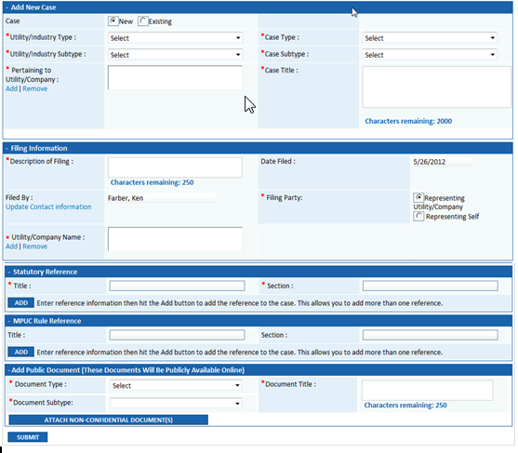

Submit New Case

Objective:

- Submit a Filing for a New Case
Step | Action
 | From the Home Page, click on Case File Submit a New Case or Filing on the access menu list
 | Select the New Radio Button
In the Add New Case Section

- Select from the drop down lists the following:
- Utility/Industry Type
- Utility/Industry Subtype
- Case Type
- Case Subtype
- To select a Pertaining to Utility/Company
- Click on Add link
- Click on Search Button to display all utilities/companies matching the previously selected Utility/Industry Type and Subtype
Select Utility/Company Checkbox and click on Select Button
- Verify that the Case Title has been auto populated in multiline text box and can be edited

In the Filing Information Section

- Enter Description of Filing in multiline test box

- Date Filed will be system populated with current date
- Filed By will be system populated with name of logged in External Registered User

To add Representing Utility/Company

- Filing Party Radio Button for Representing Utility/Company should be selected by default

- Click Add link to display listing of Utilities/Companies Represented by the logged in user.

- Select applicable Checkbox(es)
- Click on Select Button to add selection
- If selection needs to be Removed
- Click on Utility/Company Name
- Click on Remove link

Note: If the utility/company that the logged in user represents is not displayed in Utility/Company Listing user should:

- Go to Home Page
- Click on Update Contact Information and go to the bottom of the screen to update Representing
- Click on Add hyperlink

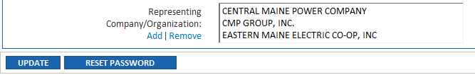

- Search for Representing Utility/Company
- Select Checkbox associated with Utility/Company that needs to be added to logged in users Representing list
- Click on Select Button
- To continue with New Case Filing go to Case File Submit New Case or Filing Screen (See Step 1 above)

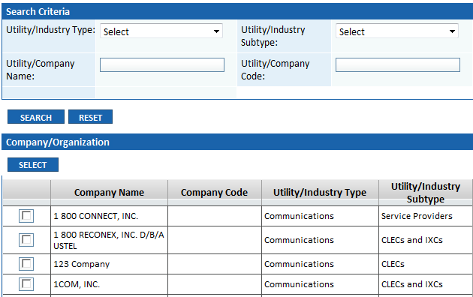

To add filing for Representing Self (individual)
- Select Filing Party Radio Button for Representing Self
  - Filed By was system populated and will be used for “Representing Self”
  - Update Contact Information hyperlink is displayed if filer information requires editing

In the Statutory Reference Section

- Enter mandatory Title in textbox
- Enter mandatory Section textbox
- Click on Add Button
In the MPUC Rule Reference Section

- Enter optional Title in textbox
- Enter optional Section in textbox
- Click on Add Button

In the Add Public Document Section
- Select Document Type and Document Subtype from the drop down lists
- Enter Document Title in the multiline textbox

- Click on Attach Non-Confidential Document(s) Button
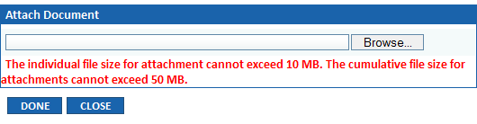
- Click on Browse and select the document you wish to attach
- Click on Open
- Click on Done
- Selected document should be displayed in the Attached Documents grid
- By clicking on Red X associated with attached document, the document can be deleted prior to submitting the filing
- Click on Submit Button

Case Filing Confirmation Message displayed
- Case Number generated
- Email Notifications distributed to
  - Notification List
  - Active Party List
  - Assigned MPUC Staff

Submit Filing in an Existing Case

Objective:

- Submit a Filing for an Existing Case
Step | Action
 | From the Home Page, click on Case File Submit New Case or Filing on the access menu list
 | Existing Radio Button should be selected by default
 | Enter the Existing Case No. in Text Box
 | Click on Go
In the Filing in Existing Case Section existing case details will be displayed
- Existing Case No.
- Utility/Industry Type
- Utility/Industry Subtype
- Case Type
- Case Subtype
- Pertaining to Utility/Company|
- Case Title
- Check if this is a Compliance Filing Checkbox

In the Filing Information Section

- Enter Description of Filing in multiline test box

- Date Filed will be system populated with current date
- Filed By will be system populated with name of logged in External Registered User

To add Representing Utility/Company

- Filing Party Radio Button for Representing Utility/Company should be selected by default

- Click Add link to display listing of Utilities/Companies Represented by the logged in user.

- Select applicable Checkbox(es)
- Click on Select Button to add selection
- If selection needs to be Removed
- Click on Utility/Company Name
- Click on Remove link

Note: If the utility/company that the logged in user represents is not displayed in Utility/Company Listing user should:

- Go to Home Page
- Click on Update Contact Information and go to the bottom of the screen to update Representing
- Click on Add hyperlink

- Search for Representing Utility/Company
- Select Checkbox associated with Utility/Company that needs to be added to logged in users Representing list
- Click on Select Button
- To continue with New Case Filing go to Case File Submit New Case or Filing Screen (See Step 1 above)

To add filing for Representing Self (individual)
- Select Filing Party Radio Button for Representing Self
  - Filed By was system populated and will be used for “Representing Self”
  - Update Contact Information hyperlink is displayed if filer information requires editing

In the Add Public Document Section
- Select Document Type and Document Subtype from the drop down lists
- Enter Document Title in the multiline textbox

- Click on Attach Non-Confidential Document(s) Button
- Click on Browse and select the document you wish to attach
- Click on Open
- Click on Done
- Selected document should be displayed in the Attached Documents grid
- By clicking on Red X associated with attached document, the document can be deleted prior to submitting the filing
To file a Confidential document, click on Attach Confidential Document(s) Button
- Click on Browse and select the Confidential Document you wish to attach
- Select Document Type and Document Subtype from drop down list
- Enter Document Title in multiline text box
- Click on Attach Button
Attach Confidential Document(s) pop-up window is displayed

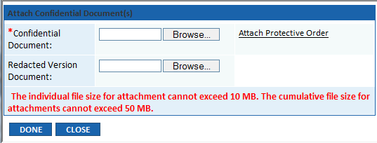

- Click on Browse and select the Confidential Document you wish to attach
- Click on Browse and select the Redacted Version Document you wish to attach

- Associate Protective Order by clicking on the hyperlink
- Click on Done Button
- Selected document should be displayed in the Attached Documents grid
- By clicking on Red X associated with attached document, the document can be deleted prior to submitting

 | - Click on Submit Button
Case Filing Confirmation Message displayed
- Email Notifications distributed to
  - Notification List
  - Active Party List
  - Assigned MPUC Staff

