How To Training
for
Tariff Submission
Submitter should be able to establish a New Tariff Book, (which will be done only once by a new company) Submit New Rate/Term in an Existing Book, and Submit Revision to Existing Rate/Term, Submit Complete Set of Rates/Terms, and View/Search Tariffs.

Submit New Tariff Book

Objective:
- Submit New Tariff Book
Step | Action
- From the Home Page
- Click on Tariff File from the Access Menu
- From the Submenu, click on Submit New Tariff Book
- Establish New Tariff Book Screen will be displayed
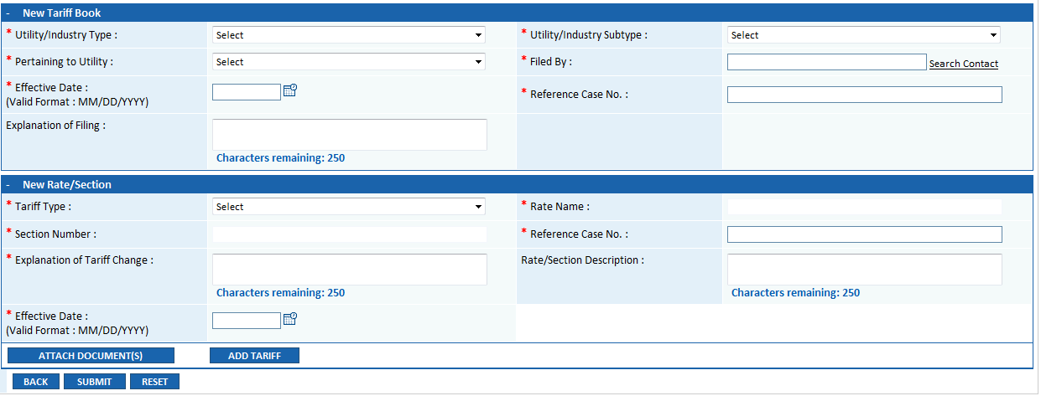

User will be required to provide data in required ( * ) fields in the following sections:
New Tariff Book
  - Utility/Industry Type (drop down list)
  - Utility/Industry Subtype (drop down list)
  - Pertaining to Utility (drop down list)
  - Filed By (with lookup for Search Contact hyperlink)
  - Effective Date (with calendar icon)
  - Reference Case Number
  - Explanation of Filing (multiline text box)

New Rate/Section
  - Tariff Type (drop down list)
  - Rate Name (text box) (When Tariff Type is Rate ; Section Number disabled and vice versa)
  - Section Number (text box)
  - Reference Case No. (text box)
  - Explanation of Tariff Change
  - Rate/Section Description
  - Effective Date (with calendar icon)
  - Attach Document(s) Button
  - Add Tariff Button (after attaching Rate Tariff user can click on button to append additional section for the Tariff)

  - Back, Submit and Reset Buttons

- If user attempts to submit a tariff book which already exists, a message will be displayed to the Submitter –

- “Tariff Book has already been established for the selected Utility Company. To make revision in existing book or add new Rate/Section, please select the appropriate Tariff Revision Screens.”
- Filer will be required to submit tariff attachment as a PDF (Image on Text) document.

- On submit, a Tariff confirmation message will be displayed

- Tariff Tracking Number will be generated (format TAR-YYYY-####, where LLL is the unique 3-digit code designated for Tariff Submissions)
- Tariff submission will be routed to the Inbox Tariff Queue of the Clerk of the Commission for processing
- Email notification confirming receipt of successful tariff submission will be sent to the Clerk of the Commission and the Submitter of the tariff

Submit New Rate/Term

Objective:
- Submit New Rate or Section in Existing Tariff Book
Step | Action
- From the Home Page
- Click on Tariff File from the Access Menu
- From the Submenu, click on Submit New Rate/Term
- New Rate or Section in Existing Book Screen will be displayed
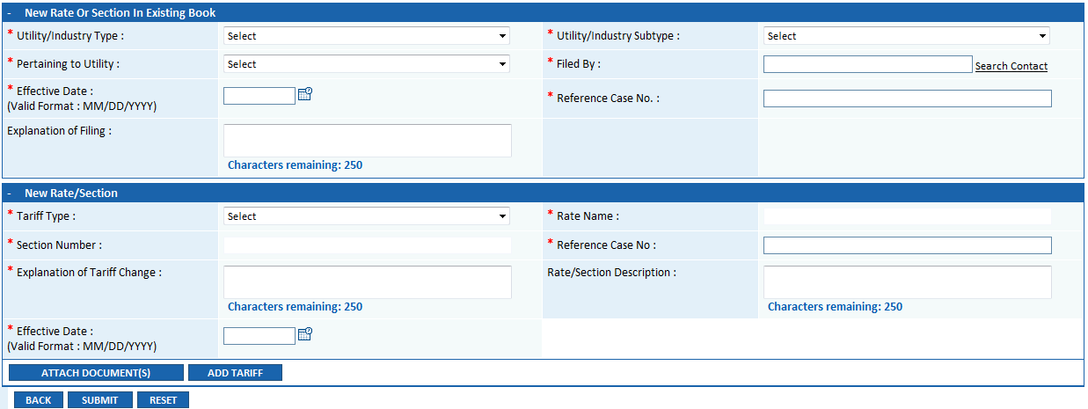

User will be required to provide data in required ( * ) fields in the following sections:
New Rate or Section in Existing Tariff Book
  - Utility/Industry Type (drop down list)
  - Utility/Industry Subtype (drop down list)
  - Pertaining to Utility (drop down list)
  - Filed By (with lookup for Search Contact hyperlink)
  - Effective Date (with calendar icon)
  - Reference Case Number
  - Explanation of Filing (multiline text box)

New Rate/Section
  - Tariff Type (drop down list)
  - Rate Name (text box) (When Tariff Type is Rate ; Section Number disabled and vice versa)
  - Section Number (text box)
  - Reference Case No. (text box)
  - Explanation of Tariff Change
  - Rate/Section Description
  - Effective Date (with calendar icon)
  - Attach Document(s) Button
  - Add Tariff Button (after attaching Rate Tariff user can click on button to append additional section for the Tariff)

  - Back, Submit and Reset Buttons

- Entry of each Rate/Section should be unique combination of tariff type and rate/section. User will be able add only one tariff for the same combination of Tariff Type/Rate/Section values.

- On unsuccessful submission, submitter will receive a message that validation failed and the submission will not be submitted in the system.

- Tariff submission will not be routed to the Clerk of Commission’s Tariff Queue.

- On successful submit, a Tariff confirmation message will be displayed

- Tariff Tracking Number will be generated (format TAR-YYYY-####, where LLL is the unique 3-digit code designated for Tariff Submissions)
- Tariff submission will be routed to the Inbox Tariff Queue of the Clerk of the Commission for processing
- Email notification confirming receipt of successful tariff submission will be sent to the Clerk of the Commission and the Submitter of the tariff

Revision to Existing Rate/Term

Objective:
- Submit Tariff Revision
Step | Action
- From the Home Page
- Click on Tariff File from the Access Menu
- From the Submenu, click on Revise Tariff
- Submit Revision To Rate/Section Screen will be displayed
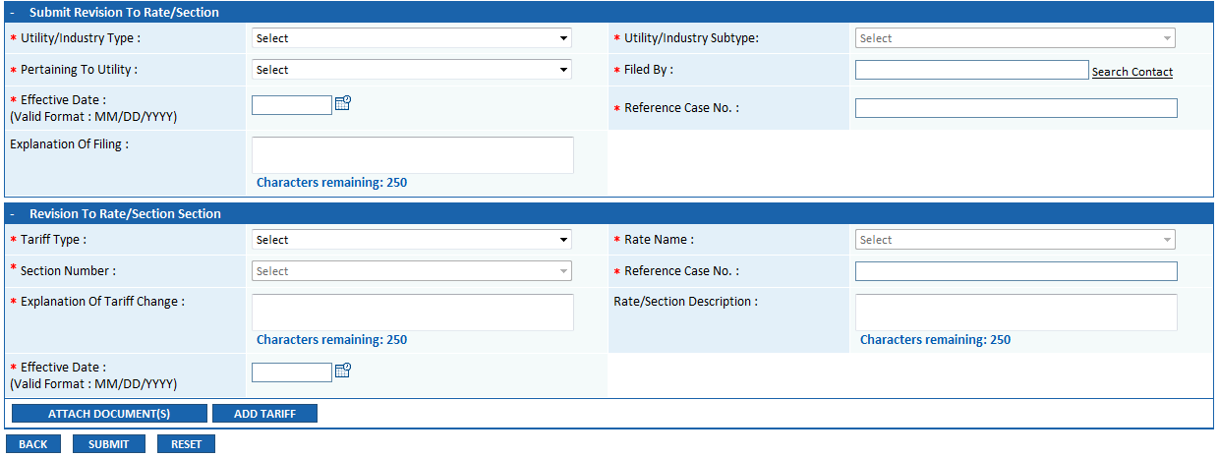

User will be required to provide data in required ( * ) fields in the following sections:
Submit Revision To Rate/Section
  - Utility/Industry Type (drop down list)
  - Utility/Industry Subtype (drop down list)
  - Pertaining to Utility (drop down list)
  - Filed By (with lookup for Search Contact hyperlink)
  - Effective Date (with calendar icon)
  - Reference Case Number
  - Explanation of Filing (multiline text box)

Revision to Rate/Section
  - Tariff Type (drop down list)
  - Rate Name (Drop Down) (When Tariff Type is Rate ; Section Number disabled and vice versa)
  - Section Number (Drop Down)
  - Reference Case No. (text box)
  - Explanation of Tariff Change
  - Rate/Section Description
  - Effective Date (with calendar icon)
  - Attach Document(s) Button
  - Add Tariff Button (after attaching Rate Tariff user can click on button to append additional section for the Tariff)

  - Back, Submit and Reset Buttons

- When External Register User logs into the application, the system should be able to identify which company (ies) they should be able to submit tariff filings on behalf of
- On the selection of the Utility/Industry Company, if Type is “Rate,” the Rate drop down list should be auto populated with the rates available in the tariff book for the selected Company
- If Type is “Term,” the Section drop down list should be auto populated with the Section(s) available in the tariff book for the selected Company
- User will be able to add more than one attachment(s) when filing a Revision to Rate/Section in Existing Book
- Filer will be required to submit tariff attachment as a PDF (Image on Text) document.

- On successful submit, a Tariff confirmation message will be displayed

- Tariff Tracking Number will be generated (format TAR-YYYY-####, where LLL is the unique 3-digit code designated for Tariff Submissions)
- Tariff submission will be routed to the Inbox Tariff Queue of the Clerk of the Commission for processing
- Email notification confirming receipt of successful tariff submission will be sent to the Clerk of the Commission and the Submitter of the tariff

Submit Complete Set of Rates/Terms in Existing Book

Objective:
- Submit Complete Set of Rates/Terms
Step | Action
- From the Home Page
- Click on Tariff File from the Access Menu
- From the Submenu, click on Submit Complete Set of Rates/Terms
- Submit Complete Set of Rates/Terms will be displayed
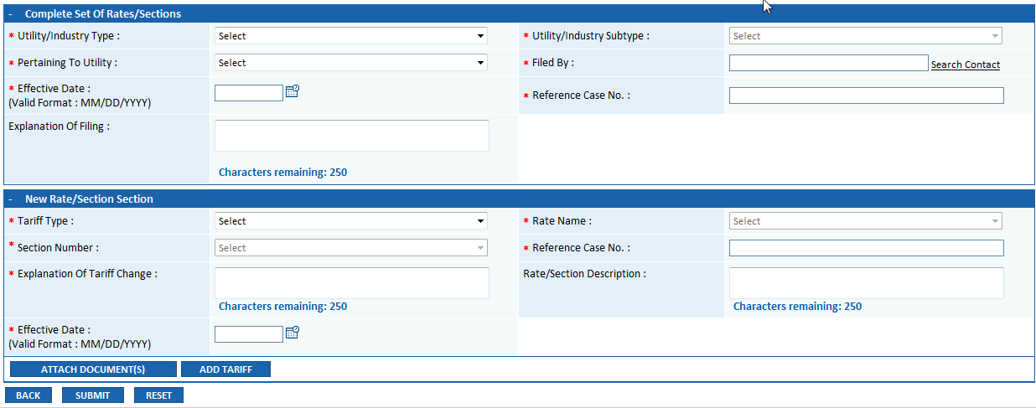

User will be required to provide data in required ( * ) fields in the following sections:
Complete Set of Rates/Sections
  - Utility/Industry Type (drop down list)
  - Utility/Industry Subtype (drop down list)
  - Pertaining to Utility (drop down list)
  - Filed By (with lookup for Search Contact hyperlink)
  - Effective Date (with calendar icon)
  - Reference Case Number
  - Explanation of Filing (multiline text box)

New to Rate/Section
  - Tariff Type (drop down list)
  - Rate Name (Drop Down) (when Tariff Type is Rate ; Section Number disabled and vice versa)
  - Section Number (Drop Down)
  - Reference Case No. (text box)
  - Explanation of Tariff Change
  - Rate/Section Description
  - Effective Date (with calendar icon)
  - Attach Document(s) Button
  - Add Tariff Button (after attaching Rate Tariff user can click on button to append additional section for the Tariff)

  - Back, Submit and Reset Buttons

- When External Register User logs into the application, the system should be able to identify which company (ies) they should be able to submit tariff filings on behalf of
- Submitter should be required to select Tariff Type: Rate or Term from mandatory drop down list.
- Filer will be required to submit tariff attachment as a PDF (Image on Text) document.
- On successful submit, a Tariff confirmation message will be displayed

- Tariff Tracking Number will be generated (format TAR-YYYY-####, where LLL is the unique 3-digit code designated for Tariff Submissions)
- Tariff submission will be routed to the Inbox Tariff Queue of the Clerk of the Commission for processing
- Email notification confirming receipt of successful tariff submission will be sent to the Clerk of the Commission and the Submitter of the tariff

View or Search a Tariff

Objective:
- View rate/term in existing tariff book

Step | Action
- From the Home Page
- Click on Tariff File from the Access Menu
- From the Submenu, click on View/Search
.

View Tariff Screen will display
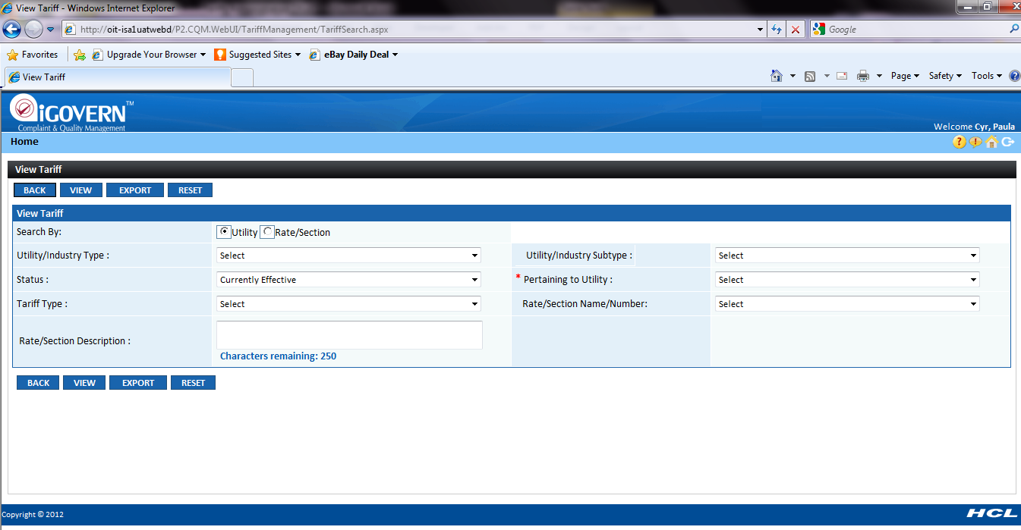

- Click respective Radio Buttons to search by utility type or rate/section
- Enter search criteria and click on View Button

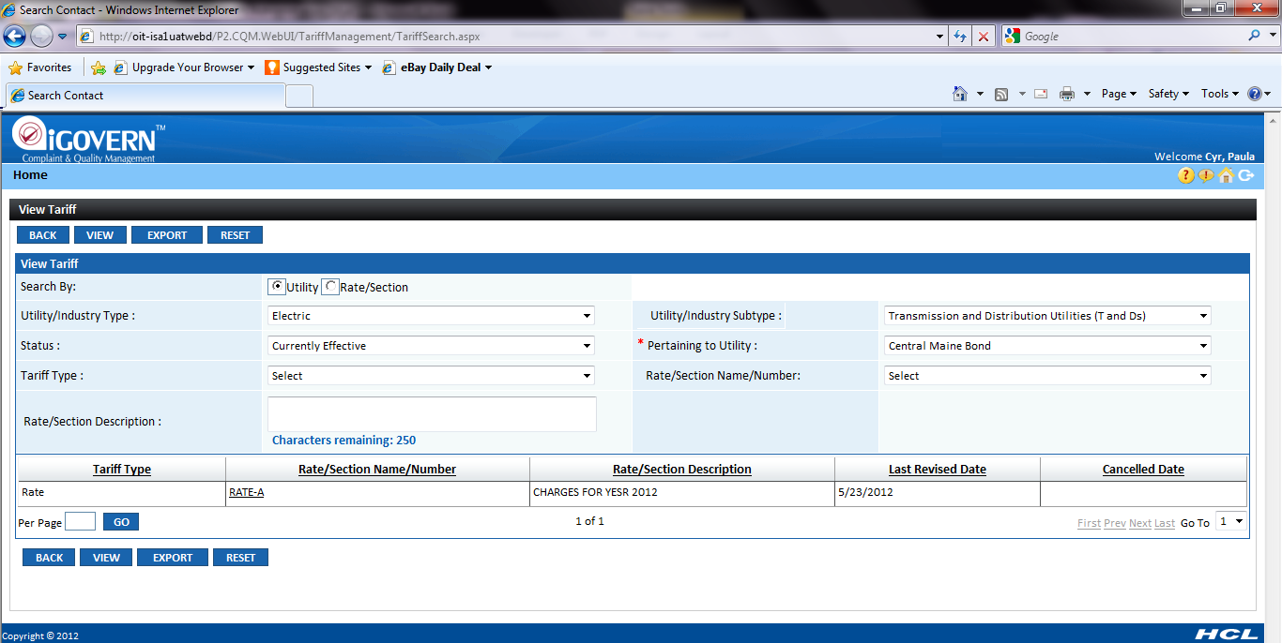
- Search results will get display. Click on Rate/Section Number hyperlink to view the associated metadata and documents.

