How To Training
For
Update Contact Information
External Registered Users will be empowered to keep their contact information up-to-date. In addition to keeping their contact information current, External Registered will also need to keep their “Representing Company/Organization” list updated as this information will be used for populating pick lists when submitting a New Case and/or Filing in a case.

Update Contact Information

Objective:

- Update Contact Information

Step | Action
 | From the Home Page , Click on Update Contact List on the access menu list
- Update Contact Information Screen will be displayed in edit mode
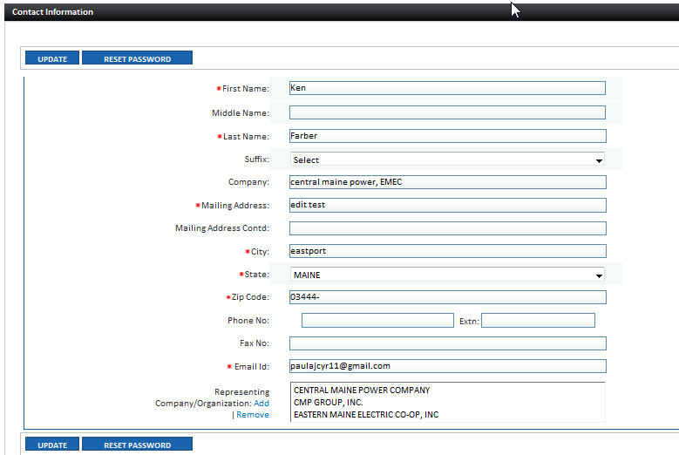

Review Representing Company/Organization details

- To update list, click on Add hyperlink
- Search for Representing Utility/Company
- Select Checkbox associated with Utility/Company that needs to be added to logged in users Representing list
- Click on Select Button
- Click on Update Button to save updated contacts

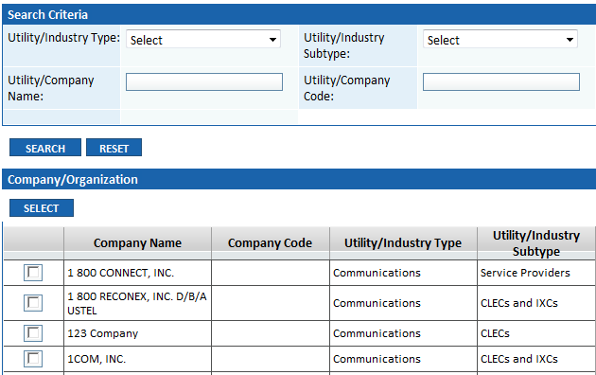

To remove a Representing Company/Organization

- Highlight Representing Name and click on Remove hyperlink

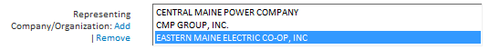

To Change Password

- Click on Reset Password Button
- Enter Old Password
- Enter New Password
- Enter Confirm New Password
- Click on Submit Button

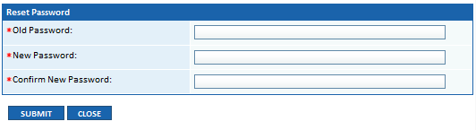
 | Click on Update Button to save changes
 | These updates will be reflected throughout the application on all Notification Lists, Active Party Lists, Master Mailing Lists, etc. to which the logged in user has subscribed.

