Bed Bug Prevention and Response Policy

The Library strives to prevent and contain the presence of bed bugs and their eggs in library facilities or on library materials. The purpose of this protocol is to ensure that you have the tools to effectively deal with the on-going presence of bed bugs in our environment.
The Library will ensure that:
- Ongoing monitoring is in place to ensure prompt and appropriate response;
- Proactive measures are taken to reduce the risk to staff and customers;
- Qualified pest control companies are contracted to work in our facilities;
- Procedures and protocols are reviewed regularly to ensure they remain current and consistent with best practices;
- Staff are kept informed of best practices for bedbug prevention and response and are actively engaged in reducing the risk of infestation.
The sections below outline the Library’s Prevention Policy for situations when Library staff or customers find or suspect bed bugs in the Library environment.
Staff Protocol – Library Facilities
If staff observes a bed bug in the facility they should contain it immediately, if possible, and alert their supervisor. The supervisor will then contact the administrator in charge or the LIC and maintenance. Maintenance staff will contain the bed bug by promptly sealing it in a ziploc plastic bag with a white sheet of paper to assist detection and identification. The suspected bed bug will then be forwarded to our pest control contractor. Special treatment may be applied by the contractor to the area of the siting.
Professional inspection and preventive treatment of the library space by qualified professionals is performed monthly. In the event that anything more than the random, isolated bed bug is reported, a trained sniffer dog and handler will be brought in to inspect the entire library building.
When a sniffer dog detects the scent of a bed bug, this area is referred to as a localized hit. A visual inspection by the dog handler is also carried out. The Library treats all areas identified by the sniffer dogs as localized hits regardless of whether there are sightings of bed bugs or not, and they will be treated.
In addition to regular professional monitoring, staff will routinely inspect all areas of the Library including furniture, stacks and carpeted areas for signs of infestation. Any signs of suspected infestation detected by staff or reported by Library patrons will be promptly reported to the Library administration for further inspection and response.
Any localized areas identified during ongoing monitoring will be treated individually; methods of treatment will be determined based on the size and nature of the area affected.
Staff Protocol – Affected Library Materials
Staff will also routinely inspect all incoming materials, including those returned at the public desks, in the book drops and through inter-library delivery, for signs that bed bugs are or have been present. These signs include eggs, nymphs, adult bed bugs, feces, and spotting associated with bed bugs.
If staff suspects that an item is affected, promptly seal it in a plastic container with a white sheet of paper to assist detection and identification. Items that are significantly infested or damaged will be destroyed; items with minor or suspected signs only will be promptly sealed in plastic, dated, and treated, after which they will be re-inspected. All Library items determined or suspected to be impacted will be reported and logged for monitoring and collection replacement purposes.
If a bed bug is seen on a book in the return bin, on a cart or on the shelves, place the book in a sealed plastic container. Books in the immediate location will be removed from their public location and inspected or treated individually, re-inspected and returned to circulation.
Staff Protocol – Internal Communication
Whenever a bed bug or suspected bed bug is seen, the staff person should contain the bug and immediately notify his or her supervisor. If the supervisor is not available, staff should communicate with the Librarian in Charge at their site. The supervisory person notified will alert maintenance and together they will determine to what extent additional materials should be segregated and the manner of segregation. It is imperative that the supervisory person on the scene notify all staff working in the area and scheduled to work in the area for the next day that this incident has occurred. While communication to staff working in the area is critical, an all staff e-mail should not be issued to accomplish this task.

Public Information Protocol
If a patron finds a bug or pest in library materials, ask the patron to immediately place the library material(s) in a plastic bag with a white sheet of paper and seal it as tightly as possible. Re-sealable “Ziploc” type bags are recommended and patrons are asked to seal the bag opening with tape to ensure secure closure.
Please reassure the patron that it is our standard procedure to ask them to do this as a precaution to guard against the worst case. Ask the patron to return the material to the Library in the sealed bag and to notify staff of the problem when the material is returned. Tell the patron not to use book drops or return bins at lending for materials with possible issues, but to hand them to staff.
Materials will either be treated or discarded at the Library’s discretion.

Public Donations Protocol
Donors are kindly asked to inspect materials prior to donating them to the library and to deliver them to the loading dock . Library staff will perform an intake inspection as soon as possible. The Library reserves the right to discard materials with signs of past or present bug activity.
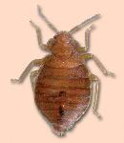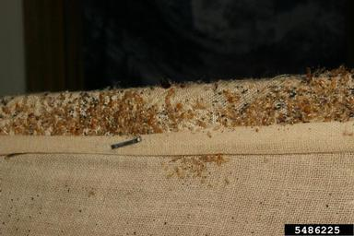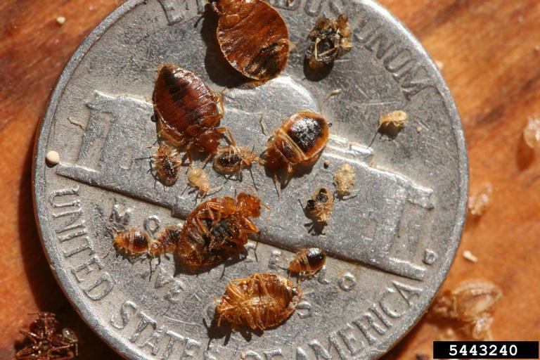
Adult bed bug An infestation Relative size
For Further Information
http://solutionsforyourlife.ufl.edu/bed_bugs/index.shtml
http://edis.ifas.ufl.edu/ig083

