Try “sifting and sorting” to find the

resource you need!

The new Digital Maine Library provides a fun and visual way to narrow down the number of resources you may want to explore for the information you seek.
Our “Sift and Sort” technology allows you to sort by subject, resource type or audience.

An elementary school student or teacher can select Elementary for the drop-down menu under Audience.

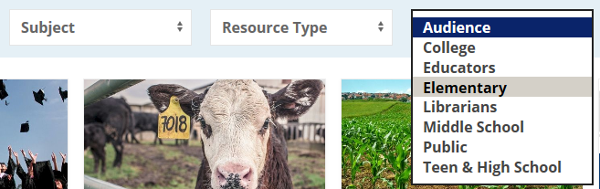

The resulting list of resources are those that we have tagged with the Elementary identifier. If you click on the Elementary tag, a page is created by the database for you to bookmark.

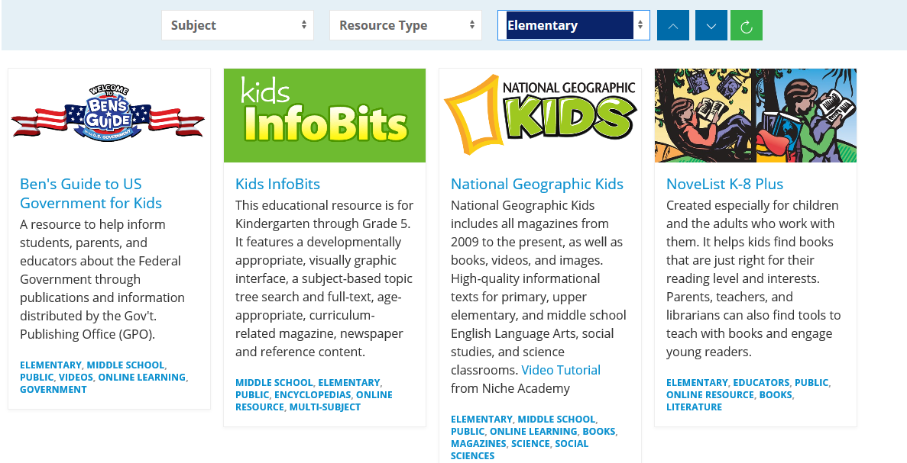

The page is created at: https://library.digitalmaine.org/audience/elementary/

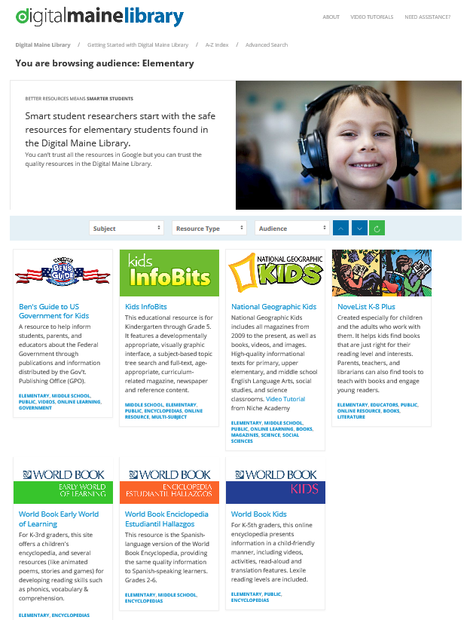

The same method can be used for the other Audiences, Resource Types or Subjects. Find all the resources with Science information by selecting Science as a Subject. Find all the resources with video content by selecting Video as Resource Type.
If you know what resource you want to use, click A-Z in the top navigation and an alphabetical and scrollable list will slide in from the left.
For those accessing the site using screen reader technology, they will be directed to a text only page with resource names and descriptions matching the same content. https://library.digitalmaine.org/all-databases/
FMI – info@digitalmainelibrary.com https://library.digitalm1aine.org August 2018

