LibraryWorld Statistics for the Annual Report

It’s a multistep process to get statistics from LibraryWorld. It will be considerably easier, if you have consistently used the Location and Collection Fields in your cataloging records.

Collection Statistics
The annual report asks for total print volumes for children/young adult and for adults. Total physical audios and videos aren’t broken out by age range.
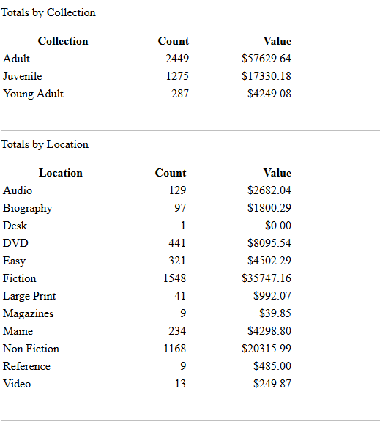

To get the audio and video counts, click on Reports. Go down to the bottom of that page to Other Reports. Click on Library Status Report. You should be able to find the totals in either the collection or location part of that report depending on how you used those fields.

The procedure is more complicated for total print volumes:
Click on Catalog, then click on Advanced.
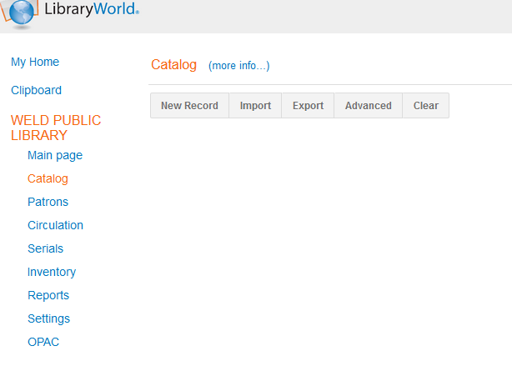
Create a Find Set by using the drop down menu to do a range search on either the Collection Field or the Location Field depending on which one you used to designate Adult, Young Adult and Juvenile.

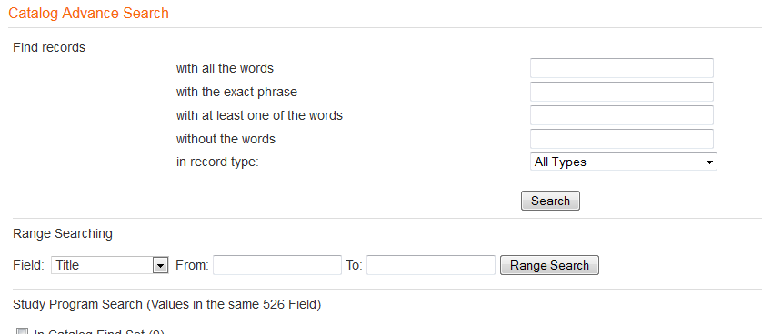
adult
adult

Click on Reports and go to Holdings Report by Location. On the next screen, choose Find Set Only. You will get a list of everything assigned to the Adult collection, for example. You can print this list and manually count the books or you can use the Edit menu to Select All and copy and paste the entire list into Excel where you can then use formulas to calculate the totals. Follow this same procedure to calculate the total Juvenile and Young Adult print materials.

Circulation Statistics

Again, you will want to create a find set for each category (Adult, Young Adult and Juvenile) following the procedure outlined above.

When you have your find set, click on Reports, look for Circulation Reports, then click on Circulation Activity Report.
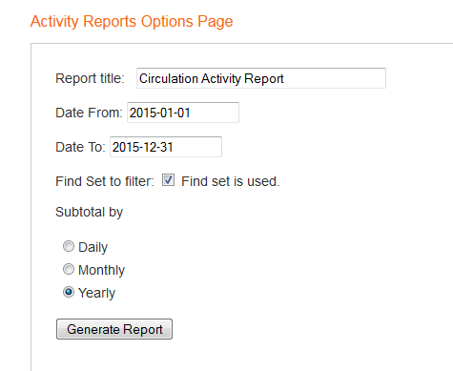
Put in your fiscal year. Make sure you click “Find set is used”. Then click on subtotal yearly. Click Submit. Record the total for your annual report. Repeat this procedure to get the circulation for Young Adult and Juvenile materials.

