Maine State Library Mobile Guide

The Maine State Library (MSL) mobile is the mobile version of the MSL/URSUS web catalog and more!

Visit the app store to download the Library Anywhere app or navigate to the mobile version of the Maine State Library catalog - URSUS or go to http://www.libanywhere.com/m/613.

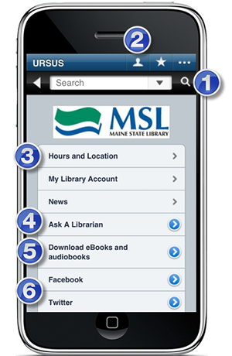

1. Search the catalog. Enter the terms in the search box then select the magnifying glass icon to search URSUS, the Maine State Library catalog.

2. Access your library account. Click on the "head" icon to access your URSUS account which will list your checkouts, holds, and fines.

3. Check hours and location for Maine State Library.

4. Ask a Librarian either by phone, email, or visit the library for help.

5. Download eBooks and audiobooks easily through the InfoNet Download Library, right from your mobile device.

6. Join Maine State Library on Facebook or follow us on Twitter!

Here is an example of a full MSL/URSUS record with information about some of the features of Library Anywhere for MSL/URSUS mobile catalog.

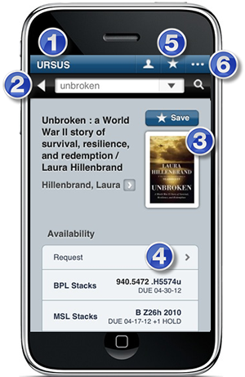

1. URSUS mobile. Clicking on this button will take you back to the URSUS mobile main menu.

2. Return to Search Results display. Click the back arrow to view the previous screen's browse display of search results.

3. Save/Bookmark an URSUS Title: Use this "Save" button to bookmark a title for the future.

4. Request a Title: Use the forward arrow to place a hold on the title from your device. You will be prompted to log into your library account.

5. View Saved/Bookmarked Titles. Click on the "star" to retrieve any bookmarked titles.

6. Browse to find another mobile library site. Use the "dotted line" icon to locate other mobile library sites.

