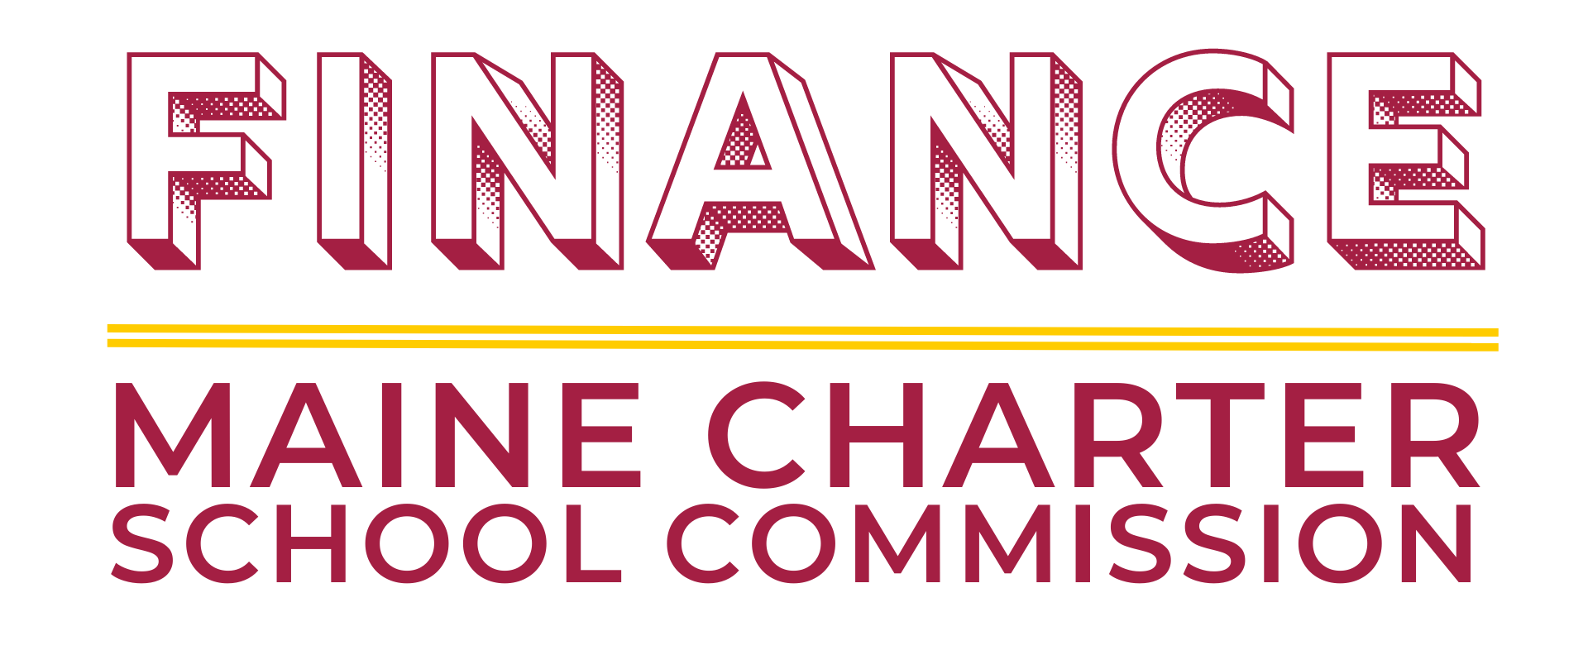
June 8, at 1pm via Zoom
Members | Present
Commission Members:
- Leigh Weisenburger Albert, Chair
- Norman Higgins
- VACANT
Other:
- Lana Ewing, Executive Director
- Amy Allen, Staff Designee
- Joe Drago, Staff Consultant

Item | Discussion | Action
Standard Agenda Items
Financial Audits |  | HCA is the last audit to be received. March was received in March … HCA extension through May 5th.
Financial Health of Each School/Portfolio

Budget vs. Actual Report(s)/Spending Dashboard (Commission Meeting Agenda Item #11b)
Amendment Requests/Fund Requests
- Community Regional Charter School’s Request for Partial BoardOnTrack Funding (Commission Meeting Agenda Item #10b)
Request to Incur Debt | None to discuss.
Ad-Hoc Agenda Items
Review the 2021-22 Annual Monitoring Reports Addendum (Commission Meeting Agenda Item #9a)
Review the Proposed Commission Per Diem Policy (Commission Meeting Agenda Item #10a)
FY24 Contracting Preview
Commission Staffing
- Benefits
- Staffing Options

