ORDERING PROCESS:
Ordering Process: Request can be received by the following methods:
Email: customers@ideatranslations.com
Online: https://customers.ideatranslations.com/
Available via telephone at 860-781-6377
Fixed Cost Per English Word rate for the twelve (12) most common languages:  Spanish, Arabic, French, Somali, Lingala, Vietnamese, Kinyarwanda, Khmer, Portuguese, Chinese, Russian, Swahili | $ 0.13
Proposed Fixed Cost Per English Word rate for other languages: | $ 0.17
Additional Rate:
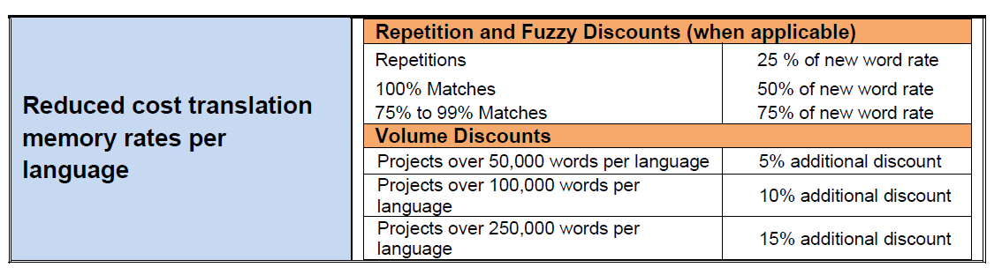
Formatting and Desktop Publishing Rates | $ 20.00/hour

Proposed Fixed Cost for another language to English | $ 0.17

