STATE OF MAINE
Governor’s Office of Policy Innovation and the Future

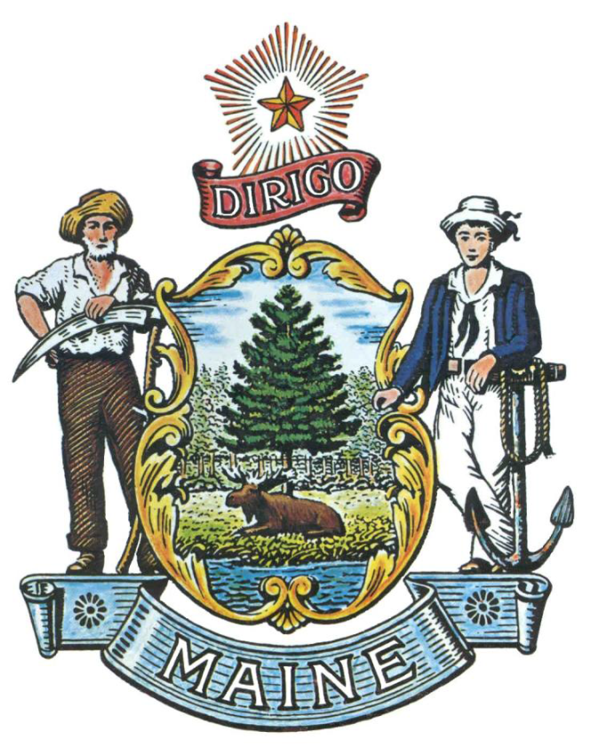

REQUEST FOR INFORMATION

RFI# 202406118

Vulnerability Assessment of State Infrastructure

RFI Coordinator | All communication regarding this RFI must be made through the RFI Coordinator identified below.  Name: Hannah Silverfine Title: Climate Risk Management Project Coordinator  Contact Information: hannah.silverfine@maine.gov
Response Submission | Submission Deadline: Friday, July 26, 2024, no later than 5:00 p.m., local time  Submit to: hannah.silverfine@maine.gov

TABLE OF CONTENTS

PUBLIC NOTICE 3

RFI DEFINITIONS/ACRONYMS 4

PART I INTRODUCTION 5

- PURPOSE AND BACKGROUND
- CURENT CONDITIONS
- CHALLENGE STATEMENT
- GENERAL PROVISIONS

PART II INFORMATION SOUGHT 8

- GENERAL INFORMATION
- FEEDBACK REQUESTED

PART III KEY RFI EVENTS AND PROCESSES 10

- SUBMITTING THE RESPONSE

PART IV REVIEW OF RESPONSES RECEIVED 11

RFI APPENDICES AND RELATED DOCUMENTS 12

APPENDIX A – RESPONSE COVER PAGE

PUBLIC NOTICE

*************************************************

State of Maine
Governor’s Office of Policy Innovation and the Future
RFI# 202406118
Vulnerability Assessment of State Infrastructure

The State of Maine, Governor’s Office of Policy Innovation and the Future, is seeking information regarding a climate vulnerability assessment of state-owned infrastructure and engaging state agencies in mitigation and adaptation strategies.

A copy of the RFI and all other related documents to this RFI, can be obtained at the following website: http://www.maine.gov/dafs/bbm/procurementservices/vendors/rfis

Responses must be submitted to: hannah.silverfine@maine.gov and be submitted by 5:00 pm, local time, on Friday, July 26, 2024.

*************************************************
RFI DEFINITIONS/ACRONYMS

The following terms and acronyms shall have the meaning indicated below as referenced in this Request for Information:

Term/Acronym | Definition
RFI | Request for Information
RFP | Request for Proposal
State | State of Maine
Office | Governor’s Office of Policy Innovation and the Future
FOAA | Maine Freedom of Access Act
Respondent | Any individual or organization submitting a response to this RFI.
State Hazard Mitigation Plan (HMP) | Maine Emergency Management Agency plan complying with federal requirements under the Stafford Act for state hazard mitigation plans. Provides an assessment of current and anticipated risks from natural hazards, many of which are exacerbated by climate change, an analysis of existing capabilities and adaptive capacity, and a mitigation strategy to implement risk reduction and to fill capability gaps.
Maine Won’t Wait | Maine State Climate Action Plan
State Assets | State government property such as land, buildings, infrastructure.

State of Maine - Governor’s Office of Policy Innovation and the Future
RFI# 202406118
Vulnerability Assessment of State Infrastructure

PART I INTRODUCTION

A. Purpose and Background

This Request for Information (RFI) is an information gathering and market research tool, not a formal solicitation of a specific requirement (such as in a “Request for Proposals” document). The Governor’s Office of Policy Innovation and the Future (“Office”) is seeking information regarding a Vulnerability Assessment of State Infrastructure from interested parties as defined in this RFI document. This is an opportunity for interested parties to help the Office better understand this specific subject matter.

This RFI is part of a larger effort set forth by the state’s four-year climate action plan, Maine Won’t Wait, to assess climate vulnerability and provide climate-ready design guidance to support the resilience of state infrastructure. The Office is seeking to expand the current available information on vulnerability of state assets by enhancing state agency mitigation strategies and building agency and local capacity through technical assistance and training.

Maine Won’t Wait specifies three areas of inquiry to understand climate vulnerability of assets:
- The climate hazards to which assets are exposed, including likelihood and intensity of hazard;
- The asset’s susceptibility to damage or failure; and
- The consequence of asset impairment on public health and safety, state and local economics, and environmental and natural resources.

The purpose of this RFI is to gather input on options and considerations for the Office’s efforts in:
- Understanding the climate vulnerability of state-owned facilities;
- Approaches for the State to inform and assist state agencies in mitigating and adapting to asset vulnerabilities, and distinctions in agency-specific guidance for climate risk management; and
- Frameworks for state vulnerability and risk management, including highly significant data sources.

Participation in this RFI process is optional. Feedback is greatly appreciated and will inform the development of the State vulnerability assessment priorities and process.

B. Current Conditions

The Office has been working with the Maine Climate Council to implement the recommendations of Maine Won’t Wait to improve the climate readiness and resilience of infrastructure so that it serves Maine better under day-to-day conditions and functions reliably during emergencies. In support of these recommendations, Maine state government’s Lead By Example plan calls for assessing the vulnerability of state-owned assets to climate change impacts and developing more specific guidance for state agencies to integrate climate risk management into asset construction and maintenance. The Office seeks to enhance existing information and develop tailored approaches for state agencies to mitigate and adapt their agency-specific asset vulnerabilities.

In 2023, the Maine Emergency Management Agency (MEMA) completed a state Hazard Mitigation Plan (HMP) in accordance with the Federal Emergency Management Agency (FEMA) requirements. This is a primary resource that compiled state assets and assessed the vulnerability of the assets by hazard type. The HMP includes many but not all the infrastructure types listed in the state climate action plan. The HMP separates Maine’s natural hazards into Tier 1 (higher priority due to historically proven risk) and Tier 2 (moderate risk to communities, may increase with climate change effects).

The HMP provides an initial analysis of state agency asset vulnerabilities, and the Office seeks to develop a framework and approaches for assisting state agencies in mitigating and adapting to agency-specific asset vulnerabilities.

Further information on vulnerability assessments in Maine is available in the following resources:
- MEMA State Hazard Mitigation Plan, 2023
- Maine Climate Council Vulnerability Mapping, 2020
- Maine Climate Council Scientific and Technical Subcommittee Report, 2024

C. Challenge Statement

The RFI is intended to explore an overarching question: What are factors the Office should consider in a state vulnerability assessment in order to understand and address the risks climate change poses to state agencies’ facilities and their ability to serve the people of Maine?

D. General Provisions

- All contact with the State regarding this RFI must be made through the aforementioned RFI Coordinator. No other person/ State employee is empowered to make binding statements regarding this RFI.
- This is a non-binding Request for Information. Therefore, no award shall be made as a result of the RFI process.
- Issuance of this RFI does not commit the Office to pay any expenses incurred by a Respondent in the preparation of their response to this RFI. This includes attendance at personal interviews or other meetings and software or system demonstrations, where applicable.
- Issuance of this RFI in no way constitutes a commitment by the State of Maine to issue a Request for Proposal (RFP).
- All responses should adhere to the instructions and format requests outlined in this RFI and all written amendments issued by the Office.
- All submissions in response to this RFI will be considered public records available for public inspection pursuant to the State of Maine Freedom of Access Act (FOAA) (1 M.R.S. §§ 401 et seq.): State of Maine Freedom of Access Act
- All applicable laws, whether or not herein contained, shall be included by this reference. It shall be Proposer’s/Vendor’s responsibility to determine the applicability and requirements of any such laws and to abide by them.

PART II INFORMATION SOUGHT

The Office seeks information regarding a Vulnerability Assessment of State Infrastructure and welcomes responses to this RFI, including creative suggestions and feedback to enhance and expedite all future processes while providing efficient, reliable and high-quality outcomes. Respondents are not required to submit responses pertaining to every question, but the Office encourages interested parties to respond to any or all relevant aspects of the RFI.

The Office seeks detailed yet succinct responses that demonstrate the Respondent’s experience and/or familiarity with the subject matter. As this is not a competitive RFP process, Respondents must not provide any specific cost or customized pricing documentation in their response.

- General Information

Provide a brief overview of yourself and your organization, if applicable.

  - Please identify yourself and any organization you represent in this RFI.
    - Name of respondent
    - Organization and affiliation
    - Address (organizational, if responding on behalf of an entity)
    - Contact information (phone number(s) and email address)
- Please identify your experiences in providing support of vulnerability assessment(s). Please describe an example of a climate vulnerability or climate risk assessment(s) your organization has conducted and include the scale of assessment covered (e.g. town, regional, sector...). If your organization has conducted any statewide vulnerability assessment(s) please highlight those examples.

- Feedback Requested

Please address the Challenge Statement (Part 1.C) paying particular attention to the following questions:

- Given the information contained in the State HMP (and other readily available sources), how might the Office approach next steps for assessing the vulnerability of state-owned infrastructure to climate change impacts in Maine?
- How might the Office work with state agencies to incorporate mitigation and adaptation steps in response to the vulnerability assessment?
  - What are options for tailoring the vulnerability assessment approach to state agency-specific facility types, mission goals, constituents, and services?
- What vulnerability or risk frameworks would best facilitate state agencies’ understanding of the risks and vulnerabilities of their assets, and how their mission, employees, and services, may be impacted?

- How might the Office design a framework for understanding, communicating, and mitigating, and tracking changes in climate vulnerability across state agency infrastructure?
- What additional information or analyses would significantly improve an agency’s understanding of its risks? What level of effort is required to obtain this information?

PART III KEY RFI EVENTS AND PROCESSES

Submitting the Response

- Responses Due
Responses must be received no later than the date and time listed in the timeline above.

- Delivery Instructions
Responses must be submitted to the RFI Coordinator, via e-mail, listed on the cover page of this RFI document.

- Response Format
Responses to this RFI may be developed in a manner that suits the respondent. A list of key questions is included within the RFI and all submissions, regardless of format will be reviewed. Respondents are asked to be brief and to respond to as many questions as possible within the RFI. Number each response to correspond to the relevant question or instruction of the RFI to allow comparison and clarity.

PART IV REVIEW OF RESPONSES RECEIVED

General Information

- The Department will review responses received for the purpose of gathering information and market research only. The Department will not score or rate responses received.

- The Department reserves the right to communicate and/or schedule interviews/presentations with Respondents, if needed, to obtain clarification of information contained in the responses received and/or additional information to enhance marketing research efforts.

APPENDIX A

STATE OF MAINE
Governor’s Office of Policy Innovation and the Future

RESPONSE COVER PAGE
RFI# 202406118
Vulnerability Assessment of State Infrastructure

Lead Point of Contact - Name/Title:
Organization Name (if applicable):
Tel: |  |  | Fax:
E-Mail: |  |  | Website:
Street Address:
City/State/Zip:

