STATE OF MAINE
Department of Transportation
Results and Information Office

RFP# 202309195

Pavement and Bridge Asset Management Software as a Service

RFP Coordinator | All communication regarding the RFP must be made through the RFP Coordinator identified below.  Name: Jennifer Chisum Title: Systems Team Leader  Contact Information: jennifer.chisum@maine.gov
Submitted Questions Due | All questions must be received by the RFP Coordinator identified above by:  Date: October 17, 2023 no later than 11:59 p.m., local time
Proposal Submission | Proposals must be received by the Division of Procurement Services by:  Submission Deadline: November 14, 2023 no later than 11:59 p.m., local time.  Proposals must be submitted electronically to the following address:  Electronic (e-mail) Submission Address: Proposals@maine.gov

TABLE OF CONTENTS
 | Page
PUBLIC NOTICE | 3
RFP DEFINITIONS/ACRONYMS | 4
PART I INTRODUCTION | 5
- PURPOSE AND BACKGROUND
- GENERAL PROVISIONS
- ELIGIBILITY TO SUBMIT BIDS
- CONTRACT TERMS
- NUMBER OF AWARDS
PART II SCOPE OF SERVICES TO BE PROVIDED | 8
PART III KEY RFP EVENTS | 9
- QUESTIONS
- AMENDMENTS
- SUBMITTING THE PROPOSAL
PART IV PROPOSAL SUBMISSION REQUIREMENTS | 11
PART V PROPOSAL EVALUATION AND SELECTION | 13
- EVALUATION PROCESS – GENERAL INFORMATION
- SCORING WEIGHTS AND PROCESS
- SELECTION AND AWARD
- APPEAL OF CONTRACT AWARDS
PART VI CONTRACT ADMINISTRATION AND CONDITIONS | 15
- CONTRACT DOCUMENT
- STANDARD STATE CONTRACT PROVISIONS
PART VII RFP APPENDICES AND RELATED DOCUMENTS | 16
APPENDIX A – PROPOSAL COVER PAGE
APPENDIX B – DEBARMENT, PERFORMANCE, and
NON-COLLUSION CERTIFICATION
APPENDIX C – QUALIFICATIONS and EXPERIENCE FORM
APPENDIX D – COST PROPOSAL FORM
APPENDIX E – SUBMITTED QUESTIONS FORM
APPENDIX F – PROPOSED SERVICES AND PROJECT SCHEDULE
FORM
APPENDIX G – PROPOSED SERVICES REQUIREMENTS
WORKSHEET
APPENDIX H – PROPOSED SERVICES IT POLICY FORM

PUBLIC NOTICE

*************************************************

State of Maine
Department of Transportation
RFP# 202309195
Pavement and Bridge Asset Management Software as a Service

The State of Maine is seeking proposals for Pavement and Bridge Asset Management Software.

A copy of the RFP, as well as the Question & Answer Summary and all amendments related to the RFP, can be obtained at: https://www.maine.gov/dafs/bbm/procurementservices/vendors/rfps

Proposals must be submitted to the State of Maine Division of Procurement Services, via e-mail, at: Proposals@maine.gov. Proposal submissions must be received no later than 11:59 p.m., local time, on November 14, 2023. Proposals will be opened the following business day. Proposals not submitted to the Division of Procurement Services’ aforementioned e-mail address by the aforementioned deadline will not be considered for contract award.

*************************************************

RFP TERMS*/ACRONYMS with DEFINITIONS

The following terms and acronyms, as referenced in the RFP, shall have the meanings indicated below:

Term/Acronym | Definition
ACORD | Association for Cooperative Operations Research and Development
ADFS | Active Directory Federation Services
ARAN | Automatic Road Analyzer- Department’s current Highway Data Collection Vehicle System
Department | Department of Transportation
Department’s LRS | The Department’s Linear Reference System, AssetWise Asset Lifecycle Information Management (ALIM)
DOT(s) | State Department of Transportation(s)
FWHA | Federal Highway Administration
MaineDOT Work Plan | A three-year work plan that outlines the work that Maine DOT plans to perform over the next three years.
HPMS | Highway Performance Monitoring System - Federal Highway Administration program which collects information on the nation’s highway system.
Off-the-shelf software | Software application that is commercially ready - made and maintained, and available for sale, lease, or license to the general public.
RFP | Request for Proposal
RPO | Recovery Point Objective - The amount of data the system can afford to lose following an outage without causing significant harm to the operations.
RTO | Recovery Time Objective - The amount of time within which the system must be restored following an outage to prevent a significant loss of data.
SaaS | Software as a Service - A software distribution model in which a third-party Provider hosts an application and makes the application available to customer via the Internet.
State | State of Maine

State of Maine - Department of Transportation
Results and Information Office
RFP# 202309195
Pavement and Bridge Asset Management Software as a Service

PART I INTRODUCTION

- Purpose and Background

The Department of Transportation (Department) is seeking Pavement and Bridge Asset Management Software as a Service as defined in this Request for Proposal (RFP) document. This document provides instructions for submitting proposals, the procedure, and criteria by which the awarded Bidder will be selected, and the contractual terms which will govern the relationship between the State of Maine (State) and the awarded Bidder.

The Department is responsible for 8,800 centerline miles of highway and 3,000 bridges. The Department requires SaaS with the capability to store, process, maintain and update inventory and condition data for these highway and bridge assets. The highway and bridge assets are on the same network but processed and stored separately.

Based on the software’s forecasting and deterioration modeling, the software must perform life-cycle cost analysis of alternative maintenance/capital work strategies to determine the optimal strategy given defined parameters, to identify short and long-term budget needs, and ensure that bridge and highway assets are in a State of Good Repair. For example, over 20 years, how often should a road with specific traffic/construction parameters have pavement rebuilt rather than patched for optimal cost/performance balance? To determine the best treatment approach for its assets, the Department currently utilizes the Incremental Benefit Cost (IBC) optimization approach that maximizes benefits while meeting a cost constraint. Based on the results of these analyses, the Department generates recommended work programs and implementation schedules. The Department is open to other optimizations approaches if they meet our business requirements. The software will be required to produce reports and maps of the assets and analysis results for publication, and Highway Performance Monitoring System (HPMS) reporting requirements for the Federal Highway Administration (FWHA) for their funding decisions.

The Department intends to continue use of the current provider, Deighton Associates Limited, through Spring 2023 to complete the analyses from the Bridge Inspection data and ARAN data that is used to fulfill 2023 MaineDOT Work Plan development and reporting requirements.

- General Provisions

  - From the time the RFP is issued until award notification is made, all contact with the State regarding the RFP must be made through the RFP Coordinator. No other person/ State employee is empowered to make binding statements regarding the RFP. Violation of this provision may lead to disqualification from the bidding process, at the State’s discretion.
  - Issuance of the RFP does not commit the Department to issue an award or to pay expenses incurred by a Bidder in the preparation of a response to the RFP. This includes attendance at personal interviews or other meetings and software or system demonstrations, where applicable.
  - All proposals must adhere to the instructions and format requirements outlined in the RFP and all written supplements and amendments (such as the Summary of Questions and Answers), issued by the Department. Proposals are to follow the format and respond to all questions and instructions specified below in the “Proposal Submission Requirements” section of the RFP.
  - Bidders will take careful note that in evaluating a proposal submitted in response to the RFP, the Department will consider materials provided in the proposal, information obtained through interviews/presentations (if any), and internal Departmental information of previous contract history with the Bidder (if any). The Department also reserves the right to consider other reliable references and publicly available information in evaluating a Bidder’s experience and capabilities.
  - The proposal must be signed by a person authorized to legally bind the Bidder and must contain a statement that the proposal and the pricing contained therein will remain valid and binding for a period of 180 days from the date and time of the bid opening.
  - The RFP and the awarded Bidder’s proposal, including all appendices or attachments, will be the basis for the final contract, as determined by the Department.
  - Following announcement of an award decision, all submissions in response to this RFP will be public records, available for public inspection pursuant to the State of Maine Freedom of Access Act (FOAA) (1 M.R.S. § 401 et seq.).
  - The Department, at its sole discretion, reserves the right to recognize and waive minor informalities and irregularities found in proposals received in response to the RFP.
  - All applicable laws, whether or not herein contained, are included by this reference. It is the Bidder’s responsibility to determine the applicability and requirements of any such laws and to abide by them.
  - Interested parties are advised that under Maine’s Freedom of Access Act, Title 1 M.R.S.A. Chapter 13 §402 (3), et seq., “Public Records” (as that term is defined in: Title 1, § 402: Definitions) are available for public inspection and copying once an award notification has been made.

As a general matter, information submitted in response to this RFP will be considered to be “Public Records”, available for public inspection and copying, once an award notification has been made. If, however, a Proposer believes that parts of its Technical Proposal fall within one or more of the exceptions to the definition of “Public Records” set forth in Title 1 M.R.S.A. Chapter 13 §402(3), that Proposer may submit those parts of its Technical Proposal, with each page marked “Confidential”. Proposers must include a non-confidential statement of the basis for Proposer’s claim that those parts of its Technical Proposal fall within one or more of the exceptions to the definition of “Public records”. Designating part of a Technical Proposal “Confidential” does not, by itself, ensure that those parts of the Technical Proposal will remain confidential. Technical Proposals with no sections designated as “Confidential” will be considered public information after award notification and will be released as such when requested.

In the event MaineDOT receives a request to inspect or copy those parts of the Proposer’s Technical Proposal marked confidential, MaineDOT will notify the Proposer that such a request has been received. If MaineDOT agrees that the documents so identified fall within one of the exceptions to the definition of “Public Records”, MaineDOT will notify the party requesting disclosure (“Requestor”) that the documents will be withheld. If MaineDOT determines that the confidential designation submitted is overbroad, MaineDOT will contact the Proposer in an effort to narrow the confidential designation. If the Proposer disagrees with MaineDOT’s determination of what constitutes public records available for disclosure, the Proposer can seek a protective order or other legal remedy under Title 1, § 409. If the Requestor files a legal action to gain access to confidential information withheld under this section, then the Proposer must retain counsel and file for a protective order. Proposer’s failure to join the action and secure a protective order shall constitute a waiver of its claim that the information is confidential. MaineDOT will comply with the order issued by the reviewing court.

- Contract Term

The Department is seeking a cost-efficient proposal to provide services, as defined in the RFP, for the anticipated contract period defined in the table below. Please note, the dates below are estimated and may be adjusted, as necessary, in order to comply with all procedural requirements associated with the RFP and the contracting process. The actual contract start date will be established by a completed and approved contract.

Contract Renewal: Following the initial term of the contract, the Department may opt to renew the contract for 2 renewal periods, as shown in the table below, and subject to continued availability of funding and satisfactory performance.

The term of the anticipated contract, resulting from the RFP, is defined as follows:

Period | Start Date | End Date
Initial Period of Performance (3 years) | February 1, 2024 | January 31, 2027
Renewal Period #1 (3 years) | February 1, 2027 | January 31, 2030
Renewal Period #2 (3 years) | February 1, 2030 | January 31, 2033

- Number of Awards

The Department anticipates making one award as a result of the RFP process.

PART II SCOPE OF SERVICES TO BE PROVIDED

Requirements are organized into three sections in this RFP:
- This section, Part II Scope of Services to be Provided has the requirements not requiring a written Proposer response in the proposal.
- APPENDIX F – PROPOSED SERVICES AND PROJECT SCHEDULE FORM has requirements requiring written Proposer response in the proposal.
- APPENDIX G – PROPOSED SERVICES REQUIREMENTS WORKSHEET has requirements requiring a short-format Proposer response in the proposal.
- APPENDIX H – PROPOSED SERVICES IT POLICY FORM has IT policy requirements requiring written Proposer response in the proposal.

A. The Department requires the following services and materials in summary:
- Pavement and Bridge Asset Management Software

- Implementation Services - All configuration and initial data setup, initial training, support of Departmental deployment testing, remediation of testing issues, customer support, and related services as appropriate to ensure the Department’s effective use and administration of the service.

- Ongoing customer support

General Requirements

  - Implementation services

    - Project management of the implementation including maintenance of a detailed implementation plan with schedule and milestones, and biweekly status reporting to the Department Contract Administrator and Program Administrator until the acceptance of completion of the implementation by the Department Contract Administrator. Biweekly reports will include actions performed in period, actions planned for next period, risks, and issues.

    - The vendor will maintain documentation of formulas and computations available to the Department at any time.
    - All work performed by the Provider will occur offsite.

  - Data Export at Termination of Contract
Upon termination of the contract, or in preparation for contract termination, at no additional charge, regardless of reason for termination, Departmental data must be provided to the Department on request in usable format such as Excel spreadsheets for import into a new SaaS and/or for long-term Departmental storage. Requested data must be provided by the Provider within 15 business days of Departmental request. The Department’s data will not be deleted from the Provider’s system until confirmation in writing by the Department Contract Administrator that the requested data has been received and is usable.

PART III KEY RFP EVENTS

- Questions

  - General Instructions: It is the responsibility of all Bidders and other interested parties to examine the entire RFP and to seek clarification, in writing, if they do not understand any information or instructions.
    - Bidders and other interested parties must use Appendix E – Submitted Questions Form – for submission of questions. The form is to be submitted as a WORD document.
    - The Submitted Questions Form must be submitted, by e-mail, and received by the RFP Coordinator, identified on the cover page of the RFP, as soon as possible but no later than the date and time specified on the RFP cover page.
    - Submitted Questions must include the RFP Number and Title in the subject line of the e-mail. The Department assumes no liability for assuring accurate/complete/on time e-mail transmission and receipt.

  - Question & Answer Summary: Responses to all questions will be compiled in writing and posted on the following website no later than seven (7) calendar days prior to the proposal due date: Division of Procurement Services RFP Page. It is the responsibility of all interested parties to go to this website to obtain a copy of the Question & Answer Summary. Only those answers issued in writing on this website will be considered binding.

- Amendments

All amendments released in regard to the RFP will also be posted on the following website: Division of Procurement Services RFP Page. It is the responsibility of all interested parties to go to this website to obtain amendments. Only those amendments posted on this website are considered binding.

- Submitting the Proposal

  - Proposals Due: Proposals must be received no later than 11:59 p.m. local time, on the date listed on the cover page of the RFP. E-mails containing original proposal submissions, or any additional or revised proposal files, received after the 11:59 p.m. deadline will be rejected without exception.

  - Delivery Instructions: E-mail proposal submissions are to be submitted to the State of Maine Division of Procurement Services at Proposals@maine.gov.
    - Only proposal submissions received by e-mail will be considered. The Department assumes no liability for assuring accurate/complete e-mail transmission and receipt.
    - E-mails containing links to file sharing sites or online file repositories will not be accepted as submissions. Only e-mail proposal submissions that have the actual requested files attached will be accepted.
    - Encrypted e-mails received which require opening attachments and logging into a proprietary system will not be accepted as submissions. Please check with your organization’s Information Technology team to ensure that your security settings will not encrypt your proposal submission.
    - File size limits are 25MB per e-mail. Bidders may submit files separately across multiple e-mails, as necessary, due to file size concerns. All e-mails and files must be received by the due date and time listed above.
    - Bidders are to insert the following into the subject line of their e-mail proposal submission: “RFP# 202309195 Proposal Submission – [Bidder’s Name]”
    - Bidder’s proposal submissions are to be broken down into multiple files, with each file named as it is titled in bold below, and include:

- File 1 [Bidder’s Name] – Preliminary Information:
PDF format preferred
Appendix A (Proposal Cover Page)
Appendix B (Debarment, Performance and Non-Collusion Certification)

- File 2 [Bidder’s Name] – Organization Qualifications and Experience:
PDF format preferred
Appendix C (Organization Qualifications and Experience Form)
Dun & Bradstreet Business Information Report Snapshot
Certificate of Insurance
And all required information and attachments stated in PART IV, Section II

- File 3 [Bidder’s Name] – Proposed Services:
PDF format preferred
Appendix F (Proposed Services Form)
Appendix G (Proposed Services Requirements Worksheet)
SLA
Uptime and Unplanned Outage Report
And all required information and attachments stated in PART IV, Section III with the exception of APPENDIX H (Proposed Services IT Policy Form)

- File 4 [Bidder’s Name] – Proposed Services: IT Policy Form
PDF format preferred
APPENDIX H, Proposed Services IT Policy Form

- File 5 [Bidder’s Name] – Cost Proposal:
Excel format preferred
Appendix D, (Cost Proposal Form)
and all required information and attachments stated in PART IV, Section IV.
PART IV PROPOSAL SUBMISSION REQUIREMENTS

This section contains instructions for Bidders to use in preparing their proposals. The Department seeks detailed yet succinct responses that demonstrate the Bidder’s qualifications, experience, and ability to perform the requirements specified throughout the RFP.

The Bidder’s proposal must follow the outline used below, including the numbering, section, and sub-section headings. Failure to use the outline specified in PART IV, or failure to respond to all questions and instructions throughout the RFP, may result in the proposal being disqualified as non-responsive or receiving a reduced score. The Department, and its evaluation team, has sole discretion to determine whether a variance from the RFP specifications will result either in disqualification or reduction in scoring of a proposal. Rephrasing of the content provided in the RFP will, at best, be considered minimally responsive.

Bidders are not to provide additional attachments beyond those specified in the RFP for the purpose of extending their response. Additional materials not requested will not be considered part of the proposal and will not be evaluated. Include any forms provided in the submission package or reproduce those forms as closely as possible. All information must be presented in the same order and format as described in the RFP.

Proposal Format and Contents

Section I Preliminary Information (File #1)

  - Proposal Cover Page
Bidders must complete Appendix A (Proposal Cover Page). It is critical that the cover page show the specific information requested, including Bidder address(es) and other details listed. The Proposal Cover Page must be dated and signed by a person authorized to enter into contracts on behalf of the Bidder.

  - Debarment, Performance and Non-Collusion Certification
Bidders must complete Appendix B (Debarment, Performance and Non-Collusion Certification Form). The Debarment, Performance and Non-Collusion Certification Form must be dated and signed by a person authorized to enter into contracts on behalf of the Bidder.

Section II Organization Qualifications and Experience (File #2)

  - Overview of the Organization
Bidders must complete Appendix C (Qualifications and Experience Form) describing their qualifications and skills to provide the requested services in the RFP.

  - Financial Viability
Bidders must provide a current copy of their Dun & Bradstreet Business Information Report Snapshot.

  - Certificate of Insurance
Bidders must provide a certificate of insurance on a standard ACORD form (or the equivalent) evidencing the Bidder’s general liability, professional liability and any other relevant liability insurance policies that might be associated with the proposed services.

Section III Proposed Services
  - Submit the following in Proposed Services File #3
    - Complete and submit Appendix F, Proposed Services Form.
    - Complete and submit Appendix G, Proposed Services Requirements Worksheet
    - Submit your Service Level Agreement (SLA). If you do not have one, submit a page stating that.
    - Submit an Uptime and Unplanned Outage Report covering the previous calendar year.

  - Submit the following in Proposed Services File #4
    - Complete and submit Appendix H, Proposed Services IT Policy Form

Section IV Cost Proposal (File #4)

  - General Instructions
    - Bidders must submit a cost proposal that covers the full period of the anticipated contract and extensions starting February 1, 2024 and ending on January 31, 2033.
    - The cost proposal must include the costs necessary for the Bidder to fully comply with the contract terms, conditions, and RFP requirements.
    - No costs related to the preparation of the proposal for the RFP, or to the negotiation of the contract with the Department, may be included in the proposal. Only costs to be incurred after the contract effective date that are specifically related to the implementation or operation of contracted services may be included.

  - Cost Proposal Form Instructions
Bidders must fill out Appendix D (Cost Proposal Form), following the instructions detailed here and in the form. Failure to provide the requested information, and to follow the required cost proposal format provided, may result in the exclusion of the proposal from consideration, at the discretion of the Department.

PART V PROPOSAL EVALUATION AND SELECTION

Evaluation of the submitted proposals will be accomplished as follows:

- Evaluation Process - General Information

  - An evaluation team, composed of qualified reviewers, will judge the merits of the proposals received in accordance with the criteria defined in the RFP.
  - Officials responsible for making decisions on the award selection will ensure that the selection process accords equal opportunity and appropriate consideration to all who are capable of meeting the specifications. The goals of the evaluation process are to ensure fairness and objectivity in review of the proposals and to ensure that the contract is awarded to the Bidder whose proposal provides the best value to the State of Maine.
  - The Department reserves the right to communicate and/or schedule interviews/presentations with Bidders, if needed, to obtain clarification of information contained in the proposals received. The Department may revise the scores assigned in the initial evaluation to reflect those communications and/or interviews/presentations. Changes to proposals, including updating or adding information, will not be permitted during any interview/presentation process and, therefore, Bidders must submit proposals that present their rates and other requested information as clearly and completely as possible.

- Scoring Weights and Process

  - Scoring Weights: The score will be based on a 100-point scale and will measure the degree to which each proposal meets the following criteria.

Section I. Organization Qualifications and Experience (25 points)
Includes all elements addressed above in Part IV, Section II.

Section II. Proposed Services (50 points)
Includes all elements addressed above in Part IV, Section III.

Section III. Cost Proposal (25 points)
Includes all elements addressed above in Part IV, Section IV.

  - Scoring Process: For proposals that demonstrate meeting the eligibility requirements in Section I, the evaluation team will use a consensus approach to evaluate and score Sections II & III above. Members of the evaluation team will not score those sections individually but, instead, will arrive at a consensus as to assignment of points for each of those sections. Sections IV, the Cost Proposal, will be scored as described below.

  - Scoring the Cost Proposal: The total cost proposed for conducting all the functions specified in the RFP will be assigned a score according to a mathematical formula. The lowest bid will be awarded 25 points. Proposals with higher bids values will be awarded proportionately fewer points calculated in comparison with the lowest bid.

The scoring formula is:

(Lowest submitted cost proposal / Cost of proposal being scored) x 25 = pro-rated score

No Best and Final Offers: The State of Maine will not seek or accept a best and final offer (BAFO) from any Bidder in this procurement process. All Bidders are expected to provide their best value pricing with the submission of their proposal.

  - Negotiations: The Department reserves the right to negotiate with the awarded Bidder to finalize a contract. Such negotiations may not significantly vary the content, nature or requirements of the proposal or the Department’s Request for Proposal to an extent that may affect the price of goods or services requested. The Department reserves the right to terminate contract negotiations with an awarded Bidder who submits a proposed contract significantly different from the proposal they submitted in response to the advertised RFP. In the event that an acceptable contract cannot be negotiated with the highest ranked Bidder, the Department may withdraw its award and negotiate with the next-highest ranked Bidder, and so on, until an acceptable contract has been finalized. Alternatively, the Department may cancel the RFP, at its sole discretion.

- Selection and Award

  - The final decision regarding the award of the contract will be made by representatives of the Department subject to approval by the State Procurement Review Committee.
  - Notification of conditional award selection or non-selection will be made in writing by the Department.
  - Issuance of the RFP in no way constitutes a commitment by the State of Maine to award a contract, to pay costs incurred in the preparation of a response to the RFP, or to pay costs incurred in procuring or contracting for services, supplies, physical space, personnel or any other costs incurred by the Bidder.
  - The Department reserves the right to reject any and all proposals or to make multiple awards.

- Appeal of Contract Awards

Any person aggrieved by the award decision that results from the RFP may appeal the decision to the Director of the Bureau of General Services in the manner prescribed in 5 M.R.S.A. § 1825-E and 18-554 Code of Maine Rules Chapter 120. The appeal must be in writing and filed with the Director of the Bureau of General Services, 9 State House Station, Augusta, Maine, 04333-0009 within 15 calendar days of receipt of notification of conditional contract award.

PART VI CONTRACT ADMINISTRATION AND CONDITIONS

- Contract Document

  - The awarded Bidder will be required to execute a State of Maine BP54-IT with appropriate riders as determined by the issuing department.

The complete set of standard State of Maine Service Contract documents, along with other forms and contract documents commonly used by the State, may be found on the Division of Procurement Services’ website at the following link: Division of Procurement Services Forms Page

  - Allocation of funds is final upon successful negotiation and execution of the contract, subject to the review and approval of the State Procurement Review Committee. Contracts are not considered fully executed and valid until approved by the State Procurement Review Committee and funds are encumbered. No contract will be approved based on an RFP which has an effective date less than fourteen (14) calendar days after award notification to Bidders. (Referenced in the regulations of the Department of Administrative and Financial Services, Chapter 110, § 3(B)(i).)

This provision means that a contract cannot be effective until at least 14 calendar days after award notification.

  - The State recognizes that the actual contract effective date depends upon completion of the RFP process, date of formal award notification, length of contract negotiation, and preparation and approval by the State Procurement Review Committee. Any appeals to the Department’s award decision(s) may further postpone the actual contract effective date, depending upon the outcome. The contract effective date listed in the RFP may need to be adjusted, if necessary, to comply with mandated requirements.

  - In providing services and performing under the contract, the awarded Bidder must act as an independent contractor and not as an agent of the State of Maine.

- Standard State Contract Provisions

  - Contract Administration
Following the award, a Contract Administrator from the Department will be appointed to assist with the development and administration of the contract and to act as administrator during the entire contract period. Department staff will be available after the award to consult with the awarded Bidder in the finalization of the contract.

  - Payments and Other Provisions
The State anticipates paying the Contractor on the basis of net 30 payment terms, upon the receipt of an accurate and acceptable invoice. An invoice will be considered accurate and acceptable if it contains a reference to the State of Maine contract number, contains correct pricing information relative to the contract, and provides any required supporting documents, as applicable, and any other specific and agreed-upon requirements listed within the contract that results from the RFP.

PART VII LIST OF RFP APPENDICES AND RELATED DOCUMENTS

Appendix A – Proposal Cover Page

Appendix B – Debarment, Performance, and Non-Collusion Certification

Appendix C – Qualifications and Experience Form

Appendix D – Cost Proposal Form

Appendix E – Submitted Question Form

Appendix F – Proposed Services and Project Schedule Form

Appendix G – Proposed Services Requirements Worksheet

Appendix H – Proposed Services IT Policy Form

Appendix I– Sample Critical Reports

Appendix J– Maine PM2 Targets

APPENDIX A

State of Maine
Department of Transportation

PROPOSAL COVER PAGE
RFP# 202309195
Bidder’s Organization Name:
Chief Executive - Name/Title:
Tel: |  |  |  | E-mail:
Headquarters Street Address:
Headquarters City/State/Zip:
(Provide information requested below if different from above)
Lead Point of Contact for Proposal - Name/Title:
Tel: |  |  |  | E-mail:
Headquarters Street Address:
Headquarters City/State/Zip:

- This proposal and the pricing structure contained herein will remain firm for a period of 180 days from the date and time of the bid opening.
- No personnel currently employed by the Department or any other State agency participated, either directly or indirectly, in any activities relating to the preparation of the Bidder’s proposal.
- No attempt has been made, or will be made, by the Bidder to induce any other person or firm to submit or not to submit a proposal.
- The above-named organization is the legal entity entering into the resulting contract with the Department if they are awarded the contract.
- The undersigned is authorized to enter contractual obligations on behalf of the above-named organization.

To the best of my knowledge, all information provided in the enclosed proposal, both programmatic and financial, is complete and accurate at the time of submission.

Name (Print): | Title:
Authorized Signature: | Date:

APPENDIX B

State of Maine
Department of Transportation
DEBARMENT, PERFORMANCE, and NON-COLLUSION CERTIFICATION
RFP# 202309195
Pavement and Bridge Asset Management Software as a Service

Bidder’s Organization Name:

By signing this document, I certify to the best of my knowledge and belief that the aforementioned organization, its principals and any subcontractors named in this proposal:
- Are not presently debarred, suspended, proposed for debarment, and declared ineligible or voluntarily excluded from bidding or working on contracts issued by any governmental agency.
- Have not within three years of submitting the proposal for this contract been convicted of or had a civil judgment rendered against them for:
  - Fraud or a criminal offense in connection with obtaining, attempting to obtain, or performing a federal, state, or local government transaction or contract.
  - Violating Federal or State antitrust statutes or committing embezzlement, theft, forgery, bribery, falsification or destruction of records, making false statements, or receiving stolen property.
- Are not presently indicted for or otherwise criminally or civilly charged by a governmental entity (Federal, State or Local) with commission of any of the offenses enumerated in paragraph (b) of this certification.
- Have not within a three (3) year period preceding this proposal had one or more federal, state, or local government transactions terminated for cause or default.
- Have not entered into a prior understanding, agreement, or connection with any corporation, firm, or person submitting a response for the same materials, supplies, equipment, or services and this proposal is in all respects fair and without collusion or fraud. The above-mentioned entities understand and agree that collusive bidding is a violation of state and federal law and can result in fines, prison sentences, and civil damage awards.
Name (Print): | Title:
Authorized Signature: | Date:

APPENDIX C

State of Maine
Department of Transportation

QUALIFICATIONS and EXPERIENCE FORM
RFP# 202309195
Pavement and Bridge Asset Management Software as a Service

Bidder’s Organization Name:

- Present a brief statement of qualifications. Describe the history of the Bidder’s organization, especially regarding skills pertinent to the specific work required by the RFP. and any special or unique characteristics of the organization which would make it especially qualified to perform the required work activities. You may expand this form and use additional pages to provide this information.

- Litigation: List all current litigation in which the Proposer is named and a list of all closed cases that have closed within the past five (5) years in which Proposer paid the claimant either as part of a settlement or by decree. For each, list the entity bringing suit, the complaint, the accusation, amount, and outcome. If no litigation will be included, write “none”.

- Subcontractors: If use of subcontractors is proposed for the provision of any services other than IT Hosting provision directly to the Department, for each subcontractor, please provide the following information:
  - Subcontractor name
  - Subcontractor role
  - How long has this subcontractor been in business?
3.4 How long has this subcontractor provided the proposed services?
3.5 How long has this subcontractor acted as a subcontractor to the Proposer?
3.6 Approximately how many installations by the Proposer using this subcontractor are currently in operation?
3.7 Provide a brief description of the organization’s qualifications and skills in providing the proposed services.

APPENDIX C (continued)

- Projects
Provide a description of projects that occurred within the past five years which reflect experience and expertise needed in performing the functions described in the “Scope of Services” portion of the RFP. For each of the project examples provided, a contact person from the client organization involved should be listed, along with that person’s telephone number and e-mail address. Please note that contract history with the State of Maine, whether positive or negative, may be considered in rating proposals even if not provided by the Bidder.

Project One
Client Name:
Client Contact Person:
Telephone:
E-Mail:
Brief Description of Project highlighting similarity to Department’s needs

Project Two
Client Name:
Client Contact Person:
Telephone:
E-Mail:
Brief Description of Project highlighting similarity to Department’s needs

APPENDIX C (continued)

Project Three
Client Name:
Client Contact Person:
Telephone:
E-Mail:
Brief Description of Project highlighting similarity to Department’s needs

- Changeover Reference
We prefer that at least one reference involves changeover from a similar type of automated system to the proposed system. If such as reference is available, please cite it below with short description of prior system. It may be one of the references cited above. If no such reference is available, please state that.

Client Name:
Client Contact Person:
Telephone:
E-Mail:
Brief Description of prior system

APPENDIX D

State of Maine
Department of Transportation

COST PROPOSAL FORM
RFP# 202309195
Pavement and Bridge Asset Management Software as a Service

Bidder’s Organization Name:
Proposed Cost  (Line 4C below) | $

The Cost score is based on the full 9-year term of the contract and renewals. Remaining costs are for incorporation in contract.

Check math carefully. If subtotal and total sums are not accurate, the Department will correct the sums, then score and contract on the corrected math. Discounts can be shown as a line item if desired (by entering a line item description such as “discount of x% off standard pricing”, and a credit amount).

No costs may be listed as to be determined, variable, by the hour or similar non-prices.

- Rate Sheet
It is likely that there could be a need for configuration changes, report customizations, additional training or other professional services after initial implementation. Please provide the professional services rates proposed for the contract.

- Itemize all annual costs, such as SaaS fees. Add lines as needed
Description | Year 1 cost | Year 2 cost | Year 3 cost | Year 4 cost  if 1st renewal | Year 5 cost  if 1st renewal | Year 6 cost  if 1st renewal | Year 7 cost  if 2nd renewal | Year 8 cost  if 2nd renewal | Year 9 cost  if 2nd renewal
2A. Total Annual Costs by Year
(sum of each column in this table)
2B. Total Annual Costs (sum of row 2A above)

- List all other costs necessary for the Bidder to fully comply with all contract terms and conditions and RFP requirements, such as implementation related services. Include cost of each modification required for items marked “will meet requirement with modifications” in Appendix G Proposed Services Requirements Worksheet; where none is listed, it will be considered $0. Add lines as needed.

Description | Cost
3A. Total All Other Costs (sum of rows in this table )

- Proposed Cost: SaaS solution  Proposed cost must be sum of the totals computed in the indicated table cells above and highlighted in yellow. | Cost
4A. Total Annual Costs (2B above)
4B. Total All Other Costs (3A above)
4C. PROPOSED COST – SUM of the two preceding rows. This is the cost that will be used for cost scoring. Enter it in the Proposed Cost header line above.

APPENDIX E

State of Maine
Department of Transportation

SUBMITTED QUESTIONS FORM
RFP# 202309195

Organization Name:

RFP Section & Page Number | Question

* If a question is not related to any section of the RFP, state “N/A” under “RFP Section & Page Number”.
** Add additional rows, if necessary

APPENDIX F

State of Maine
Department of Transportation

PROPOSED SERVICES FORM
RFP# 202309195
Pavement and Bridge Asset Management Software as a Service

Proposer’s Organization Name:

Instructions: Use as much space as necessary for a concise and meaningful response. Avoid duplication of information. Attachments or images should be inserted into the worksheet where reasonable. Information provided as separate documents must be titled clearly and reference to the question number (e.g., F1.5 System Architecture Diagram), and be included in File 3 of the e-mail proposal submission.

Do not describe functionality or implementation activities that are NOT offered as part of this proposal. Do not include cost information in this section. All costs and price lists must be in the Cost Proposal ONLY.

- Software Proposed
Software, and licenses proposed must cover all usage described in Part II of the RFP, Appendix F, and Appendix G for at least 5 users, 8800 centerline miles of highway, and 3,000 bridges. All users are State employees.

1.1. Provide the name of software proposed, including system/module names.
  - State license details including usage limitations such as user seats or asset count.
1.3. The Department requires a system already built and in use in Production. How many companies/organizations are currently using this system in Production?
1.4. Licenses for any third-party software that the Department must hold for the operation of the system as proposed, such as Crystal Reports, must be included in the proposal. Please list them, including the module names and license details. Do not include Microsoft Office products as the Department holds these licenses. Cost information must be included in the Cost Proposal (Appendix D) only.
1.5. The software must be offered as a SaaS. Minor client software installation is permitted; no State server installations are permitted. Name any software components requiring client installation including browser add-ons; their function; and indicate how they are kept up-to-date on the client machines.
1.6. Provide a system architecture diagram of the proposed software showing the major logical modules and physical structures, and how they relate to each other. Please indicate any components that reside on physically separate hosting architecture.
1.7. The Department requires the following environments, each with their own datasets and configurability:

Two fulltime working environments both used by the same set of users.
- a Work Environment where authorized users perform end of the year analysis and annual data processing on the current year’s network and assets.
- a stable Reporting Environment where authorized users produce reports on the prior year’s network and assets, to be refreshed from the working environment on request

And a test environment: a copy of the current Work Environment available when needed to test configuration changes to the Work environment.
Please describe how these requirements will be addressed.
1.8. The proposed system must provide error feedback during data uploads and data processing. Please describe the systems error logging and notification functionality.

- System Maturity
2.1. Briefly describe the proposed software application’s history, including major architecture modifications, ownership transfers, and when first offered as SaaS. If integrated systems are proposed, describe separately for each system.
2.2. List the major software releases that have been implemented in the last 3 years with approximate dates, and the primary intent of each.

- Transportation Network and Assets
The Department’s Location Reference System (LRS), AssetWise Asset Lifecycle Information Management (ALIM), is the system of authority for its road network. The proposed system must have a way of accepting extracts of that network as the basis of its network. The highway and bridge assets are located on the same base network although they are maintained and processed separately. The proposed system’s base network must consist of a minimum of Route Name, Route Length (From and To), and Network Date.

3.1. Please describe the proposed system’s base network. Elaborate on how the network is organized within the proposed system, restrictions on segments (such as length, number, allowable start/end points) if used, and how it is updated to keep it in sync with the Department’s LRS.

  - Does this system support the creation of separate asset types for bridges and highways, tracking their separate attributes and elements, with separate analysis and optimization rules appropriate to their unique attributes? Full elaboration is not requested in this response - please be brief.

- Inputs
4.1. The Department must import current pavement conditions data, highway inventory data, and structures data required for optimization from other systems within the Department, prior to analysis runs. How does the proposed system support this requirement?
4.2. Does the proposed system have the ability to customize and add new data fields to the inputs if required by the Department? Describe the process.

- Condition Index Values
5.1. The proposed system must calculate Condition Index Values for International Roughness Index (IRI), Rutting, Percent Serviceability Rating (PSR), and Percent Cracking as required by FHWA for the HPMS submittal. The Department also requires it generate values for functional and structural cracking, Average IRI, and Average RUT. Please note any of the above which are not currently computed by the system, or are not currently done in compliance with current FHWA HPMS standards. Please discuss how the bidder intends to address these gaps.
5.2. The Department calculates Percent Cracking. Cracking is defined as a fissure or discontinuity of the pavement surface not necessarily extending through the entire thickness of the pavement. Cracking percent for asphalt pavements is defined as the percentage of pavement surface exhibiting cracking as follows:
- Percentage of the total area exhibiting visible fatigue type cracking for all severity levels in the wheel path in each section.
- The percent cracking can then be derived by:
((Area of Wheel Path Fatigue Cracking) / (WIDTH*52.8)) *100

Is the proposed system able to meet this requirement? If not, how will the system perform Percent Cracking computation?
5.3. The Department computes Pavement Condition Rating (PCR), functional, and structural cracking index. PCR is calculated after the index values for Roughness, Rutting, Functional Cracking and Structural Cracking have been calculated. All four indexes are on a 0-100 scale where 0 indicates Poor condition and 100 indicates Excellent condition. The PCR is the average of the four indexes minus one standard deviation (1σ) and divided by 20 and is on a 0-5 scale.

The equation to calculate PCR is as follows:
((INDEX_IRI + INDEX_RUT + INDEX_STRC + INDEX_FUNC) / 4) -1σ) / 20

Is the proposed system able to meet this requirement? If not, how will the system perform Percent Cracking computation?
5.4 The proposed system must combine Condition Index Values to an overall condition rating Good, Fair, and Poor to generate the Maine PM2 (Performance Management Metric) Targets (See Appendix J). Please describe how the system will execute this.

- Analysis and Deterioration Modeling
6.1. Pavement Condition Data Analysis- The proposed system must perform pavement condition analysis using deterioration curves that model the condition over time. Please describe how the proposed system will meet this requirement.
6.2. Bridge Data Analysis- The proposed system must perform bridge analysis based on element-level data using Transition Probability Matrices (TPM) to model deterioration. Please describe how the proposed system will meet this requirement.

- Optimization

7.1. Describe the approach supported by the proposed system to optimize the best treatments for assets within particular budget constraints while meeting our business requirements as described in Appendix G.

7.2. Based on parameters of an asset, such as Highway Corridor Priority and Urban/Rural status, the Department would like the proposed system to trigger a treatment before the condition of a road drops below a certain level. How does the proposed system address minimum tolerable condition requirements?
7.3. Ideally, the system should be able to consolidate several smaller treatments into one larger treatment that is cost efficient. Does the proposed system generate one overarching project, as opposed to several different projects over a short period of time? Please describe.

- Mapping
8.1. The Department needs an interactive web mapping feature where all mappable contents including tables, attributes, and results in the database will be displayed accurately. Describe the features available in the proposed system.
8.2. Can users publish a map from this feature? How are maps produced for other consumers from the system?

- REPORTING
9.1. The Department is interested in analytics toolset capable of producing ad hoc reports, charts, tables, and maps for dissemination of analysis results to stakeholders. Please describe your analytics capabilities briefly and any limitations on data available or ability to join data.
9.2. Users need the ability to view reports filtered on selected highway segments and produce report results that include past, present, and future conditions of that highway segment. Does the proposed system meet these requirements?

- NBI Data Compliance

The FHWA has updated Specifications for the National Bridge Inventory (SNBI) by removing some data fields, adding new fields, and modifying some existing bridge inspection data fields as specified in the FHWA’s Implementation Memo. The Department plans a complete transition into the new data collection format by January 1, 2026. Does the proposed software currently comply with these changes? If not, what is your approach and timeline for reaching compliance?

- Implementation Services
11.1. Provide a detailed implementation plan and schedule including major milestones. Use the Start Date as stated in PART I, D of this RFP, or later if you must start on a later date. Describe each milestone including major tasks, deliverables, Provider and State roles, effort (days), key assumptions, and risks. Address THIS project rather than providing a generic schedule. Make a best estimate -- responses of “will be determined during project discovery” may be considered non-responsive. Feel free to elaborate on why a milestone timeframe is difficult to predict with specific reasons. If you are missing critical information, request it in Bidder Q&A.
11.2. Please describe the proposed user and administrator training for the initial implementation.
11.3 Transition from one system to another for the purposes of producing this type of optimization introduces risk that results from the new system may differ significantly from the results produced in the prior system even if attempts are made to keep configuration consistent. Should this occur, the users will need to be able to understand why they are seeing different results. Stakeholders may accept these changes or may expect that the system configuration be adjusted for less significant change. How does the system or team support the Department in such a situation?

- Customer Support
Customer support is required for the duration of the contract. Please describe customer support packages available based on the duration of the contract.

12.1. Provide the customer support hours.
12.2. Describe the available customer support modes of contact, such as email, website, phone.
12.3. Describe the customer support response standards for timely response.
12.4. Describe resources offered by the Bidder for post-implementation training, such as new user or refresher training manuals, videos, etc.

- IT Hosting Provision

13.1. IT Hosting Provider Name
(and purpose if multiple providers):
13.2. Identify any third-party security accreditations/attestations available for the SaaS or hosting infrastructure, such as SSAE 18 SOC 2 Type II, FISMA Level 3 ATO, FedRAMP CSP, ISO/IEC 27001:2005, US-EU Safe Harbor Framework, SkyHigh CloudTrust. The Department will require the winning Bidder to provide a report before contract authorization. Add more lines if needed.
Accreditation/Attestation | Year |  | Applies to SaaS application, or hosting Infrastructure, or both
13.3. Please state the Recovery Point Objective (RPO), Recovery Time Objective (RTO) and percentage unplanned downtime objective for the SaaS services

- Caveats and Limitations: Provide any proposal caveats or limitations of proposed services not stated elsewhere in the proposal or SLA here.

APPENDIX G
State of Maine
Department of Transportation

PROPOSED SERVICES REQUIREMENTS WORKSHEET
RFP# 202309195
PAVEMENT AND BRIDGE ASSET MANAGEMENT SOFTWARE AS A SERVICE

INSTRUCTIONS

Cost information must be included in the Cost Proposal (Appendix D) only.

Mark ONE box that best describes the fit of the proposed solution to each requirement line. The colored headers are not requirement lines.
- “will meet req. as stated” – the proposed solution will meet the requirement without modification.
- “will meet req. with mod.” – the proposed solution will meet the requirement with a reasonable modification of either the requirement or the application system
- “will not meet req.” – the proposed solution will not meet the requirement even with reasonable modification.

Please use the Comment area as follows:
- Briefly address any request for information made in that requirement line.
- If “will meet req. with mod” is selected, briefly describe the modification proposed.
- If “will not meet req.” is selected, explain briefly.

Line # | Requirement | Will meet req.  as stated | Will meet req. with mod. | Will not meet req. | Comments
 | Software Technical Requirements
 | All web components compatible with current version of Edge or Chrome web browser. If a specific internet browser is recommended, please indicate in comments.
 | Application can run on 64-bit 8 GIG RAM PC running Microsoft Windows10 Enterprise with antivirus software, encryption, and Microsoft 365 Office 2016.
 | Passwords must be statically encrypted to AES256 strength in storage; and transmitted at least TLS 1.26 strength.
 | SaaS available 24x7 with 99.5% or better uptime during those hours.
 | State User Authentication and Authorization
 | Seamless Single Sign-on w/ Active Directory
 | Systems administrator able to edit, activate, and inactivate users without corruption of historical data
 | INTENTIONALLY BLANK
 | Base Network
 | System administrator, and only system administrator, can control the base network and modify the list of routes and their lengths annually.
 | User access can be restricted by selected asset type (bridge or highway)
 | Condition Index Values
 | Able to calculate Condition Index Values using mathematical functions including standard deviation and logarithms.
 | Able to roll up values and attributes from one segment length to different segment lengths when transforming data from one table to another.
 | Data Processing
 | Allows users to create and execute batch operations for blocks of calculations and data transformations.
 | Able to create new road segment by consolidating shorter segments of related data into a contiguous segments based on defined homogeneous parameters, such as collection routes, built status, and last treatment.
 | Allows users to customize analysis treatments, triggers, and allocate budgets that help generate all possible future treatments when users run analysis.
 | Able to export tables to .accdb, .xlsx, and XML files based on user preference.
 | Optimization
 | Able to create budget scenarios for specific analysis set.
 | Able to perform multi-objective optimization.
 | Allows users to define number of levels for generations of treatment strategies. Please state the maximum number of levels in the comments.
 | Allows users to set a budget for optimization to $0 investment on an asset to run a “do nothing” strategy and compare it to other budget level optimizations.
 | Allows users to run an optimization with no budget constraints.
 | Offers filter that would apply the optimization to the selected subset of assets in the analysis.
 | Allows users to stop the optimization process after it has started.
 | Reporting
 | Able to generate budget chart with total program costs over time (See Appendix I, Budget Charts Figure I) for given analysis set and budget scenario.
 | Able to generate budget chart with various treatment costs (See Appendix I, Budget Charts, Figure II) for given analysis set and budget scenario.
 | Able to generate budget chart with various treatment lengths (See Appendix I, Budget Charts, Figure III) for given analysis set and budget scenario.
 | Able to generate condition distribution chart that displays the percentage of good, fair, and poor assets overtime (See Appendix I, Condition Distribution Chart) for given analysis set and budget scenario.
 | Able to generate budget comparison chart that displays the average condition of assets given multiple budget scenarios (See Appendix I, Budget Comparison Chart) for a selected analysis set.
 | Able to generate construction program or future work report (See Appendix I, Construction Program) after executing the analysis set and optimizing for each asset over time.
 | Able to calculate measures for condition ratings of good, fair, and poor based on the total number of bridges as well as based on the square foot deck area of bridges.
 | Authorized users able to customize charts and graphs such as adjusting the scale so that comparisons between different graphs can be made.
 | Asset Valuation
 | Able to perform Asset Valuation calculation based on age, condition, and replacement value of assets to generate a dollar value of assets.
 | Remaining Preservation Life
 | Able to calculate the remaining useful service life of assets.

APPENDIX H
State of Maine
Department of Transportation
PROPOSED SERVICES IT POLICY FORM
RFP# 202309195
PAVEMENT AND BRIDGE ASSET MANAGEMENT SOFTWARE AS A SERVICE

1. State of Maine Information Technology Policy Compliance
MaineIT expects all I.T. products to comply with the entire suite of I.T. policies (https://www.maine.gov/oit/policies-standards). Special attention must be paid to the following policies/procedures for pure SaaS offering:

- General Architecture Principles
- System and Services Acquisition Policy and Procedures (SA-1)
- Application Deployment Certification Policy
- Digital Accessibility and Usability Policy
- Remote Hosting Policy
- Data Exchange policy
- Information Security Policy
- Access Control Policy
- Access Control Procedures for Users
- Risk Assessment policy
- Vulnerability Scanning Procedure
- Security Assessment and Authorization Policy
- System and Information Integrity Policy
- Configuration Management Policy
- Business Continuity and Disaster Recovery Policy
1.1 In addition to the documents listed above, the bidder/vendor is further required to explain & demonstrate re: how the product/solution will achieve the NIST 800-53 Rev 5 for the remaining security and privacy control families to a security baseline appropriate to the impact level of the data as determined by the agency.
- Physical and Environmental Protection;
- Awareness and Training;
- Planning;
- Audit and Accountability;
- Assessment, Authorization, and Monitoring;
- Personnel Security;
- PII Processing and Transparency;
- Contingency Planning;
- Identification and Authentication;
- Incident Response;
- System and Communications Protection;
- Maintenance;
- Media Protection; and
- Supply Chain Risk Management to a security baseline appropriate to the impact level of the data as determined by the agency.
1.1. Please note any issues complying with the State of Maine Office of Information Technology Remote Hosting Policy and how you propose to address them. https://www.maine.gov/oit/policies/RemoteHostingPolicy.pdf.

Appendix I - Critical Reports

State of Maine
Department of Transportation
RFP# 202309195
PAVEMENT AND BRIDGE ASSET MANAGEMENT SOFTWARE AS A SERVICE

  - Budget Charts

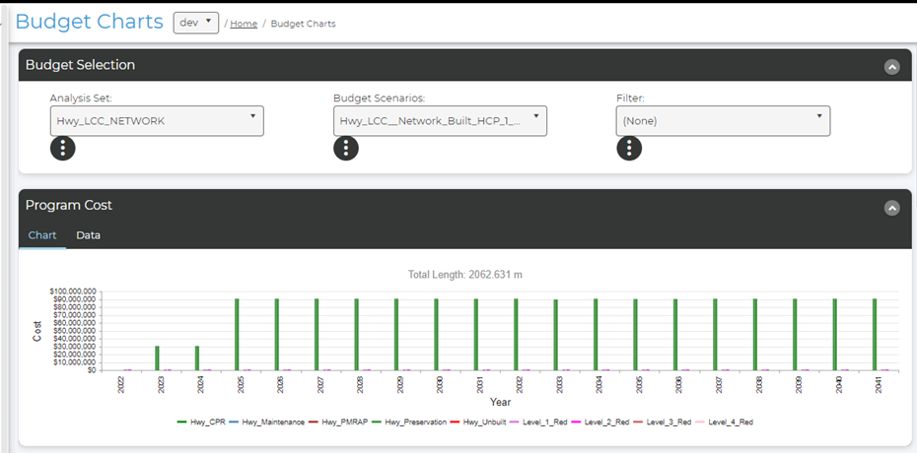

Figure I. The Budget chart displays the total program cost for the given analysis set and budget scenario over the given analysis period.

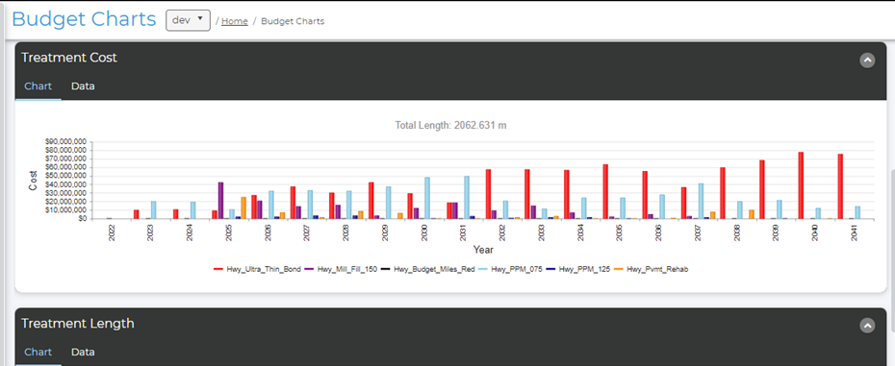

Figure II. Budget chart displaying different treatment costs that occur for the given analysis set and budget scenario over the given analysis period.

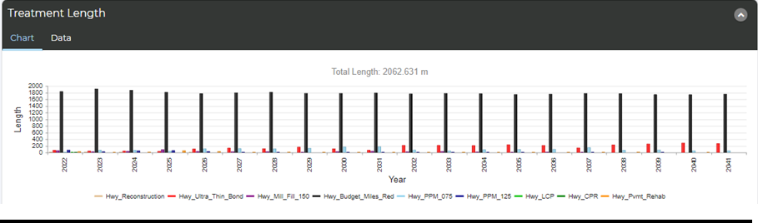

Figure III. Budget chart displaying different treatment lengths that occur for the given analysis set and budget scenario over the given analysis period.

- Condition Distribution Chart

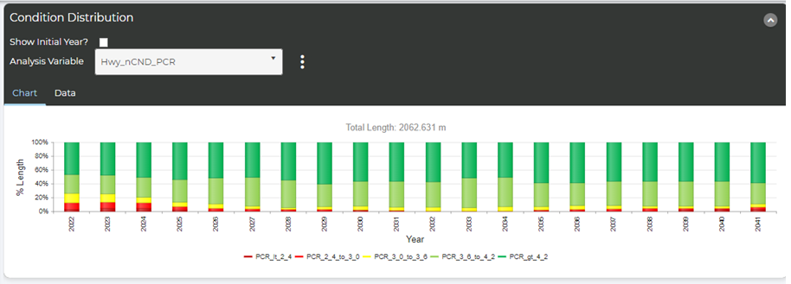

Displays the percentage of good, fair, and poor assets for given analysis set and budget scenario for a given analysis period.

- Budget Comparison Chart

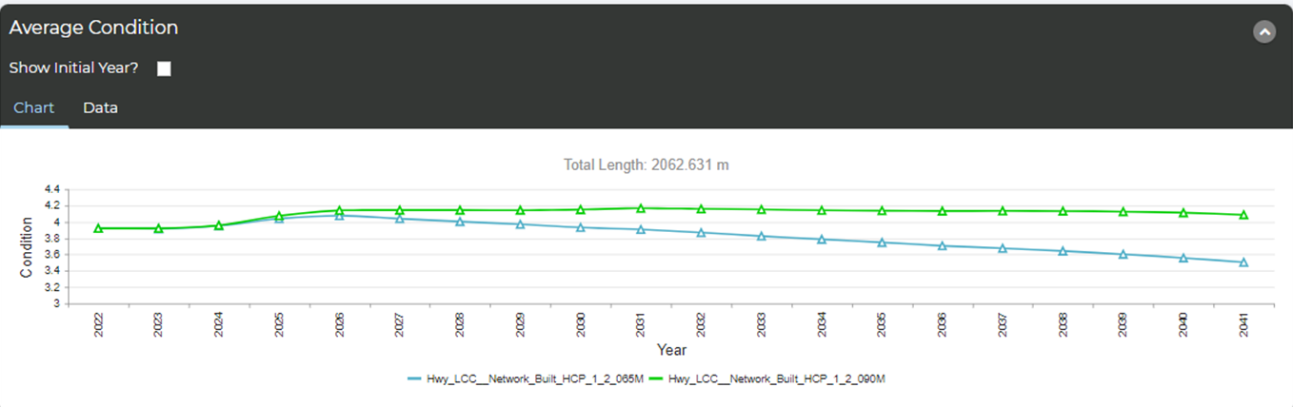

Budget Comparison Chart displaying the average condition of highway assets over time for a selected analysis set and multiple budget scenarios.

- Construction Program

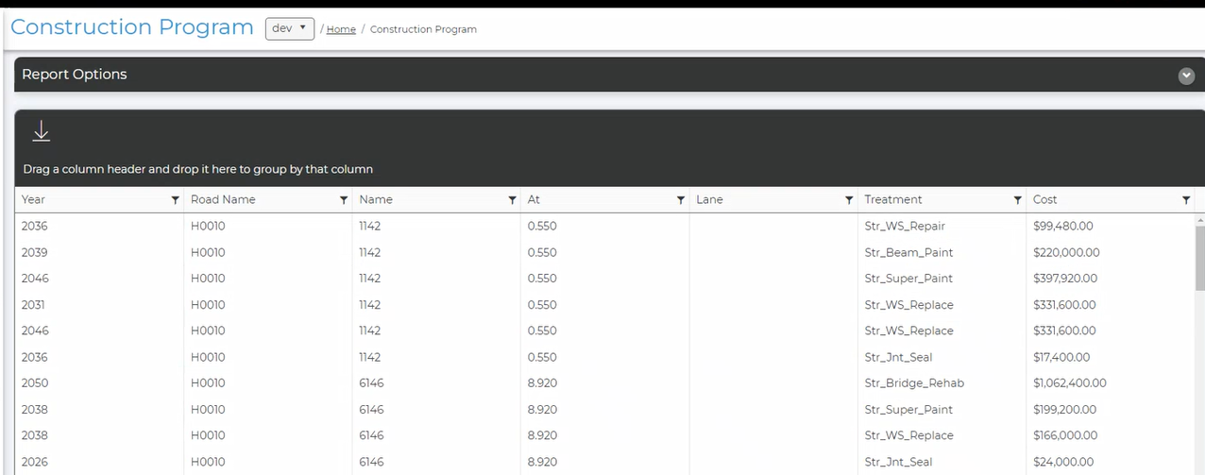

A Construction Program or future work report that displays the treatments and costs generated for each bridge structure for a selected analysis set, budget scenario, treatments, and analysis period.

Appendix J - Maine PM2 Targets
State of Maine
Department of Transportation
RFP# 202309195
PAVEMENT AND BRIDGE ASSET MANAGEMENT SOFTWARE AS A SERVICE

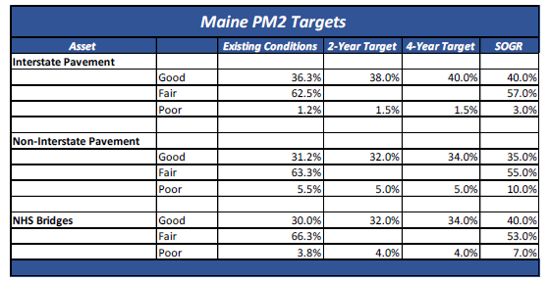

Figure: Maine Performance Management Metric (PM2) Targets.

