STATE OF MAINE
Department of Health and Human Services
Office of Aging and Disability Services

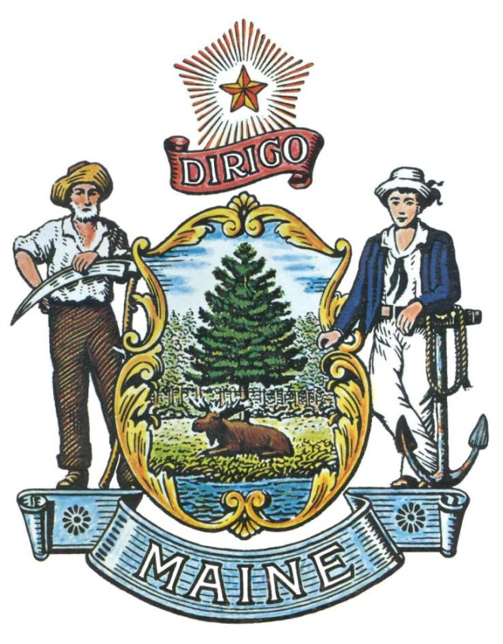
RFA# 202208125

Home and Community Based Services (HCBS)
Innovation Grants Funding Opportunity

RFA Coordinator | All communication regarding the RFA must be made through the RFA Coordinator identified below.  Name: Brittany Hall Title: Procurement Administrator  Contact Information: Brittany.hall@maine.gov
Submitted Questions | All questions must be received by the RFA Coordinator identified above by:  Date: August 29, 2022 no later than 11:59 p.m., local time and must include “RFA# 202208125 Question” in the subject line of the e-mail.
Application Submission Period | Applications must be received by the Division of Procurement Services by:  Submission Deadline: November 8, 2022, no later than 11:59 p.m., local time.  Applications must be submitted electronically to the following address:  Electronic (e-mail) Submission Address: Proposals@maine.gov  and must include “RFA# 202208125 Application Submission” in the subject line of the e-mail.

RFA TERMS/ACRONYMS with DEFINITIONS

The following terms and acronyms, as referenced in the RFA, shall have the meanings indicated below:

Term/Acronym | Definition
ARP | American Rescue Plan
CMS | Centers for Medicare and Medicaid Services
Department | Department of Health and Human Services
HCBS | Home and Community Based Services
OMS | Office of MaineCare Services
RFA | Request for Application
State | State of Maine

Details and Instructions

Application Purpose and Background

The Department of Health and Human Services (Department) is seeking applications for innovative pilot projects in alignment with Home and Community Based Services (HCBS) goals.

The Department of Health and Human Services (Department) is dedicated to promoting health, safety, resiliency, and opportunity to all Maine residents. The Department’s Office of Aging and Disability Services (OADS) is responsible for the provision of services that promote the highest level of independence, health, and safety of older citizens, vulnerable adults, and adults with disabilities.

Through this RFA, the Department intends on providing one-time grant funding to approved Applicants for the implementation of projects which are currently outside the scope of MaineCare services, that upon successful completion, must comply with the HCBS rule Waiver Section 21 (MaineCare Manual 21.05-1), Section 29 (29.05-01), Section 19 (19.04-1 to 3), as well as Section 18 (18.05-1) and Section 20 (20.05-1), including related Office of MaineCare Services (OMS) and Centers for Medicare and Medicaid Services (CMS) rules and regulations. Projects may expand an existing service with new features or services to address a specific problem or provide services for a new population. Per CMS, these approved funds may be used to supplement but not supplant existing services.

General Provisions

- From the time this RFA is issued until award notification is made, all contact with the State regarding this RFA must be made through the RFA Coordinator identified on the cover page of this RFA. No other person/State employee is empowered to make binding statements regarding this RFA. Violation of this provision may lead to disqualification from the application process, at the State’s discretion.
- The Applicant shall take careful note that in evaluating its application submitted in response to this RFA the Department will consider materials provided in the application and internal Departmental information of previous contract history, if any, with the Applicant. The Department also reserves the right to consider other reliable references and publicly available information in evaluating the Applicant’s experience and capabilities.
- All submissions in response to this RFA will be public records, available for public inspection pursuant to the State of Maine Freedom of Access Act (FOAA) (1 M.R.S. § 401 et seq.).
- All applicable laws, whether or not herein contained, shall be included by this reference. It shall be the Applicant’s responsibility to determine the applicability and requirements of any such laws and to abide by them.

Eligibility

In order to be eligible for grant funding, Applicants must be:

A current provider of CMS-funded services;

Incorporated or registered within the Maine Secretary of State and capable of doing business in the State;

In good standing as a service provider with Department (i.e., has no corrective actions or sanctions, is not under investigation for violation of Maine laws/regulations, or has not violated State or Federal laws/regulations); and

Current and in good standing with all Maine State payroll taxes, sales taxes, and State income taxes (as applicable) at the time of submission and not filed for bankruptcy within the past five (5) years.

Awards

The Department anticipates making multiple awards as a result of this RFA process, including partial awards, with a maximum award amount of $500,000. The Department reserves the right to eliminate the lowest scoring application(s), approve or deny any funding requests, and/or make awards at amounts less than that requested, whichever is in the best interest of the State. Application funding requests will be considered on a case-by-case basis.

The Department intends to apply priority scoring for projects which provide services in under-served geographic areas, specifically Aroostook, Franklin, Hancock, Penobscot, Piscataquis, and Washington.

Any person aggrieved by the award decision that results from the RFA may appeal the decision to the Director of the Bureau of General Services in the manner prescribed in 5 M.R.S.A. § 1825-E and 18-554 Code of Maine Rules Chapter 120. The appeal must be in writing and filed with the Director of the Bureau of General Services, 9 State House Station, Augusta, Maine, 04333-0009 within 15 calendar days of receipt of notification of conditional contract award.

- Contract Terms

The Department anticipates issuing awards for a contract period beginning as early as January 2023 and ending March 2024, with the possibility of extending until March 2025, if approved by CMS. Contract periods may vary based on the time each application is received and scored by the Department and the Department’s ability to fully execute each contract. The Department does not anticipate the availability of additional funding after the approved CMS end period.

Activities and Requirements

- General Requirement

  - Provide the required capacity and expertise to implement the Department approved project.

- Allowable/Non-Allowable Use of Funds for Innovation

  - Allowable use of funds may include but are not limited to:
    - Pilot projects to address gaps in HCBS services, such as:
      - Access to independence-enhancing technologies such as remote support;
      - A range of independence-enhancing living options;
      - Peer support models;
      - Transitions across the lifespan; and
      - New options close to home so individuals in out-of-state placements can return to Maine.
    - Supplement existing services;
    - Expand existing services with new features;
    - Provide services to a new population; and
    - Add services to address a specific problem.

The Department will consider other allowable innovation activities. Approval of all proposed activities will be at the discretion of the Department. Applicants who intend to apply for activities not listed above, may submit questions to the Department through the RFA Q&A process outlined in this RFA.

  - Request for and allocation of funding shall not include:
    - Duplicating or supplanting funding received from other federal or State resources;
    - Debt restructuring and/or bad debt;
    - Defense and prosecution of criminal and civil proceedings, and claims;
    - Donations and contributions;
    - Entertainment;
    - Alcoholic Beverages;
    - Fines and penalties;
    - Goods or services for personal use;
    - Interest expenses;
    - Lobbying; and
    - Patent costs.

- Evaluation of Proposed Project

            - Develop and implement an evaluation plan utilizing the Department approved evaluation plan template for the proposed project.
              - Provide the evaluation plan to the Department within thirty (30) calendar days of the contract start date.
              - Provide quarterly reports within fifteen (15) calendar days following the end of each quarter as determined by the Department.
- Provide an evaluation of the approved project with a final evaluation report due by the CMS approved period.

Awarded Applicants will be required to adhere to all Department reporting requirements outlined in the grant agreement resulting from this RFA process. Reporting requirements will be determined during grant agreement negotiations.

The Evaluation Plan Template to be used during the contract period may be obtained in a Word (.docx) format by double clicking on the document icon below.

Key Process Events

Submitting Questions about the Request for Applications

Any questions must be submitted by e-mail and received by the RFA Coordinator identified on the cover page of this RFA, as soon as possible but no later than the date and time specified on the RFA cover page. Submitted Questions must include the subject line: “RFA# 202208125 Questions”. The Department assumes no liability for assuring accurate/complete/on time e-mail transmission and receipt.

Question & Answer Summary: Responses to all questions will be compiled in writing and posted on the Division of Procurement Services Grant RFPs and RFAs website. It is the responsibility of all interested parties to go to this website to obtain a copy of the Question & Answer Summary. Only those answers issued in writing on this website will be considered binding.

Amendments to the Request for Applications

All amendments (if any) released in regard to this Request for Applications will be posted on the Division of Procurement Services Grant RFPs and RFAs website. It is the responsibility of all interested parties to go to this website to obtain amendments. Only those amendments posted on this website are considered binding.

Submitting an Application

  - Applications Due: Applications must be received no later than 11:59 p.m. local time, on the date listed on the cover page of the RFA. E-mails containing original application submissions, or any additional or revised application files, received after the 11:59 p.m. deadline will be rejected without exception.

If the need arises, the Department may reopen this RFA to fund additional innovative grants.

- Submission Instructions: Applications are to be submitted electronically to the State of Maine Division of Procurement services, via e-mail, to proposals@maine.gov.
  - Only applications received by e-mail will be considered. The Department assumes no liability for assuring accurate/complete e-mail transmission and receipt.
  - E-mails containing links to file sharing sites or online file repositories will not be accepted as submissions. Only e-mail applications that have the actual requested files attached will be accepted.
  - Encrypted e-mails received which require opening attachments and logging into a proprietary system will not be accepted as submissions. Please check with your organizations Information Technology team to ensure your security settings will not encrypt your proposal submission.
  - File size limits are 25MB per e-mail. Applicants may submit files across multiple e-mails, as necessary, due to file size concerns. All e-mails and files must be received by the due date and time listed above.
  - Applicants are to insert the following into the subject line of their e-mail submission: “RFA# 202208125 Application Submission – [Applicant’s Name]”.
  - Applications are to be submitted as a single, typed, PDF or WORD file and must include all related documents identified on the application, refer to Appendix C.
Application Evaluation and Selection

- Scoring Weights: The score will be based on a 100-point scale and will measure the degree to which each application meets the following criteria.

Scoring Criteria | Points Available
Part I – Eligibility | Pass/Fail
Part II – Prioritization Points | 15
Part III – Proposed Project Activities | 55
Part IV – Budget Forms | 30
Total Points | 100 points

- Scoring Process: The Grant Review Team will use a consensus approach to evaluate and score all sections listed above. Members of the review team will not score those sections individually but, instead, will arrive at a consensus as to assignment of points for each of those sections. Applicants receiving a total score of sixty (60) points or higher will be considered for either full or partial funding.

The Department intends to apply priority scoring for projects which provide services in under-served geographic areas, specifically Aroostook, Franklin, Hancock, Penobscot, Piscataquis, and Washington.

Regarding the Cost Proposal, the Grant Review Team will consider whether the project work and cost estimates (tasks & budget) are reasonable for the expected outcomes, along with the amount of proposed matching funds or services.

- Selection and Award: Notification of selection or non-selection will be made in writing by the Department. Issuance of this RFA in no way constitutes a commitment by the State of Maine to award a contract, or to pay costs incurred in the preparation of a response to this request, or to pay costs incurred in procuring or contracting for services, supplies, physical space, personnel, or any other costs incurred by the Applicant.

The Department will consider all application funding requests on a case-by-case basis. The Department reserves the right to approve or deny any funding requests including approval of an application at an amount lower than requested by the Applicant.

APPENDIX A

RFA# 202208125
Home and Community Based Services (HCBS)
Innovation Grants Funding Opportunity

GRANT FUNDING APPLICATION – COVER PAGE

Applicant’s Organization Name:
Chief Executive - Name/Title:
Tel: |  |  | E-mail:
Headquarters Street Address:
Headquarters City/State/Zip:
(Provide information requested below if different from above)
Lead Point of Contact for Application - Name/Title:
Tel: |  |  | E-mail:
Headquarters Street Address:
Headquarters City/State/Zip:

- This Application and the pricing structure contained herein will remain firm for a period of one hundred eighty (180) days from the date and time of the bid opening.
- No personnel currently employed by the Department or any other State agency participated, either directly or indirectly, in any activities relating to the preparation of the Applicant’s Application.
- No attempt has been made, or will be made, by the Applicant to induce any other person or firm to submit or not to submit an Application.
- The above-named organization is the legal entity entering into the resulting contract with the Department should they be awarded the contract.
- The undersigned is authorized to enter contractual obligations on behalf of the above-named organization.

To the best of my knowledge, all information provided in the enclosed application, both programmatic and financial, is complete and accurate at the time of submission.

Name (Print): | Title:
Authorized Signature: | Date:

APPENDIX B

RFA# 202208125
Home and Community Based Services (HCBS)
Innovation Grants Funding Opportunity

DEBARMENT, PERFORMANCE and NON-COLLUSION CERTIFICATION

By signing this document, I certify to the best of my knowledge and belief that the aforementioned organization, its principals and any subcontractors named in this proposal:
- Are not presently debarred, suspended, proposed for debarment, and declared ineligible or voluntarily excluded from bidding or working on contracts issued by any governmental agency.
- Have not within three years of submitting the proposal for this contract been convicted of or had a civil judgment rendered against them for:
  - Fraud or a criminal offense in connection with obtaining, attempting to obtain, or performing a federal, state, or local government transaction or contract.
  - Violating Federal or State antitrust statutes or committing embezzlement, theft, forgery, bribery, falsification or destruction of records, making false statements, or receiving stolen property.
- Are not presently indicted for or otherwise criminally or civilly charged by a governmental entity (Federal, State, or Local) with commission of any of the offenses enumerated in paragraph (b) of this certification.
- Have not within a three (3) year period preceding this proposal had one or more federal, state, or local government transactions terminated for cause or default.
- Have not entered into a prior understanding, agreement, or connection with any corporation, firm, or person submitting a response for the same materials, supplies, equipment, or services and this proposal is in all respects fair and without collusion or fraud. The above-mentioned entities understand and agree that collusive bidding is a violation of state and federal law and can result in fines, prison sentences, and civil damage awards.
Failure to provide this certification will result in the disqualification of the Applicant’s Application.
Name (Print): | Title:
Authorized Signature: | Date:

APPENDIX C

RFA# 202208125
Home and Community Based Services (HCBS)
Innovation Grants Funding Opportunity

APPLICATION FORM

The Application may be obtained in a Word (.docx) format by double clicking on the document icon below.

