STATE OF MAINE
Department of Agriculture, Conservation & Forestry
Bureau of Agriculture, Food & Rural Resources
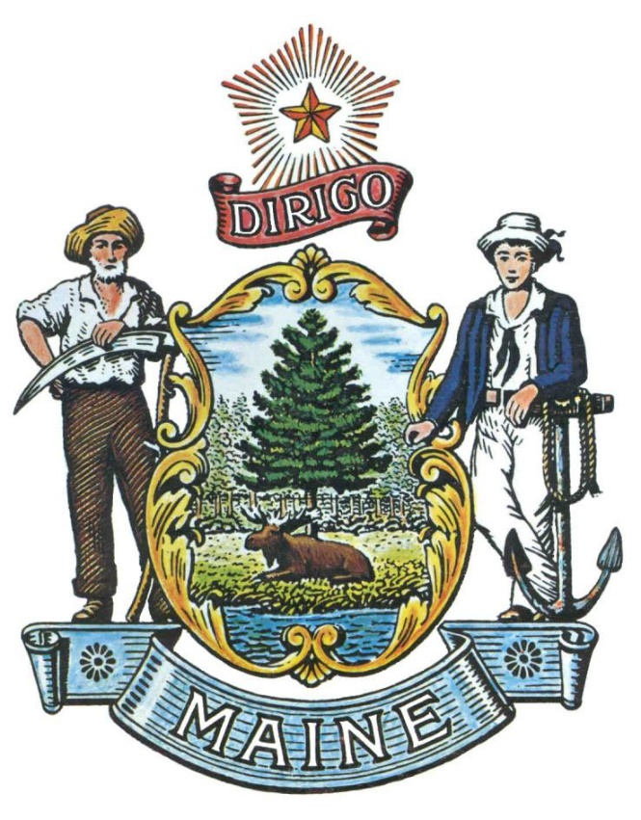
RFA# 202308182

Creating a Statewide Food Security Hub

Grant Coordinator | All communication regarding the RFA must be made through the RFA Coordinator identified below.  Name: Craig Lapine Title: Bureau Director, BAFRR  Contact Information: craig.lapine@maine.gov
Submitted Questions Due | All questions must be received by the RFP Coordinator identified above by:  Date: 10/27/2023, no later than 11:59 p.m., local time
Application  Submission | Proposals must be received by the Division of Procurement Services by:  Submission Deadline: 11/10/2023, no later than 11:59 p.m., local time.  Proposals must be submitted electronically to the following address:  Electronic (e-mail) Submission Address: Proposals@maine.gov

TABLE OF CONTENTS

 | Page
APPLICATION DETAILS AND INSTRUCTIONS | 3
- PURPOSE AND BACKGROUND
- ELIGIBILITY TO SUBMIT BIDS
- AWARDS
- APPEAL OF CONTRACT AWARDS
KEY PROCESS EVENTS | 5
- SUBMITTING QUESTIONS
- QUESTION & ANSWER SUMMARY
- AMENDMENTS TO THE REQUEST FOR APPLICATIONS
- APPLICATION SUBMISSION
APPLICATION | 8
- APPLICATION COVER PAGE
- DEBARMENT, PERFORMANCE and NON-COLLUSION CERTIFICATION
- APPLICATION

State of Maine - Department of Agriculture, Conservation & Forestry
RFA# 202308182
Creating a Statewide Food Security Hub

APPLICATION DETAILS AND INSTRUCTIONS
- Purpose and Background

The Department of Agriculture, Conservation & Forestry (Department) is seeking proposals to create a food security hub addressing the nutritional needs of homeless, sheltered, or food insecure persons as defined in this Request for Applications (RFA) document. This document provides instructions for submitting applications, the procedure and criteria by which the awarded Applicant will be selected, and the contractual terms which will govern the relationship between the State of Maine (State) and the awarded Applicant.

Maine has high rates of food insecurity that have worsened following the end of pandemic-era federal food security benefits. Food insecurity harms all people in the State of Maine, stunting the vitality of our communities. That is why the State has committed to end hunger by 2030. Maine’s agricultural producers can be uniquely important in addressing food insecurity.

Nutrition benefits and emergency food providers (pantries, etc.) address some of the need. However, unhoused people and food-insecure people in institutional settings may require prepared meals when access to a kitchen cannot be guaranteed. LD 258 is the 2024-2025 budget enacted as Public Law 2023, chapter 412, An Act Making Unified Appropriations and Allocations from the General Fund and Other Funds for the Expenditures of State Government and Changing Certain Provisions of the Law Necessary to the Proper Operations of State Government for the Fiscal Years Ending June 30, 2023, June 30, 2024 and June 30, 2025, which allocated $2 million in one-time funding to a Portland-based organization that can create a facility to prepare and distribute up to 10,000 meals daily to food-insecure people statewide. Because of the scope and breadth of this statewide initiative, the Department supports the awarded Applicant subcontracting with entities to achieve its programmatic goals.

The successful Applicant must be able to complete the construction or renovation of a facility certifiable as a commercial kitchen and capable of preparing, packing, and storing 2,000-10,000 meals per day. The successful Applicant must also have a demonstrated plan for distributing prepared meals statewide. Food purchases should prioritize Maine-grown food whenever possible.

- Eligibility to Submit Bids
Portland-based nonprofit organizations are invited to submit applications in response to this Request for Applications. For the purposes of this application, “Portland-based” is defined as based in the Portland-South Portland, ME Metro Area as delineated by the US Census Bureau. A map of eligible locations can be found at https://censusreporter.org/profiles/31000US38860-portland-south-portland-me-metro-area/
- Awards
The Department anticipates making one (1) award as a result of the RFA process.
- Appeal of Contract Awards
Any person aggrieved by the award decision that results from this Request for Applications may appeal the decision to the Director of the Bureau of General Services in the manner prescribed in 5 MRSA § 1825-E and 18-554 Code of Maine Rules, Chapter 120 (found here: Chapter 120). The appeal must be in writing and filed with the Director of the Bureau of General Services, 9 State House Station, Augusta, Maine, 04333-0009 within 15 calendar days of receipt of notification of contract award.

State of Maine - Department of Agriculture, Conservation & Forestry
RFA# 202308182
Creating a Statewide Food Security Hub

KEY PROCESS EVENTS

- Submitting Questions
It is the responsibility of all Applicants and other interested parties to examine the entire RFA and to seek clarification, in writing, if they do not understand any information or instructions.
    - Questions must be submitted, by e-mail, and received by the RFA Coordinator, identified on the cover page of the RFA, as soon as possible but no later than the date and time specified on the RFP cover page.
    - Submitted Questions must include the RFA Number and Title in the subject line of the e-mail. The Department assumes no liability for assuring accurate/complete/on time e-mail transmission and receipt.

- Question & Answer Summary
Responses to all questions will be compiled in writing and posted on the following website: Grant RFPs and RFAs. It is the responsibility of all interested parties to go to this website to obtain a copy of the Question & Answer Summary. Only those answers issued in writing on this website will be considered binding.
- Amendments
All amendments (if any) released in regard to this Request for Applications will be posted on the following website: Grant RFPs and RFAs. It is the responsibility of all interested parties to go to this website to obtain amendments. Only those amendments posted on this website are considered binding.
- Application Submission

  - Applications Due: Applications must be received no later than 11:59 p.m. local time, on the date listed on the cover page of the RFA. E-mails containing original application submissions, or any additional or revised application files, received after the 11:59 p.m. deadline will be ineligible for award consideration for that application enrollment period.

  - Submission Instructions: Applications are to be submitted to the State of Maine Division of Procurement Services, via email, to Proposals@maine.gov.
    - Only applications received by e-mail will be considered. The Department assumes no liability for assuring accurate/complete e-mail transmission and receipt.
      - Proposal submission e-mails that are successfully received by the proposals@maine.gov inbox will receive an automatic reply stating as such.
    - E-mails containing links to file sharing sites or online file repositories will not be accepted as submissions. Only e-mail applications that have the actual requested files attached will be accepted.
    - Encrypted e-mails received which require opening attachments and logging into a proprietary system will not be accepted as submissions. Please check with your organization’s Information Technology team to ensure that your security settings will not encrypt your proposal submission.
    - File size limits are 25MB per e-mail. Applicants may submit files separately across multiple e-mails, as necessary, due to file size concerns. All e-mails and files must be received by the due date and time listed above.
    - Applicants are to insert the following into the subject line of their email submission: “RFA# 202308182 Application Submission – [Applicant’s Name]”
    - Applications are to be submitted as a single, typed, PDF or WORD file and must include the information located on pages 8-10 of this RFA Document, including:
      - Application Cover Page
      - Debarment Performance and Non-Collusion Statement
      - Completed Application and all related attachments

State of Maine - Department of Agriculture, Conservation & Forestry
RFA# 202308182
Creating a Statewide Food Security Hub

APPLICATION EVALUATION AND SELECTION

- Scoring Weights and Process
  - Scoring Weights: The score will be based on a 100-point scale and will measure the degree to which each application meets the following criteria.

Scoring Criteria | Maximum Points Available
Eligibility | Pass/Fail
Qualifications & Experience | 25 points
Proposed Services | 25 points
Assurances on Food Hub Procurement and Distribution | 20 points
Reporting Requirements | 5 points
Budget | 25 points
Total Points | 100 points

  - Scoring Process: The Grant Review Team will use a consensus approach to evaluate and score all sections listed above. Members of the review team will not score those sections individually but, instead, will arrive at a consensus as to assignment of points for each of those sections.

  - Regarding the proposed funds requested and the proposed work, the Grant Review Team will consider the degree to which the project represents a good return for the investment (money, time) as well as whether the project work and cost estimates (tasks & budget) are reasonable for the expected outcomes, along with the amount and quality of proposed matching funds or services.

State of Maine - Department of Agriculture, Conservation & Forestry
RFA# 202308182
Creating a Statewide Food Security Hub

APPLICATION COVER PAGE

Applicant’s Organization Name:
Tel: |  |  | E-mail:
Headquarters’ Street Address:
Headquarters’ City/State/Zip:
Point of Contact for Application (Name and Title):
Tel: |  |  | E-mail:
Headquarters’ Street Address:
Headquarters’ City/State/Zip:
Dollar Amount of Application:

- No personnel currently employed by the Department or any other State agency participated, either directly or indirectly, in any activities relating to the preparation of the Applicant’s application.
- No attempt has been made, or will be made, by the Applicant to induce any other person or firm to submit or not to submit an application.
- The above-named organization is the legal entity entering into the resulting agreement with the Department should they be awarded a contract.
- The undersigned is authorized to enter contractual obligations on behalf of the above-named organization.
To the best of my knowledge, all information provided in the enclosed application, both programmatic and financial, is complete and accurate at the time of submission.
Name (Print): | Title:
Authorized Signature: | Date:
State of Maine - Department of Agriculture, Conservation & Forestry
RFA# 202308182
Creating a Statewide Food Security Hub
DEBARMENT, PERFORMANCE and NON-COLLUSION CERTIFICATION

Applicant’s Organization Name:

By signing this document, I certify to the best of my knowledge and belief that the aforementioned organization, its principals and any subcontractors named in this proposal:
- Are not presently debarred, suspended, proposed for debarment, and declared ineligible or voluntarily excluded from bidding or working on contracts issued by any governmental agency.
- Have not within three years of submitting the proposal for this contract been convicted of or had a civil judgment rendered against them for:
  - Fraud or a criminal offense in connection with obtaining, attempting to obtain, or performing a federal, state, or local government transaction or contract.
  - Violating Federal or State antitrust statutes or committing embezzlement, theft, forgery, bribery, falsification or destruction of records, making false statements, or receiving stolen property.
- Are not presently indicted for or otherwise criminally or civilly charged by a governmental entity (Federal, State or Local) with commission of any of the offenses enumerated in paragraph (b) of this certification.
- Have not within a three (3) year period preceding this proposal had one or more federal, state, or local government transactions terminated for cause or default.
- Have not entered into a prior understanding, agreement, or connection with any corporation, firm, or person submitting a response for the same materials, supplies, equipment, or services and this proposal is in all respects fair and without collusion or fraud. The above-mentioned entities understand and agree that collusive bidding is a violation of state and federal law and can result in fines, prison sentences, and civil damage awards.
Failure to provide this certification may result in the disqualification of the Applicant’s application, at the discretion of the Department.

Name (Print): | Title:
Authorized Signature: | Date:
State of Maine - Department of Agriculture, Conservation & Forestry
RFA# 202308182
Creating a Statewide Food Security Hub

APPLICATION
The Applicant is asked to be brief and concise in providing written information required in the application.

Double click on the icon below to access the Application.

