STATE OF MAINE
Department of Inland Fisheries and Wildlife
Lands Management Program

RFP# 202405096

Timber Stumpage
Bud Leavitt WMA – Compartments 5, 6, and 7
and Mattawamkeag River WMA – Page Farm Unit

Sale Coordinator | All questions regarding timber sale specifics should be made through the Sale Coordinator identified below:  Name: Jack Chappen Title: Forester II  Contact: john.chappen@maine.gov
RFP Coordinator | All communication regarding non-timber sale specifics must be made through the RFP Coordinator identified below:  Name: Leigh E. Hoar III (Eric) Title: Lands Management Biologist  Contact Information: leigh.e.hoar@maine.gov
Pre-Bid Meetings | A pre-bid meeting will be held at the location noted in Part III, A of the RFP.  Date: 5/30/2024 Time: 3:00 P. M.
Submitted Questions Due | All questions must be received by the RFP Coordinator identified above by:  Date: 6/13/2024, no later than 11:59 p.m., local time
Proposal Submission | Proposals must be received by the Division of Procurement Services by:  Submission Deadline: 6/27/2024, no later than 11:59 p.m., local time. Proposals must be submitted electronically to the following address:  Electronic (e-mail) Submission Address: Proposals@maine.gov

TABLE OF CONTENTS
 | Page
PUBLIC NOTICE | 3
RFP DEFINITIONS/ACRONYMS | 4
PART I INTRODUCTION | 5
- PURPOSE AND BACKGROUND
- GENERAL PROVISIONS
- ELIGIBILITY TO SUBMIT BIDS
- CONTRACT TERM
- NUMBER OF AWARDS
PART II SCOPE OF SERVICES TO BE PROVIDED | 7
PART III KEY RFP EVENTS | 14
- PRE-BID MEETING
- QUESTIONS
- AMENDMENTS
- SUBMITTING THE PROPOSAL
PART IV PROPOSAL SUBMISSION REQUIREMENTS  - SUBMISSION | 16
PART V PROPOSAL EVALUATION AND SELECTION | 17
- BID ANALYSIS
- SELECTION AND AWARD
- APPEAL OF CONTRACT AWARDS
PART VI CONTRACT ADMINISTRATION AND CONDITIONS | 20
- CONTRACT DOCUMENT
- STANDARD STATE CONTRACT PROVISIONS
PART VII RFP APPENDICES AND RELATED DOCUMENTS | 21
APPENDIX A – PROPOSAL COVER PAGE
APPENDIX B – DEBARMENT, PERFORMANCE AND NON-COLLUSION CERTIFICATION
APPENDIX C – BUD LEAVITT – COMPARTMENTS 5, 6, AND 7 BID PRICE FORM
APPENDIX D – MATTAWAMKEAG RIVER – PAGE FARM UNIT BID PRICE FORM
APPENDIX E – MASTER LOGGER CERTIFIED AND LICENSED FORESTER FORM
APPENDIX F – BUD LEAVITT – COMPARTMENTS 5, 6, AND 7 – LOCATION AND ACCESS MAP
APPENDIX G – MATTAWAMKEAG RIVER – PAGE FARM UNIT – LOCATION AND ACCESS MAP
APPENDIX H – BUD LEAVITT – COMPARTMENTS 5, 6, AND 7 – MEETING AND COMPARTMENT MAP
APPENDIX I. A. and B. – BUD LEAVITT – COMPARTMENTS 5, 6, AND 7 – ROADS, TURNAROUNDS AND YARDS MAPS
APPENDIX J – MATTAWAMKEAG RIVER – PAGE FARM UNIT – ROADS, TURNAROUNDS, AND YARDS MAP
APPENDIX K – TYPICAL ROAD SECTION SPECIFICATIONS

APPENDIX L – HARVEST AND HABITAT MANAGEMENT EVALUATION REPORT

PUBLIC NOTICE

*************************************************
State of Maine
Department of Inland Fisheries and Wildlife
RFP# 202405097
Timber Stumpage
Bud Leavitt WMA – Compartments 5, 6, and 7 and
Mattawamkeag River WMA – Page Farm Unit

The State of Maine is seeking proposals for the sale of 13,900 gross tons of “TIMBER STUMPAGE” on the Bud Leavitt and Mattawamkeag River Wildlife Management Areas.

A copy of the RFP, as well as the Question & Answer Summary and all amendments related to the RFP, can be obtained at: https://www.maine.gov/dafs/bbm/procurementservices/vendors/rfps

Proposals must be submitted to the State of Maine Division of Procurement Services, via e-mail, at: Proposals@maine.gov. Proposal submissions must be received no later than 11:59 p.m., local time, on 6/27/2024. Proposals will be opened the following business day. Proposals not submitted to the Division of Procurement Services’ aforementioned e-mail address by the aforementioned deadline will not be considered for contract award.

*************************************************

RFP TERMS/ACRONYMS with DEFINITIONS

The following terms and acronyms, as referenced in the RFP, shall have the meanings indicated below:

Term/Acronym | Definition
BMP | Best Management Practices as defined by the Maine Forest Service
Department | Department of Inland Fisheries and Wildlife
Director | Director-Resource Management for Inland Fisheries and Wildlife
RFP | Request for Proposal
State | State of Maine

State of Maine - Department of Inland Fisheries and Wildlife
Lands Management Program
RFP# 202405097
Timber Stumpage
Bud Leavitt Wildlife Management Area – Compartments 5, 6, and 7 And
Mattawamkeag River Wildlife Management Area – Page Farm Unit

PART I INTRODUCTION

- Purpose and Background

The Department of Inland Fisheries and Wildlife (Department) offers for sale by bid 13,900 gross tons of "Timber Stumpage" as defined in this Request for Proposal (RFP) document. This document provides instructions for submitting proposals, the procedure and criteria by which the Provider(s) will be selected and the contractual terms which will govern the relationship between the State of Maine (State) and the awarded Bidder(s).

- General Provisions

  - From the time the RFP is issued until award notification is made, all contact with the State regarding the RFP must be made through the RFP Coordinator. No other person/ State employee is empowered to make binding statements regarding the RFP. Violation of this provision may lead to disqualification from the bidding process, at the State’s discretion.
  - Issuance of the RFP does not commit the Department to issue an award or to pay expenses incurred by a Bidder in the preparation of a response to the RFP. This includes attendance at personal interviews or other meetings and software or system demonstrations, where applicable.
  - All proposals must adhere to the instructions and format requirements outlined in the RFP and all written supplements and amendments (such as the Summary of Questions and Answers), issued by the Department. Proposals are to follow the format and respond to all questions and instructions specified below in the “Proposal Submission Requirements” section of the RFP.
  - Bidders will take careful note that in evaluating a proposal submitted in response to the RFP, the Department will consider materials provided in the proposal, information obtained through interviews/presentations (if any), and internal Departmental information of previous contract history with the Bidder (if any). The Department also reserves the right to consider other reliable references and publicly available information in evaluating a Bidder’s experience and capabilities.
  - The proposal must be signed by a person authorized to legally bind the Bidder and must contain a statement that the proposal and the pricing contained therein will remain valid and binding for a period of 180 days from the date and time of the bid opening.
  - The RFP and the awarded Bidder’s proposal, including all appendices or attachments, will be the basis for the final contract, as determined by the Department.
  - Following announcement of an award decision, all submissions in response to this RFP will be public records, available for public inspection pursuant to the State of Maine Freedom of Access Act (FOAA) (1 M.R.S. § 401 et seq.).
  - The Department, at its sole discretion, reserves the right to recognize and waive minor informalities and irregularities found in proposals received in response to the RFP.
  - All applicable laws, whether or not herein contained, are included by this reference. It is the Bidder’s responsibility to determine the applicability and requirements of any such laws and to abide by them.

- Eligibility to Submit Bids

All interested parties are invited to submit bids in response to this Request for Proposals. Contractors currently under contract with the Department on other timber sales may not bid on this project.

- Contract Term

The term of the anticipated contract, resulting from this RFP, is defined as follows:

Period | Start Date | End Date
Initial Period of Performance | 1 December 2024 | 15 July 2025

Contract Renewal: Following the initial term of the contract, the Department may opt to renew the contract to ensure completion of the scope of work in this RFP.

- Number of Awards

The Department may make up to two (2) awards as a result of the RFP process.

PART II - SCOPE OF SERVICES TO BE PROVIDED

This sale includes work on the Bud Leavitt WMA – Compartments 5, 6, and 7 located in the towns of Charleston, Garland, Dover-Foxcroft, and Atkinson and the Mattawamkeag River WMA – Page Farm Unit located in Drew Plantation. Of the 13,900 gross tons, approximately 1,300 tons are located at the Mattawamkeag River WMA and must be harvested during freezing conditions. The remaining 12,600 tons are located at the Bud Leavitt WMA, of which, about 5,544 tons is “summer wood”. All remaining tonnage at Bud Leavitt is to be harvested in freezing conditions. A short 15% slope uphill section of forwarding will be necessary to access roughly 556 tons at Bud Leavitt. Some unusually long forwarding distances, up to 4,000 feet, will be required for this timber sale. An estimate of volume for forwarding over 2000’, separated by yard number and summer and winter volume, is provided below in Part II, A, 5.

One road at Bud Leavitt will require maintenance (right of way widening, ditch improvement, and culvert installations and replacements) to access a portion of the harvest area. The road must have basic improvements made and the right of way widened this winter (2024/2025). Two other roads that will be utilized as truck turnarounds and yards at Bud Leavitt will need some gravel and light shoulder and surface shaping.

By submitting a proposal in response to this RFP, the Bidder is agreeing to provide Timber Stumpage services as stated below as well as meet all stated Requirements, Policies and Procedures:

- Trees to be Harvested

- This timber sale is a cut to length operation exclusively. Extra points will be awarded to those contractors that can also bring a feller buncher for a hybrid cut to length system. This is due to the amount of smaller diameter wood located in the harvest blocks on Lamb Road at Bud Leavitt which consists approximately of 700 gross tons. If a hybrid cut to length system is going to be used, it must be used for the entire harvest, not just certain areas. Minimum required equipment for this sale includes: a processor and a forwarder. Management includes both marked wood areas and designated areas.

- Harvest system and equipment mix specifications:
  - Cut to Length System Equipment Requirements
    - Processor specifications are as follows:
      - Machine may be metal tracked or rubber wheeled. Tracks attached to rubber wheeled machines does not count as a tracked machine.
      - Felling head may be dangle or fixed mount.
      - Minimum weight of at least 50,000 lbs. including felling head.
      - Maximum weight of no more than 72,000 lbs. including felling head.
      - Maximum width of no more than 11’ 6” as measured to the outside of the tracks.
      - Minimum boom reach of 30 feet from the center of the undercarriage to the center of the cutting head at full extension.
      - Maximum tail swing over the side of 18” for tracked machines.
    - Forwarder specifications are as follows:
      - Maximum width of 12’ 6” outside tires.

  - Hybrid Cut to Length System Equipment Requirements
    - Feller Buncher specifications are as follows:
      - Minimum weight of at least 50,000 lbs. including felling head.
      - Maximum weight of no more than 72,000 lbs. including felling head.
      - Maximum width of no more than 11’ 6” as measured to the outside of the tracks.
      - Minimum boom reach of 25 feet from the center of the undercarriage to the center of the cutting head at full extension.
      - Maximum tail swing over the side of 18”.
    - Processor specifications must meet the same requirements as stated for a cut to length system.
    - Forwarder specifications must meet the same requirements as stated for a cut to length system.

- Harvest trails will be laid out in advance by a representative of the Department. Trails will be spaced 70’ to 80’ apart depending on the equipment mix. Trail width will be minimized down to 15’ with the use of living bumper trees where appropriate.

- Harvesting is to occur from the back of harvest blocks to the front. Wood harvested while cutting trails in may be placed off the trail at a 45-degree angle, placed behind the harvester or stood up along the trail. All trail trees are to be placed in a bundle when harvesting back out a harvest trail.

- Processing must occur in the trail with trees angled at a 45-degree angle so that processed material from the tree stays within the width of the harvest trail with minimal overhang.

- Forwarding distances at Bud Leavitt WMA over 2000 feet, estimated in 500 foot increments, and by yard number and summer and winter volume in tons, are as follows:

Yard 1 | Winter | Summer
2000 – 2500 ft | 53 | -
Yard 2 | Winter | Summer
2000 - 2500 ft | 148 | 104
2500 - 3000 ft | 160 | 64
Yard 3 | Winter | Summer
2000 - 2500 ft | 368 | -
2500 - 3000 ft | 244 | -
3000 - 3500 ft | 76 | -
Yard 4 | Winter | Summer
2000 - 2500 ft | - | 169
2500 - 3000 ft | - | 198
3000 - 3500 ft | - | 182
3500 - 4000 ft | - | 50
Yard 5 | Winter | Summer
2000 - 2500 ft | 196 | 186
Yard 8 | Winter | Summer
2000 - 2500 ft | - | 252
2500 - 3000 ft | - | 205
3000 - 3500 ft | - | 151
Yard 10 | Winter | Summer
2000 - 2500 ft | 64 | -
Yard 14 | Winter | Summer
2000 - 2500 ft | 171 | -

Forwarding distances at Mattawamkeag River WMA are under 2,000ft.

- Summer harvesting in 2025 can begin after 1 August.

- Brook and stream crossings: A “set” of timber mats means 4 individual mats to completely cover required crossings. The center mats are designed to close the gap between the outer mats and prevent debris from falling in the brook. Steel bridges may be substituted for mats. Minimum length of mats is 16 feet. Two sets of mats must be 20 feet long. Enough mats to accommodate four crossings at any given time are required.

- Except in patches identified by the Department, care will be taken to minimize damage to the regeneration. Residual trees will be left standing and undamaged – the residual stand damage criterion is 10% or less.

- The successful bidder(s) will be required to cut and haul all wood in a timely manner.

- Stumpage payments shall be made at least bi-weekly and be accompanied by copies of scale slips and trip tickets. All conditions of Maine State Trip Ticket Law must be met. The Department will supply the required trip tickets. A mailbox will be placed on site for one copy of a trip ticket for each load or product group. More information is contained in Part VI, Section B (2) of the RFP.

- General Road Construction Requirements and Closeout of Roads and Trails

  - ACCESS AND YARDS – Work at Bud Leavitt WMA will entail improving approximately 787 feet of ditch line, installing 3 culverts, creating 14 yards, and 10 turnarounds. Tree harvesting at Bud Leavitt will consist of moving equipment at least 4 times; 1.) move to Biddy Road 2.) move to Whiting Rd 3.) move to Field Access Road 4.) move to Lamb Road. The entrances of Whiting Road, Biddy Road, and Field Access Road are all located within 1 mile from each other. The entrance to Lamb Rd is located 4 miles from the entrance to Whiting Road. Biddy Road will require removing merchantable wood from approximately 3,313 feet of its right of way for proper daylighting and management.

Work at Mattawamkeag River WMA consists of creating 2 yards and 2 turnarounds accessible from Lower Drew Road in Drew Plantation. The distance between work at Mattawamkeag River WMA and Bud Leavitt WMA is roughly 74 miles.

Please refer to the Location and Access Maps in the attached Appendix G and H and the Roads, Turnarounds, and Yards Maps in Appendix I and J.

    - Biddy Road Improvements:
      - Approximately 1,024 feet of road will need basic improvements to facilitate timber harvesting in the winter of 2024/2025. This work must occur before all other management.
    - Biddy Road Daylighting:
      - Approximately 3,313 feet of the Biddy Road must be daylighted by harvesting back approximately 15 feet from the shoulder on either side of the roads after the initial improvements have been made. The Department will designate or mark clearing limits. Daylighting and forwarding of accumulated wood must occur on frozen ground and will facilitate maintenance of the road in the early summer of 2025 under a separate contract.

  - SPECIFICATIONS
    - Biddy Road – Improvements:
      - This road will be a permanent three-season road. The Department will not require graveling of the roads.
      - Installation of the following culverts and structures:
        - 2 – 15” x 30’ culverts
        - 1 – 18” x 30’ culverts
      - All roads and structures will remain in place following operations.

3. CLEARING - All trees and shrubs over 1 inch in diameter must be harvested from the designated width of the right-of-way. All processing of right-of-way material must be processed outside the right-of-way to avoid limbed material accumulating in existing and proposed future ditch lines. Merchantable stems and products are to be cut to length and sold with other products of the timber sale. No berm, spoil bank or other obstruction is to be created along the right-of-way edge. Freezing conditions must be occurring when forwarding wood from the road right-of-way.

  - EARTHWORK – Road improvement work is to be accomplished solely with an excavator with an operating weight of no less than 20 tons. All roots, stumps, debris and other non-merchantable materials generated while improving Biddy Road are to be hauled and dumped at Bud Leavitt WMA TA #1 to be used to form that turnaround. Please refer to the Roads, Turnarounds, and Yards Map in Appendix I.
The Contractor is to construct ditches between designated culvert and relief locations. Ditch sections along the right-of-way are to be of the shape and width as shown in Appendix K: Typical Road Section, except that shape may be modified where ledge is encountered. Ditch relief is to be constructed as directed. Relief ditches and road drainage ditches are to empty onto an unscarified filter strip.

- CULVERTS / MATERIALS – Culverts will be provided by the Department. Culvert and relief locations are to be located by the Department. All culvert installations of 18” in diameter and under on summer roads are to include one 16-yard minimum load of gravel. Gravel is to be 3” minus screened. Bank stabilization at the ends of all culverts, including cross drains, is required.

Culverts at brook crossings are to be installed in line with the natural channel and with the inlet and outlet slightly below the stream bed at the natural channel elevation. Rocks found during excavation may be used to stabilize culvert openings.

- GRADING – None.

- GRAVEL – In addition to the culvert installations on Biddy Road, two 16 yard loads of gravel will be required to help form TA #9.

- STABILIZATION / EROSION CONTROL - Exposed mineral soil within 75 feet of stream crossings will be stabilized with straw (as mulch) the same day as installation or removal is completed. During the growing season grass seed will be spread over exposed soil in addition to straw.

- WINTER MAINTENANCE – The contractor is responsible for all plowing necessary to access the timber sale. If necessary, the contractor may be required to “wing back” snowbanks along roads to allow melt water to flow from the road surface.

No woody material, such as chips, will be spread on any road surface in an attempt to arrest thawing or improve traction.

- INVASIVE PLANTS – In order to reduce the spread of invasive plant species, all equipment (harvesting, forwarding, skidding, road construction, transportation, etc.) must be made “shovel clean” prior to its arrival on Department land.

13. SUSPENSION OF WORK - All work associated with the contract (road construction/reconstruction, harvesting, skidding, forwarding, trucking, etc.) shall cease during and after substantial rainfall or unseasonal weather that may result in damage to truck roads, siltation of brooks or rutting of harvest trails as determined by the Department.

- STABILIZATION / EROSION CONTROL – any earthwork or soil disturbance resulting in exposed mineral soil along a road or harvest trail within 75’ feet of a brook or stream will be stabilized with straw (as mulch) the same day as the disturbance is created During the growing season, grass seed will be spread over exposed soil in addition to straw. The Department will provide seed and straw and be responsible for spreading it. The contractor may be responsible for transporting the straw and seed to the site if it is inaccessible by pickup truck.

- CLOSEOUT – The Department may issue a separate contract with the winning bidder for all closeout work, therefore, those costs should not be factored into stumpage rates. All final closeout will require an excavator.

  - Roads – Roads are not required to be closed following completion of the work. Harvest trails will be water barred in accordance with BMP specifications. The Department will layout close out of harvest trails. The Maine Forest Service’s “Best Management Practices for Forestry: Protecting Maine’s Water Quality - Third Edition” can be found at: https://digitalmaine.com/for_docs/53/
  - Yards – Upon leaving a yard, all material accumulated during the course of merchandising forest products must be either hauled back into the woods or buried. Final closeout yards will have all remaining debris buried and covered with soil to form a smooth surface.

16. HARVEST PERFORMANCE - The Department expects high quality results from contractors operating on the Wildlife Management Areas, therefore, all work must be done to BMP standards. This means, for example, that any road construction is to be done to specification, residual trees are to remain standing and undamaged, and careful consideration is to be paid to regeneration and the residual stand when harvesting, skidding and forwarding. Please see the Harvest and Habitat Management Evaluation Report in Appendix L. Failure to meet these expectations may result in the termination or failure to renew the permit.

- Timber Sales Policies and Procedures

POLICIES

1. BONDED LABOR
It is the Department’s policy to favor the employment of U.S. citizens over non-immigrant temporary labor (bonded labor, so-called) on harvesting operations carried out under stumpage permits issued for Wildlife Management Areas. This policy may be waived by the Director for a specific permit and contract period upon certification by Department staff that the permit holder has complied with the procedure specified by the Maine Bureau of Employment Security for employment of bonded labor.
2. EXPORT OF UNPROCESSED TIMBER
It is the policy of Inland Fisheries and Wildlife to support domestic markets whenever possible. Sales will be to the domestic market only, unless the Director-Wildlife Division determines that a combined domestic-export sale is warranted. Bidders supplying the domestic market will be allowed the opportunity to match a high bid involving export.

3. INSURANCE
Contractors are required to maintain in full force and effect throughout the term of the permit (and extension), public liability insurance with a liability limit of not less than $300,000 single limit coverage; and workmen's compensation insurance, such policies of insurance to be issued by insurance companies qualified to do business in Maine, to name the Department of Inland Fisheries and Wildlife as an additional insured as its interests may appear and to provide for no cancellation thereof without notice to the Department. The contractor shall deliver to the Department, promptly upon request, a certificate evidencing such insurance coverage.

4. SUPERVISION
For the duration of the timber sale an experienced foreman must be available to assist with supervision and to address problems should they arise. The foreman must not be a harvesting crew member.

5. COMPETITIVE BIDDING
Timber sales will be made under a permit awarded on the basis of competitive bidding together with an evaluation of a logging contractor's experience, reliability, reputation, financial responsibility and similar factors.

6. HIGHEST VALUE
All severed timber shall be scaled, and stumpage paid on the best product value.

PROCEDURES

1. All bidded timber sales will be advertised in local, regional or statewide newspapers, as appropriate. Logging contractors on Department’s mailing list will be contacted directly.

2. All timber sales will require the posting of performance and payment security by the contractor, up to the amount of 20 percent of the estimated total value of the stumpage.

3. All timber sales will use either "mill scale" or a mutually agreed upon Maine Licensed Scaler. Any additional expense due to scaling needs will be borne by the Contractor. Mills may forward stumpage checks directly to Lands Program.

PART III KEY RFP EVENTS

Pre-Bid Meeting

The Department will sponsor a non-mandatory Pre-Bid Meeting concerning this RFP beginning at the date and time indicated on the RFP cover page. The purpose of the Pre-Bid Meetings is to answer and/or field questions, clarify for potential Bidders any aspect of the RFP requirements that may be necessary and provide supplemental information to assist potential Bidders in submitting responses to the RFP. Bidders are also welcome to walk the area for themselves.

The Pre-bid meeting location will begin at Bud Leavitt WMA on Biddy Road off Rt. 15 north of the Mountain View Correctional Facility in Charleston. Work at Mattawamkeag River WMA will be discussed but not visited. Bidders are welcome to visit the work site at Mattawamkeag River WMA themselves. See attached Meeting Location and Compartment Map – Appendix H for the location of the meeting site and the Roads, Turnarounds and Yards Maps – Appendix I and J for the general harvest sites and yard locations.

- Questions

  - General Instructions: It is the responsibility of all Bidders and other interested parties to examine the entire RFP and to seek clarification, in writing, if they do not understand any information or instructions.
    - Questions regarding the RFP must be emailed to the RFP Coordinator identified on the cover page of the RFP as soon as possible but no later than the date and time specified on the RFP cover page. Phone calls and texts to the Sale Coordinator nor the RFP Coordinator are permitted.
    - Submitted Questions must include the RFP Number and Title in the subject line of the e-mail. The Department assumes no liability for assuring accurate/complete/on time e-mail transmission and receipt.

  - Question & Answer Summary: Responses to all questions will be compiled in writing and posted on the following website no later than seven (7) calendar days prior to the proposal due date: Division of Procurement Services RFP Page. It is the responsibility of all interested parties to go to this website to obtain a copy of the Question & Answer Summary. Only those answers issued in writing on this website will be considered binding.

- Amendments

All amendments released in regard to the RFP will also be posted on the following website: Division of Procurement Services RFP Page. It is the responsibility of all interested parties to go to this website to obtain amendments. Only those amendments posted on this website are considered binding.

- Submitting the Proposal

  - Proposals Due: Proposals must be received no later than 11:59 p.m. local time, on the date listed on the cover page of the RFP. E-mails containing original proposal submissions, or any additional or revised proposal files, received after the 11:59 p.m. deadline will be rejected without exception.

  - Delivery Instructions: E-mail proposal submissions are to be submitted to the State of Maine Division of Procurement Services at Proposals@maine.gov.
    - Only proposal submissions received by e-mail will be considered. The Department assumes no liability for assuring accurate/complete e-mail transmission and receipt.
      - Proposal submission e-mails that are successfully received by the proposals@maine.gov inbox will receive an automatic reply stating as such.
    - E-mails containing links to file sharing sites or online file repositories will not be accepted as submissions. Only e-mail proposal submissions that have the actual requested files attached will be accepted.
    - Encrypted e-mails received which require opening attachments and logging into a proprietary system will not be accepted as submissions. Please check with your organization’s Information Technology team to ensure that your security settings will not encrypt your proposal submission.
    - File size limits are 25MB per e-mail. Bidders may submit files separately across multiple e-mails, as necessary, due to file size concerns. All e-mails and files must be received by the due date and time listed above.
    - Bidders are to insert the following into the subject line of their e-mail proposal submission: “RFP# 202405096 – Proposal Submission – [Bidder’s Name]”
    - Bidder’s proposal submissions are to be broken down into multiple files, with each file named as it is titled in bold below, and include:

- File 1 [Bidder’s Name] – Preliminary Information:
PDF format preferred
Appendix A (Proposal Cover Page)
Appendix B (Debarment, Performance and Non-Collusion Certification)
Appendix E (Master Logger Certified and Maine Licensed Forester Form)
Certificate of Insurance: Bidders must provide a certificate of insurance on a standard Acord form (or the equivalent) evidencing the Bidder’s general liability, professional liability and any other relevant liability insurance policies that might be associated with the proposed services.

- File 2 [Bidder’s Name] – Bid Price Form:
PDF format preferred
Appendix C and D (Completed Bid Price Form)
PART IV PROPOSAL SUBMISSION REQUIREMENTS

- Submission

It is the responsibility of the Bidder to provide all information requested in the RFP package at the time of submission. Failure to provide information requested in this RFP may result in a lower score or disqualification.

PART V PROPOSAL EVALUATION AND SELECTION

Bid Analysis

Evaluation of the submitted proposals will be made on multiple factors: (1) Master Logger certification and employment of a Maine Licensed Forester, (2) bid prices for wood products, and (3) availability of a hybrid or traditional cut to length system.

The contract will be conditionally awarded to the mathematically highest scoring proposal based on the following criteria:

- Master Logger Certified and Maine Licensed Forester 10 points each

In addition to price, bids will be awarded points in these categories based on declarations included in the bid submission. Bidders must check the box for the category being proposed in Appendix E. This is to reflect that the following criteria are preferred by the Department. Only bidders meeting these criteria will qualify for points. A successful bidder employing a Maine licensed forester will be required to assign that individual as a supervising foreman (Part II, C, 4).

Category | Points
Master Logger Certified¹ | 10
Employs a Maine Licensed Forester² | 10

¹Master Logger Certified by the Professional Logging Contractors of Maine
²Maine Licensed Forester as defined under 32 M.R.S § 5501.3

- Price 60 points

In the Bid Price Form in Appendix C and D for Bud Leavitt WMA – Compartments 5, 6, and 7 and Mattawamkeag River WMA – Page Farm Unit, bidders must enter a stumpage price per pay unit (tons, MBF, etc.). Bid totals will be based on the sum of values for which volume estimates are provided in the tables below. Bidders must also enter a price in the Bid Price Form for all products, species and grades where any blank cells occur. Bidders may submit prices for either Bud Leavitt WMA or Mattawamkeag River WMA or both; bidding on both WMAs is not a requirement. The highest bid total will be awarded the full 60 points. Points for other proposals will be calculated by dividing each proposal by the highest bid total and multiplying each result by the full 60 points.

3. Hybrid Cut to Length System Preference 20 points maximum

Extra points will be awarded to those contractors who can supply a hybrid cut to length system consisting of a feller buncher, processor, and forwarder. Equipment must adhere to the requirements outlined in Part II, A, 2. Bidders must check the box for the harvest system they intend to use in Appendix E. Bidders who have access to both systems should only check one system. A maximum of 20 points will be awarded for this criteria.
Harvest System | Points
Cut to length | 10
Hybrid cut to length | 20

Bud Leavitt – Compartments 5, 6, and 7: Bid Volume Estimates

SPECIES | SAWLOGS (includes pallet)  (MBF*) | PALLET LOGS  (MBF*) | PULP  (Tons)
Eastern Hemlock | 1.7 | 0.1 | 215
White Pine | 1.7 | 0.1 | 215
Spruce | 28.6 |  | 700
Balsam fir | 24.3 |  | 5,643
White Cedar | 0.1 |  | 0.1
Aspen Hygrade | 0.1
Product | Grade | MBF | Tons
Hardwood pulp (includes aspen) |  |  | 4,839

HARDWOOD  LOGS  (MBF) | SAWLOG  14”+ 3 CF | SAWLOG  12”+ 3 CF | SAWLOG  12”+ 2 CF | SAWLOG  10”+ 2 CF | PALLET  No rot, seams, shake  8”+ 0-1 CF
Red oak | 0.1 | 0.1 | 0.1 | 0.1 | 0.1
Hard maple | 0.1 | 0.7 | 6.4 | 6.4 | 20
Yellow birch | 0.1 | 0.4 | 3.6 | 3.6 | 11.4
White birch | 0.1 | 0.4 | 3.7 | 3.7 | 8.9
Soft maple | 0.1 | 0.7 | 7.6 | 7.6 | 23.6
White ash | 0.1 | 0.7 | 7.6 | 7.6 | 23.6
Brown ash | 0.1 | 0.1 | 0.1 | 0.1 | 0.1
Black cherry | 0.1 | 0.1 | 0.1 | 0.1 | 0.1
Beech |  |  |  |  | 2.9
Tie logs |  |  |  |  | 0.1
Mat logs |  |  |  |  | 0.1

Rotary Veneer will be paid at the following rate percentages.

ROTARY VENEER LOGS | MILL DELIVERED VALUE | STUMPAGE  RATE PERCENTAGE
All species and grades | $0 - $800 | 40%
 | $800 - $1500 | 50%
 | $1500 - $2000 | 55%
 | $2000+ | 60%

Mattawamkeag River WMA – Page Farm Unit: Bid Volume Estimates

SPECIES | SAWLOGS (includes pallet)  (MBF*) | PALLET LOGS  (MBF*) | PULP  (Tons)
Eastern Hemlock | 7.5 | 0.1 | 10
White Pine | 7.5 | 0.1 | 100
Spruce | 6.5 |  | 50
Balsam fir | 8 |  | 140
Aspen hygrade |  |  | 200
Product | Grade | MBF | Tons
Hardwood pulp |  |  | 375

HARDWOOD  LOGS  (MBF) | SAWLOG  14”+ 3 CF | SAWLOG  12”+ 3 CF | SAWLOG  12”+ 2 CF | SAWLOG  10”+ 2 CF | PALLET  No rot, seams, shake  8”+ 0-1 CF
White birch | 0.1 | 0.1 | 0.5 | 3.5 | 3.5
Soft maple | 0.1 | 0.1 | 0.5 | 3.5 | 3.5
White ash | 0.1 | 0.1 | 0.1 | 0.1 | 0.1
Tie logs |  |  |  |  | 0.1
Mat logs |  |  |  |  | 0.1

Rotary Veneer will be paid at the following rate percentages.

ROTARY VENEER LOGS | MILL DELIVERED VALUE | STUMPAGE  RATE PERCENTAGE
All species and grades | $0 - $800 | 40%
 | $800 - $1500 | 50%
 | $1500 - $2000 | 55%
 | $2000+ | 60%

*MBF = 1,000 board feet
¹
The above volumes are estimates only, and the Department makes no warranty or representation of the actual volume of wood on the sale area.

NOTE: All stumpage prices are subject to review and adjustment as necessary on January 15th and July 15th, or when mill delivered prices change by 15% or more.

Prices for species, products and grades generated, but not specifically listed on Bid Price Form in Appendix C and D, will be negotiated at the time of production and prior to sale.

Specialty grades such as slicer veneer, birdseye, curly, etc. will be paid at 60% of mill delivered value.

Stumpage price paid for firewood will at least equal the hardwood pulp price.

Selection and Award

1. The final decision regarding the award of the contract will be made by representatives of the Department subject to approval by the State Procurement Review Committee.
2. Notification of contractor selection or non-selection will be made in writing by the Department.
3. Issuance of this RFP in no way constitutes a commitment by the State of Maine to award a contract, to pay costs incurred in the preparation of a response to this request, or to pay costs incurred in procuring or contracting for services, supplies, physical space, personnel or any other costs incurred by the Bidder.
4. The Department reserves the right to reject any and all proposals.

- Appeal of Contract Awards

Any person aggrieved by the award decision that results from the RFP may appeal the decision to the Director of the Bureau of General Services in the manner prescribed in 5 M.R.S.A. § 1825-E and 18-554 Code of Maine Rules Chapter 120. The appeal must be in writing and filed with the Director of the Bureau of General Services, 9 State House Station, Augusta, Maine, 04333-0009 within 15 calendar days of receipt of notification of conditional contract award.

PART VI CONTRACT ADMINISTRATION AND CONDITIONS

Contract Document

- The successful Bidder will be required to execute a Stumpage Contract.

2. Contracts are not considered fully executed and valid until approved by the State Procurement Review Committee. No contract will be approved based on an RFP which has an effective date less than fourteen (14) calendar days after award notification to Bidders. (Referenced in the regulations of the Department of Administrative and Financial Services, Chapter 110, § 3(B)(i): Chapter 110

This provision means that a contract cannot be effective until at least 14 days after award notification.

3. The State recognizes that the actual contract effective date depends upon completion of the RFP process, date of formal award notification, length of contract negotiation, and preparation and approval by the State Procurement Review Committee. Any appeals to the Department’s award decision(s) may further postpone the actual contract effective date, depending upon the outcome. The contract effective date listed in this RFP may need to be adjusted, if necessary, to comply with mandated requirements.

      - In providing services and performing under the contract, the successful Bidder(s) shall act as an independent contractor and not as an agent of the State of Maine.

Standard State Agreement Provisions

1. Agreement Administration
a. Following the award, an Agreement Administrator from the Department will be appointed to assist with the development and administration of the contract and to act as administrator during the entire contract period. Department staff will be available after the award to consult with the successful Bidder in the finalization of the contract.
b. In the event that an acceptable contract cannot be negotiated with the highest ranked Bidder, the Department may withdraw its award and negotiate with the next-highest ranked Bidder, and so on, until an acceptable contract has been finalized. Alternatively, the Department may cancel the RFP, at its sole discretion.

2. Payments and Other Provisions
The State expects stumpage payments to be made bi-weekly, at a minimum. Payments must contain a stumpage summary with the following information by load: MFS harvest notification number, trucking date, IF&W trip ticket number, mill ticket (scale slip) number, destination (mill), species, product, grade, pay unit basis (tons, MBF, etc.), rate and net pay. Trip tickets and scale slips for each load must also be provided.

PART VII LIST OF RFP APPENDICES AND RELATED DOCUMENTS

Appendix A – Proposal Cover Page

Appendix B – Debarment, Performance and Non-Collusion Certification

Appendix C – Bud Leavitt – Compartments 5, 6, and 7 Bid Price Form

Appendix D – Mattawamkeag River – Page Farm Unit Bid Price Form

Appendix E – Master Logger Certified, Maine Licensed Forester Employment, and Harvest System Availability Form

Appendix F – Bud Leavitt – Compartments 5, 6, and 7: Location and Access Map

Appendix G – Mattawamkeag River – Page Farm Unit: Location and Access Map

Appendix H – Bud Leavitt – Compartments 5, 6, and 7: Meeting Location and Compartment Map

Appendix I. A. and B. – Bud Leavitt – Compartments 5, 6, and 7: Roads, Turnarounds and Yards Maps

Appendix J – Mattawamkeag River – Page Farm Unit: Roads, Turnarounds and Yards Map

Appendix K – Typical Road Section

Appendix L – Harvest and Habitat Management Evaluation Report

APPENDIX A

State of Maine
Department of Inland Fisheries and Wildlife

PROPOSAL COVER PAGE
RFP# 202405096
Timber Stumpage
Bud Leavitt WMA – Compartments 5, 6, and 7
And Mattawamkeag River WMA – Page Farm Unit

Bidder’s Organization Name:
Chief Executive - Name/Title:
Tel: |  |  |  | E-mail:
Headquarters Street Address:
Headquarters City/State/Zip:
(Provide information requested below if different from above)
Lead Point of Contact for Proposal - Name/Title:
Tel: |  |  |  | E-mail:
Headquarters Street Address:
Headquarters City/State/Zip:

- This proposal and the pricing structure contained herein will remain firm for a period of 180 days from the date and time of the bid opening.
- No personnel currently employed by the Department or any other State agency participated, either directly or indirectly, in any activities relating to the preparation of the Bidder’s proposal.
- No attempt has been made, or will be made, by the Bidder to induce any other person or firm to submit or not to submit a proposal.
- The above-named organization is the legal entity entering into the resulting contract with the Department if they are awarded the contract.
- The undersigned is authorized to enter contractual obligations on behalf of the above-named organization.

To the best of my knowledge, all information provided in the enclosed proposal, both programmatic and financial, is complete and accurate at the time of submission.

Name (Print): | Title:
Authorized Signature: | Date:

APPENDIX B

State of Maine
Department of Inland Fisheries and Wildlife
DEBARMENT, PERFORMANCE, and NON-COLLUSION CERTIFICATION
RFP# 202405096
Timber Stumpage
Bud Leavitt WMA – Compartments 5, 6, and 7
And Mattawamkeag River WMA – Page Farm Unit

Bidder’s Organization Name:

By signing this document, I certify to the best of my knowledge and belief that the aforementioned organization, its principals and any subcontractors named in this proposal:
- Are not presently debarred, suspended, proposed for debarment, and declared ineligible or voluntarily excluded from bidding or working on contracts issued by any governmental agency.
- Have not within three years of submitting the proposal for this contract been convicted of or had a civil judgment rendered against them for:
  - Fraud or a criminal offense in connection with obtaining, attempting to obtain, or performing a federal, state or local government transaction or contract.
  - Violating Federal or State antitrust statutes or committing embezzlement, theft, forgery, bribery, falsification or destruction of records, making false statements, or receiving stolen property.
- Are not presently indicted for or otherwise criminally or civilly charged by a governmental entity (Federal, State or Local) with commission of any of the offenses enumerated in paragraph (b) of this certification.
- Have not within a three (3) year period preceding this proposal had one or more federal, state or local government transactions terminated for cause or default.
- Have not entered into a prior understanding, agreement, or connection with any corporation, firm, or person submitting a response for the same materials, supplies, equipment, or services and this proposal is in all respects fair and without collusion or fraud. The above-mentioned entities understand and agree that collusive bidding is a violation of state and federal law and can result in fines, prison sentences, and civil damage awards.
Name (Print): | Title:
Authorized Signature: | Date:

APPENDIX C

State of Maine
Department of Inland Fisheries and Wildlife

BID PRICE FORM – BUD LEAVITT WMA
RFP# 202405096
Timber Stumpage
Bud Leavitt WMA – Compartments 5, 6, and 7
And Mattawamkeag River WMA – Page Farm Unit

Enter stumpage prices for all products, species and grades for which volumes are provided in the table under “Price Evaluation” in Part V. Bidders must also enter a price for all products, species and grades where any blank cells occur.

SPECIES | SAWLOGS (includes pallet)  (MBF*) | PALLET LOGS  (MBF*) | PULP  (Tons)
Eastern Hemlock
White Pine
Spruce
Balsam fir
White Cedar
Aspen Hygrade
Product | Grade | MBF | Tons
Hardwood pulp (includes aspen)

HARDWOOD  LOGS  (MBF) | SAWLOG  14”+ 3 CF | SAWLOG  12”+ 3 CF | SAWLOG  12”+ 2 CF | SAWLOG  10”+ 2 CF | PALLET  No rot, seams, shake  8”+ 0-1 CF
Red oak
Bur oak
Hard maple
Yellow birch
White birch
Soft maple
White ash
Brown ash
Black cherry
Beech
Tie logs
Mat logs

Rotary Veneer will be paid at the following rate percentages.

ROTARY VENEER LOGS | MILL DELIVERED VALUE | STUMPAGE  RATE PERCENTAGE
All species and grades | $0 - $800 | 40%
 | $800 - $1500 | 50%
 | $1500 - $2000 | 55%
 | $2000+ | 60%

*MBF = 1,000 board feet

NOTE: All stumpage prices are subject to review and adjustment as necessary on January 15th and July 15th, or when mill delivered prices change by 15% or more.

Enter a bid price in all blanks, if any, not shaded regardless of whether a volume estimate is provided.

Prices for species, products and grades generated, but not specifically listed on the BID PRICE FORM, will be negotiated at the time of production and prior to sale.

Specialty grades such as slicer veneer, birdseye, curly, etc. will be paid at 60% of mill delivered value.

Stumpage price paid for firewood will at least equal the hardwood pulp price.

APPENDIX D

State of Maine
Department of Inland Fisheries and Wildlife

BID PRICE FORM – MATTAWAMKEAG RIVER WMA
RFP# 202405096
Timber Stumpage
Bud Leavitt WMA – Compartments 5, 6, and 7
And Mattawamkeag River WMA – Page Farm Unit

Enter stumpage prices for all products, species and grades for which volumes are provided in the table under “Price Evaluation” in Part V. Bidders must also enter a price for all products, species and grades where any blank cells occur.

SPECIES | SAWLOGS (includes pallet)  (MBF*) | PALLET LOGS  (MBF*) | PULP  (Tons)
Eastern Hemlock
White Pine
Spruce
Balsam fir
White Cedar
Aspen Hygrade
Product | Grade | MBF | Tons
Hardwood pulp (includes aspen)

HARDWOOD  LOGS  (MBF) | SAWLOG  14”+ 3 CF | SAWLOG  12”+ 3 CF | SAWLOG  12”+ 2 CF | SAWLOG  10”+ 2 CF | PALLET  No rot, seams, shake  8”+ 0-1 CF
White birch
Soft maple
White ash
Tie logs
Mat logs

Rotary Veneer will be paid at the following rate percentages.

ROTARY VENEER LOGS | MILL DELIVERED VALUE | STUMPAGE  RATE PERCENTAGE
All species and grades | $0 - $800 | 40%
 | $800 - $1500 | 50%
 | $1500 - $2000 | 55%
 | $2000+ | 60%

*MBF = 1,000 board feet

NOTE: All stumpage prices are subject to review and adjustment as necessary on January 15th and July 15th, or when mill delivered prices change by 15% or more.

Enter a bid price in all blanks, if any, not shaded regardless of whether a volume estimate is provided.

Prices for species, products and grades generated, but not specifically listed on the BID PRICE FORM, will be negotiated at the time of production and prior to sale.

Specialty grades such as slicer veneer, birdseye, curly, etc. will be paid at 60% of mill delivered value.

Stumpage price paid for firewood will at least equal the hardwood pulp price.

APPENDIX E
State of Maine
Department of Inland Fisheries and Wildlife

MASTER LOGGER CERTIFICATION, MAINE LICENSED FORESTER EMPLOYMENT, AND HARVEST SYSTEM AVAILABILITY
RFP# 202405096
Timber Stumpage
Bud Leavitt WMA – Compartments 5, 6, and 7
And Mattawamkeag River WMA – Page Farm Unit

Bidder’s Organization Name:

Clearly check the appropriate box below for being Master Logger Certified and employing a Maine Licensed Forester. See the section on Bid Analysis in Part V, A, 1 for an explanation of the scoring criteria.

Category | Check if applicable
Master Logger Certified¹ | ☐
Employs a Maine Licensed Forester² | ☐

¹Master Logger Certified by the Professional Logging Contractors of Maine

²Maine Licensed Forester as defined under 32 M.R.S § 5501.3

Harvest System | Check if applicable
Cut to Length | ☐
Hybrid cut to length | ☐

APPENDIX F – Bud Leavitt – Compartments 5, 6, and 7 – Location and Access Map
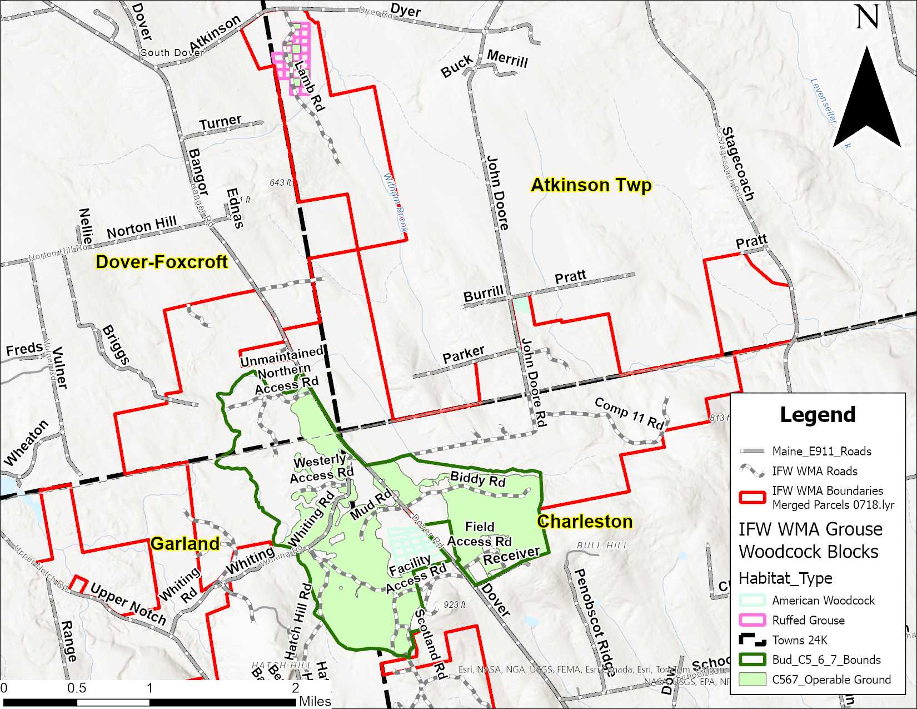
APPENDIX G – Mattawamkeag River – Page Farm Unit Location and Access Map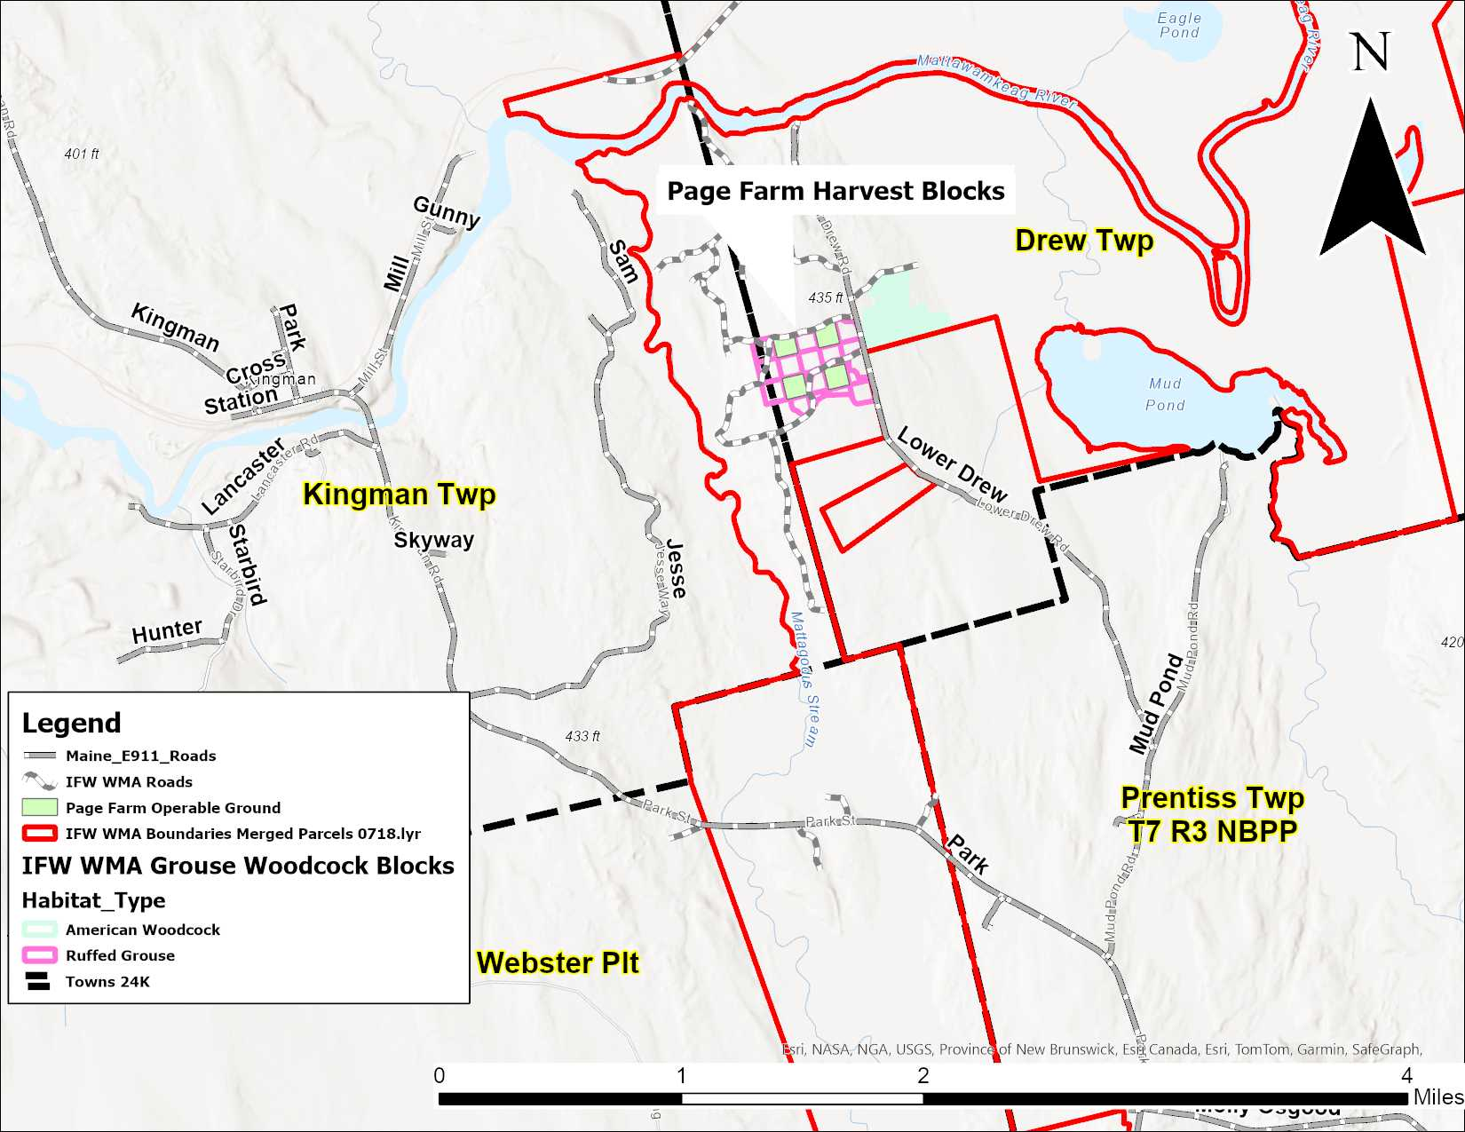
APPENDIX H – Bud Leavitt and Mattawamkeag River– Meeting Location Map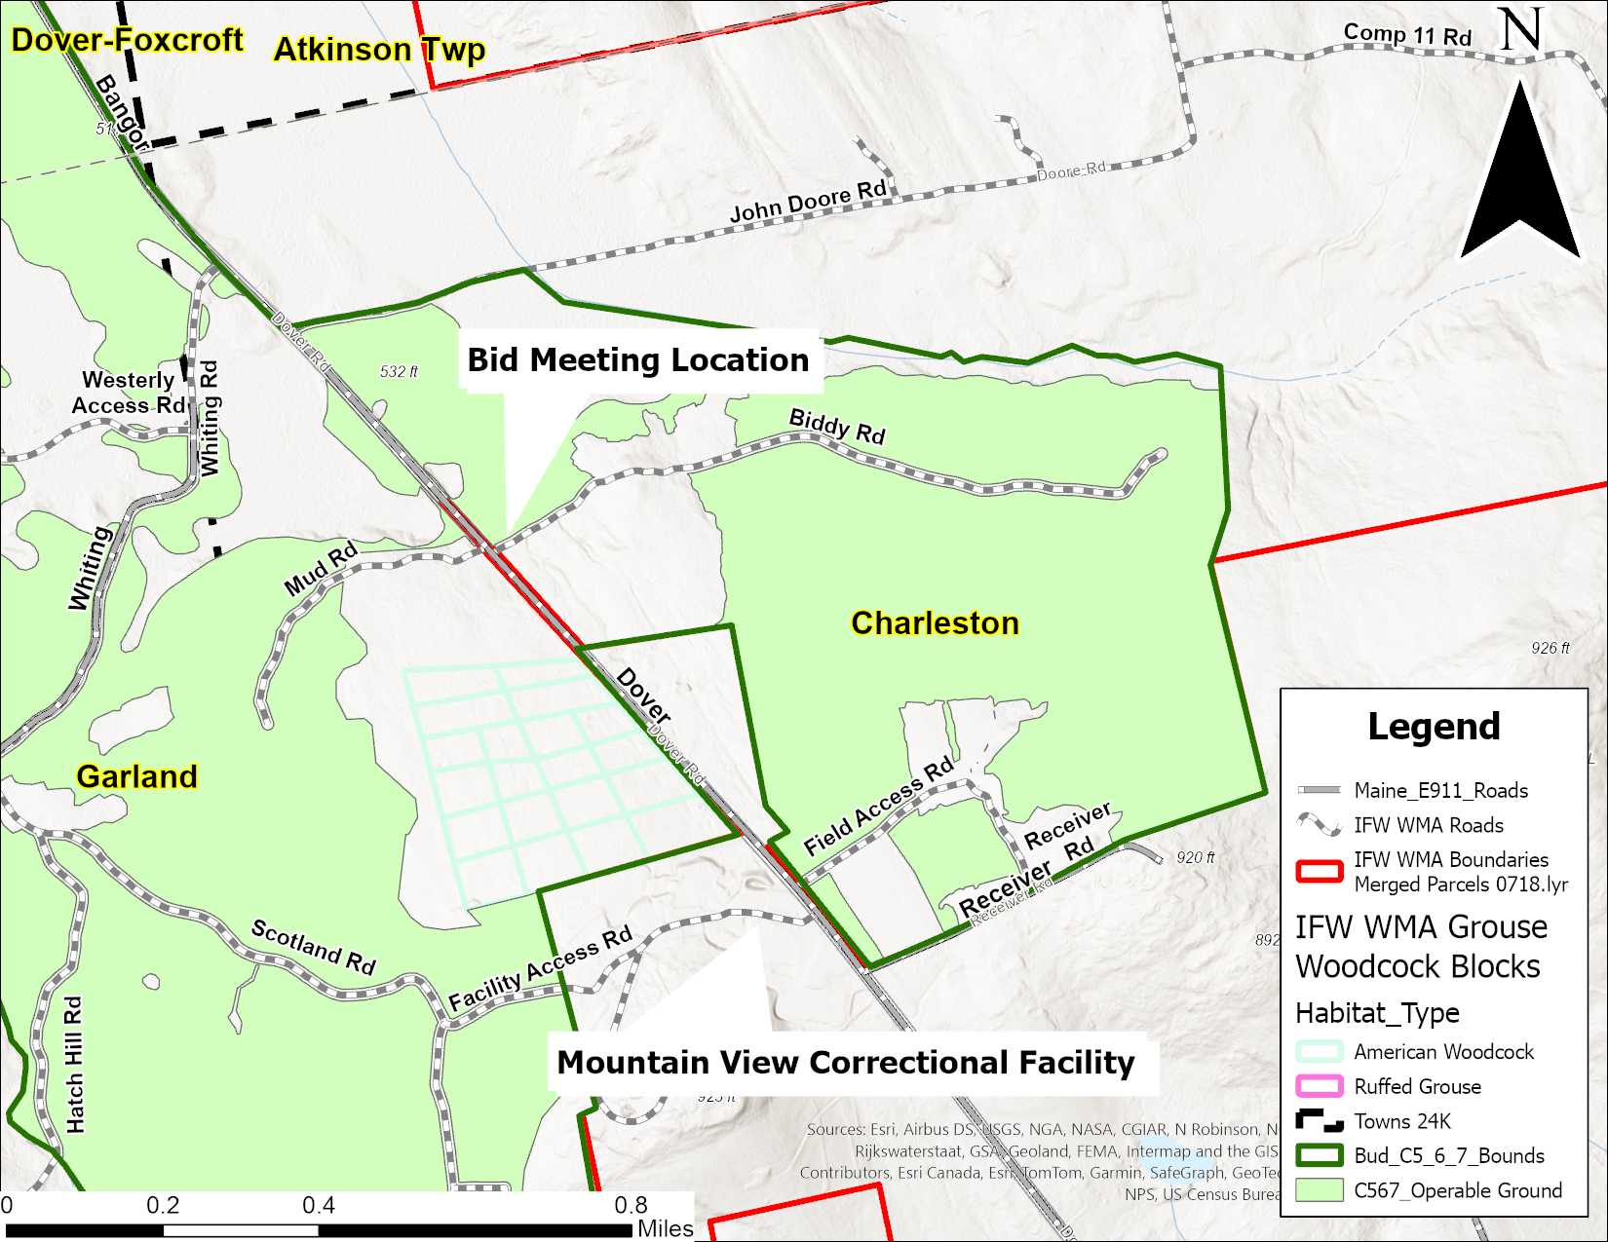

APPENDIX I. A. – Bud Leavitt – Compartments 5, 6, and 7 – Roads, Turnarounds and Yards Maps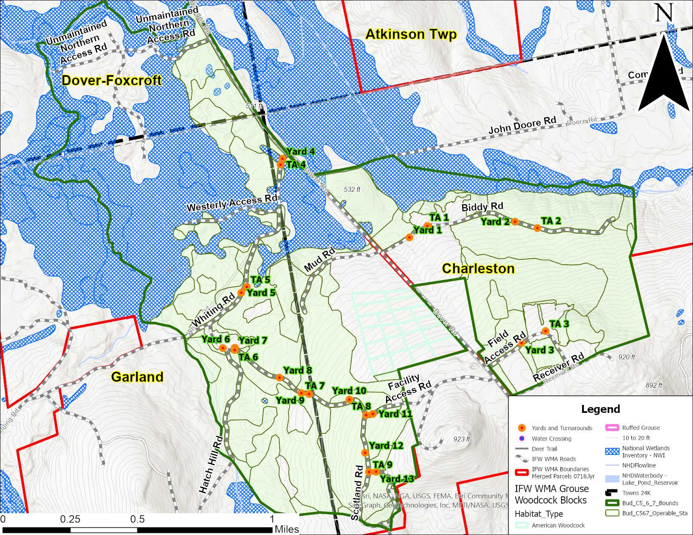
APPENDIX I. B. – Bud Leavitt – Compartments 5, 6, and 7 – Roads, Turnarounds and Yards Maps
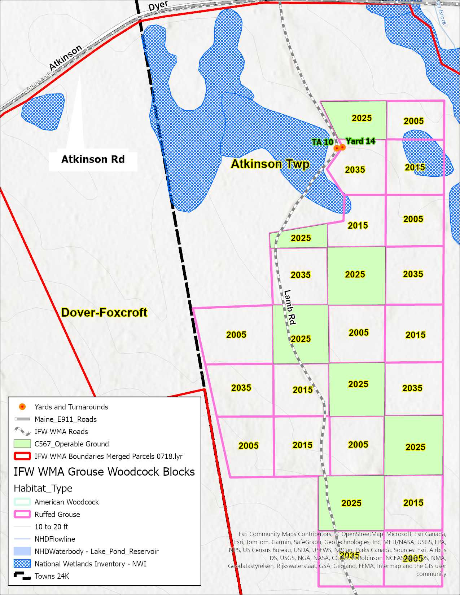
APPENDIX J – Mattawamkeag River – Page Farm Unit – Roads, Turnarounds and Yards Maps 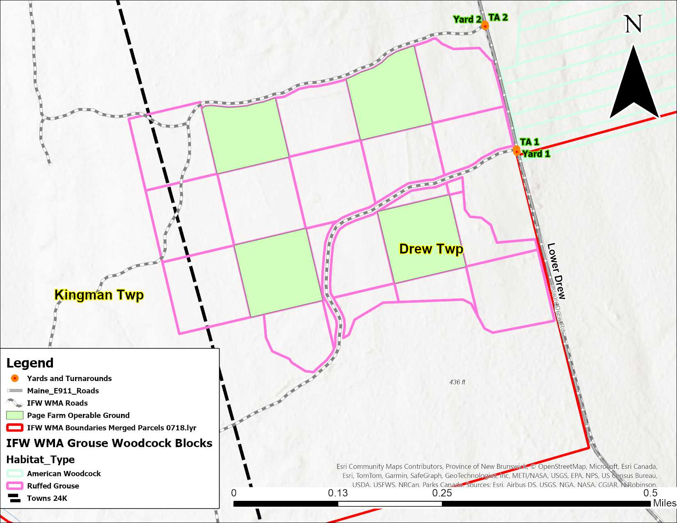
APPENDIX K - Typical Road Section

APPENDIX L – Harvest and Habitat Management Evaluation Report
Inland Fisheries and Wildlife
Harvest and Habitat Management Evaluation Report

Interim______ Final______ | Period ______________ to__________________
Contractor_____________________________________ | Subcontractor ____________________________
WMA/Compartment _____________________________ | Area Inspected ___________________________
Crew Name(s)/#___________________________________________________________________________
Harvest Equipment / Method_________________________________________________________________
Scoring: Full points – acceptable, half points - needs improvement, 0 = unacceptable, NA = not applicable
 |  | Criteria |  | Guidelines
1. | (12) | Wildlife habitat | ____ | Den/cavity trees, nests, mast trees, coarse woody debris, riparian zone integrity, shrubs
2. | (8) | Prescription goals achieved I | ____ | 95%+ marked with designated wood harvested
3. | (8) | Prescription goals achieved II | ____ | <5% non-trail and unmarked wood harvested
4. | (8) | Residual stand damage | ____ | Minimal residual stand damage* (scars, roots, tops/limbs)
5. | (8) | Regeneration damage | ____ | Minimal impact on future stand viability
6. | (8) | Skid trail spacing/width | ____ | Meets specifications and/or in accordance with layout
7. | (8) | Skid trail ruts/erosion control | ____ | BMPs & soil disturbance policy met, adequate water bars
8. | (8) | Utilization | ____ | Wood merchandized to highest value
9. | (8) | Infrastructure impact | ____ | Crushed culverts, compromised ditches or roads
10. | (8) | Compliance w/ BMPs/laws/regs | ____ | Contract, LUPC, DEP
11. | (8) | Oil/fuel spill assessment | ____ | Spill kits on hand, immediate clean-up, proper disposal
12. | (8) | Aesthetics | ____ | No garbage, no debris, tops <4’ high
REMARKS:

Total Scored Points________ | Total Criteria Points_______ | Evaluation Score_______

Evaluator________________________________

