TSD-1a

Meteorological Modeling using Penn State/NCAR 5th Generation Mesoscale Model (MM5)

Bureau of Air Quality Analysis and Research
Division of Air Resources
New York State Department of Environmental Conservation
Albany, NY 12233

February 1, 2006

Meteorological Modeling using Penn State/NCAR 5th Generation Mesoscale Model (MM5)
Version 3.6 of MM5 was used to generate annual 2002 meteorology for the OTC modeling work. Prof. Dalin Zhang of the University of Maryland performed the MM5 simulations in consultation with NYSDEC staff. The model was applied in Lambert conformal map projection and utilized MPP Version developed for clusters. The two-way nested domain consisted of coarse (36km) and fine (12km) mesh corresponding to 149x129 and 175x175 grids, respectively, in this application (see Figure 1).

The Lambert projection used in this work followed the Regional Planning Organization (RPO) national domain setup with the center at (40ºN, 97ºW) and parallels at 33ºN and 45ºN. Map projection parameters in reference to the projection center point are as follows: Southwest corner for the 36 km grid is at (-2664km, -2304km) and the northeast corner at (2664km, 2304km). In the case of the 12km grid, the southwest corner is at (252km, -900km) and the northeast corner at (2340km, 1188km). In the vertical direction, the terrain following σ-coordinate system was used with the pressure at each σ-level determined from a reference state that is estimated using the hydrostatic equation from a given sea-level pressure and temperature with a standard lapse rate. There are 30 unevenly spaced σ levels, giving 29 vertical layers, with higher resolution within the planetary boundary layer (PBL). The σ levels are:
1.0000, 0.9974, 0.9940, 0.8980, 0.9820, 0.9720, 0.9590, 0.9430, 0.9230, 0.8990,
0.8710, 0.8390, 0.8030, 0.7630, 0.7180, 0.6680, 0.6180, 0.5680, 0.5180, 0.4680,
0.3680, 0.3180, 0.2680, 0.2180, 0.1680, 0.1230, 0.0800, 0.0400, 0.0000
The surface layer was set at about 10m, the level at which surface winds were typically observed, and the model top was set at 50hPa with a radiative top boundary condition. The time steps for the 36km and 12km domains were 75 and 25 seconds, respectively.
The important model physics options used for this MM5 simulation include:
- Kain-Fritsch (1993) convective scheme for both 36- and 12-km domains
- Explicit moisture scheme (without the mixed phase) containing prognostic equations for cloud water (ice) and rainwater (snow) (Dudhia 1989; Zhang 1989)
- Modified version of the Blackadar planetary boundary layer (PBL) scheme (Zhang and Anthes 1982; Zhang and Zheng 2004)
- Simple radiative cooling scheme (Grell et al. 1994)
- Multi-layer soil model to predict land surface temperatures using the surface energy budget equation (Dudhia 1996)
Note that the Blackadar PBL scheme has been modified in order to correct the phase shift of surface wind speed and temperature diurnal cycle, following a study that compared five different PBL schemes: the Gayno-Seaman TKE scheme (Shafran et al. 2000), Burk-Thompson (1989), Blackadar (Zhang and Anthes 1982), MRF (Hong and Pan 1996), and Mellor-Yamada-Jajic (Mellor and Yamada 1974; Jajic 1990, 1994). The details of the study can be found at Zhang and Zheng (2004).

Nudging Processes
The MM5 provides options for nudging observations for each domain during the model integration process (Stauffer and Seaman, 1990; Stauffer et al. 1991). The Eta analyses of upper-air winds, temperature and water-vapor mixing ratio as well as their associated surface fields were used for nudging every 6 hours, and the Eta surface wind fields blended with surface wind observations were used to nudge every 3 hours. While only the surface winds were nudged, their influences could extend into the PBL as well (see Stauffer et al. 1991). Based on UMD’s prior experience in numerical experiments, the following nudging coefficients have been used:
- Upper-air wind fields: 5. 0E-4s⁻¹ for Domain 1 (36km), and 2. 5E-4s⁻¹ for Domain 2 (12km);
- Upper-air temperature fields: 1.0E-5s⁻¹ for both Domains;
- Surface winds: 5. 0s⁻¹E-4s⁻¹ for Domain 1, and 2.5E-4s⁻¹ for Domain 2; and
- Surface temperature and moisture: not nudged due to instability consideration.
ASSESSMENT
This assessment covers the period of May through September 2002.
National Weather Service (NWS) and CASTNet data – Surface temperature, Wind Speed, and Humidity
NWS (TDL) and CASTNet (www.epa.gov/castnet/)surface measurements of temperature, wind speed, and humidity (note there were no humidity measurements for CASTNet) were used to compare with the MM5 outputs. The evaluation was performed with METSTAT program developed by Environ Corporation (www.camx.com/files/metstat.15feb05.tar.gz..When comparing to NWS data, the METSTAT interpolates the first layer MM5 (at 10m height) temperature and humidity data to a height of 2m, the level that corresponds to the NWS measurement of these parameters. However, no such interpolation was made for wind speed and direction. In the case of CASTNet surface measurements, no such changes were needed as CASTNet data were reported at a height of 10m. In this analysis, no exclusion was made for calm conditions. The reported calm winds (zero wind speed measured) were treated as is in this evaluation effort. The METSTAT calculated standard statistical measures – average, bias, error and index of agreement between the measured and predicted parameters.
Figure 2 displays the temperature and wind speed comparison of MM5 and measured data from NWS and CASTNet networks for August 2002. MM5 performance for both in magnitude and diurnal timing, temperature can be considered to be quite good for both NWS and CASTNet data, while MM5 underpredicted NWS and overpredicted CASTNet daytime wind speed, respectively. It should be pointed out that there are differences in how the meteorological information is collected and reported by the two networks as well as in MM5. The CASTNet measurements are based on hourly averaged wind speed while NWS reports 2min average at 10min before the hour, whereas MM5 predictions are reflective of the last time-step of the hour of computation. Interestingly, MM5 appears to track quite well the nighttime minimum wind speed for both networks. In the case of humidity (not shown), MM5 tracks the NWS observed humidity trend well, but MM5 missed the observed semi-diurnal cycles. Comparisons for the five months including bias and root mean square error from both NWS and CASTNet are available on request from NYSDEC.
The above assessment is based on domain-wide averages to provide an overall response of the model over the five months. Another way of assessing the model is to examine the degree of correlation between the measured and predicted parameters. Figure 3 displays such a comparison for temperature and wind speed for the NWS hourly data covering the period of May through September 2002. For the NWS data, the correlations are in the range from 0.7 to 0.8 for wind speed, above 0.96 for temperature, and in the range of 0.8 to 0.9 for humidity. CASTNet data (not shown) also exhibit similar correlation. These correlations indicate that MM5 simulation has captured both the diurnal and synoptic scale variations. Detailed plots of this comparison are available on request from NYSDEC.

Vertical Profiler – Winds
The Wind-Profiler network measurements along the U. S. East Coast (www.madis-fsl.org/cap) were used to evaluate the vertical profiles from MM5. There are twelve wind-profiler measurement stations from which data were available for comparison. For convenience of comparison, the wind-profiler measurements were interpolated to the MM5 vertical levels. The approach used was simple interpolation between two adjacent wind-profiler layers to the MM5 vertical level, and was limited to that reported by the profiler measurement. The focus of the comparison was to assess if MM5 was able to capture the measured vertical structure, and for this we used the observed Low Level Jet (LLJ) as an indicator. The comparison was performed for June, July and August 2002. In general it is found that MM5 captures the profiler measured vertical wind field structure reasonably well. Figure 4 displays an example of the MM5 and wind profiler comparison for the August 2002 episode at Richmond, VA and Concord, NH. MM5 predicted weaker LLJ winds compared to those based on the wind-profiler measurements. The detailed plots of this comparison are available on request from NYSDEC.
Cloud Cover – Satellite cloud image
Cloud information derived from satellite image data (www.atmos.umd.edu/~srb/gcip/webgcip.htm )were used to assess the MM5 prediction of cloud cover. The 0.5º by 0.5º resolution of the satellite data were interpolated into the 12km MM5 grid for comparison. The MM5 total cloud fraction was estimated by MCIP based on the MM5’s low cloud, middle cloud and high cloud predictions. In general, MM5 captured the satellite cloud pattern well but underestimates the satellite cloud fraction (see Figure 5 as an example). Part of problem may due to the coarse resolution of the satellite cloud data. The detailed plots of this comparison are available on request from NYSDEC or at the following URL
Precipitation comparison
The monthly total observed precipitation data were constructed from 1/8-degree daily precipitation analysis data (http://data.eol.ucar.edu/codiac/dss/id=21.093 produced by Climate Prediction Center, based on 7,000-8,000 hourly/6-hourly gauge reports and radar). The MM5 monthly total precipitation was estimated from the MM5 predicted convective and non-convective rainfall and summed up for each month. In general, MM5 captured the observed spatial patterns in May and September, but no so well for June, July and August (See Figure 6), perhaps reflective of the summertime convective rain activities not captured by MM5. Detailed plots of this comparison are available on request from NYSDEC.

Calm Conditions

Calm conditions are defined as observed wind speed of zero knots and wind direction as 0º. It would be useful to assess how MM5 performs under observed calm conditions, because of potential pollutant buildup that could occur under such conditions. Table 1 lists the summary of the percentage of calm condition at each hour for the August 2002 from the NWS data within the 12km domain. It is apparent from the Table that the calm conditions occur primarily during the night and early morning hours, from 23Z (7 p.m. EDT) to 15Z (11 a.m. EDT) with a peak at 10Z (6 a.m. EDT). To assess MM5 performance, the observed and MM5 predicted wind speeds were divided into calm and non-calm according to observed wind speed. Figure 7 displays such a comparison of the MM5 predicted wind speed to the observed wind speed under the calm and non-calm conditions for the month of August 2002. For the “calm” group, the average wind speed for MM5 varies from 1 m/s during the night and early morning hours and over 1.5 m/s during the day. MM5 is over-predicting during observed calm wind conditions. There are local minima every 3 hours, due to the surface observed wind speed nudging in MM5. In contrast under the non-calm conditions, MM5 underpredicts by about 0.5 m/s for all hours with noticeable local maximum happening at the nudging hours. The MM5 nudging process would pull predictions toward the measured data, while the underprediction of MM5 for the non-calm conditions may due to the adopted PBL scheme in this simulation.

Summary

In this study, we performed an assessment of the MM5 simulation to real-world data, both at the surface level as well as in the vertical. While there are no specific recommended procedures identified for this assessment, similar approaches have been used elsewhere (Dolwick 2005, Baker 2004, and Johnson 2004). Traditionally, the NWS surface measurements are used for such a comparison. Since NWS data had been used through nudging processes in developing the MM5 simulation, the comparisons should not be far removed from each other. In this study, we extended the evaluation by using CASTNet measurements that were not used in the MM5 simulations. Thus comparison with CASTNet data provides for an independent assessment and should complement the comparison with NWS data. We also compared the MM5 results with the wind profiler data and cloud data derived from satellite images to diagnose if the MM5 simulation is yielding the right type of dynamics in the vertical. The analyses shows that in general, the performance of the MM5 is reasonable both at the surface and in the vertical, thereby providing confidence in the use of these data in the CMAQ simulations.

References

Baker, K. 2004: www.ladco.org/tech/photo/photochemical.html

Burk, S. D. and W. T. Thompson, 1989: A vertically nested regional numerical weather prediction model with second-order closure physics. Mon. Wea. Rev., 117, 2305–2324.

Dudhia, J., 1989: Numerical study of convection observed during the winter monsoon experiments using a mesoscale two-dimensional model. J. Atmos. Sci., 46, 3077–3107.

Dudhia, J., 1996: A multi-layer soil temperature model for MM5. Preprints, 6th Annual MM5 Users Workshop, Boulder, CO.

Dolwick, P. 2005: http://cleanairinfo.com/modelingworkshop/presentations/MPE_Dolwick.pdf

Grell, G. A., J. Dudhia , and D. R. Stauffer 1994: A description of the fifth-generation Penn State/NCAR Mesoscale Model (MM5). NCAR Tech.Note NCAR/TN-398 1 STR, 122 pp.

Hong, S.-H., and H.-L. Pan, 1996: Nonlocal boundary layer vertical diffusion in a medium-range forecast model. Mon. Wea. Rev., 124, 2322–2339.

Jajic, Z. I., 1990: The step-mountain coordinate: Physical package. Mon. Wea. Rev., 118, 1429-1443.

Jajic, Z. I., 1994: The step-mountain Eta coordinate model: Further development of the convection, viscous sublayer and turbulent closure schemes. Mon. Wea. Rev., 122, 927-945.

Johnson, M. 2004: www.ladco.org/tech/photo/photochemical.html

Kain, J.S., and J.M. Fritsch, 1993: Convective parameterization for mesoscale models: The Kain-Fritsch scheme. Cumulus Parameterization. Meteor. Monogr., 46, Amer. Meteor. Soc., 165-170.

Mellor, G. L., and T. Yamada, 1974: A hierarchy of turbulence closure models for planetary boundary layers. J. Atmos. Sci., 31, 1791–1806.

Shafran, P.C., N.L. Seaman, and G. A. Gayno, 2000: Evaluation of numerical predictions of boundary layer structure during the Lake Michigan ozone study. J. Appl. Meteor., 39, 412-426.

Stauffer, D. R., N. L. Seaman and F. S. Binkowski 1991: Use of four-dimensional data assimilation in a limited-area mesoscale model. Part II: Effects of data assimilation within the planetary boundary layer. Mon. Wea. Rev., 119, 734-754.

Stauffer, D. R. and N. L. Seaman, 1990: Use of four-dimensional data assimilation in a limited-area mesoscale model. Part I: Experiments with synoptic-scale data. Mon. Wea. Rev., 118, 1250-1277.

Zhang, D.-L., 1989: The effect of parameterized ice microphysics on the simulation of vortex circulation with a mesoscale hydrostatic model. Tellus, 41A, 132-147.

Zhang, D.-L, and R. A. Anthes, 1982: A high-resolution model of the planetary boundary layer-sensitivity tests and comparisons with SESAME-79 data. J. Appl. Meteor., 21, 1594–1609.

Zhang, D.-L, and W.-Z. Zheng, 2004: Diurnal cycles of surface winds and temperatures as simulated by five boundary-layer parameterizations. J. Appl. Meteor., 43, 157-169.

Table 1 Measured calm and non-calm occurrences over the modeling domain during August 2002 based on NWS data

Hour | #Non-Calm | #Calm | #Total | % Calm
00Z | 18209 | 3924 | 22133 | 17.7
01Z | 16531 | 6026 | 22557 | 26.7
02Z | 15604 | 6929 | 22533 | 30.8
03Z | 14983 | 7245 | 22228 | 32.6
04Z | 14309 | 7540 | 21849 | 34.5
05z | 14073 | 7735 | 21808 | 35.5
06Z | 13934 | 7949 | 21883 | 36.3
07Z | 13792 | 8040 | 21832 | 36.8
08Z | 13542 | 8273 | 21815 | 37.9
09Z | 13542 | 8385 | 21927 | 38.2
10Z | 13708 | 8591 | 22299 | 38.5
11Z | 14139 | 8693 | 22832 | 38.1
12Z | 15297 | 7690 | 22987 | 33.5
13Z | 17336 | 5192 | 22528 | 23
14Z | 18522 | 3439 | 21961 | 15.7
15Z | 18755 | 2617 | 21372 | 12.2
16Z | 19169 | 2015 | 21184 | 9.5
17Z | 19555 | 1617 | 21172 | 7.6
18Z | 19982 | 1430 | 21412 | 6.7
19Z | 20149 | 1389 | 21538 | 6.4
20Z | 20565 | 1288 | 21853 | 5.9
21Z | 20518 | 1383 | 21901 | 6.3
22Z | 20672 | 1556 | 22228 | 7
23Z | 20231 | 2292 | 22523 | 10.2

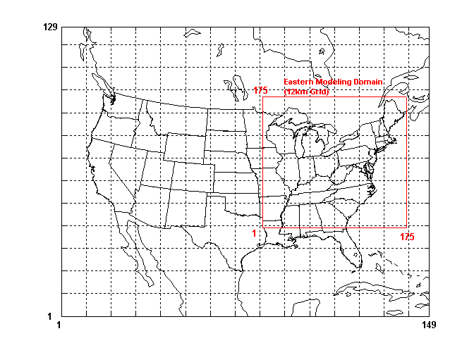

Figure 1: OTC MM5 modeling domain with areal extent of 12km and 36km grids

Figure 2: Temperature and Wind speed comparisons for August 2002. In each case the upper panel corresponds to comparison between MM5 and NWS data and the lower panel between MM5 and CASTNet data.

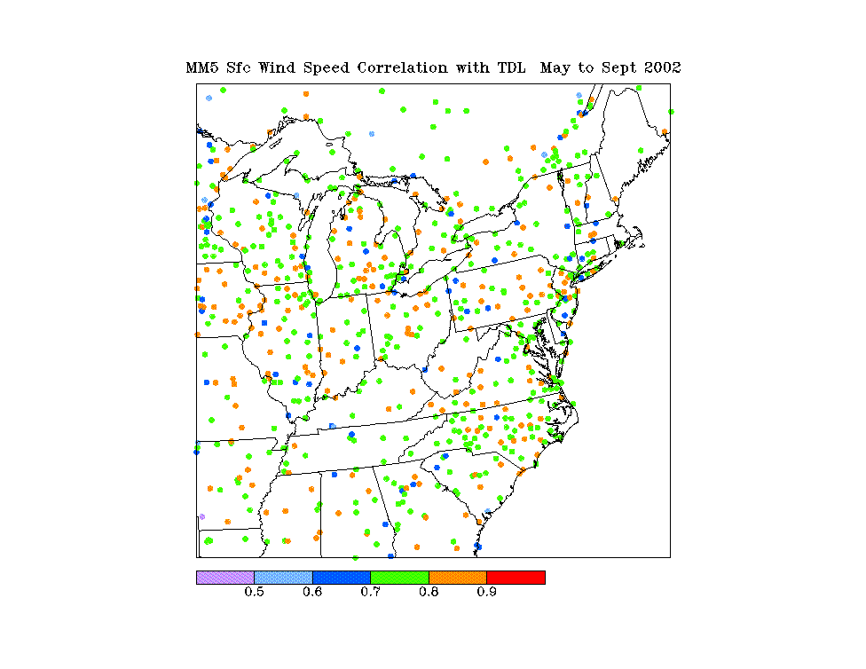
Figure 3a: Spatial correlation estimates between MM5 and NWS data for wind speed
from May to September 2002

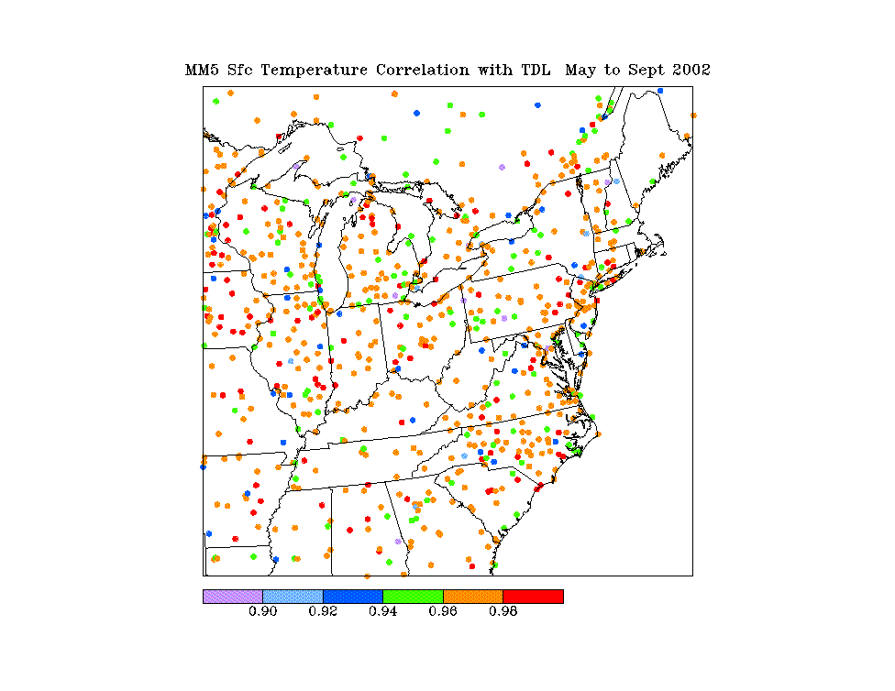
Figure 3b: Spatial distribution of correlation coefficients for Temperature between MM5 and NWS data from May to September 2002.

Richmond, VA
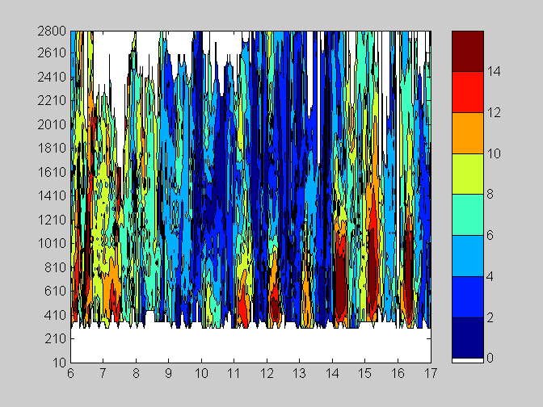
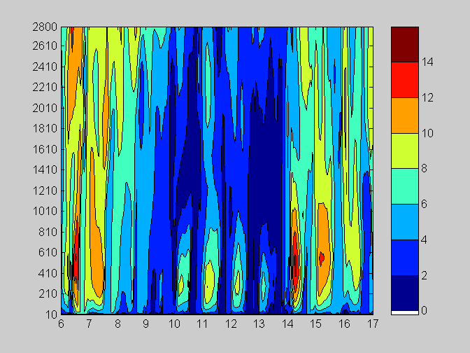
Concord, NH
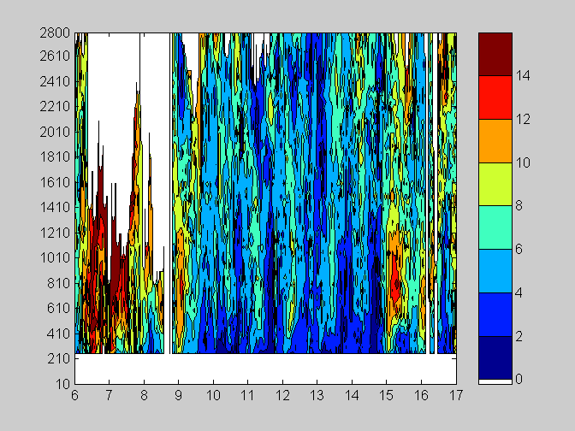
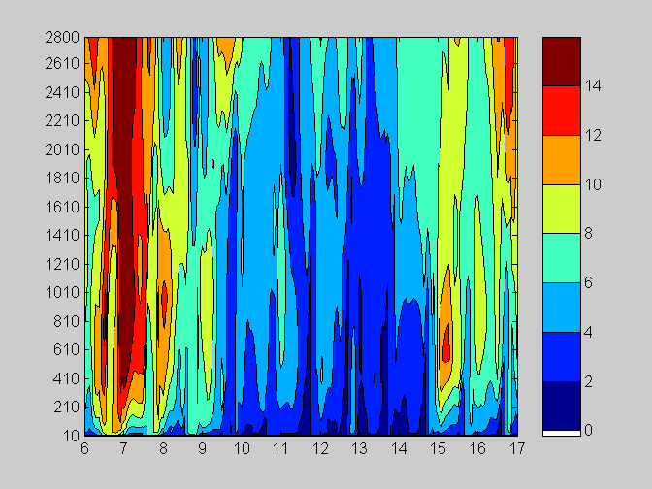

Figure 4: MM5 and Wind profiler comparison for August 6 to 17, 2002 at Richmond, VA and Concord, NH. The upper and lower panes at each station are for MM5 and profiler, respectively. The abcissa represents day and the ordinate the height (m).

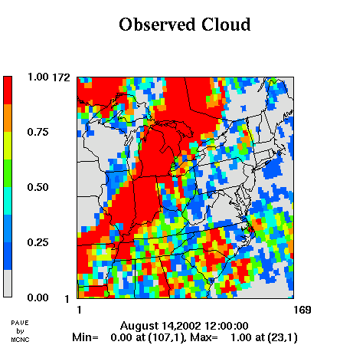
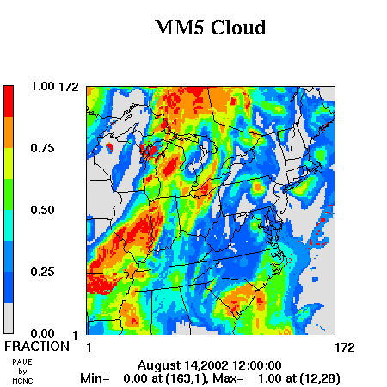

Figure 5: MM5 and Satellite cloud images for August 14, 2002 at 0700 EST

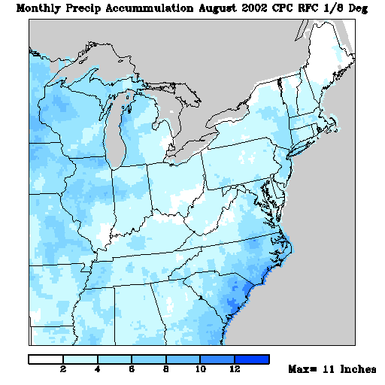

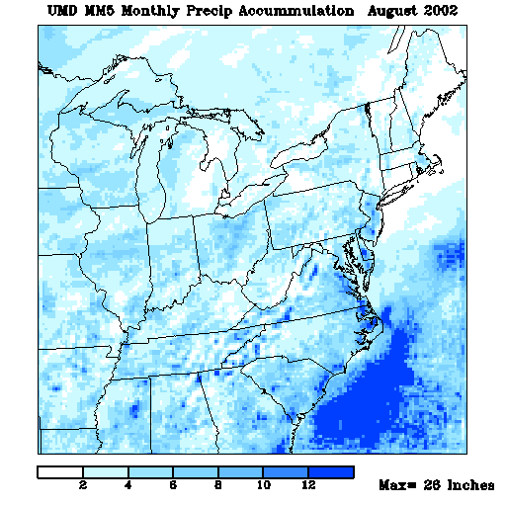

Figure 6: MM5 predicted and measured precipitation over the domain for the month of August 2002

Figure 7: Comparison of averaged wind speed between MM5 and observed under calm (C) and non-calm (NC) conditions.

