Tracking Visibility Progress Mid-Atlantic/Northeast U.S.

2004-2018

(1st RH SIP Metrics)

**Prepared by**

**Maine Department of Environmental Protection (ME DEP)**

for the

Mid-Atlantic/Northeast Visibility Union (MANE-VU)

Project Manager- Tom Downs (MEDEP)

**May 1, 2020 revision**



**Acknowledgments**

This document is to be considered an update to the NESCAUM 2013 revision summary document: (<http://www.nescaum.org/documents/manevu-trends-2004-2011-report-final-20130430.pdf/view>). This document is also a companion technical document to go with the following report: *Mid-Atlantic/Northeast U.S. Visibility Data 2004-2018 ( 2nd RH SIP Metrics) – 5-1-2020 Update* (MANE-VU 2020).

We could not have completed this work without the IMPROVE (Interagency Monitoring of Protected Visual Environments) program and long-term commitment of the National Park Service and other state and federal partners to maintain visibility networks and the Federal Land Manager Environmental Database (FED). FED is hosted at the Colorado State University’s Cooperative Institute for Research in the Atmosphere (CIRA). IMPROVE is a collaborative association of state, tribal, and federal agencies, and international partners. US Environmental Protection Agency is the primary funding source, with contracting and research support from the National Park Service. The Air Quality Group at the University of California, Davis is the central analytical laboratory, with ion analysis provided by Research Triangle Institute, and carbon analysis provided by Desert Research Institute.

Special thanks to Scott Copeland, USDA Forest Service Air Data Analyst for all his efforts to complete data analyses used in this report, Rich Greves with the Maine Department of Environmental Protection for his help creating analysis plots and Martha Webster with the Maine Department of Environmental Protection for her help creating monitoring site maps.

**i**

**TABLE OF CONTENTS**

Acknowledgments.............................................................................................................. i

Executive Summary ......................................................................................................... vii

1. Introduction................................................................................................................ 1-1

1.1. Background ...................................................................................................... 1-1

2. Process for Tracking Progress ................................................................................... 2-1

2.1. Long Term Goals and Natural Visibility ......................................................... 2-1

2.2. Reasonable Progress Goals .............................................................................. 2-2

2.3. Measurement and Data Support ....................................................................... 2-3

3. Results........................................................................................................................ 3-1

3.1. Haze Index Trends ........................................................................................... 3-1

3.2. Constituent Light Extinction Trends................................................................ 3-6

3.3. Conclusions on Visibility Progress ................................................................ 3-26

4. Discussion .................................................................................................................. 4-1

5. References .................................................................................................................. 5-1

Appendix A: Tracking Progress Data for Class I Areas and IMPROVE Protocol Sites In and Adjacent to the MANE-VU Region

Appendix B: Natural Conditions for Class I Areas and IMPROVE Protocol Sites In and Adjacent to the MANE-VU Region

Appendix C: Constituent Light Extinction Data for Class I Areas and IMPROVE Protocol Sites in and Adjacent to the MANE-VU Region

**ii**

**FIGURES**

Figure 1-1. Class I Areas and IMPROVE Protocol Sites in and Adjacent to the

MANE-VU Region ...................................................................................... 1-3

Figure 3-1. Annual Haze Index Levels at Acadia National Park.................................... 3-2

Figure 3-2. Annual Haze Index Levels at Moosehorn Wilderness Area ........................ 3-2

Figure 3-3. Annual Haze Index Levels at Great Gulf Wilderness Area ......................... 3-3

Figure 3-4. Annual Haze Index Levels at Lye Brook Wilderness Area ......................... 3-3

Figure 3-5. Annual Haze Index Levels at Brigantine Wilderness Area ......................... 3-4

Figure 3-6. Annual Haze Index Levels at Dolly Sods Wilderness Area ........................ 3-4

Figure 3-7. Annual Haze Index Levels at Shenandoah National Park ........................... 3-5

Figure 3-8. Annual Haze Index Levels at James River Face Wilderness Area .............. 3-5

Figure 3-9. Individual Constituent Contribution to Annual Haze Index Levels at

Acadia National Park on 20 Percent Best and Worst Visibility Days .................. 3-8

Figure 3-10. Individual Constituent Contribution to Annual Haze Index Levels at

Moosehorn Wilderness Area on 20 Percent Best and Worst Visibility Days ....... 3-8

Figure 3-11. Individual Constituent Contribution to Annual Haze Index Levels at

Great Gulf Wilderness Area on 20 Percent Best and Worst Visibility Days ........ 3-9

Figure 3-12. Individual Constituent Contribution to Annual Haze Index Levels at

Lye Brook Wilderness Area on 20 Percent Best and Worst Visibility Days ........ 3-9

Figure 3-13. Individual Constituent Contribution to Annual Haze Index Levels at

Brigantine Wilderness Area on 20 Percent Best and Worst Visibility Days ....... 3-10

Figure 3-14. Individual Constituent Contribution to Annual Haze Index Levels at

Dolly Sods Wilderness Area on 20 Percent Best and Worst Visibility Days ...... 3-10

Figure 3-15. Individual Constituent Contribution to Annual Haze Index Levels at

Shenandoah National Park on 20 Percent Best and Worst Visibility Days ......... 3-11

Figure 3-16. Individual Constituent Contribution to Annual Haze Index Levels at

James River Face Wilderness Area on 20 Percent Best and Worst

Visibility Days .....................................................................................................3-11

Figure 3-17. 1997-2018 NOx Trends by Month............................................................ 3-12

Figure 3-18. Current and Baseline 5-Year Average Light Extinction at Class I Sites

on 20 Percent Best and Worst Visibility Days.................................................... 3-13

Figure 3-19. Range of Observed and Estimated Natural Light Extinction for

Select Individual Constituents at Acadia National Park on 20 Percent Best

and Worst Visibility Days ................................................................................... 3-14

Figure 3-20. Range of Observed and Estimated Natural Light Extinction for

Select Individual Constituents at Moosehorn Wilderness Area on 20

Percent Best and Worst Visibility Days .............................................................. 3-15

Figure 3-21. Range of Observed and Estimated Natural Light Extinction for

Select Individual Constituents at Great Gulf Wilderness Area on 20 Percent

Best and Worst Visibility Days ........................................................................... 3-16

Figure 3-22. Range of Observed and Estimated Natural Light Extinction for

Select Individual Constituents at Lye Brook Wilderness Area on 20 Percent

Best and Worst Visibility Days ........................................................................... 3-17

Figure 3-23. Range of Observed and Estimated Natural Light Extinction for

Select Individual Constituents at Brigantine Wilderness Area on 20 Percent

Best and Worst Visibility Days ........................................................................... 3-18

**iii**

**FIGURES (cont.)**

Figure 3-24. Range of Observed and Estimated Natural Light Extinction for

Select Individual Constituents at Dolly Sods Wilderness Area on 20 Percent

Best and Worst Visibility Days ........................................................................... 3-19

Figure 3-25. Range of Observed and Estimated Natural Light Extinction for

Select Individual Constituents at Shenandoah National Park on 20 Percent

Best and Worst Visibility Days ........................................................................... 3-20

Figure 3-26. Range of Observed and Estimated Natural Light Extinction for

Select Individual Constituents at James River Face Wilderness Area on 20 Percent

Percent Best and Worst Visibility Days .............................................................. 3-21

**TABLES**

Table 1-1. Members of the Mid-Atlantic/Northeast Visibility Union (MANE-VU)...... 1-2

Table 1-2. IMPROVE Monitoring Sites......................................................................... 1-2

Table 2-1. Natural Visibility Conditions for Class I Areas in and Adjacent to the

MANE-VU Region ............................................................................................... 2-1

Table 2-2. Natural Visibility Conditions for IMPROVE Protocol Sites in and

Adjacent to the MANE-VU Region ...................................................................... 2-2

Table 2-3. 2018 Goals for Class I Areas in or Adjacent to the MANE-VU Region ...... 2-3

Table A-1. Tracking Progress Data for Acadia National Park (ME) and Brigantine

Wilderness (NJ) Class I Areas in the MANE-VU Region (dv)............................ A-1

Table A-2. Tracking Progress Data for Great Gulf Wilderness (NH) and Lye Brook

Wilderness (VT) Class I Areas in the MANE-VU Region (dv)........................... A-2

Table A-3. Tracking Progress Data for the Moosehorn Wilderness (ME) Class I Area

in the MANE-VU Region (dv)............................................................................. A-3

Table A-4. Tracking Progress Data for the Dolly Sods Wilderness (WV) Class I Area

Adjacent to the MANE-VU Region (dv).............................................................. A-3

Table A-5. Tracking Progress Data for James River Face Wilderness and Shenandoah

National Park (VA) Class I areas Adjacent to the MANE-VU Region (dv)........ A-4

Table A-6. Tracking Progress Data for Addison Pinnacle (NY) and Arendtsville (PA)

IMPROVE Protocol Sites in the MANE-VU Region (dv)................................... A-5

Table A-7. Tracking Progress Data for Baltimore (MD) and Bridgton (ME)

IMPROVE Protocol Sites in the MANE-VU Region (dv)................................... A-6

Table A-8. Tracking Progress Data for Casco Bay (ME) and Cape Cod (MA)

IMPROVE Protocol Sites in the MANE-VU Region (dv)................................... A-7

Table A-9. Tracking Progress Data for Connecticut Hill (NY) and Frostburg Reservoir

(MD) IMPROVE Protocol Sites in the MANE-VU Region (dv)......................... A-8

Table A-10. Tracking Progress Data for Londonderry (NH) and Martha’s Vineyard

(MA) IMPROVE Protocol Sites in the MANE-VU Region (dv)......................... A-9

Table A-11. Tracking Progress Data for M.K. Goddard (PA) and Mohawk Mt. (CT)

IMPROVE Protocol Sites in the MANE-VU Region (dv).................................. A-10

Table A-12. Tracking Progress Data for New York IS52 and Old Town (ME)

IMPROVE Protocol Sites in the MANE-VU Region (dv).................................. A-11

Table A-13. Tracking Progress Data for Penobscot Nation (ME) and Pack Monadnock

Summit (NH) IMPROVE Protocol Sites in the MANE-VU Region (dv)…....... A-12

Table A-14. Tracking Progress Data for Proctor Maple R.F. (VT) and Presque Isle

(ME) IMPROVE Protocol Sites in the MANE-VU Region (dv)……………..... A-13

Table A-15. Tracking Progress Data for Quabbin Reservoir (MA) and Washington

D.C. IMPROVE Protocol Sites in the MANE-VU Region (dv).......................... A-14

**iv**

**TABLES (cont.)**

Table A-16. Tracking Progress Data for the Quaker City (OH) IMPROVE Protocol

Site Adjacent to the MANE-VU Region (dv)...................................................... A-15

Table B-1. 20 Percent Best Days Natural Conditions for Class I and IMPROVE Protocol

Sites in and Adjacent to the MANE-VU Region................................................... B-1

Table B-2. 20 Percent Worst Days Natural Conditions for Class I and IMPROVE Protocol

Sites in and Adjacent to the MANE-VU Region................................................... B-2

Table C-1. Observed Light Extinction Conditions for theAcadia National Park (ME)

MANE-VU Class I Area....................................................................................... C-1

Table C-2. Observed Light Extinction Conditions for theBrigantine Wilderness Area

(NJ) MANE-VU Class I Area............................................................................... C-2

Table C-3. Observed Light Extinction Conditions for theGreat Gulf Wilderness Area

(NH) MANE-VU Class I Area.............................................................................. C-3

Table C-4. Observed Light Extinction Conditions for theLye Brook Wilderness Area

(VT) MANE-VU Class I Area............................................................................... C-4

Table C-5. Observed Light Extinction Conditions for theMoosehorn Wilderness Area

(ME) MANE-VU Class I Area.............................................................................. C-5

Table C-6. Observed Light Extinction Conditions for theDolly Sods Wilderness Area

(WV) Nearby Adjacent Class I Area..................................................................... C-6

Table C-7. Observed Light Extinction Conditions for theShenandoah National Park

(VA) Nearby Adjacent Class I Area...................................................................... C-7

Table C-8. Observed Light Extinction Conditions for theJames River Face

Wilderness Area (VA) Nearby Adjacent Class I Area.......................................... C-8

Table C-9. Observed Light Extinction Conditions for theAddison Pinnacle (NY)

MANE-VU IMPROVE Protocol Site................................................................... C-9

Table C-10. Observed Light Extinction Conditions for theArendtsville (PA)

MANE-VU IMPROVE Protocol Site................................................................... C-9

Table C-11. Observed Light Extinction Conditions for theBaltimore (MD)

MANE-VU IMPROVE Protocol Site.................................................................. C-10

Table C-12. Observed Light Extinction Conditions for theBridgton (ME)

MANE-VU IMPROVE Protocol Site.................................................................. C-10

Table C-13. Observed Light Extinction Conditions for theCasco Bay (ME)

MANE-VU IMPROVE Protocol Site.................................................................. C-11

Table C-14. Observed Light Extinction Conditions for theCape Cod (MA)

MANE-VU IMPROVE Protocol Site.................................................................. C-12

Table C-15. Observed Light Extinction Conditions for theConnecticut Hill (NY)

MANE-VU IMPROVE Protocol Site.................................................................. C-13

Table C-16. Observed Light Extinction Conditions for theFrostburg Reservoir (MD)

MANE-VU IMPROVE Protocol Site.................................................................. C-13

Table C-17. Observed Light Extinction Conditions for theLondonderry (NH)

MANE-VU IMPROVE Protocol Site.................................................................. C-14

Table C-18. Observed Light Extinction Conditions for theMartha’s Vineyard (MA)

MANE-VU IMPROVE Protocol Site.................................................................. C-15

Table C-19. Observed Light Extinction Conditions for theM. K. Goddard (PA)

MANE-VU IMPROVE Protocol Site.................................................................. C-16

Table C-20. Observed Light Extinction Conditions for theMohawk Mt, (CT)

MANE-VU IMPROVE Protocol Site.................................................................. C-17

**v**

**TABLES (cont.)**

Table C-21. Observed Light Extinction Conditions for theNew York IS52

MANE-VU IMPROVE Protocol Site.................................................................. C-18

Table C-22. Observed Light Extinction Conditions for theOld Town

MANE-VU IMPROVE Protocol Site.................................................................. C-19

Table C-23. Observed Light Extinction Conditions for thePenobscot Nation (ME)

MANE-VU IMPROVE Protocol Site.................................................................. C-19

Table C-24. Observed Light Extinction Conditions for thePack Monadnock Summit

(NH) MANE-VU IMPROVE Protocol Site......................................................... C-20

Table C-25. Observed Light Extinction Conditions for theProctor Maple R. F. (VT)

MANE-VU IMPROVE Protocol Site.................................................................. C-21

Table C-26. Observed Light Extinction Conditions for thePresque Isle (ME)

MANE-VU IMPROVE Protocol Site.................................................................. C-22

Table C-27. Observed Light Extinction Conditions for theQuabbin Summit (MA)

MANE-VU IMPROVE Protocol Site.................................................................. C-23

Table C-28. Observed Light Extinction Conditions for theWashington D. C.

MANE-VU IMPROVE Protocol Site.................................................................. C-24

Table C-29. Observed Light Extinction Conditions for theQuaker City (OH)

Nearby Adjacent IMPROVE Protocol Site.......................................................... C-25

**vi**

**Executive Summary**

This document presents visibility trends at IMPROVE (Interagency Monitoring of Protected Visual Environments) monitoring sites at federal Class I areas in and adjacent to the Mid-Atlantic/Northeast Visibility Union (MANE-VU) region that are subject to US Environmental Protection Agency’s (USEPA’s) Regional Haze Rule (RHR). This document also presents visibility trends at IMPROVE Protocol monitoring sites in and adjacent to the MANE-VU region. The analyses were performed to determine the extent of progress in meeting short-term and long-term visibility goals for the first RHR State Implementation Plan (SIP) period that ends in 2018 using metrics specified in the state SIPs.

This technical document provides an analysis of visibility data collected at the IMPROVE monitoring sites, starting in the baseline period of 2000-2004 through 2014-2018, the most recent five-year period with available data.

The results of this analysis continue to show the following:

* There continues to be definite downward trends in overall haze levels at all Class I areas in and adjacent to the MANE-VU region and at IMPROVE Protocol monitoring sites.
* Based on rolling five-year averages demonstrating progress since the 2000-2004 baseline period, MANE-VU Class I areas have all met 2018 Reasonable Progress Goals (RPG’s) for both 20 percent best and 20 percent worst visibility days.
* The trends are mainly driven by large reductions in sulfate light extinction, and to a lesser extent, nitrate light extinction.
* Levels of organic carbon mass (OCM) and light absorbing carbon (LAC) appear to be approaching natural background levels at most MANE-VU Class I areas.
* In all cases, 2018 RPG’s for all Class I areas in and adjacent to the MANE-VU region have been met, and progress beyond these goals appears achievable.
* Percent contribution of nitrate light extinction has been significantly increasing at most of the MANE-VU Class I areas.

**vii**

**1. INTRODUCTION**

**1.1. Background**

Haze, or reduced visibility, occurs when ambient particulate matter and gases scatter or absorb light (“light extinction”) that would otherwise reach an observer. Particles responsible for regional haze are produced naturally, from windblown dust, forest fires, and aerosolized sea salt; and by human-caused pollution from vehicles, power plants, and other combustion and dust-generating activities. Haze-forming particles can also cause serious health effects in the lungs and cardiopulmonary system, potentially leading to premature death. In addition, some particle constituents contribute to acidic deposition and other environmental harms.

In 1999, the US Environmental Protection Agency (USEPA) issued a rule under Section 169A of the Clean Air Act (Visibility Protection for the Federal Class I Areas) to address human-caused regional haze: Regional Haze Rule (RHR) [64 FR 35614 (July 1, 1999)]. The RHR is designed to improve visibility at certain national parks and wilderness areas (Class I areas) on the 20 percent haziest (‘worst’) days while not exacerbating haze on the 20 percent clearest (‘best’) days. The RHR requires states to submit state implementation plans (SIPs) to USEPA every ten years, setting interim progress goals and strategies consistent with the long-term national visibility goal of achieving natural conditions at Class I areas by 2064. States submitted their first haze SIPs to USEPA beginning in 2008. States additionally are required to track their progress against their historic baseline period1 in achieving reductions in regional haze, submitting reports every five years, and to adjust their emissions management strategies accordingly.

The Mid-Atlantic/Northeast Visibility Union (MANE-VU) was formed to support visibility planning efforts in the mid-Atlantic and northeastern portion of the country, and includes members listed in Table 1-1. Seven Class I areas in the MANE-VU region (black text) and four Class I areas adjacent to the MANE-VU region (blue text) are shown in Figure 1-1(a). This document also includes analyses for IMPROVE Protocol monitoring sites (see Figure 1-1(b)) with twenty monitors in the MANE-VU region (black text) and one adjacent to the MANE-VU region (blue text)). IMPROVE Protocol sites are in operation to provide expanded spatial coverage for the network.  Protocol sites are separately sponsored by state, regional, tribal, and national organizations and use the same instrumentation, monitoring, and analysis protocols as IMPROVE.  Table 1-2 contains more detailed information for all IMPROVE and IMPROVE Protocol monitoring sites. The purpose of this report is to support MANE-VU states in meeting the tracking progress requirement of the RHR.

____________________

1 The title of this and earlier trends reports use 2004 as the base year because the trend is based on rolling averages of 5-year periods, and 2004 was the end of the initial 5-year period used as the baseline.

**Page 1-1**

**Table 1-1. Members of the Mid-Atlantic/Northeast Visibility Union (MANE-VU)**

Connecticut Pennsylvania

Delaware Penobscot Indian Nation

District of Columbia Rhode Island

Maine St. Regis Mohawk Tribe

Maryland Vermont Massachusetts National Park Service New Hampshire U.S. EPA

New Jersey U.S. Fish and Wildlife Service

New York U.S. Forest Service

**Table 1-2. IMPROVE Monitoring Sites**

|  |  |  |  |  |  |  |  |
| --- | --- | --- | --- | --- | --- | --- | --- |
| **Site Code** | **Class I Area or IMPROVE Protocol Site Name** | **State** | **Latitude** | **Longitude** | **Elevation (m AMSL)** | **Start Date** | **End Date** |
| **MANE-VU Class I Areas** | | | | | | | |
| ACAD | Acadia National Park | ME | 44.3771 | -68.261 | 157 | 3/1988 | Active |
| BRIG | Brigantine Wilderness | NJ | 39.465 | -74.4492 | 5 | 9/1991 | Active |
| GRGU | Great Gulf Wilderness | NH | 44.3082 | -71.2177 | 453 | 6/1995 | Active |
| LYBR | Lye Brook Wilderness | VT | 43.1482 | -73.1268 | 1015 | 9/1991 | 9/2012 |
| LYEB | Lye Brook Wilderness | VT | 42.9561 | -72.9098 | 882 | 1/2012 | Active |
| MOOS | Moosehorn Wilderness | ME | 45.1259 | -67.2661 | 77 | 12/1994 | Active |
| **Nearby Class I Areas** | | | | | | | |
| DOSO | Dolly Sods Wilderness | WV | 39.1053 | -79.4261 | 1182 | 9/1991 | Active |
| SHEN | Shenandoah National Park | VA | 38.5229 | -78.4348 | 1079 | 3/1988 | Active |
| JARI | James River Face Wilderness | VA | 37.6266 | -79.5125 | 289 | 6/2000 | Active |
| **MANE-VU IMPROVE Protocol Sites** | | | | | | | |
| ADPI | Addison Pinnacle | NY | 42.0912 | -77.2099 | 512 | 4/2001 | 6/2010 |
| AREN | Arendtsville | PA | 39.9232 | -77.3079 | 267 | 4/2001 | 12/2010 |
| BALT | Baltimore | MD | 39.2547 | -76.7093 | 78 | 7/2004 | 12/2006 |
| BRMA | Bridgton | ME | 44.1074 | -70.7292 | 233 | 3/2001 | 12/2015 |
| CABA | Casco Bay | ME | 43.8325 | -70.0644 | 26 | 3/2001 | Active |
| CACO | Cape Cod | MA | 41.9758 | -70.0242 | 49 | 4/2001 | Active |
| COHI | Connecticut Hill | NY | 42.4009 | -76.6534 | 519 | 4/2001 | 6/2006 |
| FRRE | Frostburg Reservoir | MD | 39.7058 | -79.0122 | 767 | 4/2004 | Active |
| LOND | Londonderry | NH | 42.8624 | -71.3801 | 124 | 1/2011 | Active |
| MAVI | Martha’s Vineyard | MA | 41.3309 | -70.7846 | 2 | 1/2003 | Active |
| MKGO | M.K. Goddard | PA | 41.4269 | -80.1453 | 379 | 4/2001 | 12/2010 |
| MOMO | Mohawk Mt. | CT | 41.8214 | -73.2973 | 521 | 9/2001 | Active |
| NEYO | New York City - IS-52 | NY | 40.8161 | -73.9019 | 45 | 8/2004 | 6/2010 |
| OLTO | Old Town | ME | 44.9334 | -68.6457 | 51 | 7/2001 | 5/2006 |
| PACK | Pack Monadnock Summit | NH | 42.8619 | -71.8786 | 695 | 10/2007 | Active |
| PENO | Penobscot Nation | ME | 44.948 | -68.6479 | 45 | 1/2006 | Active |
| PMRF | Proctor Maple R. F. | VT | 44.5284 | -72.8688 | 401 | 12/1993 | Active |
| PRIS | Presque Isle | ME | 46.6964 | -68.0333 | 165 | 3/2001 | Active |
| QURE | Quabbin Summit | MA | 42.2985 | -72.3346 | 317 | 3/2001 | 12/2015 |
| WASH | Washington D.C. | DC | 38.8762 | -77.0344 | 15 | 3/1988 | 12/2014 |
| **Nearby IMPROVE Protocol Site** | | | | | | | |
| QUCI | Quaker City | OH | 39.9428 | -81.3378 | 366 | 5/2001 | Active |

**Page 1-2**

**Figure 1-1. Class I Areas and IMPROVE Protocol Monitoring Sites In and Adjacent to the MANE-VU Region**

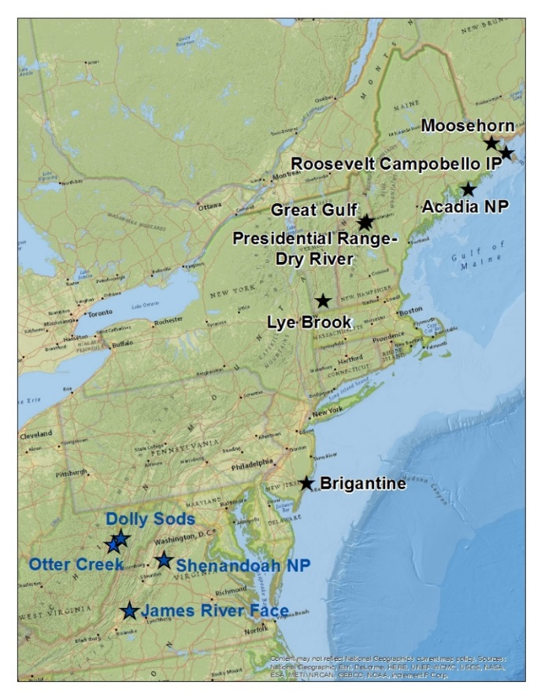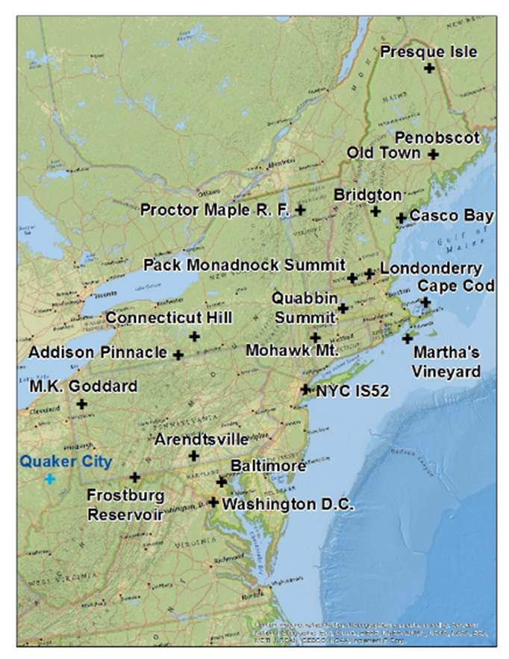

1. Class I Areas
2. IMPROVE Protocol Monitoring Sites

While this report provides readers with a basic background on regional haze, it does not include in-depth discussions of topics covered in previous reports. For a broader understanding of these topics, readers can visit EPA’s regional haze website: <https://www.epa.gov/visibility>, the IMPROVE technical documentation website: <http://vista.cira.colostate.edu/improve/>, the Publications section of the MANE-VU website: <http://www.otcair.org/manevu/document.asp?Fview=Reports>, the MARAMA regional haze website: <http://www.marama.org/technical-center/regional-haze-planning> and the NESCAUM regional haze documents archive, located at the following web address: <http://www.nescaum.org/topics/regional-haze>

**Page 1-3**

**2. PROCESS FOR TRACKING PROGRESS**

**2.1. Long Term Goals and Natural Visibility**

Even in the absence of emissions from human activities, some level of light extinction occurs from natural causes. This “natural haze” represents the best expectation for long-term progress at Class I areas and is the goal for these areas by 2064.

USEPA (2003a) has guidance for calculating natural haze levels based on measurements of particulate constituents at Class I areas during a baseline period. States combine measurements of several parameters to calculate a “Haze Index” in deciview (dv) units based on estimates of light extinction. A fuller explanation of tracking progress procedures is presented in a 2003 USEPA guidance document for tracking progress (USEPA 2003b; hereafter, “the Guidance”), though readers should note that the calculation for estimating total light extinction has since been updated. Details on the revised IMPROVE algorithm used to estimate light extinction are presented elsewhere (e.g., NESCAUM 2010).

Natural haze levels are calculated for both the 20 percent best days and the 20 percent worst days, because changing natural processes lead to variability in natural visibility. Natural visibility levels on the 20 percent best and 20 percent worst days for the MANE-VU and adjacent Class I areas are presented in Table 2-1. Table 2-2 shows natural visibility levels for IMPROVE Protocol sites. Achievement of these goals through constant annual incremental improvement in the Haze Index (in dv) such that natural conditions will be reach by 2064 is termed a “uniform rate of progress” (also referred to as the glidepath). Natural background haze levels are not available for some Class I areas without monitoring data, i.e., Presidential Range/Dry River Wilderness Area, Roosevelt Campobello International Park and Otter Creek Wilderness Area.

**Table 2-1. Natural Visibility Conditions for Class I Areas In and Adjacent to the**

**MANE-VU Region**

|  |  |  |  |
| --- | --- | --- | --- |
| Class I Area | State  Abbr. | Best Days  (dv) | Worst  Days (dv) |
| Acadia National Park | ME | 4.66 | 12.43 |
| Moosehorn Wilderness | ME | 5.02 | 12.01 |
| Roosevelt Campobello International Park | ME | * | * |
| Great Gulf Wilderness | NH | 3.73 | 11.99 |
| Presidential Range/Dry River Wilderness | NH | * | * |
| Lye Brook Wilderness | VT | 2.79 | 11.73 |
| Brigantine Wilderness | NJ | 5.52 | 12.25 |
| James River Face† | VA | 4.39 | 11.13 |
| Dolly Sods Wilderness† | WV | 3.64 | 10.39 |
| Otter Creek Wilderness† | WV | * | * |
| Shenandoah National Park† | VA | 3.15 | 11.35 |

† *Class I area adjacent to the MANE-VU region.*

* *Natural haze values for the Presidential Range/Dry River Wilderness Area, Roosevelt Campobello International Park and Otter Creek Wilderness are represented by the IMPROVE monitors for Great Gulf, Moosehorn and Dolly Sods, respectively.*

*Source: Natural Conditions II updated December 2019 file on the IMPROVE website.*

**Page 2-1**

**Table 2-2. Natural Visibility Conditions for IMPROVE Protocol Sites in and Adjacent to the MANE-VU Region**

|  |  |  |  |  |
| --- | --- | --- | --- | --- |
| Class I Area | State  Abbr. | Best Days  (dv) | Worst  Days (dv) | NC First Year^ |
| Addison Pinnacle (ADPI) | NY | 4.12 | 11.57 | - |
| Arendtsville (AREN) | PA | 4.24 | 11.77 | - |
| Baltimore (BALT) | MD | * | * | * |
| Bridgton (BRMA) | ME | 4.65 | 12.07 | - |
| Casco Bay (CABA) | ME | 4.83 | 12.83 | - |
| Cape Cod (CACO) | MA | 5.95 | 13.20 | - |
| Connecticut Hill (COHI) | NY | 4.30 | 11.50 | - |
| Connecticut Hill (COHI) | NY | 4.30 | 11.50 | - |
| Frostburg Reservoir (FRRE) | MD | 4.48 | 10.89 | 2005^ |
| Londonderry (LOND) | NH | 5.00 | 11.85 | 2011^ |
| Martha’s Vineyard (MAVI) | MA | 6.11 | 14.01 | 2003^ |
| M. K. Goddard (MKGO) | PA | 4.52 | 11.36 | - |
| Mohawk Mt. (MOMO) | CT | 3.67 | 12.42 | - |
| New York IS52 (NEYO) | NY | 5.52 | 12.24 | 2005^ |
| Old Town (OLTO) | ME | 4.86 | 12.65 | 2003^ |
| Penobscot Nation (PENO) | ME | 4.62 | 12.71 | 2006^ |
| Pack Monadnock Summit (PACK) | NH | 3.17 | 11.13 | 2008^ |
| Proctor Maple R. F. (PMRF) | VT | 3.86 | 11.84 | - |
| Presque Isle (PRIS) | ME | 4.91 | 12.42 | - |
| Quabbin Reservoir (QURE) | MA | 3.92 | 12.05 | - |
| Washington D.C. (WASH) | DC | 5.52 | 11.86 | - |
| Quaker City (QUCI)† | OH | 4.96 | 10.97 | - |

*^ If 3-years are not available during the 2000-04 baseline period, natural conditions are based on the first five years of data available..*

* *Natural haze values are not calculated for areas with less than 3-years of available monitoring data.*

† *IMPROVE Protocol site adjacent to the MANE-VU region.*

*Source: Natural Conditions II updated December 2019 file on the IMPROVE website.*

**2.2. Reasonable Progress Goals**

The RHR requires states to evaluate current regional haze conditions at Class I areas subject to the rule relative to conditions during a historic baseline period. The baseline period is the five-year period from 2000 through 2004. State haze SIPs established reasonable progress goals (RPGs) for reduction of regional haze through 2018. Comparison between the five-year average Haze Index in 2018 (average of the 2014-2018 annual Haze Index values) and the baseline Haze Index will determine if a state has met its 2018 RPG.

Class I States, in consultation with other states and federal land managers, set RPGs for the 20 percent worst days and for the 20 percent best days. The RPGs are designed to at least ensure no degradation for 20 percent best days visibility and achievement of reasonable progress toward natural conditions for 20 percent worst days visibility. In most cases, states

**Page 2-2**

in the MANE-VU region have adopted RPGs that achieve lower Haze Index values by 2018 than would be achieved using either the “no degradation” and “uniform rate of progress” rates for 20 percent best days and 20 percent worst days, respectively. Table 2-3 presents the 20 percent best days and 20 percent worst days RPGs adopted by states for each Class I area in or adjacent to the MANE-VU region per state haze SIPs.

**Table 2-3. 2018 Goals for Class I Areas in or Adjacent to the MANE-VU Region**

|  |  |  |  |  |  |  |
| --- | --- | --- | --- | --- | --- | --- |
| **Class I Area** | **IMPROVE SITE DATA CODE(S)** | **State Abbr.** | **BEST DAYS** | | **WORST DAYS** | |
| **No Degradation (dv)** | **Reasonable Progress Goal (dv)** | **Uniform Rate of Progress (dv)** | **Reasonable Progress Goal (dv)** |
| Acadia National Park | ACAD | ME | 8.78 | 8.30 | 20.45 | 19.40 |
| Moosehorn Wilderness Area | MOOS | ME | 9.16 | 8.60 | 19.46 | 19.00 |
| Roosevelt Campobello International Park | MOOS | ME | 9.16 | 8.60 | 19.46 | 19.00 |
| Great Gulf Wilderness Area | GRGU | NH | 7.66 | 7.20 | 20.29 | 19.10 |
| Presidential Range/Dry River Wilderness Area | GRGU | NH | 7.66 | 7.20 | 20.29 | 19.10 |
| Lye Brook Wilderness Area | LYBR 2000-11 LYEB 2012-17 | VT | 6.37 | 5.50 | 21.48 | 20.90 |
| Brigantine Wilderness Area | BRIG | NJ | 14.33 | 14.30 | 25.10 | 25.10 |
| Dolly Sods Wilderness Area† | DOSO | WV | 12.28 | 11.10 | 24.69 | 21.70 |
| Otter Creek Wilderness Area† | DOSO | WV | 12.28 | 11.10 | 24.69 | 21.70 |
| James River Face Area† | JARI | VA | 14.21 | 12.40 | 24.92 | 22.40 |
| Shenandoah National Park† | SHEN | VA | 10.93 | 8.70 | 25.12 | 21.90 |

*Note: The Class I areas are arranged with the areas located in the MANE-VU region presented first, followed by those adjacent to MANE-VU.*

† *Class I area adjacent to the MANE-VU region.*

*Sources: Maine: 76 FR 73956-73982; New Hampshire: 77 FR 11809-11826; New Jersey: 76 FR 49711-*

*49724; Vermont: 77 FR 11914-11928; Virginia: 77 FR 3691-3711; West Virginia: 76 FR 41158-41177.*

**2.3. Measurement and Data Support**

The Haze Index is calculated using light extinction estimates based on measured concentrations of particulate matter (PM) species. Measurements are taken at a network of monitoring sites in the IMPROVE program at or near Class I areas. IMPROVE is the result of coordination between the National Park Service, the Fish and Wildlife Service, the Bureau of Land Management, the Forest Service, and USEPA. IMPROVE has operated many sites within the MANE-VU region (see Figure 1-1(a) and Figure 1-1(b)).

IMPROVE monitoring data and analyses are available on the Federal Land Manager Environmental Database (FED) website (<http://views.cira.colostate.edu/fed/DataWizard/>). FED is hosted at the Colorado State University’s Cooperative Institute for Research in the Atmosphere (CIRA). Data are also available on the IMPROVE website (<http://vista.cira.colostate.edu/Improve/rhr-summary-data/>). For all analyses in this report, the latest available (1/14/2020) data was downloaded from the FED website for natural (IMPROVE Natural Haze Levels II version 2) haze levels, daily calculated light extinction and deciview values (using the revised (new) IMPROVE algorithm including patched data) for 2000 through 2018.

**Page 2-3**

**3. RESULTS**

Haze Index and individual constituent light extinction annual results were analyzed for each IMPROVE monitoring site in and adjacent to the MANE-VU region for years between 2000 and 2018. The following sections describe the results of this analysis. Section 3.1 provides results for the total Haze Index for each site and discusses trends and progress toward meeting the first SIP planning period goals. Section 3.2 provides individual constituent analysis and trends for each site over the time period in the context of regional emissions reduction efforts and continued regional and federal policy directions. Finally, Section 3.3 summarizes conclusions based on these results. Results indicate consistent improvement in regional haze meeting the first SIP planning period goals during the 20 percent best and 20 percent worst visibility days across the region.

**3.1. Haze Index Trends**

Figure 3-1 through Figure 3-8 present annual Haze Index on the 20 percent best and 20 percent worst days at MANE-VU and adjacent Class I areas between 2000 and 2018 in the context of short and long-term visibility goals. Tables A-1 through Table A-5 in Appendix A presents these data numerically. Table A-6 through Table A-16 in Appendix A presents Haze Index trends numerically for all IMPROVE Protocol sites in and adjacent to the MANE-VU Region.

These figures show that haze levels on the 20 percent best days and 20 percent worst days from 2000 through 2018 have dropped across the entire region. Trends evident in the first report (NESCAUM 2013) for annual average haze levels on 20 percent best days and 20 percent worst days through 2011 have continued through 2018.

The grey region in the figures denotes the range of 20 percent best days to 20 percent worst days haze levels expected to occur under natural conditions. Thus, the uniform rate of progress line intersects with the highest portion of the grey area in 2064 for most sites. For the Brigantine, Dolly Sods and James River Face Wilderness Areas, whose haze levels on the 20 percent best days during the 2000 to 2004 baseline period were higher than estimated natural conditions on the 20 percent worst days, the no degradation line (representing the long-term 20 percent best days goal) is higher than the uniform rate of progress line (representing the long-term 20 percent worst days goal) at dates approaching 2064. This nonsensical situation by 2064 is an artifact of technical guidance and only represents stated haze level goals, not anticipated results.

Comparison of the five-year annual average haze index to the glidepaths for the 2018 SIP commitments show that all areas in and adjacent to the MANE-VU region have met those commitments.

**Page 3-1**

**Figure 3-1. Annual Haze Index Levels at Acadia National Park**

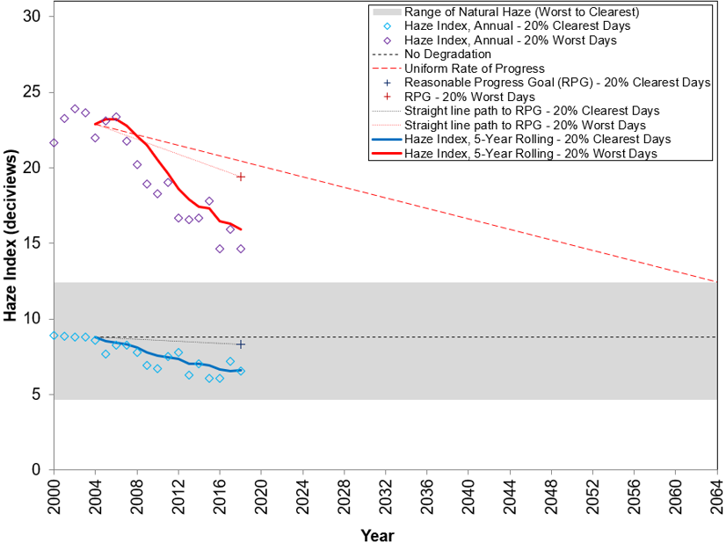

**Figure 3-2. Annual Haze Index Levels at Moosehorn Wilderness Area**

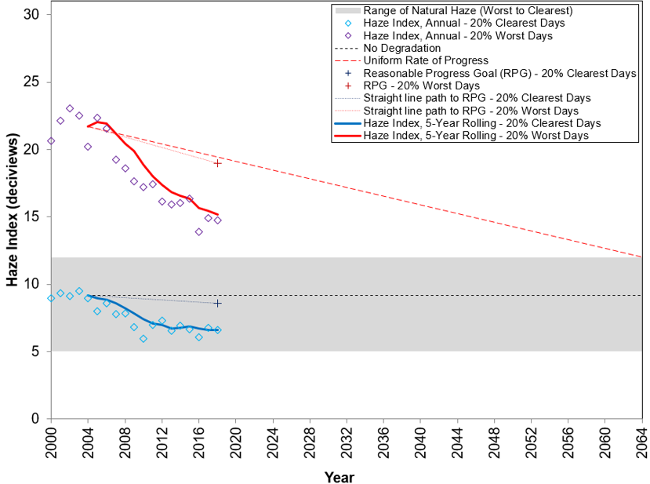

**Page 3-2**

**Figure 3-3. Annual Haze Index Levels at Great Gulf Wilderness Area**

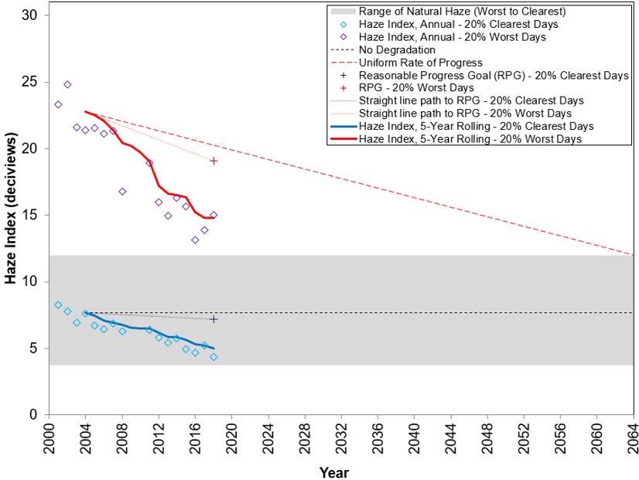

**Figure 3-4. Annual Haze Index Levels at Lye Brook Wilderness Area**

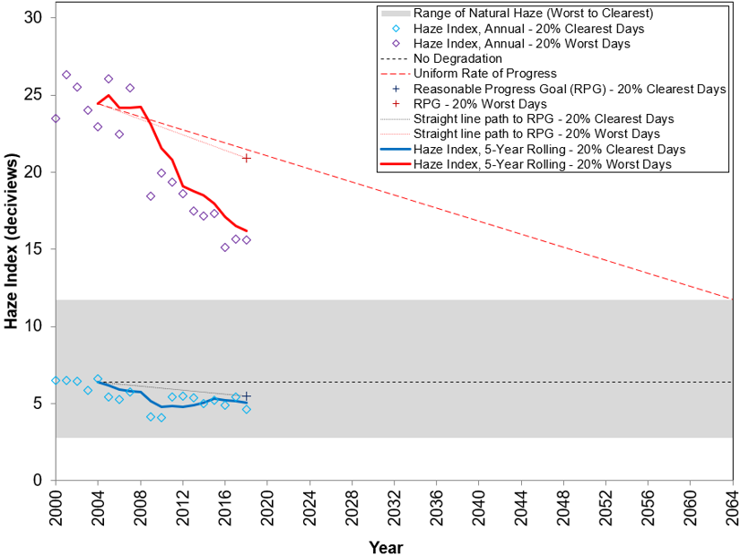

**Page 3-3**

**Figure 3-5. Annual Haze Index Levels at Brigantine Wilderness Area**

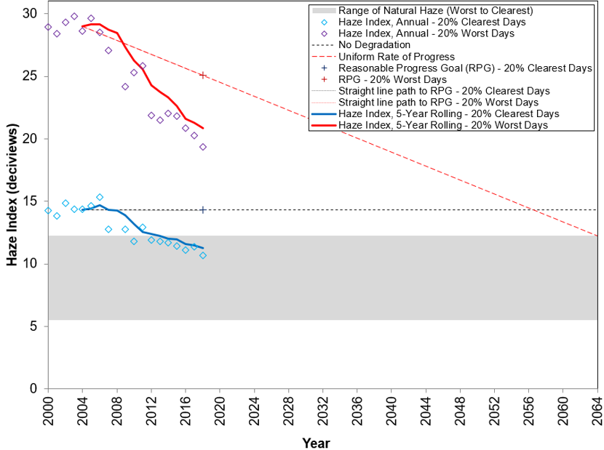

**Figure 3-6. Annual Haze Index Levels at Dolly Sods Wilderness Area**

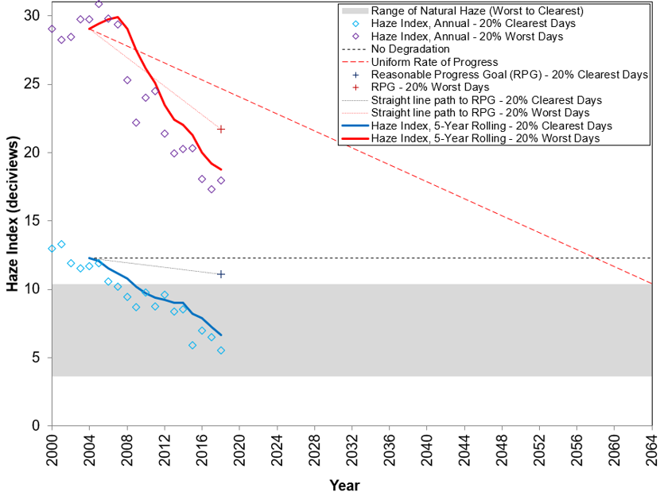

**Page 3-4**

**Figure 3-7. Annual Haze Index Levels at Shenandoah National Park**

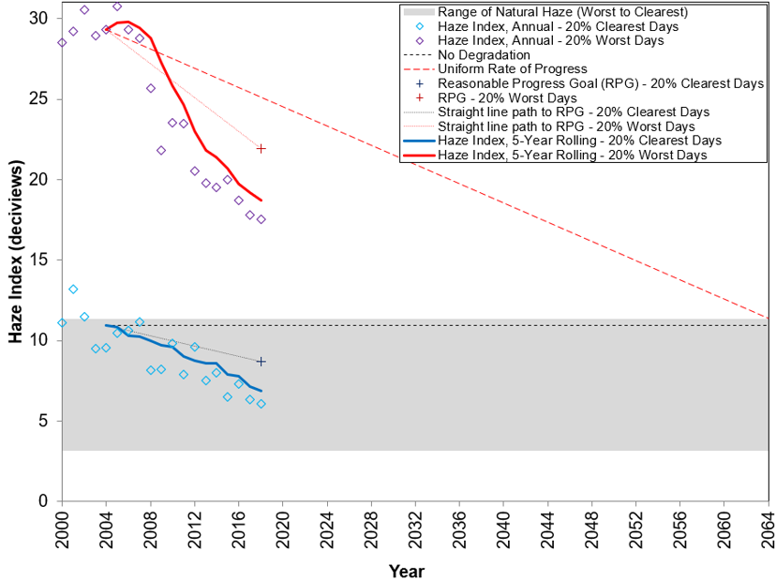

**Figure 3-8. Annual Haze Index Levels at James River Face Wilderness**

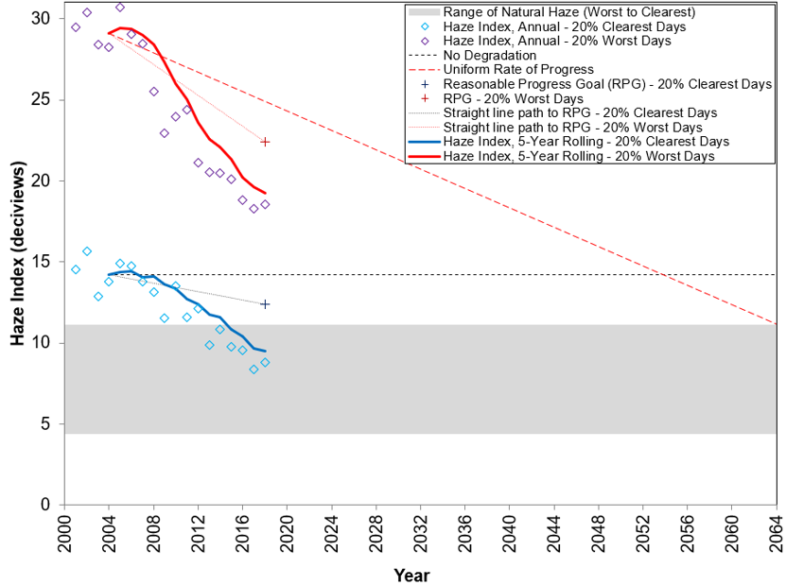

**Page 3-5**

**3.2. Constituent Light Extinction Trends**

In addition to analyzing trends in overall visibility changes at the IMPROVE sites, changes of individual PM constituent contributions to visibility impairment were analyzed. Figure 3-9 through Figure 3-16 present the annual Haze Index by constituent on the 20 percent best and 20 percent worst days at MANE-VU and adjacent Class I areas between 2000 and 2018 in the context of RPGs. The figures are arranged with the areas located in the MANE-VU region presented first, followed by those adjacent to MANE-VU. Table B-1 and Table B-2 in Appendix B present constituent contributions numerically for natural conditions. Table C-1 through Table C-28 in Appendix C present constituent contributions numerically for all Class I and IMPROVE Protocol sites in and adjacent to the MANE-VU region. Note that data for individual constituents in Appendix B and Appendix C are light extinction (units = inverse megameters (Mm-1)) and data plotted in Figure 3-9 through Figure 3-16 are the relative contributions (haze index*(constituent light extinction/total light extinction) [units = deciview (dv)]).

These figures show individual constituent relative contributions as stacked bar charts for sulfate, nitrate, organic carbon mass (OCM), light absorbing carbon (LAC), soil, coarse mass, sea salt, and Rayleigh extinction levels on 20 percent best days (“a” plot) and 20 percent worst days (“b” plot). The total of the stacked bars represents annual Haze Index values and are marked by circles connected by a thin black line. The thick black line represents five-year back annual averages from 2004 to 2018. The 2018 RPG from the state haze SIP is marked with a black plus sign. Two red lines descend from the 2004 five-year back average (i.e., the baseline value): the red dotted line represents the glidepath to the 2018 RPG; and the red dashed line represents the glidepath to the 2064 natural visibility goal, or the “uniform rate of progress” line.

These figures confirm that large reductions in overall Haze Index values on the 20 percent worst days are primarily due to decreases in sulfate visibility impacts at MANE-VU Class I areas. Significant decreases in sulfate contributions started in 2007 at Maine’s Class I areas and in 2008 at all other Class I areas analyzed. As the sulfate contributions declined, relative nitrate contributions have started to increase at many sites especially at the Brigantine Wilderness Area. This increase is primarily due to having more winter days in the 20 percent worst mix of days (MANE-VU 2016) during recent years. During the winter, relative nitrate contributions are much higher than during the summer. [Seasonality of nitrogen oxides (NOx) emissions are shown in the Figure 3-17 monitoring data trends plot for sites located in or close to large cities (Boston, Philadelphia and Baltimore)]. Steady decreases in sulfate and nitrate contributions have reduced overall haze levels on the 20 percent best days. These decreases on the 20 percent best days started to occur after 2004 at most of the studied areas.

At the Brigantine Wilderness Area, the contribution from coarse mass in 2011 was unusually high, indicating a possible anomaly for that year (Pietarinen 2013). This increase in coarse mass contribution offset reductions in both nitrate and sulfate levels from the preceding years. Contribution from OCM appears to be highly variable from year to year at most sites due to natural OCM from forest fires and variations in the cost of residential heating fuels. For instance, high OCM extinction levels at Brigantine and Lye Brook Wilderness Areas in 2002, at Great Gulf Wilderness Area in 2011 and at many sites in 2015 on the 20 percent worst days, undercut declines in contributions from sulfate to raise overall haze levels for those years.

**Page 3-6**

Sulfate remains the most significant contributor to light extinction at all Class I areas on the 20 percent worst days in and adjacent to the MANE-VU region, followed by nitrate and OCM. For the most part, light extinction from soil and sea salt, which help indicate the extent to which natural haze processes contribute to overall haze levels, are insignificant when compared to extinction from sulfate and nitrate. Based on these figures, continued progress in sulfate and nitrate levels appears to be driving the trend in overall improvement in 20 percent worst days and 20 percent best days haze level reductions.

Current and baseline 5-year average light extinction levels for the 20 percent best (see Figure 3-18(a)) and 20 percent worst (see Figure 3-18(b)) visibility days for all Class I IMPROVE sites are shown side by side. This is just another way to show reductions in the region and shows that reductions were primarily due to sulfate reductions with nitrate and OCM reductions more evident during the 20 percent best days. As was mentioned before, because more winter days are in the current 20 percent worst days mix, the relative contribution of nitrates increased from the baseline especially at the Brigantine Wilderness Class I area.

To examine the individual constituent trends more closely, the range of individual light extinction on 20 percent best days and 20 percent worst days from 2000 through 2018 at the Class I areas were plotted against the estimated light extinction under natural conditions. Figure 3-19 through Figure 3-26 show the range of light extinction levels at the MANE-VU Class I areas as compared to natural light extinction for selected constituents. IMPROVE Protocol sites are excluded from this analysis for simplicity and light extinction from soil and sea salt are excluded from this analysis as those contributions are small and are primarily natural. (note: numerical data for all constituents and sites are in Appendix B and Appendix C). Estimated natural light extinction is represented in each chart by a purple line for 20 percent worst days and by a red line for 20 percent best days. For the carbonaceous species, OCM and LAC, the green band is observed OCM and the dark grey band is observed LAC. Note that the observations do not represent the range of the highest and lowest 20 percent light extinction levels for those constituents; rather, they represent the range of constituent light extinction levels on the 20 percent best and 20 percent worst visibility days.

It is clear from these charts that levels of extinction from sulfate have dropped significantly since the baseline period at all Class I areas, although still remaining at levels higher than the estimated natural range at all sites. Extinction due to nitrate is closer to natural levels than sulfates and is approaching natural levels on the 20 percent best days however the range of nitrate extinction has expanded in recent years with the highest levels at southern Class I areas greater than the baseline period. As mentioned earlier, this is primarily due to more winter days in the mix. At the Brigantine Wilderness Area, extinction due to nitrate remains considerably higher than the natural baseline. At most Class I areas, levels of extinction due to carbonaceous constituents and coarse mass appear to be near or slightly above natural range levels. Prior peaks in carbonaceous matter extinction at most sites were driven by OCM levels. At the Brigantine Wilderness Area, coarse mass light extinction levels remain above natural levels, though the 2011 peak in coarse mass light extinction may be a result of construction activity near the monitor location (Pietarinen 2013).

**Page 3-7**

**Figure 3-9. Individual Constituent Contribution to Annual Haze Index Levels at Acadia National Park on 20 Percent Best and Worst Visibility Days**

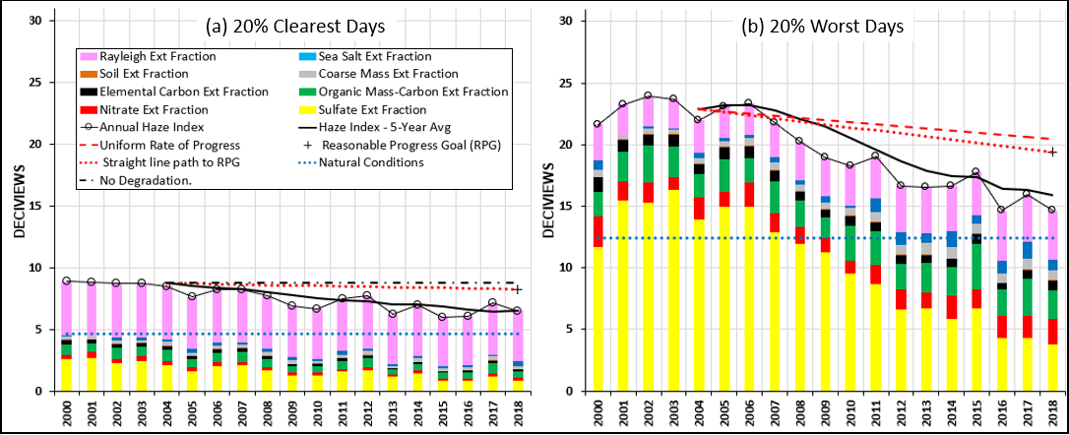

**Figure 3-10. Individual Constituent Contribution to Annual Haze Index Levels at Moosehorn Wilderness Area on 20 Percent Best and Worst Visibility Days**

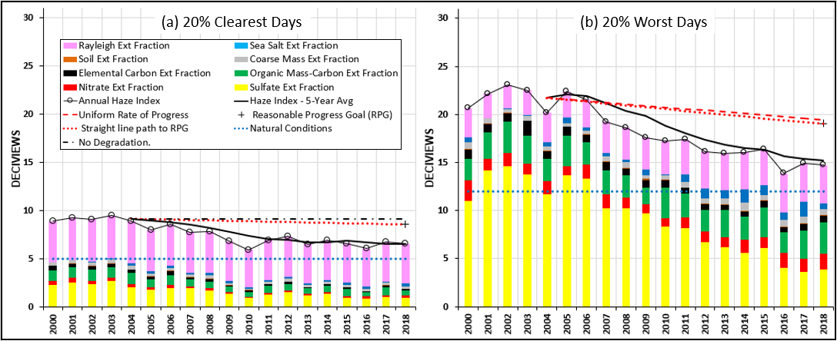

**Page 3-8**

**Figure 3-11. Individual Constituent Contribution to Annual Haze Index Levels at Great Gulf Wilderness Area on 20 Percent Best and Worst Visibility Days**

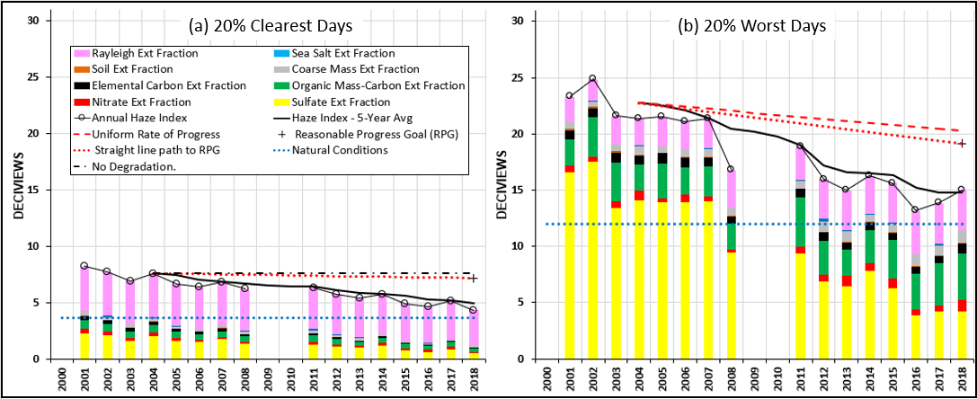

**Figure 3-12. Individual Constituent Contribution to Annual Haze Index Levels at Lye Brook Wilderness Area on 20 Percent Best and Worst Visibility Days**

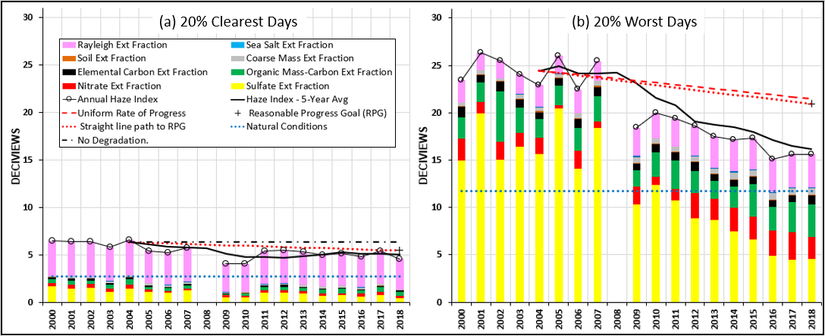

**Page 3-9**

**Figure 3-13. Individual Constituent Contribution to Annual Haze Index Levels at Brigantine Wilderness Area on 20 Percent Best and Worst Visibility Days**

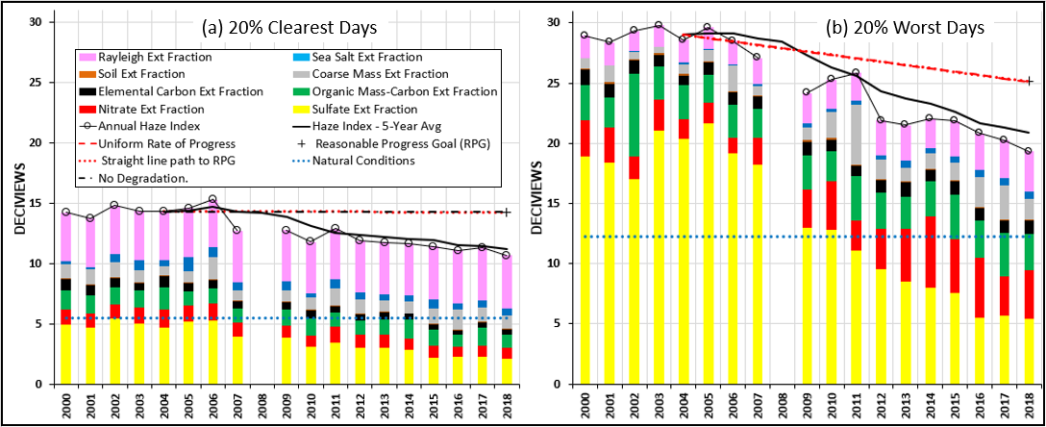

**Figure 3-14. Individual Constituent Contribution to Annual Haze Index Levels at Dolly Sods Wilderness Area on 20 Percent Best and Worst Visibility Days**

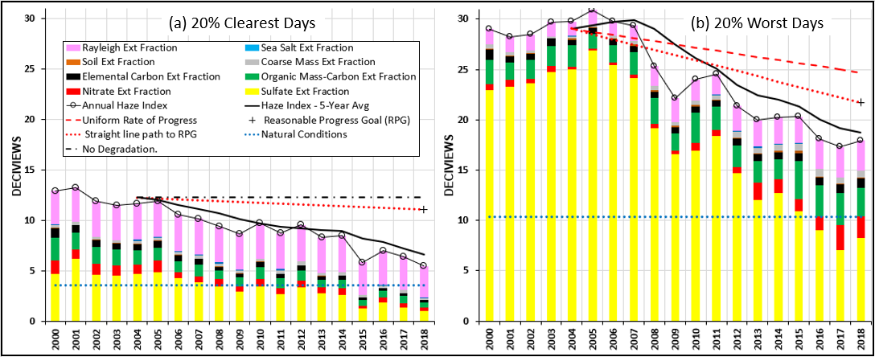

**Page 3-10**

**Figure 3-15. Individual Constituent Contribution to Annual Haze Index Levels at Shenandoah National Park on 20 Percent Best and Worst Visibility Days**

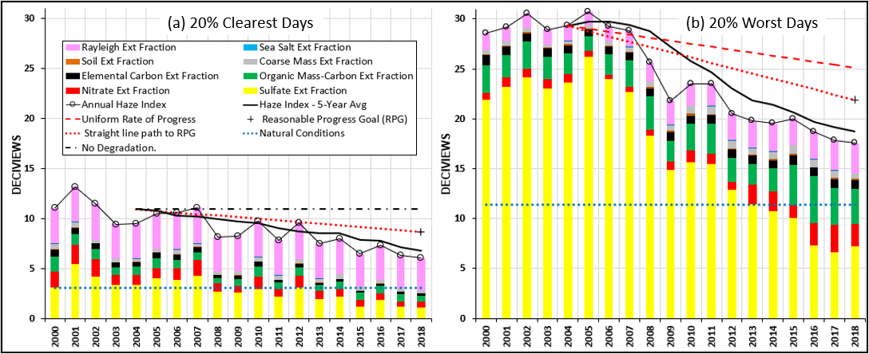

**Figure 3-16. Individual Constituent Contribution to Annual Haze Index Levels at James River Face Wilderness Area on 20 Percent Best and Worst Visibility Days**

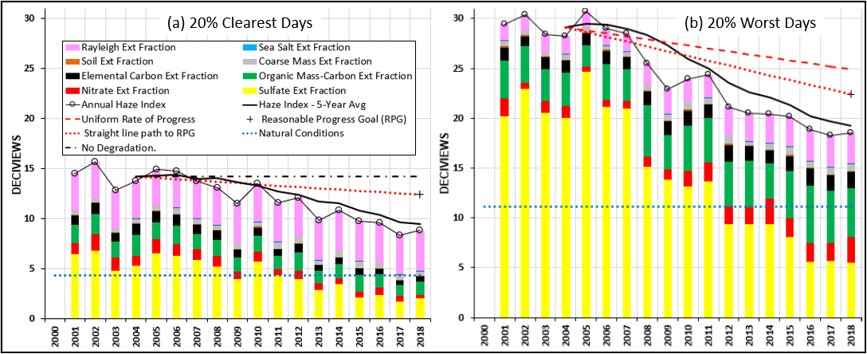

**Page 3-11**

**Figure 3-17. 1997-2018 NOx Trends by Month**

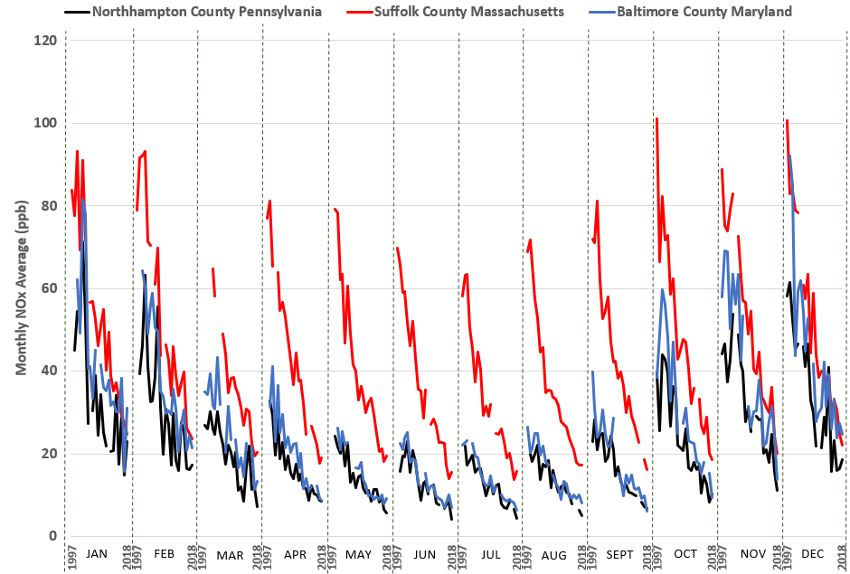

**Source: USEPA Air Quality System (AQS) data**

**Page 3-12**

**Figure 3-18. Current and Baseline 5-Year Average Light Extinction at Class I Sites on 20 Percent Best and Worst Visibility Days**

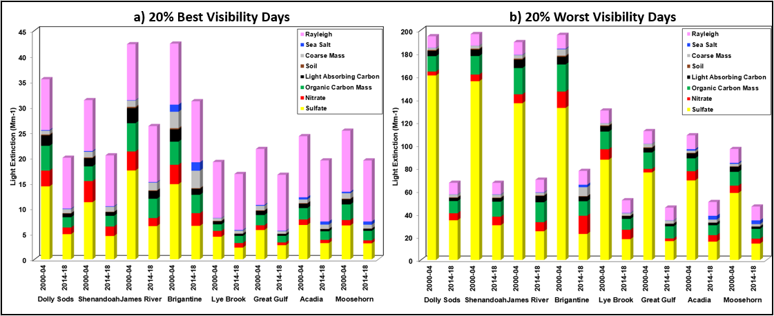

**Page 3-13**

**Figure 3-19. Range of Observed and Estimated Natural Light Extinction for Select Individual Constituents at Acadia National Park on 20 Percent Best and Worst Visibility Days**

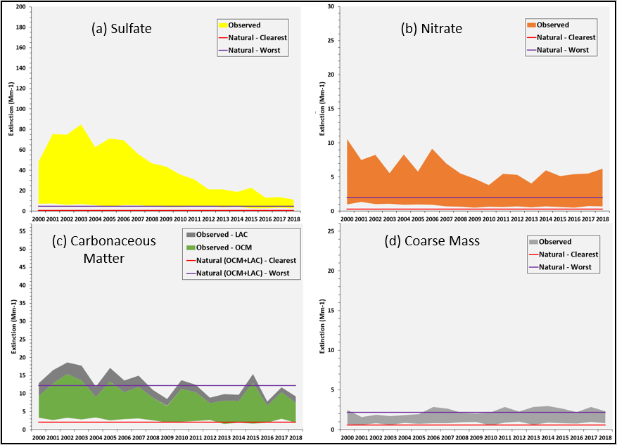

**Notes: Light extinction from (a) sulfate, (b) nitrate, (c) carbonaceous matter (i.e., organic carbon mass or OCM and light absorbing carbon or LAC), and (d) coarse mass, alongside estimated natural light extinction from those constituents.**

**Page 3-14**

**Figure 3-20. Range of Observed and Estimated Natural Light Extinction for Select Individual Constituents at Moosehorn Wilderness Area on 20 Percent Best and Worst Visibility Days**

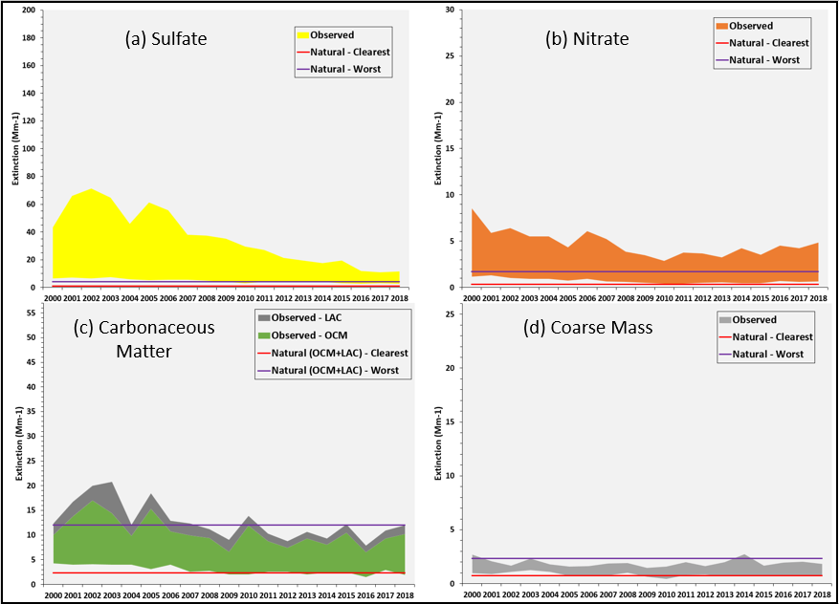

**Notes: Light extinction from (a) sulfate, (b) nitrate, (c) carbonaceous matter (i.e., organic carbon mass or OCM and light absorbing carbon or LAC), and (d) coarse mass, alongside estimated natural light extinction from those constituents.**

**Page 3-15**

**Figure 3-21. Range of Observed and Estimated Natural Light Extinction for Select Individual Constituents at Great Gulf Wilderness Area on 20 Percent Best and Worst Visibility Days**

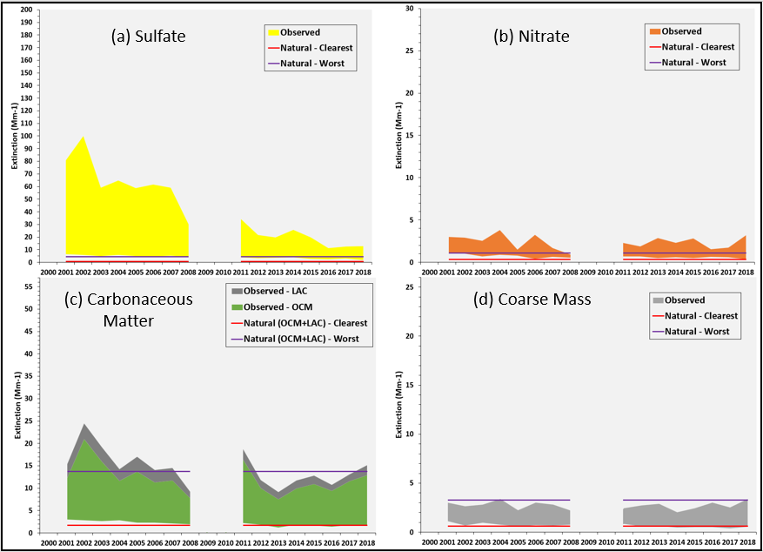

**Notes: Light extinction from (a) sulfate, (b) nitrate, (c) carbonaceous matter (i.e., organic carbon mass or OCM and light absorbing carbon or LAC), and (d) coarse mass, alongside estimated natural light extinction from those constituents.**

**Page 3-16**

**Figure 3-22. Range of Observed and Estimated Natural Light Extinction for Select Individual Constituents at Lye Brook Wilderness Area on 20 Percent Best and Worst Visibility Days**

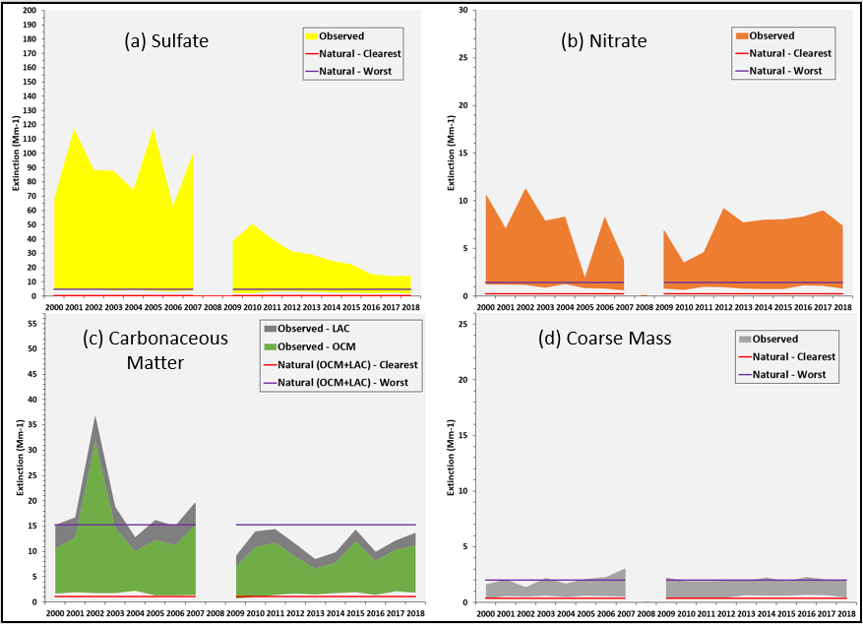

**Notes: Light extinction from (a) sulfate, (b) nitrate, (c) carbonaceous matter (i.e., organic carbon mass or OCM and light absorbing carbon or LAC), and (d) coarse mass, alongside estimated natural light extinction from those constituents.**

**Page 3-17**

**Figure 3-23. Range of Observed and Estimated Natural Light Extinction for Select Individual Constituents at Brigantine Wilderness Area on 20 Percent Best and Worst Visibility Days**

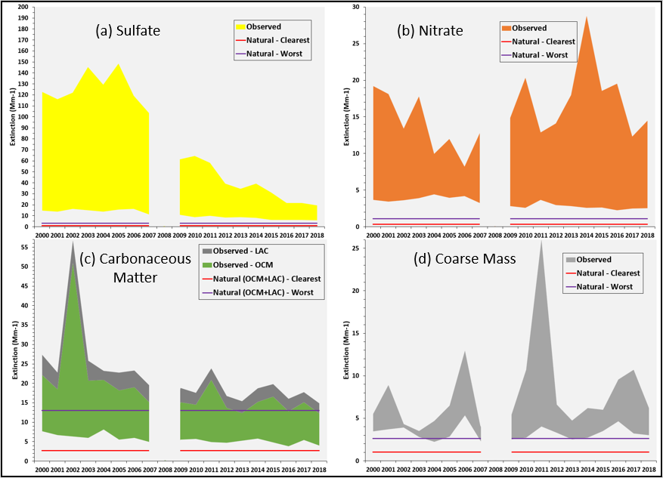

**Notes: Light extinction from (a) sulfate, (b) nitrate, (c) carbonaceous matter (i.e., organic carbon mass or OCM and light absorbing carbon or LAC), and (d) coarse mass, alongside estimated natural light extinction from those constituents.**

**Page 3-18**

**Figure 3-24. Range of Observed and Estimated Natural Light Extinction for Select Individual Constituents at Dolly Sods Wilderness Area on 20 Percent Best and Worst Visibility Days**

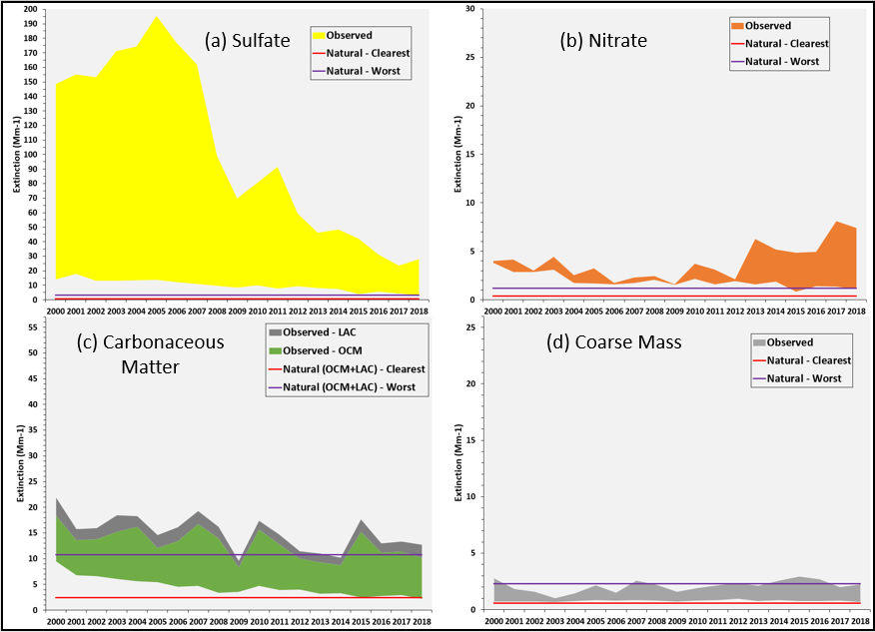

**Notes: Light extinction from (a) sulfate, (b) nitrate, (c) carbonaceous matter (i.e., organic carbon mass or OCM and light absorbing carbon or LAC), and (d) coarse mass, alongside estimated natural light extinction from those constituents.**

**Page 3-19**

**Figure 3-25. Range of Observed and Estimated Natural Light Extinction for Select Individual Constituents at Shenandoah National Park on 20 Percent Best and Worst Visibility Days**

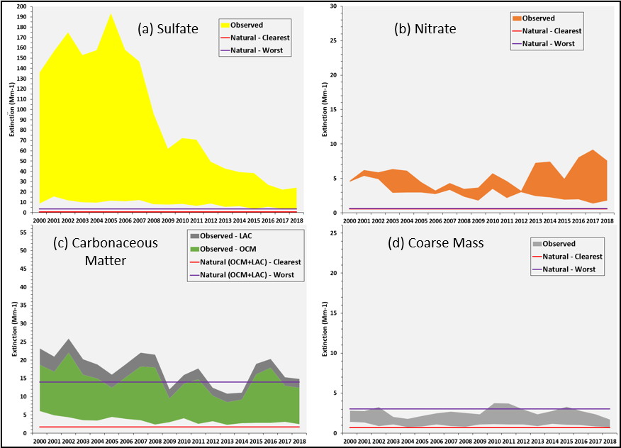

**Notes: Light extinction from (a) sulfate, (b) nitrate, (c) carbonaceous matter (i.e., organic carbon mass or OCM and light absorbing carbon or LAC), and (d) coarse mass, alongside estimated natural light extinction from those constituents.**

**Page 3-20**

**Figure 3-26. Range of Observed and Estimated Natural Light Extinction for Select Individual Constituents at James River Face Wilderness Area on 20 Percent Best and Worst Visibility Days**

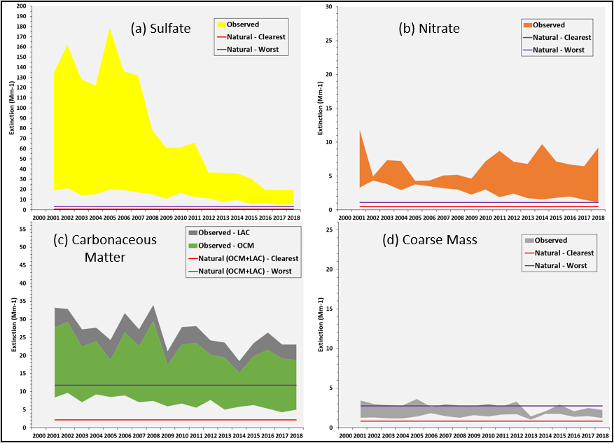

**Notes: Light extinction from (a) sulfate, (b) nitrate, (c) carbonaceous matter (i.e., organic carbon mass or OCM and light absorbing carbon or LAC), and (d) coarse mass, alongside estimated natural light extinction from those constituents.**

**Page 3-21**

**3.3. Conclusions on Visibility Progress**

Despite variability in the year-to-year data, there are definite downward trends in overall haze levels at Class I areas in and adjacent to the MANE-VU region. Based on rolling five-year averages demonstrating progress since the 2000-2004 baseline period, the Class I areas have met their 2018 RPGs for both 20 percent best visibility days and 20 percent worst visibility days. The trends are mainly driven by large reductions in sulfate light extinction. Levels of nitrate extinction are approaching natural conditions for the 20 percent best days; however, levels are increasing for the 20 percent worst days in recent years as more winter days are in the 20 percent worst days mix, especially for southern Class I areas. Levels of carbonaceous matter (OCM and LAC) appear to be approaching natural levels at most of the Class I areas. In all cases, the levels set by 2018 RPGs have been met, and progress beyond the 2018 RPGs appears achievable. Though states have met 2018 RPGs, challenges remain for all Class I Areas going into the future. Continued sulfate and nitrate reductions are primary drivers in continuing to improve visibility.

**Page 3-22**

**4. DISCUSSION**

Reductions in air pollution continue to bring down levels of fine particulate matter in the eastern United States, which in turn are leading to improved visibility at federally protected Class I areas within and adjacent to the MANE-VU region. Since the first report (NESCAUM 2013), significant improvements in visibility at the MANE-VU Class I sites have been observed, and these changes have been largely driven by reductions in sulfate levels.

Large emission reductions of nitrogen oxides (NOx) and sulfur dioxide (SO2) across the region in response to regional emission reduction requirements for power plants (i.e., NOx SIP Call, NOx Reasonably Available Control Technology (RACT), Cross State Air Pollution Rule (CSAPR), 2010 SO2 NAAQS, etc.) is likely a principal driver for these visibility improvements. Reductions have occurred recently as the power sector continued to control or phase out coal plants across the eastern United States in response to competitive pressures from natural gas generation, overall reduced electricity demand, and more stringent requirements to reduce emissions of air toxics (i.e., 2011 Mercury and Air Toxics (MATS) rule).

In addition to addressing emissions from power plants, states across the Northeast have enacted or are in process of enacting low sulfur content requirements for fuel oils, which cover home heating oil (distillate) and residual oils (#4 and #6). At the federal level, USEPA finalized the Tier 3 motor vehicle program in 2014 that includes lowering sulfur content in gasoline. While gasoline combustion is a minor source of SO2 emissions, the Tier 3 fuel requirements will significantly reduce NOx emissions from the existing fleet of on-road gasoline vehicles by reducing sulfur poisoning of the catalyst in catalytic converters, thus improving control technology performance. This would lead to lower nitrate levels, most notably during colder weather months when nitrates are more thermally stable. In warmer weather months, NOx promotes ground-level ozone formation, which in turn can enhance formation of visibility-limiting secondary organic aerosols (Carleton *et al.* 2010). Therefore, lower levels of NOx as a result of Tier 3 can also improve visibility by reducing ozone formation that leads to carbonaceous PM.

In summary, the visibility data examined in this report demonstrate that broad, regional efforts to reduce emissions of visibility-impairing pollutants have had a beneficial effect at the region’s Class I areas. The most recent IMPROVE data indicate that states have met their 2018 reasonable progress goals for improved visibility. Further progress may occur through additional pollution reductions achievable under recently adopted or proposed regulatory programs.

**Page 4-1**

**5. REFERENCES**

Carleton, A.G., R.W. Pinder, P.V. Bhave, and G.A. Pouliot. 2010. To What Extent Can Biogenic SOA be Controlled? 44 *Environ. Sci. Technol.* 3376-3380, doi:10.1021/es903506b.

Federal Land Manager Environmental Database (FED). 2016. IMPROVE and RHR Summary Data. Available at: <http://views.cira.colostate.edu/fed/DataWizard/>

MANE-VU. 2016. Regional Haze Metrics Trends and HYSPLIT Trajectory Analyses, May 31, 2016. Available at <http://www.otcair.org/MANEVU/Upload/Publication/Reports/MANE-VU_Speciation_and_Trajectory_Analyses_-_Final.pdf>

MANE-VU. 2020. Mid-Atlantic/Northeast U.S. Visibility Data 2004-2018 (2nd RH SIP Metrics)– 5-1-2020 Update.

NESCAUM. 2010. Tracking Visibility Progress, 2004-2008 (2010). MANE-VU Technical Memorandum, May 12, 2010. Available at <http://www.nescaum.org/topics/regional-haze/regional-haze-documents>

NESCAUM. 2013. Tracking Visibility Progress, 2004-2011 (2013). MANE-VU Technical Memorandum, May 24, 2013. Available at <http://www.nescaum.org/topics/regional-haze/regional-haze-documents>

Pietarinen, C. 2013. Conversation with Charles Pietarinen, Chief of the Bureau of Air Monitoring at the New Jersey Department of Environmental Protection on March 11, 2013. Mr. Pietarinen indicated that construction activity at the Brigantine Visitor’s Center, which is very close to the monitor, may have affected the monitoring site in recent years. Prescribed burns may also be having an influence at the site.

US Environmental Protection Agency (USEPA). 2003a. Guidance for Estimating Natural Visibility Conditions Under the Regional Haze Rule. Research Triangle Park: Office of Air Quality Planning and Standards, September 2003. EPA-454/B-03-005.

US Environmental Protection Agency (USEPA). 2003b. Guidance for Tracking Progress Under the Regional Haze Rule. Research Triangle Park: Office of Air Quality Planning and Standards, September 2003. EPA-454/B-03-004.

**Page 5-1**

**Appendix A: Tracking Progress Data for Class I Areas in and Adjacent to the MANE-VU Region**

**Table A-1. Tracking Progress Data for Acadia National Park (ME) and Brigantine Wilderness (NJ) Class I Areas in the MANE-VU Region (dv)**

|  |  |  |  |  |  |
| --- | --- | --- | --- | --- | --- |
|  |  | 20 Percent Best Days | | 20 Percent Worst Days | |
| Class I Area | Year | Haze Index,  Annual | Haze Index, 5-  Year Rolling | Haze Index,  Annual | Haze Index,  Year Rolling |
| Acadia National Park (ACAD) | 2000 | 8.90 | - | 21.64 | - |
| 2001 | 8.87 | - | 23.28 | - |
| 2002 | 8.77 | - | 23.91 | - |
| 2003 | 8.77 | - | 23.65 | - |
| 2004 | 8.56 | 8.78 | 21.98 | 22.89 |
| 2005 | 7.66 | 8.53 | 23.09 | 23.18 |
| 2006 | 8.25 | 8.40 | 23.37 | 23.20 |
| 2007 | 8.28 | 8.30 | 21.74 | 22.77 |
| 2008 | 7.76 | 8.10 | 20.21 | 22.08 |
| 2009 | 6.92 | 7.77 | 18.93 | 21.47 |
| 2010 | 6.71 | 7.58 | 18.27 | 20.50 |
| 2011 | 7.51 | 7.44 | 19.01 | 19.63 |
| 2012 | 7.75 | 7.33 | 16.67 | 18.62 |
| 2013 | 6.25 | 7.03 | 16.54 | 17.88 |
| 2014 | 7.03 | 7.05 | 16.68 | 17.43 |
| 2015 | 6.05 | 6.92 | 17.79 | 17.34 |
| 2016 | 6.08 | 6.63 | 14.63 | 16.46 |
| 2017 | 7.18 | 6.52 | 15.93 | 16.31 |
| 2018 | 6.53 | 6.58 | 14.64 | 15.93 |
| **2018 RPG** |  | **8.30 RPG** |  | **19.40 RPG** |
| **2064 NAT** |  | **4.66 NAT** |  | **12.43 NAT** |
| Brigantine Wilderness  (BRIG) | 2000 | 14.26 | - | 28.95 | - |
| 2001 | 13.80 | - | 28.38 | - |
| 2002 | 14.83 | - | 29.31 | - |
| 2003 | 14.39 | - | 29.79 | - |
| 2004 | 14.36 | 14.33 | 28.59 | 29.01 |
| 2005 | 14.61 | 14.40 | 29.62 | 29.14 |
| 2006 | 15.35 | 14.71 | 28.50 | 29.16 |
| 2007 | 12.74 | 14.29 | 27.07 | 28.72 |
| 2008 | * | 14.26 | * | 28.45 |
| 2009 | 12.78 | 13.87 | 24.17 | 27.34 |
| 2010 | 11.82 | 13.17 | 25.28 | 26.25 |
| 2011 | 12.92 | 12.56 | 25.83 | 25.59 |
| 2012 | 11.93 | 12.36 | 21.88 | 24.29 |
| 2013 | 11.80 | 12.25 | 21.51 | 23.74 |
| 2014 | 11.66 | 12.03 | 22.03 | 23.31 |
| 2015 | 11.44 | 11.95 | 21.84 | 22.62 |
| 2016 | 11.12 | 11.59 | 20.83 | 21.62 |
| 2017 | 11.36 | 11.48 | 20.28 | 21.30 |
| 2018 | 10.70 | 11.26 | 19.33 | 20.86 |
| **2018 RPG** |  | **14.30 RPG** |  | **25.10 RPG** |
| **2064 NAT** |  | **5.52 NAT** |  | **12.25 NAT** |

“-” = not applicable; “*\**” *=* no data available; “RPG” = Reasonable Progress Goal; “NAT” = Natural Conditions

**Page A-1**

**Table A-2. Tracking Progress Data for Great Gulf Wilderness (NH) and Lye Brook Wilderness (VT) Class I Areas in the MANE-VU Region (dv)**

|  |  |  |  |  |  |
| --- | --- | --- | --- | --- | --- |
|  |  | 20 Percent Best Days | | 20 Percent Worst Days | |
| Class I Area | Year | Haze Index,  Annual | Haze Index, 5-  Year Rolling | Haze Index,  Annual | Haze Index,  Year Rolling |
| Great Gulf Wilderness Area  (GRGU) | 2000 | * | - | * | - |
| 2001 | 8.26 | - | 23.29 | - |
| 2002 | 7.77 | - | 24.84 | - |
| 2003 | 6.94 | - | 21.59 | - |
| 2004 | 7.61 | 7.65 | 21.36 | 22.77 |
| 2005 | 6.69 | 7.46 | 21.53 | 22.52 |
| 2006 | 6.43 | 7.09 | 21.12 | 22.09 |
| 2007 | 6.86 | 6.91 | 21.35 | 21.39 |
| 2008 | 6.26 | 6.77 | 16.78 | 20.43 |
| 2009 | * | 6.56 | * | 20.19 |
| 2010 | * | 6.52 | * | 19.75 |
| 2011 | 6.39 | 6.50 | 18.90 | 19.01 |
| 2012 | 5.81 | 6.16 | 15.97 | 17.21 |
| 2013 | 5.41 | 5.87 | 14.98 | 16.62 |
| 2014 | 5.75 | 5.84 | 16.27 | 16.53 |
| 2015 | 4.92 | 5.66 | 15.64 | 16.35 |
| 2016 | 4.69 | 5.32 | 13.16 | 15.20 |
| 2017 | 5.22 | 5.20 | 13.88 | 14.79 |
| 2018 | 4.37 | 4.99 | 15.02 | 14.80 |
| **2018 RPG** |  | **7.20 RPG** |  | **19.10 RPG** |
| **2064 NAT** |  | **3.73 NAT** |  | **11.99 NAT** |
| Lye Brook Wilderness Area  (LYBR 2000-2011)  (LYEB 2012-current) | 2000 | 6.49 | - | 23.45 | - |
| 2001 | 6.47 | - | 26.33 | - |
| 2002 | 6.43 | - | 25.52 | - |
| 2003 | 5.83 | - | 24.02 | - |
| 2004 | 6.61 | 6.37 | 22.91 | 24.45 |
| 2005 | 5.45 | 6.16 | 26.04 | 24.96 |
| 2006 | 5.24 | 5.91 | 22.43 | 24.19 |
| 2007 | 5.74 | 5.78 | 25.45 | 24.17 |
| 2008 | * | 5.76 | * | 24.21 |
| 2009 | 4.11 | 5.14 | 18.44 | 23.09 |
| 2010 | 4.08 | 4.80 | 19.96 | 21.57 |
| 2011 | 5.40 | 4.83 | 19.38 | 20.80 |
| 2012 | 5.49 | 4.77 | 18.57 | 19.09 |
| 2013 | 5.35 | 4.89 | 17.46 | 18.76 |
| 2014 | 5.00 | 5.07 | 17.14 | 18.50 |
| 2015 | 5.20 | 5.29 | 17.31 | 17.97 |
| 2016 | 4.88 | 5.19 | 15.13 | 17.12 |
| 2017 | 5.43 | 5.17 | 15.64 | 16.53 |
| 2018 | 4.62 | 5.03 | 15.62 | 16.17 |
| **2018 RPG** |  | **5.50 RPG** |  | **20.90 RPG** |
| **2064 NAT** |  | **2.79 NAT** |  | **11.73 NAT** |

“-” = not applicable; “*\**” *=* no data available; “RPG” = Reasonable Progress Goal; “NAT” = Natural Conditions

**Page A-2**

**Table A-3. Tracking Progress Data for the Moosehorn Wilderness (ME) Class I Area in the MANE-VU Region (dv)**

|  |  |  |  |  |  |
| --- | --- | --- | --- | --- | --- |
|  |  | 20 Percent Best Days | | 20 Percent Worst Days | |
| Class I Area | Year | Haze Index,  Annual | Haze Index, 5-  Year Rolling | Haze Index,  Annual | Haze Index,  Year Rolling |
| Moosehorn Wilderness Area  (MOOS) | 2000 | 8.94 | - | 20.63 | - |
| 2001 | 9.31 | - | 22.14 | - |
| 2002 | 9.12 | - | 23.07 | - |
| 2003 | 9.48 | - | 22.50 | - |
| 2004 | 8.93 | 9.16 | 20.20 | 21.71 |
| 2005 | 7.99 | 8.97 | 22.36 | 22.05 |
| 2006 | 8.60 | 8.82 | 21.55 | 21.94 |
| 2007 | 7.79 | 8.56 | 19.24 | 21.17 |
| 2008 | 7.82 | 8.23 | 18.62 | 20.40 |
| 2009 | 6.83 | 7.81 | 17.61 | 19.88 |
| 2010 | 5.98 | 7.41 | 17.20 | 18.85 |
| 2011 | 6.97 | 7.08 | 17.40 | 18.02 |
| 2012 | 7.32 | 6.99 | 16.13 | 17.39 |
| 2013 | 6.55 | 6.73 | 15.92 | 16.85 |
| 2014 | 6.90 | 6.74 | 16.04 | 16.54 |
| 2015 | 6.64 | 6.88 | 16.37 | 16.37 |
| 2016 | 6.09 | 6.70 | 13.86 | 15.67 |
| 2017 | 6.77 | 6.59 | 14.89 | 15.42 |
| 2018 | 6.57 | 6.59 | 14.73 | 15.18 |
| **2018 RPG** |  | **8.60 RPG** |  | **19.00 RPG** |
| **2064 NAT** |  | **5.02 NAT** |  | **12.01 NAT** |

“-” = not applicable; “RPG” = Reasonable Progress Goal; “NAT” = Natural Conditions

**Table A-4. Tracking Progress Data for the Dolly Sods Wilderness (WV) Class I Area Adjacent to the MANE-VU Region (dv)**

|  |  |  |  |  |  |
| --- | --- | --- | --- | --- | --- |
|  |  | 20 Percent Best Days | | 20 Percent Worst Days | |
| Class I Area | Year | Haze Index,  Annual | Haze Index, 5-  Year Rolling | Haze Index,  Annual | Haze Index,  Year Rolling |
| Dolly Sods Wilderness (DOSO) | 2000 | 12.96 | - | 29.03 | - |
| 2001 | 13.30 | - | 28.24 | - |
| 2002 | 11.91 | - | 28.47 | - |
| 2003 | 11.54 | - | 29.73 | - |
| 2004 | 11.67 | 12.28 | 29.76 | 29.05 |
| 2005 | 11.91 | 12.07 | 30.89 | 29.42 |
| 2006 | 10.57 | 11.52 | 29.80 | 29.73 |
| 2007 | 10.20 | 11.18 | 29.36 | 29.91 |
| 2008 | 9.44 | 10.76 | 25.32 | 29.03 |
| 2009 | 8.70 | 10.16 | 22.17 | 27.51 |
| 2010 | 9.74 | 9.73 | 24.02 | 26.13 |
| 2011 | 8.75 | 9.37 | 24.50 | 25.07 |
| 2012 | 9.59 | 9.25 | 21.38 | 23.48 |
| 2013 | 8.34 | 9.03 | 19.94 | 22.40 |
| 2014 | 8.52 | 8.99 | 20.25 | 22.02 |
| 2015 | 5.88 | 8.22 | 20.30 | 21.27 |
| 2016 | 7.00 | 7.87 | 18.07 | 19.99 |
| 2017 | 6.47 | 7.24 | 17.31 | 19.17 |
| 2018 | 5.52 | 6.68 | 17.93 | 18.77 |
| **2018 RPG** |  | **11.10 RPG** |  | **21.70 RPG** |
| **2064 NAT** |  | **3.64 NAT** |  | **10.39 NAT** |

“-” = not applicable; “RPG” = Reasonable Progress Goal; “NAT” = Natural Conditions

**Page A-3**

**Table A-5. Tracking Progress Data for James River Face Wilderness and Shenandoah National Park (VA) Class I Areas Adjacent to the MANE-VU Region (dv)**

|  |  |  |  |  |  |
| --- | --- | --- | --- | --- | --- |
|  |  | 20 Percent Best Days | | 20 Percent Worst Days | |
| Class I Area | Year | Haze Index,  Annual | Haze Index, 5-  Year Rolling | Haze Index,  Annual | Haze Index,  Year Rolling |
| James River Face  (JARI) | 2000 | * | - | * | - |
| 2001 | 14.54 | - | 29.46 | - |
| 2002 | 15.65 | - | 30.36 | - |
| 2003 | 12.85 | - | 28.42 | - |
| 2004 | 13.80 | 14.21 | 28.23 | 29.12 |
| 2005 | 14.92 | 14.35 | 30.69 | 29.43 |
| 2006 | 14.75 | 14.39 | 29.03 | 29.35 |
| 2007 | 13.78 | 14.02 | 28.47 | 28.97 |
| 2008 | 13.15 | 14.08 | 25.52 | 28.39 |
| 2009 | 11.55 | 13.63 | 22.93 | 27.33 |
| 2010 | 13.51 | 13.35 | 23.93 | 25.98 |
| 2011 | 11.57 | 12.71 | 24.36 | 25.04 |
| 2012 | 12.12 | 12.38 | 21.12 | 23.57 |
| 2013 | 9.86 | 11.72 | 20.50 | 22.57 |
| 2014 | 10.81 | 11.58 | 20.45 | 22.07 |
| 2015 | 9.76 | 10.83 | 20.12 | 21.31 |
| 2016 | 9.57 | 10.42 | 18.83 | 20.20 |
| 2017 | 8.38 | 9.68 | 18.29 | 19.64 |
| 2018 | 8.82 | 9.47 | 18.55 | 19.25 |
| **2018 RPG** |  | **12.40 RPG** |  | **22.40 RPG** |
| **2064 NAT** |  | **4.39 NAT** |  | **11.13 NAT** |
| Shenandoah National Park  (SHEN) | 2000 | 11.08 | - | 28.53 | - |
| 2001 | 13.21 | - | 29.21 | - |
| 2002 | 11.49 | - | 30.54 | - |
| 2003 | 9.48 | - | 28.94 | - |
| 2004 | 9.55 | 10.96 | 29.32 | 29.31 |
| 2005 | 10.48 | 10.84 | 30.75 | 29.75 |
| 2006 | 10.59 | 10.32 | 29.30 | 29.77 |
| 2007 | 11.13 | 10.25 | 28.79 | 29.42 |
| 2008 | 8.16 | 9.98 | 25.65 | 28.76 |
| 2009 | 8.23 | 9.72 | 21.81 | 27.26 |
| 2010 | 9.79 | 9.58 | 23.51 | 25.81 |
| 2011 | 7.87 | 9.04 | 23.50 | 24.65 |
| 2012 | 9.63 | 8.73 | 20.52 | 23.00 |
| 2013 | 7.50 | 8.60 | 19.78 | 21.82 |
| 2014 | 8.02 | 8.56 | 19.52 | 21.37 |
| 2015 | 6.50 | 7.90 | 20.01 | 20.66 |
| 2016 | 7.32 | 7.79 | 18.71 | 19.71 |
| 2017 | 6.35 | 7.14 | 17.81 | 19.17 |
| 2018 | 6.09 | 6.85 | 17.55 | 18.72 |
| **2018 RPG** |  | **8.70 RPG** |  | **21.90 RPG** |
| **2064 NAT** |  | **3.15 NAT** |  | **11.35 NAT** |

“-” = not applicable; “*\**” *=* no data available; “RPG” = Reasonable Progress Goal; “NAT” = Natural Conditions

**Page A-4**

**Table A-6. Tracking Progress Data for Addison Pinnacle (NY) and Arendtsville (PA) IMPROVE Protocol Sites in the MANE-VU Region (dv)**

|  |  |  |  |  |  |
| --- | --- | --- | --- | --- | --- |
|  |  | 20 Percent Best Days | | 20 Percent Worst Days | |
| Class I Area | Year | Haze Index,  Annual | Haze Index, 5-  Year Rolling | Haze Index,  Annual | Haze Index,  Year Rolling |
| Addison Pinnacle  (ADPI) | 2000 | * | - | * | - |
| 2001 | * | - | * | - |
| 2002 | 12.38 | - | 29.04 | - |
| 2003 | 11.79 | - | 28.18 | - |
| 2004 | 11.18 | 11.78 | 27.52 | 28.25 |
| 2005 | 11.63 | 11.75 | 29.87 | 28.65 |
| 2006 | 10.27 | 11.45 | 26.83 | 28.29 |
| 2007 | 10.65 | 11.11 | 28.12 | 28.10 |
| 2008 | 10.99 | 10.94 | 25.36 | 27.54 |
| 2009 | 9.57 | 10.62 | 22.90 | 26.62 |
| 2010 | * | * | * | * |
| 2011 | * | * | * | * |
| 2012 | * | * | * | * |
| 2013 | * | * | * | * |
| 2014 | * | * | * | * |
| 2015 | * | * | * | * |
| 2016 | * | * | * | * |
| 2017 | * | * | * | * |
| 2018 | * | * | * | * |
| **2064 NAT** |  | **4.12 NAT** |  | **11.57 NAT** |
| Arendtsville  (AREN) | 2000 | * | - | * | - |
| 2001 | * | - | * | - |
| 2002 | 15.49 | - | 31.32 | - |
| 2003 | 14.32 | - | 30.26 | - |
| 2004 | 12.87 | 14.23 | 30.59 | 30.72 |
| 2005 | 14.41 | 14.27 | 31.63 | 30.95 |
| 2006 | 13.29 | 14.08 | 29.83 | 30.73 |
| 2007 | 13.22 | 13.62 | 28.79 | 30.22 |
| 2008 | 13.69 | 13.50 | 27.03 | 29.57 |
| 2009 | 11.70 | 13.26 | 26.05 | 28.66 |
| 2010 | 11.74 | 12.73 | 25.33 | 27.40 |
| 2011 | * | * | * | * |
| 2012 | * | * | * | * |
| 2013 | * | * | * | * |
| 2014 | * | * | * | * |
| 2015 | * | * | * | * |
| 2016 | * | * | * | * |
| 2017 | * | * | * | * |
| 2018 | * | * | * | * |
| **2064 NAT** |  | **4.24 NAT** |  | **11.77 NAT** |

“-” = not applicable; “*\**” *=* no data available; “NAT” = Natural Conditions

**Page A-5**

**Table A-7. Tracking Progress Data for Baltimore (MD) and Bridgton (ME) IMPROVE Protocol Sites in the MANE-VU Region (dv)**

|  |  |  |  |  |  |
| --- | --- | --- | --- | --- | --- |
|  |  | 20 Percent Best Days | | 20 Percent Worst Days | |
| Class I Area | Year | Haze Index,  Annual | Haze Index, 5-  Year Rolling | Haze Index,  Annual | Haze Index,  Year Rolling |
| Baltimore  (BALT) | 2000 | * | - | * | - |
| 2001 | * | - | * | - |
| 2002 | * | - | * | - |
| 2003 | * | - | * | - |
| 2004 | * | * | * | * |
| 2005 | 16.35 | * | 31.99 | * |
| 2006 | 15.13 | * | 30.83 | * |
| 2007 | * | * | * | * |
| 2008 | * | * | * | * |
| 2009 | * | * | * | * |
| 2010 | * | * | * | * |
| 2011 | * | * | * | * |
| 2012 | * | * | * | * |
| 2013 | * | * | * | * |
| 2014 | * | * | * | * |
| 2015 | * | * | * | * |
| 2016 | * | * | * | * |
| 2017 | * | * | * | * |
| 2018 | * | * | * | * |
| **2064 NAT** |  | **\*** |  | **\*** |
| Bridgton  (BRMA) | 2000 | * | - | * | - |
| 2001 | * | - | * | - |
| 2002 | 9.34 | - | 24.29 | - |
| 2003 | 8.92 | - | 23.09 | - |
| 2004 | 9.19 | 9.15 | 22.71 | 23.36 |
| 2005 | 7.77 | 8.81 | 21.51 | 22.90 |
| 2006 | 8.15 | 8.67 | 22.80 | 22.88 |
| 2007 | 7.71 | 8.35 | 21.00 | 22.22 |
| 2008 | 7.88 | 8.14 | 18.89 | 21.38 |
| 2009 | 6.64 | 7.63 | 18.21 | 20.48 |
| 2010 | 6.30 | 7.33 | 18.57 | 19.89 |
| 2011 | 7.33 | 7.17 | 18.76 | 19.09 |
| 2012 | 7.44 | 7.12 | 17.07 | 18.30 |
| 2013 | 6.71 | 6.89 | 16.09 | 17.74 |
| 2014 | 6.93 | 6.94 | 16.67 | 17.43 |
| 2015 | 6.22 | 6.93 | 16.80 | 17.08 |
| 2016 | * | * | * | * |
| 2017 | * | * | * | * |
| 2018 | * | * | * | * |
| **2064 NAT** |  | **4.65 NAT** |  | **12.07 NAT** |

“-” = not applicable; “*\**” *=* no data available

**Page A-6**

**Table A-8. Tracking Progress Data for Casco Bay (ME) and Cape Cod (MA) IMPROVE Protocol Sites in the MANE-VU Region (dv)**

|  |  |  |  |  |  |
| --- | --- | --- | --- | --- | --- |
|  |  | 20 Percent Best Days | | 20 Percent Worst Days | |
| Class I Area | Year | Haze Index,  Annual | Haze Index, 5-  Year Rolling | Haze Index,  Annual | Haze Index,  Year Rolling |
| Casco Bay  (CABA) | 2000 | * | - | * | - |
| 2001 | * | - | * | - |
| 2002 | 9.84 | - | 24.50 | - |
| 2003 | 9.52 | - | 25.10 | - |
| 2004 | 10.12 | 9.82 | 22.84 | 24.15 |
| 2005 | 8.88 | 9.59 | 23.26 | 23.93 |
| 2006 | 8.98 | 9.47 | 23.83 | 23.91 |
| 2007 | 8.77 | 9.25 | 22.45 | 23.50 |
| 2008 | 9.65 | 9.28 | 21.28 | 22.73 |
| 2009 | 7.75 | 8.80 | 20.75 | 22.31 |
| 2010 | 7.47 | 8.52 | 19.17 | 21.50 |
| 2011 | 8.75 | 8.48 | 20.28 | 20.79 |
| 2012 | 9.17 | 8.56 | 19.04 | 20.10 |
| 2013 | 7.68 | 8.16 | 17.81 | 19.41 |
| 2014 | 7.81 | 8.18 | 17.80 | 18.82 |
| 2015 | 7.67 | 8.22 | 18.29 | 18.64 |
| 2016 | 7.35 | 7.94 | 15.93 | 17.77 |
| 2017 | 8.01 | 7.70 | 16.98 | 17.36 |
| 2018 | 7.41 | 7.65 | 17.65 | 17.33 |
| **2064 NAT** |  | **4.83 NAT** |  | **12.83 NAT** |
| Cape Cod  (CACO) | 2000 | * | - | * | - |
| 2001 | * | - | * | - |
| 2002 | 11.18 | - | 25.25 | - |
| 2003 | 10.94 | - | 26.13 | - |
| 2004 | 11.97 | 11.36 | 24.44 | 25.27 |
| 2005 | 12.12 | 11.55 | 25.62 | 25.36 |
| 2006 | 10.87 | 11.42 | 25.02 | 25.29 |
| 2007 | 10.02 | 11.19 | 25.10 | 25.26 |
| 2008 | 10.82 | 11.16 | 22.20 | 24.48 |
| 2009 | 9.89 | 10.74 | 21.80 | 23.95 |
| 2010 | 9.86 | 10.29 | 20.97 | 23.02 |
| 2011 | 10.35 | 10.19 | 20.69 | 22.15 |
| 2012 | 9.74 | 10.13 | 19.12 | 20.95 |
| 2013 | 9.49 | 9.87 | 18.68 | 20.25 |
| 2014 | 9.12 | 9.71 | 18.26 | 19.54 |
| 2015 | 8.74 | 9.49 | 18.60 | 19.07 |
| 2016 | 8.33 | 9.09 | 16.79 | 18.29 |
| 2017 | 9.59 | 9.05 | 17.25 | 17.91 |
| 2018 | 9.35 | 9.03 | 18.19 | 17.82 |
| **2064 NAT** |  | **5.95 NAT** |  | **13.20 NAT** |

“-” = not applicable; “*\**” *=* no data available; “NAT” = Natural Conditions

**Page A-7**

**Table A-9. Tracking Progress Data for Connecticut Hill (NY) and Frostburg Reservoir (MD) IMPROVE Protocol Sites in the MANE-VU Region (dv)**

|  |  |  |  |  |  |
| --- | --- | --- | --- | --- | --- |
|  |  | 20 Percent Best Days | | 20 Percent Worst Days | |
| Class I Area | Year | Haze Index,  Annual | Haze Index, 5-  Year Rolling | Haze Index,  Annual | Haze Index,  Year Rolling |
| Connecticut Hill  (COHI) | 2000 | * | - | * | - |
| 2001 | * | - | * | - |
| 2002 | 12.06 | - | 28.77 | - |
| 2003 | 11.76 | - | 27.43 | - |
| 2004 | 11.43 | 11.75 | 27.17 | 27.79 |
| 2005 | 12.27 | 11.88 | 29.55 | 28.23 |
| 2006 | * | * | * | * |
| 2007 | * | * | * | * |
| 2008 | * | * | * | * |
| 2009 | * | * | * | * |
| 2010 | * | * | * | * |
| 2011 | * | * | * | * |
| 2012 | * | * | * | * |
| 2013 | * | * | * | * |
| 2014 | * | * | * | * |
| 2015 | * | * | * | * |
| 2016 | * | * | * | * |
| 2017 | * | * | * | * |
| 2018 | * | * | * | * |
| **2064 NAT** |  | **4.30 NAT** |  | **11.50 NAT** |
| Frostburg Reservoir  (FRRE) | 2000 | * | - | * | - |
| 2001 | * | - | * | - |
| 2002 | * | - | * | - |
| 2003 | * | - | * | - |
| 2004 | * | * | * | * |
| 2005 | 14.49 | * | 32.22 | * |
| 2006 | 13.69 | * | 30.06 | * |
| 2007 | 12.82 | 13.67 | 29.26 | 30.52 |
| 2008 | 12.74 | 13.44 | 25.43 | 29.24 |
| 2009 | 10.85 | 12.92 | 24.08 | 28.21 |
| 2010 | 11.81 | 12.38 | 24.83 | 26.73 |
| 2011 | 11.11 | 11.87 | 24.83 | 25.68 |
| 2012 | 11.76 | 11.66 | 21.81 | 24.19 |
| 2013 | 10.57 | 11.22 | 21.52 | 23.41 |
| 2014 | 10.94 | 11.24 | 21.88 | 22.97 |
| 2015 | 9.44 | 10.77 | 20.63 | 22.13 |
| 2016 | 9.46 | 10.44 | 18.63 | 20.89 |
| 2017 | 9.53 | 9.99 | 19.21 | 20.37 |
| 2018 | 9.03 | 9.68 | 18.76 | 19.82 |
| **2064 NAT** |  | **4.48^ NAT** |  | **10.89^ NAT** |

“-” = not applicable; “*\**” *=* no data available; “NAT” = Natural Conditions; “^” = 2005 NAT first year

**Page A-8**

**Table A-10. Tracking Progress Data for Londonderry (NH) and Martha’s Vineyard (MA) IMPROVE Protocol Sites in the MANE-VU Region (dv)**

|  |  |  |  |  |  |
| --- | --- | --- | --- | --- | --- |
|  |  | 20 Percent Best Days | | 20 Percent Worst Days | |
| Class I Area | Year | Haze Index,  Annual | Haze Index, 5-  Year Rolling | Haze Index,  Annual | Haze Index,  Year Rolling |
| Londonderry  (LOND) | 2000 | * | - | * | - |
| 2001 | * | - | * | - |
| 2002 | * | - | * | - |
| 2003 | * | - | * | - |
| 2004 | * | * | * | * |
| 2005 | * | * | * | * |
| 2006 | * | * | * | * |
| 2007 | * | * | * | * |
| 2008 | * | * | * | * |
| 2009 | * | * | * | * |
| 2010 | * | * | * | * |
| 2011 | 9.84 | * | 21.17 | * |
| 2012 | 9.34 | * | 19.95 | * |
| 2013 | 8.17 | 9.12 | 19.35 | 20.16 |
| 2014 | 8.33 | 8.92 | 18.61 | 19.77 |
| 2015 | 7.98 | 8.73 | 19.38 | 19.69 |
| 2016 | 7.79 | 8.32 | 17.16 | 18.89 |
| 2017 | 8.72 | 8.20 | 18.06 | 18.51 |
| 2018 | 7.87 | 8.14 | 17.49 | 18.14 |
| **2064 NAT** |  | **5.00^ NAT** |  | **11.85^ NAT** |
| Martha’s Vineyard  (MAVI) | 2000 | * | - | * | - |
| 2001 | * | - | * | - |
| 2002 | * | - | * | - |
| 2003 | 11.83 | - | 27.55 | - |
| 2004 | 12.25 | * | 25.02 | * |
| 2005 | 12.31 | 12.13 | 26.41 | 26.33 |
| 2006 | 11.22 | 11.90 | 25.83 | 26.20 |
| 2007 | 10.46 | 11.62 | 24.42 | 25.85 |
| 2008 | 10.77 | 11.40 | 24.37 | 25.21 |
| 2009 | 9.94 | 10.94 | 23.08 | 24.82 |
| 2010 | 9.98 | 10.48 | 22.39 | 24.02 |
| 2011 | 11.29 | 10.49 | 22.47 | 23.35 |
| 2012 | 9.93 | 10.38 | 20.29 | 22.52 |
| 2013 | 8.92 | 10.01 | 20.56 | 21.76 |
| 2014 | 10.23 | 10.07 | 20.27 | 21.19 |
| 2015 | 10.14 | 10.10 | 21.50 | 21.02 |
| 2016 | 9.42 | 9.73 | 19.70 | 20.46 |
| 2017 | 10.03 | 9.75 | 20.76 | 20.56 |
| 2018 | 8.73 | 9.71 | 19.42 | 20.33 |
| **2064 NAT** |  | **6.11**~ **NAT** |  | **14.01**~ **NAT** |

“-” = not applicable; “*\**” *=* no data available; “^” = 2011 NAT first year; “~” = 2003 NAT first year

**Page A-9**

**Table A-11. Tracking Progress Data for M.K. Goddard (PA) and Mohawk Mt. (CT) IMPROVE Protocol Sites in the MANE-VU Region (dv)**

|  |  |  |  |  |  |
| --- | --- | --- | --- | --- | --- |
|  |  | 20 Percent Best Days | | 20 Percent Worst Days | |
| Class I Area | Year | Haze Index,  Annual | Haze Index, 5-  Year Rolling | Haze Index,  Annual | Haze Index,  Year Rolling |
| M.K. Goddard  (MKGO) | 2000 | * | - | * | - |
| 2001 | * | - | * | - |
| 2002 | 14.75 | - | 29.36 | - |
| 2003 | 13.76 | - | 28.29 | - |
| 2004 | 13.76 | 14.09 | 28.41 | 28.69 |
| 2005 | 14.78 | 14.26 | 31.48 | 29.39 |
| 2006 | 13.02 | 14.01 | 28.56 | 29.22 |
| 2007 | 12.91 | 13.65 | 29.10 | 29.17 |
| 2008 | 13.30 | 13.55 | 26.67 | 28.84 |
| 2009 | 11.81 | 13.16 | 25.94 | 28.35 |
| 2010 | 11.54 | 12.52 | 26.24 | 27.30 |
| 2011 | * | * | * | * |
| 2012 | * | * | * | * |
| 2013 | * | * | * | * |
| 2014 | * | * | * | * |
| 2015 | * | * | * | * |
| 2016 | * | * | * | * |
| 2017 | * | * | * | * |
| 2018 | * | * | * | * |
| **2064 NAT** |  | **4.52 NAT** |  | **11.36 NAT** |
| Mohawk Mt.  (MOMO) | 2000 | * | - | * | - |
| 2001 | * | - | * | - |
| 2002 | 10.34 | - | 26.93 | - |
| 2003 | 9.31 | - | 26.63 | - |
| 2004 | 9.85 | 9.83 | 27.13 | 26.90 |
| 2005 | 8.87 | 9.59 | 28.39 | 27.27 |
| 2006 | 8.39 | 9.35 | 26.06 | 27.03 |
| 2007 | 7.88 | 8.86 | 27.01 | 27.04 |
| 2008 | * | 8.75 | * | 27.15 |
| 2009 | 6.97 | 8.03 | 21.02 | 25.62 |
| 2010 | 6.71 | 7.49 | 21.36 | 23.86 |
| 2011 | 8.06 | 7.40 | 21.66 | 22.76 |
| 2012 | 7.50 | 7.31 | 19.78 | 20.95 |
| 2013 | 6.70 | 7.19 | 18.92 | 20.55 |
| 2014 | 7.35 | 7.26 | 17.73 | 19.89 |
| 2015 | 6.08 | 7.14 | 18.76 | 19.37 |
| 2016 | 6.30 | 6.79 | 17.67 | 18.57 |
| 2017 | 6.19 | 6.53 | 16.51 | 17.92 |
| 2018 | 6.03 | 6.39 | 16.87 | 17.51 |
| **2064 NAT** |  | **3.67 NAT** |  | **12.42 NAT** |

“-” = not applicable; “*\**” *=* no data available; “NAT” = Natural Conditions

**Page A-10**

**Table A-12. Tracking Progress Data for New York IS 52 and Old Town (ME) IMPROVE Protocol Sites in the MANE-VU Region (dv)**

|  |  |  |  |  |  |
| --- | --- | --- | --- | --- | --- |
|  |  | 20 Percent Best Days | | 20 Percent Worst Days | |
| Class I Area | Year | Haze Index,  Annual | Haze Index, 5-  Year Rolling | Haze Index,  Annual | Haze Index,  Year Rolling |
| New York IS 52  (NEYO) | 2000 | * | - | * | - |
| 2001 | * | - | * | - |
| 2002 | * | - | * | - |
| 2003 | * | - | * | - |
| 2004 | * | * | * | * |
| 2005 | 16.53 | * | 32.04 | * |
| 2006 | 14.94 | * | 31.49 | * |
| 2007 | 15.27 | 15.58 | 30.91 | 31.48 |
| 2008 | 15.79 | 15.63 | 28.05 | 30.63 |
| 2009 | 14.47 | 15.40 | 27.58 | 30.02 |
| 2010 | * | * | * | * |
| 2011 | * | * | * | * |
| 2012 | * | * | * | * |
| 2013 | * | * | * | * |
| 2014 | * | * | * | * |
| 2015 | * | * | * | * |
| 2016 | * | * | * | * |
| 2017 | * | * | * | * |
| 2018 | * | * | * | * |
| **2064 NAT** |  | **5.52^ NAT** |  | **12.24^ NAT** |
| Old Town  (OLTO) | 2000 | * | - | * | - |
| 2001 | * | - | * | - |
| 2002 | * | - | * | - |
| 2003 | 10.86 | - | 26.33 | - |
| 2004 | 11.05 | * | 23.94 | * |
| 2005 | 10.35 | 10.75 | 24.69 | 24.99 |
| 2006 | * | * | * | * |
| 2007 | * | * | * | * |
| 2008 | * | * | * | * |
| 2009 | * | * | * | * |
| 2010 | * | * | * | * |
| 2011 | * | * | * | * |
| 2012 | * | * | * | * |
| 2013 | * | * | * | * |
| 2014 | * | * | * | * |
| 2015 | * | * | * | * |
| 2016 | * | * | * | * |
| 2017 | * | * | * | * |
| 2018 | * | * | * | * |
| **2064 NAT** |  | **4.86**~ **NAT** |  | **12.65**~ **NAT** |

“-” = not applicable; “*\**” *=* no data available; “^” = 2005 NAT first year; “~” = 2003 NAT first year

**Page A-11**

**Table A-13. Tracking Progress Data for Penobscot Nation (ME) and Pack Monadnock Summit (NH) IMPROVE Protocol Sites in the MANE-VU Region (dv)**

|  |  |  |  |  |  |
| --- | --- | --- | --- | --- | --- |
|  |  | 20 Percent Best Days | | 20 Percent Worst Days | |
| Class I Area | Year | Haze Index,  Annual | Haze Index, 5-  Year Rolling | Haze Index,  Annual | Haze Index,  Year Rolling |
| Penobscot Nation  (OLTO) | 2000 | * | - | * | - |
| 2001 | * | - | * | - |
| 2002 | * | - | * | - |
| 2003 | * | - | * | - |
| 2004 | * | - | * | - |
| 2005 | * | - | * | - |
| 2006 | 9.18 | - | 22.60 | - |
| 2007 | 8.37 | - | 21.92 | - |
| 2008 | 8.52 | 8.69 | 21.08 | 21.87 |
| 2009 | 7.55 | 8.41 | 21.51 | 21.78 |
| 2010 | 7.24 | 8.17 | 20.32 | 21.49 |
| 2011 | 8.38 | 8.01 | 20.44 | 21.05 |
| 2012 | 8.50 | 8.04 | 18.99 | 20.47 |
| 2013 | 8.19 | 7.97 | 18.65 | 19.98 |
| 2014 | 7.77 | 8.02 | 18.11 | 19.30 |
| 2015 | 6.96 | 7.96 | 19.55 | 19.15 |
| 2016 | 6.74 | 7.63 | 17.15 | 18.49 |
| 2017 | 8.11 | 7.55 | 16.23 | 17.94 |
| 2018 | 7.45 | 7.41 | 17.09 | 17.63 |
| **2064 NAT** |  | **3.17^ NAT** |  | **\*11.13^ NAT** |
| Pack Monadnock Summit  (PACK) | 2000 | * | - | * | - |
| 2001 | * | - | * | - |
| 2002 | * | - | * | - |
| 2003 | * | - | * | - |
| 2004 | * | * | * | * |
| 2005 | * | * | * | * |
| 2006 | * | * | * | * |
| 2007 | * | * | * | * |
| 2008 | 6.56 | * | 19.64 | * |
| 2009 | 4.82 | * | 18.97 | * |
| 2010 | 5.14 | 5.51 | 19.29 | 19.30 |
| 2011 | 5.63 | 5.54 | 18.89 | 19.20 |
| 2012 | 5.55 | 5.54 | 18.01 | 18.96 |
| 2013 | 5.12 | 5.25 | 16.62 | 18.36 |
| 2014 | 4.88 | 5.26 | 16.67 | 17.90 |
| 2015 | 4.57 | 5.15 | 16.89 | 17.41 |
| 2016 | 4.57 | 4.94 | 14.21 | 16.48 |
| 2017 | 5.27 | 4.88 | 14.54 | 15.78 |
| 2018 | 4.21 | 4.70 | 15.09 | 15.48 |
| **2064 NAT** |  | **3.17**~ **NAT** |  | **11.13**~ **NAT** |

“-” = not applicable; “*\**” *=* no data available; “NAT” = Natural Conditions; “^” = 2006 NAT first year; “~” = 2008 NAT first year

**Page A-12**

**Table A-14. Tracking Progress Data for Proctor Maple R. F. (VT) and Presque Isle (ME) IMPROVE Protocol Sites in the MANE-VU Region (dv)**

|  |  |  |  |  |  |
| --- | --- | --- | --- | --- | --- |
|  |  | 20 Percent Best Days | | 20 Percent Worst Days | |
| Class I Area | Year | Haze Index,  Annual | Haze Index, 5-  Year Rolling | Haze Index,  Annual | Haze Index,  Year Rolling |
| Proctor Maple R. F.  (PMRF) | 2000 | * | - | * | - |
| 2001 | * | - | * | - |
| 2002 | 8.67 | - | 26.29 | - |
| 2003 | 7.82 | - | 23.82 | - |
| 2004 | 8.26 | 8.25 | 24.67 | 24.93 |
| 2005 | 7.94 | 8.17 | 25.93 | 25.18 |
| 2006 | 7.97 | 8.13 | 22.36 | 24.61 |
| 2007 | 7.71 | 7.94 | 24.07 | 24.17 |
| 2008 | 7.58 | 7.89 | 20.32 | 23.47 |
| 2009 | 6.27 | 7.49 | 19.24 | 22.38 |
| 2010 | 6.77 | 7.26 | 19.37 | 21.07 |
| 2011 | 7.82 | 7.23 | 20.19 | 20.64 |
| 2012 | 6.40 | 6.97 | 17.75 | 19.37 |
| 2013 | 6.48 | 6.75 | 16.76 | 18.66 |
| 2014 | 6.54 | 6.80 | 17.47 | 18.31 |
| 2015 | 5.72 | 6.59 | 17.75 | 17.98 |
| 2016 | 5.65 | 6.15 | 14.65 | 16.88 |
| 2017 | 6.07 | 6.09 | 15.14 | 16.36 |
| 2018 | 5.56 | 5.91 | 16.01 | 16.20 |
| **2064 NAT** |  | **3.86 NAT** |  | **11.84 NAT** |
| Presque Isle  (PRIS) | 2000 | * | - | * | - |
| 2001 | * | - | * | - |
| 2002 | 9.39 | - | 23.73 | - |
| 2003 | 9.53 | - | 21.69 | - |
| 2004 | 9.52 | 9.48 | 21.62 | 22.35 |
| 2005 | 8.80 | 9.31 | 21.15 | 22.05 |
| 2006 | 9.37 | 9.32 | 21.48 | 21.93 |
| 2007 | 8.24 | 9.09 | 18.17 | 20.82 |
| 2008 | 8.21 | 8.83 | 20.23 | 20.53 |
| 2009 | 8.40 | 8.61 | 19.26 | 20.06 |
| 2010 | 6.81 | 8.21 | 18.66 | 19.56 |
| 2011 | 8.25 | 7.99 | 17.88 | 18.84 |
| 2012 | 7.85 | 7.91 | 17.74 | 18.75 |
| 2013 | 7.20 | 7.70 | 16.52 | 18.01 |
| 2014 | 8.39 | 7.70 | 17.08 | 17.57 |
| 2015 | 6.66 | 7.67 | 16.92 | 17.23 |
| 2016 | 7.26 | 7.47 | 15.01 | 16.65 |
| 2017 | 7.68 | 7.44 | 15.78 | 16.26 |
| 2018 | 6.33 | 7.26 | 15.83 | 16.12 |
| **2064 NAT** |  | **4.91 NAT** |  | **12.42 NAT** |

“-” = not applicable; “*\**” *=* no data available; “NAT” = Natural Conditions

**Page A-13**

**Table A-15. Tracking Progress Data for Quabbin Summit (MA) and Washington (DC) IMPROVE Protocol Sites in the MANE-VU Region (dv)**

|  |  |  |  |  |  |
| --- | --- | --- | --- | --- | --- |
|  |  | 20 Percent Best Days | | 20 Percent Worst Days | |
| Class I Area | Year | Haze Index,  Annual | Haze Index, 5-  Year Rolling | Haze Index,  Annual | Haze Index,  Year Rolling |
| Quabbin Summit  (QURE) | 2000 | * | - | * | - |
| 2001 | * | - | * | - |
| 2002 | 9.83 | - | 27.45 | - |
| 2003 | 9.51 | - | 26.13 | - |
| 2004 | 10.06 | 9.80 | 25.26 | 26.28 |
| 2005 | 9.11 | 9.63 | 27.23 | 26.52 |
| 2006 | 8.50 | 9.40 | 25.77 | 26.37 |
| 2007 | 8.32 | 9.10 | 25.78 | 26.03 |
| 2008 | * | 9.00 | * | 26.01 |
| 2009 | 7.46 | 8.35 | 21.56 | 25.08 |
| 2010 | 6.82 | 7.77 | 21.26 | 23.59 |
| 2011 | 7.74 | 7.58 | 20.63 | 22.31 |
| 2012 | 7.45 | 7.37 | 19.51 | 20.74 |
| 2013 | 6.41 | 7.17 | 18.32 | 20.26 |
| 2014 | 6.64 | 7.01 | 17.53 | 19.45 |
| 2015 | 6.41 | 6.93 | 19.32 | 19.06 |
| 2016 | * | * | * | * |
| 2017 | * | * | * | * |
| 2018 | * | * | * | * |
| **2064 NAT** |  | **3.92 NAT** |  | **12.05 NAT** |
| Washington D.C.  (WASH) | 2000 | 17.83 | - | 30.65 | - |
| 2001 | 17.10 | - | 30.58 | - |
| 2002 | 17.92 | - | 30.65 | - |
| 2003 | 16.79 | - | 30.34 | - |
| 2004 | 16.29 | 17.19 | 30.32 | 30.51 |
| 2005 | 17.71 | 17.16 | 32.13 | 30.81 |
| 2006 | 17.29 | 17.20 | 29.31 | 30.55 |
| 2007 | 16.80 | 16.98 | 30.12 | 30.45 |
| 2008 | 16.30 | 16.88 | 27.73 | 29.93 |
| 2009 | 15.01 | 16.62 | 25.61 | 28.98 |
| 2010 | * | 16.35 | * | 28.20 |
| 2011 | 14.29 | 15.60 | 24.72 | 27.05 |
| 2012 | 13.25 | 14.71 | 23.41 | 25.37 |
| 2013 | * | 14.18 | * | 24.58 |
| 2014 | 12.69 | 13.41 | 23.61 | 23.91 |
| 2015 | * | * | * | * |
| 2016 | * | * | * | * |
| 2017 | * | * | * | * |
| 2018 | * | * | * | * |
| **2064 NAT** |  | **5.52 NAT** |  | **11.86 NAT** |

“-” = not applicable; “*\**” *=* no data available; “NAT” = Natural Conditions

**Page A-14**

**Table A-16. Tracking Progress Data for the Quaker City (OH) IMPROVE Protocol Site Adjacent to the MANE-VU Region (dv)**

|  |  |  |  |  |  |
| --- | --- | --- | --- | --- | --- |
|  |  | 20 Percent Best Days | | 20 Percent Worst Days | |
| Class I Area | Year | Haze Index,  Annual | Haze Index, 5-  Year Rolling | Haze Index,  Annual | Haze Index,  Year Rolling |
| Quaker City  (QUCI) | 2000 | * | - | * | - |
| 2001 | * | - | * | - |
| 2002 | 15.59 | - | 30.73 | - |
| 2003 | 15.30 | - | 30.13 | - |
| 2004 | 14.67 | 15.19 | 30.54 | 30.46 |
| 2005 | 16.09 | 15.41 | 32.37 | 30.94 |
| 2006 | 14.75 | 15.28 | 29.40 | 30.63 |
| 2007 | 14.71 | 15.10 | 30.33 | 30.55 |
| 2008 | 14.04 | 14.85 | 26.66 | 29.86 |
| 2009 | 13.02 | 14.52 | 25.33 | 28.82 |
| 2010 | 13.99 | 14.10 | 26.67 | 27.68 |
| 2011 | 12.80 | 13.71 | 26.29 | 27.06 |
| 2012 | 12.24 | 13.22 | 23.35 | 25.66 |
| 2013 | 12.12 | 12.83 | 23.51 | 25.03 |
| 2014 | 12.47 | 12.72 | 23.86 | 24.73 |
| 2015 | 11.53 | 12.23 | 22.97 | 23.99 |
| 2016 | 10.51 | 11.77 | 20.60 | 22.86 |
| 2017 | 10.17 | 11.36 | 20.49 | 22.29 |
| 2018 | 11.07 | 11.15 | 20.16 | 21.62 |
| **2064 NAT** |  | **4.96 NAT** |  | **10.97 NAT** |

“-” = not applicable; “*\**” *=* no data available; “NAT” = Natural Conditions

**Page A-15**

**Appendix B: Natural Conditions for Class I Areas and IMPROVE Protocol Sites in and Adjacent to the MANE-VU Region**

**Table B-1. 20 Percent Best Days Natural Conditions for Class I and IMPROVE Protocol Sites in and Adjacent to the MANE-VU Region**

|  |  |  |  |  |  |  |  |  |
| --- | --- | --- | --- | --- | --- | --- | --- | --- |
| **Site** | **Deciview**  **(dv)** | **Sulfate Extinction**  **(Mm-1)** | **Nitrate Extinction**  **(Mm-1)** | **Organic Mass Carbon Extinction**  **(Mm-1)** | **Light Absorbing Carbon Extinction (LAC or EC)**  **(Mm-1)** | **Coarse Mass Extinction**  **(Mm-1)** | **Sea Salt Extinction**  **(Mm-1)** | **Soil Extinction**  **(Mm-1)** |
| **MANE-VU Class I Areas** | | | | | | | | |
| ACAD | 4.66 | 0.7595 | 0.2730 | 2.0005 | 0.0835 | 0.5637 | 0.1863 | 0.1043 |
| BRIG | 5.52 | 0.8812 | 0.3524 | 2.5448 | 0.1196 | 1.0397 | 0.2223 | 0.2423 |
| GRGU | 3.73 | 0.6705 | 0.3543 | 1.6115 | 0.0820 | 0.6313 | 0.1070 | 0.0962 |
| LYBR | 2.79 | 0.3948 | 0.2593 | 1.0268 | 0.0589 | 0.3773 | 0.0462 | 0.0857 |
| MOOS | 5.02 | 0.8399 | 0.3252 | 2.2457 | 0.1245 | 0.7514 | 0.1612 | 0.1196 |
| **Nearby Class I Areas** | | | | | | | | |
| DOSO | 3.64 | 0.7995 | 0.3831 | 2.3514 | 0.1045 | 0.5750 | 0.0698 | 0.1678 |
| SHEN | 3.15 | 0.5570 | 0.5537 | 1.6363 | 0.0838 | 0.7178 | 0.0711 | 0.1449 |
| JARI | 4.39 | 0.8129 | 0.4689 | 2.0729 | 0.0962 | 0.8321 | 0.0638 | 0.1978 |
| **MANE-VU IMPROVE Protocol Sites** | | | | | | | | |
| ADPI | 4.12 | 0.6648 | 0.3750 | 2.0577 | 0.0899 | 0.6184 | 0.1917 | 0.1261 |
| AREN | 4.24 | 0.6960 | 0.2867 | 2.0404 | 0.0918 | 0.8223 | 0.1702 | 0.1927 |
| BALT | * | * | * | * | * | * | * | * |
| BRMA | 4.65 | 0.7448 | 0.3002 | 1.8444 | 0.0781 | 0.6553 | 0.2117 | 0.1086 |
| CABA | 4.83 | 0.7265 | 0.2298 | 1.9915 | 0.0796 | 0.8690 | 0.1760 | 0.1680 |
| CACO | 5.95 | 0.7803 | 0.4336 | 2.5550 | 0.1174 | 1.0377 | 1.1255 | 0.1444 |
| COHI | 4.30 | 0.6786 | 0.4191 | 2.1085 | 0.0889 | 0.7231 | 0.2415 | 0.1442 |
| FRRE | 4.48 | 0.7919 | 0.3985 | 2.1404 | 0.1056 | 0.9543 | 0.1184 | 0.2014 |
| LOND | 5.00 | 0.8434 | 0.2438 | 2.1785 | 0.0820 | 0.8089 | 0.2628 | 0.1028 |
| MAVI | 6.11 | 0.8419 | 0.3516 | 2.5356 | 0.1230 | 0.9759 | 1.5067 | 0.1482 |
| MKGO | 4.52 | 0.7938 | 0.4743 | 2.1387 | 0.0899 | 0.8723 | 0.2068 | 0.1993 |
| MOMO | 3.67 | 0.6412 | 0.2817 | 1.6037 | 0.0798 | 0.5512 | 0.1542 | 0.1597 |
| NEYO | 5.52 | 0.7400 | 0.2261 | 2.5901 | 0.1149 | 0.9419 | 0.5000 | 0.2848 |
| OLTO | 4.86 | 0.7025 | 0.2078 | 1.9690 | 0.0945 | 0.8387 | 0.3115 | 0.1879 |
| PENO | 4.62 | 0.6704 | 0.2211 | 1.8016 | 0.0697 | 0.7300 | 0.2831 | 0.1328 |
| PACK | 3.17 | 0.5190 | 0.2293 | 1.3624 | 0.0734 | 0.4253 | 0.1000 | 0.0677 |
| PMRF | 3.86 | 0.5701 | 0.2456 | 2.0416 | 0.0870 | 0.5556 | 0.1459 | 0.0884 |
| PRIS | 4.91 | 0.7197 | 0.2682 | 2.0451 | 0.1177 | 0.8076 | 0.2050 | 0.2071 |
| QURE | 3.92 | 0.6233 | 0.2170 | 1.8398 | 0.0800 | 0.7206 | 0.2309 | 0.1189 |
| WASH | 5.52 | 0.8651 | 0.3912 | 2.3469 | 0.1282 | 1.1902 | 0.1747 | 0.2892 |
| **Nearby IMPROVE Protocol Site** | | | | | | | | |
| QUCI | 4.96 | 0.7689 | 0.5849 | 2.6676 | 0.1145 | 0.9722 | 0.1241 | 0.2230 |

* = no data available

*Source: Natural Conditions II updated December 2019 file on the IMPROVE website.*

**Page B-1**

**Table B-2. 20 Percent Worst Days Natural Conditions for Class I and IMPROVE Protocol Sites in and Adjacent to the MANE-VU Region**

|  |  |  |  |  |  |  |  |  |
| --- | --- | --- | --- | --- | --- | --- | --- | --- |
| **Site** | **Deciview**  **(dv)** | **Sulfate Extinction**  **(Mm-1)** | **Nitrate Extinction**  **(Mm-1)** | **Organic Mass Carbon Extinction**  **(Mm-1)** | **Light Absorbing Carbon Extinction (LAC or EC)**  **(Mm-1)** | **Coarse Mass Extinction**  **(Mm-1)** | **Sea Salt Extinction**  **(Mm-1)** | **Soil Extinction**  **(Mm-1)** |
| **MANE-VU Class I Areas** | | | | | | | | |
| ACAD | 12.43 | 4.7938 | 1.9725 | 11.8060 | 0.3984 | 2.1727 | 2.1266 | 0.5171 |
| BRIG | 12.25 | 3.1557 | 1.0712 | 12.7780 | 0.2888 | 2.6208 | 3.5770 | 0.8464 |
| GRGU | 11.99 | 4.5183 | 1.0773 | 13.3285 | 0.3758 | 3.2946 | 0.1126 | 0.5272 |
| LYBR | 11.73 | 4.8210 | 1.4101 | 14.8187 | 0.4443 | 2.0124 | 0.0986 | 0.6646 |
| MOOS | 12.01 | 4.0468 | 1.7126 | 11.6411 | 0.3554 | 2.3472 | 1.5153 | 0.3980 |
| **Nearby Class I Areas** | | | | | | | | |
| DOSO | 10.39 | 3.1743 | 1.1875 | 10.4959 | 0.2926 | 2.2789 | 0.3489 | 0.7503 |
| SHEN | 11.35 | 3.5743 | 0.6118 | 13.7010 | 0.3436 | 3.0203 | 0.1859 | 0.8311 |
| JARI | 11.13 | 3.1837 | 1.1060 | 11.4800 | 0.2935 | 2.7547 | 0.2565 | 0.8107 |
| **MANE-VU IMPROVE Protocol Sites** | | | | | | | | |
| ADPI | 11.57 | 4.0435 | 1.0870 | 13.1229 | 0.3389 | 2.5252 | 0.2276 | 0.8356 |
| AREN | 11.77 | 3.0944 | 1.3121 | 12.5786 | 0.3170 | 2.8528 | 1.4241 | 0.9127 |
| BALT | * | * | * | * | * | * | * | * |
| BRMA | 12.07 | 4.4127 | 1.5194 | 12.7723 | 0.3840 | 1.9131 | 0.5394 | 0.5898 |
| CABA | 12.83 | 3.5904 | 1.4688 | 14.1171 | 0.3408 | 3.1164 | 2.7239 | 0.6534 |
| CACO | 13.20 | 3.2401 | 1.0399 | 13.0792 | 0.3146 | 2.4678 | 6.7525 | 0.6412 |
| COHI | 11.50 | 3.8570 | 1.2038 | 11.9970 | 0.3449 | 2.4144 | 0.4405 | 0.8520 |
| FRRE | 10.89 | 3.2448 | 0.9922 | 10.8241 | 0.3022 | 2.5304 | 0.1650 | 0.8128 |
| LOND | 11.85 | 3.0387 | 1.6478 | 11.1502 | 0.3565 | 2.6836 | 1.7789 | 0.3759 |
| MAVI | 14.01 | 2.9496 | 1.3614 | 8.8873 | 0.2809 | 2.9418 | 12.5710 | 0.4767 |
| MKGO | 11.36 | 3.7290 | 1.1855 | 10.5895 | 0.3040 | 2.8081 | 0.8853 | 0.8369 |
| MOMO | 12.42 | 4.2753 | 1.3525 | 14.2693 | 0.3722 | 2.4683 | 1.3911 | 0.8018 |
| NEYO | 12.24 | 2.9740 | 1.3707 | 10.3465 | 0.2881 | 2.6819 | 3.8545 | 0.7752 |
| OLTO | 12.65 | 3.0499 | 1.7568 | 13.2007 | 0.3507 | 3.3140 | 2.3555 | 0.8157 |
| PENO | 12.71 | 3.6768 | 1.8651 | 13.8185 | 0.4285 | 3.2772 | 1.0796 | 0.6290 |
| PACK | 11.13 | 3.9200 | 1.4672 | 10.7690 | 0.3972 | 2.6537 | 0.3539 | 0.4463 |
| PMRF | 11.84 | 4.8277 | 1.4642 | 12.8883 | 0.3771 | 2.1432 | 0.2927 | 0.6634 |
| PRIS | 12.42 | 3.9481 | 1.8214 | 12.6747 | 0.3279 | 3.0528 | 0.7848 | 0.9000 |
| QURE | 12.05 | 4.0619 | 1.6509 | 14.8310 | 0.3837 | 2.5297 | 0.3974 | 0.8275 |
| WASH | 11.86 | 2.5865 | 1.3201 | 11.4738 | 0.2832 | 2.5099 | 2.3017 | 0.7971 |
| **Nearby IMPROVE Protocol Site** | | | | | | | | |
| QUCI | 10.97 | 3.6478 | 0.7340 | 10.3656 | 0.2864 | 2.5784 | 0.7847 | 0.9253 |

* = no data available

*Source: Natural Conditions II updated December 2019 file on the IMPROVE website.*

**Page B-2**

**Appendix C: Constituent Light Extinction Data for Class I Areas and IMPROVE Protocol Sites in and Adjacent to the MANE-VU Region**

**Table C-1. Observed Light Extinction Conditions for the Acadia National Park (ME) MANE-VU Class I Area**

|  |  |  |  |  |  |  |  |  |
| --- | --- | --- | --- | --- | --- | --- | --- | --- |
| **Year** | **Sulfate**  **(Mm-1)** | **Nitrate**  **(Mm-1))** | **Organic Mass Carbon**  **(Mm-1)** | **Light Absorbing Carbon (LAC or EC)**  **(Mm-1)** | **Coarse Mass**  **(Mm-1)** | **Sea Salt**  **(Mm-1)** | **Soil**  **(Mm-1)** | **Total PM@**  **(Mm-1)** |
| **20 PERCENT BEST DAYS** | | | | | | | | |
| **2000** | 7.2439 | 0.9890 | 2.2073 | 1.0977 | 0.6710 | 0.2676 | 0.0982 | 12.5746 |
| **2001** | 7.5656 | 1.3663 | 1.8168 | 0.8588 | 0.6108 | 0.1218 | 0.1346 | 12.4748 |
| **2002** | 6.2921 | 1.0140 | 2.4590 | 0.8563 | 0.8157 | 0.6305 | 0.0969 | 12.1646 |
| **2003** | 6.8416 | 1.0701 | 2.0937 | 0.7825 | 0.6141 | 0.6702 | 0.1005 | 12.1727 |
| **2004** | 5.8580 | 0.9467 | 2.6046 | 0.7523 | 0.8663 | 0.5067 | 0.1235 | 11.6581 |
| **2005** | 4.7447 | 0.9704 | 1.8038 | 0.7750 | 0.7140 | 0.8166 | 0.0732 | 9.8977 |
| **2006** | 5.7911 | 0.9134 | 2.0078 | 0.9063 | 0.8187 | 0.6178 | 0.0758 | 11.1310 |
| **2007** | 5.9094 | 0.7130 | 2.3377 | 0.7633 | 0.7959 | 0.3754 | 0.1028 | 10.9975 |
| **2008** | 4.9094 | 0.6604 | 1.9764 | 0.5716 | 0.9105 | 0.8242 | 0.0898 | 9.9423 |
| **2009** | 3.9262 | 0.5181 | 1.5387 | 0.4616 | 0.9874 | 0.5966 | 0.0904 | 8.1191 |
| **2010** | 3.8472 | 0.6466 | 1.6922 | 0.5004 | 0.5350 | 0.4318 | 0.0746 | 7.7278 |
| **2011** | 4.6437 | 0.5931 | 1.8658 | 0.5420 | 0.8809 | 0.7508 | 0.0495 | 9.3258 |
| **2012** | 4.9138 | 0.6765 | 2.0322 | 0.6118 | 1.0204 | 0.5447 | 0.0951 | 9.8945 |
| **2013** | 3.5974 | 0.5339 | 1.2331 | 0.3073 | 0.5955 | 0.5328 | 0.0421 | 6.8422 |
| **2014** | 4.3119 | 0.6779 | 1.5715 | 0.3670 | 0.8943 | 0.5999 | 0.0466 | 8.4690 |
| **2015** | 2.6593 | 0.5998 | 1.4613 | 0.2484 | 0.8013 | 0.6041 | 0.0331 | 6.4073 |
| **2016** | 2.7208 | 0.5094 | 1.5919 | 0.3522 | 0.7841 | 0.4607 | 0.0391 | 6.4582 |
| **2017** | 3.5016 | 0.7208 | 2.3469 | 0.6753 | 0.9776 | 0.3367 | 0.0581 | 8.6169 |
| **2018** | 2.7723 | 0.6757 | 1.4215 | 0.5064 | 0.7853 | 1.0822 | 0.0491 | 7.2925 |
| **20 PERCENT WORST DAYS** | | | | | | | | |
| **2000** | 48.3659 | 10.5613 | 8.2161 | 4.6455 | 2.4776 | 3.0650 | 0.3200 | 77.6513 |
| **2001** | 75.4901 | 7.4842 | 11.9347 | 4.5252 | 1.5811 | 0.0238 | 0.6013 | 101.6404 |
| **2002** | 74.8401 | 8.2284 | 14.5603 | 4.0425 | 1.8699 | 0.7600 | 0.8162 | 105.1175 |
| **2003** | 84.9202 | 5.5528 | 12.8398 | 4.8698 | 1.6909 | 0.6118 | 0.4707 | 110.9560 |
| **2004** | 62.4690 | 8.2750 | 8.2863 | 3.5744 | 1.8095 | 1.9132 | 0.4056 | 86.7329 |
| **2005** | 71.0036 | 5.7719 | 12.6032 | 4.5009 | 1.9544 | 1.3306 | 0.2528 | 97.4174 |
| **2006** | 69.6108 | 9.1610 | 9.4641 | 4.1107 | 2.8336 | 1.3395 | 0.3600 | 96.8797 |
| **2007** | 56.3828 | 6.9572 | 11.0731 | 3.8705 | 2.6551 | 1.8771 | 0.3860 | 83.2018 |
| **2008** | 46.6651 | 5.5000 | 8.2498 | 2.7879 | 2.0962 | 1.3100 | 0.3294 | 66.9384 |
| **2009** | 43.5207 | 4.7636 | 6.1035 | 2.3529 | 2.0470 | 1.9810 | 0.3837 | 61.1524 |
| **2010** | 35.8810 | 3.8200 | 10.7852 | 2.8918 | 2.1605 | 0.7101 | 0.4099 | 56.6585 |
| **2011** | 30.9966 | 5.4701 | 9.8044 | 2.6145 | 2.8711 | 3.8853 | 0.1958 | 55.8379 |
| **2012** | 21.2875 | 5.3422 | 6.6997 | 2.1792 | 2.2836 | 3.5852 | 0.2519 | 41.6294 |
| **2013** | 21.4273 | 4.0362 | 7.7598 | 2.0869 | 2.8644 | 2.4650 | 0.2356 | 40.8751 |
| **2014** | 18.8637 | 5.9896 | 7.5501 | 2.1235 | 2.9911 | 4.0283 | 0.1819 | 41.7281 |
| **2015** | 22.7416 | 5.1292 | 12.7561 | 2.6503 | 2.6623 | 2.1537 | 0.2380 | 48.3312 |
| **2016** | 12.9688 | 5.3942 | 6.2469 | 1.5688 | 2.1977 | 3.2296 | 0.1451 | 31.7511 |
| **2017** | 13.7880 | 5.5243 | 9.7080 | 1.9956 | 2.8538 | 4.3831 | 0.1970 | 38.4499 |
| **2018** | 11.3448 | 6.2068 | 6.9560 | 2.2701 | 2.3262 | 2.5311 | 0.2053 | 31.8402 |

“@” = does not include Rayleigh (12 Mm-1)

**Page C-1**

**Table C-2. Observed Light Extinction Conditions for the Brigantine Wilderness Area (NJ) MANE-VU Class I Area**

|  |  |  |  |  |  |  |  |  |
| --- | --- | --- | --- | --- | --- | --- | --- | --- |
| **Year** | **Sulfate**  **(Mm-1)** | **Nitrate**  **(Mm-1))** | **Organic Mass Carbon**  **(Mm-1)** | **Light Absorbing Carbon (LAC or EC)**  **(Mm-1)** | **Coarse Mass**  **(Mm-1)** | **Sea Salt**  **(Mm-1)** | **Soil**  **(Mm-1)** | **Total PM@**  **(Mm-1)** |
| **20 PERCENT BEST DAYS** | | | | | | | | |
| **2000** | 14.8238 | 3.6542 | 4.6951 | 2.9656 | 3.4484 | 0.7103 | 0.2252 | 30.5226 |
| **2001** | 13.7510 | 3.4354 | 4.3173 | 2.3960 | 3.7181 | 0.4069 | 0.2474 | 28.2721 |
| **2002** | 16.3451 | 3.6267 | 4.3113 | 2.0506 | 3.9049 | 2.0065 | 0.2334 | 32.4786 |
| **2003** | 15.1058 | 3.9268 | 4.0418 | 1.9022 | 2.8311 | 2.6278 | 0.1906 | 30.6260 |
| **2004** | 13.8696 | 4.4112 | 5.3658 | 2.7658 | 2.2370 | 1.2595 | 0.2807 | 30.1895 |
| **2005** | 15.7543 | 3.9352 | 3.3387 | 2.1872 | 2.8512 | 3.4870 | 0.1678 | 31.7215 |
| **2006** | 16.1510 | 4.1794 | 3.9553 | 2.0306 | 5.3474 | 2.6397 | 0.2519 | 34.5552 |
| **2007** | 11.2823 | 3.2614 | 3.2743 | 1.6435 | 2.3860 | 1.9732 | 0.2112 | 24.0319 |
| **2008** | * | * | * | * | * | * | * | * |
| **2009** | 10.9321 | 2.8349 | 3.8262 | 1.6765 | 2.5362 | 2.0940 | 0.2574 | 24.1573 |
| **2010** | 8.8392 | 2.6038 | 3.8829 | 1.8747 | 2.7450 | 0.9082 | 0.2386 | 21.0923 |
| **2011** | 9.9082 | 3.6809 | 3.3135 | 1.6273 | 4.0391 | 1.9930 | 0.1506 | 24.7126 |
| **2012** | 8.4524 | 2.9757 | 3.3331 | 1.3942 | 3.3176 | 1.5212 | 0.1470 | 21.1413 |
| **2013** | 8.5972 | 2.8276 | 3.6730 | 1.5700 | 2.5344 | 1.4887 | 0.1325 | 20.8234 |
| **2014** | 8.0833 | 2.5614 | 4.5244 | 1.2381 | 2.7491 | 1.3747 | 0.1385 | 20.6695 |
| **2015** | 6.2453 | 2.6372 | 3.6758 | 1.1527 | 3.5153 | 2.1706 | 0.1648 | 19.5617 |
| **2016** | 6.3094 | 2.2466 | 2.9277 | 0.8905 | 4.6521 | 1.4024 | 0.1265 | 18.5552 |
| **2017** | 6.3476 | 2.5019 | 4.1128 | 1.3472 | 3.2181 | 1.7228 | 0.1425 | 19.3928 |
| **2018** | 5.9055 | 2.5561 | 2.7823 | 1.2534 | 3.0266 | 1.6183 | 0.1200 | 17.2621 |
| **20 PERCENT WORST DAYS** | | | | | | | | |
| **2000** | 122.7397 | 19.1973 | 19.1837 | 8.1374 | 5.5064 | 0.4700 | 0.6489 | 175.8834 |
| **2001** | 116.1949 | 18.1227 | 16.0999 | 6.6620 | 8.8879 | 0.1096 | 1.1152 | 167.1923 |
| **2002** | 122.0994 | 13.3958 | 48.8899 | 7.8816 | 4.3365 | 0.0564 | 1.0951 | 197.7547 |
| **2003** | 145.3202 | 17.7621 | 18.7848 | 6.9933 | 3.5191 | 0.4207 | 0.8308 | 193.6311 |
| **2004** | 129.2826 | 9.9709 | 18.0991 | 5.1344 | 4.6975 | 0.9303 | 1.1542 | 169.2689 |
| **2005** | 148.4988 | 11.9817 | 15.9732 | 6.8266 | 6.5111 | 0.8561 | 0.5899 | 191.2374 |
| **2006** | 119.2774 | 8.1999 | 16.9367 | 6.3685 | 12.9434 | 0.7768 | 0.7994 | 165.3022 |
| **2007** | 103.3914 | 12.7637 | 13.3221 | 6.0094 | 4.1785 | 1.1315 | 0.6710 | 141.4675 |
| **2008** | * | * | * | * | * | * | * | * |
| **2009** | 61.2979 | 14.8795 | 13.4672 | 5.3166 | 5.1792 | 1.3111 | 0.7535 | 102.2049 |
| **2010** | 64.3917 | 20.3210 | 12.6229 | 4.9314 | 10.7119 | 1.5839 | 0.8129 | 115.3756 |
| **2011** | 58.0357 | 12.8624 | 19.2698 | 4.5503 | 26.0453 | 1.9280 | 0.3860 | 123.0776 |
| **2012** | 39.3715 | 14.0830 | 12.2865 | 4.4238 | 6.6244 | 1.3666 | 0.4090 | 78.5647 |
| **2013** | 34.5306 | 17.9804 | 10.7885 | 4.6177 | 4.7240 | 2.3304 | 0.3055 | 75.2769 |
| **2014** | 39.1323 | 28.7918 | 14.0240 | 4.7237 | 6.2264 | 2.0129 | 0.4558 | 95.3670 |
| **2015** | 31.1216 | 18.5360 | 15.3749 | 4.4328 | 6.0159 | 2.0455 | 0.5580 | 78.0847 |
| **2016** | 21.6416 | 19.5248 | 11.9343 | 4.1391 | 9.5626 | 2.2528 | 0.3913 | 69.4467 |
| **2017** | 21.4893 | 12.3241 | 13.8185 | 3.9042 | 10.7272 | 2.2413 | 0.2881 | 64.7926 |
| **2018** | 19.4234 | 14.4869 | 10.9644 | 3.8803 | 6.2106 | 2.1897 | 0.3715 | 57.5269 |

“*\**” *=* no data available; “@” = does not include Rayleigh (12 Mm-1)

**Page C-2**

**Table C-3. Observed Light Extinction Conditions for the Great Gulf Wilderness Area (NH) MANE-VU Class I Area**

|  |  |  |  |  |  |  |  |  |
| --- | --- | --- | --- | --- | --- | --- | --- | --- |
| **Year** | **Sulfate**  **(Mm-1)** | **Nitrate**  **(Mm-1))** | **Organic Mass Carbon**  **(Mm-1)** | **Light Absorbing Carbon (LAC or EC)**  **(Mm-1)** | **Coarse Mass**  **(Mm-1)** | **Sea Salt**  **(Mm-1)** | **Soil**  **(Mm-1)** | **Total PM@**  **(Mm-1)** |
| **20 PERCENT BEST DAYS** | | | | | | | | |
| **2000** | * | * | * | * | * | * | * | * |
| **2001** | 6.4643 | 1.1261 | 2.1295 | 0.8689 | 1.1306 | 0.0493 | 0.1617 | 11.9304 |
| **2002** | 5.9630 | 1.0314 | 2.0081 | 0.8356 | 0.6854 | 0.3935 | 0.0607 | 10.9777 |
| **2003** | 4.8105 | 0.6938 | 1.8576 | 0.8166 | 0.9618 | 0.0462 | 0.0691 | 9.2556 |
| **2004** | 5.8231 | 0.8862 | 2.0356 | 0.7826 | 0.7848 | 0.1797 | 0.1227 | 10.6146 |
| **2005** | 4.9606 | 0.7958 | 1.5668 | 0.7495 | 0.6082 | 0.1230 | 0.0505 | 8.8543 |
| **2006** | 4.7361 | 0.4188 | 1.5973 | 0.6683 | 0.7403 | 0.0730 | 0.0818 | 8.3155 |
| **2007** | 5.2079 | 0.6450 | 1.4722 | 0.6859 | 0.7000 | 0.1614 | 0.0980 | 8.9704 |
| **2008** | 4.1777 | 0.5729 | 1.4414 | 0.4709 | 0.7601 | 0.2762 | 0.0868 | 7.7861 |
| **2009** | * | * | * | * | * | * | * | * |
| **2010** | * | * | * | * | * | * | * | * |
| **2011** | 3.9855 | 0.6828 | 1.6364 | 0.5368 | 0.8527 | 0.3130 | 0.0472 | 8.0544 |
| **2012** | 3.5133 | 0.6748 | 1.4012 | 0.4949 | 0.6135 | 0.1974 | 0.0656 | 6.9606 |
| **2013** | 3.5433 | 0.5099 | 0.9524 | 0.3053 | 0.6614 | 0.3016 | 0.0431 | 6.3168 |
| **2014** | 3.9499 | 0.6105 | 1.3963 | 0.4815 | 0.4897 | 0.0938 | 0.0459 | 7.0676 |
| **2015** | 2.6693 | 0.5148 | 1.4270 | 0.2617 | 0.5017 | 0.0420 | 0.0264 | 5.4429 |
| **2016** | 2.3030 | 0.6382 | 1.1407 | 0.2984 | 0.5188 | 0.1261 | 0.0327 | 5.0579 |
| **2017** | 3.0619 | 0.6171 | 1.3255 | 0.4418 | 0.4000 | 0.1018 | 0.0386 | 5.9866 |
| **2018** | 1.9074 | 0.3547 | 1.1808 | 0.3911 | 0.5545 | 0.1205 | 0.0252 | 4.5343 |
| **20 PERCENT WORST DAYS** | | | | | | | | |
| **2000** | * | * | * | * | * | * | * | * |
| **2001** | 80.8830 | 3.0088 | 11.0283 | 3.9139 | 2.9959 | 0.0230 | 0.5884 | 102.4412 |
| **2002** | 100.0603 | 2.9084 | 20.1324 | 4.3690 | 2.6542 | 0.1749 | 0.7400 | 131.0392 |
| **2003** | 58.9896 | 2.5345 | 15.1511 | 4.0040 | 2.7977 | 0.0043 | 0.4226 | 83.9038 |
| **2004** | 64.7236 | 3.8032 | 10.8830 | 3.3230 | 3.3713 | 0.3906 | 0.5299 | 87.0247 |
| **2005** | 58.7447 | 1.4928 | 12.9885 | 4.0071 | 2.2202 | 0.1929 | 0.2458 | 79.8919 |
| **2006** | 61.4704 | 3.2653 | 10.6060 | 3.4807 | 2.9956 | 0.0943 | 0.4249 | 82.3370 |
| **2007** | 59.2138 | 1.6866 | 11.0284 | 3.4519 | 2.8290 | 0.3260 | 0.4542 | 78.9899 |
| **2008** | 30.7636 | 0.9423 | 7.3264 | 1.9225 | 2.2051 | 0.0225 | 0.3305 | 43.5129 |
| **2009** | * | * | * | * | * | * | * | * |
| **2010** | * | * | * | * | * | * | * | * |
| **2011** | 34.4836 | 2.2831 | 15.8325 | 2.8826 | 2.4293 | 0.2666 | 0.1951 | 58.3729 |
| **2012** | 21.7584 | 1.8814 | 9.5289 | 2.2825 | 2.7268 | 0.9790 | 0.2369 | 39.3940 |
| **2013** | 19.8853 | 2.8601 | 7.2428 | 1.8643 | 2.9087 | 0.2771 | 0.2693 | 35.3076 |
| **2014** | 25.6404 | 2.2760 | 9.4763 | 2.2395 | 2.0312 | 0.2143 | 0.1905 | 42.0682 |
| **2015** | 19.7974 | 2.8343 | 10.6724 | 2.1291 | 2.4266 | 0.2766 | 0.2657 | 38.4020 |
| **2016** | 11.1879 | 1.5445 | 9.1074 | 1.6214 | 3.0200 | 0.0671 | 0.2124 | 26.7606 |
| **2017** | 12.4994 | 1.7471 | 11.1117 | 1.9527 | 2.5294 | 0.4163 | 0.1781 | 30.4346 |
| **2018** | 12.9085 | 3.1907 | 12.5247 | 2.6326 | 3.3970 | 0.1046 | 0.2301 | 34.9881 |

“*\**” *=* no data available; “@” = does not include Rayleigh (11 Mm-1)

**Page C-3**

**Table C-4. Observed Light Extinction Conditions for the Lye Brook Wilderness Area^ (VT) MANE-VU Class I Area**

|  |  |  |  |  |  |  |  |  |
| --- | --- | --- | --- | --- | --- | --- | --- | --- |
| **Year** | **Sulfate**  **(Mm-1)** | **Nitrate**  **(Mm-1))** | **Organic Mass Carbon**  **(Mm-1)** | **Light Absorbing Carbon (LAC or EC)**  **(Mm-1)** | **Coarse Mass**  **(Mm-1)** | **Sea Salt**  **(Mm-1)** | **Soil**  **(Mm-1)** | **Total PM@**  **(Mm-1)** |
| **20 PERCENT BEST DAYS** | | | | | | | | |
| **2000** | 5.0730 | 1.2224 | 1.1102 | 0.5864 | 0.3690 | 0.0141 | 0.0787 | 8.4537 |
| **2001** | 4.3964 | 1.2348 | 1.2440 | 0.6783 | 0.5800 | 0.0107 | 0.1613 | 8.3056 |
| **2002** | 4.6585 | 1.1722 | 1.2096 | 0.5562 | 0.5116 | 0.0731 | 0.0579 | 8.2390 |
| **2003** | 3.6867 | 0.8746 | 1.1944 | 0.5886 | 0.6148 | 0.0541 | 0.0549 | 7.0682 |
| **2004** | 4.3933 | 1.2637 | 1.6766 | 0.5782 | 0.4973 | 0.1027 | 0.1148 | 8.6265 |
| **2005** | 3.7873 | 0.8479 | 0.7910 | 0.4881 | 0.5808 | 0.0300 | 0.0557 | 6.5808 |
| **2006** | 3.3859 | 0.7785 | 0.8306 | 0.4587 | 0.5574 | 0.0733 | 0.0629 | 6.1473 |
| **2007** | 4.1401 | 0.5893 | 0.9304 | 0.4850 | 0.5311 | 0.1317 | 0.0712 | 6.8789 |
| **2008** | * | * | * | * | * | * | * | * |
| **2009** | 2.2098 | 0.7777 | 0.3783 | 0.2772 | 0.3799 | 0.1260 | 0.0578 | 4.2067 |
| **2010** | 2.1616 | 0.6283 | 0.7178 | 0.2853 | 0.3021 | 0.0485 | 0.0643 | 4.2080 |
| **2011** | 3.3050 | 0.9908 | 1.0028 | 0.4270 | 0.4547 | 0.1268 | 0.0433 | 6.3502 |
| **2012** | 3.2847 | 0.9485 | 1.1227 | 0.5641 | 0.4243 | 0.0964 | 0.0511 | 6.4919 |
| **2013** | 3.0485 | 0.7958 | 1.1521 | 0.3481 | 0.6484 | 0.2108 | 0.0478 | 6.2515 |
| **2014** | 2.5889 | 0.7431 | 1.3781 | 0.3925 | 0.6074 | 0.1360 | 0.0369 | 5.8830 |
| **2015** | 2.5698 | 0.7208 | 1.5549 | 0.3717 | 0.5963 | 0.2239 | 0.0590 | 6.0963 |
| **2016** | 2.1129 | 1.0996 | 1.0990 | 0.3044 | 0.6968 | 0.0952 | 0.0437 | 5.4515 |
| **2017** | 2.5184 | 1.0784 | 1.6167 | 0.4661 | 0.6342 | 0.0818 | 0.0805 | 6.4761 |
| **2018** | 1.7638 | 0.7862 | 1.4058 | 0.4796 | 0.4175 | 0.0774 | 0.0381 | 4.9685 |
| **20 PERCENT WORST DAYS** | | | | | | | | |
| **2000** | 68.6622 | 10.7131 | 10.0128 | 5.1871 | 1.6389 | 0.0219 | 0.3715 | 96.6076 |
| **2001** | 117.4323 | 7.0978 | 12.0870 | 4.6629 | 2.0764 | 0.0305 | 0.7603 | 144.1472 |
| **2002** | 88.2080 | 11.3277 | 31.2475 | 5.7232 | 1.3926 | 0.0592 | 0.8317 | 138.7900 |
| **2003** | 87.7013 | 7.9077 | 13.9783 | 4.8251 | 2.1835 | 0.1924 | 0.5132 | 117.3017 |
| **2004** | 74.4244 | 8.3599 | 9.3994 | 3.4105 | 1.6874 | 0.1713 | 0.7252 | 98.1780 |
| **2005** | 117.9252 | 1.9816 | 11.8146 | 4.4331 | 2.1328 | 0.2047 | 0.3870 | 138.8790 |
| **2006** | 63.2845 | 8.3441 | 10.8111 | 4.2688 | 2.2908 | 0.2333 | 0.4420 | 89.6747 |
| **2007** | 99.5944 | 3.6646 | 14.7674 | 4.9317 | 3.0999 | 0.1459 | 0.6821 | 126.8860 |
| **2008** | * | * | * | * | * | * | * | * |
| **2009** | 38.4431 | 6.9467 | 6.4857 | 2.4615 | 2.2390 | 0.5348 | 0.5334 | 57.6442 |
| **2010** | 50.4386 | 3.5436 | 10.5743 | 3.3830 | 1.9089 | 0.0452 | 0.5967 | 70.4904 |
| **2011** | 40.2514 | 4.5920 | 11.3046 | 3.0941 | 1.9087 | 0.2379 | 0.2856 | 61.6744 |
| **2012** | 31.3152 | 9.2599 | 8.3565 | 3.2062 | 1.9609 | 0.1807 | 0.3336 | 54.6130 |
| **2013** | 29.2746 | 7.7260 | 6.2276 | 2.2830 | 1.9427 | 0.2318 | 0.2596 | 47.9453 |
| **2014** | 24.7463 | 8.0242 | 7.4222 | 2.4254 | 2.2545 | 0.3150 | 0.2955 | 45.4832 |
| **2015** | 22.1662 | 8.0427 | 11.5957 | 2.6897 | 1.9251 | 0.2977 | 0.3112 | 47.0284 |
| **2016** | 15.3087 | 8.3623 | 7.8544 | 2.0779 | 2.2816 | 0.2776 | 0.2566 | 36.4191 |
| **2017** | 14.0200 | 9.0166 | 9.8526 | 2.3465 | 2.0693 | 0.2179 | 0.2196 | 37.7425 |
| **2018** | 14.2449 | 7.4135 | 10.7379 | 2.9254 | 2.0455 | 0.2361 | 0.2806 | 37.8838 |

“*\**” *=* no data available; “^” = site location changed in 2012; “@” = does not include Rayleigh (11 Mm-1)

**Page C-4**

**Table C-5. Observed Light Extinction Conditions for the Moosehorn Wilderness Area (ME) MANE-VU Class I Area**

|  |  |  |  |  |  |  |  |  |
| --- | --- | --- | --- | --- | --- | --- | --- | --- |
| **Year** | **Sulfate**  **(Mm-1)** | **Nitrate**  **(Mm-1))** | **Organic Mass Carbon**  **(Mm-1)** | **Light Absorbing Carbon (LAC or EC)**  **(Mm-1)** | **Coarse Mass**  **(Mm-1)** | **Sea Salt**  **(Mm-1)** | **Soil**  **(Mm-1)** | **Total PM@**  **(Mm-1)** |
| **20 PERCENT BEST DAYS** | | | | | | | | |
| **2000** | 6.6094 | 1.1516 | 3.0241 | 1.2397 | 0.9853 | 0.0436 | 0.0933 | 13.1471 |
| **2001** | 7.0210 | 1.2883 | 3.0124 | 1.0359 | 0.9001 | 0.1404 | 0.1360 | 13.5341 |
| **2002** | 6.5543 | 1.0383 | 3.0820 | 1.0036 | 1.0919 | 0.2597 | 0.1245 | 13.1543 |
| **2003** | 7.3850 | 0.9131 | 3.0920 | 0.9067 | 1.2369 | 0.3470 | 0.1041 | 13.9848 |
| **2004** | 5.7625 | 0.9065 | 3.1237 | 0.9300 | 1.1010 | 0.7105 | 0.1144 | 12.6485 |
| **2005** | 5.1411 | 0.7229 | 2.2331 | 0.8519 | 0.7050 | 0.8046 | 0.0784 | 10.5369 |
| **2006** | 5.4998 | 0.9418 | 2.8619 | 1.1318 | 0.6747 | 0.7096 | 0.1060 | 11.9256 |
| **2007** | 5.5015 | 0.6425 | 1.9018 | 0.6390 | 0.7789 | 0.3474 | 0.1051 | 9.9162 |
| **2008** | 4.9058 | 0.5831 | 2.0750 | 0.6781 | 0.9991 | 0.6877 | 0.1256 | 10.0546 |
| **2009** | 4.0301 | 0.5086 | 1.6421 | 0.4299 | 0.6257 | 0.6457 | 0.0794 | 7.9616 |
| **2010** | 2.9271 | 0.4116 | 1.5581 | 0.4693 | 0.4481 | 0.4170 | 0.0802 | 6.3114 |
| **2011** | 3.9249 | 0.3987 | 2.0636 | 0.5066 | 0.8260 | 0.4426 | 0.0325 | 8.1948 |
| **2012** | 4.4018 | 0.5129 | 2.0315 | 0.5243 | 0.8596 | 0.5161 | 0.0943 | 8.9404 |
| **2013** | 3.5665 | 0.5318 | 1.6561 | 0.4143 | 0.6694 | 0.5175 | 0.0448 | 7.4003 |
| **2014** | 4.0176 | 0.4524 | 2.0136 | 0.4123 | 0.7870 | 0.3383 | 0.0606 | 8.0817 |
| **2015** | 2.9793 | 0.4800 | 2.1457 | 0.3508 | 0.7836 | 0.7284 | 0.0397 | 7.5075 |
| **2016** | 2.8048 | 0.6860 | 1.3279 | 0.2047 | 0.7386 | 0.6593 | 0.0433 | 6.4646 |
| **2017** | 3.0473 | 0.6140 | 2.4057 | 0.5582 | 0.7249 | 0.3768 | 0.0754 | 7.8024 |
| **2018** | 2.8920 | 0.6387 | 1.5495 | 0.4286 | 0.7352 | 1.0528 | 0.0540 | 7.3508 |
| **20 PERCENT WORST DAYS** | | | | | | | | |
| **2000** | 43.4688 | 8.5142 | 8.7600 | 3.6188 | 2.7035 | 2.0578 | 0.2794 | 69.4024 |
| **2001** | 66.0637 | 5.9004 | 12.7952 | 3.9643 | 2.0879 | 0.0260 | 0.4696 | 91.3071 |
| **2002** | 71.4989 | 6.3950 | 16.0319 | 3.9885 | 1.6725 | 0.4941 | 0.4241 | 100.5050 |
| **2003** | 64.6918 | 5.4923 | 13.4746 | 7.2680 | 2.3338 | 0.3941 | 0.3581 | 94.0127 |
| **2004** | 45.8372 | 5.4966 | 8.9401 | 3.1379 | 1.7691 | 1.7445 | 0.3785 | 67.3039 |
| **2005** | 61.2351 | 4.3371 | 14.4797 | 3.9331 | 1.5805 | 2.6280 | 0.2519 | 88.4454 |
| **2006** | 55.7664 | 6.0578 | 9.5989 | 3.2654 | 1.6432 | 1.3639 | 0.2835 | 77.9791 |
| **2007** | 37.9364 | 5.2368 | 9.3126 | 3.0747 | 1.8871 | 1.4063 | 0.3069 | 59.1609 |
| **2008** | 37.2244 | 3.8707 | 8.6733 | 2.4974 | 1.8986 | 1.1486 | 0.3441 | 55.6571 |
| **2009** | 35.2473 | 3.4765 | 6.1889 | 2.8586 | 1.4676 | 2.1895 | 0.3816 | 51.8101 |
| **2010** | 29.3617 | 2.8803 | 11.4338 | 2.4710 | 1.5779 | 0.3536 | 0.4067 | 48.4850 |
| **2011** | 27.0803 | 3.7689 | 8.2791 | 2.0185 | 1.9824 | 2.6168 | 0.1829 | 45.9289 |
| **2012** | 21.2175 | 3.6579 | 6.8628 | 1.9427 | 1.6054 | 3.5100 | 0.2237 | 39.0201 |
| **2013** | 19.4137 | 3.2610 | 8.8882 | 1.7445 | 2.0045 | 2.5127 | 0.2122 | 38.0367 |
| **2014** | 17.5658 | 4.2435 | 7.6589 | 1.6380 | 2.7352 | 4.2737 | 0.1902 | 38.3054 |
| **2015** | 19.4455 | 3.5188 | 10.0740 | 2.1104 | 1.6495 | 3.2636 | 0.2240 | 40.2858 |
| **2016** | 11.9114 | 4.5330 | 6.3156 | 1.5502 | 1.9475 | 2.2782 | 0.1608 | 28.6967 |
| **2017** | 10.8081 | 4.2471 | 8.7102 | 2.2305 | 2.0439 | 4.6335 | 0.1729 | 32.8463 |
| **2018** | 11.5644 | 4.8620 | 9.7725 | 2.2241 | 1.8275 | 1.7342 | 0.1808 | 32.1654 |

“@” = does not include Rayleigh (12 Mm-1)

**Page C-5**

**Table C-6. Observed Light Extinction Conditions for the Dolly Sods Wilderness Area (WV) Nearby Adjacent Class I Area**

|  |  |  |  |  |  |  |  |  |
| --- | --- | --- | --- | --- | --- | --- | --- | --- |
| **Year** | **Sulfate**  **(Mm-1)** | **Nitrate**  **(Mm-1))** | **Organic Mass Carbon**  **(Mm-1)** | **Light Absorbing Carbon (LAC or EC)**  **(Mm-1)** | **Coarse Mass**  **(Mm-1)** | **Sea Salt**  **(Mm-1)** | **Soil**  **(Mm-1)** | **Total PM@**  **(Mm-1)** |
| **20 PERCENT BEST DAYS** | | | | | | | | |
| **2000** | 14.1466 | 4.0176 | 6.5973 | 2.8846 | 0.7419 | 0.1281 | 0.2106 | 28.7267 |
| **2001** | 17.9991 | 2.8831 | 4.6931 | 2.1210 | 0.7378 | 0.0141 | 0.1950 | 28.6431 |
| **2002** | 13.1993 | 2.9989 | 4.6255 | 1.9693 | 0.7351 | 0.0028 | 0.1443 | 23.6752 |
| **2003** | 12.9810 | 3.0857 | 4.4461 | 1.6669 | 0.6758 | 0.0656 | 0.1626 | 23.0838 |
| **2004** | 13.4115 | 2.5299 | 4.0154 | 1.6233 | 0.7774 | 0.4166 | 0.1786 | 22.9527 |
| **2005** | 13.7662 | 3.2482 | 3.5989 | 1.8871 | 0.8640 | 0.1212 | 0.1588 | 23.6444 |
| **2006** | 12.0237 | 1.6111 | 2.9423 | 1.5956 | 0.8240 | 0.1772 | 0.1714 | 19.3452 |
| **2007** | 10.9418 | 1.7498 | 3.2278 | 1.4795 | 0.8306 | 0.2100 | 0.1889 | 18.6285 |
| **2008** | 9.7196 | 2.0432 | 2.3644 | 1.0493 | 0.7962 | 0.3067 | 0.1588 | 16.4381 |
| **2009** | 8.3081 | 1.5507 | 2.4941 | 1.0434 | 0.7285 | 0.1285 | 0.2595 | 14.5128 |
| **2010** | 10.0016 | 2.1692 | 3.4043 | 1.3171 | 0.7944 | 0.0642 | 0.2051 | 17.9559 |
| **2011** | 7.7774 | 1.5901 | 2.8769 | 1.0764 | 0.8510 | 0.3453 | 0.1047 | 14.6219 |
| **2012** | 9.3727 | 1.9137 | 2.7927 | 1.2251 | 0.9676 | 0.0776 | 0.1834 | 16.5328 |
| **2013** | 8.0718 | 1.5874 | 2.2204 | 0.9367 | 0.7561 | 0.0835 | 0.0959 | 13.7516 |
| **2014** | 7.4931 | 1.8611 | 2.3603 | 0.9700 | 0.8653 | 0.1416 | 0.1192 | 13.8107 |
| **2015** | 4.1304 | 0.8187 | 1.8949 | 0.5658 | 0.7754 | 0.1075 | 0.0884 | 8.3811 |
| **2016** | 5.5703 | 1.3965 | 2.0647 | 0.6652 | 0.7795 | 0.0845 | 0.0947 | 10.6555 |
| **2017** | 4.1534 | 1.3632 | 2.1916 | 0.7762 | 0.8081 | 0.0619 | 0.0817 | 9.4361 |
| **2018** | 3.3867 | 1.1409 | 1.5782 | 0.6440 | 0.6778 | 0.1009 | 0.0503 | 7.5788 |
| **20 PERCENT WORST DAYS** | | | | | | | | |
| **2000** | 148.6200 | 3.8184 | 15.4418 | 6.4424 | 2.7819 | 0.0298 | 0.5922 | 177.7265 |
| **2001** | 155.1238 | 4.1211 | 11.5071 | 4.2094 | 1.8356 | 0.2999 | 0.7941 | 177.8910 |
| **2002** | 153.2829 | 2.8646 | 11.8235 | 4.1404 | 1.5747 | 0.0056 | 0.8210 | 174.5127 |
| **2003** | 171.2086 | 4.4413 | 13.5167 | 4.9432 | 1.0043 | 0.0044 | 0.5542 | 195.6728 |
| **2004** | 174.3876 | 1.7374 | 14.5899 | 3.6744 | 1.4804 | 0.3166 | 1.1032 | 197.2895 |
| **2005** | 195.2850 | 1.6633 | 10.1625 | 4.4360 | 2.1427 | 0.1269 | 0.7156 | 214.5320 |
| **2006** | 176.8509 | 1.7525 | 11.8044 | 4.3055 | 1.5012 | 0.1695 | 0.7331 | 197.1171 |
| **2007** | 164.2747 | 2.2995 | 15.6813 | 4.0479 | 2.6374 | 0.1388 | 0.8596 | 189.9391 |
| **2008** | 100.3560 | 2.4915 | 12.5541 | 3.2405 | 2.2032 | 0.1127 | 0.8920 | 121.8499 |
| **2009** | 69.7018 | 1.5870 | 7.2627 | 2.3286 | 1.5886 | 0.0169 | 0.6646 | 83.1502 |
| **2010** | 80.4749 | 3.7158 | 14.3111 | 3.0461 | 1.9083 | 0.0415 | 0.8686 | 104.3663 |
| **2011** | 91.4807 | 3.1020 | 11.6794 | 3.0053 | 2.1495 | 0.2819 | 0.4124 | 112.1111 |
| **2012** | 59.3904 | 2.1242 | 8.8378 | 2.5771 | 2.3631 | 0.2416 | 0.6059 | 76.1401 |
| **2013** | 46.1389 | 6.2854 | 8.3851 | 2.6365 | 2.0981 | 0.3550 | 0.3192 | 66.2181 |
| **2014** | 48.3608 | 5.1561 | 7.8162 | 2.3998 | 2.5455 | 0.2296 | 0.5796 | 67.0876 |
| **2015** | 40.9752 | 4.7093 | 14.7332 | 3.0441 | 2.9129 | 0.1663 | 0.6927 | 67.2337 |
| **2016** | 30.9497 | 4.9478 | 10.5118 | 2.4911 | 2.6737 | 0.1917 | 0.3220 | 52.0879 |
| **2017** | 23.5923 | 8.4035 | 10.7167 | 2.8068 | 1.9946 | 0.1033 | 0.2332 | 47.8503 |
| **2018** | 27.9984 | 7.4058 | 9.5171 | 3.1869 | 2.2351 | 0.1527 | 0.4059 | 50.9019 |

“@” = does not include Rayleigh (10 Mm-1)

**Page C-6**

**Table C-7. Observed Light Extinction Conditions for the Shenandoah National Park (VA) Nearby Adjacent Class I Area**

|  |  |  |  |  |  |  |  |  |
| --- | --- | --- | --- | --- | --- | --- | --- | --- |
| **Year** | **Sulfate**  **(Mm-1)** | **Nitrate**  **(Mm-1))** | **Organic Mass Carbon**  **(Mm-1)** | **Light Absorbing Carbon (LAC or EC)**  **(Mm-1)** | **Coarse Mass**  **(Mm-1)** | **Sea Salt**  **(Mm-1)** | **Soil**  **(Mm-1)** | **Total PM@**  **(Mm-1)** |
| **20 PERCENT BEST DAYS** | | | | | | | | |
| **2000** | 8.7478 | 4.6604 | 4.0378 | 2.0622 | 1.4201 | 0.0906 | 0.1602 | 21.1790 |
| **2001** | 15.7978 | 5.3540 | 3.1117 | 1.7873 | 1.3521 | 0.2586 | 0.2044 | 27.8660 |
| **2002** | 11.9042 | 4.8729 | 2.7816 | 1.6172 | 0.9004 | 0.0029 | 0.1368 | 22.2160 |
| **2003** | 10.0164 | 2.9020 | 2.2700 | 1.3118 | 1.0800 | 0.1302 | 0.1665 | 17.8768 |
| **2004** | 9.7242 | 2.9751 | 2.2549 | 1.2500 | 0.7637 | 0.2556 | 0.1252 | 17.3488 |
| **2005** | 11.5988 | 2.9367 | 2.7523 | 1.6925 | 0.8282 | 0.1313 | 0.1311 | 20.0708 |
| **2006** | 10.8099 | 3.2486 | 2.3501 | 1.5255 | 1.1004 | 0.2713 | 0.2052 | 19.5111 |
| **2007** | 12.1544 | 4.3317 | 2.1840 | 1.3783 | 0.8723 | 0.1863 | 0.1395 | 21.2465 |
| **2008** | 8.0929 | 2.3305 | 1.5283 | 0.8868 | 0.7935 | 0.1485 | 0.1268 | 13.9073 |
| **2009** | 7.7142 | 1.7652 | 1.9921 | 0.9887 | 1.0924 | 0.0972 | 0.1407 | 13.7905 |
| **2010** | 8.3517 | 3.4914 | 2.7915 | 1.2714 | 1.1434 | 0.0751 | 0.1637 | 17.2882 |
| **2011** | 6.5673 | 2.1707 | 1.7210 | 0.8535 | 1.0937 | 0.2929 | 0.0727 | 12.7718 |
| **2012** | 8.6585 | 3.1769 | 2.2517 | 1.0074 | 1.0954 | 0.1083 | 0.1496 | 16.4479 |
| **2013** | 5.6372 | 2.4554 | 1.6530 | 0.6622 | 0.8900 | 0.2996 | 0.1150 | 11.7124 |
| **2014** | 6.2681 | 2.2664 | 1.9677 | 0.8285 | 1.1921 | 0.1635 | 0.1031 | 12.7893 |
| **2015** | 3.8239 | 1.9364 | 2.2123 | 0.6580 | 1.0629 | 0.0848 | 0.0534 | 9.8318 |
| **2016** | 5.5528 | 1.9586 | 2.1164 | 0.6997 | 1.0231 | 0.0488 | 0.0932 | 11.4926 |
| **2017** | 3.8136 | 1.3365 | 2.3997 | 0.7464 | 0.8401 | 0.0676 | 0.0598 | 9.2636 |
| **2018** | 3.5086 | 1.7945 | 1.8406 | 0.6840 | 0.7503 | 0.1823 | 0.0678 | 8.8282 |
| **20 PERCENT WORST DAYS** | | | | | | | | |
| **2000** | 135.8777 | 4.5372 | 16.6831 | 6.5454 | 2.8225 | 0.0290 | 0.4442 | 166.9391 |
| **2001** | 156.1980 | 6.2072 | 15.0748 | 5.8770 | 2.7548 | 0.0334 | 0.6043 | 186.7495 |
| **2002** | 174.8349 | 5.8912 | 20.3997 | 5.4766 | 3.2744 | 0.0057 | 1.1222 | 211.0046 |
| **2003** | 153.0304 | 6.3358 | 14.6814 | 5.5678 | 2.0471 | 0.0044 | 0.4846 | 182.1515 |
| **2004** | 157.5948 | 6.1272 | 13.6740 | 5.1187 | 1.7911 | 0.3654 | 0.9681 | 185.6393 |
| **2005** | 193.4325 | 4.4850 | 10.7779 | 5.2921 | 2.1451 | 0.3586 | 0.5107 | 217.0019 |
| **2006** | 158.0071 | 2.7336 | 13.8519 | 5.1587 | 2.4656 | 0.3622 | 0.7060 | 183.2852 |
| **2007** | 146.6409 | 3.3144 | 16.8593 | 5.1953 | 2.6936 | 0.3890 | 0.7548 | 175.8473 |
| **2008** | 95.8189 | 3.5008 | 17.1203 | 4.3557 | 2.5391 | 0.3281 | 0.7541 | 124.4170 |
| **2009** | 62.0411 | 3.6471 | 8.5018 | 3.4959 | 2.3426 | 0.2287 | 0.5696 | 80.8268 |
| **2010** | 72.3735 | 5.7566 | 12.2175 | 3.7365 | 3.7651 | 0.0759 | 0.9286 | 98.8537 |
| **2011** | 70.7822 | 4.6113 | 13.9277 | 3.7712 | 3.7112 | 0.3643 | 0.3831 | 97.5510 |
| **2012** | 49.4737 | 3.0188 | 9.2545 | 3.1828 | 2.9667 | 0.3163 | 0.6214 | 68.8341 |
| **2013** | 42.7826 | 7.2473 | 7.8324 | 3.0251 | 2.3703 | 0.3314 | 0.2563 | 63.8454 |
| **2014** | 39.3801 | 7.4255 | 8.4173 | 2.7147 | 2.7895 | 0.3150 | 0.6468 | 61.6889 |
| **2015** | 38.3717 | 4.9448 | 15.4702 | 3.5481 | 3.2827 | 0.2075 | 0.6143 | 66.4393 |
| **2016** | 26.8804 | 8.0695 | 17.2567 | 3.1107 | 2.7570 | 0.2265 | 0.2992 | 58.6000 |
| **2017** | 22.3529 | 9.2035 | 12.2126 | 3.0888 | 2.3649 | 0.2132 | 0.3665 | 49.8023 |
| **2018** | 24.1489 | 7.5902 | 11.7922 | 3.0637 | 1.6936 | 0.2430 | 0.3846 | 48.9163 |

“@” = does not include Rayleigh (10 Mm-1)

**Page C-7**

**Table C-8. Observed Light Extinction Conditions for the James River Face Wilderness Area (VA) Nearby Adjacent Class I Area**

|  |  |  |  |  |  |  |  |  |
| --- | --- | --- | --- | --- | --- | --- | --- | --- |
| **Year** | **Sulfate**  **(Mm-1)** | **Nitrate**  **(Mm-1))** | **Organic Mass Carbon**  **(Mm-1)** | **Light Absorbing Carbon (LAC or EC)**  **(Mm-1)** | **Coarse Mass**  **(Mm-1)** | **Sea Salt**  **(Mm-1)** | **Soil**  **(Mm-1)** | **Total PM@**  **(Mm-1)** |
| **20 PERCENT BEST DAYS** | | | | | | | | |
| **2000** | * | * | * | * | * | * | * | * |
| **2001** | 19.1849 | 3.2609 | 5.3709 | 2.8101 | 1.2455 | 0.0531 | 0.2245 | 32.1499 |
| **2002** | 21.1568 | 4.9388 | 6.2412 | 3.4439 | 1.3101 | 0.0039 | 0.2379 | 37.3326 |
| **2003** | 14.0850 | 3.8128 | 4.5797 | 2.4597 | 1.1918 | 0.0287 | 0.2739 | 26.4316 |
| **2004** | 15.4764 | 2.9258 | 6.0497 | 3.1613 | 1.1898 | 0.2229 | 0.2445 | 29.2706 |
| **2005** | 19.9807 | 4.2811 | 5.2626 | 3.2265 | 1.4257 | 0.1126 | 0.2319 | 34.5212 |
| **2006** | 19.2788 | 3.4986 | 5.5706 | 3.4102 | 1.8087 | 0.1551 | 0.2657 | 33.9877 |
| **2007** | 17.3316 | 3.2157 | 4.3385 | 2.7048 | 1.4582 | 0.2023 | 0.2249 | 29.4760 |
| **2008** | 15.3003 | 3.0229 | 4.7469 | 2.6927 | 1.2672 | 0.1033 | 0.2097 | 27.3430 |
| **2009** | 10.9888 | 2.2523 | 3.8284 | 2.0831 | 1.5694 | 0.1648 | 0.2033 | 21.0900 |
| **2010** | 16.4704 | 3.0192 | 4.5629 | 2.1453 | 1.4140 | 0.0464 | 0.3205 | 27.9787 |
| **2011** | 12.3627 | 1.8692 | 3.7655 | 1.7429 | 1.6762 | 0.2397 | 0.1593 | 21.8155 |
| **2012** | 11.2247 | 2.3930 | 5.3282 | 2.3958 | 1.7214 | 0.1250 | 0.2383 | 23.4263 |
| **2013** | 8.0644 | 1.7259 | 3.5406 | 1.4275 | 0.9973 | 0.2212 | 0.1725 | 16.1496 |
| **2014** | 9.6828 | 1.5492 | 4.0243 | 1.7648 | 1.7273 | 0.1115 | 0.1411 | 19.0011 |
| **2015** | 5.8387 | 1.7649 | 4.5823 | 1.7035 | 1.7368 | 0.1577 | 0.1371 | 15.9209 |
| **2016** | 6.6056 | 1.9722 | 3.8130 | 1.4122 | 1.3947 | 0.0954 | 0.1169 | 15.4099 |
| **2017** | 4.9494 | 1.4940 | 3.0558 | 1.2448 | 1.4754 | 0.0561 | 0.1301 | 12.4057 |
| **2018** | 5.5900 | 1.1057 | 3.5380 | 1.4845 | 1.2259 | 0.1670 | 0.1311 | 13.2422 |
| **20 PERCENT WORST DAYS** | | | | | | | | |
| **2000** | * | * | * | * | * | * | * | * |
| **2001** | 133.4376 | 12.1635 | 24.7589 | 8.5259 | 3.4717 | 0.5034 | 0.8717 | 183.7325 |
| **2002** | 161.7551 | 4.3346 | 25.8320 | 7.0289 | 2.9599 | 0.0057 | 1.0697 | 202.9860 |
| **2003** | 128.1132 | 7.3677 | 20.0045 | 7.2228 | 2.8328 | 0.0042 | 0.5565 | 166.1016 |
| **2004** | 122.1241 | 7.2071 | 20.7599 | 6.9376 | 2.8074 | 0.4728 | 0.8491 | 161.1579 |
| **2005** | 178.7487 | 3.7681 | 15.5005 | 8.7794 | 3.6303 | 0.2117 | 0.5105 | 211.1491 |
| **2006** | 135.7779 | 4.3070 | 23.0447 | 8.6613 | 2.6009 | 0.3543 | 0.6427 | 175.3887 |
| **2007** | 131.9792 | 5.0850 | 19.9011 | 7.3430 | 2.9584 | 0.2926 | 0.7641 | 168.3234 |
| **2008** | 78.6144 | 5.1924 | 26.8931 | 7.0977 | 2.8043 | 0.3144 | 0.7461 | 121.6622 |
| **2009** | 60.8337 | 4.5891 | 15.3913 | 5.7674 | 2.7370 | 0.1225 | 0.5909 | 90.0317 |
| **2010** | 61.1252 | 7.1418 | 20.9104 | 6.9805 | 3.0034 | 0.0296 | 0.7117 | 99.9024 |
| **2011** | 65.9647 | 8.7429 | 21.7585 | 6.3750 | 2.6945 | 0.3725 | 0.3647 | 106.2727 |
| **2012** | 36.7966 | 7.1158 | 17.8069 | 6.3601 | 3.3154 | 0.2161 | 0.6057 | 72.2167 |
| **2013** | 36.4907 | 6.7989 | 18.0007 | 5.5381 | 1.4371 | 0.2535 | 0.2841 | 68.8032 |
| **2014** | 35.7306 | 9.6953 | 13.4648 | 4.9778 | 2.0805 | 0.5612 | 0.4066 | 66.9167 |
| **2015** | 30.5682 | 7.1552 | 18.0547 | 5.3315 | 2.9235 | 0.2588 | 0.8445 | 65.1364 |
| **2016** | 19.8247 | 6.7025 | 20.1711 | 6.1300 | 2.0633 | 0.3105 | 0.3119 | 55.5140 |
| **2017** | 19.3861 | 6.4564 | 17.8969 | 5.1708 | 2.4933 | 0.1085 | 0.2983 | 51.8103 |
| **2018** | 19.4987 | 9.1960 | 17.2116 | 5.8458 | 2.2343 | 0.2856 | 0.3597 | 54.6317 |

“*\**” *=* no data available; “@” = does not include Rayleigh (11 Mm-1)

**Page C-8**

**Table C-9. Observed Light Extinction Conditions for the Addison Pinnacle (NY) MANE-VU IMPROVE Protocol Site**

|  |  |  |  |  |  |  |  |  |
| --- | --- | --- | --- | --- | --- | --- | --- | --- |
| **Year** | **Sulfate**  **(Mm-1)** | **Nitrate**  **(Mm-1))** | **Organic Mass Carbon**  **(Mm-1)** | **Light Absorbing Carbon (LAC or EC)**  **(Mm-1)** | **Coarse Mass**  **(Mm-1)** | **Sea Salt**  **(Mm-1)** | **Soil**  **(Mm-1)** | **Total PM@**  **(Mm-1)** |
| **20 PERCENT BEST DAYS** | | | | | | | | |
| **2002** | 14.3098 | 3.2439 | 3.2420 | 1.6765 | 1.1586 | 0.0475 | 0.1581 | 23.8365 |
| **2003** | 12.0673 | 3.5573 | 3.5365 | 1.6258 | 0.8857 | 0.1424 | 0.1445 | 21.9594 |
| **2004** | 10.3916 | 3.0171 | 3.3263 | 1.6408 | 0.9852 | 0.4677 | 0.1308 | 19.9594 |
| **2005** | 12.9827 | 3.2517 | 2.6764 | 1.8089 | 0.9346 | 0.1856 | 0.1189 | 21.9587 |
| **2006** | 9.0989 | 1.7265 | 3.2227 | 1.5076 | 1.2961 | 0.2365 | 0.2099 | 17.2982 |
| **2007** | 9.6633 | 2.5217 | 2.9100 | 1.4816 | 1.2204 | 0.1937 | 0.1669 | 18.1576 |
| **2008** | 10.1652 | 2.6421 | 3.5225 | 1.5237 | 1.2474 | 0.1716 | 0.2107 | 19.4831 |
| **2009** | 8.8203 | 1.4799 | 2.3712 | 1.0268 | 1.2121 | 0.1999 | 0.1353 | 15.2455 |
| **20 PERCENT WORST DAYS** | | | | | | | | |
| **2002** | 146.3168 | 15.4657 | 14.2878 | 6.4500 | 2.5001 | 0.0485 | 0.8535 | 185.9224 |
| **2003** | 133.5324 | 12.9956 | 13.6605 | 5.8010 | 2.1050 | 0.0545 | 0.6142 | 168.7633 |
| **2004** | 121.4519 | 8.5131 | 18.7551 | 5.4087 | 1.9093 | 0.3490 | 0.7424 | 157.1296 |
| **2005** | 172.8439 | 7.2454 | 10.3302 | 5.8710 | 2.3248 | 0.3178 | 0.5212 | 199.4543 |
| **2006** | 109.2943 | 11.0376 | 12.2160 | 5.9783 | 2.2525 | 0.3257 | 0.5649 | 141.6693 |
| **2007** | 127.0224 | 8.3061 | 15.8843 | 6.4382 | 3.5983 | 0.2273 | 0.8507 | 162.3273 |
| **2008** | 91.5076 | 9.6965 | 10.7826 | 4.6496 | 2.7823 | 0.2306 | 0.7068 | 120.3561 |
| **2009** | 61.3650 | 14.6719 | 8.8577 | 4.4220 | 2.0589 | 0.4318 | 0.5428 | 92.3501 |

“@” = does not include Rayleigh (11 Mm-1)

**Table C-10. Observed Light Extinction Conditions for the Arendtsville (PA) MANE-VU IMPROVE Protocol Site**

|  |  |  |  |  |  |  |  |  |
| --- | --- | --- | --- | --- | --- | --- | --- | --- |
| **Year** | **Sulfate**  **(Mm-1)** | **Nitrate**  **(Mm-1))** | **Organic Mass Carbon**  **(Mm-1)** | **Light Absorbing Carbon (LAC or EC)**  **(Mm-1)** | **Coarse Mass**  **(Mm-1)** | **Sea Salt**  **(Mm-1)** | **Soil**  **(Mm-1)** | **Total PM@**  **(Mm-1)** |
| **20 PERCENT BEST DAYS** | | | | | | | | |
| **2002** | 22.0022 | 6.4678 | 4.5852 | 2.4352 | 1.3356 | 0.0395 | 0.2230 | 37.0884 |
| **2003** | 16.1986 | 6.2926 | 4.8707 | 2.3333 | 1.5366 | 0.0830 | 0.2085 | 31.5232 |
| **2004** | 12.0715 | 5.0880 | 4.4856 | 2.1399 | 1.4076 | 0.4677 | 0.1880 | 25.8484 |
| **2005** | 17.9307 | 6.9589 | 3.6971 | 2.7031 | 1.5183 | 0.5123 | 0.1592 | 33.4796 |
| **2006** | 15.0883 | 3.6052 | 3.6534 | 2.2960 | 2.0266 | 0.3328 | 0.3637 | 27.3660 |
| **2007** | 14.0387 | 4.4303 | 3.8319 | 2.2713 | 2.0327 | 0.4273 | 0.1952 | 27.2274 |
| **2008** | 16.3690 | 4.6788 | 3.9762 | 1.9267 | 1.5260 | 0.4150 | 0.2849 | 29.1767 |
| **2009** | 11.9705 | 2.5735 | 3.4752 | 1.5925 | 1.4796 | 0.3480 | 0.2354 | 21.6748 |
| **2010** | 11.1675 | 3.0761 | 3.5510 | 1.6060 | 1.8222 | 0.1833 | 0.2213 | 21.6273 |
| **20 PERCENT WORST DAYS** | | | | | | | | |
| **2002** | 161.9823 | 24.0903 | 30.7137 | 7.2597 | 3.9596 | 0.8442 | 1.4057 | 230.2555 |
| **2003** | 133.1753 | 39.7815 | 18.2857 | 7.4714 | 3.1853 | 0.9438 | 0.6889 | 203.5318 |
| **2004** | 137.0108 | 37.9577 | 20.2229 | 7.5022 | 3.5375 | 1.7047 | 0.8707 | 208.8064 |
| **2005** | 173.9950 | 28.3893 | 15.4342 | 7.8602 | 3.6734 | 1.1669 | 0.6839 | 231.2028 |
| **2006** | 135.4618 | 24.5308 | 18.6420 | 8.4750 | 3.3161 | 0.9126 | 0.5981 | 191.9364 |
| **2007** | 119.0132 | 20.3159 | 18.8258 | 7.3366 | 3.8245 | 0.7587 | 0.6502 | 170.7250 |
| **2008** | 91.1394 | 26.2413 | 15.7964 | 5.4047 | 2.9831 | 1.0647 | 0.6342 | 143.2638 |
| **2009** | 70.8032 | 34.2957 | 12.5439 | 5.8117 | 2.4768 | 0.7264 | 0.6657 | 127.3233 |
| **2010** | 71.9924 | 20.2489 | 16.2779 | 5.5194 | 3.6005 | 0.2872 | 0.6910 | 118.6173 |

“@” = does not include Rayleigh (11 Mm-1)

**Page C-9**

**Table C-11. Observed Light Extinction Conditions for the Baltimore (MD) MANE-VU IMPROVE Protocol Site**

|  |  |  |  |  |  |  |  |  |
| --- | --- | --- | --- | --- | --- | --- | --- | --- |
| **Year** | **Sulfate**  **(Mm-1)** | **Nitrate**  **(Mm-1))** | **Organic Mass Carbon**  **(Mm-1)** | **Light Absorbing Carbon (LAC or EC)**  **(Mm-1)** | **Coarse Mass**  **(Mm-1)** | **Sea Salt**  **(Mm-1)** | **Soil**  **(Mm-1)** | **Total PM@**  **(Mm-1)** |
| **20 PERCENT BEST DAYS** | | | | | | | | |
| **2005** | 20.7144 | 6.7091 | 5.2773 | 3.9675 | 2.8526 | 1.0273 | 0.3081 | 40.8563 |
| **2006** | 15.6950 | 6.0582 | 5.1599 | 3.6313 | 2.8208 | 0.4703 | 0.4319 | 34.2674 |
| **20 PERCENT WORST DAYS** | | | | | | | | |
| **2005** | 167.4155 | 25.0571 | 25.3475 | 13.9059 | 5.2515 | 1.3835 | 0.9017 | 239.2626 |
| **2006** | 138.5668 | 22.7526 | 27.0426 | 16.0339 | 5.1294 | 2.1810 | 1.0404 | 212.7468 |

“@” = does not include Rayleigh (12 Mm-1)

**Table C-12. Observed Light Extinction Conditions for the Bridgton (ME) MANE-VU IMPROVE Protocol Site**

|  |  |  |  |  |  |  |  |  |
| --- | --- | --- | --- | --- | --- | --- | --- | --- |
| **Year** | **Sulfate**  **(Mm-1)** | **Nitrate**  **(Mm-1))** | **Organic Mass Carbon**  **(Mm-1)** | **Light Absorbing Carbon (LAC or EC)**  **(Mm-1)** | **Coarse Mass**  **(Mm-1)** | **Sea Salt**  **(Mm-1)** | **Soil**  **(Mm-1)** | **Total PM@**  **(Mm-1)** |
| **20 PERCENT BEST DAYS** | | | | | | | | |
| **2002** | 6.5068 | 1.1147 | 3.3996 | 1.3354 | 0.9291 | 0.2309 | 0.0941 | 13.6107 |
| **2003** | 6.4513 | 0.9757 | 2.5871 | 1.0466 | 0.8844 | 0.5976 | 0.1004 | 12.6430 |
| **2004** | 6.4566 | 1.3435 | 2.9691 | 1.1354 | 0.7100 | 0.4664 | 0.1437 | 13.2247 |
| **2005** | 5.3204 | 0.8802 | 1.9260 | 0.9305 | 0.6332 | 0.2303 | 0.0673 | 9.9879 |
| **2006** | 5.9962 | 0.7028 | 2.0918 | 0.8815 | 0.8410 | 0.2012 | 0.1347 | 10.8493 |
| **2007** | 5.2315 | 0.6149 | 1.8749 | 0.8460 | 0.8070 | 0.2139 | 0.1307 | 9.7189 |
| **2008** | 4.8453 | 0.7733 | 2.3597 | 0.8825 | 0.8528 | 0.2418 | 0.1466 | 10.1022 |
| **2009** | 3.3433 | 0.5732 | 1.9008 | 0.7066 | 0.7854 | 0.1462 | 0.0558 | 7.5112 |
| **2010** | 3.2480 | 0.4166 | 1.8345 | 0.6461 | 0.5718 | 0.0909 | 0.0893 | 6.8972 |
| **2011** | 4.2680 | 0.4760 | 2.4528 | 0.7117 | 0.7644 | 0.1871 | 0.0491 | 8.9091 |
| **2012** | 4.4539 | 0.6537 | 2.2453 | 0.7930 | 0.8536 | 0.1320 | 0.0927 | 9.2241 |
| **2013** | 3.8550 | 0.5873 | 1.7434 | 0.5043 | 0.6199 | 0.3390 | 0.0412 | 7.6900 |
| **2014** | 4.1292 | 0.4561 | 2.3145 | 0.5896 | 0.6553 | 0.0670 | 0.0715 | 8.2832 |
| **2015** | 3.0030 | 0.4985 | 1.9250 | 0.4655 | 0.7191 | 0.0961 | 0.0490 | 6.7562 |
| **20 PERCENT WORST DAYS** | | | | | | | | |
| **2002** | 79.2865 | 6.6624 | 18.2860 | 5.5670 | 1.5782 | 0.0460 | 0.7020 | 112.1282 |
| **2003** | 68.8216 | 6.5123 | 16.4316 | 5.8747 | 2.1004 | 0.2783 | 0.4490 | 100.4679 |
| **2004** | 74.5008 | 6.7080 | 11.0543 | 4.4748 | 1.6398 | 0.5357 | 0.6606 | 99.5741 |
| **2005** | 57.1285 | 3.8286 | 10.5464 | 4.8890 | 1.4832 | 0.2839 | 0.2987 | 78.4584 |
| **2006** | 68.0791 | 5.5818 | 12.9944 | 6.0704 | 1.8750 | 0.2547 | 0.4056 | 95.2610 |
| **2007** | 50.1071 | 4.3611 | 12.2490 | 4.2879 | 2.5790 | 0.3050 | 0.3947 | 74.2838 |
| **2008** | 37.3014 | 2.9176 | 9.9856 | 3.6605 | 2.3600 | 0.2583 | 0.4866 | 56.9698 |
| **2009** | 37.3525 | 3.7582 | 8.2563 | 3.4638 | 1.7036 | 0.1467 | 0.4181 | 55.0993 |
| **2010** | 33.4387 | 1.8633 | 18.9386 | 3.6634 | 1.6465 | 0.0696 | 0.4606 | 60.0806 |
| **2011** | 31.6662 | 3.5307 | 13.3260 | 3.4454 | 1.9014 | 0.4334 | 0.2085 | 54.5117 |
| **2012** | 21.9794 | 4.2609 | 11.1191 | 3.9258 | 1.9651 | 0.2763 | 0.2737 | 43.8003 |
| **2013** | 20.6671 | 5.6804 | 8.9259 | 3.1597 | 1.0233 | 0.5714 | 0.2528 | 40.2807 |
| **2014** | 21.4352 | 4.6638 | 10.8055 | 3.5295 | 0.9392 | 0.4111 | 0.1788 | 41.9633 |
| **2015** | 18.6215 | 4.8334 | 13.0961 | 3.1304 | 2.0599 | 0.7351 | 0.2266 | 42.7029 |

“@” = does not include Rayleigh (12 Mm-1)

**Page C-10**

**Table C-13. Observed Light Extinction Conditions for the Casco Bay (ME) MANE-VU IMPROVE Protocol Site**

|  |  |  |  |  |  |  |  |  |
| --- | --- | --- | --- | --- | --- | --- | --- | --- |
| **Year** | **Sulfate**  **(Mm-1)** | **Nitrate**  **(Mm-1))** | **Organic Mass Carbon**  **(Mm-1)** | **Light Absorbing Carbon (LAC or EC)**  **(Mm-1)** | **Coarse Mass**  **(Mm-1)** | **Sea Salt**  **(Mm-1)** | **Soil**  **(Mm-1)** | **Total PM@**  **(Mm-1)** |
| **20 PERCENT BEST DAYS** | | | | | | | | |
| **2002** | 6.9717 | 1.3286 | 3.3737 | 1.4910 | 1.1093 | 0.4593 | 0.2577 | 14.9912 |
| **2003** | 7.0204 | 1.0527 | 3.0516 | 1.3818 | 1.0457 | 0.4674 | 0.1226 | 14.1422 |
| **2004** | 7.2197 | 1.2592 | 3.5968 | 1.4790 | 1.1877 | 0.8551 | 0.1411 | 15.7387 |
| **2005** | 6.3643 | 0.9904 | 2.6444 | 1.4617 | 0.7411 | 0.4118 | 0.1010 | 12.7146 |
| **2006** | 5.9500 | 0.9737 | 2.7449 | 1.4267 | 1.1580 | 0.4858 | 0.1161 | 12.8552 |
| **2007** | 6.0368 | 0.8225 | 2.6782 | 1.1812 | 0.9444 | 0.4763 | 0.0981 | 12.2376 |
| **2008** | 6.6669 | 1.2631 | 3.1171 | 1.2708 | 1.1315 | 0.9036 | 0.1327 | 14.4858 |
| **2009** | 3.7985 | 0.8163 | 2.6830 | 1.0390 | 0.9768 | 0.4165 | 0.0829 | 9.8129 |
| **2010** | 3.7638 | 0.4194 | 2.6770 | 0.9572 | 0.9017 | 0.3750 | 0.1072 | 9.2011 |
| **2011** | 5.6074 | 0.6563 | 2.7696 | 1.1589 | 1.2815 | 0.5014 | 0.0765 | 12.0515 |
| **2012** | 5.4883 | 0.9129 | 3.3724 | 1.3128 | 1.5722 | 0.4018 | 0.1052 | 13.1656 |
| **2013** | 4.1198 | 0.8417 | 2.4618 | 0.8302 | 0.9247 | 0.4673 | 0.0450 | 9.6906 |
| **2014** | 4.6067 | 0.6526 | 2.6086 | 0.7785 | 1.0936 | 0.3798 | 0.0845 | 10.2041 |
| **2015** | 3.6036 | 0.6904 | 2.6868 | 0.8427 | 1.2129 | 0.5999 | 0.0736 | 9.7100 |
| **2016** | 3.3965 | 0.7968 | 2.3699 | 0.7629 | 1.0312 | 0.5289 | 0.0506 | 8.9366 |
| **2017** | 4.0325 | 0.9554 | 2.7486 | 0.9078 | 1.0970 | 0.6043 | 0.0944 | 10.4400 |
| **2018** | 2.9129 | 1.0379 | 2.2403 | 1.0662 | 1.0722 | 0.7452 | 0.0711 | 9.1458 |
| **20 PERCENT WORST DAYS** | | | | | | | | |
| **2002** | 65.6121 | 10.2400 | 24.0365 | 7.2943 | 2.9821 | 0.9420 | 0.7040 | 111.8109 |
| **2003** | 64.7336 | 7.0499 | 40.8487 | 8.4572 | 3.3465 | 0.1983 | 0.5704 | 125.2046 |
| **2004** | 56.2620 | 11.3940 | 13.5610 | 5.5877 | 2.6254 | 2.8045 | 0.6230 | 92.8576 |
| **2005** | 60.5685 | 8.8052 | 13.5842 | 7.1359 | 1.5797 | 1.2869 | 0.2860 | 93.2464 |
| **2006** | 67.2329 | 8.9699 | 14.0308 | 6.9408 | 2.3113 | 0.9627 | 0.4175 | 100.8659 |
| **2007** | 49.5755 | 8.6318 | 16.9973 | 6.2850 | 2.7267 | 2.1288 | 0.3808 | 86.7259 |
| **2008** | 45.0250 | 5.9849 | 13.9578 | 5.6115 | 3.0872 | 1.4413 | 0.3822 | 75.4898 |
| **2009** | 42.0949 | 5.8726 | 14.6223 | 5.4458 | 1.8820 | 1.6069 | 0.4458 | 71.9702 |
| **2010** | 32.1185 | 4.0601 | 15.7116 | 5.5757 | 2.6239 | 0.5638 | 0.4674 | 61.1209 |
| **2011** | 28.5742 | 5.5634 | 19.3321 | 5.9926 | 3.7015 | 1.2945 | 0.2371 | 64.6953 |
| **2012** | 18.8352 | 8.8136 | 16.0206 | 5.7675 | 3.4580 | 2.5422 | 0.2333 | 55.6705 |
| **2013** | 20.7630 | 7.6767 | 10.6179 | 4.3752 | 2.3929 | 2.9797 | 0.2176 | 49.0229 |
| **2014** | 18.5218 | 7.9536 | 11.1267 | 4.3103 | 2.8640 | 2.7763 | 0.1893 | 47.7420 |
| **2015** | 19.3197 | 7.7541 | 13.7670 | 4.1828 | 3.3213 | 2.6963 | 0.3040 | 51.3452 |
| **2016** | 10.8085 | 6.6979 | 10.7172 | 3.8478 | 3.0786 | 2.7584 | 0.2315 | 38.1399 |
| **2017** | 11.7017 | 6.8359 | 13.3249 | 3.9352 | 2.8419 | 4.4853 | 0.2342 | 43.3591 |
| **2018** | 11.4614 | 8.8970 | 15.3301 | 5.6317 | 3.6460 | 1.9051 | 0.2651 | 47.1364 |

“@” = does not include Rayleigh (12 Mm-1)

**Page C-11**

**Table C-14. Observed Light Extinction Conditions for the Cape Cod (MA) MANE-VU IMPROVE Protocol Site**

|  |  |  |  |  |  |  |  |  |
| --- | --- | --- | --- | --- | --- | --- | --- | --- |
| **Year** | **Sulfate**  **(Mm-1)** | **Nitrate**  **(Mm-1))** | **Organic Mass Carbon**  **(Mm-1)** | **Light Absorbing Carbon (LAC or EC)**  **(Mm-1)** | **Coarse Mass**  **(Mm-1)** | **Sea Salt**  **(Mm-1)** | **Soil**  **(Mm-1)** | **Total PM@**  **(Mm-1)** |
| **20 PERCENT BEST DAYS** | | | | | | | | |
| **2002** | 8.7183 | 2.1123 | 2.7332 | 1.0693 | 2.1392 | 1.7875 | 0.1288 | 18.6888 |
| **2003** | 7.9934 | 1.8886 | 2.6160 | 0.9503 | 2.4574 | 2.0636 | 0.1029 | 18.0722 |
| **2004** | 9.3367 | 2.1563 | 3.1652 | 1.1716 | 2.2252 | 3.0661 | 0.1319 | 21.2530 |
| **2005** | 9.0531 | 2.0156 | 3.0087 | 1.1159 | 2.6698 | 3.8321 | 0.1087 | 21.8038 |
| **2006** | 8.2121 | 1.4494 | 2.4948 | 0.8715 | 2.0135 | 2.5928 | 0.1341 | 17.7680 |
| **2007** | 6.4979 | 1.5679 | 2.3042 | 0.6978 | 1.6533 | 2.5264 | 0.0759 | 15.3235 |
| **2008** | 7.3679 | 1.8205 | 3.1270 | 0.9675 | 2.1612 | 2.0988 | 0.1357 | 17.6786 |
| **2009** | 6.3511 | 1.5907 | 2.0891 | 0.6154 | 1.4596 | 2.9063 | 0.0988 | 15.1110 |
| **2010** | 5.2692 | 1.2610 | 2.6414 | 0.8289 | 2.0712 | 2.8219 | 0.1077 | 15.0012 |
| **2011** | 6.5535 | 1.4917 | 2.5496 | 0.8673 | 1.9673 | 2.7183 | 0.1103 | 16.2580 |
| **2012** | 5.5078 | 1.5293 | 2.7486 | 0.7840 | 1.8231 | 2.1637 | 0.0718 | 14.6283 |
| **2013** | 4.6562 | 1.3485 | 2.4598 | 0.7863 | 2.2242 | 2.4919 | 0.0898 | 14.0566 |
| **2014** | 4.7730 | 1.1507 | 2.3014 | 0.5282 | 1.9366 | 2.2738 | 0.0768 | 13.0405 |
| **2015** | 4.2916 | 1.1158 | 2.2686 | 0.4204 | 1.9361 | 2.0517 | 0.0575 | 12.1417 |
| **2016** | 3.6306 | 1.2773 | 1.6470 | 0.4767 | 1.6836 | 2.3156 | 0.0596 | 11.0903 |
| **2017** | 4.4140 | 1.8383 | 2.6438 | 0.7300 | 2.1798 | 2.2958 | 0.0753 | 14.1769 |
| **2018** | 4.4035 | 1.3435 | 2.3138 | 0.8130 | 2.5469 | 2.0698 | 0.0839 | 13.5745 |
| **20 PERCENT WORST DAYS** | | | | | | | | |
| **2002** | 76.9690 | 9.8577 | 24.2551 | 5.0389 | 3.8638 | 0.3438 | 0.7736 | 121.1019 |
| **2003** | 107.3463 | 6.7442 | 15.2486 | 5.2450 | 3.9724 | 2.6797 | 0.6668 | 141.9030 |
| **2004** | 82.2743 | 6.4592 | 11.7384 | 3.9660 | 3.4149 | 1.2208 | 0.7460 | 109.8195 |
| **2005** | 101.6966 | 6.3236 | 10.9021 | 4.6435 | 3.5508 | 4.4338 | 0.4226 | 131.9729 |
| **2006** | 73.8676 | 7.9218 | 23.5708 | 5.7463 | 3.1364 | 2.3819 | 0.4526 | 117.0775 |
| **2007** | 90.2604 | 7.2246 | 10.0402 | 4.0574 | 3.8453 | 1.9939 | 0.5280 | 117.9498 |
| **2008** | 54.0542 | 7.3232 | 12.3511 | 3.3542 | 3.2503 | 2.4045 | 0.4898 | 83.2273 |
| **2009** | 55.4258 | 6.8537 | 8.5985 | 3.4067 | 2.7395 | 1.6083 | 0.6563 | 79.2887 |
| **2010** | 40.6564 | 7.2058 | 10.1962 | 2.7192 | 4.5086 | 8.2019 | 0.4874 | 73.9754 |
| **2011** | 35.2951 | 7.2305 | 12.9008 | 3.6168 | 4.4377 | 4.5831 | 0.2798 | 68.3437 |
| **2012** | 28.8485 | 7.7051 | 9.3144 | 3.1433 | 3.1817 | 4.4294 | 0.2871 | 56.9096 |
| **2013** | 23.6981 | 7.0942 | 8.6471 | 2.5401 | 4.2454 | 7.5834 | 0.4369 | 54.2452 |
| **2014** | 19.7156 | 8.1713 | 6.7172 | 2.1295 | 5.0251 | 8.4275 | 0.4227 | 50.6088 |
| **2015** | 24.4474 | 7.2773 | 10.5801 | 2.6688 | 3.6594 | 4.0091 | 0.4907 | 53.1327 |
| **2016** | 15.7461 | 5.2801 | 6.7115 | 1.7978 | 4.3687 | 8.3907 | 0.2738 | 42.5686 |
| **2017** | 14.5974 | 5.2045 | 8.1503 | 1.8850 | 4.8469 | 9.8941 | 0.2895 | 44.8678 |
| **2018** | 16.5979 | 7.3178 | 10.7516 | 2.7765 | 5.5478 | 7.3169 | 0.3636 | 50.6720 |

“@” = does not include Rayleigh (12 Mm-1)

**Page C-12**

**Table C-15. Observed Light Extinction Conditions for the Connecticut Hill (NY) MANE-VU IMPROVE Protocol Site**

|  |  |  |  |  |  |  |  |  |
| --- | --- | --- | --- | --- | --- | --- | --- | --- |
| **Year** | **Sulfate**  **(Mm-1)** | **Nitrate**  **(Mm-1))** | **Organic Mass Carbon**  **(Mm-1)** | **Light Absorbing Carbon (LAC or EC)**  **(Mm-1)** | **Coarse Mass**  **(Mm-1)** | **Sea Salt**  **(Mm-1)** | **Soil**  **(Mm-1)** | **Total PM@**  **(Mm-1)** |
| **20 PERCENT BEST DAYS** | | | | | | | | |
| **2002** | 13.1353 | 3.9869 | 2.9622 | 1.4036 | 1.1462 | 0.1793 | 0.1878 | 23.0014 |
| **2003** | 10.6877 | 4.0304 | 3.7690 | 1.6017 | 1.0717 | 0.5295 | 0.1547 | 21.8447 |
| **2004** | 11.2351 | 3.7072 | 2.9054 | 1.2993 | 0.9151 | 0.4207 | 0.1540 | 20.6369 |
| **2005** | 13.8840 | 3.8265 | 2.9981 | 1.7393 | 1.4630 | 0.1919 | 0.1677 | 24.2705 |
| **20 PERCENT WORST DAYS** | | | | | | | | |
| **2002** | 136.3244 | 20.8518 | 15.6840 | 5.4464 | 2.5034 | 0.2199 | 1.0075 | 182.0374 |
| **2003** | 119.7051 | 12.2546 | 12.2175 | 5.3526 | 1.9909 | 0.0890 | 0.5932 | 152.2029 |
| **2004** | 111.8198 | 13.9262 | 13.8022 | 5.0618 | 1.9690 | 0.6581 | 0.9059 | 148.1430 |
| **2005** | 159.8236 | 9.6011 | 12.4985 | 5.3881 | 2.8178 | 0.2778 | 0.5340 | 190.9410 |

“@” = does not include Rayleigh (11 Mm-1)

**Table C-16. Observed Light Extinction Conditions for the Frostburg Reservoir (MD) MANE-VU IMPROVE Protocol Site**

|  |  |  |  |  |  |  |  |  |
| --- | --- | --- | --- | --- | --- | --- | --- | --- |
| **Year** | **Sulfate**  **(Mm-1)** | **Nitrate**  **(Mm-1))** | **Organic Mass Carbon**  **(Mm-1)** | **Light Absorbing Carbon (LAC or EC)**  **(Mm-1)** | **Coarse Mass**  **(Mm-1)** | **Sea Salt**  **(Mm-1)** | **Soil**  **(Mm-1)** | **Total PM@**  **(Mm-1)** |
| **20 PERCENT BEST DAYS** | | | | | | | | |
| **2005** | 19.5307 | 4.6939 | 3.8228 | 2.7718 | 1.4485 | 0.1692 | 0.2050 | 32.6420 |
| **2006** | 16.6169 | 3.4710 | 3.8400 | 2.5899 | 1.7274 | 0.1224 | 0.3124 | 28.6799 |
| **2007** | 15.7978 | 2.4874 | 3.3963 | 2.2525 | 1.5201 | 0.1794 | 0.2561 | 25.8895 |
| **2008** | 15.2038 | 3.3614 | 3.4822 | 1.9813 | 1.4243 | 0.0867 | 0.2515 | 25.7913 |
| **2009** | 12.4382 | 1.8374 | 2.1476 | 1.3663 | 1.0161 | 0.0913 | 0.1622 | 19.0590 |
| **2010** | 13.3502 | 2.7730 | 3.0765 | 1.7378 | 1.5518 | 0.1217 | 0.2502 | 22.8612 |
| **2011** | 11.5495 | 2.4756 | 2.9537 | 1.4885 | 1.1988 | 0.3958 | 0.1254 | 20.1872 |
| **2012** | 11.2503 | 2.9650 | 3.4149 | 1.8485 | 2.1214 | 0.1353 | 0.2560 | 21.9914 |
| **2013** | 9.8060 | 2.4969 | 2.3486 | 1.1689 | 1.9725 | 0.2133 | 0.1410 | 18.1471 |
| **2014** | 10.0682 | 2.6941 | 2.9209 | 1.4022 | 1.9191 | 0.2274 | 0.1654 | 19.3973 |
| **2015** | 7.3375 | 2.3083 | 3.1229 | 1.4135 | 1.0481 | 0.0730 | 0.1190 | 15.4223 |
| **2016** | 7.0219 | 2.1840 | 3.0797 | 1.2238 | 1.6037 | 0.1125 | 0.1258 | 15.3514 |
| **2017** | 7.2708 | 2.3975 | 2.9038 | 1.1779 | 1.2158 | 0.0879 | 0.0997 | 15.1535 |
| **2018** | 6.0902 | 2.4698 | 2.5948 | 1.3251 | 1.0301 | 0.2306 | 0.1241 | 13.8646 |
| **20 PERCENT WORST DAYS** | | | | | | | | |
| **2005** | 223.2837 | 3.3317 | 10.9371 | 5.4107 | 2.0464 | 0.0588 | 0.7143 | 245.7826 |
| **2006** | 176.0734 | 2.4902 | 11.6520 | 4.8670 | 2.3361 | 0.0450 | 0.7322 | 198.1959 |
| **2007** | 155.2803 | 2.5941 | 15.4957 | 5.2125 | 3.1590 | 0.0850 | 0.8886 | 182.7151 |
| **2008** | 95.4048 | 4.4401 | 11.5946 | 4.1517 | 2.5751 | 0.0577 | 0.8228 | 119.0468 |
| **2009** | 80.7827 | 7.4065 | 8.1013 | 3.6029 | 2.2215 | 0.1159 | 0.7069 | 102.9377 |
| **2010** | 85.5632 | 5.5864 | 12.2346 | 3.9098 | 3.3506 | 0.0110 | 0.7527 | 111.4083 |
| **2011** | 90.3056 | 3.7734 | 13.3879 | 3.9890 | 3.3577 | 0.2615 | 0.3716 | 115.4467 |
| **2012** | 53.9858 | 7.0423 | 9.4493 | 3.8708 | 3.3908 | 0.2233 | 0.5056 | 78.4680 |
| **2013** | 46.7828 | 12.1985 | 9.1271 | 4.0653 | 3.7819 | 0.3149 | 0.2770 | 76.5475 |
| **2014** | 48.3676 | 15.5712 | 7.7072 | 4.1887 | 2.5524 | 0.1951 | 0.2852 | 78.8675 |
| **2015** | 41.3228 | 7.8231 | 12.6700 | 3.7083 | 2.8577 | 0.2481 | 0.6062 | 69.2362 |
| **2016** | 30.7481 | 7.3658 | 9.6679 | 3.0439 | 2.6109 | 0.1878 | 0.2759 | 53.9003 |
| **2017** | 28.2064 | 13.0064 | 10.9324 | 3.5525 | 2.5175 | 0.1571 | 0.2484 | 58.6207 |
| **2018** | 28.7842 | 10.2219 | 9.5070 | 4.0896 | 2.6208 | 0.2141 | 0.3456 | 55.7832 |

“@” = does not include Rayleigh (11 Mm-1)

**Page C-13**

**Table C-17. Observed Light Extinction Conditions for the Londonderry (NH) MANE-VU IMPROVE Protocol Site**

|  |  |  |  |  |  |  |  |  |
| --- | --- | --- | --- | --- | --- | --- | --- | --- |
| **Year** | **Sulfate**  **(Mm-1)** | **Nitrate**  **(Mm-1))** | **Organic Mass Carbon**  **(Mm-1)** | **Light Absorbing Carbon (LAC or EC)**  **(Mm-1)** | **Coarse Mass**  **(Mm-1)** | **Sea Salt**  **(Mm-1)** | **Soil**  **(Mm-1)** | **Total PM@**  **(Mm-1)** |
| **20 PERCENT BEST DAYS** | | | | | | | | |
| **2011** | 6.2645 | 1.1709 | 4.0150 | 1.7625 | 1.2097 | 0.3493 | 0.1037 | 14.8757 |
| **2012** | 5.4793 | 1.2984 | 3.5015 | 1.4822 | 1.4031 | 0.3723 | 0.1040 | 13.6407 |
| **2013** | 4.3779 | 0.9793 | 2.6627 | 1.0693 | 1.0926 | 0.5664 | 0.0834 | 10.8316 |
| **2014** | 4.6697 | 0.8976 | 3.2118 | 1.1417 | 1.2596 | 0.3351 | 0.1018 | 11.6173 |
| **2015** | 4.1106 | 0.8347 | 2.8049 | 0.9961 | 1.1157 | 0.3105 | 0.1129 | 10.2853 |
| **2016** | 3.6141 | 0.9369 | 2.5247 | 0.9780 | 1.4608 | 0.3658 | 0.0859 | 9.9662 |
| **2017** | 4.0964 | 1.4122 | 3.3031 | 1.2478 | 1.4828 | 0.3975 | 0.0903 | 12.0300 |
| **2018** | 3.2567 | 1.1490 | 2.6598 | 1.2755 | 1.1608 | 0.5961 | 0.0702 | 10.1682 |
| **20 PERCENT WORST DAYS** | | | | | | | | |
| **2011** | 35.4592 | 6.8467 | 19.7280 | 6.0461 | 2.5523 | 1.2074 | 0.3211 | 72.1609 |
| **2012** | 25.2688 | 8.8236 | 17.3961 | 6.6660 | 2.4520 | 1.7893 | 0.3513 | 62.7470 |
| **2013** | 26.1322 | 9.2913 | 13.9935 | 5.0330 | 2.5473 | 0.5710 | 0.4772 | 58.0455 |
| **2014** | 22.6958 | 8.6120 | 12.6102 | 5.0912 | 2.6498 | 0.9105 | 0.3077 | 52.8771 |
| **2015** | 22.8504 | 10.3893 | 15.7321 | 5.0945 | 3.7612 | 0.8478 | 0.3942 | 59.0694 |
| **2016** | 13.3659 | 9.0657 | 13.3981 | 5.2861 | 2.4325 | 0.8194 | 0.2604 | 44.6282 |
| **2017** | 13.9456 | 8.8526 | 17.2661 | 5.5406 | 2.9938 | 0.8763 | 0.2511 | 49.7261 |
| **2018** | 12.6391 | 10.5253 | 13.9892 | 5.0874 | 2.9371 | 0.9836 | 0.3012 | 46.4629 |

“@” = does not include Rayleigh (12 Mm-1)

**Page C-14**

**Table C-18. Observed Light Extinction Conditions for the Martha’s Vineyard (MA) MANE-VU IMPROVE Protocol Site**

|  |  |  |  |  |  |  |  |  |
| --- | --- | --- | --- | --- | --- | --- | --- | --- |
| **Year** | **Sulfate**  **(Mm-1)** | **Nitrate**  **(Mm-1))** | **Organic Mass Carbon**  **(Mm-1)** | **Light Absorbing Carbon (LAC or EC)**  **(Mm-1)** | **Coarse Mass**  **(Mm-1)** | **Sea Salt**  **(Mm-1)** | **Soil**  **(Mm-1)** | **Total PM@**  **(Mm-1)** |
| **20 PERCENT BEST DAYS** | | | | | | | | |
| **2003** | 10.8222 | 2.0740 | 3.7599 | 1.2498 | 1.9621 | 1.1291 | 0.1424 | 21.1395 |
| **2004** | 9.3018 | 2.4877 | 3.4634 | 1.4371 | 2.3856 | 2.9856 | 0.1487 | 22.2098 |
| **2005** | 10.8933 | 2.3023 | 2.3525 | 1.2992 | 2.0316 | 3.5102 | 0.1185 | 22.5076 |
| **2006** | 8.8065 | 1.8137 | 2.6572 | 1.2203 | 2.0339 | 2.2347 | 0.1251 | 18.8913 |
| **2007** | 6.9478 | 1.8565 | 2.1894 | 0.8402 | 2.3056 | 2.2860 | 0.1126 | 16.5380 |
| **2008** | 8.0043 | 1.9408 | 2.3850 | 0.9749 | 2.0102 | 2.1225 | 0.1534 | 17.5911 |
| **2009** | 6.3300 | 1.4967 | 2.1481 | 0.8140 | 2.0975 | 2.1173 | 0.1216 | 15.1251 |
| **2010** | 5.4134 | 1.3882 | 2.6449 | 0.8812 | 2.1720 | 2.6969 | 0.1266 | 15.3232 |
| **2011** | 7.2447 | 1.8620 | 3.0244 | 0.8444 | 2.8517 | 3.2222 | 0.1170 | 19.1664 |
| **2012** | 5.7813 | 1.5651 | 2.7404 | 0.8143 | 2.2629 | 1.8954 | 0.1025 | 15.1619 |
| **2013** | 4.0052 | 1.3179 | 1.9339 | 0.6963 | 3.0522 | 2.0821 | 0.0828 | 13.1703 |
| **2014** | 5.6109 | 1.9058 | 2.3256 | 0.7689 | 2.8817 | 2.3271 | 0.1140 | 15.9340 |
| **2015** | 4.6062 | 1.2953 | 2.2204 | 0.5726 | 4.5833 | 2.3162 | 0.0879 | 15.6819 |
| **2016** | 4.2220 | 1.5061 | 1.8954 | 0.5895 | 3.6326 | 1.8536 | 0.0767 | 13.7759 |
| **2017** | 5.0410 | 1.9351 | 2.5496 | 0.7648 | 2.5959 | 2.3530 | 0.0841 | 15.3236 |
| **2018** | 3.6614 | 1.4187 | 1.8624 | 0.7916 | 1.8117 | 2.4686 | 0.0816 | 12.0962 |
| **20 PERCENT WORST DAYS** | | | | | | | | |
| **2003** | 120.7355 | 9.7245 | 13.8212 | 4.7265 | 2.8499 | 4.3522 | 0.5325 | 156.7423 |
| **2004** | 87.3750 | 9.7411 | 10.2138 | 3.6330 | 3.2071 | 2.5001 | 0.7693 | 117.4394 |
| **2005** | 108.6433 | 9.1769 | 8.3204 | 4.7248 | 4.0949 | 5.5511 | 0.4770 | 140.9884 |
| **2006** | 92.2873 | 9.0308 | 12.4111 | 3.9473 | 4.1149 | 6.4804 | 0.5313 | 128.8031 |
| **2007** | 75.2799 | 9.1185 | 7.0299 | 3.1276 | 5.1033 | 6.6171 | 0.5087 | 106.7850 |
| **2008** | 64.6912 | 9.5810 | 17.8475 | 3.6473 | 4.2788 | 5.1967 | 0.6646 | 105.9071 |
| **2009** | 56.3161 | 9.0951 | 7.8704 | 2.8245 | 4.5701 | 9.7038 | 0.6566 | 91.0367 |
| **2010** | 43.6522 | 12.5457 | 9.7842 | 2.8800 | 5.4344 | 11.1602 | 0.6920 | 86.1488 |
| **2011** | 46.5144 | 9.9539 | 11.6253 | 2.9831 | 9.2744 | 9.6147 | 0.3339 | 90.2997 |
| **2012** | 25.9319 | 9.5785 | 7.8581 | 2.3307 | 6.2150 | 12.8786 | 0.3339 | 65.1269 |
| **2013** | 27.0827 | 9.9083 | 7.2395 | 2.3795 | 8.3504 | 11.7510 | 0.4243 | 67.1356 |
| **2014** | 22.5089 | 11.3138 | 6.6194 | 1.9156 | 9.4221 | 12.4187 | 0.5312 | 64.7296 |
| **2015** | 29.8599 | 10.6007 | 10.3980 | 2.4349 | 12.8145 | 7.7343 | 0.6342 | 74.4764 |
| **2016** | 14.9683 | 9.1303 | 7.1539 | 2.1572 | 16.3892 | 11.6348 | 0.3106 | 61.7443 |
| **2017** | 16.5963 | 7.6481 | 8.4941 | 1.8543 | 30.8788 | 14.1015 | 0.3392 | 79.9122 |
| **2018** | 16.3292 | 9.0580 | 7.7124 | 2.0457 | 7.1053 | 16.0406 | 0.3913 | 58.6825 |

“@” = does not include Rayleigh (12 Mm-1)

**Page C-15**

**Table C-19. Observed Light Extinction Conditions for the M.K. Goddard (PA) MANE-VU IMPROVE Protocol Site**

|  |  |  |  |  |  |  |  |  |
| --- | --- | --- | --- | --- | --- | --- | --- | --- |
| **Year** | **Sulfate**  **(Mm-1)** | **Nitrate**  **(Mm-1))** | **Organic Mass Carbon**  **(Mm-1)** | **Light Absorbing Carbon (LAC or EC)**  **(Mm-1)** | **Coarse Mass**  **(Mm-1)** | **Sea Salt**  **(Mm-1)** | **Soil**  **(Mm-1)** | **Total PM@**  **(Mm-1)** |
| **20 PERCENT BEST DAYS** | | | | | | | | |
| **2002** | 17.7122 | 6.0997 | 5.2179 | 2.7078 | 1.2241 | 0.0033 | 0.1928 | 33.1580 |
| **2003** | 13.3865 | 6.1889 | 5.4603 | 2.6730 | 1.3967 | 0.2096 | 0.2142 | 29.5292 |
| **2004** | 14.3822 | 5.4775 | 5.1188 | 2.5964 | 1.1767 | 0.4740 | 0.1987 | 29.4243 |
| **2005** | 18.4982 | 5.3294 | 5.2542 | 2.9640 | 1.7132 | 0.3384 | 0.1862 | 34.2836 |
| **2006** | 13.1529 | 3.5211 | 4.4659 | 2.9140 | 1.5649 | 0.4755 | 0.2693 | 26.3636 |
| **2007** | 12.3619 | 4.4558 | 4.4874 | 2.6555 | 1.3001 | 0.4348 | 0.1908 | 25.8862 |
| **2008** | 13.6642 | 4.5931 | 5.0039 | 2.4250 | 1.1841 | 0.2529 | 0.2546 | 27.3777 |
| **2009** | 11.1118 | 2.4858 | 4.3083 | 2.0400 | 1.3470 | 0.2770 | 0.1891 | 21.7589 |
| **2010** | 9.4091 | 2.7387 | 4.7290 | 2.4187 | 1.2865 | 0.3600 | 0.2448 | 21.1867 |
| **20 PERCENT WORST DAYS** | | | | | | | | |
| **2002** | 134.6414 | 20.2613 | 18.6476 | 7.3463 | 3.2484 | 0.3960 | 1.0977 | 185.6387 |
| **2003** | 114.5140 | 19.3518 | 18.4484 | 7.9008 | 2.6836 | 0.9395 | 0.5717 | 164.4097 |
| **2004** | 115.0278 | 19.4937 | 20.9981 | 7.9563 | 2.8604 | 0.8545 | 0.8248 | 168.0157 |
| **2005** | 187.3292 | 13.7414 | 16.5004 | 8.7013 | 3.2440 | 0.4571 | 0.6509 | 230.6243 |
| **2006** | 126.3719 | 14.6898 | 16.1435 | 8.2527 | 2.6131 | 0.5437 | 0.6850 | 169.2997 |
| **2007** | 129.7793 | 15.0581 | 19.3348 | 8.5274 | 3.1525 | 0.4538 | 0.9364 | 177.2422 |
| **2008** | 87.5414 | 20.4168 | 18.6933 | 7.1778 | 2.5829 | 0.3890 | 0.7841 | 137.5853 |
| **2009** | 76.1498 | 26.2766 | 14.5399 | 6.3388 | 2.4827 | 0.4373 | 0.6983 | 126.9234 |
| **2010** | 81.3995 | 19.9999 | 18.1678 | 6.8522 | 2.3359 | 0.3783 | 0.7472 | 129.8809 |

“@” = does not include Rayleigh (11 Mm-1)

**Page C-16**

**Table C-20. Observed Light Extinction Conditions for the Mohawk Mt. (CT) MANE-VU IMPROVE Protocol Site**

|  |  |  |  |  |  |  |  |  |
| --- | --- | --- | --- | --- | --- | --- | --- | --- |
| **Year** | **Sulfate**  **(Mm-1)** | **Nitrate**  **(Mm-1))** | **Organic Mass Carbon**  **(Mm-1)** | **Light Absorbing Carbon (LAC or EC)**  **(Mm-1)** | **Coarse Mass**  **(Mm-1)** | **Sea Salt**  **(Mm-1)** | **Soil**  **(Mm-1)** | **Total PM@**  **(Mm-1)** |
| **20 PERCENT BEST DAYS** | | | | | | | | |
| **2002** | 9.3532 | 2.3162 | 2.8952 | 1.4436 | 1.2737 | 0.0992 | 0.1617 | 17.5429 |
| **2003** | 8.0144 | 1.5965 | 2.7895 | 1.2836 | 0.7407 | 0.0873 | 0.1418 | 14.6537 |
| **2004** | 8.1904 | 2.1376 | 2.9937 | 1.2570 | 0.8491 | 0.4916 | 0.1467 | 16.0660 |
| **2005** | 7.5203 | 1.5636 | 2.3574 | 1.2520 | 0.9531 | 0.2256 | 0.1157 | 13.9876 |
| **2006** | 6.5565 | 1.3116 | 2.4017 | 1.1065 | 0.9348 | 0.1889 | 0.1432 | 12.6431 |
| **2007** | 6.2404 | 0.9544 | 1.9199 | 0.9959 | 0.8145 | 0.2144 | 0.1082 | 11.2477 |
| **2008** | * | * | * | * | * | * | * | * |
| **2009** | 4.1491 | 1.0581 | 1.7300 | 0.8088 | 1.1085 | 0.3136 | 0.0724 | 9.2406 |
| **2010** | 3.9627 | 1.1592 | 1.8881 | 0.7093 | 0.7556 | 0.1923 | 0.1383 | 8.8055 |
| **2011** | 5.5822 | 1.6276 | 2.2673 | 0.9437 | 0.9948 | 0.2398 | 0.0714 | 11.7268 |
| **2012** | 5.1647 | 1.5193 | 1.8940 | 0.7863 | 0.7572 | 0.2612 | 0.0963 | 10.4791 |
| **2013** | 4.2424 | 1.1461 | 1.7616 | 0.6410 | 0.7125 | 0.2032 | 0.0626 | 8.7695 |
| **2014** | 4.6490 | 1.4651 | 2.1135 | 0.7509 | 1.2191 | 0.1324 | 0.0607 | 10.3906 |
| **2015** | 3.0929 | 1.0114 | 1.8668 | 0.6171 | 0.7940 | 0.1185 | 0.0733 | 7.5740 |
| **2016** | 3.1386 | 1.1654 | 1.9228 | 0.6367 | 0.8212 | 0.1955 | 0.0683 | 7.9485 |
| **2017** | 3.2054 | 1.2010 | 1.7936 | 0.6363 | 0.7471 | 0.0984 | 0.0599 | 7.7416 |
| **2018** | 2.6493 | 1.1174 | 1.8794 | 0.7766 | 0.7000 | 0.2174 | 0.0561 | 7.3961 |
| **20 PERCENT WORST DAYS** | | | | | | | | |
| **2002** | 110.2930 | 11.9054 | 17.7061 | 6.3317 | 2.5839 | 0.2034 | 0.8029 | 149.8264 |
| **2003** | 100.9785 | 14.7080 | 16.8173 | 6.7164 | 2.2713 | 1.9688 | 0.7045 | 144.1648 |
| **2004** | 114.5274 | 6.2810 | 29.4253 | 5.0081 | 1.5875 | 0.1887 | 1.0178 | 158.0360 |
| **2005** | 142.2760 | 9.4440 | 15.1461 | 7.1472 | 2.4099 | 0.1855 | 0.6216 | 177.2304 |
| **2006** | 99.1197 | 8.7903 | 16.9922 | 6.5207 | 2.5203 | 0.2607 | 0.6214 | 134.8254 |
| **2007** | 119.8707 | 6.4189 | 14.7297 | 5.4869 | 2.9893 | 0.1693 | 0.6987 | 150.3635 |
| **2008** | * | * | * | * | * | * | * | * |
| **2009** | 52.4388 | 9.0261 | 9.3379 | 3.5752 | 1.7563 | 0.0984 | 0.5988 | 76.8315 |
| **2010** | 49.2946 | 7.7508 | 12.9270 | 4.5257 | 2.6761 | 0.1216 | 0.6036 | 77.8993 |
| **2011** | 46.9085 | 8.8546 | 13.7997 | 4.4630 | 3.0442 | 0.3683 | 0.2801 | 77.7184 |
| **2012** | 33.5902 | 11.8147 | 10.5042 | 4.1983 | 2.0630 | 0.3745 | 0.3338 | 62.8787 |
| **2013** | 30.4161 | 9.3327 | 9.7888 | 3.6249 | 2.3221 | 0.3028 | 0.2976 | 56.0850 |
| **2014** | 23.3471 | 9.3650 | 7.9648 | 3.0858 | 3.8496 | 0.5462 | 0.3382 | 48.4967 |
| **2015** | 26.3677 | 10.2936 | 12.8209 | 3.8251 | 2.5652 | 0.3220 | 0.4441 | 56.6385 |
| **2016** | 17.9577 | 9.2098 | 20.4432 | 3.8927 | 2.7249 | 0.4526 | 0.3082 | 54.9892 |
| **2017** | 15.6933 | 8.6647 | 11.0518 | 3.1265 | 2.4416 | 0.2877 | 0.2489 | 41.5145 |
| **2018** | 16.7047 | 8.1161 | 12.3920 | 4.0981 | 2.0624 | 0.3163 | 0.3567 | 44.0462 |

“*\**” *=* no data available; “@” = does not include Rayleigh (11 Mm-1)

**Page C-17**

**Table C-21. Observed Light Extinction Conditions for the New York IS52 MANE-VU IMPROVE Protocol Site**

|  |  |  |  |  |  |  |  |  |
| --- | --- | --- | --- | --- | --- | --- | --- | --- |
| **Year** | **Sulfate**  **(Mm-1)** | **Nitrate**  **(Mm-1))** | **Organic Mass Carbon**  **(Mm-1)** | **Light Absorbing Carbon (LAC or EC)**  **(Mm-1)** | **Coarse Mass**  **(Mm-1)** | **Sea Salt**  **(Mm-1)** | **Soil**  **(Mm-1)** | **Total PM@**  **(Mm-1)** |
| **20 PERCENT BEST DAYS** | | | | | | | | |
| **2005** | 16.9244 | 5.5845 | 5.5949 | 8.9965 | 3.0185 | 0.8983 | 0.4210 | 41.4381 |
| **2006** | 13.2596 | 2.6846 | 5.7483 | 6.9929 | 3.2383 | 0.6564 | 0.4800 | 33.0599 |
| **2007** | 12.5377 | 4.0225 | 5.5480 | 7.5357 | 3.8317 | 0.6193 | 0.4388 | 34.5337 |
| **2008** | 13.7515 | 5.0618 | 5.6993 | 8.5164 | 2.7126 | 0.7443 | 0.5144 | 37.0003 |
| **2009** | 11.6988 | 2.7621 | 5.3155 | 6.9155 | 2.9724 | 0.7023 | 0.4660 | 30.8326 |
| **20 PERCENT WORST DAYS** | | | | | | | | |
| **2005** | 134.6877 | 44.7923 | 25.3529 | 25.4806 | 7.1778 | 2.8762 | 1.2433 | 241.6108 |
| **2006** | 120.2326 | 42.0531 | 32.0236 | 25.5070 | 6.2945 | 2.6108 | 1.1858 | 229.9073 |
| **2007** | 106.9237 | 39.8679 | 29.0748 | 25.0341 | 7.1763 | 2.8152 | 1.3173 | 212.2094 |
| **2008** | 71.1787 | 32.2091 | 25.1018 | 19.7903 | 6.0785 | 1.8826 | 1.1829 | 157.4238 |
| **2009** | 61.7598 | 39.3743 | 20.1350 | 20.5781 | 6.1642 | 2.4914 | 1.2780 | 151.7808 |

“@” = does not include Rayleigh (12 Mm-1)

**Page C-18**

**Table C-22. Observed Light Extinction Conditions for the Old Town (ME) MANE-VU IMPROVE Protocol Site**

|  |  |  |  |  |  |  |  |  |
| --- | --- | --- | --- | --- | --- | --- | --- | --- |
| **Year** | **Sulfate**  **(Mm-1)** | **Nitrate**  **(Mm-1))** | **Organic Mass Carbon**  **(Mm-1)** | **Light Absorbing Carbon (LAC or EC)**  **(Mm-1)** | **Coarse Mass**  **(Mm-1)** | **Sea Salt**  **(Mm-1)** | **Soil**  **(Mm-1)** | **Total PM@**  **(Mm-1)** |
| **20 PERCENT BEST DAYS** | | | | | | | | |
| **2003** | 8.9815 | 0.8444 | 3.5614 | 2.1298 | 1.4546 | 0.8049 | 0.1526 | 17.9292 |
| **2004** | 8.4670 | 1.0120 | 3.7397 | 2.5136 | 2.1746 | 0.3595 | 0.2757 | 18.5421 |
| **2005** | 7.8260 | 0.6815 | 3.2005 | 2.5602 | 2.1219 | 0.3563 | 0.1570 | 16.9034 |
| **20 PERCENT WORST DAYS** | | | | | | | | |
| **2003** | 71.5431 | 8.5678 | 36.1099 | 10.8892 | 5.8938 | 1.4658 | 0.8268 | 135.2963 |
| **2004** | 68.9408 | 7.6041 | 16.4892 | 6.0680 | 4.0303 | 1.2446 | 0.7802 | 105.1570 |
| **2005** | 60.0936 | 7.8942 | 25.7547 | 11.6923 | 3.2584 | 1.4208 | 0.4198 | 110.5338 |

“*\**” *=* no data available; “@” = does not include Rayleigh (12 Mm-1)

**Table C-23. Observed Light Extinction Conditions for the Penobscot Nation (ME) MANE-VU IMPROVE Protocol Site**

|  |  |  |  |  |  |  |  |  |
| --- | --- | --- | --- | --- | --- | --- | --- | --- |
| **Year** | **Sulfate**  **(Mm-1)** | **Nitrate**  **(Mm-1))** | **Organic Mass Carbon**  **(Mm-1)** | **Light Absorbing Carbon (LAC or EC)**  **(Mm-1)** | **Coarse Mass**  **(Mm-1)** | **Sea Salt**  **(Mm-1)** | **Soil**  **(Mm-1)** | **Total PM@**  **(Mm-1)** |
| **20 PERCENT BEST DAYS** | | | | | | | | |
| **2006** | 6.3117 | 0.9210 | 2.6610 | 1.4045 | 1.3422 | 0.5202 | 0.1660 | 13.3264 |
| **2007** | 5.4866 | 0.6090 | 2.7115 | 1.1489 | 0.7900 | 0.4125 | 0.1342 | 11.2927 |
| **2008** | 5.2648 | 0.7396 | 2.6271 | 1.2742 | 1.1349 | 0.5205 | 0.1387 | 11.6998 |
| **2009** | 3.8265 | 0.6526 | 2.3481 | 0.9930 | 1.2474 | 0.2427 | 0.1308 | 9.4410 |
| **2010** | 3.8102 | 0.4320 | 2.2784 | 0.8915 | 0.9777 | 0.3284 | 0.1058 | 8.8240 |
| **2011** | 5.1089 | 0.5069 | 2.7476 | 1.0301 | 1.5062 | 0.3117 | 0.0849 | 11.2962 |
| **2012** | 4.6924 | 0.7005 | 2.6865 | 1.0140 | 1.4501 | 0.9624 | 0.1152 | 11.6211 |
| **2013** | 4.4052 | 0.7072 | 2.3957 | 0.9256 | 2.0916 | 0.3450 | 0.1286 | 10.9990 |
| **2014** | 4.3162 | 0.5338 | 2.6455 | 0.8321 | 1.5159 | 0.1684 | 0.0628 | 10.0746 |
| **2015** | 2.8211 | 0.5757 | 2.4916 | 0.6927 | 1.2763 | 0.3106 | 0.0742 | 8.2422 |
| **2016** | 2.9048 | 0.6724 | 1.9979 | 0.6864 | 1.0099 | 0.4040 | 0.0748 | 7.7503 |
| **2017** | 3.9128 | 0.7030 | 2.9301 | 0.9145 | 1.8129 | 0.2182 | 0.1365 | 10.6281 |
| **2018** | 2.7058 | 0.8160 | 2.3286 | 1.0555 | 1.2940 | 0.8356 | 0.1082 | 9.1437 |
| **20 PERCENT WORST DAYS** | | | | | | | | |
| **2006** | 53.8903 | 6.3984 | 15.8054 | 6.9237 | 3.5978 | 0.4829 | 0.4720 | 87.5705 |
| **2007** | 43.4663 | 6.4638 | 19.3963 | 6.6226 | 3.3099 | 0.9511 | 0.5498 | 80.7598 |
| **2008** | 40.8102 | 6.5735 | 18.5258 | 6.8773 | 2.1922 | 0.7038 | 0.4781 | 76.1610 |
| **2009** | 42.4270 | 4.5753 | 18.6675 | 7.3398 | 4.6312 | 0.8227 | 0.6986 | 79.1621 |
| **2010** | 32.1206 | 4.3948 | 20.5242 | 5.9810 | 3.9934 | 0.6094 | 0.6001 | 68.2236 |
| **2011** | 28.4545 | 6.7981 | 18.0878 | 6.8678 | 5.4997 | 1.5555 | 0.3716 | 67.6350 |
| **2012** | 23.4129 | 5.7649 | 15.1394 | 5.8241 | 4.6490 | 1.3708 | 0.4257 | 56.5869 |
| **2013** | 18.8027 | 6.1634 | 14.5590 | 5.1297 | 7.2259 | 1.8482 | 0.7115 | 54.4405 |
| **2014** | 17.8915 | 6.3791 | 14.4945 | 4.7432 | 4.1269 | 2.5830 | 0.2992 | 50.5174 |
| **2015** | 20.4943 | 6.9872 | 22.5398 | 6.0722 | 3.9290 | 1.3155 | 0.3609 | 61.6990 |
| **2016** | 13.3539 | 6.8491 | 13.3317 | 5.4007 | 4.1124 | 2.2112 | 0.3772 | 45.6362 |
| **2017** | 11.3945 | 5.2965 | 13.5627 | 4.0808 | 3.3815 | 1.4041 | 0.2694 | 39.3895 |
| **2018** | 12.6654 | 6.7298 | 13.6927 | 5.2099 | 4.0280 | 1.4563 | 0.3007 | 44.0827 |

“*\**” *=* no data available; “@” = does not include Rayleigh (12 Mm-1)

**Page C-19**

**Table C-24. Observed Light Extinction Conditions for the Pack Monadnock Summit (NH) MANE-VU IMPROVE Protocol Site**

|  |  |  |  |  |  |  |  |  |
| --- | --- | --- | --- | --- | --- | --- | --- | --- |
| **Year** | **Sulfate**  **(Mm-1)** | **Nitrate**  **(Mm-1))** | **Organic Mass Carbon**  **(Mm-1)** | **Light Absorbing Carbon (LAC or EC)**  **(Mm-1)** | **Coarse Mass**  **(Mm-1)** | **Sea Salt**  **(Mm-1)** | **Soil**  **(Mm-1)** | **Total PM@**  **(Mm-1)** |
| **20 PERCENT BEST DAYS** | | | | | | | | |
| **2008** | 4.3131 | 0.8160 | 1.6656 | 0.6319 | 0.8070 | 0.1731 | 0.0897 | 8.4963 |
| **2009** | 2.3170 | 0.4759 | 1.4107 | 0.4830 | 0.4112 | 0.1952 | 0.0639 | 5.3569 |
| **2010** | 2.7436 | 0.5448 | 1.5079 | 0.4668 | 0.4713 | 0.1038 | 0.0716 | 5.9098 |
| **2011** | 3.1593 | 0.4990 | 1.8138 | 0.6292 | 0.6312 | 0.0588 | 0.0587 | 6.8498 |
| **2012** | 3.4098 | 0.6552 | 1.2654 | 0.5682 | 0.4384 | 0.1979 | 0.0604 | 6.5952 |
| **2013** | 3.0724 | 0.5540 | 1.1161 | 0.4599 | 0.4193 | 0.2254 | 0.0392 | 5.8863 |
| **2014** | 2.7088 | 0.5690 | 1.3191 | 0.3650 | 0.3930 | 0.2808 | 0.0300 | 5.6655 |
| **2015** | 2.2442 | 0.4814 | 1.3628 | 0.3782 | 0.4183 | 0.0606 | 0.0335 | 4.9790 |
| **2016** | 1.8194 | 0.5932 | 1.3948 | 0.4004 | 0.6169 | 0.1107 | 0.0341 | 4.9693 |
| **2017** | 2.3033 | 0.8320 | 1.6444 | 0.6696 | 0.4862 | 0.0822 | 0.0443 | 6.0619 |
| **2018** | 1.7448 | 0.5221 | 1.1231 | 0.4814 | 0.3540 | 0.1016 | 0.0226 | 4.3496 |
| **20 PERCENT WORST DAYS** | | | | | | | | |
| **2008** | 46.6548 | 2.6606 | 9.7811 | 2.8596 | 2.4691 | 0.1586 | 0.4932 | 65.0771 |
| **2009** | 41.5541 | 5.2114 | 8.2553 | 2.8709 | 1.9207 | 0.0586 | 0.5466 | 60.4175 |
| **2010** | 42.3140 | 2.9636 | 11.6129 | 3.0015 | 1.9608 | 0.0121 | 0.4987 | 62.3638 |
| **2011** | 35.8563 | 3.7712 | 11.1519 | 3.0512 | 2.4435 | 0.2346 | 0.2608 | 56.7694 |
| **2012** | 27.7733 | 6.9608 | 9.6796 | 3.4847 | 1.8317 | 0.8833 | 0.3585 | 50.9719 |
| **2013** | 24.4724 | 6.6301 | 6.9698 | 2.5010 | 1.8329 | 0.4034 | 0.3956 | 43.2051 |
| **2014** | 23.2547 | 6.2792 | 8.2482 | 2.7699 | 1.5729 | 0.3432 | 0.2630 | 42.7310 |
| **2015** | 21.3399 | 7.1847 | 10.8197 | 2.7721 | 2.1450 | 0.2474 | 0.3452 | 44.8540 |
| **2016** | 12.7468 | 6.2573 | 8.0930 | 2.1885 | 1.7194 | 0.3326 | 0.2540 | 31.5917 |
| **2017** | 12.5757 | 5.1072 | 9.8629 | 2.4153 | 2.0984 | 0.1792 | 0.2249 | 32.4636 |
| **2018** | 11.7429 | 7.0196 | 10.2554 | 3.3254 | 2.5183 | 0.3047 | 0.2808 | 35.4472 |

“@” = does not include Rayleigh (11 Mm-1)

**Page C-20**

**Table C-25. Observed Light Extinction Conditions for the Proctor Maple R.F. (VT) MANE-VU IMPROVE Protocol Site**

|  |  |  |  |  |  |  |  |  |
| --- | --- | --- | --- | --- | --- | --- | --- | --- |
| **Year** | **Sulfate**  **(Mm-1)** | **Nitrate**  **(Mm-1))** | **Organic Mass Carbon**  **(Mm-1)** | **Light Absorbing Carbon (LAC or EC)**  **(Mm-1)** | **Coarse Mass**  **(Mm-1)** | **Sea Salt**  **(Mm-1)** | **Soil**  **(Mm-1)** | **Total PM@**  **(Mm-1)** |
| **20 PERCENT BEST DAYS** | | | | | | | | |
| **2002** | 5.9488 | 1.4018 | 3.0953 | 1.1501 | 1.1571 | 0.1783 | 0.1033 | 13.0348 |
| **2003** | 5.3978 | 0.9670 | 2.7246 | 1.0366 | 0.6116 | 0.2143 | 0.0839 | 11.0358 |
| **2004** | 5.6241 | 1.3382 | 2.7812 | 1.0793 | 0.7034 | 0.3640 | 0.1134 | 12.0037 |
| **2005** | 5.4871 | 1.2700 | 2.4577 | 1.2398 | 0.8252 | 0.1872 | 0.0779 | 11.5449 |
| **2006** | 5.0904 | 0.9190 | 2.7036 | 1.1789 | 1.1897 | 0.2374 | 0.1095 | 11.4285 |
| **2007** | 5.1846 | 1.3521 | 2.2895 | 0.9050 | 0.5334 | 0.3441 | 0.1075 | 10.7161 |
| **2008** | 5.0932 | 1.0848 | 2.2435 | 0.6846 | 1.0269 | 0.2432 | 0.1113 | 10.4876 |
| **2009** | 3.6918 | 0.6024 | 1.9927 | 0.6681 | 0.7540 | 0.1458 | 0.0734 | 7.9282 |
| **2010** | 3.9128 | 0.9372 | 2.2889 | 0.7910 | 0.5350 | 0.2666 | 0.1139 | 8.8452 |
| **2011** | 5.3599 | 0.8719 | 2.5922 | 0.7943 | 1.0853 | 0.2028 | 0.0720 | 10.9783 |
| **2012** | 3.6687 | 0.7775 | 1.8291 | 0.5613 | 0.8108 | 0.3887 | 0.0748 | 8.1110 |
| **2013** | 4.0806 | 0.8304 | 1.7347 | 0.6038 | 0.7588 | 0.2549 | 0.0606 | 8.3238 |
| **2014** | 4.1222 | 0.7259 | 1.8746 | 0.6909 | 0.7842 | 0.1444 | 0.0656 | 8.4078 |
| **2015** | 3.0275 | 0.7021 | 1.9620 | 0.3982 | 0.6255 | 0.0920 | 0.0433 | 6.8508 |
| **2016** | 2.6504 | 0.9036 | 1.6867 | 0.4434 | 0.7424 | 0.2113 | 0.0489 | 6.6867 |
| **2017** | 3.1405 | 0.9037 | 2.0984 | 0.6265 | 0.6749 | 0.0460 | 0.0542 | 7.5442 |
| **2018** | 2.6437 | 0.7774 | 1.7149 | 0.6749 | 0.5140 | 0.1448 | 0.0421 | 6.5118 |
| **20 PERCENT WORST DAYS** | | | | | | | | |
| **2002** | 112.4366 | 11.4085 | 15.1052 | 5.1512 | 1.9273 | 0.1004 | 0.7000 | 146.8292 |
| **2003** | 78.1299 | 6.9579 | 16.2064 | 4.8809 | 1.8934 | 0.0036 | 0.4841 | 108.5563 |
| **2004** | 90.3864 | 10.8146 | 12.5491 | 4.5785 | 1.6240 | 0.3195 | 0.7432 | 121.0155 |
| **2005** | 112.9023 | 3.5843 | 12.6820 | 5.1128 | 1.6682 | 0.1703 | 0.3925 | 136.5123 |
| **2006** | 62.3783 | 7.1273 | 11.6822 | 4.3337 | 1.7776 | 0.2380 | 0.3854 | 87.9224 |
| **2007** | 80.1810 | 8.5807 | 12.1715 | 4.7919 | 1.1544 | 0.1736 | 0.5738 | 107.6267 |
| **2008** | 50.1987 | 4.6447 | 9.3677 | 3.1254 | 1.9114 | 0.0715 | 0.5003 | 69.8196 |
| **2009** | 42.1562 | 6.6839 | 8.7034 | 3.1308 | 1.7651 | 0.1652 | 0.4305 | 63.0352 |
| **2010** | 41.2814 | 4.9089 | 11.1071 | 3.2940 | 0.9555 | 0.0914 | 0.4582 | 62.0966 |
| **2011** | 38.1624 | 10.6142 | 14.2299 | 3.4799 | 1.8109 | 0.3284 | 0.2399 | 68.8656 |
| **2012** | 28.0512 | 6.1056 | 8.5279 | 3.0581 | 1.8019 | 0.9486 | 0.2652 | 48.7585 |
| **2013** | 26.1099 | 5.6494 | 7.4941 | 2.2749 | 1.7985 | 0.1646 | 0.2159 | 43.7073 |
| **2014** | 27.6472 | 6.7908 | 8.5097 | 2.8324 | 1.9150 | 0.3374 | 0.2195 | 48.2520 |
| **2015** | 24.4067 | 6.3976 | 12.0287 | 3.3247 | 2.1710 | 0.3569 | 0.2631 | 48.9487 |
| **2016** | 15.4764 | 4.0127 | 8.7614 | 2.1047 | 1.9106 | 0.6110 | 0.2392 | 33.1159 |
| **2017** | 13.3849 | 5.3793 | 11.9756 | 2.6549 | 1.8330 | 0.1163 | 0.1937 | 35.5376 |
| **2018** | 14.7911 | 9.9332 | 10.2312 | 3.1206 | 1.4681 | 0.2561 | 0.2377 | 40.0378 |

“@” = does not include Rayleigh (11 Mm-1)

**Page C-21**

**Table C-26. Observed Light Extinction Conditions for the Presque Isle (ME) MANE-VU IMPROVE Protocol Site**

|  |  |  |  |  |  |  |  |  |
| --- | --- | --- | --- | --- | --- | --- | --- | --- |
| **Year** | **Sulfate**  **(Mm-1)** | **Nitrate**  **(Mm-1))** | **Organic Mass Carbon**  **(Mm-1)** | **Light Absorbing Carbon (LAC or EC)**  **(Mm-1)** | **Coarse Mass**  **(Mm-1)** | **Sea Salt**  **(Mm-1)** | **Soil**  **(Mm-1)** | **Total PM@**  **(Mm-1)** |
| **20 PERCENT BEST DAYS** | | | | | | | | |
| **2002** | 6.0901 | 0.7359 | 3.2724 | 1.4467 | 1.8093 | 0.0368 | 0.3474 | 13.7386 |
| **2003** | 5.3617 | 0.6920 | 3.4593 | 1.9003 | 2.1466 | 0.2825 | 0.2750 | 14.1174 |
| **2004** | 5.9751 | 0.8713 | 3.0309 | 1.8203 | 1.8130 | 0.4302 | 0.2017 | 14.1424 |
| **2005** | 5.5373 | 0.6303 | 2.6188 | 1.6274 | 1.3859 | 0.4887 | 0.1444 | 12.4329 |
| **2006** | 5.9251 | 0.6172 | 3.1068 | 1.6328 | 2.0148 | 0.2532 | 0.2110 | 13.7609 |
| **2007** | 5.3524 | 0.4205 | 2.2781 | 1.0287 | 1.4070 | 0.3224 | 0.1541 | 10.9632 |
| **2008** | 4.8733 | 0.4654 | 2.3033 | 0.9115 | 1.8232 | 0.2663 | 0.1988 | 10.8420 |
| **2009** | 4.9813 | 0.8105 | 2.2257 | 1.1078 | 1.5624 | 0.3810 | 0.1772 | 11.2459 |
| **2010** | 3.2246 | 0.3181 | 1.9121 | 0.6511 | 1.3050 | 0.3750 | 0.1558 | 7.9417 |
| **2011** | 4.9538 | 0.5305 | 2.5015 | 0.8497 | 1.6678 | 0.3191 | 0.1139 | 10.9362 |
| **2012** | 4.2667 | 0.5303 | 2.3279 | 0.9150 | 1.5563 | 0.3455 | 0.1403 | 10.0820 |
| **2013** | 3.4235 | 0.4123 | 2.0976 | 0.6348 | 1.5787 | 0.4709 | 0.0874 | 8.7052 |
| **2014** | 4.7842 | 0.6336 | 2.4693 | 0.9183 | 1.8361 | 0.4225 | 0.1376 | 11.2014 |
| **2015** | 2.5756 | 0.4277 | 2.1263 | 0.5518 | 1.5566 | 0.2870 | 0.1027 | 7.6277 |
| **2016** | 2.8498 | 0.5620 | 2.3831 | 0.8328 | 1.7029 | 0.3653 | 0.1041 | 8.7999 |
| **2017** | 3.0695 | 0.6813 | 2.6322 | 0.9161 | 1.9994 | 0.2201 | 0.2000 | 9.7186 |
| **2018** | 2.2955 | 0.3979 | 1.6334 | 0.9825 | 1.0238 | 0.5156 | 0.0967 | 6.9454 |
| **20 PERCENT WORST DAYS** | | | | | | | | |
| **2002** | 62.6758 | 10.1117 | 23.1017 | 6.0062 | 5.0444 | 0.5740 | 0.9588 | 108.4725 |
| **2003** | 39.9631 | 5.6406 | 19.5539 | 5.5960 | 6.0991 | 0.1817 | 0.8968 | 77.9311 |
| **2004** | 51.0076 | 6.0510 | 13.5734 | 4.7341 | 4.8516 | 0.7049 | 0.8432 | 81.7659 |
| **2005** | 44.3080 | 4.9349 | 14.8551 | 5.5380 | 4.5885 | 0.6205 | 0.6038 | 75.4487 |
| **2006** | 51.0229 | 5.2599 | 14.0177 | 5.2876 | 3.8238 | 0.2365 | 0.5059 | 80.1542 |
| **2007** | 26.5364 | 4.0698 | 9.3756 | 4.1743 | 4.9629 | 0.6518 | 0.7793 | 50.5501 |
| **2008** | 33.9447 | 4.9290 | 12.6360 | 5.3390 | 8.4930 | 0.8916 | 1.1360 | 67.3694 |
| **2009** | 32.5261 | 4.7758 | 11.9569 | 4.5115 | 5.4237 | 1.1411 | 0.7235 | 61.0586 |
| **2010** | 24.6190 | 3.8632 | 19.4805 | 3.6522 | 4.6484 | 0.4391 | 0.8405 | 57.5428 |
| **2011** | 23.9996 | 3.8930 | 12.2181 | 3.7062 | 3.5243 | 0.8277 | 0.3076 | 48.4766 |
| **2012** | 15.9481 | 5.0243 | 12.5829 | 4.5720 | 6.7769 | 2.5411 | 0.6094 | 48.0546 |
| **2013** | 15.1578 | 4.6850 | 10.0623 | 3.4060 | 5.9470 | 1.1952 | 0.6457 | 41.0990 |
| **2014** | 18.6125 | 4.8726 | 8.5678 | 3.5478 | 5.1134 | 2.3691 | 0.5599 | 43.6432 |
| **2015** | 17.3155 | 4.9968 | 11.1571 | 2.9413 | 4.9870 | 1.4346 | 0.4523 | 43.2846 |
| **2016** | 12.0985 | 5.1435 | 7.8613 | 3.0947 | 4.2818 | 0.6339 | 0.4051 | 33.5187 |
| **2017** | 9.7952 | 3.7486 | 11.3201 | 3.0631 | 5.9753 | 2.6349 | 0.5142 | 37.0514 |
| **2018** | 11.0731 | 4.3319 | 12.5058 | 3.9805 | 4.2492 | 0.3479 | 0.5483 | 37.0367 |

“@” = does not include Rayleigh (12 Mm-1)

**Page C-22**

**Table C-27. Observed Light Extinction Conditions for the Quabbin Summit (MA) MANE-VU IMPROVE Protocol Site**

|  |  |  |  |  |  |  |  |  |
| --- | --- | --- | --- | --- | --- | --- | --- | --- |
| **Year** | **Sulfate**  **(Mm-1)** | **Nitrate**  **(Mm-1))** | **Organic Mass Carbon**  **(Mm-1)** | **Light Absorbing Carbon (LAC or EC)**  **(Mm-1)** | **Coarse Mass**  **(Mm-1)** | **Sea Salt**  **(Mm-1)** | **Soil**  **(Mm-1)** | **Total PM@**  **(Mm-1)** |
| **20 PERCENT BEST DAYS** | | | | | | | | |
| **2002** | 8.7360 | 1.4980 | 3.1423 | 1.4287 | 1.0350 | 0.0682 | 0.1367 | 16.0449 |
| **2003** | 8.1240 | 1.3764 | 2.7190 | 1.3321 | 1.0553 | 0.4162 | 0.1203 | 15.1433 |
| **2004** | 8.4933 | 2.0595 | 3.1251 | 1.1864 | 0.8605 | 0.6640 | 0.1592 | 16.5479 |
| **2005** | 8.1678 | 1.4947 | 2.5061 | 1.3084 | 0.7654 | 0.3605 | 0.0996 | 14.7023 |
| **2006** | 6.8134 | 0.9413 | 2.4860 | 1.1023 | 1.0471 | 0.3127 | 0.1578 | 12.8606 |
| **2007** | 6.3782 | 0.8752 | 2.5085 | 1.1659 | 0.8128 | 0.3377 | 0.1115 | 12.1898 |
| **2008** | * | * | * | * | * | * | * | * |
| **2009** | 4.4180 | 1.1751 | 2.5844 | 0.9510 | 0.7106 | 0.3178 | 0.0958 | 10.2527 |
| **2010** | 4.4277 | 0.8346 | 2.0701 | 0.8020 | 0.5855 | 0.1490 | 0.1004 | 8.9692 |
| **2011** | 4.9204 | 0.9940 | 2.6365 | 0.9750 | 0.9782 | 0.2626 | 0.0770 | 10.8437 |
| **2012** | 4.9341 | 1.0878 | 2.2377 | 0.8340 | 0.7773 | 0.2506 | 0.0777 | 10.1993 |
| **2013** | 3.6430 | 0.8781 | 1.8449 | 0.6616 | 0.6905 | 0.3824 | 0.0608 | 8.1614 |
| **2014** | 3.6155 | 0.7482 | 2.6904 | 0.8088 | 0.7503 | 0.1924 | 0.0674 | 8.8730 |
| **2015** | 3.2001 | 0.7587 | 2.4806 | 0.6919 | 0.7758 | 0.1779 | 0.0547 | 8.1397 |
| **20 PERCENT WORST DAYS** | | | | | | | | |
| **2002** | 94.9783 | 16.0056 | 34.5178 | 8.2025 | 2.6258 | 0.4188 | 0.9675 | 157.7163 |
| **2003** | 96.8952 | 13.7581 | 20.1704 | 6.4130 | 2.3130 | 0.0577 | 0.6209 | 140.2284 |
| **2004** | 98.7057 | 9.1547 | 14.0715 | 5.3242 | 1.7504 | 0.3820 | 0.9474 | 130.3359 |
| **2005** | 123.9323 | 8.7332 | 15.4454 | 6.7514 | 1.1875 | 0.1757 | 0.5627 | 156.7882 |
| **2006** | 89.9086 | 9.3467 | 19.0391 | 6.8225 | 2.2673 | 0.2604 | 0.6033 | 128.2478 |
| **2007** | 98.5007 | 6.4816 | 15.2749 | 6.1661 | 2.3457 | 0.2616 | 0.6573 | 129.6879 |
| **2008** | * | * | * | * | * | * | * | * |
| **2009** | 52.2320 | 9.3619 | 11.4253 | 4.6238 | 2.1734 | 0.1033 | 0.6529 | 80.5726 |
| **2010** | 50.4654 | 8.7551 | 13.8993 | 4.7548 | 1.4604 | 0.1892 | 0.6258 | 80.1500 |
| **2011** | 39.1146 | 6.7497 | 14.9753 | 4.7875 | 2.4120 | 0.3901 | 0.3076 | 68.7368 |
| **2012** | 31.0536 | 9.9089 | 11.9536 | 4.7295 | 2.2535 | 0.3091 | 0.3257 | 60.5339 |
| **2013** | 25.9548 | 10.3127 | 10.7275 | 3.8798 | 1.3210 | 0.3580 | 0.3945 | 52.9481 |
| **2014** | 22.5443 | 8.4412 | 10.1761 | 3.6808 | 1.7543 | 0.3296 | 0.2829 | 47.2092 |
| **2015** | 24.8543 | 12.8486 | 14.5175 | 4.1727 | 2.6172 | 0.4235 | 0.3710 | 59.8048 |

“*\**” *=* no data available; “@” = does not include Rayleigh (11 Mm-1)

**Page C-23**

**Table C-28. Observed Light Extinction Conditions for the Washington D.C. MANE-VU IMPROVE Protocol Site**

|  |  |  |  |  |  |  |  |  |
| --- | --- | --- | --- | --- | --- | --- | --- | --- |
| **Year** | **Sulfate**  **(Mm-1)** | **Nitrate**  **(Mm-1))** | **Organic Mass Carbon**  **(Mm-1)** | **Light Absorbing Carbon (LAC or EC)**  **(Mm-1)** | **Coarse Mass**  **(Mm-1)** | **Sea Salt**  **(Mm-1)** | **Soil**  **(Mm-1)** | **Total PM@**  **(Mm-1)** |
| **20 PERCENT BEST DAYS** | | | | | | | | |
| **2000** | 20.2290 | 8.3613 | 8.1563 | 7.8486 | 2.9868 | 0.2903 | 0.4916 | 48.3639 |
| **2001** | 21.8856 | 6.4138 | 6.9678 | 5.2682 | 2.5693 | 0.4244 | 0.4576 | 43.9868 |
| **2002** | 24.7875 | 7.7029 | 7.3664 | 5.3982 | 2.3853 | 0.4245 | 0.4397 | 48.5045 |
| **2003** | 18.7825 | 8.9710 | 6.6378 | 5.2137 | 2.3440 | 0.1197 | 0.4276 | 42.4963 |
| **2004** | 15.9874 | 6.9398 | 6.7776 | 5.1714 | 3.2455 | 0.9924 | 0.4796 | 39.5935 |
| **2005** | 21.0992 | 7.5743 | 6.4890 | 7.3366 | 3.6654 | 1.0452 | 0.4160 | 47.6257 |
| **2006** | 16.8418 | 6.3650 | 8.2168 | 9.2784 | 3.4092 | 0.7547 | 0.5817 | 45.4476 |
| **2007** | 18.7606 | 5.7842 | 6.3020 | 7.1679 | 2.9891 | 0.5558 | 0.4960 | 42.0557 |
| **2008** | 16.5293 | 6.2891 | 6.4253 | 6.3233 | 2.7337 | 0.8000 | 0.6174 | 39.7181 |
| **2009** | 16.1941 | 3.3231 | 4.7106 | 5.8078 | 2.4292 | 0.4784 | 0.4419 | 33.3851 |
| **2010** | * | * | * | * | * | * | * | * |
| **2011** | 11.9330 | 3.9007 | 5.5201 | 5.0175 | 2.9507 | 0.7124 | 0.3664 | 30.4009 |
| **2012** | 11.8355 | 2.8581 | 4.1455 | 3.6473 | 2.8459 | 0.4337 | 0.3679 | 26.1339 |
| **2013** | * | * | * | * | * | * | * | * |
| **2014** | 9.4982 | 2.9110 | 5.4467 | 3.2020 | 2.1887 | 0.5367 | 0.3278 | 24.1112 |
| **20 PERCENT WORST DAYS** | | | | | | | | |
| **2000** | 113.5965 | 33.0634 | 39.2184 | 16.2489 | 4.1454 | 1.0331 | 1.0690 | 208.3748 |
| **2001** | 119.4093 | 32.3164 | 34.1628 | 13.3039 | 4.2747 | 1.4804 | 1.0361 | 205.9837 |
| **2002** | 132.5002 | 18.7666 | 40.9715 | 10.4469 | 4.1965 | 0.5892 | 1.4800 | 208.9509 |
| **2003** | 132.4142 | 26.1522 | 28.0508 | 11.4543 | 3.3395 | 0.7320 | 1.1018 | 203.2450 |
| **2004** | 127.3803 | 29.8858 | 27.0001 | 10.1986 | 4.0978 | 1.4639 | 1.3015 | 201.3280 |
| **2005** | 169.9585 | 25.3982 | 23.7286 | 16.7644 | 5.1844 | 1.4122 | 0.9553 | 243.4017 |
| **2006** | 118.9391 | 15.2246 | 24.3246 | 16.8461 | 4.3887 | 1.3576 | 0.9979 | 182.0786 |
| **2007** | 139.8520 | 15.4788 | 23.1709 | 13.6219 | 4.0085 | 1.2475 | 1.0715 | 198.4511 |
| **2008** | 97.8115 | 13.4819 | 24.0772 | 11.7833 | 4.2498 | 0.6935 | 1.2566 | 153.3538 |
| **2009** | 62.1834 | 20.9178 | 20.6695 | 12.1187 | 3.6920 | 1.3270 | 0.9299 | 121.8382 |
| **2010** | * | * | * | * | * | * | * | * |
| **2011** | 52.1519 | 16.6910 | 20.9920 | 11.8570 | 4.7160 | 0.8187 | 0.7173 | 107.9440 |
| **2012** | 31.0462 | 26.5942 | 19.8548 | 11.0885 | 3.9768 | 0.9407 | 0.7121 | 94.2132 |
| **2013** | * | * | * | * | * | * | * | * |
| **2014** | 35.2157 | 32.8476 | 14.6222 | 8.9530 | 3.9380 | 1.5735 | 0.6205 | 97.7705 |

“*\**” *=* no data available; “@” = does not include Rayleigh (12 Mm-1)

**Page C-24**

**Table C-29. Observed Light Extinction Conditions for the Quaker City (OH) Nearby Adjacent IMPROVE Protocol Site**

|  |  |  |  |  |  |  |  |  |
| --- | --- | --- | --- | --- | --- | --- | --- | --- |
| **Year** | **Sulfate**  **(Mm-1)** | **Nitrate**  **(Mm-1))** | **Organic Mass Carbon**  **(Mm-1)** | **Light Absorbing Carbon (LAC or EC)**  **(Mm-1)** | **Coarse Mass**  **(Mm-1)** | **Sea Salt**  **(Mm-1)** | **Soil**  **(Mm-1)** | **Total PM@**  **(Mm-1)** |
| **20 PERCENT BEST DAYS** | | | | | | | | |
| **2002** | 20.5021 | 6.5356 | 5.1468 | 2.7708 | 1.6979 | 0.1220 | 0.2376 | 37.0128 |
| **2003** | 17.6515 | 7.5608 | 5.5429 | 2.8919 | 2.0305 | 0.0030 | 0.2955 | 35.9762 |
| **2004** | 17.1741 | 6.7031 | 4.4364 | 2.2990 | 1.7848 | 0.3877 | 0.2755 | 33.0607 |
| **2005** | 23.3790 | 5.9021 | 4.4962 | 3.0408 | 2.1995 | 0.2783 | 0.2602 | 39.5560 |
| **2006** | 19.4179 | 4.3872 | 4.2179 | 2.6986 | 2.1460 | 0.2141 | 0.2285 | 33.3102 |
| **2007** | 18.1715 | 5.3346 | 4.3119 | 2.5535 | 2.0699 | 0.3296 | 0.2729 | 33.0439 |
| **2008** | 17.1187 | 3.6323 | 4.3403 | 2.1668 | 2.4037 | 0.1282 | 0.3142 | 30.1041 |
| **2009** | 15.3529 | 2.8048 | 3.2733 | 1.7114 | 2.5106 | 0.1752 | 0.2954 | 26.1237 |
| **2010** | 15.8395 | 3.1055 | 4.6230 | 2.3837 | 3.3120 | 0.2014 | 0.3712 | 29.8364 |
| **2011** | 12.0258 | 3.8813 | 4.1104 | 2.1617 | 2.5419 | 0.5807 | 0.1825 | 25.4842 |
| **2012** | 12.0549 | 3.0941 | 3.6715 | 1.8241 | 2.6965 | 0.1402 | 0.2874 | 23.7686 |
| **2013** | 12.0585 | 3.0855 | 3.0215 | 1.6305 | 2.7867 | 0.1984 | 0.2033 | 22.9844 |
| **2014** | 12.0703 | 3.7801 | 3.3463 | 1.9473 | 2.4510 | 0.1887 | 0.2086 | 23.9924 |
| **2015** | 9.4963 | 2.5841 | 4.4384 | 1.9158 | 2.3409 | 0.1248 | 0.2370 | 21.1371 |
| **2016** | 8.2828 | 2.5227 | 3.1935 | 1.3246 | 2.5283 | 0.1005 | 0.1318 | 18.0842 |
| **2017** | 7.2834 | 2.6762 | 3.3910 | 1.5753 | 1.9262 | 0.0667 | 0.1337 | 17.0525 |
| **2018** | 8.2044 | 3.0168 | 4.0251 | 2.0282 | 1.8785 | 0.1455 | 0.1914 | 19.4899 |
| **20 PERCENT WORST DAYS** | | | | | | | | |
| **2002** | 183.2875 | 6.1682 | 16.2389 | 5.6048 | 2.8213 | 0.0059 | 1.5280 | 215.6545 |
| **2003** | 171.9215 | 6.3603 | 12.6530 | 6.3921 | 2.1062 | 0.6484 | 0.6145 | 200.6960 |
| **2004** | 179.6134 | 7.5725 | 15.0949 | 5.9782 | 2.8915 | 0.3989 | 1.2361 | 212.7854 |
| **2005** | 224.1233 | 5.2592 | 11.3965 | 6.1850 | 4.4695 | 0.1201 | 0.7247 | 252.2782 |
| **2006** | 159.1919 | 3.0619 | 13.4763 | 6.1771 | 3.5103 | 0.1270 | 0.7171 | 186.2616 |
| **2007** | 166.4584 | 7.6842 | 16.1797 | 6.4937 | 4.8301 | 0.1672 | 1.1324 | 202.9458 |
| **2008** | 106.3263 | 9.3804 | 13.6502 | 5.4429 | 4.3391 | 0.2279 | 0.9622 | 140.3289 |
| **2009** | 85.2158 | 13.7619 | 10.8174 | 5.3632 | 3.1877 | 0.1017 | 0.7662 | 119.2139 |
| **2010** | 93.9445 | 23.3947 | 10.8403 | 5.0825 | 3.6149 | 0.0949 | 0.7032 | 137.6750 |
| **2011** | 93.8585 | 12.4591 | 12.9713 | 4.8908 | 4.5084 | 0.4304 | 0.4272 | 129.5457 |
| **2012** | 56.8658 | 12.8955 | 8.7745 | 4.2917 | 9.6266 | 0.3414 | 0.6109 | 93.4063 |
| **2013** | 57.8524 | 22.2571 | 7.9429 | 4.5810 | 4.0105 | 0.4690 | 0.4017 | 97.5146 |
| **2014** | 49.8108 | 29.2059 | 8.7798 | 6.6579 | 3.2153 | 0.5282 | 0.5004 | 98.6983 |
| **2015** | 49.5568 | 18.2888 | 14.0456 | 5.2524 | 3.3367 | 0.3042 | 0.4225 | 91.2070 |
| **2016** | 28.5011 | 20.9715 | 11.4979 | 3.8174 | 3.3883 | 0.2812 | 0.3285 | 68.7859 |
| **2017** | 30.4569 | 17.2925 | 12.1613 | 4.5141 | 3.3122 | 0.1743 | 0.3588 | 68.2700 |
| **2018** | 27.9551 | 19.4098 | 10.3047 | 4.7470 | 2.7711 | 0.3794 | 0.3299 | 65.8970 |

“*\**” *=* no data available; “@” = does not include Rayleigh (11 Mm-1)

**Page C-25**