WATER QUALITY ASSESSMENT
MEMORANDUM

TO: Laura Paye, Hydropower Coordinator, Bureau of Land Resources

FROM: Wendy Garland, Director
Division of Environmental Assessment, Bureau of Water Quality

DATE: May 3, 2024

RE: Rumford Falls Hydroelectric Project Water Quality Assessment

This Water Quality Assessment Memorandum (WQAM) provides a summary of the Bureau of Water Quality’s Division of Environmental Assessment staff review of the Rumford Falls Hydroelectric Project (Project) Water Quality Certification (WQC) application. Additionally, staff provided a preliminary assessment of whether the Project attains applicable State water quality standards and staff recommendations for WQC conditions or mitigation measures.
This WQAM is advisory in nature and does not contain any Department findings or constitute a Department action related to the Project WQC application. The Department’s WQC Order, signed by the Commissioner, will represent the Department’s findings regarding the Project’s attainment of water quality standards and will include any applicable conditions.

Project Description
The Project is located at River Mile (RM) 80 on the Androscoggin River in Oxford County in the Town of Rumford, Maine (see Project location map). The Project consists of two discrete developments – the Upper Station Development and the Lower Station Development. The total nameplate capacity of the Project is 44.5 MW. The Upper Station Development’s total installed nameplate capacity is 29.3 MW, with a maximum hydraulic capacity of 4,550 cubic feet per second (cfs). The Lower Station Development’s total nameplate capacity is 15.2 MW with a maximum hydraulic capacity of 3,100 cfs. Consistent with Article 401 of the Project’s existing FERC license, the Project is operated in a run-of-river mode for the protection of water quality and aquatic resources. The Licensee maintains the Upper Dam and Middle Dam impoundments within 1 foot of full pond elevation (elevation 601.24 feet U.S. Geological Survey Datum [USGS] at the Upper Dam impoundment and elevation 502.74 feet USGS at the Middle Dam impoundment) and acts to minimize the fluctuations of the reservoir surface elevation (i.e., maintain a discharge from the Project so that, at any point in time, flows immediately downstream from the Project tailraces approximate the sum of the inflows to the Project head ponds).

The Upper Station Development’s principal features consist of the Upper Dam, a forebay, a gatehouse, four short penstocks, a powerhouse, an impoundment, two overhead transmission lines, and appurtenant facilities. The Upper Station Development has a total installed nameplate capacity of 29.3 MW and a maximum hydraulic capacity of 4,550 cfs. The Upper Station Development consists of: 1) a concrete gravity dam having a 464-foot-long by 37-foot-high, ogee-type spillway section with a crest elevation of 598.74 feet National Geodetic Vertical Datum of 1929 (NGVD29), topped with 30-inch-high, pin-supported, wooden flashboards and an Obermeyer spillway system; (2) a forebay approximately 2,300 feet long by 150 feet wide; (3) a gatehouse with eight headgates (two headgates for each of the four penstocks), trashracks, and other appurtenant equipment; (4) four underground, steel-plate penstocks, each approximately 110 feet long, three of which are 12 feet in diameter and one which is 13 feet in diameter; (5) a masonry powerhouse integral with the dam, which includes two stations: (a) the older station, about 30 feet wide by 110 feet long by 92 feet high, equipped with one horizontal generating unit with a capacity of 4,300 kilowatt (kW), and (b) the newer station, approximately 60 feet wide by 140 feet long by 76 feet high, equipped with three vertical generating units, two with a capacity of 8,100 kW each and one with a capacity of 8,800 kW; (6) an impoundment with a gross storage capacity of 2,900 acre-feet, surface area of about 419 acres, normal maximum headwater elevation of 601.24 feet, and tailwater elevation of 502.74 feet; (7) four overhead 11.5 kilovolt (kV) transmission lines; and (8) appurtenant facilities.

The principal features of the Lower Station Development consist of the Middle Dam, the Middle Canal headgate structure with a waste weir, the Middle Canal, a gatehouse, two penstocks, a powerhouse, an impoundment, a short transmission line, and appurtenant facilities. The existing development has a total nameplate capacity of 15.2 MW and a total maximum hydraulic capacity of 3,100 cfs. The Lower Station Development consists of: (1) a rock-filled, wooden-cribbed, and concrete capped Middle Dam, having a 328.6-foot-long by 20-foot-high gravity spillway section, with a crest elevation at 502.74 feet with 16-inch-high, pin-supported, wooden flashboards; (2) a Middle Canal concrete headgate structure, located adjacent to the dam, approximately 120 feet long, with 10 steel headgates and a waste weir section perpendicular to the headgate structure, approximately 120 feet long, with a crest elevation of 502.6 feet with 12-inch-high flashboards; (3) a Middle Canal, approximately 2,400 feet long, with width ranging from 75 to 175 feet and depth from 8 to 11 feet; (4) a gatehouse containing two headgates, trashracks, and other appurtenant equipment; (5) two 12-foot-diameter, steel-plate penstocks, each extending approximately 815 feet to two cylindrical surge tanks, each approximately 36 feet in diameter by 50.5 feet high, and the penstocks continuing 77 feet to the powerhouse; (6) a masonry powerhouse, equipped with two identical vertical units, each with 7,600 kW capacity; (7) an impoundment with a gross storage capacity of 141 acre-feet, surface area of about 21 acres, normal maximum headwater elevation of 502.74 feet, and tailwater elevation of 423.24 feet; (8) 600-foot-long, 11.5 kV generator leads; and (9) appurtenant facilities.
The current FERC license requires Brookfield to: (1) maintain the Upper Dam impoundment within one-foot of full pond elevation, 601.24 feet; (2) release a minimum flow of 1 cfs from the Upper Dam into the bypass reach, provided via leakage from the flashboards; (3) maintain the Middle Dam impoundment within one-foot of full pond elevation, 502.74 feet; and (4) release a minimum flow of 21 cfs into the bypass reach, which is provided via a 12-inch-diameter and an 18-inch-diameter pipe located near the center of the dam, which is combined with leakage from the flashboards and pressure release vertical drain holes.
Run-of-river operations may be temporarily modified if required by operating emergencies beyond the control of the Applicant or for short periods if there is mutual agreement with the Applicant, the U.S. Fish and Wildlife Service (USFWS), the Maine Department of Inland Fisheries and Wildlife (MDIFW), and the Department. During high flows that are in excess of the hydraulic capacity of the generating units at the Upper (4,550 cfs) and Lower (3,100 cfs) Stations, flow passes over the spillways into each Station’s bypass reach. During low flow conditions, the Applicant operates the Project to maintain the levels of the Upper and Middle Dam Impoundments and to provide the required downstream minimum flows, described above. During both scheduled and unscheduled maintenance, the Applicant continues to pass inflow downstream through the operation of the remaining unit(s) or over the Stations’ spillways.
Brookfield proposes the following in the new FERC license: (1) to alter the minimum flows from the Middle dam to 95 cfs from May 1st to October 31st and 54 cfs from November 1st to April 30th; (2) if the Middle Dam requires flashboard maintenance or other work that requires the Middle Dam Impoundment to be drawn down temporarily below dam crest, the minimum flow during that period will be 21 cfs; (3) Whitewater boating releases through the Middle Dam bypass reach during three days June through August, to be determined with the Town of Rumford and American Whitewater, between 1,200 and 1,500 cfs; (4) build and maintain access from behind the Rumford Public Library to the Middle Dam bypass reach; (5) aesthetic flow releases in the Upper Dam bypass reach during three days June through August, to be determined with the Town of Rumford, between 1,200 and 1,500 cfs; (6) provide flood lighting for the upper falls at river flows greater than 6,000 cfs.

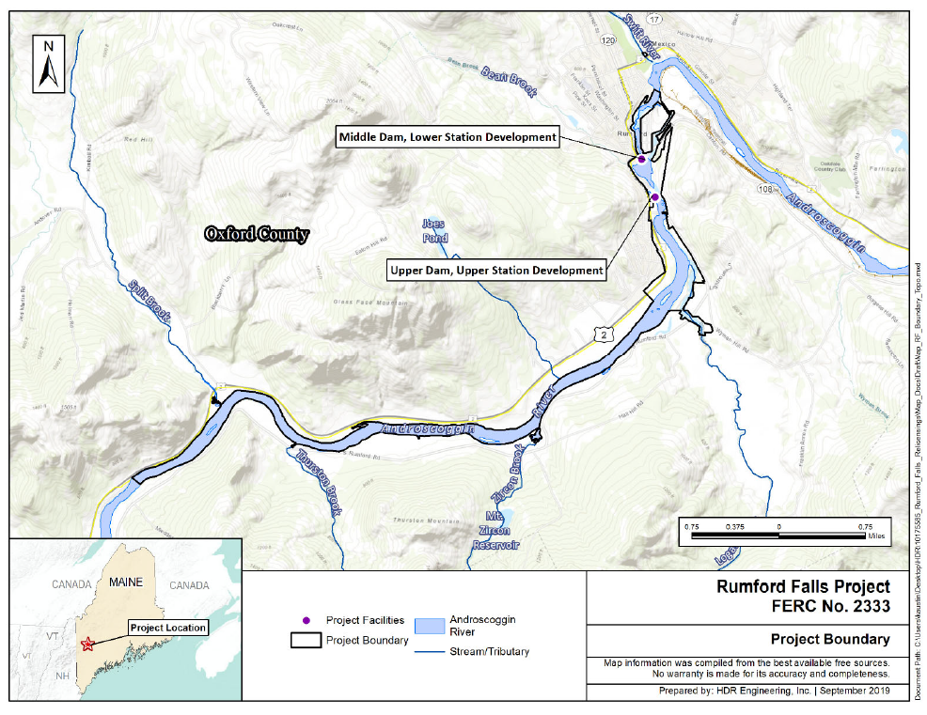
Applicable Standards
Water Quality Standards and the water quality classifications of all surface waters of Maine are established by the Maine Legislature (38 M.R.S. § 464-468). The Androscoggin River above, within, and downstream of the Project Boundary are classified as Class C waters. Class C waters must be of such quality that they are suitable for the designated uses of drinking water supply after treatment, fishing, agriculture, recreation, industrial process and cooling water supply, hydroelectric power generation (except as prohibited under Title 12, section 403), navigation, and as habitat for fish and other aquatic life, as well as specific standards relating to Atlantic Salmon (Salmo salar) habitat.
Water Quality Assessment
Division of Environmental Assessment (DEA) staff reviewed the WQC application and evaluated associated data to assess whether the Project meets applicable water quality standards. DEA staff assessments for each water quality standard are summarized below.

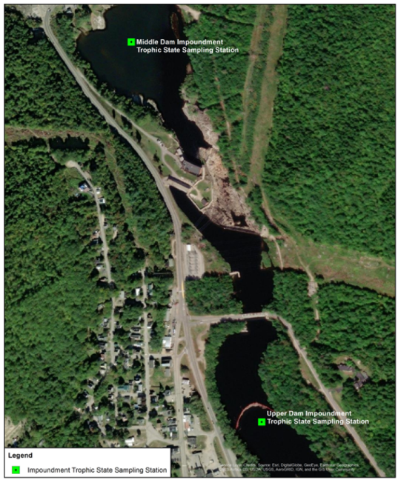
- Trophic State, Dissolved Oxygen and Temperature of Upper and Middle Dam Impoundments
A trophic state study and dissolved oxygen and temperature profile monitoring were conducted at the deepest location in each of the Upper Dam and Middle Dam impoundments (Figure 1). DEP staff certified the consulting staff obtaining these data. In 2020, the DEP Lake Trophic State Sampling Protocol for Hydropower Studies (MDEP 2019) was not totally followed so some repeat monitoring occurred in 2022. It is unknown why specific conductance was not measured during August of 2020; units in the table on page A-6 were incorrect in the 2020 monitoring report.

Secchi disk transparency (SDT), DO, temperature and water chemistry data were collected twice monthly from June through October 2020. Water temperature and DO profiles were taken from just below the water surface (0.1 meter) and then at 1-meter intervals to 0.5 meter above the bottom depth. Integrated epilimnetic core samples were collected for total phosphorus, chlorophyll-a, color, pH, and total alkalinity through the monitoring period, and additional parameters were collected in August. In 2022, profile and trophic parameter monitoring was repeated. Trophic parameter results are summarized below:

 | Upper Impoundment |  | Middle Impoundment
Parameter | Range | Average | Range | Average
2020
Secchi Disk Transparency (meters) | 2.7 to 5.0 | 3.7 | 1.8 to 4.6 | 3.5
Color (Standard Platinum-Cobalt Units) | 5 to 35 | 25 | 10 to 35 | 24
Chlorophyll-a (ug/L or ppb) | <1.0 to 2.7 | 1.6 | <1.0 to 3.4 | 1.6
Total Phosphorus (ug/L or ppb) * | <100 | <100 | <100 | <100
2022
Secchi Disk Transparency (meters) | 2.1 to 4.6 | 3.4 | 2.3 to 4.1 | 3.2
Chlorophyll-a (ug/L or ppb) | 1.0 to 4.0 | 2.0 | 2.0 to 3.0 | 2.0
Total Phosphorus (ug/L or ppb) | 10 to 20 | 13 | 10 to 22 | 13
* Analytical lab unable to analyze for low level phosphorus

DO and temperature profiles indicate that the impoundments did not stratify. DO values in both impoundments were well above the Class C standard of 5 mg/L and 60% saturation throughout the water column at all sample dates. Lowest recorded values were 7.68 mg/L (85.3% saturation) in the Upper Impoundment and 7.62 mg/L (83.7% saturation) in the Middle Impoundment. Oxygen profiles obtained on October 13, 2020, were likely undersaturated due to the delay of reoxygenation as water was cooling in the fall.

Based on the sampling results and information contained in the WQC application, the Project impoundment meets applicable Class C water quality standards and is free of culturally induced algal blooms. Trophic data indicates that that the waters are in the meso-eutrophic range.

- Stream Aquatic Life
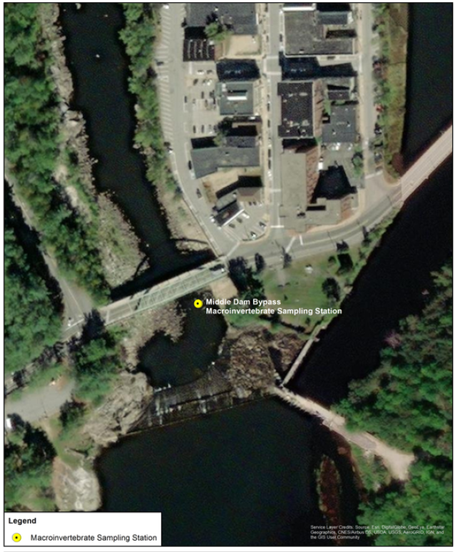
The applicant completed benthic macroinvertebrate sampling downstream of the Middle Dam consistent with MDEP’s Methods for Biological Sampling and Analysis of Maine’s Rivers and Streams,

The study included one sampling location, 200 feet downstream of the Middle Dam. Macroinvertebrate rock basket samplers were deployed at the designated station on July 30, 2020 and retrieved 29 days later on August 27, 2020. A second sample location was originally requested further downstream but was removed due to concerns about the influence of effluent from the ND Paper Mill.

DEP staff analyzed resulting data using its linear discriminant model and found that the macroinvertebrate community at this site met aquatic life criteria for Class A, and therefore also attained criteria for Class C.

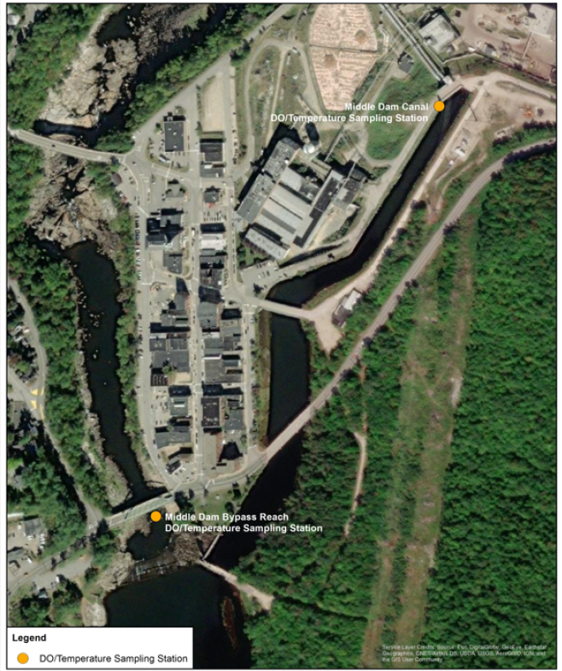
- Dissolved Oxygen and Temperature
The Applicant conducted a continuous Dissolved Oxygen (DO) and Temperature Study in the Middle Bypass Reach and Middle Dam Canal adjacent to the intake at the lower powerhouse in accordance with the Department’s Sampling Protocol for Hydropower Studies between June and October 2020. Data were gathered downstream of Middle Dam in the bypass reach and in the power canal. DO concentrations recorded during the study ranged from 7.61 mg/L to 10.46 mg/L and between 92.5% and 106.4% saturation at both locations below Middle Dam.

Analysis of the sampling results indicates that DO concentration met applicable Class C water quality standards in the Middle Bypass and Middle Dam Canal. Based on the results of DO and temperature monitoring results, the Department concludes that the Applicant has provided sufficient information to demonstrate that the Project meets applicable Class C dissolved oxygen numeric criteria under critical water quality conditions.

- Stream Aquatic Habitat
To maintain adequate habitat for aquatic life, the Department’s Hydropower Flow and Water Level Policy requires that a weighted average of 75% of an affected river/stream cross-sectional area as measured from bank full conditions be wetted at all times. On a case-by-case basis, alternative flows may be established if it can be demonstrated that all applicable water quality standards are met, including standards for aquatic life.

In the middle bypass reach, the 75% wetted cross-sectional area policy is not met under the current flow regime (minimum flow of 21 cfs with annual median flow of 240 cfs). DEP recognized the site limitations associated with the steep channel gradient and morphology, and the Applicant conducted additional studies to explore potential site-specific alternative flows. Data to determine wetted cross-sectional area were initially collected at two transects established with MDEP within the Middle Dam bypass reach for analysis using a HEC-RAS model. An additional study was completed at five transects using two approaches, Demonstrated Flow Analysis (DFA) and a one-dimensional (1-D) hydraulic model, to analyze flow-habitat relationships at a range of flow conditions using habitat suitability criteria for fish and macroinvertebrates developed for this study.

Both methods showed an average increase in benthic macroinvertebrate (BMI) suitable habitat with increased flow up to the maximum flow values measured or modeled for the study (265 cfs for the DFA and 400 cfs for the 1-D model), however the amount of optimal habitat was much lower than suitable habitat values at all flows. In the DFA analysis, Transect XS 1-PL had no optimal habitat for benthic macroinvertebrates at any of the measured flows up to 265 cfs and Transect XS 2-PL did not have any suitable or optimal habitat even at the maximum flow of 265 cfs. Overall however, Table 8 in the 2022 Updated Study Report indicates that based on weighted average values for all 5 transects, some suitable habitat and a limited amount of optimal habitat occurs at all measured flows, with the most habitat (97.4 feet suitable and 9.6 feet optimal) occurring at 265 cfs. Summary tables and plots in Section 5.2 One-Dimensional (1-D) Flow Modeling also suggest that the rate of increase in suitable habitat declines at higher flows and begins to substantially level off at approximately 200 cfs. In addition to BMI, a comparison of the weighted average values between 90 cfs and 193 cfs indicates that suitable and optimal habitat increases for all included three fish species. Based on these studies, an alternative flow of 200 cfs will satisfy the requirements of the Department’s flow policy. Providing additional flow beyond this level would be highly beneficial to increase habitat for aquatic life in areas where suitable habitat is still predicted to be lacking.

