Exhibit E
Green Lake Project (P7189)
Environmental Report

Revision: September 12, 2022

Amended: April 20, 2024

Contents
0.0 Introduction 0-1
0.1 Document Organization 0-1
1.0 River basin 1-1
1.1 Overview 1-1
1.2 Project Drainage Basin Tributary Streams 1-2
1.3 Topography 1-9
1.4 Climate 1-9
1.5 Major Land Uses 1-10
1.6 Economic Activities 1-11
1.7 References 1-11
2.0 Cumulative Effects 2-1
2.1 Introduction 2-1
2.2 Resources Identified 2-1
2.3 Geographic Scope 2-1
2.4 Temporal Scope 2-2
2.5 References 2-2
3.0 statutory and regulatory requirements 3-1
3.1 Federal Power Act 3-1
3.1.1 Section 4(e) FERC Can Issue Licenses 3-1
3.1.2 Section 18 Fishway Prescriptions 3-2
3.1.3 Section 10(j) Recommendations 3-3
3.2 Section 401 of the Clean Water Act 3-3
3.3 Endangered Species Act (ESA) 3-4
3.4 Magnuson-Stevens Fishery Conservation and Management Act 3-4
3.5 Coastal Zone Management Act (CZMA) 3-5
3.6 National Historic Preservation Act (NHPA) 3-5
3.7 Maine Title 5, §9055. Ex parte communications; separation of function 3-6
3.8 Consultation 3-6
3.8.1 Comments on the Draft License Application (DLA) 3-8
3.9 References 3-9
4.0 Project Facilities and Operation 4-1
5.0 Proposed action and action alternatives 5-1
5.1 Background 5-1
5.2 Geology and Soils Resources 5-1
5.2.1 Existing Geological Features 5-1
5.2.2 Bedrock Geology 5-2
5.2.3 Soils 5-4
5.2.4 Erosion 5-9
5.2.5 Construction 5-10
5.2.6 References 5-11
5.3 Aquatic Resources 5-12
5.3.1 Drainage Area 5-12
5.3.2 Streamflow, Gage Data, and Flow Statistics 5-12
5.3.3 Existing and Proposed Uses of Water 5-14
5.3.4 Existing Instream Flow Uses 5-14
5.3.5 Existing Water Rights 5-14
5.3.6 Available Reservoir Information 5-15
5.3.7 Gradient of Downstream Reaches 5-16
5.3.8 Federally-Approved Water Quality Standards 5-16
5.3.9 Water Quality Monitoring 5-18
5.3.10 Benthic Macroinvertebrates 5-18
5.3.11 References 5-19
5.4 Fish and Aquatic Resources 5-21
5.4.1 Existing Fish and Aquatic Communities 5-21
5.4.2 Aquatic Habitat 5-26
5.4.3 Essential Fish Habitat 5-26
5.4.4 Affected environment 5-27
5.4.5 Environmental analysis 5-28
5.4.6 Proposed environmental measures 5-32
5.4.7 Unavoidable adverse impacts 5-35
5.5 Terrestrial Resources 5-35
5.5.1 Upland Wildlife and Botanical Resources 5-35
5.5.2 Shoreline Wildlife and Botanical Resources 5-38
5.5.3 Affected environment 5-41
5.5.4 Environmental analysis 5-42
5.5.5 Proposed environmental measures 5-44
5.5.6 Unavoidable adverse impacts 5-45
5.6 Maine State-listed Species 5-45
5.6.1 Species 5-45
5.6.2 Affected environment 5-45
5.6.3 Golden Eagle 5-46
5.6.4 Northern Long-eared Bat 5-47
5.6.5 Little Brown Bat 5-47
5.6.6 Brook Floater Mussel 5-49
5.6.7 Tidewater Mucket Mussel 5-49
5.6.8 Yellow Lampmussel 5-50
5.6.9 Proposed environmental measures 5-51
5.7 Threatened and Endangered Species 5-52
5.7.1 Threatened and Endangered Wildlife Resources and Habitats 5-52
5.7.2 Threatened and Endangered Wildlife Species Distribution and Life History information 5-54
5.7.3 Threatened and Endangered Botanical Resources and Habitats 5-60
5.7.4 Threatened and Endangered Botanical Species Distribution and Life History information 5-60
5.7.5 Affected environment 5-60
5.7.6 Environmental analysis 5-60
5.7.7 Proposed environmental measures 5-62
5.7.8 Unavoidable adverse impacts 5-63
5.7.1 References 5-63
5.8 Recreation, Land Use, and Aesthetic Resources 5-65
5.8.1 Existing Project Recreation Opportunities and Use 5-65
5.8.2 Regional Recreation Opportunities 5-66
5.8.3 Recreation Needs Identified in Management Plans 5-66
5.8.4 Land Uses and Management Within the Project Vicinity 5-67
5.8.5 Land Use and Management of Project Lands 5-69
5.9 Aesthetic Resources 5-69
5.9.1 Visual Character of the Project Vicinity 5-69
5.9.2 Visual Character of Project Lands and Waters 5-70
5.9.3 Nearby Scenic Attractions 5-71
5.9.4 Affected environment 5-72
5.9.5 Environmental analysis 5-72
5.9.6 Proposed environmental measures 5-73
5.9.7 Unavoidable adverse impacts 5-73
5.10 Cultural resources 5-73
5.10.1 History of the Project Vicinity 5-73
5.10.2 Identification Of Historic And Archaeological Site In The Project Vicinity 5-75
5.10.3 Prior Cultural Resource Investigations 5-75
5.10.4 Tribal Resources 5-75
5.10.5 Architectural 5-76
5.10.6 Archeological 5-76
5.11 Socioeconomic Conditions 5-78
5.11.1 GENERAL LAND USE PATTERNS 5-78
5.11.2 POPULATION PATTERNS 5-78
5.11.3 PROJECT VICINITY EMPLOYMENT SOURCES 5-79
5.12 References 5-80
6.0 Consistency with Comprehensive Plans 6-1
6.1 FERC-Approved State of Maine Comprehensive Plans 6-1
6.2 FERC-Approved Federal Comprehensive Plans 6-8
6.3 References: 6-12
7.0 Study Results 7-1
7.1 Overview 7-1
7.2 Study Results 7-2
7.2.1 Study #1 – Water Quality – Encompasses Data Requested from the Maine Department of Environmental Protection (MDEP), United States National Marine Fisheries Service (US NMFS), United States Fish and Wildlife Service (US FWS) and FERC to determine current mpoundment and downstream water quality. 7-2
7.2.2 Study #2 – Aquatic Resources – Encompasses Data Requested from MDEP for Aquatic Habitat Cross-Section Flow and from US NMFS In-stream Flow 7-15
7.2.3 Study #3 – Aquatic Resources - Eel Passage Survey Requested by the United States Fish and Wildlife Service (US FWS) 7-23
7.2.4 Study #4 – Cultural Resources – Erosion Reconnaissance Survey 7-27
7.2.5 ADDITIONAL INFORMATION REQUESTED 7-34
7.2.6 References 7-38

APPENDICES – These were submitted as separate files and are not included with this filing.
They can be found with the original Final License Application – filed on March 31, 2022:
APPENDIX A – DLA RESPONSES
APPENDIX B – CONSULTATIONS AND MEETINGS
APPENDIX C – STUDY REPORTS AND DATA
APPENDIX D – STUDY PLAN EVOLUTION
APPENDIX E – FLOW DURATION CURVES

List of Tables

Table 3-1 – Consultation Table 3-8
Table 5-1 – Soils Types in Hancock County, Maine 5-4
Table 5-2 – List of Soils by Type, Size (Acres), and Percent within an Approximate 1-mile Radius of the Project 5-5
Table 5-3 – List of Soils by Type, Size (Acres), and Percent within Hancock County, Maine 5-7
Table 5-4 – Watershed Characteristics 5-13
Table 5-5 – Mean, Median, Minimum, and Maximum river flows by Month for the Green Lake Project (August 1, 1998 to December 31, 2018).* 5-13
Table 5-6 – Established and Proposed Maine Water Quality Standards for Select Parametersª 5-17
Table 5-7 – Fish Species in Green Lake 5-21
Table 5-8 – Amphibian and aquatic reptile species with the potential to occur in vicinity of the Green Lake Hydroelectric Project 5-25
Table 5-9 – Invasive Plants Potentially Occurring within the Project 5-37
Table 5-10 – Federally Listed Endangered or Threatened Wildlife Species Documented as Occurring in The Project Area 5-52
Table 5-11 – Endangered, Threatened, and Species of Special Concern that May Occur in the Project or in the Project Vicinity 5-53
Table 5-12 Land Use patterns for the Maine Coastal Watershed, Hancock County and Maine -- 2010 5-78
Table 5-13 Population Statistics for the City of Ellsworth, Hancock County and Maine, 2020 5-78
Table 5-14 Employment Statistics for the City of Ellsworth, Hancock County, and Maine, 2020 5-79
Table 7-1 – Turbine Operation During Study Period 7-1
Table 7-2 – Station #1 – Base Water Samples and Secchi Disk data 7-3
Table 7-3 – Station #2 – Base Water Samples and Secchi Disk data 7-4
Table 7-4 – Late August extended water sample results 7-5
Table 7-5 – Calculation for Water Temperature and Flow Duration exceeding 1500 7-13
Table 7-6 – Dissolved Oxygen and Temperature Readings at DO 1, DO 2, DO3, and DO 4 7-14
Table 7-7 – Transect 1 Flow Quantities 7-18
Table 7-8 – Transect 2 Flow Quantities 7-19
Table 7-9 – Transect 3 Flow Quantities 7-20
Table 7-10 – Transect 4 Flow Quantities 7-21
Table 7-11 – Night time Eel Surveys 7-26
Table 7-12 – Loon and Nest Count 7-34

List of Figures

Figure 1–1 – Union River Basin 1-7
Figure 1–2 – Project Drainage Area 1-8
Figure 1–3 – Graph of precipitation range recorded by month 1-10
Figure 1–4 – Graph of total precipitation recorded by year 1-10
Figure 5-1 – Geographical Provinces of Maine 5-1
Figure 5-2 – General Topography of Maine 5-2
Figure 5-3 – Bedrock geology of Maine 5-3
Figure 5-4 – Soils Within an Approximate 1-mile Radius of the Project 5-5
Figure 5-5 – Bathymetry of Green Lake 5-16
Figure 5-6 – Estimated Inland Range of Atlantic Salmon 5-22
Figure 5-7 – Wetlands in the Vicinity of the Project 5-39
Figure 5-8 – Estimated Total Returns to New England for Outer Bay of Fundy (OBF), GOM DPS, Central New England Complex (CNE), and Long Island Sound (LIS) Complex from 1967 to 2014 5-56
Figure 5-9 – Green Lake Area Land Cover -- Map 5-68
Figure 5-10 – Green Lake Area Land Cover – Image 5-69
Figure 7–1 – Littoral Drawdown Area 7-6
Figure 7–2 – Littoral Drawdown Volume 7-6
Figure 7–3 – Possible Arctic Char Spawning Sites – Map provided by MDIFW 7-7
Figure 7–4 – Logger 1 Temp °F Graph – at potential spawning location 4 7-8
Figure 7–5 – Logger 2 Temp °F Graph – at potential spawning location 2 7-9
Figure 7–6 – Green Lake Level from August 31 - November 30 2020 7-10
Figure 7–7 – Locations for Temperature and DO sampling in Reeds Brook. 7-12
Figure 7–8 – Brook Run Elevation, Source GLWP 7-16
Figure 7–9 – Flow through Waste Gate 2 7-17
Figure 7-10 – Approval Letter from MHPC 7-27
Figure 7-11 – Map of possible Erosion Sites 7-28
Figure 7-12 – Erosion Survey South End 7-31
Figure 7-13 – Erosion Survey South East End 7-32
Figure 7-14 – Erosion Survey North End 7-32
Figure 7-15 – Location of Docks included in the GLA Survey data 7-36
Figure 7-16 – Location of Docks included in the Google Maps survey 7-37

List of Photos

Photo 1-1 – Great Brook at Scott’s Neck Road 1-3
Photo 1-2 – Mountainy Pond Brook at Beech Hill Pond Road 1-4
Photo 1-3 – Mann Brook at Green Lake Road 1-5
Photo 1-4 – Jellison Brook at Green Lake Road 1-6
Photo 1-5 – Boggy Brook at Upper Boggy Brook Road 1-6
Photo 5-1 – Green Lake 5-70
Photo 5-2 – Green Lake 5-71
Photo 7-1 – On Green Lake to gather samples 7-2
Photo 7-2 – A Rock Filled Basket in Reeds Brook 7-11
Photo 7-3 – Bank full at Transect 1 7-18
Photo 7-4 – Bank full for Transect 2 7-19
Photo 7-5 – Transect 2 7-20
Photo 7-6 – Transect 3 Bank Full 7-21
Photo 7-7 – Transect 4 Bank Full 7-22
Photo 7-8 – Looking for eels at night – spillway 7-24
Photo 7-9 – Looking for eels at night – below dam 7-25
Photo 7-10 – Loons on the lake 7-33

Introduction
Green Lake Water Power Company (GLWP) is using the Federal Energy Regulatory Commission’s (FERC or Commission) Integrated Licensing Process (ILP) for the relicensing of the Green Lake Hydroelectric Project (Project). The Licensee is filing a Final License Application (FLA).

Document Organization
The format of Exhibit E for an FLA produced under the ILP is prescribed by 18 Code of Federal Regulation (CFR) § 5.18(b). This document generally follows FERC’s guidelines for preparing Environmental Documents, but where there are differences between the two, 18 CFR § 5.18(b) is followed because, as FERC’s guidelines document states in its Preface: “These guidelines… do not set Commission policy or substitute for the Commission’s regulations.”
Per 18 CFR § 5.18(b), this Exhibit E must meet the following format and content requirements:
Section 0.0 – General Description of the River Basin.
Section 1.0 – Cumulative Effects
Section 3.0 – Applicable Laws
Section 4.0 – Project Facilities and Operation
Section 5.0 – Proposed Action and Action Alternatives

River basin

Overview
The Green Lake Dam Hydroelectric Project, FERC No. 7189 (GLWP, P7189, or the Project) is located on Green Lake and Reeds Brook near the City of Ellsworth, Hancock County, Maine. The Project intake is at the Green Lake dam and the tailrace discharges into Reeds Brook near Graham Lake. The Green Lake drainage area is part of the Union River watershed.
The Union River watershed has an area of 547 square miles. Within that area, the Green Lake watershed has an area of approximately 46 square miles. Green Lake stretches 6.1 miles from the dam to the northwest end of the lake.
Reeds Brook flows about 2000 feet (about 1800 feet straight line distance) from Green Lake just downstream of the Green Lake dam to Graham Lake, dropping about 45 feet in the process. The elevation difference between Green Lake and Graham Lake is 57.7 feet with both lakes at normal high water.
The Project power station is about 7 miles upriver from the head of tidewater on the Union River at the Ellsworth dam. The tidewater of the Union River flows a further 4.2 miles and enters the Union River Bay, part of the Atlantic Ocean. The power station is therefore about 11.2 miles, and the Green Lake dam about 11.6 miles, upstream of Union River Bay.
The following ponds and associated wetlands drain into Green Lake via streams:
- Hatcase Pond
- Mountainy Pond
- Little Burnt Pond
- Rocky Pond
- Wormwood Pond
- Little Duck Pond
- Little Rocky Pond
- Goose Pond
These ponds and wetlands absorb precipitation and have a large effect on the quantity and timing of rain runoff into Green Lake. Small amounts of precipitation result in little new water in Green Lake beyond that which falls directly on the lake. Larger amounts of precipitation cause disproportionately larger amounts of runoff—the actual amount depending on season, weather, and prior precipitation.
Ellsworth Hydroelectric’s Union River Watershed map includes Phillips Lake. USGS maps show both Mann Brook and Mill Stream as possible outlets for Phillips Lake. GLWP conducted a field survey and determined that there was a large flow of water north from Phillips Lake into Mill Stream and, on the ground, Mann Brook does not connect with Phillips Lake. Because of this GLWP concluded Phillips lake drains to the north, away from the Union river, and is not part of the Green Lake Watershed.

Project Drainage Basin Tributary Streams
Deleted to reduce file size. There were no changes to this section.

Topography
The land around Green Lake is characterized by hills to the north and broad ridges of moderate height to the south. The hills to the north within the project drainage area rise to a maximum elevation of just over 1100 feet. See Figure 1–2 Project Drainage Area above.

Climate
The climate of the Green Lake area is quite varied. Summer and fall can be anything from a severe, extended dry period to a period of frequent, heavy rain. Hurricanes and tropical depressions traveling northeast near the coast can spiral large amounts of moisture inland from the Gulf Stream. With Green Lake located about 30 miles from the ocean, winters are a battle between cold air masses traveling westward from the middle of the country and moist, warm onshore flows from storms. Resulting winter weather can bring snow which accumulates until spring; or snow followed by rain which results in a shallow, dense snow pack; or mostly rain, which results in negligible snow pack, but icy conditions between storms.
A “typical” water year would be damp in the late fall with rain and some snow. Snow starts accumulating from late December. Snow and frost melt and run off into Green Lake around mid-April. Spring rain is intermixed with sunny periods into June, which kicks the trees on the land surrounding Green Lake into full growth. From July through September precipitation is reduced from spring levels--trees are absorbing much of the precipitation that falls on the land surrounding Green Lake. Individual years can vary greatly from this typical scenario.
The hills to the northwest of Green Lake affect the climate of the Green Lake Watershed. Low pressure areas that track northeast near Maine cause a moist airflow from the southeast which condenses and forms rain/snow as it cools from being forced to rise over the hills. The Green Lake Watershed often receives more precipitation from large storms than surrounding areas and than the National Weather Service (NWS) predicts. Even though the Green Lake Watershed is located between two NWS monitoring and recording stations (the Bar Harbor and Bangor Airports), forecasts and records for these locations are not necessarily a good prediction of Green Lake Watershed precipitation. During the summer, Project experience has been that actual precipitation amounts are often quite a bit less than amounts called for by NWS forecasts 2 to 3 days before the rain.
GLWP recorded the following precipitation amounts by month and year over the last eighteen years: (Sources: GLWP Daily Hydrological Logs, 2000 to 2018)

Source: GLWP Daily Hydrological Logs, 2000 to 2018
Figure 1–3 – Graph of precipitation range recorded by month

Source: GLWP Daily Hydrological Logs, 2000 to 2018
Figure 1–4 – Graph of total precipitation recorded by year

Major Land Uses
Most of the land in the Green Lake watershed is used for tree growth. Some rural residential, seasonal recreational and commercial uses are also found within the drainage area.

Economic Activities
Much of the land in the Project vicinity is used for tree growth, with scattered residential and recreational uses. There are also a few businesses (small mechanics, stores, commercial beaches, rental properties, etc.)

References
U.S. Geological Survey (USGS) maps, https://store.usgs.gov/maps
Bangor, Maine, 1:100k, 1994
Bar Harbor, 1:100k, 1991
Beech Hill Pond, 1:24k, 1981
Branch Lake, 1:24k, 1981
Brewer Lake, 1:24k, 1982
Chemo Pond, 1:24k, 1988
Ellsworth, 1:24k, 1981
Green Lake, 1:24k, 1982
Hopkins Pond, 1:24k, 1988
Veazie, 1:24k, 1988
Ellsworth Hydroelectric Project (FERC No. 2727) License application, Dec-2015,
https://www.ferc.gov/docs-filing/elibrary.asp
Lakes of Maine, https://www.lakesofmaine.org/lake-overview.html?m=4294

Cumulative Effects

Introduction
According to the Council on Environmental Quality’s regulation for implementing the National Environmental Policy Act (NEPA) (40 C.F.R. § 1508.7), a cumulative effect is the effect on the environment that results from the incremental impact of the action when added to other past, present, and reasonably foreseeable future actions, regardless of what agency (federal or non-federal) or person undertakes such other actions. Cumulative effects can result from individually minor but collectively significant actions taking place over a period of time, including hydropower and other land and water development activities.

Resources Identified
The following potentially cumulatively affected resources were identified in the Commission’s Scoping Document, consultation and study results:

- Migratory fish (i.e., alewife, American eel, American shad, Atlantic salmon, blueback herring, and sea lamprey)
- Lake wildlife (loons and arctic char)
- Aquatic habitat

Geographic Scope
The geographic scope chosen for migratory fish analysis is from the upstream extent of the Green Lake Project to the Graham Lake Development of the Ellsworth Project No. 2727 (Ellsworth Project), and the Union River from the Ellsworth Project downstream to the Union River Bay. This geographic scope was chosen because the operation and maintenance of the Green Lake Project, in combination with several other dams on the Union River, may affect migratory fish. GLWP notes that the population of Atlantic salmon at the Green Lake National Fish Hatchery (GLNFH, or the Hatchery) is also affected by the Project (in addition to the obvious effects from the Hatchery) and believes the Hatchery should be included in the geographic scope for cumulative effects analysis.

The geographic scope chosen for lake wildlife analysis is Green Lake. This geographic scope was chosen because Project operation, combined with development around the lake and/or Hatchery operation, may affect lake wildlife.

The geographic scope chosen for aquatic habitat is from the upstream extent of the Green Lake Project to Graham Lake. This includes Green Lake, Reeds Brook and the Hatchery. This geographic scope was chosen because the operation of the Green Lake Project, combined with the operation of the Green Lake National Fish Hatchery and development around Green Lake could affect aquatic habitat.

Temporal Scope
The temporal scope for cumulative effects analysis includes a discussion of past, present, and reasonably foreseeable future actions and their effects on each resource that could be cumulatively affected. Based on the potential term of a new license, the temporal scope will look 30 to 50 years into the future, concentrating on the effect on the resources from reasonably foreseeable future actions.

References
Scoping document 2 – 20190913-3000 – under Docket P-7189-014 on the FERC site https://elibrary.ferc.gov/eLibrary/search

Hatchery Populations of Atlantic Salmon - NOAA’s Endangered and Threatened Species: Determination of Endangered Status for the Gulf of Maine Distinct Population Segment of Atlantic Salmon” (Federal Register/ Vol. 74, No. 117/Friday, June 19, 2009, page 29344)

40 C.F.R. § 1508.7 - CEQ Regulations for Implementing the Procedural Provisions of NEPA (energy.gov)

statutory and regulatory requirements
Deleted to reduce file size. There were no changes to this section.

Project Facilities and Operation

This information is provided in Exhibit A.

Proposed action and action alternatives

Background
The Green Lake dam has a long history. It was originally authorized (as Reeds Pond dam to be built by the Great Brook and Reeds Pond Dam Company) in February of 1869, “on or near the dam of Benjamin Franklin and Sons, in the town of Ellsworth” for the purpose of running logs down Reeds Brook. Per this, it appears that some sort of dam has been on Green Lake since at least before 1865. The dam with its current height and configuration is believed to have been built in the early 1900’s. Bangor Hydro Electric Company (BHE) construction drawings were found by GLWP dating from 1943 which show some details of the dam. These drawings pertain to rebuilding the fish screens and contain a note as follows: “Present screens to be altered to fit new frame” indicating fish screens have been used on the gates at the Green Lake dam to prevent landlocked salmon from leaving the lake since before 1943. A BHE drawing from 1959 shows fish screens on the Green Lake dam spillway. It is not clear from the drawings if spillway fish screens were in place before 1943, but it is likely they were because fish screens were used on the gates. The Green Lake dam raises the water level about 7.5 ft from its original level.
BHE managed the dam before GLWP acquired the dam and created the Project in 1984. GLWP has copies of BHE level logs from1957 through mid-1981. BHE managed the lake level over a range of 3.0 to 8.0 feet on the staff gauge (156.5 – 161.5 NGVD29 datum), with unusual levels as low as 2.4 feet and as high as 9.5 feet. They appear to have used a management approach based on moderately stable, mostly full levels during the summer, with a drawdown in the fall or winter for spring runoff. GLWP, under the current license, manages the lake to a smaller level fluctuation (4.0 – 7.2 feet on the staff gauge) than BHE did historically (3.0 – 8.0 feet on the staff gauge).

Geology and Soils Resources
Deleted to reduce file size. There were no changes to this section.

Aquatic Resources

Drainage Area
The drainage area of Green Lake is approximately 46 square miles. (USGS, 2018b).

Streamflow, Gage Data, and Flow Statistics
There is no active USGS gage associated with the Green Lake project area, so a comparative analysis was completed to estimate the flow into Green Lake. The USGS Gage No. 01021480 Old Stream near Wesley, Maine was used as a surrogate gage. A comparison of the two watersheds was completed to confirm that the Old Stream gage was appropriate. The Old Stream gage has a smaller watershed and slightly less open water, however the characteristics of the watershed are very similar. The table below summarizes the characteristics of each watershed. (Background: Dudley, R. W. 2004).

Table 5-4 – Watershed Characteristics
Metric | Old Stream Watershed | Green Lake Watershed
Drainage Area (sq. miles) | 29.1 | 47
Mean Annual Temperature (F) | 41.8 | 44.3
Mean Annual Precipitation (in.) | 46.25 | 43.7
% Open Water | 3.17% | 15.28%
% Low Intensity Residential | 0.97% | 1.74%
% Commercial | 0.20% | 0.32%
% Deciduous Forest | 10.66% | 36.26%
% Evergreen Forest | 26.58% | 13.49%
% Mixed Forest | 32.46% | 17.55%
% Other | 25.97% | 15.36%
Based on our analysis of the two watersheds, we feel that prorating the Old Stream gage using the drainage area ratio method is appropriate to estimate the inflow and flow duration curves for the Green Lake Dam. A proration factor of 1.615 was applied to the Old Stream gage flow data to create annual and monthly flow duration curves (see Appendix C) based on a period of record from August 1998 through December 2018.

Table 5-5 – Mean, Median, Minimum, and Maximum river flows by Month for the Green Lake Project (August 1, 1998 to December 31, 2018).*
Month | Mean/Average | Median flow | Minimum | Maximum
 | flow (cfs) | (cfs) | flow (cfs) | flow (cfs)
January | 104 | 77 | 9 | 892
February | 84 | 55 | 13 | 862
March | 154 | 110 | 18 | 1003
April | 252 | 204 | 44 | 1471
May | 126 | 97 | 15 | 883
June | 74 | 43 | 13 | 704
July | 36 | 19 | 4 | 730
August | 27 | 13 | 3 | 467
September | 27 | 11 | 3 | 809
October | 70 | 30 | 3 | 1357
November | 125 | 96 | 7 | 1153
December | 154 | 107 | 9 | 2358
Annual | 102 | 61 | 3 | 2358
Source: Kleinschmidt Group 2019
*River flow data was prorated from USGS Gage # 01021480 based on comparable watershed characteristics.

Hatchery water flows are not included in the above tables. When they are, the available flows are significantly reduced. Reeds Brook is an intermittent stream. Given the limited flows and tight lake level constraints during the summer, GLWP can do little to change that.

Existing and Proposed Uses of Water
GLWP currently uses water from Green Lake and discharges it directly into Reeds Brook. Some seasonal residential use occurs from Green Lake waters; in addition, water from the lake is used by the U. S. Fish & Wildlife Service’s Green Lake National Fish Hatchery. Hatchery effluent discharges into Reeds Brook. No changes are proposed or likely.
Green Lake

Existing Instream Flow Uses
Inflows are used primarily for water storage, hydroelectric generation and by the fish hatchery. There is also some recreational use and domestic water use at seasonal residences.

Existing Water Rights
A water right may be defined as: “the right of a user to use water from a water source. This right includes the right to use water from any water source like a river, stream, pond and source of groundwater. Rights to water are established by actual use of the water, and maintained by continued use and need” (USLegal, 2016).
Under the terms of the current FERC license, GLWP must allow the Hatchery to draw up to 30 CFS from Green Lake at any time. To facilitate this draw of water by the Hatchery an interconnection is installed between the Project penstock and the Hatchery’s water filtration plant to be used whenever the Hatchery’s priority use of 30 cfs is unavailable through its own water supply lines. This is expected to only occur at lake levels below 158 ft NGVD29. Furthermore, the Hatchery shall not draw water through the penstock tap as an alternative to proper, continued maintenance and use of its water supply lines. (Article 29). (FERC, 25-May-1984).

Available Reservoir Information
The reservoir is Green Lake, which is wholly within Hancock county, Maine. This lake has a surface area of 3,312 acres and a gross volume of 107,000 acre-feet. The drainage area is approximately 46 square miles. Green Lake is a glacially formed lake with the deepest portion being below mean sea level. The earliest form of the current dam was a dry stone and timber structure built in the early 1900’s for water storage. In the 1960’s Bangor Hydroelectric Company added sheet steel to the dam and built a new concrete gate structure. GLWP replaced the main spillway portion of the dam with a concrete structure in the late 1980’s. The main spillway has a crest elevation of 160.7 feet NGVD29 datum, and the sill elevation of the gates is 154.0 feet (GLWP, 1983). Neither the spillway nor gate sill elevation has been changed since at least the 1960’s. It is believed that the current spillway elevation is the same as when the dam was originally built in the early 1900’s.

Figure 5-5 – Bathymetry of Green Lake
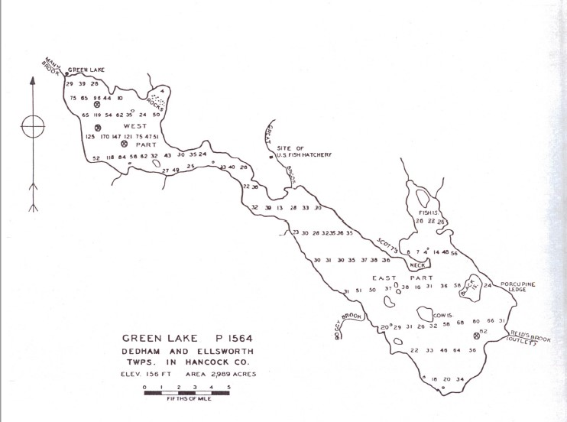
Source: MDIFW, rev. 1995

Gradient of Downstream Reaches
The outlet from the Green Lake dam is Reeds Brook, which runs into Graham Lake. This brook has a natural elevation of 150± (NGVD29 datum) feet at the dam, falling over a distance of 2000± feet to an elevation of 104± feet at the tailrace of the powerhouse, and flowing downstream to Graham Lake (USGS, 2018).

Federally-Approved Water Quality Standards
Maine statute 38 MRSA §464-470 establishes the state of Maine’s classification system for surface waters. Reeds Brook from the Green Lake dam to Graham Lake is Class B; Green Lake is Class GPA (MRS, 1989a).
Class GPA is the sole classification for natural lakes in Maine. Class GPA waters must be of such quality to support the designated uses of drinking water after disinfection; fishing; agriculture; recreation in and on the water; industrial process and cooling water supply; hydroelectric power generation; navigation; and habitat for fish and other aquatic life. The habitat must be characterized as natural. (MRS, 1989b).
Class B waters must be of such quality that they are suitable for the designated used of drinking water supply after treatment; fishing; agriculture; recreation in and on the water; industrial process and cooling water supply; hydroelectric power generation; navigation; and as habitat for fish and other aquatic life (MRS, 1989b).
Class GPA water quality standards are evaluated by the trophic state of the lake.
The state of Maine has established Class A and Class B water quality standards for DO, iron, chloride, and aluminum, and has developed draft nutrient criteria for total phosphorus, chlorophyll-a, pH, and water transparency (i.e., Secchi disk depth)

Table 5-6 – Established and Proposed Maine Water Quality Standards for Select Parametersª
Parameter | Criteria | Water Classification
Dissolved Oxygenª | The greater of: >=7 ppm or 75% of saturation^{d} | Class A
 | The greater of: >=7 ppm or 75% of saturation^{d} | Class B
Iron^{b} | 1000 μ/L (ppb) | Freshwater
Chloride^{b} | 230,000 μ/L (ppb) | Freshwater
Aluminum^{b} | 87 μ/L (ppb) at pH 6.5-9.0 | Freshwater
Total Phosphorus^{c} | <=18.0 μ/L (ppb) | Class A
 | <=30.0 μ/L (ppb) | Class B
Water Column Chlorophyll-a^{c} | <=3.5 μ/L (ppb) | Class A
 | <=8.0 μ/L (ppb) | Class B
Secchi Disk Depth^{c} | >=2.0 m | All
pH^{c} | 6.0-8.5 | All
ªMRS, 1989b
^{b}MDEP, 2012a values refer to the criterion continuous concentration (CCC) which is an estimate of the highest concentration of the substance in surface water to which an aquatic community can be exposed indefinitely without resulting in an unacceptable effect.
^{c}MDEP, 2012b
^{d}Except that for the period from October 1st to May 14th, in order to ensure spawning and egg incubation of indigenous fish species, the 7-day mean dissolved oxygen concentration may not be less than 9.5 parts per million and the one-day minimum dissolved oxygen concentration may not be less than 8.0 parts per million in identified fish spawning areas (MRS, 1989b).

Water Quality Monitoring
The Green Lake Association (GLA), the association of property owners surrounding Green Lake, performs regular water quality monitoring during the summer (See 7.2 below).
The data is available online at the Lakes of Maine website: https://www.lakesofmaine.org/lake-monitoring.html?m=4294

Benthic Macroinvertebrates
Benthic macroinvertebrates include aquatic insects (e.g., mayflies, stoneflies), annelids (e.g., worms), arthropods (e.g., crayfish), and mollusks (e.g., freshwater mussels, snails). The abundance of Ephemeroptera (mayflies), Plecoptera (stoneflies), and Trichoptera (caddisflies) (EPT) is a useful indicator of water quality because these species have a low tolerance to pollution; EPT richness values greater than 10 are indicative of excellent water quality. Furthermore, EPT are high-quality forage for freshwater fish species, including trout and salmon. The Hilsenhoff Biotic Index (HBI) is another indicator of the level of pollution-sensitive macroinvertebrates in a surface water body; the HBI ranges from 0 to 10 with lower values indicating a higher abundance of pollution sensitive macroinvertebrates (Hilsenhoff, 1987).
For Class A waters, the aquatic life and bacteria content must be as naturally occurs (MRS, 1989b). For Class B waters, MRS 1989b merely states discharges to these waters may not cause adverse impact to aquatic life in that the receiving waters must be of sufficient quality to support all aquatic species indigenous to the receiving water without detrimental changes in the resident biological community.
MDEP has a Biological Monitoring Program that includes macroinvertebrate sampling in rivers and streams. Statistical models are used to determine if water bodies are attaining biological goals as described by water classifications, such as Class A, Class B, Class C.
Indicator species for Class A:
- Brachycentrus (Trichoptera: Brachycentridae)
- Serratella (Ephemeroptera: Ephemerellidae)
- Leucrocuta (Ephemeroptera: Heptageniidae)
- Glossosoma (Trichoptera: Glossosomatidae)
- Paragnetina (Plecoptera: Perlidae)
- Eurylophella (Ephemeroptera: Ephemerellidae)
- Psilotreta (Trichoptera: Odontoceridae)
There appear to be no specific standards for Class B waters concerning benthic macroinvertebrates.
(MDEP, 2018)

References
Dudley, R. W. 2004. – Estimating Monthly, Annual, and Low 7-Day, 10-Year Streamflows for Ungaged Rivers in Maine. United States Geological Survey. Scientific Investigates Report 2004-5026. https://pubs.usgs.gov/sir/2004/5026/pdf/sir2004-5026.pdf. Accessed March 28, 2019.
(FERC) 1984 – Federal Energy Regulatory Commission Order Issuing License (Minor) for Green Lake Hydroelectric Project (FERC No. 7189). 27 FERC ¶62,023. Issued April 5, 1984.
(GLWP). 1983 – Green Lake Water Power Project. Application for a License for a Minor Water Power Project – FERC No. 4894.
Hilsenhoff, W.L. 1987. – An improved biotic index of organic stream pollution. The Great Lake Entomologist. Pgs. 31-39.
(MDEP). 2012a. – Maine Department of Environmental Protection. Chapter 584 Surface Water Quality Criteria for Toxic Pollutants. July 29, 2012. Accessed October 30, 2017. [Online] http://www.maine.gov/dep/water/wd/general.html.
(MDEP). 2012b – Maine Department of Environmental Protection. Draft Chapter 583 Nutrient Criteria for Surface Waters. June 12, 2012. Accessed October 30, 2017. [Online] http://www.maine.gov/dep/water/nutrient-criteria/index.html
(MDEP). 2018 – Maine Department of Environmental Protection. Benthic Macroinvertebrates. [Online.] https://www.maine.gov/dep/water/monitoring/biomonitoring/sampling/bugs/index.html. Accessed 03/16/2019
(MDIFW) rev 1995 – Maine Department of Inland Fisheries and Wildlife. 1942, rev. 1995. Lake Survey. Surveyed August, 1942; revised 1953, 1975, 1995. [Online] URL: https://www.maine.gov/ifw/docs/lake-survey-maps/hancock/green_lake.pdf. Accessed March 22, 2019.
(MRS). 1989a – Maine Revised Statutes. Title 38 Chapter 3 Subchapter 1 Article 4-A §465-A. Standards for classification of lakes and ponds https://legislature.maine.gov/statutes/38/title38sec465-A.html . Accessed 4/20/2024.
(MRS). 1989b – Maine Revised Statutes. Title 38 Chapter 3 Subchapter 1 Article 4-A §465. Standards for classification of fresh surface waters. http://legislature.maine.gov/statutes/38/title38sec465.html. Accessed 3/19/2018.
(USGS). 2018 – United States Geological Survey. The National Map, 3DEP Elevation Program. [Online] URL: https://viewer.nationalmap.gov/advanced-viewer/. Accessed March 22, 2019.
USGS, 2018b. The National Map. Watershed Boundary Dataset – 12-digit HU (Subwatershed) layer. Metadata: Green Lake (HUC 12-010500021215); Mountany Pond (HUC 12-010500021214). [Online] URL: https://viewer.nationalmap.gov/advanced-viewer/. Accessed March 22, 2019
USLegal. 2016. – Water Rights Law and Legal Definition. [Online] URL: https://definitions.uslegal.com/w/water-rights/

Fish and Aquatic Resources

Existing Fish and Aquatic Communities
Table 5-7 – Fish Species in Green Lake
Common Name | Scientific Name
Landlocked salmon | Salmo salar
Lake trout (togue) | Salvelinus namaycush
Brook trout | Salvelinus fontinalis
Sunapee charr | Salvelinus alpinus
Rainbow smelt | Osmerus mordax
Smallmouth bass | Micropterus dolomieui
White perch | Roccus americanus
Yellow perch | Perca flavescens
Chain pickerel | Esox niger
Common shiner | Notropis cornutus
Creek chub | Semotilus atromaculatus
Fallfish (chub) | Semotilus corporalis
White sucker | Catostomus commersoni
Hornpout (bullhead) | Ictalurus nebulosus
Banded killifish | Fundulus diaphanus
Threespine stickleback | Gasterosteus aculeatus
Pumpkinseed sunfish | Lepomis gibbosus
American eel | Anguilla rostrata
Source: MDIFW, rev. 1995

Diadromous Fish Species
Figure 5-6 – Estimated Inland Range of Atlantic Salmon
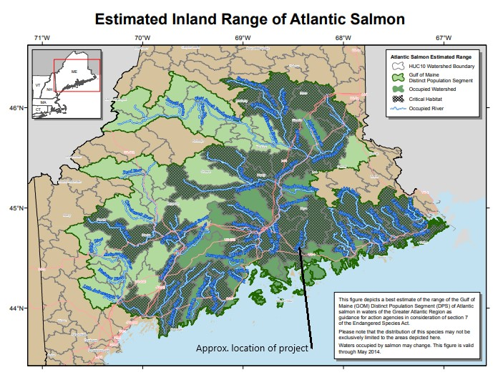
Source: NMFS, 2014

The Maine Department of Inland Fisheries and Wildlife (MDIFW) in its stakeholder response noted: “[a]rctic char occur in the lake. In addition, our Agency stocks both landlocked salmon and lake trout. Lake trout do not spawn in the lake, but there is a large contribution of wild landlocked salmon from the tributaries. There is also a smallmouth bass fishery” (Appendix B).
In its stakeholder response, the National Marine Fisheries Service (NMFS) noted that “Green Lake is located within the GOM [Gulf of Maine] DPS [distinct population segment] for federally endangered Atlantic salmon, and occurs within the designated critical habitat for that species. Other diadromous fish species (including alewives, blueback herring, American shad, sea lamprey, and American eels) also use the habitat within the Union River watershed for a portion of their life cycles” (Appendix B).
The U. S. Fish and Wildlife Service (USFWS) operates the Green Lake National Fish Hatchery. In their stakeholder response, it was noted that one of the 14 U.S. populations of arctic char occur in Green Lake (Appendix B).
NMFS further noted “[t]he Green Lake Project does not currently have safe, timely, and effective passage for diadromous fish, including federally listed Atlantic salmon.” However, MDIFW in its stakeholder response stated: “Currently there is no fishway at the dam. If a fishway is constructed, our Agency would have concerns for possible impacts to the existing fisheries resulting from the upstream passage of certain species, such as largemouth bass, that could access the lake from Graham Lake downstream.”
GLWP’s current license contains discussion and requirements related to preventing fish passage. Discussion in the license document has the following:
Fish Passage Barriers
Fish passage is not recommended by Interior because of the possibility of alewife being introduced into Green Lake and contaminating water withdrawn for the Green Lake National Fish Hatchery (GLNFH) with alewife-borne diseases. To prevent fish from migrating upstream over the dam into Green Lake, GLWP proposed, with concurrence from Interior and MDEP, to maintain the existing fish screens at the crest of the project dam. GLWP also proposed, at the request of Interior and MDEP, to install screens at the project intake with a maximum mesh size of 2 inches to prevent adult salmonids from moving out of Green Lake.
Article 28 requires the Licensee to install screens at the project intake to minimize mortality due to entrainment and to prevent out-migration of adult salmonids from Green Lake. (FERC, 1984)

GLWP’s current license contains the following requirement specifically limiting fish passage in both directions:
Article 28. The Licensee shall continue to consult with the U.S. Fish and Wildlife Service and the Maine Department of Environmental Protection, and within 6 months from the date of issuance of this license, file, for Commission approval, functional design drawings and a schedule for construction of an intake screen that would minimize fish mortality due to entrainment, and prevent downstream movement of adult salmonids from Green Lake. Comments on the drawings from the consulted agencies shall be included in the filing. Further, within 90 days after completion of project construction, Licensee shall file as-built drawings with the Commission. (FERC, 1984)
50 CFR 226.217 Critical habitat for the Gulf of Maine Distinct Population Segment of Atlantic Salmon first paragraph starts:
“Critical habitat is designated to include all perennial rivers, streams, and estuaries and lakes connected to the marine environment within the range of the Gulf of Maine Distinct Population Segment of Atlantic Salmon (GOM DPS), except for those particular areas within the range which are specifically excluded.”
50 CFR 226.217 Section (b) states:
“The textual descriptions of critical habitat for each SHRU are included in paragraphs (b)(3) through (6) of this section, and these descriptions are the definitive source for determining the critical habitat boundaries. A general location map (Figure 1) is provided at the end of paragraph (b)(2) and is for general guidance purposes only, and not as a definitive source for determining critical habitat boundaries.”
50 CFR 226.217 Section (b)(7)(i) lists Grham Lake and Union River Bay as critical Downeast Coastal salmon habitat recovery units (SHRUs) but does not explicitly list Green Lake or Reeds Brook. Reeds Brook is an intermittent stream, not a perennial stream. Since Green Lake is connected to the marine environment by Reeds Brook, it would not meet the criteria listed in 50 CFR 226.217 (b)(3) to be considered habitat essential to the conservation of Atlantic salmon.
GLWP also notes that the NMFS final rule establishing critical habitat for the Atlantic salmon GOM DPS (NMFS, 2009) does indicate that there is critical habitat for Atlantic salmon within the Graham Lake watershed. However, it states the following:
“We hereby designate as critical habitat 45 specific areas occupied by Atlantic Salmon at the time of listing that comprise approximately 19,571 km of perennial river, stream, and estuary habitat and 799 square km of lake habitat within the range of the GOM DPS and in which are found those physical and biological features essential to the conservation of the species.”
NMFS also states:
“We previously determined that naturally spawned and several hatchery populations of Atlantic salmon which constitute the GOM DPS warrant listing as endangered under the Endangered Species Act of 1973, as amended.”
Reeds Brook is an intermittent stream. It and Green Lake do not meet the description of “perennial river, stream, and estuary habitat,” and would therefore not be included as actual critical habitat. GLWP believes the parts of the Hatchery housing Atlantic Salmon would clearly be considered critical habitat since Hatchery populations of Atlantic salmon are listed as endangered.
Considering Green Lake and Reeds Brook as indistinguishable from the “Union River watershed” as a whole does not recognize and acknowledge some of the unique aspects of the Project. The Project does have an effect on the Atlantic Salmon through the Hatchery. When cumulative effects analysis considers the Project operating in conjunction with the Hatchery, the Project effects are seen to be positive rather than detrimental to Atlantic salmon.

Amphibian and Aquatic Reptile Species
Maine is home to at least 39 species and subspecies of reptiles and amphibians (MDIFW 2018). Sixteen common amphibian species and six common aquatic reptiles are known to occur in the region and have life history requirements that could result in their use of the riverine or lacustrine habitat found within the Green Lake Project area. Seven species of salamander (blue-spotted salamander, spotted salamander, eastern newt, northern dusky salamander, northern redback, four-toed salamander, and northern two-lined salamander) inhabit both aquatic and terrestrial habitat. Nine species of frogs and toads may occur and require use of aquatic habitat. The primarily aquatic or semi-aquatic reptilian species include the snapping turtle, painted turtle, and the wood turtle. Four species of snake (northern redbelly, common garter, and northern ringneck snake) may make limited use of riparian areas for shelter and feeding (DeGraaf and Yamasaki 2001, Hunter et al., 1999).
Table 5-8 – Amphibian and aquatic reptile species with the potential to occur in vicinity of the Green Lake Hydroelectric Project
Common Name | Scientific Name
Amphibians
Blue-spotted salamander | Ambystoma laterale
Spotted salamander | Ambystoma maculatum
Eastern newt | Notophthalmus v. viridescens
Northern dusky salamander | Desmognathus fuscus
Northern redback salamander | Plethodon cinereus
Four-toed salamander | Hemidactylium scutatum
Northern two-lined salamander | Eurycea bislineata
Eastern American toad | Bufo americanus
Eastern Spring peeper | Pseudacris crucifer
Gray treefrog | Hyla versicolor
Bullfrog | Rana catesbeiana
Green frog | Rana clamitans
Mink frog | Rana septentrionalis
Pickerel frog | Rana palustris
Wood frog | Rana sylvatica
Northern leopard frog | Rana pipiens
Reptiles
Painted turtle | Chrysemys picta
Snapping turtle | Chelydra serpentine
Wood turtle | Clemmys insculpta
Northern ringneck snake | Diadophis punctatus
Northern redbelly snake | Storeria occipitomaculatum
Common garter snake | Thamnophis sirtalis
Source: Degraaf and Yamasaki 2001, Hunter et al., 1999

Aquatic Habitat
The Maine Department of Inland Fisheries and Wildlife Green Lake (MDIFW) manages Green Lake for cold-water fish. MDIFW stocks both landlocked salmon and lake trout in Green Lake, and notes that arctic char, smallmouth bass are present and wild landlocked salmon are in the lake (Appendix B). Currently, the USFWS’s GLNFH raises Atlantic salmon for restocking several river systems in New England (USFWS, 2018). NMFS in its stakeholder response noted “Green Lake is located within the GOM DPS for federally endangered Atlantic salmon, and occurs within the designated critical habitat for that species…” (Appendix B).

Essential Fish Habitat
The Union River watershed is within the Gulf of Maine (GOM) distinct population segment (DPS) for Atlantic salmon. As covered above in Section 5.4.1.1, Reeds Brook and Green Lake, while in the Union River watershed, are not critical habitat for Atlantic Salmon.
There is fish passage through the Union River various structures and methods to Graham Lake, into which Reeds Brook flows. Fish using these structures include Atlantic salmon and river herring. Graham Lake is fairly shallow, with a mean depth of 17 feet and a maximum depth of 47 feet, and supports warmwater species such as smallmouth and largemouth bass, chain pickerel, and white perch (Black Bear 2015). (In contrast, Green Lake has a maximum depth of 170 feet (MDIFW, rev. 1995)
The Union River Stakeholders Group (including USFWS and Maine Department of Marine Resources) formed to address fisheries management in the Union River drainage, have included the provision of fish passage at the Ellsworth Hydroelectric Project.
Landlocked salmon are native to Green Lake. (Boucher, 2012) Substantial numbers of wild salmon are produced in Great Brook and Jellison Brook. Creel surveys indicate that wild salmon comprise from 30-45% of the salmon harvest in most years. Biologists have also confirmed the presence of a relic population of Sunapee charr (AKA Arctic charr). Green Lake also produces smallmouth bass. (MDIFW, 1995)
The lake trout fishery is entirely dependent upon stocking. (MDIFW, 1995) Records were found on fish stocking in Green Lake since 2010. Every year from 2010 through 2020 landlocked salmon have been stocked in Green Lake, and lake trout every other year. (MDIFW, 2020)
Green Lake is one of 14 lakes and ponds in Maine in which arctic charr exist and reproduce. It has never been firmly established that Arctic charr are native to Green Lake as Arctic charr were stocked in the late 1800's, however, Green Lake does now support a wild population of Arctic charr that appears to be genetically distinct from the Floods Pond fish believed to have been used for stocking. (NFC 2019) . Arctic charr have a varied diet which is commonly adapted to feeding on a given prey which is available in a lake or pond. They are a cold water fish that is susceptible to over-harvesting and invasive species. (Charr 2021)
The following migratory fish were identified during scoping: alewife, American eel, American shad, Atlantic salmon, blueback herring, and sea lamprey. With the exception of landlocked salmon and American eel, none of these are currently present in Green Lake. These species are all migratory fish that have potentially been present in the Union River. Atlantic salmon are discussed in the Threatened and Endangered Species section below. The others will be discussed in this section.
More information on diadromous fish is included in GLWP’s response to MDMR’s comments on the Project FLA. The information is mainly on pages 7-14 of that document.

Affected environment
The Green Lake dam affects the lake level of Green Lake and the flow in Reeds Brook. The dam also has fish screens to avoid passage of most fish and to stop turbine entrainment of large fish.

Environmental analysis
Fish and wildlife species that are present in Green Lake have at least successfully tolerated the historical conditions in the lake, and some may have benefited from them. This would include all the species listed in Table 5-7 above.
Study results demonstrate that Green Lake and Reeds Brook meet the MDEP water quality criteria. Study results are in section 6.0 below.
Aquatic resources, called out by resource agencies for special consideration or identified during scoping, are discussed in the following sections and in sections 5.6 and 5.7 below:

Eel
A series of eel surveys were performed during study season one to determine if eels were climbing the Green Lake dam. No eels were found during the surveys. For study results, see section 6.0 below.
During the 19 years that the current team has managed the Project they have encountered three eels in the penstock: two that traveled down the penstock when the turbine was not running and attempted to swim out holes that were flowing water. These holes have since been fixed. In addition, one eel was discovered when the turbine was shut down and opened up to remove debris. This action, which takes about an hour, is performed occasionally. It is most frequent in the fall when sticks that can pass through the trash racks are common in Green Lake.
A GLWP inspection of the trash racks on the penstock intake has revealed a two-inch gap on one side of the trash racks. It is likely that this gap is occasionally used by eels to gain access to the penstock. The two-inch gap is consistent with the current license but is substantially wider than the one inch clear spacing on the remainder of the rack assemblies. The fish screens on the dam gates have a slightly narrower clear spacing of about 0.75 inches.

Landlocked salmon
Landlocked salmon are stocked in Green Lake on a regular basis. They also spawn in the lake’s tributaries. Fish access to tributaries would depend on the amount of water in the brooks and streams involved. The effect of project operation on landlocked salmon would be from effects to lake water quality and the effect of the drawdown on the littoral zone. Lake trophic state and habitat studies done during the summer of 2020 indicate that Green Lake meets MDEP water quality standards. For study results see section 7 below.
John Perry at MDIFW provided the following data:
Green Lake supports one of the four original 4 wild landlocked salmon strains in Maine. This spawning has historically occurred in these sections of the stream well before the dam was put in and the current lake levels have very little influence on spawning success.
(1) Landlocked salmon spawn in the following tributaries to Green Lake: Mann Brook, Jellison Brook, Great Brook and Sucker Brook.
(2) Landlocked salmon mainly spawn in the lower quadrants of each of those tributaries where the substrate is appropriate (no exact distances, just in the lower reaches of these tributaries). As stated earlier, we do not think that the project operations are impacting landlocked salmon spawning in the tributaries.”
(3) Speaking with our regional fisheries biologist (Greg Burr, cc’d), there are no barriers to landlocked salmon spawning in the tributaries at Green Lake within the drawdown zone. An important thing to remember is that the fish spawned in these tributaries before the dams were put in. Finally, we find that landlock salmon can easily jump over a 21-inch elevation change.
These emails are included in the MDIFW-Files.pdf attachment.

Lake trout
Lake trout in Green Lake are purely from stocking, rather than from lake trout spawning in the lake. The effect of project operation on lake trout would be from effects to lake water quality and the effect of the drawdown on the littoral zone. Lake trophic state and habitat studies done during the summer of 2020 indicate that Green Lake meets MDEP water quality standards. For study results see section 6.0 below.

Arctic charr
Green Lake is a deep, cold-water lake that is a suitable habitat for Arctic charr. The best available data indicates that the Arctic charr in Green Lake spawn using their historic spawning beds, which would be more than 7.5 feet below the full pond lake level. Because of this, the Project fall drawdown (with a maximum drawdown of 3.2 feet from full pond) will not affect Arctic charr spawning regardless of timing.

Smallmouth bass
Smallmouth bass are not native to Maine. Smallmouth bass are a common game fish, with successful fisheries in almost every U.S. state. As adults, they feed on smaller fish and crayfish. They are flexible in what species they eat, preferring to eat what is available rather than travel long distances for preferred prey. Young smallmouth bass eat a varied diet that changes as they mature—progressing from mainly aquatic microorganisms, small insects and larvae; to larger insects; to tadpoles, frogs, smaller fish and young crayfish. (Hetke 2008)
Smallmouth bass prefer clear, relatively cool water with sufficient levels of dissolved oxygen, but they are adaptable to less than perfect conditions. They are an upper-echelon predator in many natural freshwater ecosystems. Their young are prey for numerous freshwater species (including other smallmouth bass), but once matured they are rarely prey for other fish. Other upper-echelon predator fish (such as lake trout) can be competitors for available prey and for spawning habitat. Largemouth bass are a competitor which will tend to outcompete and extirpate smallmouth bass in small lakes where habitat diversity is low. Generally smallmouth bass prefer a rockier and largemouth bass prefer a weedier littoral habitat. (Hetke 2008), (Cornwell 2020)
Smallmouth bass will winter, summer and spawn in one body of water, using different habitats depending on water temperature. Spawning activity begins when water temperatures reach 59-65°F with nest building in shallow areas with gravel, bedrock, sand or other hard-bottom surfaces. Smallmouth bass spawning responsibilities vary greatly with gender. The female arrives at the nest shortly before and leaves shortly after the eggs are laid. The male builds and defends the nest. He continues to defend the nest, eggs and hatchlings until they cease schooling. (Hetke 2008)
Green Lake is a good smallmouth bass habitat, with clean, clear water, abundant habitat, and suitable prey. Project operations have not compromised smallmouth bass habitat in Green Lake. For study results, see section 7 6.0 below.

River herring (alewife, blueback herring)
River herring are currently captured by the Ellsworth dam fish trap. Some are trucked upstream to Graham Lake, some are harvested, and some are released into Lake Leonard. The MDIFW, in a letter dated June 26, 2019, expressed concern with alewife fish passage upstream into Green Lake because of competition with landlocked smelts. Smelt are an established fishery in Green Lake as well as the preferred forage species of landlocked salmon. (MDIFW 2019)
Blueback herring are captured by the Ellsworth station trap operation along with alewives. Blueback herring typically run up-river later in the season than alewives. The trapped and not harvested late run river herring are released in Lake Leonard because the Union River stretch from there to Graham Lake dam is regarded as more suitable spawning habitat for blueback herring than the larger lakes upstream. Graham lake dam upstream of Lake Leonard does not have fish passage. This means that the majority of the blueback herring in the Union River do not have access to Green Lake Project waters. (Ellsworth FLA 2015)
It has been reported verbally to GLWP that Hatchery staff observed river herring in Reeds Brook in May of 2021. 2021 was a very unusual flow year. The spring of 2021 was unusually dry. The gates at the dam remained closed from late Dec-2020 until late Sep-2021. No water was used for generation by the Project from 04-May-2021 until unusually heavy rain occurred in Jul-2021. Flows in Reeds Brook would have been low in May-2021, and it is likely that Hatchery staff observed river herring in the lower reach of Reeds Brook near where it enters Graham Lake.

GLWP performed an analysis of the likely preferred alewife spawning habitat area that is present in Green Lake. This analysis determined that about 23.4 acres of habitat are available. At MDMR’s projection of 235 returning alewives per spawning acre of habitat, this amounts to a potential increase of about 5499 alewives, of which about 4680 would be harvested. This is a very small contribution toward MDMR’s projection of 2,000,000 alewives for harvest—even if the intermittent nature of Reeds Brook and the lack of sufficient flows for fish passage could be overcome.

American shad
There is no current nor historical habitat of American shad identified in the project area. American shad are not expected to have access to Reeds Brook now, nor in the future. (Ellsworth FLA 2015), (MDMR 2014)

Sea lamprey
Sea lamprey have gotten a bit of a bad reputation for a couple of reasons:
- Their physical appearance bothers many people.
- They have decimated native fisheries in some lakes where they are an invasive species.
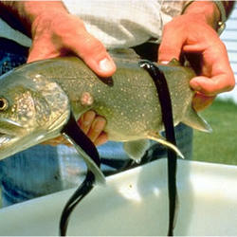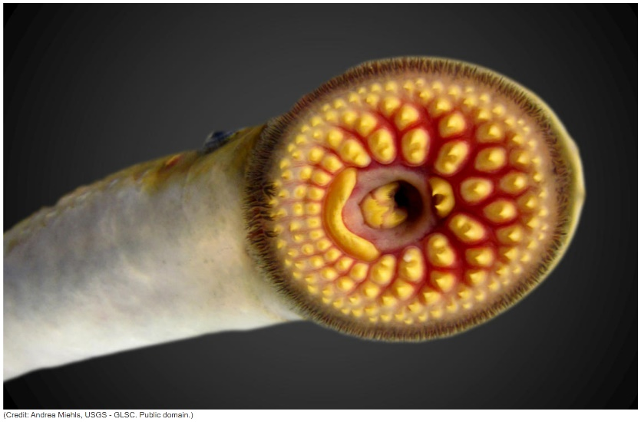
Source: NOAA
#1 is not very surprising given the above Sea Lamprey images.
#2 refers to sea lamprey in the Great Lakes where they are a serious invasive species which has impacted lake trout.
Sea lamprey are native to Maine waters. They may still have a public relations problem in Maine, but in their natural area they do not cause invasive species problems. This is because they are an anadromous fish that feeds in salt water during most of its growth to maturity. During the first 4-8 years of their lives, they burrow into the muddy bottoms of streams, rivers and lakes, filter feeding upon planktonic drift. After emerging from their burrows, they metamorphose into their migration life stage which is similar to the final adult form. Unlike the sea lamprey in the Great Lakes, Maine’s sea lamprey do not typically prey on fish while in fresh water. If migrating sea lamprey attach to a fresh water fish, it is rarely fatal for the fish (unlike in salt water). (Kircheis 2004)
Adult sea lamprey that return to fresh water die soon after spawning. Native Maine anadromous sea lamprey cannot survive in freshwater as adults. Sea lamprey are seen as a beneficial part of their native aquatic ecosystem. (Kircheis 2004)
Future fish passage for sea lamprey past the Ellsworth and Graham Lake dams, and even the future presence of these dams, are unknown at this point. (Ellsworth FLA 2015) Downstream fish passage of sea lamprey is facilitated by their lack of a swim bladder. In most situations they can pass through a turbine without suffering decompression damage. (Colotelo 2012)

Proposed environmental measures

Eel
There are currently no eel passage provisions on the Graham Lake dam nor on the Ellsworth dam. (Ellsworth FLA 2015) If eel passage is put in at the Graham Lake dam and at the Ellsworth dam, and young eel are found to be climbing or attempting to climb the Green Lake Dam, the need for upstream eel passage should be evaluated. Downstream passage should also be investigated at that time.
The three instances of eel entrainment in the penstock appear to have been allowed by a gap on one side of the intake trash racks. GLWP proposes that the trash rack assemblies be modified to close the two-inch gap at the side of the racks or to reduce it to a maximum opening of one inch. This will make the clear spacing of the trash racks consistent at one inch.
In addition to modifying the trash racks to avoid eel entrainment in the penstock, the fish screens on the dam gates could be modified or rebuilt to remove every other bar. This would result in a two-inch clear spacing. A small structure could also be built and placed below one of the gates to create a hole under the gate large enough to pass eels with the gate closed. This opening could be blocked outside eel migration season.
GLWP questions whether Green Lake was actually historic eel habitat for a significant number of eels. Before the Graham Lake Dam was built, Reeds Brook flowed through a very large marsh (in what is now Graham Lake) before discharging into the Union River. At about the point at which Reeds Brook would have started to climb toward Green Lake, another stream that had flowed along the edge of the marsh for most of its length, discharged into Reeds Brook. The Union River also meandered through the marsh for miles.

The Atlantic States Marine Fisheries Commission’s (ASMFC) Interstate Fishery Management Plan for American Eel, April 2000, states:

- “American eel are classified as a warmwater species [...] that are most abundant in relatively warm streams and shallow lakes or embayments [...], while relatively scarce in deep, steep gradient cold-water lakes.”
- “Current research shows extensive use and home-range development of shallow lakes (<17meters) by American Eel.”
- “Elvers orient to river currents for their upstream migration [...] and are strongly attracted to the odor of decaying leaf detritus.”

The various Union River and brook reaches that travel through the marsh would have attracted elvers much more than the cool, clean waters in the upper reach of Reeds Brook. Green Lake, as a deep, steep gradient cold-water lake presents little habitat for eels.
These issues and further references are present in GLWP’s response to MDMR’s FLA comments.

Landlocked salmon
No changes are proposed for landlocked salmon. Landlocked salmon habitat in Green Lake has not been compromised by project operations and no changes are proposed in project operation that would modify this. Potential effects on landlocked salmon and their habitat should be evaluated as part of any fish passage evaluation in the future.

Lake trout
No changes are proposed for lake trout. Lake trout habitat in Green Lake has not been compromised by project operations and no changes are proposed in project operation that would modify this. Potential effects on lake trout and their habitat should be evaluated as part of any fish passage evaluation in the future.

Arctic charr
Some changes are proposed for Arctic charr. Arctic charr habitat in Green Lake has not been compromised by project operations and no changes are proposed in the general summer and winter lake levels allowed for project operation. Changes are proposed in the fall, winter, and spring drawdown restrictions. Potential effects on Arctic charr and their habitat should also be evaluated as part of any fish passage evaluation in the future.
It is now known that fall, winter, and spring drawdowns to the maximum allowed level will not affect Arctic charr spawning in the lake, as discussed in Section 5.4.5.4 above and in Exhibit A. GLWP is therefore proposing that the fall drawdown restrictions previously believed to be needed for Arctic charr protection be removed. This would allow the fall drawdown to be performed in a way that benefits lake residents and potentially the Hatchery.
GLWP is proposing that the summer and winter lake level ranges remain unchanged. These levels provide protection for the Arctic charr in Green Lake.

Smallmouth bass
No changes are proposed for smallmouth bass. Smallmouth bass habitat in Green Lake has not been compromised by project operations and no changes are proposed in project operation that would modify this. Potential effects on smallmouth bass and their habitat should be evaluated as part of any fish passage evaluation in the future.

River herring
No changes are proposed for river herring. Alewife passage would risk fish in the lake and, as covered in Section 5.4.5.6 above, there is not enough alewife habitat in Green Lake to warrant alewife passage, even if it is practical. Blueback herring are not expected to access Reeds Brook.

American shad
No changes are proposed for American shad. American shad are not expected to have access to Reeds Brook.

Sea lamprey
No changes are proposed for sea lamprey. There is currently no fish passage for sea lamprey into Graham Lake. If such fish passage is established in the future, sea lamprey passage past Green Lake dam should be evaluated as to benefits, dangers, and practicality.

Unavoidable adverse impacts

Invasive species
Operation of the Project per the current and any expected future license makes Green Lake more appealing for recreational and habitational uses. With the concomitant launching of small boats, landscaping and access by people who also frequent other areas there is an increased risk of invasive wildlife species being introduced to the lake. No invasive species are documented as occurring in Green Lake, and the Green Lake Association has a boat inspection program. Invasive species are not considered to be a problem for Green Lake at this time.
The introduction of zebra mussels to a watershed poses a serious threat to native freshwater mussels in the watershed. Zebra mussels out compete native mussels for space and food. Zebra mussels have not been found in Maine as of the writing of this document. (MDIFW 2003a)

Terrestrial Resources

Upland Wildlife and Botanical Resources

Wildlife Habitats in the Project Area and Vicinity
Land cover
From the original request for a license (GLWP, 1983):
The project area is located in the hemlock-white pine-northern hardwoods region of the eastern deciduous forest. Most of the land surrounding the project is forested; both hardwood and spruce-fir forest species are present. Dominant overstory species noted at the project site include red oak, maple, beech, white and yellow birch, hemlock, white pine, spruce, and cedar. The understory consists of saplings of the overstory species along with striped maple, mountain maple, yew, red spruce, hemlock, and hobblebush. Ground layer vegetation is sparse.
…. Mowed lawns and a variety of ornamental shrubs are located around the [GLNFH and the GLWP powerhouse]. Plant species common to disturbed areas are found along the existing gravel road between the hatchery [, powerhouse,] and the Green Lake Dam. The area at the mouth of Reeds Brook contains lowland shrubs and herbaceous plants characteristic of riverine or streamside communities.

Urban/Suburban
The City of Ellsworth is located approximately 6 miles below the project site; no land in the immediate vicinity of the project boundary is considered Urban/Suburban.

Wildlife Resources in the Project Area and Vicinity
From the original request for license (GLWP, 1983):
The project area supports a variety of wildlife species typical of eastern Maine. Species presumed to exist in the region include deer, fox, mink, otter, skunk, raccoon, muskrat, porcupine, woodchuck, varying hare, grouse, woodcock, and a variety of songbirds, hawks, and owls.
….
There are two known bald eagle nests on the Green Lake shoreline. One of these nests is on an island near in the northwest section of the lake. When last monitored in 2018 this nest contained a single adult. The other nest is in the southeast region of the lake on Scott’s Neck. When last monitored in 2018 this nest contained a resident pair.
Two other nests are in the project vicinity on Graham Lake. The nearest of these is about 2 miles from the project boundary. Both of these nests contained breeding pairs when last monitored in 2018.
Source: Arcgis.com
https://www.arcgis.com/apps/webappviewer/index.html?id=796b7baa18de43b49f911fe82dc4a0f1 There are several deer wintering areas in the vicinity of Green Lake (MDIFW, 2003). Deer have been observed in the project area during the winter of 2018-2019. It is not anticipated that deer habitat will be affected by project operations.
There are several areas of state-classified inland wading bird and waterfowl habitat in the vicinity of Green Lake (MDIFW, 2003). The MDIFW stakeholder response also discussed these (see Appendix B). These areas occur specifically at the north end of Green Lake and are likely sensitive to water quality and lake levels. GLWP will evaluate these habitats and their wildlife as part of the relicensing process.

Invasive Wildlife Species
None are known within the project area.

Invasive Plants and Weeds
The Maine Department of Agriculture, Conservation and Forestry considers these species to be currently considered invasive in Maine:
Table 5-9 – Invasive Plants Potentially Occurring within the Project
Scientific Name | Common Name
Alliaria petiolata | Garlic Mustard
Berberis thunbergii | Japanese Barberry
Celastrus orbiculata | Asiatic Bittersweet
Cynanchum louiseae | Black Swallowwort
Elaeagnus umbellata | Autumn Olive
Fallopia japonica | Japanese knotweed
Frangula alnus | Glossy buckthorn
Impatiens glandulifera | Ornamental Jewelweed
Lepidium latifolium | Perennial Pepperwort
Lonicera morrowii | Morrow Honeysuckle
Lonicera tartarica | Tartarian Honeysuckle
Lythrum salicaria | Purple loosestrife
Phragmites australis | Common reed
Rosa multiflora | Multiflora or Rambler rose
Aquatic Species
Cabomba caroliniana | Fanwort
Egeria densa | Brazilian Elodea
Hydrilla verticillata | Hydrilla
Hydrocharis morsus-ranae | European Frog-bit
Myriophyllum aquaticum | Parrot Feather
Myriophyllum heterophyllum | Variable-leaf milfoil
Myriophyllum spicatum L. | Eurasian Milfoil
Najas minor | European Naiad
Nymphoides peltate | Yellow Floating Heart
Poa nemoralis | Wood Blue Grass
Potamogeton crispus | Curly-leaf Pondweed
Rhamnus cathartica | Common Buckthorn
Trapa natans L. | Water Chestnut
Source: MDACF, 2013; MDEP, 2018

Shoreline Wildlife and Botanical Resources

Floodplain and Wetland Species and Habitats of the Project Area and Vicinity
The majority of the wetlands in the project area are classified by the National Wetlands Inventory (NWI) as Freshwater Forested/Shrub Wetland.
Wetlands, both freshwater emergent wetland (FEW) and freshwater forested/shrub wetland (FFSW), occur within a mile of Green Lake and Reeds Brook, primarily to the southwest of the lower part of Green Lake. Areas of FFSW occur at or near the shoreline of the lake, mostly at the upper end; the nearest FEW area is approximately 1,500 feet from the lake, in the area between Green and Phillips lakes (USFWS, 2018a).
Within the project boundary there are two areas of Freshwater Forested/Shrub Wetland with a total area of 91.5 acres. No other wetland types or areas are marked within the project boundary.

Figure 5-7 – Wetlands in the Vicinity of the Project

Riparian and Littoral Species and Habitats of the Project Area and Vicinity
The Green Lake Hydroelectric Project includes Green Lake and Reeds Brook. Green Lake’s shoreline is mostly forested, with some open areas including residential and recreation land uses, wetlands, and islands. The area immediately adjacent to Reeds Brook is mostly forested.
From the original license application (GLWP, 1983), in the discussion about a botanical assessment conducted for the application, these forested areas include:
Some species common in the spruce-fir forests are mixed in with the northern hardwood species in the study area…
White pine, hemlock, beech, balsam fir, and paper birch are common overstory species… Red spruce, hemlock, and hobblebush were the dominant species in the shrub layer. The ground layer [includes] wild sarsaparilla and starflower … with rock polypody covering several rocks near the forest edge by the dam. Mosses were quite common.
….
Reeds Brook flows … in a narrow ravine from Green Lake to Graham Lake…. The forest … was characteristic of a northern hardwoods forest… including beech, red oak, white ash, white spruce, birches, and hemlock…lower layers [also included] striped maple, mountain maple, and yew … [and] a few herbaceous species … in the rather sparse ground layer.
At the mouth of Reeds Brook the stream channel broadens. A riverine or streamside community was present along the channel and on slightly elevated areas within the channel …with characteristic lowland shrubs and herbaceous plants. The stream empties into an inlet of Graham Lake. Since the lake has a fluctuating pool elevation (which is at a low level in September), plants have invaded onto exposed gravel bars and mudflats that are probably inundated with water earlier in the year. A sedge, spearwort, and arrowhead were the dominant species on the gravel bars and mudflats in this area. Along the edges of the stream, alder, sweet gale, and inkberry were rather abundant.
The penstock runs alongside Reeds Brook and between it and the road that runs from the hatchery and powerhouse area. Plant species characteristic of disturbed or waste areas are common along the road and between the road and the penstock, such as goldenrods, asters, hop clover, rabbitfoot clover, red and white clovers, and grasses, plus shrubs and tree seedlings from the nearby forested land. (GLWP, 1983)
There have been no major changes to the littoral or upland habitat around Green Lake since 1983.
Two species of birds are mentioned in stakeholder responses: loons (GLA, Appendix B) and bald eagles – directly addressed in the original license (FERC, 1984). The concern with eagles is on preserving nesting sites and habitats for prey/feed species. The current license requires maintaining a 1-cfs flow in Reeds Brook in part because it is where eagles feed, planning and executing construction of the powerhouse and transmission line to minimize disturbance to eagles, and designing and building the powerhouse to allow continued access to Reeds Brook by bald eagles.
The concern with loons is the flooding of nest sites if lake levels rise.
Common Loons are a classic bird of the North Woods lakes. They are excellent indicators of water quality as they require crystal-clear lakes (which makes it easier for them to see prey underwater) with abundant populations of small fish. Lakes with coves and islands are preferred as they provide cover from predators while resting and nesting. … Loons nest in quiet, protected, hidden spots of lakeshore, typically in the lee of islands or in a sheltered back bay. Loons can’t walk well on land, so nests are built close to a bank, often with a steep dropoff that allows the bird to approach the nest from underwater. (Cornell, 2017)
No changes to either the shoreland around Green Lake or the edges of Reeds Brook are anticipated as a result of continued project operation.
The northern long-eared bat and small brown bat, terrestrial resources that may occur in the Project area, are discussed in the Threatened and Endangered Species and Maine State listed species sections below.

Affected environment
Project operation affects the level of the water in Green Lake. Along with the effects on the littoral zone of the lake, this affects the distance from points on the shore (that may be used by nesting loons, for example) to the water in the lake. Given the small range of the summer water level fluctuations (+/- 6 inches) and the small drawdown (3.2 feet of a 55 foot littoral zone) the effects on most terrestrial resources around the lake (from such things as water table variations and accessibility of water by most wildlife species) are unlikely to be greater than effects of natural lake variations.

Vegetation Management
The lawn in front of the station is mowed roughly once per week during the summer months.
The non-forest area along the penstock is mowed with a motorized string trimmer or similar twice per year once in mid-summer and once in late summer or early fall. The late fall trim is done largely as a deer tick control measure before penstock patching work commences in mid-October. Deer ticks bites present a high likelihood of Lyme disease in Maine.
The trees under the overhead part of the 12.47 kV transmission line are trimmed as needed. This area is one pole span from the road.

Environmental analysis

Acreage of upland vegetation types within the project boundary:
The Project has about 2 acres of upland within the project boundary. The two primary types of upland vegetation are Grass (about 1.2 acre) and Forest (about 0.6 acre). In addition about 0.2 acres of upland area is developed (penstock, power house, driveway).

Loon
Common loon information provided by MDIFW in their ISR responses (MDIFW 2021) is overly simplistic: “Maine is home to 75% of the territorial pairs of loons in New England and New York, making it the stronghold for the northeast breeding population. Thus, despite the common loon’s relatively stable and secure population within the State, Maine holds a high responsibility in the Northeastern United States for the species’ continued conservation.” This statement ignores the fact that that New England and New York are in the extreme southern limit of common loon breeding habitat.
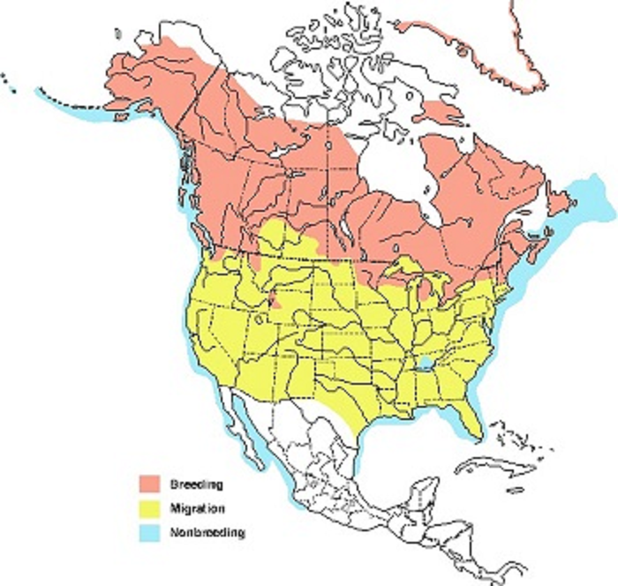
From an area of habitat point of view, the Northeastern United States has a relatively small responsibility for the species’ continued conservation. It is at the southern extreme of the climactic conditions tolerated by the loon. A continuing summer climate warming trend in North America would likely move the loon’s preferred habitat further north.
“Water level management was shown to cause 60-70% of nest failure for loons on three lakes in Voyageur’s National Park in Minnesota (Reiser 1988).” (MDIFW 2021) This statement is misleading. The report in question studied two lakes in the Voyageur’s National Park that are relatively large, with managed levels, as well as a number of smaller lakes with no level management. The two large lakes studied were Rainy Lake (Rainy) and Namakan Reservoir (Namakan). The two lakes had level management schemes that resulted in Rainy having less level fluctuation than natural, and Namakan more level fluctuation than normal. Loon breeding success was higher than normal on Rainy Lake and lower than normal on Namakan Reservoir. So technically, lake level management both increased and decreased loon nest failure in Voyageur’s National Park. Rainy had similar lake level fluctuations during the late spring and summer (the time period of concern for loons) to Green Lake. The recommendation of the cited study is “regulated water levels should peak by the first week of June and remain relatively stable through the second week of July.” (Reiser 1988)
Loons may delay nesting until fluctuating water allow access to traditional nesting sites. (Windels 2013) This aligns well with the very high spring melt runoff conditions that occur some years at Green Lake. The maximum Green Lake water level that the Project is allowed to manage to is 160.7 ft NGVD29 datum year round. The absolute minimum level is 157.5 ft during the winter, allowing a 3.2 ft range for the lake, but this is only during the parts of the year that do not affect loon nesting. From the first of June until early September (Labor Day) the minimum level the Project can manage to is 159.7 ft. Typically the lake is near 160.7 on the first of June, reflecting the effects of spring runoff on the lake.
MDIFW’s recommendation for the new license is to require the Green Lake water level be maintained with no more than 0.5 vertical feet up and 1 vertical foot down occurring within any 28-day period from 15-May through 31-July. GLWP believes this level maintenance method is impractical, and not necessarily in the best interest of the loons on Green Lake. It has the potential to drop water levels ever lower during the summer without the possibility of restoring water levels when heavy rain occurs. This ignores the fact that loons attempt to use traditional nest sites again. Dropping the lake without restoring the lake level quickly when possible, could leave traditional nest sites difficult for loons to access.
GLWP consulted with MDIFW on 05-May-2021 to work out a more practical solution that would also be less risky for the loons. The opinion of the staff biologist concerned with waterfowl on the call (Danielle D’Auria) was that the only solution was as stated in the recommendations (range of +0.5/-1.0 ft during any 28 day period for the 11 week period from 15-May to 31-Jul) and that the time range could not be narrowed down more than that by considering the specifics of Green Lake. The MDIFW Environmental Review Coordinator (John Perry) suggested that other projects have recommended a fixed range to manage the lake level to during the loon nesting season.
GLWP notes that MDIFW’s statement that “water level management” is responsible for loon difficulties is, at face value, contradictory with their proposed solution: water level management. Perhaps a better statement would be that “water level mismanagement” is responsible for loon difficulties. GLWP does not believe it has been mismanaging water levels with respect to the loons.
GLWP has been operating under the current license with a range of 160.2 NGVD29 datum+/- 0.5 ft from 01-Jun through Labor Day, except for conditions beyond GLWP’s control. This summer level range has been in use on Green Lake at least since 1985, so it is likely that traditional loon nesting sites will have been established by the loons based on this range.

Bald Eagle
Bald eagles have been reported in the project area. There are two known bald eagle nests on the Green Lake shoreline. One of these nests is on an island near in the northwest section of the lake. When last monitored in 2018 this nest contained a single adult. The other nest is in the southeast region of the lake on Scott’s Neck. When last monitored in 2018 this nest contained a resident pair.
Two other nests are in the project vicinity on Graham Lake. The nearest of these is about 2 miles from the project boundary. Both of these nests contained breeding pairs when last monitored in 2018.
There is no major construction, major blasting or large tree felling expected as a result of relicensing.
Source: Arcgis.com

Proposed environmental measures

Loons
GLWP recommends the new license maintain the summer level range from the current license. For the protection of the loons, the proposed summer range is 160.2 ft NGVD29 datum plus or minus 0.5 ft from 01-June through at least 31-July.

Bald Eagle
Any minor blasting considered as an alternative for the leaching field feed piping work would be conducted during a season that minimize disturbance of eagles. All necessary permits and approvals would be obtained before work began.

Unavoidable adverse impacts

Invasive species
Operation of the Project per the current and any expected future license makes the Green Lake area more appealing for recreational and habitational uses. With the concomitant landscaping and access by people who also frequent other areas there is an increased risk of invasive wildlife species being introduced to the area. No invasive species are documented as occurring around Green Lake. Invasive species are not considered to be a problem for the Green Lake area at this time.

Maine State-listed Species

Species
The following Maine State-listed Species have been identified as potentially in the project area:
- Golden Eagle
- Northern Long-eared Bat
- Little Brown Bat
- Brook Floater Mussel
- Tidewater Mucket Mussel
- Yellow Lampmussel

Affected environment
Project operation affects the level of the water in Green Lake. Along with the effects on the littoral zone of the lake, this affects the distance from points on the shore (that may be used by nesting loons, for example) to the water in the lake. Given the small range of the summer water level fluctuations (+/- 6 inches) and the small drawdown (3.2 feet of a 55 foot littoral zone) the effects on most terrestrial resources around the lake (from such things as water table variations and accessibility of water by most wildlife species) are unlikely to be greater than effects of natural lake variations.
Project operation also affects the flows in Reeds Brook. The range of flows in the brook is similar to the natural range, but on the average project operations reduce the yearly flow down Reeds Brook, which is a cumulative affect with Hatchery water use. On a rough scale, the timing of flows will be similar to natural flows (high flows in the spring and low flows in the late summer, for example), but project operations may affect the timing and duration of such flows on a shorter timescale.

Golden Eagle
Golden eagles are traditionally associated with rugged topography and open country including rangelands, tundra and alpine areas. In Maine, golden eagles have been typically associated with mountainous areas in the western and northwestern portions of the state. Golden eagles have always been rare in Maine. Their range in Maine is shown in the following map:
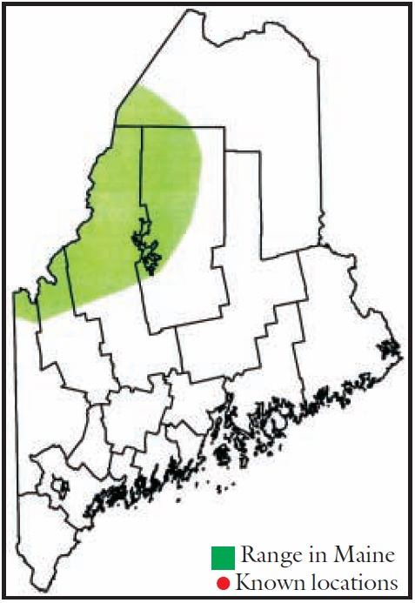
The golden eagle range in Maine is far removed from the greater project area. No known golden eagle sightings have occurred in the project area.

Northern Long-eared Bat
The northern long-eared bat is discussed in the Threatened and Endangered Species section 5.7 below.

Little Brown Bat
Little brown bats hibernate in large groups in caves and mines during the winter. During the summer they roost during the day in such places as tree hollows, wood piles, rocky outcrops, buildings, etc. They prefer to roost in places that are warm and dark. Since little brown bats eat insects, they often forage along the edges of lakes and streams. (MDIFW 2015), (Fenton 1980)
Wind turbines are listed as a high severity stressor for little brown bats. Dams/water level fluctuation are not listed as a stressor. (MDIFW 2015)
The Green Lake watershed has a relative estimated little brown bat habitat potential of 2 on a 1-7 scale:
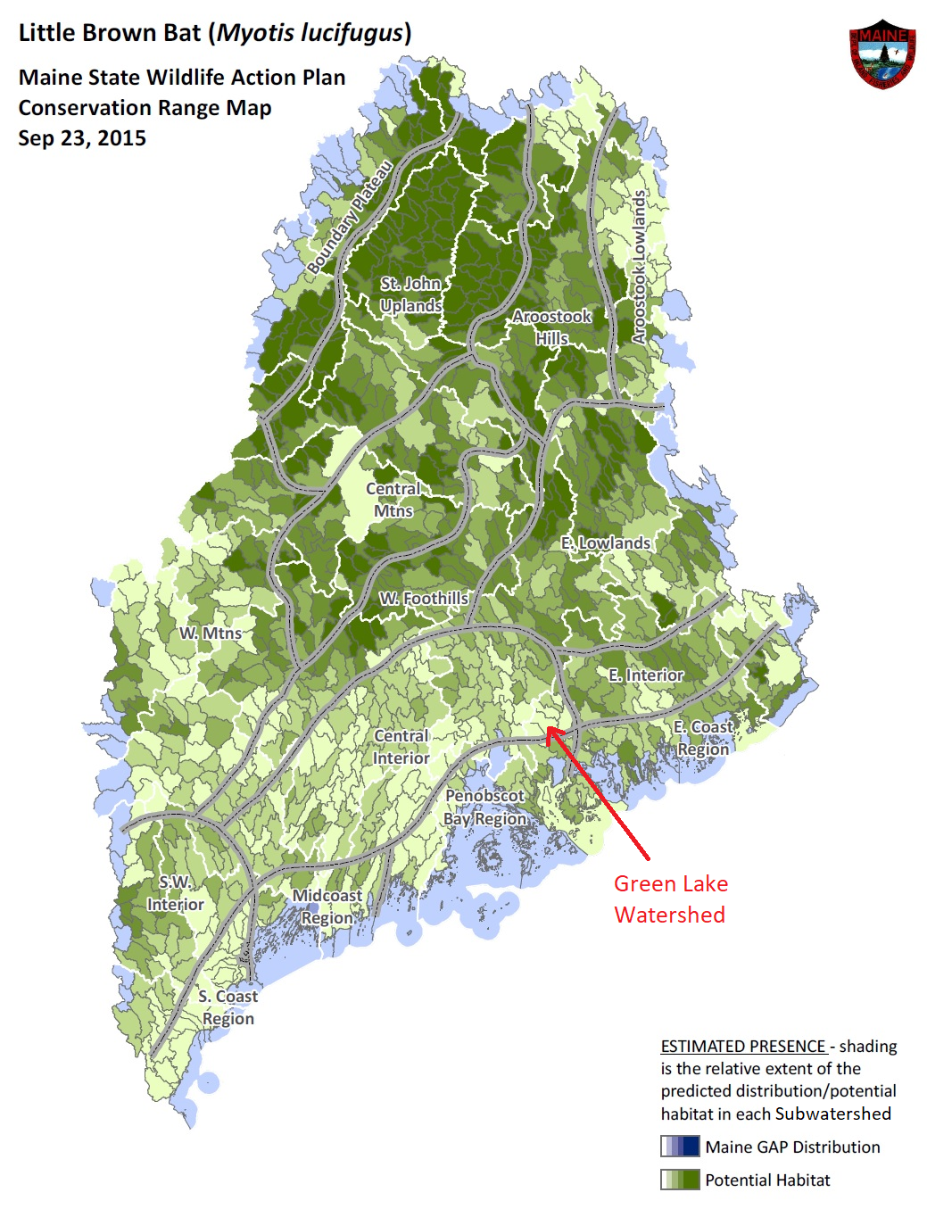
(MDIFW 2015), GLWP modified: legend “Town” to “Subwatershed”, labeled Green Lake
By supporting clean water in the Green Lake watershed and Reeds Brook and maintaining stable water levels during the summer the Project is unlikely to adversely affect little brown bats.

Brook Floater Mussel
In Maine, the brook floater mussel’s distribution is largely concentrated in the Penobscot River drainage and several Downeast river systems, with a few scattered populations in the Kennebec, St. George and Sheepscot River watersheds. An isolated population in the Pleasant River (Cuberland Co.) is the only known occurrence in southern Maine. The Union River watershed is near the Penobscot watershed, and is commonly considered a “Downeast river system.” (MDIFW 2012)
Brook floater mussels are documented as being present in the West Branch of the Union River above Graham Lake. (DACF UpperUnion)
Brook floater mussels inhabit flowing water, from small streams to large rivers. It does not live in high-gradient streams with very fast current, nor is it usually found in slow water. It seems to prefer stable substrates such as coarse sand and gravel, and is often found in association with rooted aquatic vegetation. During part of their life cycle they burrow into the bottom, anchoring themselves with a muscular foot. (MDIFW 2012)
Green Lake, being essentially still water, would not be suitable habitat for brook floater mussels. Reeds Brook has sections that are medium or low gradient with moderate flows. The percentage of substrates that could be described as “course sand and gravel” is 11%, and this is in small pockets between cobble or boulders. The other 89% of the substrate is larger. Average flow velocities, even at higher CFS flow levels in Reeds Brook were not particularly high. Project operation has been shown to maintain good water quality in Reeds Brook. (See Study Results in section 7 below)
Reeds Brook offers some habitat for brook floater mussels, but it does not appear to be ideal, or (on average) very acceptable habitat. With moderate flow speeds and support for good water quality in Reeds Brook, GLWP believes project operations have not, and are not expected to, adversely affect brook floater mussels or their habitat.

Tidewater Mucket Mussel
In Maine, the tidewater mucket mussel is found in the Merrymeeting Bay and the Penobscot, St. George, lower Kennebec and lower Androscoggin River watersheds. Its distribution is very similar to that of the yellow lampmussel, and they are often found together. (MDIFW 2003a)

The range of the tidewater mucket mussel in Maine is shown in the following map:
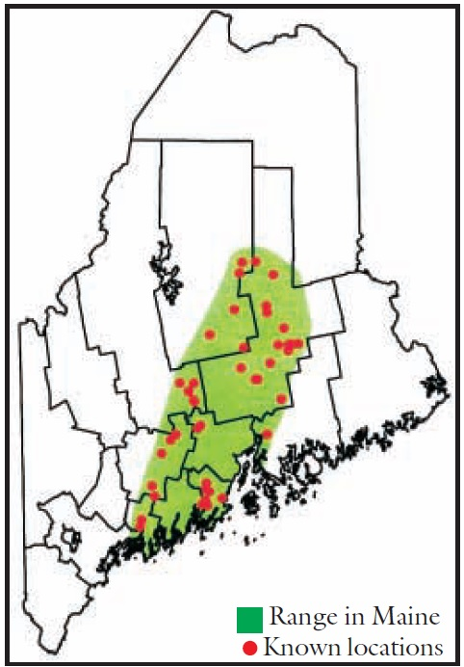
(MDIFW 2003b)
The tidewater mucket mussel range does not include any of the Green Lake watershed.

Yellow Lampmussel
In Maine, the yellow lampmussel is only known to exist in the Penobscot, St. Geore and lower Kennebec River watersheds. This species typically prefers medium to large rivers, but in Maine is often found in lakes and ponds, and will tolerate impounded sections of rivers. (MDIFW 2003b)

The range of the yellow lampmussel in Maine is shown in the following map:
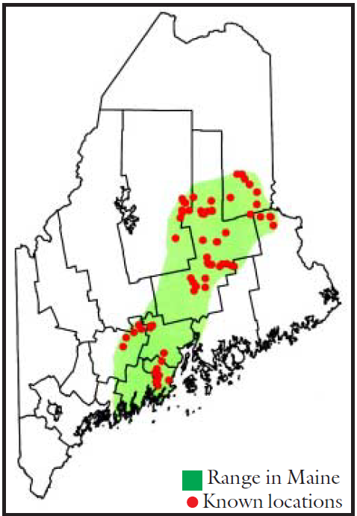
(MDIFW 2003b)
The yellow lampmussel range does not include any of the Green Lake watershed.

Proposed environmental measures
No changes are proposed for Maine state listed species.

Threatened and Endangered Species

Threatened and Endangered Wildlife Resources and Habitats
The Endangered Species Act (ESA) was passed in 1973 to protect those animals and plants and associated habitats that are in danger of becoming extinct. The USFWS classifies animals and plants into two categories: "endangered species" are in danger of extinction throughout the area in which they are usually found and "threatened species" are those that could become endangered in the near future. The bald eagle was removed from the ESA list on June 28, 2007. However, bald eagles remain federally protected under the Bald and Golden Eagle Protection Act of 1940 and the Migratory Bird Treaty Act.
Wildlife species in Maine may also be protected under the Maine Endangered Species Act (MESA) like the ESA. Depending on their level of vulnerability to extinction, species may be listed as Endangered or Threatened. Under MESA, a species may also be identified as Special Concern if it does not meet the criteria of endangered or threatened but is particularly vulnerable and could easily become threatened, or is suspected to be endangered or threatened but for which insufficient data exists (MDIFW, 2009).
MESA includes the designation and protection of Essential Habitats, which are defined as “areas currently or historically providing physical or biological features essential to the conservation of endangered or threatened species in Maine and which may require species management considerations” (MDIFW, 2009). The Natural Resources Protection Act (NRPA) provides protection to certain natural resources including Significant Wildlife Habitats and is administered by the MDEP.
The USFWS has identified one fish and one bat as listed on the federal endangered species list (USDOI, 2018) within the Project Area: Atlantic salmon and northern long eared bat
(Table 5-10).
Table 5-10 – Federally Listed Endangered or Threatened Wildlife Species Documented as Occurring in The Project Area
Common Name | Scientific Name | Federal Status
Atlantic salmon | Salmo salar | Endangered
Northern long-eared bat | Myotis septentrionalis | Threatened
Rusty patched bumble bee | Bombus affinis | Endangered
Source: USDOI, 2018
A review of the Maine list of threatened and endangered species was completed. Based on the available habitat and ranges of the species listed, there are five Maine state listed species identified as potentially occurring within the Project. In addition, there are eighteen species listed as Species of Special Concern that may occur in the Project (Table 5-11) (MDIFW, 2019).
Table 5-11 – Endangered, Threatened, and Species of Special Concern that May Occur in the Project or in the Project Vicinity
Species Common Name | Endangered | Threatened | Special Concern
Amphibian
Blue-spotted salamander |  |  | X
Northern leopard frog |  |  | X
Bird
Great blue heron |  |  | X
Bald eagle |  |  | X
Northern Harrier |  |  | X
Barn owl |  |  | X
Whip-poor-will |  |  | X
Barn swallow |  |  | X
Northern rough-winged swallow |  |  | X
Veery |  |  | X
Rusty blackbird |  |  | X
Fish
American eel |  |  | X
Mammal
Little brown bat | X
Northern long-eared bat | X |  | X
Red bat |  |  | X
Hoary bat |  |  | X
Silver-haired bat |  |  | X
Eastern pipistrelle |  |  | X
Reptile
Northern ribbon snake |  |  | X
Mussel
Brook floater |  | X
Tidewater mucket |  | X
Yellow lampmussel |  | X
Source: MDIFW, 2019

Threatened and Endangered Wildlife Species Distribution and Life History information
Atlantic Salmon
Species Description and Listing
Atlantic salmon are an anadromous fish species with a complex life history. Individuals spend most of their adult life in marine environments but return to freshwater rivers and streams to spawn (Fay et al., 2006). Atlantic salmon are native to the North Atlantic Ocean and have been found worldwide as far south as Portugal in the eastern Atlantic and the Connecticut and Housatonic Rivers in the western Atlantic, and north to Ungava Bay in Quebec as well as the Nastapoka River in Hudson Bay (Morin, 1991). Atlantic salmon were initially listed as endangered on November 17, 2000, on eight coastal Maine watersheds by the NMFS and the USFWS (65 FR 69459). NMFS and the USFWS expanded the listing to include Atlantic salmon that inhabit large Maine rivers (Androscoggin, Kennebec, and Penobscot) that were partially or wholly excluded in the initial listing (74 FR 29344; June 19, 2009). NMFS determined that Atlantic salmon that inhabit the Gulf of Maine watersheds from the Androscoggin River eastward to the Dennys River are a distinct population segment (i.e., GOM DPS) and thus should be listed as a “species.”
Currently, the GOM DPS includes Atlantic salmon that occupy freshwater from the Androscoggin River to the Dennys River, as well as anywhere Atlantic salmon occur in the estuarine and marine environments. The historical upstream limits of the species’ freshwater range are primarily determined by impassable falls in the Penobscot River watershed, including Big Niagara Falls on Nesowadnehunk Stream in Township 3 Range 10 (91.2 miles north of the project), Grand Pitch Falls on Webster Brook in Trout Brook Township (100 miles northwest of the project), and Grand Falls on the Passadumkeag River (38 miles north of the project) (74 FR 29344; June 19, 2009). Additionally, conservation hatchery populations maintained by Green Lake National Fish Hatchery and Craig Brook National Fish Hatchery are included in the GOM DPS. Landlocked and commercially raised salmon are excluded from the listing (74 FR 29344; June 19, 2009).

Life History of the Atlantic Salmon
Anadromous Atlantic salmon go through several distinct phases which are accompanied by changes in behavior, physiology, morphology, and habitat requirements. While spawning by adult Atlantic salmon does not occur until fall, upstream migration begins in the spring. In Maine, most Atlantic salmon begin to ascend rivers from May to mid-July, but migration may continue until the fall (Meister, 1958). As soon as fish enter freshwater, they stop feeding and darken in coloration. Salmon that return in the early spring may spend up to 5 months in the river before spawning. These fish spend the summer months in cool water refuges such as deep pools, springs, and mouths of cold-water tributaries (Fay et al. 2006). In either the fall or the following spring, post-spawned adults (i.e., “kelts”) migrate downstream after spawning and resume feeding once reaching the marine environment. A small percentage may return to spawn 1 to 2 years later.
Spawning typically takes place from late October through November when water temperatures are around 7°C to 10°C (45°F to 50°F). Preferred spawning sites consist of gravel substrate within flowing water (Peterson, 1978), with water depth ranging from 30 to 61 centimeters (11.8 to 24 inches) and water velocities averaging 60 centimeters a second (2.0 feet a second) (Beland, 1984). Eggs are deposited in a series of nests (i.e., redds) scoured from the gravel by the female. As they are deposited in the redd, one or more males will fertilize the eggs. A returning female can produce approximately 7,500 eggs (Fay et al., 2006).
In late March or April, salmon eggs hatch as alevin (or sac fry). Alevin remain in the redd for approximately 6 weeks nourished by their yolk sac. In mid-May, alevins emerge from the gravel and begin to actively feed, at which point they are called fry. Salmon fry enter the parr stage within days of emerging. This stage is indicated by vertical bars (i.e., “parr marks”) which appear on their sides. Sites preferred by parr include areas with sufficient cover, water depths from roughly 10 to 60 centimeters (4.0 to 23.6 inches), water velocities between 30 and 92 centimeters a second (0.9 to 3.0 feet a second), and water temperatures around 16°C (60.8°F) (Fay et al. 2006). The diet of juvenile salmon includes aquatic invertebrates such as the larvae of mayflies, stoneflies, chironomids, caddisflies, aquatic annelids, and mollusks, as well as a variety of terrestrial invertebrates that fall into the river (Fay et al. 2006). In the fall, parr will seek shelter in the substrate as water flows increase and temperature and day length decrease (Fay et al., 2006).
Parr will remain in freshwater for 1 to 3 years before undergoing smoltification, which is a series of physiological, morphological, and behavioral changes that prepare the salmon to move from freshwater to marine environments. In the Penobscot River watershed, smolts migrate back to the marine environment between late April and early June with a peak movement in early May (Fay et al., 2006). After returning to sea, Atlantic salmon commence long migrations from their natal rivers. During this time, Atlantic salmon experience a period of rapid growth. Once they reach maturity, they return to their natal river (Fay et al., 2006). Atlantic salmon may spend up to 3 years in the marine environment before returning to their natal freshwater streams to spawn (Fay et al., 2006).

Status and Trends of Atlantic Salmon in the Gulf of Maine Distinct Population Segment
The overall abundance of Atlantic salmon has been declining since the 1800s (Fay et al., 2006). Although comprehensive data on adult abundance are not available until after 1967, current abundance levels of Atlantic salmon are significantly lower than historical estimates Whereas Foster and Adkins (1869) estimated that approximately 100,000 adult Atlantic salmon returned to the Penobscot Rivers historically, since 1967 it has been uncommon for adult returns for the entire Gulf of Maine DPS to exceed 5,000 individuals (Fay et al., 2006, USASAC, 2014). Adult returns have remained low since 2011; only 376 individuals returned to the Gulf of Maine area in 2014, a 24 percent decrease from 2013 (USASAC, 2014). In 2016, 626 adult salmon returned to USA rivers; of these, 616 returned to the Gulf of Maine (USASAC, 2017).
Figure 5-8 – Estimated Total Returns to New England for Outer Bay of Fundy (OBF), GOM DPS, Central New England Complex (CNE), and Long Island Sound (LIS) Complex from 1967 to 2014
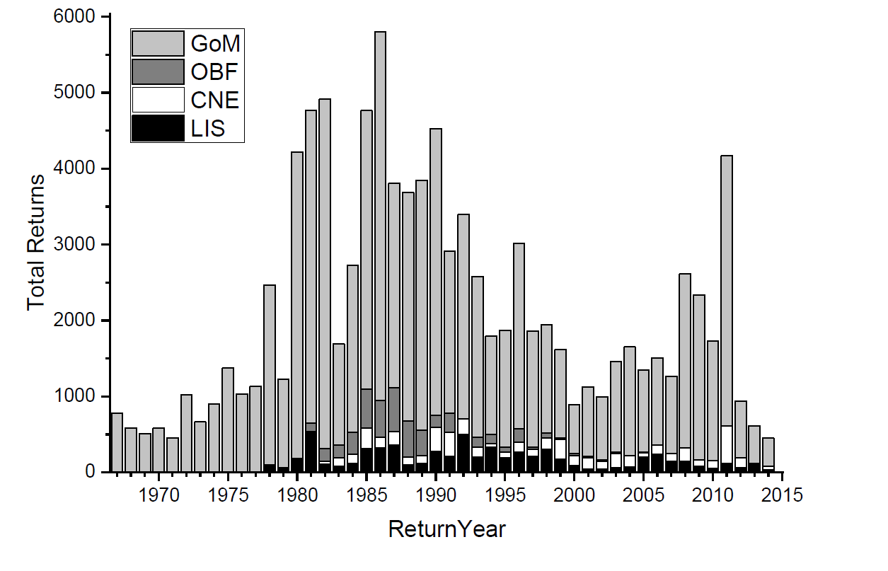

Critical Habitat for Atlantic Salmon in the Gulf of Maine Distinct Population Segment
Section (5)(A) of the Endangered Species Act defines “critical habitat’’ for a threatened or endangered species as:
(i) the specific areas within the geographical area occupied by the species, at the time it is listed in accordance with the provisions of section 4 of this Act, on which are found those physical or biological features (I) essential to the conservation of the species and (II) which may require special management considerations or protection; and (ii) specific areas outside the geographical area occupied by the species at the time it is listed in accordance with the provisions of section 4 of this Act, upon a determination by the Secretary that such areas are essential for the conservation of the species.
Coincident with the June 19, 2009, Atlantic salmon listing, NMFS designated critical (74 FR 29300; June 19, 2009). The final rule was revised on August 10, 2009, (74 FR 39003; August 10, 2009) in which designated critical habitat for the Atlantic salmon was revised to exclude trust and fee holdings of the Penobscot Indian Nation. Reeds Brook is not classified as critical habitat for species recovery (74 FR 29300; June 19, 2009).
In its stakeholder response, the National marine Fisheries Service said “Green Lake … occurs within the designated critical habitat for [Atlantic salmon].” (emphasis added) (Appendix B)
In its application for relicensing the Ellsworth Project, Black Bear discusses the Gulf of Maine Distinct Population Segment of Atlantic salmon, and notes the area included for all naturally reproducing Atlantic salmon populations includes the Union River, of which Graham Lake is a part. (Green Lake and Reeds Brook are upstream of Graham Lake.) That document notes: “[t]he Ellsworth Project falls within the designated critical habitat of the Downeast Coastal Salmon Habitat Recovery Unit for Atlantic salmon (NMFS 2009; Sean McDermott, NMFS, personal communication July 2, 2014).” (emphasis added) (Black Bear, 2015).
Based on these documents, GLWP believes Green Lake, if connected downstream through a perennial stream, would be classified as critical habitat rather than essential habitat for Atlantic salmon. Green Lake is connected through Reeds Brook, an intermittent stream. An important part of this critical habitat is the Green Lake National Fish Hatchery and its water supply.
Northern Long-Eared Bat
The northern long-eared bat (NLEB) is listed as a federally threatened species and is listed as Endangered at the state level. The NLEB was listed as threatened on April 2, 2015, with a final rule published in the Federal Register on January 14, 2016. On April 27, 2016, the USFWS determined that the designation of critical habitat for the species was not prudent; therefore, no critical habitat is established for the NLEB (USFWS, 2018).
The northern long-eared bat feeds on invertebrates and is known to glean prey from vegetation and water surfaces. The NLEB winters in underground caves and cave like structures, but summers singly or in small colonies in cavities, under bark, or in hollows of live and dead trees typically, greater than 3 in. in diameter. Suitable roosting trees also include exfoliating bark, cavities, or cracks (USFWS, 2018).
Since the discovery of White-nose Syndrome (WNS) in 2006 in northeastern United States NLEB populations have experienced die-offs of greater than 90 percent. Specific population decline information for NLEB in Maine is lacking, however, WNS is present in neighboring states. It is predicted that WNS could extirpate cave and mine hibernating bats from the northeastern United States.
While the Project falls within the range of the NLEB it is unlikely that the overwintering or summer roosting occurs with the Project, although feeding may occur over the impoundment.

State Species
Little Brown Bat
The little brown bat (LBB) is listed as state endangered. The LBB was state listed in 2015 based on their decline in Maine and throughout their range in the United States. The LBB is part of Maine’s Wildlife Action Plan, which looks at many rare or poorly known species and charts a path for their conservation.
The LBB feeds on feeds on invertebrates such as flying insects, especially mosquitoes, midges, caddisflies, and smaller beetles. This species a member of the cave bats and hibernates (winters) in underground caves or cave like structures, which include tunnels, abandoned mines, and building with a steady temperature of about 2-12 C. Maternity colonies commonly are in warm sites in buildings (e.g., attics) and other structures; also, infrequently in hollow trees (NatureServe, 2017a).
Since the discovery of White-nose Syndrome (WNS) in 2006 in northeastern United States LBB populations have experienced die-offs of greater than 90 percent. Specific population decline information for LBB in Maine is lacking, however, WNS is present in neighboring states. It is predicted that WNS could extirpate cave and mine hibernating bats from the northeastern United States.
While the Project falls within the range of the LBB it is unlikely that the overwintering occurs within the Project, although feeding may occur over the impoundment.

Brook Floater
The Brook Floater is listed as threatened under Maine’s Endangered Species Act. The brook floater is found in creeks and small rivers where it is found among rocks in gravel substrates and in sandy shoals, the brook floater inhabits flowing-water habitats only. It occurs in running water and although typically found in riffles and moderate rapids with sandy shoals or riffles with gravel bottoms, it can also be found in a range of flow conditions (NatureServe, 2017b).
Although little is known about the feeding habitats of the species, stomach content analysis indicates freshwater mussels generally feed on mud, desmids, diatoms, rotifers, flagellates, and other unicellular organisms (NatureServe, 2017b).
Glochidia (larval form) of freshwater mussels are typically parasitic on fish. Historically in Maine, the species may have used the Atlantic salmon as a host species to transport larva. The brook floater is a long-term brooder. Like most species of freshwater mussels, the brook floater is long-lived and can live between 30 to 70 years (NatureServe, 2017b).
Tidewater Mucket
The tidewater mucket (TWM) is listed as threatened under Maine’s Endangered Species Act. The TWM inhabits ponds, canals, and slow-moving sections of rivers; including artificial impoundments, using substrates such as silt, sand, gravel, cobble, and occasionally clay (NatureServe, 2017c).
This species is a long-term brooder as eggs are fertilized in late summer and glochidia are released the following spring. The only confirmed fish host for this species is white perch (NatureServe, 2017c).
Yellow Lampmussel
The yellow lampmussel (YLM) is listed as threatened under Maine’s Endangered Species Act. The YLM occurs in larger streams and rivers, typically found in sand and gravel where good current exists, but has also been seen to inhabit ponds in northern portions of range, but generally prefers flowing water (NatureServe, 2017d).
Dispersal of the species occurs with the glochidia attaching its self to the host fish. Adult mussels may have passive movement downstream (NatureServe, 2017d). Glochidia of the YLM are parasitic on fish while the adult mussels are filter filters.
This species is a long-term brooder where eggs are fertilized in late summer and glochidia are released the following spring (Nedeau et al., 2000).

Threatened and Endangered Botanical Resources and Habitats
On the USFWS list of threatened, endangered, candidate and proposed species in Maine, no plant species are documented as occurring within Hancock County. (USFWS, 2017)
We believe there are no known state-listed plant species within the Project Boundary. (MDIFW, 2003)

Threatened and Endangered Botanical Species Distribution and Life History information
There are no federally or state listed threatened or endangered botanical species anticipated to occur in proximity of the Project.

Affected environment
The Green Lake dam affects the lake level of Green Lake and the flow in Reeds Brook. The dam also has fish screens to avoid passage of most fish and to stop turbine entrainment of large fish.
Project operation also affects the Green Lake National Fish Hatchery in a positive way.

Environmental analysis

Atlantic salmon
Atlantic salmon are native to Green Lake. Atlantic salmon potentially have fish passage into Graham Lake (if fish trapped at the Ellsworth dam are released in the southern end of Graham Lake and not kept as brood stock or released in the Union River above Graham Lake.)
With the current return rates for Atlantic salmon in the Union River, if returning salmon were released into southern Graham Lake and swam to the upper Union River and Reeds Brook proportionally to the drainage area, fewer than one Atlantic salmon in 20 years would swim up Reeds Brook.
Upstream fish passage at the Green Lake dam, if possible, would risk allowing invasive species and warm water fish from Graham Lake into Green Lake, a cold water lake. Some species, such as largemouth bass, are likely to over-compete with existing fisheries in Green Lake. Green Lake has been a largely landlocked lake for many years. The existing fisheries have likely adapted to that environment.
Per US FWS, fish passage downstream requires at least 25 cfs and upstream fishway requires at least 40 cfs. The Green Lake National Fish Hatchery has priority use of up to 30 cfs from Green Lake. During the summer they typically use much less than this, but most summers with their actual use, the release of 1 cfs minimum flow in Reeds Brook, and no generation, the Project has a water deficit in the lake (the lake level drops). Details on this are in GLWP’s Comments and Information Regarding NMFS Study Dispute. (GLWP 2020)
Any discussion of Atlantic salmon at the Green Lake project must consider cumulative effects with the Green Lake National Fish Hatchery (Hatchery). The Green Lake project is beneficial to the Hatchery. The Hatchery requires the Green Lake dam for a reliable supply of high quality water. Without the lake level rise caused by the dam, the Hatchery intake pipes would not be able to flow sufficient water to meet their needs. Also, a penstock tap provides the Hatchery with a reliable supply of warm, oxygenated surface water during seasons when that is beneficial.
Because of pressure changes in the penstock when the turbine is running, turbine startups have been coordinated between GLWP and the Hatchery. Also, normal penstock patching cannot be performed when the Hatchery is using the penstock tap in the summer. This routine maintenance work has been deferred until the fall. These Project activities involve expense and inconvenience for GLWP, but they have been undertaken voluntarily as part of supporting the Hatchery and its mission to protect and restore Atlantic salmon. As Project routine maintenance requirements have increased, this method of operation has become less practical.

Northern long-eared bat
Northern long-eared bats hibernate in large groups in caves and mines during the winter. During the spring and summer they spend the day roosting in trees and artificial structures, switching roosts every other day on average. Roost trees tend to be close together and within 2000 ft of forage areas. They are well suited to foraging in the forest interior on a diet focused on moths, but they also eat beetles, flies and other insects. They forage under the forest canopy or at the edge of forests. (MDIFW 2015b), (Foster 1999)

Wind turbines are listed as a high severity stressor for little brown bats. Dams/water level fluctuation are not listed as a stressor. (MDIFW 2015)
The Green Lake watershed has a relative estimated northern long-eared bat habitat potential of 2 on a 1-7 scale: (MDIFW 2015b)
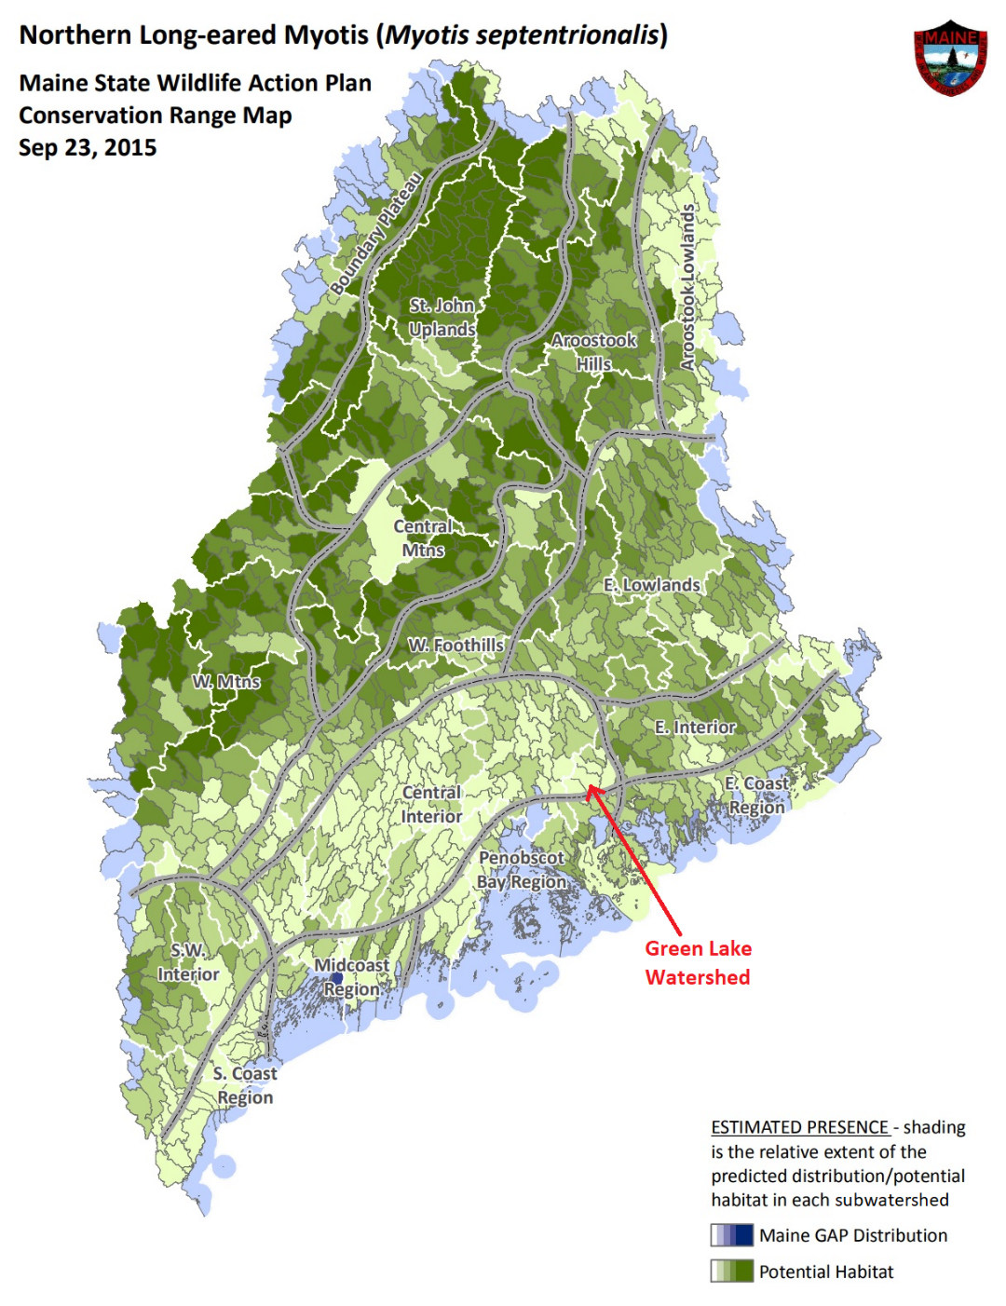
GLWP modified: legend “Town” to “Subwatershed”, labeled Green Lake
By supporting clean water in the Green Lake watershed and Reeds Brook and maintaining stable water levels during the summer the Project is unlikely to adversely affect northern long-eared bats.

Proposed environmental measures

Atlantic salmon
No changes are proposed for Atlantic salmon.

Northern long-eared bat
No changes are proposed for northern long-eared bats.

Unavoidable adverse impacts
No unavoidable adverse impacts are expected for threatened and endangered species.

References
Beland, K. F. 1984. Strategic plan for management of Atlantic salmon in the state of Maine. Atlantic Sea Run Salmon Commission. Bangor, ME. 92 pp.
Black Bear 2015 – Black Bear Hydro Partners LLC. 2015. Ellsworth Hydroelectric Project FERC No. 2727-092, Application for a New License for Major Water Power Project – Existing Dam. [Online] URL: https://elibrary.ferc.gov/idmws/common/opennat.asp?fileID=14086043. Accessed March 27, 2019.
Fay, C., M. Bartron, S. Craig, A. Hecht, J. Pruden, R. Saunders, T. Sheehan, and J. Trial. 2006. Status review for anadromous Atlantic salmon (Salmo salar) in the United States. Report to the National Marine Fisheries Service and U.S. Fish and Wildlife Service. 294 pages.
Foster, N.W. and C.G. Atkins. 1869. Second report of the Commissioners of Fisheries of the state of Maine 1868. Owen and Nash, Printers to the State, Augusta, ME.
MDIFW. 2003. – Maine Department of Inland Fisheries and Wildlife - Map 2 – Plant and Animal Habitats: Maine State Listed Plants layer. [Online] URL: https://webapps2.cgis-solutions.com/beginningwithhabitat/map2/ . Accessed March 27, 2019.
MDIFW. 2009. Maine Endangered and Threatened Species Listing Handbook. [Online] URL: https://www.maine.gov/ifw/docs/listingHandbook.pdf. Accessed May 21, 2018.
MDIFW. 2019. Species of Special Concern. [Online] URL: https://www.maine.gov/ifw/fish-wildlife/wildlife/endangered-threatened-species/listed-species.html. Accessed March 18, 2019.
Meister, A.L. 1958. The Atlantic Salmon (Salmo salar) of Cove Brook, Winterport, Maine. M.S. Thesis. University of Maine. Orono, ME. 151pp.
Morin, R. 1991. Atlantic salmon (Salmo salar) in the lower Nastapoka River, Quebec: distribution and origins of salmon in eastern Hudson Bay. Canadian Journal of Zoology 69:1674-1681
Peterson, R.H. 1978. Physical characteristics of Atlantic salmon spawning gravel in some New Brunswick streams. Fisheries and Marine Service Technical Report 785. Fisheries and Environment, Canada, Fisheries and Marine Service. Biological Station, St. Andrews, NB.
NatureServe Explorer (NatureServe). 2017a. Little Brown Bat. [Online] http://explorer.natureserve.org/servlet/NatureServe?sourceTemplate=tabular_report.wmt&loadTemplate=species_RptComprehensive.wmt&selectedReport=RptComprehensive.wmt&summaryView=tabular_report.wmt&elKey=100473&paging=home&save=true&startIndex=1&nextStartIndex=1&reset=false&offPageSelectedElKey=105810&offPageSelectedElType=species&offPageYesNo=true&post_processes=&radiobutton=radiobutton&selectedIndexes=105810&selectedIndexes=100473. Accessed May 21, 2018.
NatureServe Explorer (NatureServe). 2017b. Brook Floater. [Online] http://explorer.natureserve.org/servlet/NatureServe?sourceTemplate=tabular_report.wmt&loadTemplate=species_RptComprehensive.wmt&selectedReport=RptComprehensive.wmt&summaryView=tabular_report.wmt&elKey=111437&paging=home&save=true&startIndex=1&nextStartIndex=1&reset=false&offPageSelectedElKey=111437&offPageSelectedElType=species&offPageYesNo=true&post_processes=&radiobutton=radiobutton&selectedIndexes=111437. Accessed May 21, 2018.
NatureServe Explorer (NatureServe). 2017c. Tidewater Mucket. [Online] http://explorer.natureserve.org/servlet/NatureServe?sourceTemplate=tabular_report.wmt&loadTemplate=species_RptComprehensive.wmt&selectedReport=RptComprehensive.wmt&summaryView=tabular_report.wmt&elKey=114703&paging=home&save=true&startIndex=1&nextStartIndex=1&reset=false&offPageSelectedElKey=114703&offPageSelectedElType=species&offPageYesNo=true&post_processes=&radiobutton=radiobutton&selectedIndexes=114703. Accessed May 21, 2018.
NatureServe Explorer (NatureServe). 2017d. Yellow Lampmussel. [Online] http://explorer.natureserve.org/servlet/NatureServe?sourceTemplate=tabular_report.wmt&loadTemplate=species_RptComprehensive.wmt&selectedReport=RptComprehensive.wmt&summaryView=tabular_report.wmt&elKey=109623&paging=home&save=true&startIndex=1&nextStartIndex=1&reset=false&offPageSelectedElKey=109623&offPageSelectedElType=species&offPageYesNo=true&post_processes=&radiobutton=radiobutton&selectedIndexes=109623. Accessed May 21, 2018.
Nedeau, J., McCollough, M.A., and Swartz, B. 2000. The Freshwater Mussels of Maine. Maine Department of Inland Fisheries and Wildlife, Augusta. 118 pp.
U.S. Atlantic salmon assessment committee (USASAC). 2014. Annual report of the U.S. Atlantic salmon assessment committee: Report No. 26 – 2013 Activities. Old Lyme, CT.
U.S. Department of the Interior. (USDOI). 2018. Fish and Wildlife Office. Maine Ecological Services Field Office. List of threatened and endangered species that may occur in your proposed project location, and/or may be affected by your proposed project. May 21, 2018.
U.S. Fish and Wildlife Service (USFWS). 2017. ECOS Environmental Conservation Online System. Listed species believed to or known to occur in Maine. [Online] URL: https://ecos.fws.gov/ecp0/reports/species-listed-by-state-report?state=ME&status=listed . Accessed March 27, 2019.
USFWS. 2018a. Species Profile: Northern Long-Eared Bat (Myotis septentrionalis). Available online at http://www.fws.gov/midwest/endangered/mammals/nlba/index.html. Accessed May 22, 2018.
USFWS. 2018b. National Wetlands Inventory. [Online] URL: https://www.fws.gov/wetlands/data/Mapper.html. Accessed March 18, 2019

Recreation, Land Use, and Aesthetic Resources

Existing Project Recreation Opportunities and Use
Green Lake provides a variety of recreational opportunities which include fishing, swimming, and boating during the warmer seasons and ice fishing in the winter. The lake’s high quality water and proximity to the cities of Bangor and Ellsworth make it an attractive area for summer use. As of 2019 approximately 50% of the shoreline is estimated to be developed with private camps and recreational facilities which include a beach and boat launch site maintained by the City of Ellsworth, two private beaches at the north end of the lake, and a tenting area on the east side. A variety of secondary roads provide access to most of the lake shore. The boat ramp was extended and improved during the fall of 2018.
There are no project-specific recreational facilities within or adjacent to the Project Boundary.
There are hiking trails at the Green Lake National Fish Hatchery.
From the Green Lake National Fish Hatchery website:
“These trails pass glacial erratics and old cellar holes and reward visitors with a bench overlooking Green Lake. A self-guided tour features information about the stocking program and a look at young salmon.”
https://www.mainetrailfinder.com/trails/trail/green-lake-national-fish-hatchery-trails
Also, the Green Lake Association contributes to the quality of the lake and recreation in the area. Their website states:
“The Green Lake Association, serving the area surrounding Green Lake in Maine, was formed for charitable, educational and scientific purposes and was officially incorporated as a non-profit organization in 2007. Its objective is to advance and protect Green Lake as a valuable and natural resource. The Association undertakes educational and informational activities that promote the best practices for lake property owners and recreational users of the lake.”
https://greenlakeme.com

Regional Recreation Opportunities
Other recreation opportunities in the area include coastal sites, Mount Desert Island including Acadia National Park and Bar Harbor, numerous lakes, streams, and ponds, and so forth.

State Recreation Areas
There are no known state recreation areas in the project vicinity.

County/Municipal Recreation Areas
The City of Ellsworth maintains a beach and boat launch site. As of 2019, the boat launch site is being improved and extended to provide improved access to the lake by boaters during periods of low water.

Recreation Needs Identified in Management Plans
2014-2019 Maine State Comprehensive Outdoor Recreation Plan
The Maine State Comprehensive Outdoor Recreation Plan (MSCORP) provides information on the supply and demand for outdoor recreation opportunities in Maine, assesses recreation issues, provides an implementation plan, as well as serves to qualify Maine for funding from the federal Land and Water Conservation Fund (LWCF) to acquire or develop lands for public outdoor recreation. There are no recommendations specific to the Green Lake Project. Recreation priorities outlined in the MSCORP that may bear relevance to the Project are (MDACF, 2015):
- To connect Mainers with the health and wellness benefits of outdoor recreation;
- To support regionally connected trail systems in less developed regions to increase access and enhance economic development;
- To connect to future tourism markets through recreation interests; and
- To increase access to and awareness of local and regional recreation opportunities through effective communication and collaboration between the public, municipal, and private landowners.

Green Lake and Reeds Brook do not appear to be part of any State Management Plan for public reserved land.

Land Uses and Management Within the Project Vicinity
See Table 5-12 in Section 5.10.1 below for land cover and land use data for the Maine Coastal Watershed, Hancock County, and the state. Based on that table, the watershed land cover is primarily forested (approximately 70%), woody wetland (approximately 12%), and scrub/shrub (approximately 7-8%).

Figure 5-9 – Green Lake Area Land Cover -- Map
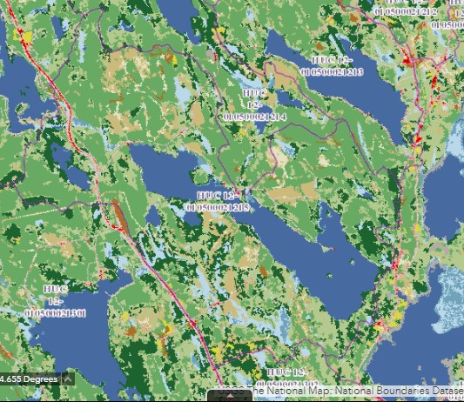
Source: USGS, 2018
Figure 5-10 – Green Lake Area Land Cover – Image
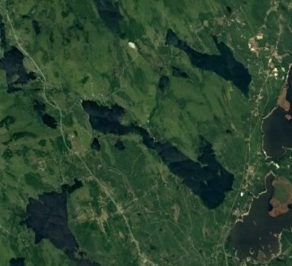
Source: Google Maps, 2018

Land Use and Management of Project Lands
Project operations and maintenance are the primary activities that occur on project lands. There are no formal public recreation facilities at the Project and access to the dam is closed to unauthorized vehicles. There is a foot path that goes near the southwest end of the dam that is maintained by the GLNFH.

Aesthetic Resources

Visual Character of the Project Vicinity
The Green Lake Project is on Green Lake in Hancock County, Maine. Green Lake is located in a rural region which provides a variety of scenic and aesthetic resources. The lake’s scenic shoreline, high quality water, and recreational opportunities attract both seasonal and year-round residents (GLWP, 1983)

Photo 5-1 – Green Lake
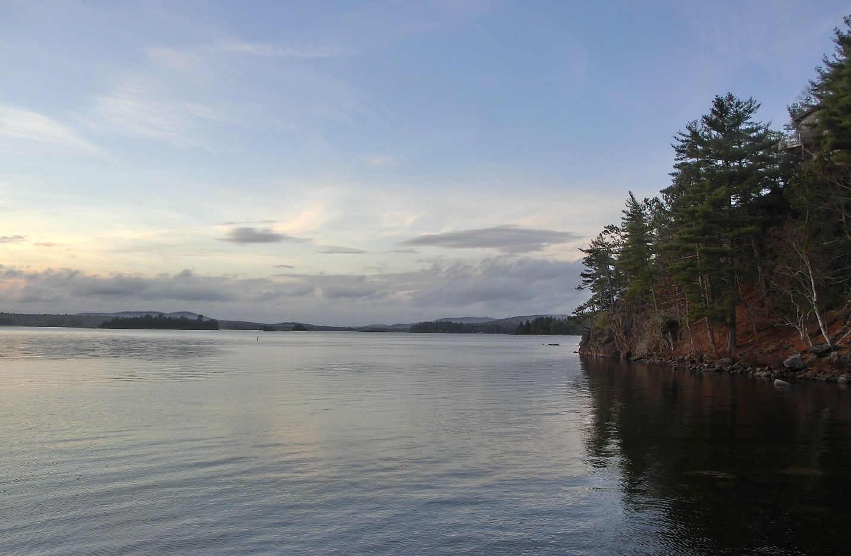

Visual Character of Project Lands and Waters
Project facilities include a 3-story powerhouse, of which only one story is visible from the access road. Green Lake is a glacially-formed lake lined with forest, woody wetland, and scrub/shrub areas. Much of the shoreline has private year-round and seasonal residences and camps.

Photo 5-2 – Green Lake
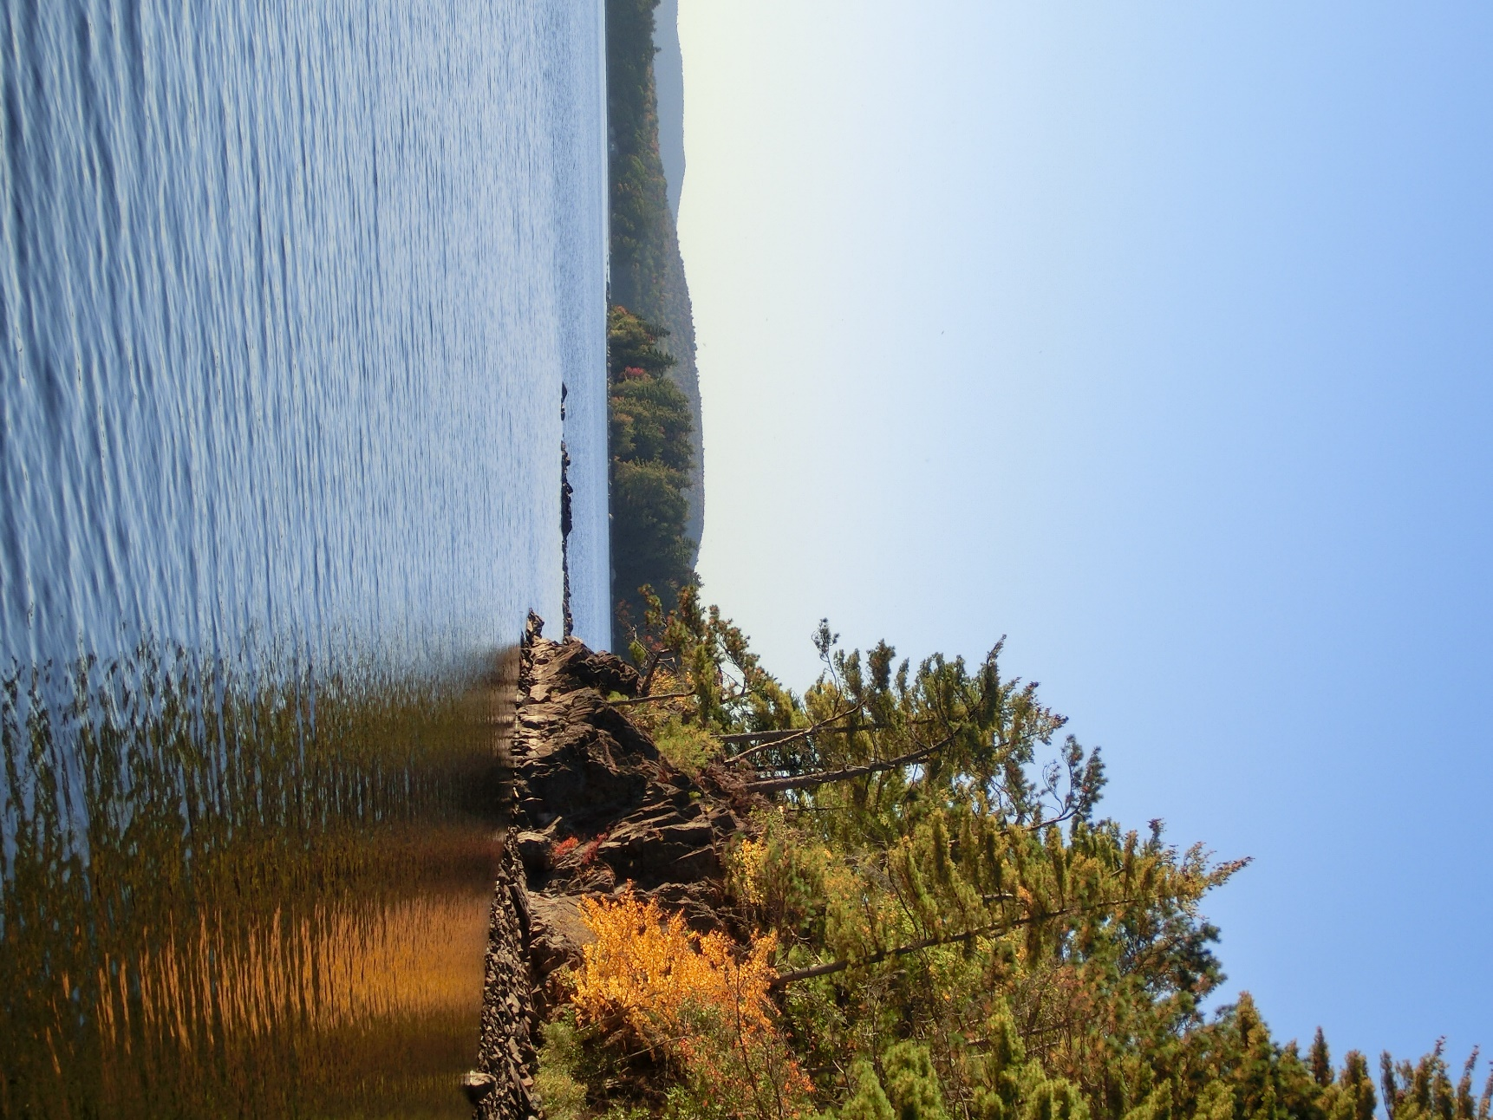

Nearby Scenic Attractions
See Sections 5.8.2 and 5.8.3 above for a description of recreational opportunities in the general area of the project.

Affected environment
The project affects the lake level in Green Lake. This affects docks, beaches and boat ramps on Green Lake.

Environmental analysis
Green Lake is a scenic, deep-water lake. It is desirable place to have a seasonal camp or year-round residence, and is popular for boating and fishing. It has a boat ramp and beach created and maintained by the City of Ellsworth on the southwest side near the middle of the lake. The boat ramp was recently extended so that it is usable at lower water levels in the fall. There is a commercial beach at the extreme northwest end of the lake and various private beaches around the lake. There are about 218 docks on the lake associated with camps and residences. Typically docks and floats are deployed in the spring and moved onto the shore, outside the reach of water and ice during the winter.
Much of the shore of Green Lake is rocky, with boulders or large cobble of varying sizes. During the 2020 study period an erosion survey was done, and no serious major or progressing erosion was found. Study results are in section 7 below.
Traditionally, other than ice fishing and other on-ice activities, recreational use of the lake has been during the summer period. The construction of year-round residences around the lake has started to change that somewhat. Depending on the weather conditions of any particular fall, residents may want to use the lake into September, and some years into October. A warming climate would further this shift.
Current project operations give priority to recreational uses of the lake during the summer. During the summer the water level is maintained within six inches of 160.2 feet NGVD29 datum. This stable water level facilitates the use of simple dock structures and increases predictability when navigating boats around rocks.
Outside the summer months, other factors are foremost in the management objectives. With concerns about dewatering fish eggs laid in the fall, the fall water level sets the minimum allowed water level until the following summer. This means that having room in Green Lake to absorb heavy spring runoff requires the lake be drawn down in the fall, and that the drawdown is completed before the fish in question spawn. As covered above in Sections 5.4.5.4 and 5.4.6.4, the fall/winter/spring maximum drawdown level alone is sufficient to protect fish eggs in Green Lake. The fall drawdown timing restrictions should be removed.
Another issue affecting lake residents as more permanent dock structures are built around the lake is ice. The maximum drawdown allowed by the Project is 2.2 feet below the summer range. During a heavy ice year with ice motion this is not enough of a height buffer to guarantee that structures that are near or under water in the summer will be protected from ice. It is not uncommon to have 2.5 feet of ice on some parts of the lake. When this ice is floating it rises about 3 inches above the water level, but pushed against the shore by wind it will rise 30 inches above the bottom.
The weather in the Ellsworth area is affected by the ocean more than non-coastal areas of central Maine. Some winters have thaws throughout the winter that keep an appreciable snowpack from forming. These winters may have cold dry spells that build significant ice on the lake as well. Without a snowpack to refill the lake in the spring, the lake must be kept reasonably full during the winter to avoid the lake level being too low during the following summer. These winters have the combined problem of higher than is considered “normal” water levels plus reasonably thick ice.

Proposed environmental measures
As covered above in Sections 5.4.5.4 and 5.4.6.4 above, some of the fall/winter/spring drawdown restrictions are now known not to be needed. GLWP proposes they be removed to benefit Green Lake recreational users and adjacent landowners, and the Hatchery.

Unavoidable adverse impacts
Water level fluctuations, waves and ice conditions are inherent in the lake, whether the lake level is managed or not.

Cultural resources

History of the Project Vicinity
The State of Maine’s cultural history began during the Paleo-Indian Period around 11,500 years before present. Before contact, about 20,000 Indians lived in Maine. As the "People of the Dawn," they shared language, culture, and ancestry with the larger Wabanaki confederation across New England and eastern Canada. The Ellsworth area was originally inhabited by members of the Passamaquoddy and Penobscot tribes. (MHO 2010a, Wikipedia 2019).
The first documented European visitor to Maine was Florentine seafarer Giovanni da Verrazano (~1485-1528), who came from France in search of gold. In the 1600’s Pierre Du Gua, Sieur de Monts, and French Royal Geographer Samuel de Champlain established a colony on a small island at the mouth of a river they named St. Croix, at Passamaquoddy Bay (MHO 2010a).
The Penobscot River was used to explore the Maine lands during which time the explorers created a friendship with the Abenaki sagamore Bessabez (or Bashaba). (MHO 2010a).
In the 1700s inland towns became anchored to water sources. As millwrights gained economic footing, water power sites, attracted general stores, public houses, warehouses, distilleries, foundries, blacksmith shops, carding and fulling mills, spinning factories, or gristmills, and substantial towns formed. Around 1763 a party of English settled in the Union River area. They intended to build dams and sawmills to exploit the area’s timber and water power. In the latter part of the 1700’s ship building became a significant industry on the Union River. (MHO 2010b, Wikipedia 2019).
In the second half of the 1800s the lumber, leather, granite, ice, slate, fish, and lime industries still supported more than 40 percent of Maine's working population at the end of the century (MHO 2010c).
Between 1880 and 1900 some 40 mills were built in Maine to take advantage of the water resource, sustaining one of the most active periods of industrial expansion in Maine's history. This growth of mills moved the industries to the water, building new industrial centers in small towns and wilderness regions in the upper Androscoggin, Kennebec, and Penobscot River Basins (MHO 2010c).
Without access to cheap coal for steam power, hydroelectric power transmission promised to overcome these barriers. The hundreds of waterpower sites in upland Maine effectively placed a ceiling on development in the late 1800s monopolizing the energy by the rivers (MHO 2010c).
Before World War II, Maine hosted some 37 pulp and paper mills, 80 textile mills, and 11 large tanneries. The resulting pollution and related impacts to public health triggered the motion of river authorities, boards and other pollution control networks, and eventually contributed toward development of the federal Water Quality Act of 1965 (MHO 2010d).
The effort to restore migratory fish received a boost in 1997 when the Edwards Dam in Augusta became the first in history to have its license renewal refused by the Federal Energy Regulatory Commission, because its environmental costs outweighed its economic benefits. After the dam was removed, subsequent years saw dramatic increases in sea-run and resident fish and in osprey, bald eagles, heron, cormorants, and kingfishers (MHO 2010e).
A similar restoration project on the Penobscot River was undertaken with the Penobscot Indian Nation, American Rivers, Maine Audubon, Natural Resources Council of Maine, and Trout Unlimited to form the Penobscot River Restoration Trust in 2005. The migratory fish restoration project, like other aspects of Maine's environmental movement, reflected a strong commitment to forging ahead economically while preserving the best of Maine's past (MHO 2010e).
Hydropower continues to play an important role in electricity generation in the state. Maine produces more hydropower per capita than any other state east of the Mississippi (U.S. Energy Information Administration, 2013). Based on data derived from the U.S. Energy Information Administration, Form EIA-923, "Power Plant Operations Report" in 2012 hydroelectric generation was estimated at approximately 3,732 GWh, or 26% of the total energy generated in Maine. (Kleinschmidt, 2015)

Identification Of Historic And Archaeological Site In The Project Vicinity
No sites listed on the National Register of Historic Places are located within the Project boundary or within 2.5 miles of the project boundary (NPS, 2014).

Prior Cultural Resource Investigations
In 2011 a phase I survey was completed of the Nevells Shore Subdivision project by the Northeast Archaeology Research Center, Inc. No Native American or historic Euroamerican cultural material was recovered during this work. On the basis of the negative results of the survey, it is unlikely that significant Native American sites are present in the project and no further archaeological work is recommended for the Nevells Shore Subdivision Project. The archaeological report is included in the MHPC-Files attachment with this submission.
GLWP is not aware of any other prior cultural resource investigation in the project boundary.
In its application for the original license, GLWP noted: “The Maine Historic Preservation Commission has identified several prehistoric Indian archaeological sites along the western shore of Graham Lake near Reeds Brook. The sites contain scattered prehistoric stone tools deposited in mud beneath the water surface” (GLWP, 1983). It should be noted these areas are outside the project boundary.
Continued project operation will have little or no change to the condition of these sites.

Tribal Resources
GLWP is not aware that the Project affects any Native American tribe. There are no Native American lands, known Native American traditional cultural properties or religious properties, or National Register-eligible or -listed sites associated with Native American Nations within the Project boundary to GLWP’s knowledge.
The representatives of tribes in Maine have been included in the licensing process.
Tribes of Maine | Address
Aroostook Band of Micmacs | 7 Northern Road  Presque Isle, ME 04769
Houlton Band of Maliseet Indians | 88 Bell Road #1  Littleton, ME 04730
Passamaquoddy Tribe – Indian Township | PO Box 301  Princeton, ME 04668
Passamaquoddy Tribe – Pleasant Point | PO Box 343  Perry, ME 04667
Penobscot Nation | 12 Wabanaki Way  Indian Island, ME 04468
Source: USDOI (no date)
The only tribe to communicate with GLWP regarding the relicensing is the Houlton Band of Maliseet Indians. They have not participated in the relicensing process but have provided these comments:
“We do not have an immediate concern with your project or project site and we do not currently have the resources to fully investigate same. Should any human remains, archaeological properties or other items of historical importance be unearthed while working on the project, we recommend you stop your project and report your findings to the appropriate authorities including the Houlton Band of Maliseet Indians.”

Architectural
An architectural survey was done for the project in 2020. No architectural properties associated with the Project were found eligible for listing in the National Register of Historic places. The Maine State Historic Preservation Commission concurred. See study results in section 7.0 below.

Archeological
The Maine State Historic Preservation Commission determined, during the original licensing of the Green Lake project that it would not affect archeological resources:
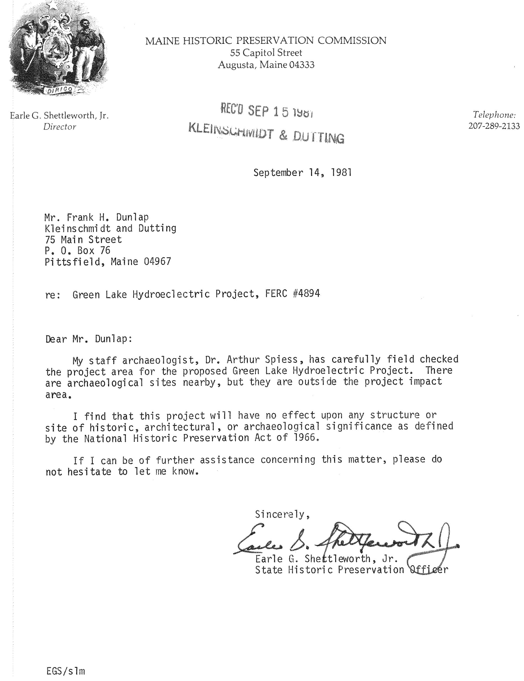
No changes to the basic project boundary are being requested during relicensing, and no erosion was found that would extend the area of potential affect beyond that of the original project. See study results in 7.0 below.

Socioeconomic Conditions
Deleted to reduce file size. There were no changes to this section.

Consistency with Comprehensive Plans

Deleted to reduce file size. There were no changes to this section.

Study Results
Deleted to reduce file size. There were no changes to this section.

Accession # 20200320-5152 - GLWP Response to NMFS Study Dispute – included in the record under /application materials/GLWP-FLA-Files/11-20220331-5449_Green-Lake-FLA-Exhibit-E-Appendix-D-Study-Planning.pdf – starting at page 206 of the pdf
19810930-DOI-Memo-re-Green-Lake-Project.pdf – This is included with this submission as a separate file.
May 25, 1984 Order Amending License P-7189 – This is included with this submission as a separate file.
This is online at https://www.ecfr.gov/current/title-50/chapter-II/subchapter-C/part-226/section-226.217
This is online at https://www.federalregister.gov/documents/2009/06/19/E9-14268/endangered-and-threatened-species-designation-of-critical-habitat-for-atlantic-salmon-salmo-salar
Accession # 20230706-5117 - GLWP response to the MDMR comments on the FLA
Clarified by MDIFW in email to GLWP on April 10, 2024 – email is included with this submission as a separate file.
Accession # 20230706-5117 - GLWP response to the MDMR comments on the FLA - pages 10-11
Accession # 20230706-5117 - GLWP response to the MDMR comments on the FLA - pages 7-9
Accession # 20230706-5117 - GLWP response to the MDMR comments on the FLA - pages 7-9
https://www.ecfr.gov/current/title-50/chapter-II/subchapter-C/part-226/section-226.217 and https://www.federalregister.gov/documents/2009/06/19/E9-14268/endangered-and-threatened-species-designation-of-critical-habitat-for-atlantic-salmon-salmo-salar
19810930-DOI-Memo-re-Green-Lake-Project.pdf – This is included with this submission as a separate file.

