- Scarborough (Tibbets Road) [EGAD # 157184]
  - DEP ID - 08-013
  - Licensee: Town of Scarborough
  - Off the southern end of Tibbetts Road (see map).
  - Site name???
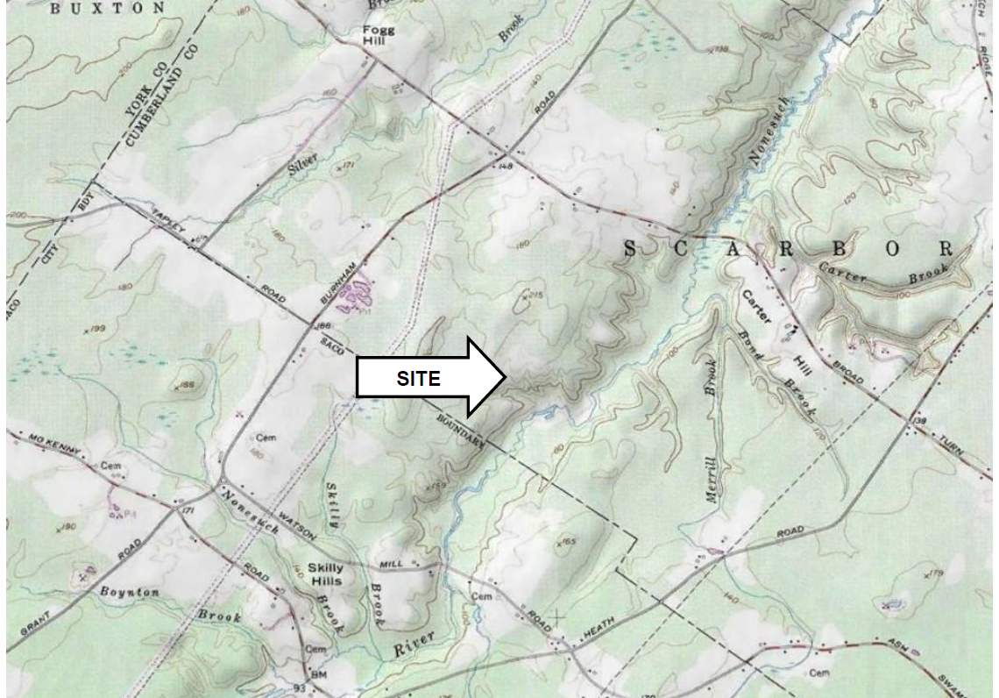
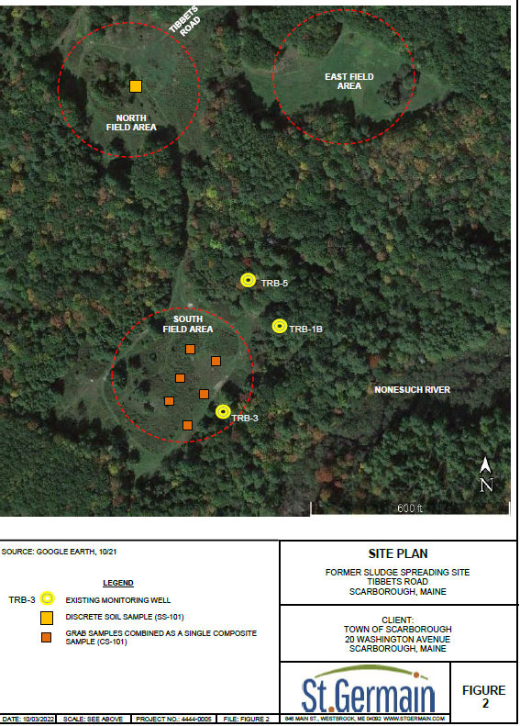

- North Yarmouth (Site 1) [EGAD # 157185]
  - DEP ID - ???
  - Licensee: Town of North Yarmouth
  - Off Milliken Road
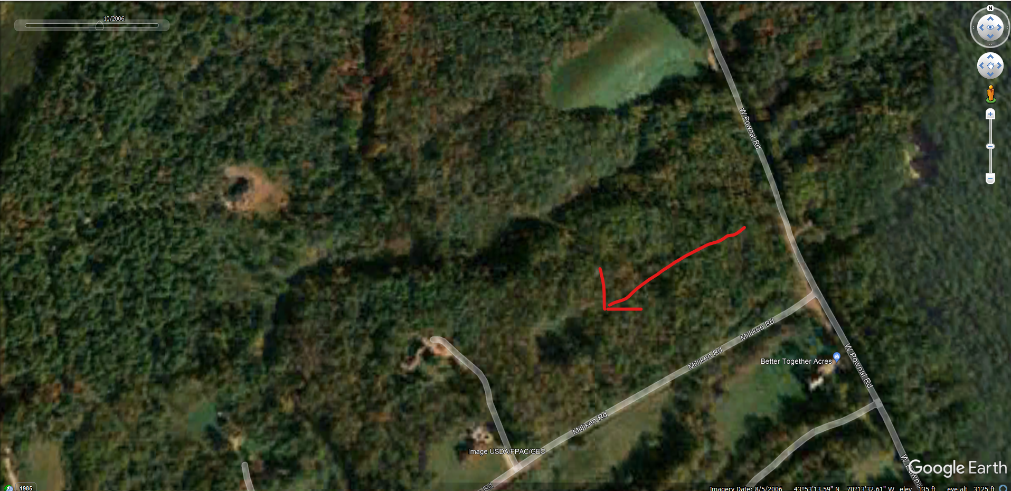

- North Yarmouth Site 2 [EGAD # 157186]
  - DEP ID – 00-3015-05150
  - Licensee: Charles Gillespie
  - Area – only approximate location – off route 115 and Baston Road
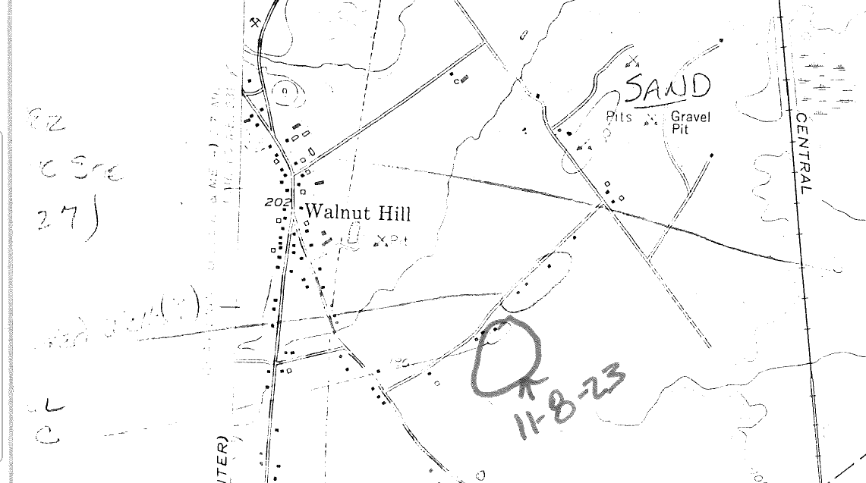
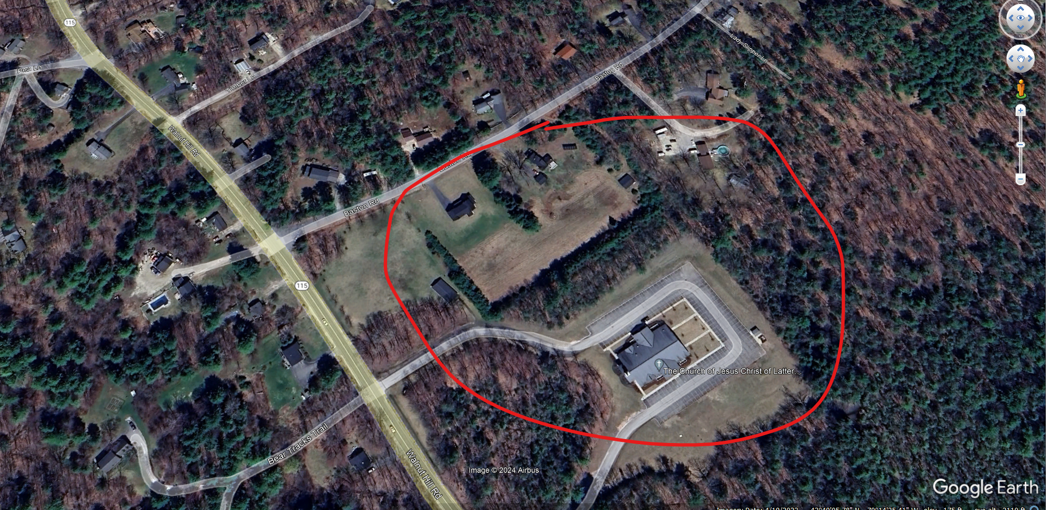

- Phippsburg [EGAD # 157187]
  - DEP ID – 00-3780-23060
  - Licensee: Town of Phippsburg
  - Off Parker Head Road
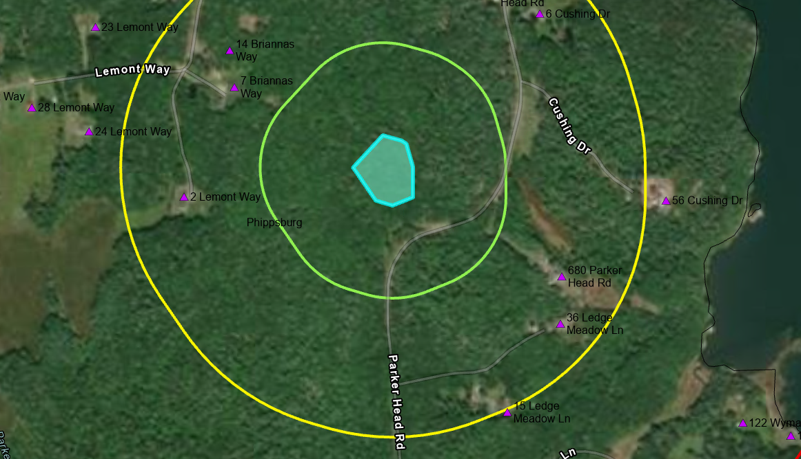

- Wells [EGAD # 157188]
  - DEP ID – 00-3455-31270
  - Licensee: Darling’s A-1 Service Inc.
  - Off Brogdon Road

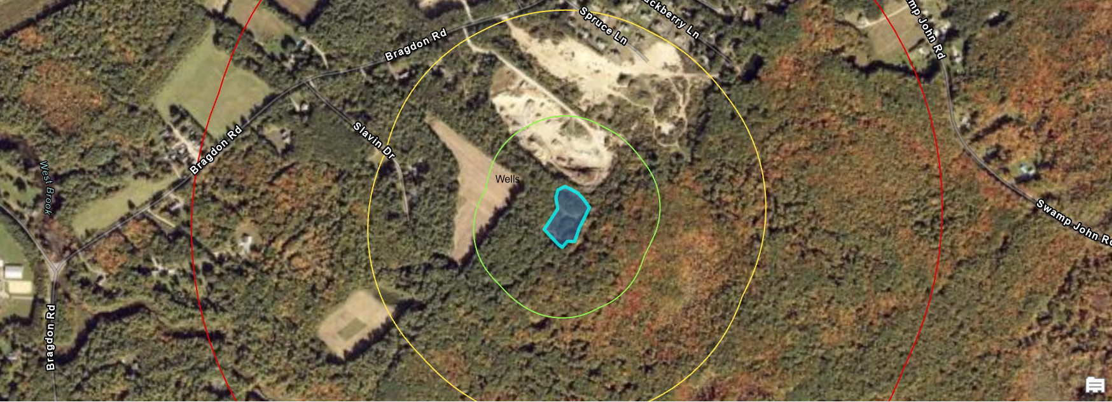

- Wells [EGAD # 157189]
  - DEP ID – 00-6387-31270
  - Licensee: Town of Wells
  - Off Branch Road
