Selected photographs and captions from: https://photos.google.com/share/AF1QipOVqk0KjDt3zFIybyQy0ANZihwqUvX_lyJbJz6HXywrKaIGET3E3pVRZXar13k2vQ?key=NG5NZWpsS0JweDV6MjNEWHZ2OUVHNHNteE9ZckxR
Submitted by William Weary in comment letter dated 1/9/2020, RE: NRPA application #L-28397-4E-A-N

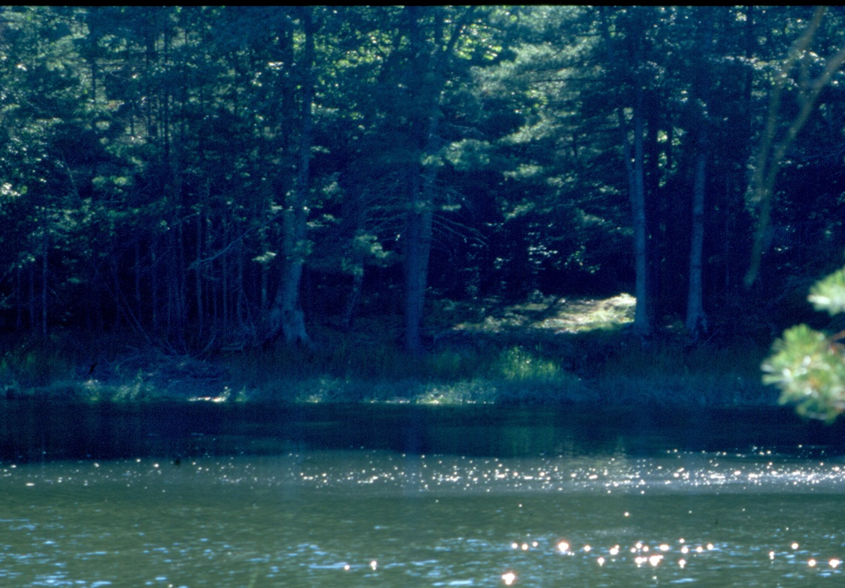
Summer 2003: After 2002 purchase of the property and May 2003 permit and before any work on a dock. Note the salt marsh along the clearing, permanently removed in the years to come. Note also the background foliage.

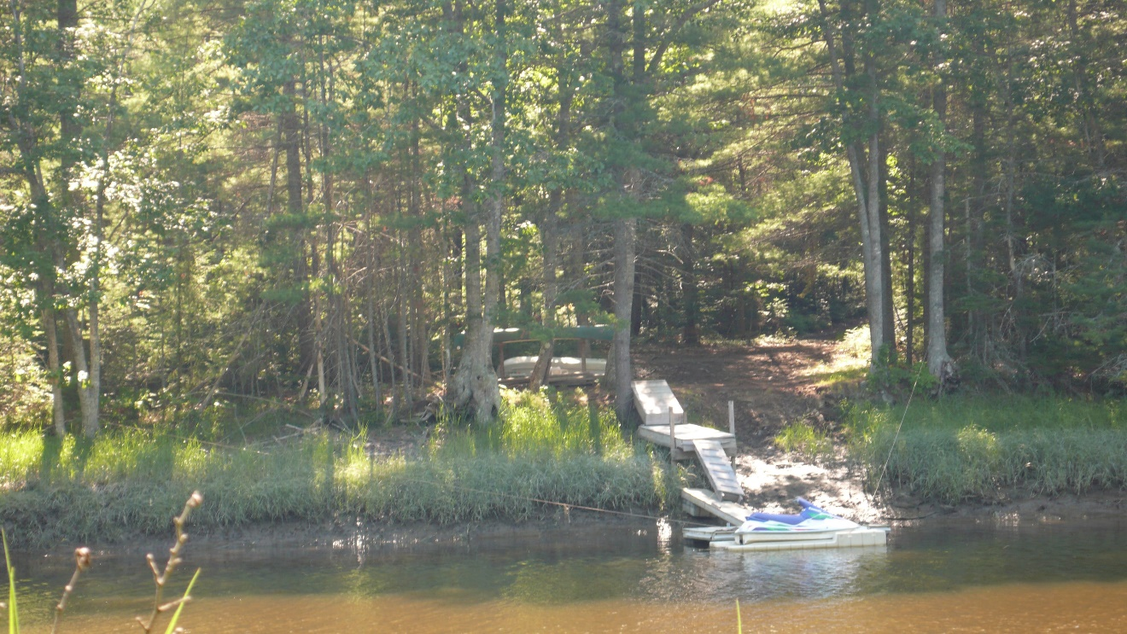
July 13, 2007: The first dock installation now is complete, four years after issuance of permit. Note short extension over the riverbank, narrow width of actual dock-plank, all of wood, no railings. For comparison purposes later, check the size of the clearing. Although still permanent, the size is small.

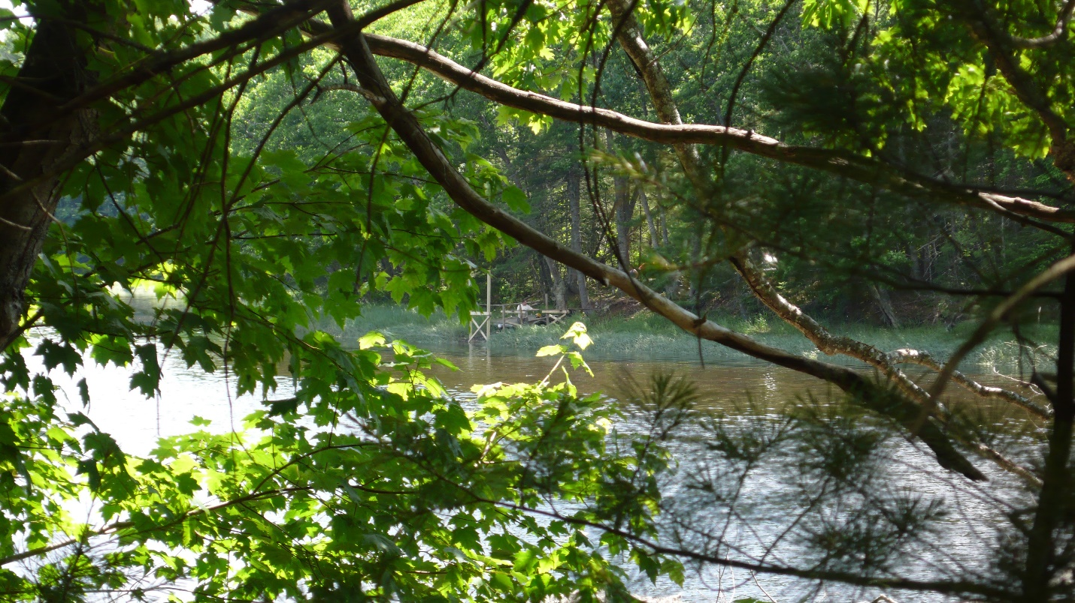
June 24, 2012: The new dock is going in, Jeff Spinney working on it. Note that there now are six pilings into the river bank, making it "more" permanent.

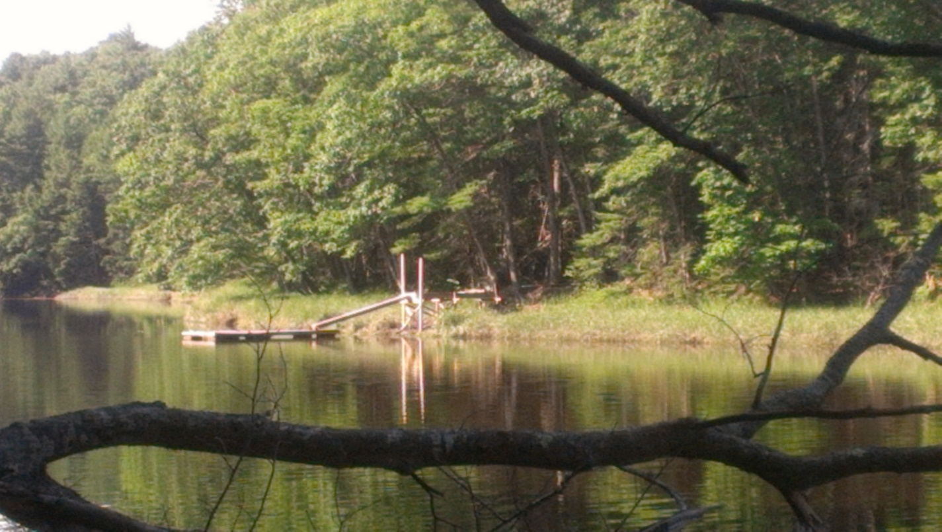
July 13, 2012: The installation is complete. Note longer dock down to the float.

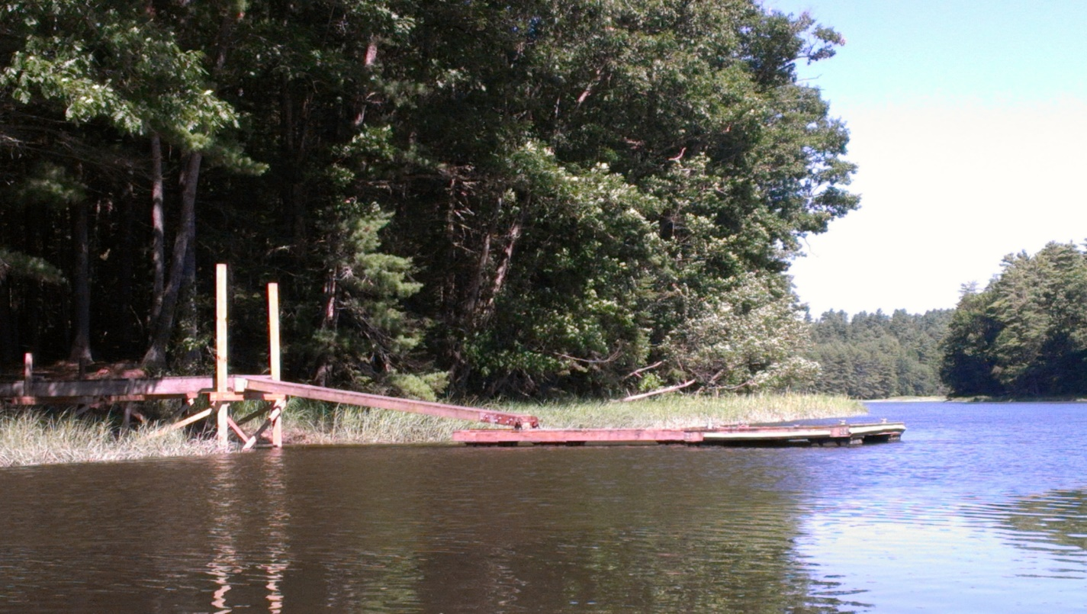
July 31, 2012: Looking up river from the new installation.

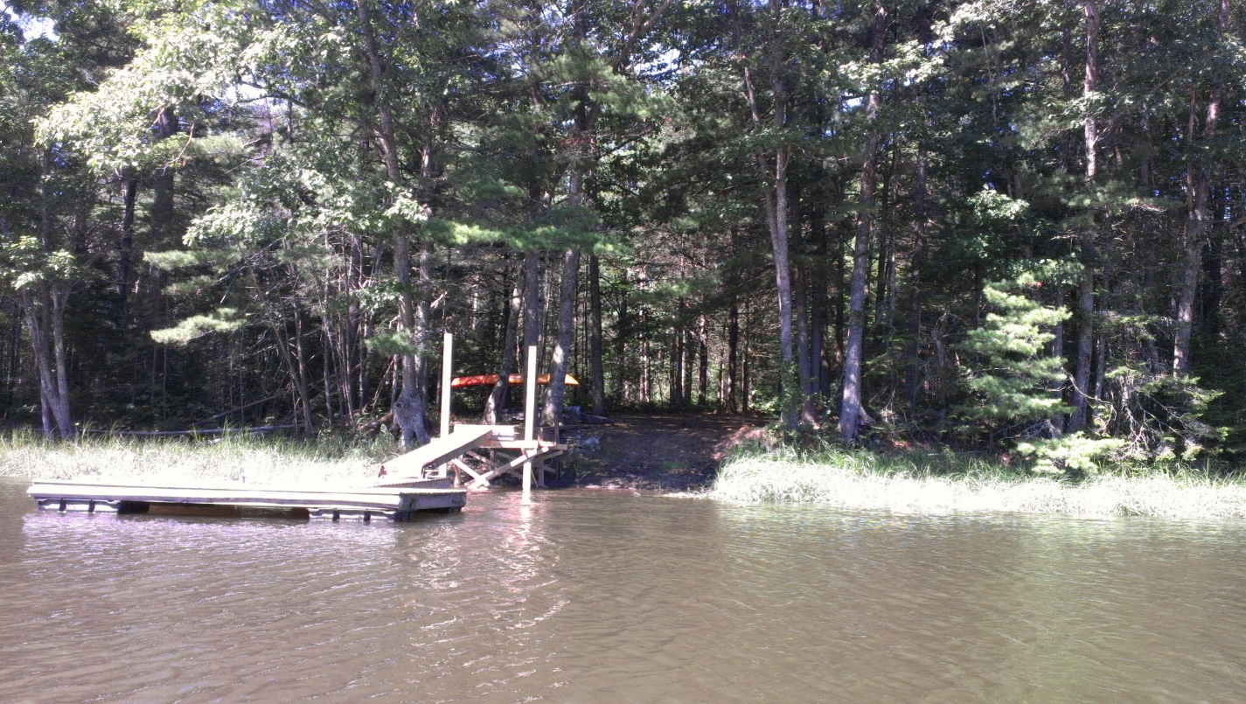
July 31, 2012: The cut for a boat launch is clearly visible as well as a more open stand of trees behind.

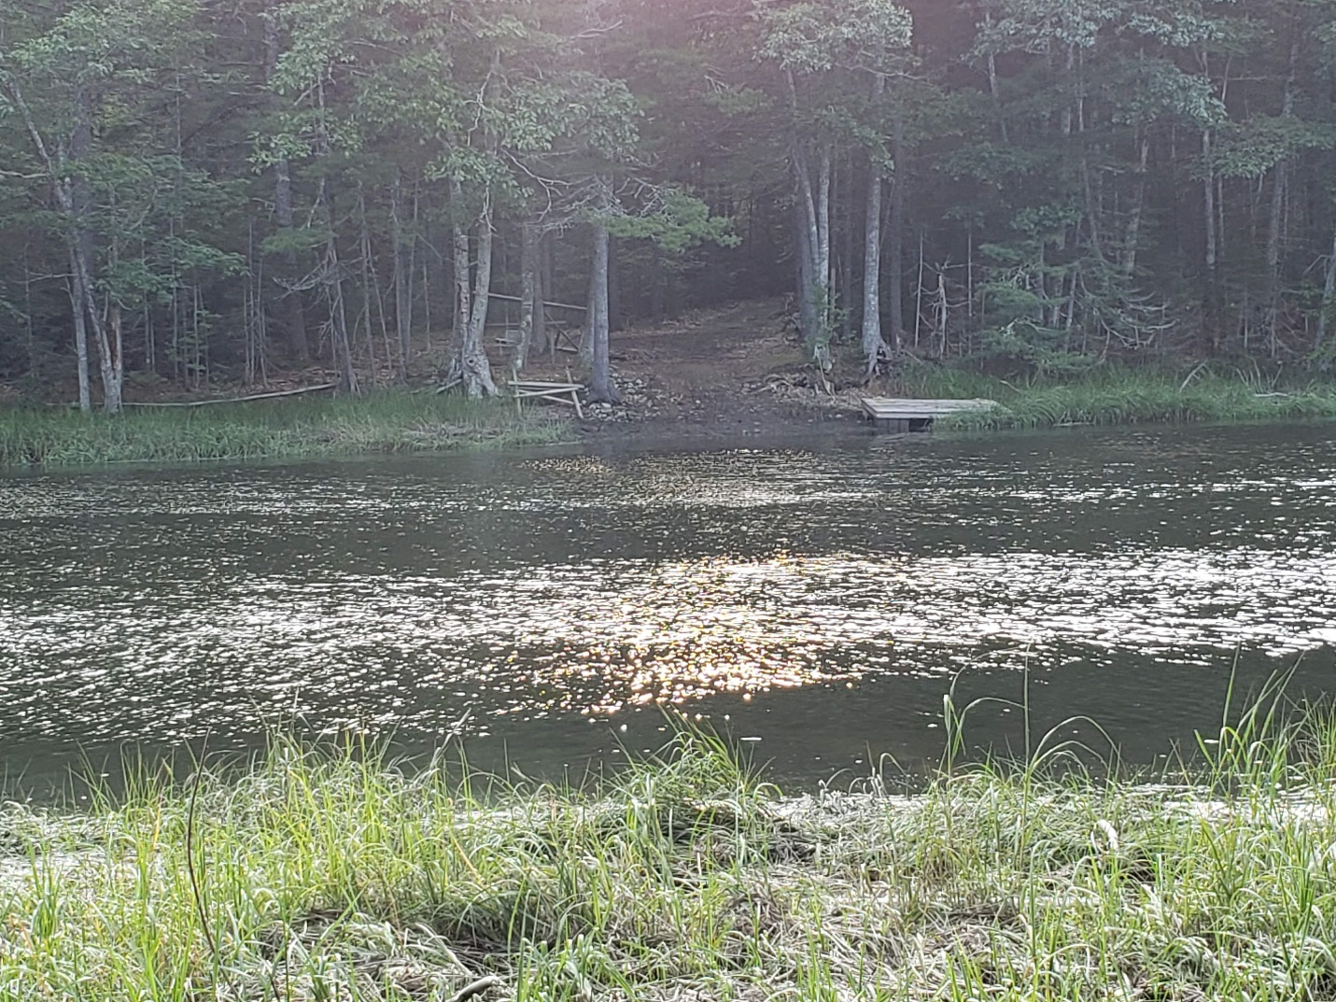
August 22, 2019: Wreckage and float on the shore, the cuts for dock and boat launch clear, as well as an enlarged clearing on shore.

