Spring 2024 Survey Schedule
*Select a day below to see a chart of the area (jpg Files, 1059KB to 2125KB), with tow locations, loran bearings, and latitude/longitude. Note that loran coordinates in the table data inserted on the charts may be slightly off.
Week 1 Region 1 – April 29th – May 3rd – New Hampshire to Saco Bay
- Day 1, tentatively April 29th – Appledore to Old Scantum
- Day 2, tentatively April 30th – SE to SW of Boon Island
- Day 3, tentatively May 1st – Cape Neddick to offshore Kennebunkport
- Day 4, tentatively May 2nd –Tanta Grounds to Portland S. Approach
- Day 5, tentatively May 3rd - Saco Bay

Week 2 Region 2 – May 6th – May 10th – Casco Bay to Muscongus Bay
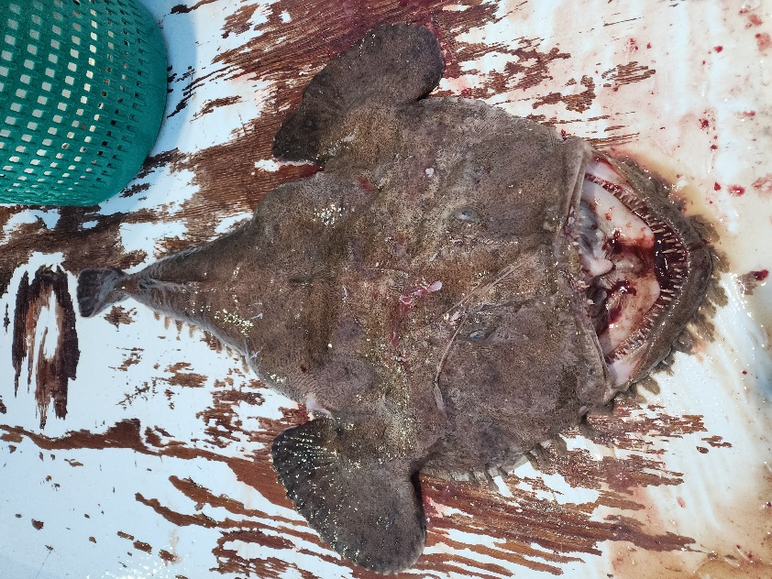 | - Day 6, tentatively May 6th – E. of Cod Ledge to Offshore  - Day 7, tentatively May 7th –Inside Casco Bay to Seguin  - Day 8, tentatively May 8th – Mouth of Sheepscot to S. of Seguin  - Day 9, tentatively May 9th –Off Outer Pumpkin Ledge  - Day 10, tentatively May 10th –Boothbay Harbor to of Monhegan
Week 3 Region 3 – May 13th – May 17th –Penobscot Bay Area
- Day 11, tentatively May 13th – S. of Metinic to False Halibut Ledge
- Day 12, tentatively May 14th – Inner Penobscot Bay
- Day 13, tentatively May 15th – Offshore past Matinicus Rock
- Day 14, tentatively May 16th –Around Seal Island
- Day 15, tentatively May 17th – East Penobscot Bay
Week 4 Region 4 – May 20th – May 24th – Isle Au Haut to Frenchman’s Bay
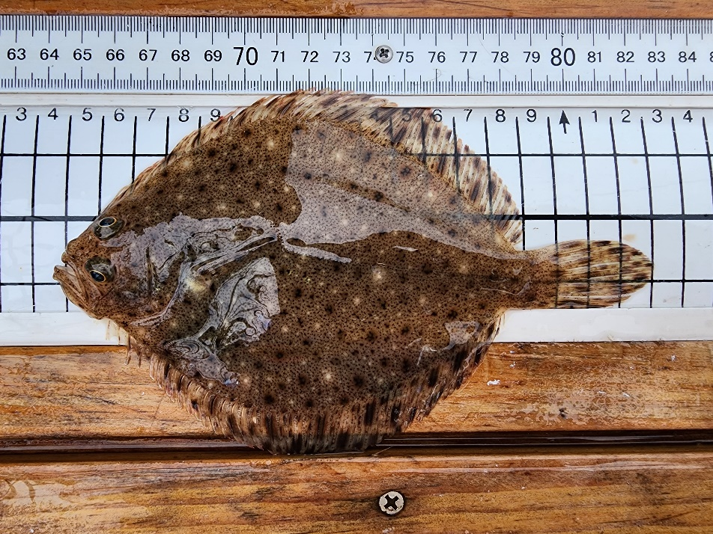 | - Day 16, tentatively May 20th – Around Grumpy Ledge and Offshore  - Day 17, tentatively May 21st – W. of Swans and into Blue Hill Bay  - Day 18 tentatively May 22nd – Off Great Gott to W. of Mt. Desert Rk.  - Day 19, tentatively May 23rd – Around Inner Schoodic Ridge  - Day 20, tentatively May 24th - Mouth of Frenchmans
Week 5 Region 5- May 27th – May 31st – Schoodic to Grand Manan Channel
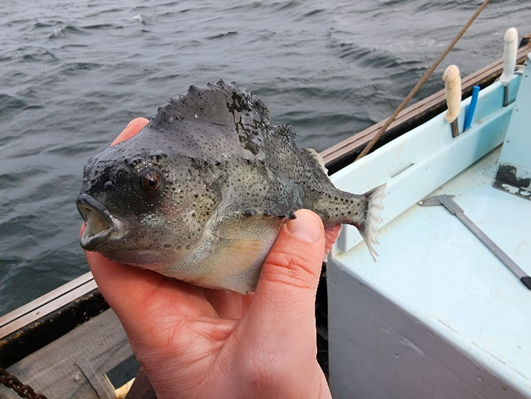 | - Day 21, tentatively May 27th – Offshore Petit Manan  - Day 22, tentatively May 28th – Eastern Island to Black Rock  - Day 23, tentatively May 29th - Offshore S. of Great Wass Island  - Day 24, tentatively May 30th – Off Great Wass to Misery Ledge  - Day 25, tentatively May 31st - Grand Manan Channel

