Unit 1: Building Strong Communities
Week 2: How do we benefit from being part of communities?
Dear Families,
This week we are continuing to learn about what makes our communities strong. We are thinking about how being part of a community gives us benefits—good or positive things that happen.
Here are some activities to do with your child this week. When you do an activity, check the box. You don’t have to do every activity and you can do any of them more than once. Remember to make time for reading, too!
Please help your child return this Family Links to school at the end of the week. We hope you enjoy learning with your child!
This week we are reading…
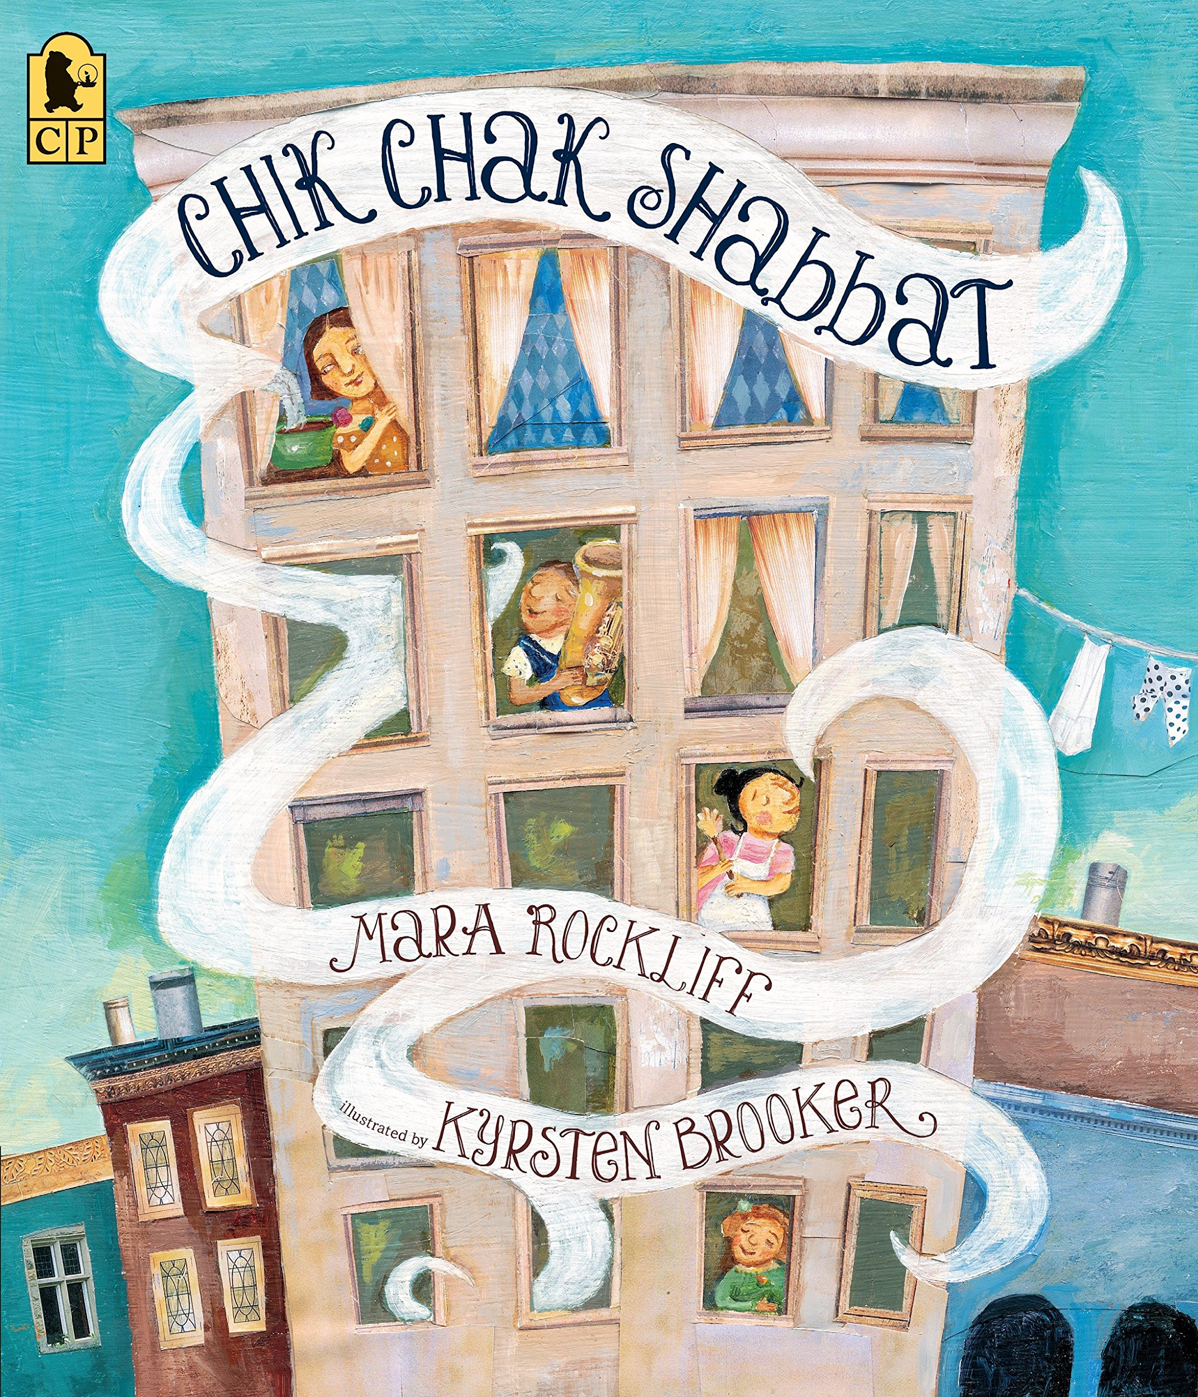 | Chik Chak Shabbat  by Mara Rockliff  and Kyrsten Brooker | 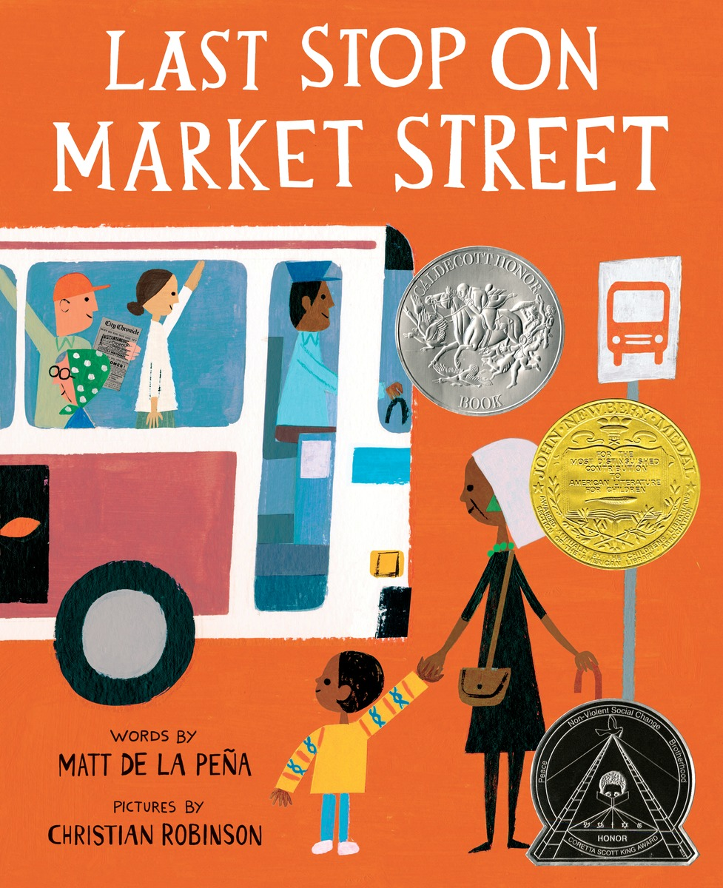 | Last Stop on Market Street  by Matt de la Peña  and Christian Robinson
Go to the library or look on your bookshelf at home to find more books about people helping each other in their communities—or about anything that interests you!

Your child is practicing reading “You’ll Sing a Song and I’ll Sing a Song” by Ella Jenkins (attached). You can sing and read along with Ella Jenkins by searching Ella Jenkins - You’ll Sing a Song and I’ll Sing a Song on YouTube. Listen to her other songs, too! Also this week's books can also be found on YouTube.

Reading Log
Your child can read to you, and you can read to your child.

It’s always a good idea to read a book many times. We can find something new in a book each time we read the words or look at the illustrations.
Title and Author | What do you think?

Unit 1: Building Strong Communities
Week 2: How do we benefit from being part of communities?
Go outside  Take a walk or ride together around your neighborhood. What is happening in your community on a sunny day? On a cloudy or rainy day? |  |  | Talk about…  … something you like to do.  Give step by step directions about how to do that activity. The listener can ask questions to get more information. The person explaining can add to the directions.
Tell a story  Have you ever shared a meal with other people in your community? With extended family? With people you don’t know? Tell a story about that meal, or make one up! |  | Read together!  at least 10 minutes every day  Record your reading on the front of this page. |  | Play with math ideas  Play Number BINGO  (attached).  You will need scissors to cut the numbers apart and small objects such as pennies, paper clips, or scraps of paper to mark your BINGO boards.
Explore science and engineering  Meteorologists are scientists who study the weather. The weather affects what happens in our communities. Make a weather calendar! (attached) Look at the sky, and make a symbol to show what’s happening outside through the month. |  |  | Play with words  One of our Weekly Words is rule. Talk with your child about a rule they have at home or at school.  Grow a Reader  Talk about this week's stories. Ask your child…  -Who were the characters in the story?  -Where did the story take place?  -Who made a positive contribution to the community?

Child’s name ___________________________ Adult’s name ___________________________

Teachers need to print:
*This weeks letter (front and back)
*Number Bingo
*Weather Calendar
*You’ll Sing a Song and I’ll Sing a Song

