NEO Staff Operations Manual

^{th}
Last Updated August 4 , 2020
Table of Contents
NEO Staff Overview .................................................................................................................................................... 4
What is NEO Staff? .................................................................................................................................................. 4
Who Needs to be Entered in NEO Staff? ................................................................................................................ 4 How do I log into NEO Staff? .................................................................................................................................. 5
I can’t Log in to NEO Staff? ..................................................................................................................................... 5
Validating Your Newly Created NEO Account ........................................................................................................ 5
Manage Staff ............................................................................................................................................................... 7
Difference between Staff Search and SAU Search ................................................................................................. 7
Staff Search ......................................................................................................................................................... 7
SAU Search .......................................................................................................................................................... 8
How to Find a Person .............................................................................................................................................. 9
Using the Staff Search Option ............................................................................................................................. 9
Using the SAU Search Option ........................................................................................................................... 11
How to Create a New Person ................................................................................................................................ 11
Creating an assignment for a staff person ............................................................................................................ 12
Creating a Classroom Teacher assignment ....................................................................................................... 14
Creating a Teaching Principal assignment ........................................................................................................ 16
Creating an Ed Tech that is split between two programs (one EPS, one not)? ................................................ 16
Creating a Long Term Sub & how do I return the original teacher? ................................................................. 17
Creating an Administrative Assistant that is split between school and district level? ..................................... 18
Creating a CTE Teacher? ................................................................................................................................... 18
Creating assignments for Special Education Teacher, ELL Teacher, GT Teacher ............................................. 19
Certification Report ..............................................................................................................................................
22 How to read position chart counts ................................................................................................................... 22 Explain the District Roles area. Changes this year in what you see ................................................................. 23 Explain process of updating District Roles throughout the year ......................................................................
24
Explain the EPS table ........................................................................................................................................ 24 Explain the certification process ....................................................................................................................... 25 Reports ..................................................................................................................................................................
25
Staff Details Report – Courses .......................................................................................................................... 25
Staff Details Report – FTE ......................................................................................................................................... 25
FTE By Person ........................................................................................................................................................... 25

Staff with Multiple Positions .................................................................................................................................... 26
Additional Help Documents ...................................................................................................................................... 26

NEO Staff Overview
What is NEO Staff?
The NEO Staff system is an application to record data on all staff members.
NEO Staff uses a hierarchy data entry methodology by providing only the necessary options to an end-user for completing the task at hand.
Data entered in NEO Staff is used for both EPS and Certification needs as well as providing reports as needed for federal programs.
The NEO Staff System is NOT a personnel system. Your district has one of those already. There is no association with the NEO Staff data and the data Maine PERS retirement system may collect. NEO Staff simply lists staff members who are actively employed at any moment in time during a school year.
Who Needs to be Entered in NEO Staff?
- All staff employed by a school district.
- Contractors with “unsupervised sustained direct contact with students”.
Include contracted staff for work that is considered part of the regular operations.
- Include individuals who contract directly with a school district; this is not limited to cases in which the individual receives retirement and other benefits from the district or state. Examples may include bus drivers, school nurses, psychologists, physical therapists.
- Include staff employed by another entity that is contracted to provide work that can be considered part of the district’s regular operations. These staff work within the district but are employees of the entity with which the district contracts. The district does not pay retirement or other benefits. Examples may include staff of the school; school security personnel provided by a private firm; or charter school teachers who are employees of a charter school operator.
Do not include employees of contractors who provide a non-regular service; these are staff furnished by the contractor, on- or off-site, to provide the service. Examples may include carpenters, electricians, etc. working for a firm hired to refurbish a school building, or cooks and truck drivers who prepare and deliver meals once a week to schools under a contract with a food-service firm.
The distinction between staff reported and not reported is whether the service is part of the district’s regular operation or if it is a non-regular service. For example, if a district contracts with a company for a school bus driving service (where the buses are used regularly), the drivers should be reported. If a district contracts with a company for lunchroom services onsite, the food servers who serve the students on daily basis should be reported as well.
How do I log into NEO Staff?
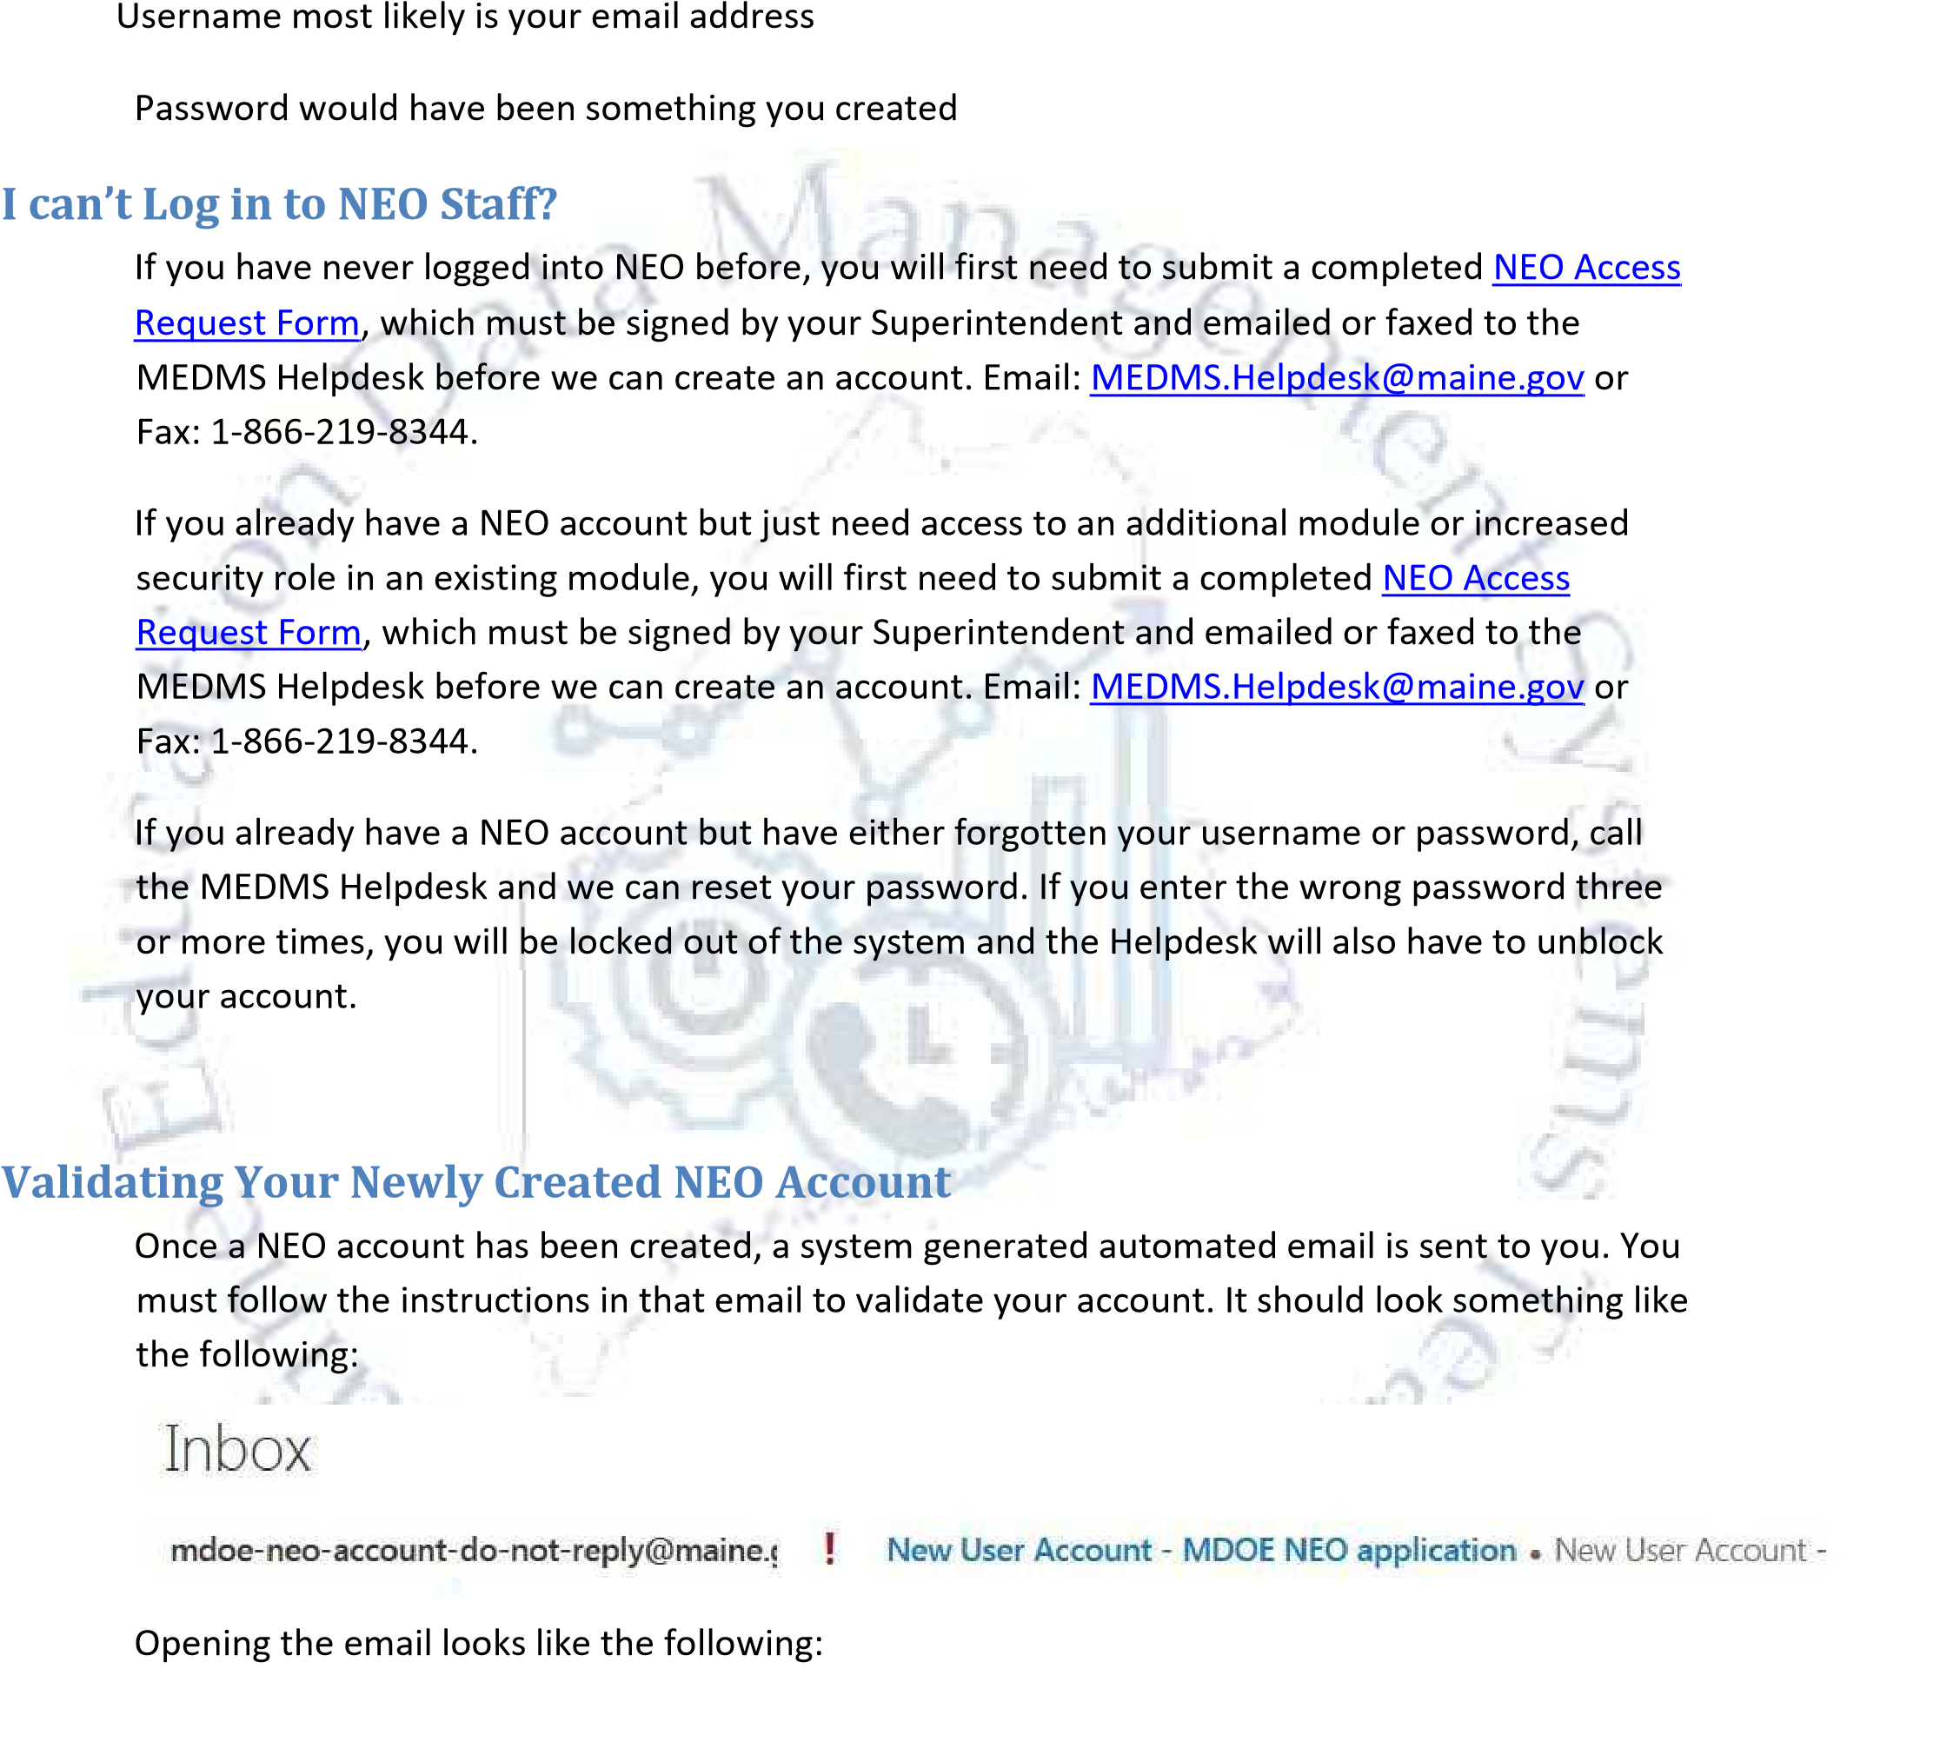
Go to the following URL:
https://neo.maine.gov/DOE/NEO/Accounts/Account/Login
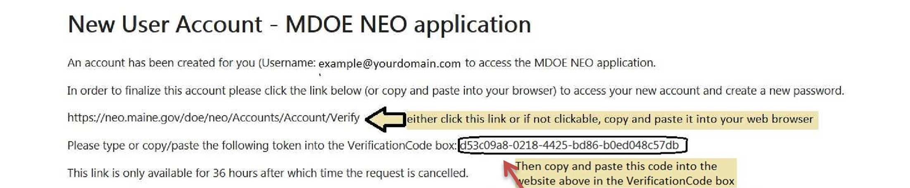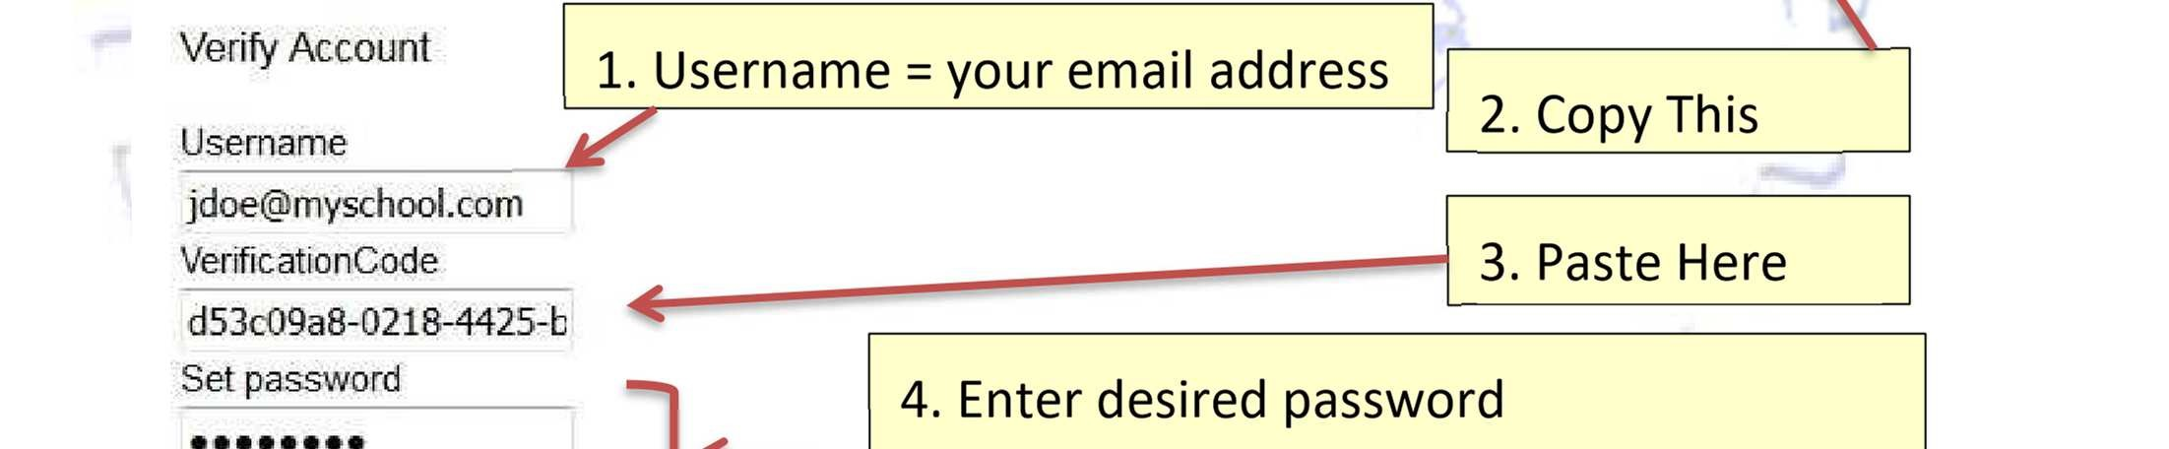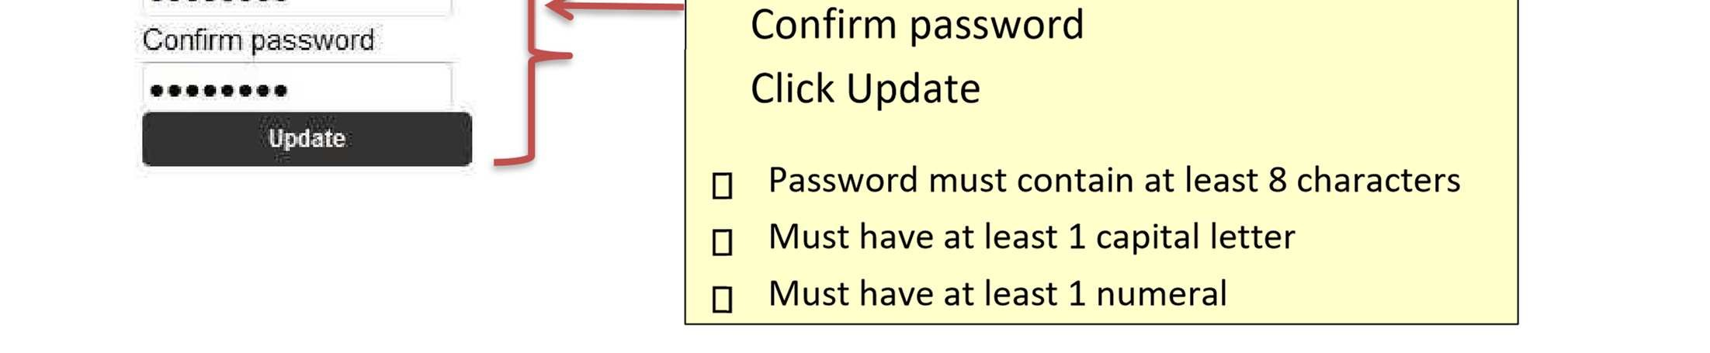

Manage Staff
Difference between Staff Search and SAU Search
You may search by Personal Details (First Name and/or Last Name and/or Birthdate) OR
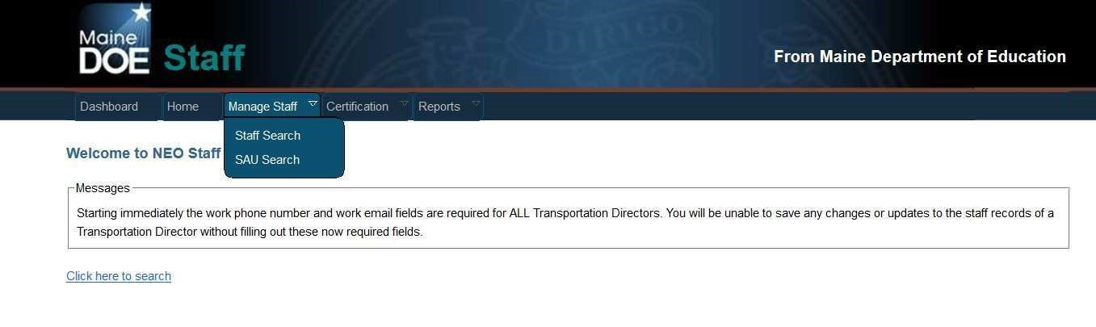
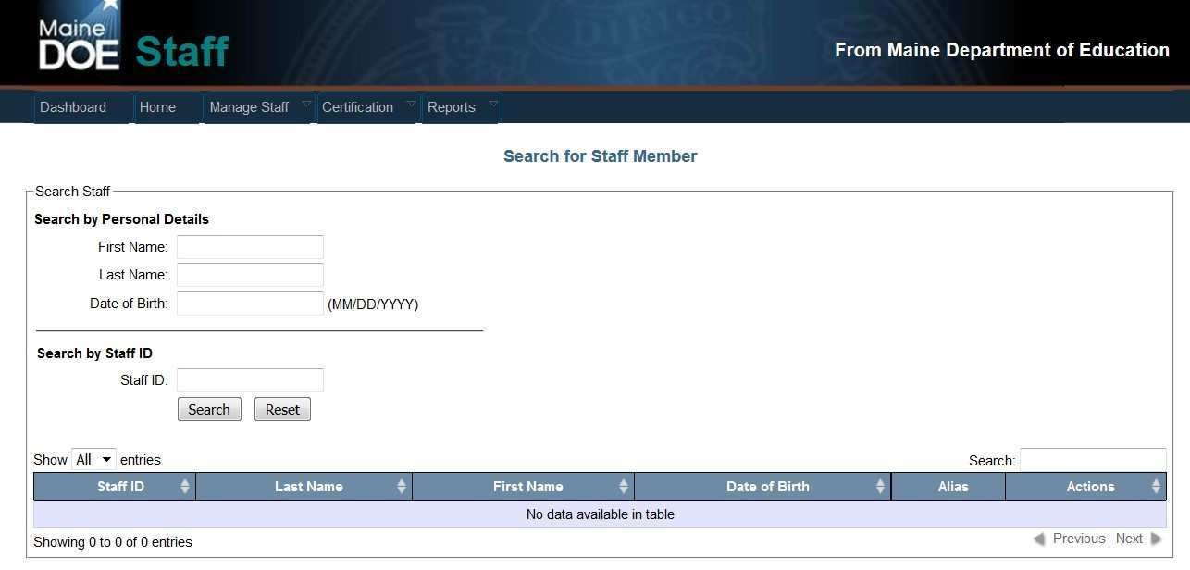
You may search by the Staff ID if known and already in the NEO Staff System

Staff Search

Staff Search is used to search for a person not already part of your staff which you want to add as part of

your staff. They may or may not have been employed somewhere else in Maine previously and are
already listed in our system.
Staff Search is also used to locate a person currently employed by your district for the purpose of
modifying demographic information on that staff person or modify the Highest Degree Earned for that

staff person.

Using the Staff Search methodology requires that you must know the complete 9-digit Social Security
Number for this staff person.

If your search produces too many results, you can refine your search by adding more details in the Personal Details or by adding this same information in the Search field text box.
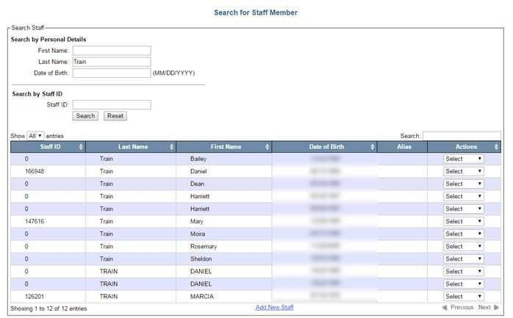
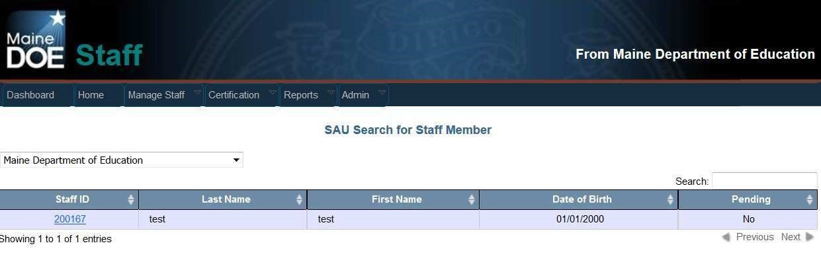
How to Find a Person

SAU Search

The SAU Search methodology is used to search for existing active and previously employed staff. If you
have security credentials to access more than one SAU, you will need to select the SAU from the drop-
down list. Otherwise, by selecting the
SAU Search
option, you will be brought directly to your staff list.

If the person you need to find is new to the SAU, use the Staff Search methodology. If the person is an active staff member or previously employed staff member of your SAU, use the SAU Search option.

Using the Staff Search Option
The Staff Search option should be used for those one-offs you need to add to your district. The majority of your time will be spent using the SAU Search option from the Manage Staff menu. If using the Staff Search option, you may search by First Name and/or Last name and/or Birthdate. Keep in mind the broader your criteria, the more names it will produce and the longer it will take for the search results to appear.
If you know the person’s Staffed, you may also search by that. This will always produce only 1 result in the search results assuming that StaffID previously exists.
In the example below, notice a search for last name of Que produces three results. In addition to finding Que, you also find Queally.

Note also that in the Staff ID column, two records have a Staff ID while the third displays 0. This means that two have been entered into the NEO Staff system at one time and have had a Staff ID assigned to them. The one with a Staff ID of 0 means there was a person entered into NEO through a different module but just is not in the Staff system. This may or may not be the person you’re looking for which is why we also display the birthdate to assist you in determining the correct person.
In the Actions column there is a drop-down list. If the person currently has a Staff ID assigned, the possible options to select from this drop down are Edit or View. If the person does not currently have a Staff ID assigned, the possible options to select from this drop down are just Add.
By selecting the Edit or View options, you will be viewing that person’s demographic information or profile page; specifically, the data you see below:
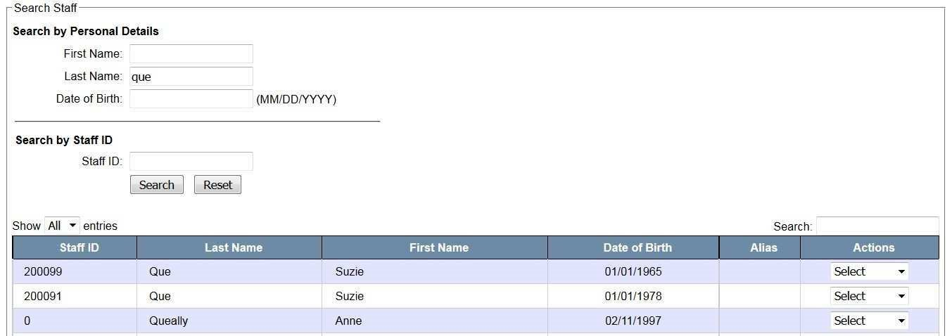
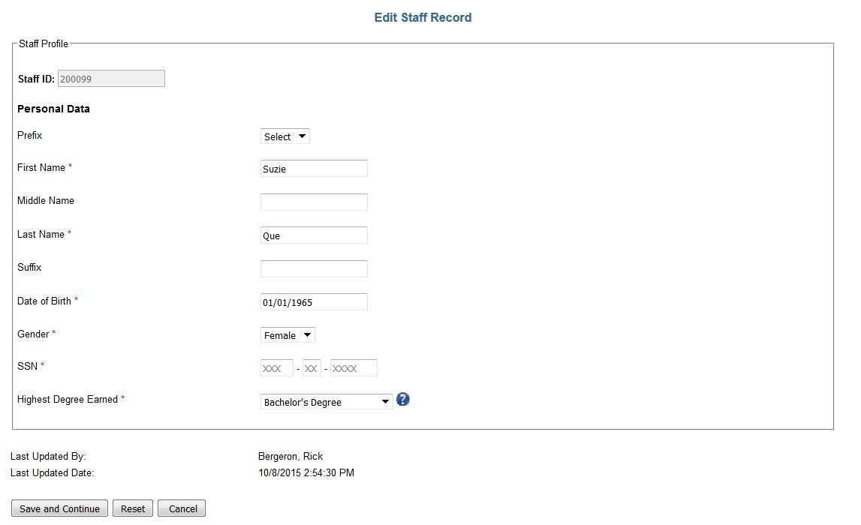
If the search results found the correct person but they have never previously been entered into the NEO Staff System (as in Anne Queally in the example above), you would select Add from the drop-down list. This will bring you to a completely new Profile screen. The required fields that must have valid data in order to save this are First Name, Last name, Date of Birth, Gender, SSN and Highest Degree Earned.

Notice that the Social Security numbers have been hidden. This does not mean they are missing. This
means that in order to continue editing this record or go to the assignment screen to be able to add an
assignment for this person, you would need to know the whole 9-digit SSN for this person in order to
continue. If you enter a SSN that does not ma
tch the one currently on file for this person, you will get an

error message and will not be able to continue. At this point, you should verify the SSN directly with the
person in question.
If a staff person legally changes their name, you simply

overwrite the exiting name listed and save but

you will also be prompted to re-enter the full SSN for any edits made before you can save. It is also
important that you update the Highest Degree Earned field as needed because it may or may not

determine if the assignment created will be eligible for subsidy. For example, a classroom teacher must

have a bachelor’s degree or higher in this field in order to count for subsidy.
Click the Save and Continue button to go to the Assignment screen.

Using the SAU Search Option
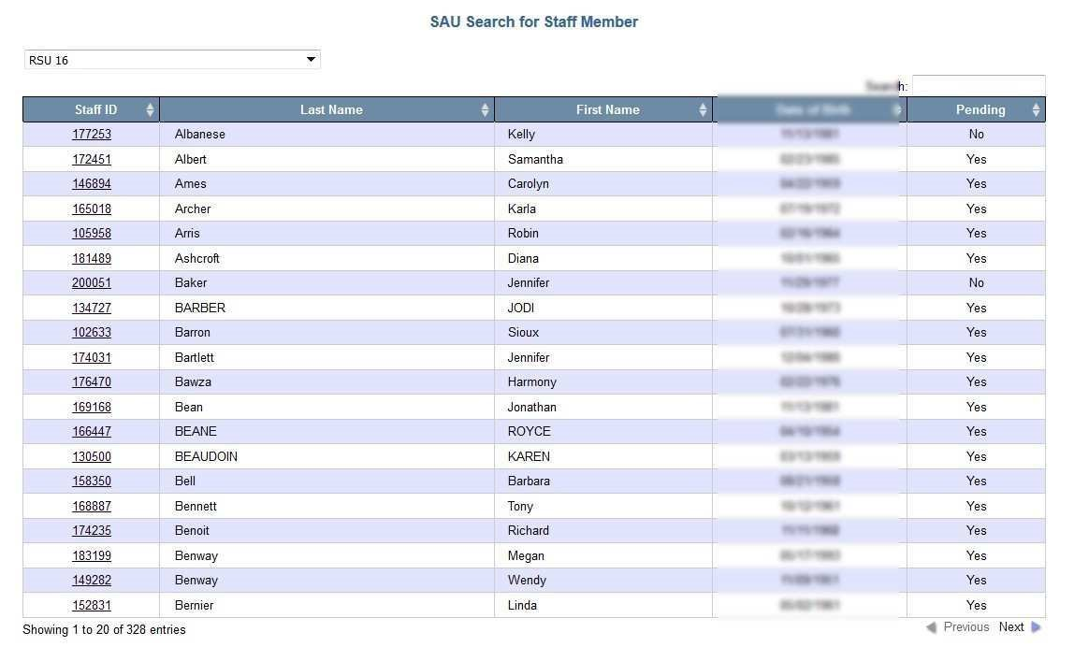
The SAU Search option is where you will spend the majority of your time. When you select SAU Search from the Manage Staff menu, you will either be directed to your current staff list or if you have security rights to more than one SAU, you will need to select an SAU first.

The results are listed alphabetically. The Pending column tells you if the assignments for this person are
still in a Pending status and have not been submitted as Active. Note: your superintendent will not be

able to certify staff data if there are any Pending records.

To view the assignment for a specific staff person, click on the link located with the associated Staff ID of
the staff person. This will bring you to the assignment page.

How to Create a New Person

If the search results did not find the person you were looking for using the Staff Search methodology,
click the

Add New Staff

link at the bottom of the search results (see image below). This will also bring

you to a blank profile page.
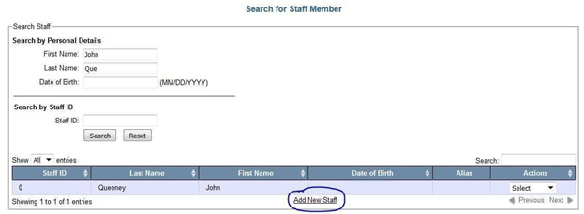
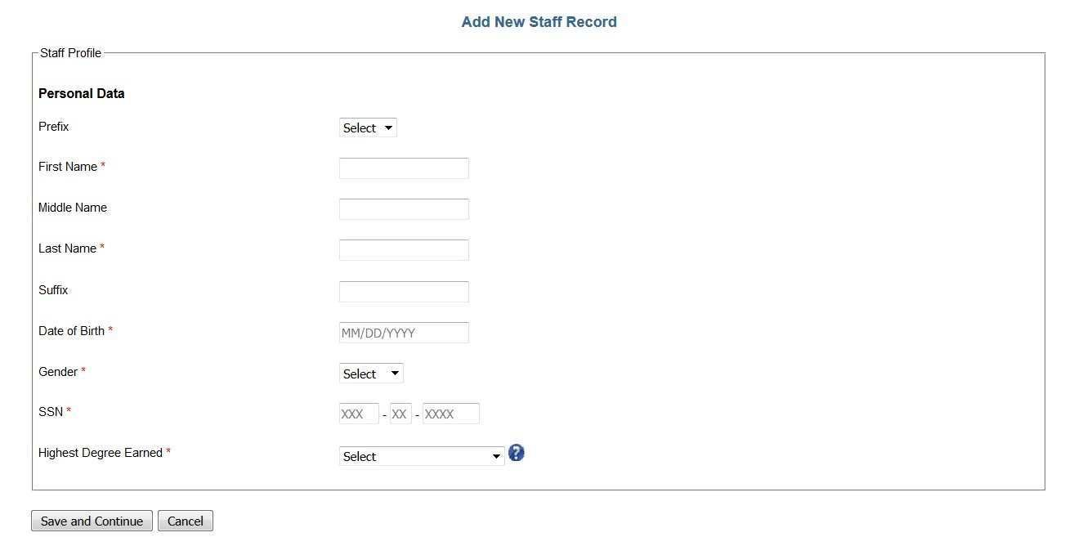

Once on the blank profile page, all the required fields are designated with an asterisk. These fields are
First Name, Last Name, Date of Birth, Gender, SSN, and Highest Degree Earned. After all the required

have been completed, click Save and Continu
e to be brought to the Add Assignment screen. Note: if you

attempt to save a profile and the SSN already exists in the NEO Staff System, an error message will be

displayed, and you will not be able to save the record. If after validating the SSN with

the staff person

and you still cannot save the record, please call the Helpdesk.

Creating an assignment for a staff person
Before creating a new assignment, you want to make sure there isn’t a current assignment that either needs to be ended or modified. Staff that had assignments last year is still there unless the assignment
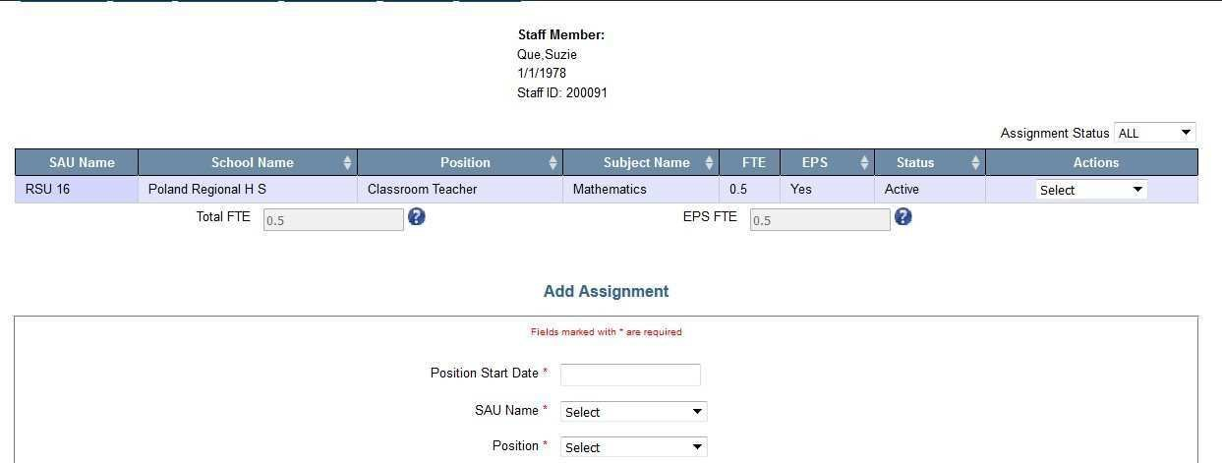
was ended. Unlike MEDMS Staff where you had to end all assignments and then recreate new ones every
year, NEO Staff requires you need only modify an existing assignment as things change. There are some
parts of an assignment that will not allow it to be modified. In these cases, the existing assignment must
be ended, and a new assignment created.

The Assignment screen is laid out in a chronological order and you should always enter data from the

top down. It is not recommended you pick and choose which fields to put data in without entering data
in the top/down order. This is because the field validation may change depending on what you selected
in the field above it. For example, if you selected that the position was a district level position and not a
school level position before you actu
ally selected the position and then selected Classroom Teacher as

the position, the field where you selected District Position is now gone. Many of these fields are

dependent upon what was selected in previous fields.
You do not have to have all the information in front of you in order to create an assignment. If you
realize you’re missing some information, you can always save the assignment as a pending record

and it

will save the information you entered so you won’t lose it. There is however a minimum or three fields
(

possibly four) that must be entered before the assignment can be saved into a pending status. These

fields are:
•

Position St
art Date

•

SAU Name

•

Position

•

School (depends on position selected)

If you selected a position that requires a school to be selected, then the school must also be entered
before the record can be saved into a pending status.

Once you find the staff person you which to create an assignment for either through the Staff Search or
SAU Search, you are immediately brought to the Add Assignment screen. If this is an existing staff

person, you may see a current assignment already listed in the assignment grid.

Be sure not to confuse adding a new assignment with editing the existing assignment. Notice in the above example, this person is a classroom teacher teaching mathematics with a Full Time Equivalent (FTE) of 0.5. That means they have been working half time or about 20 hours per week. If the staff person will continue this assignment in the upcoming school year and nothing has changed in that assignment like salary, FTE, etc. You need not do anything with this assignment. If something like salary changed, you need only “Edit” this assignment and save the changes. The only fields you cannot modify in an existing assignment are SAU Name, Position and School. Everything else can be edited. If SAU Name, Position or School needs to be changed, you must first end the current assignment and then create a completely new assignment.
As you are completing an assignment record, you will notice some fields are added or removed depending on what you select in a previous field. Also, sometimes a field may all of a student be labeled as a required field in some scenarios and not a required field in other scenarios.
It may be helpful to become familiar with the following document called NEO Staff Field Definitions located at https://www.maine.gov/doe/data-reporting/collection/helpdesk/resources/staffdataentryguides. This document defines what is being asked for in each field on the assignment page.
In order to explain this, add assignment properly, it is probably easier to go through a few specific examples of different scenarios.

Creating a Classroom Teacher assignment
The following example is a straight forward scenario of a math teacher. Notice this teacher has 30 years of experience as a classroom teacher. The years of experience in the position often gets misunderstood with years in education. A teacher might have been an Ed Tech for a few years prior to becoming a teacher but those years are not included in the Years of Experience for this assignment. Years of Experience has nothing to do with Maine PERS Retirement System. The years of experience in a specific position is used to determine the experience level of that person in that specific position which is used in the subsidy calculation for the SAU. Years of experience from other school districts in Maine or outside of Maine are all included as long as they are all considered the same position.

The values in the School field are dependent to what is selected in the SAU Name field. The Education Level is used to determine if the staff person is a teaching Career and Technical Education students (CTE) or not. This field is only available for specific positions. This data point would not be visible for a position like Superintendent or any other district level position. Finally, the Subject Matter field appears because
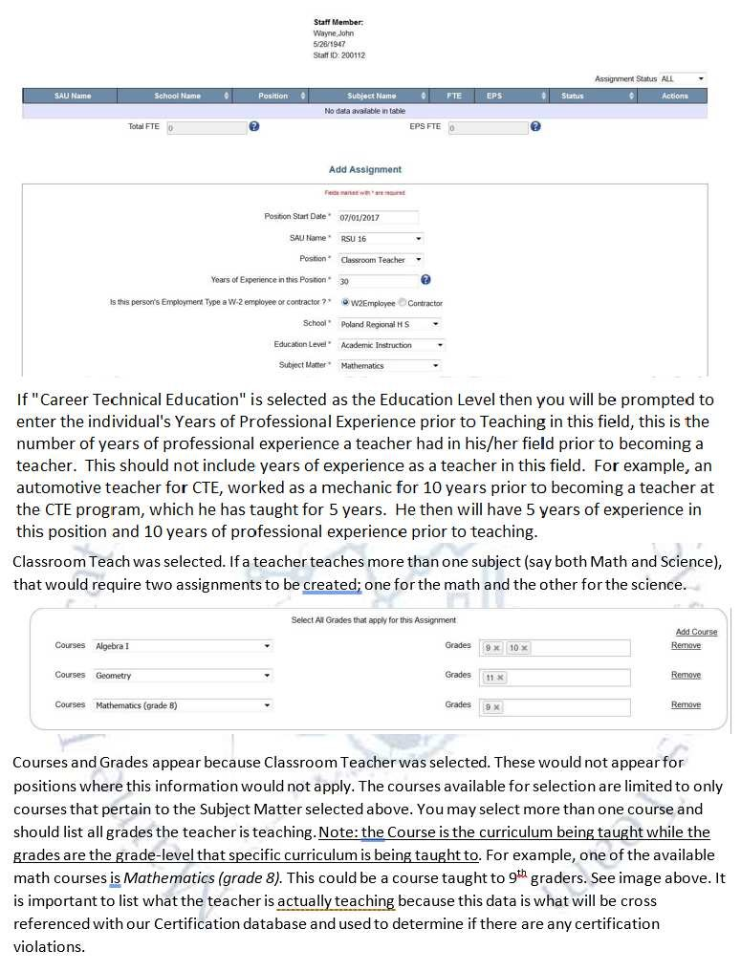
Creating an Ed Tech that is split between two programs (one EPS, one not)?
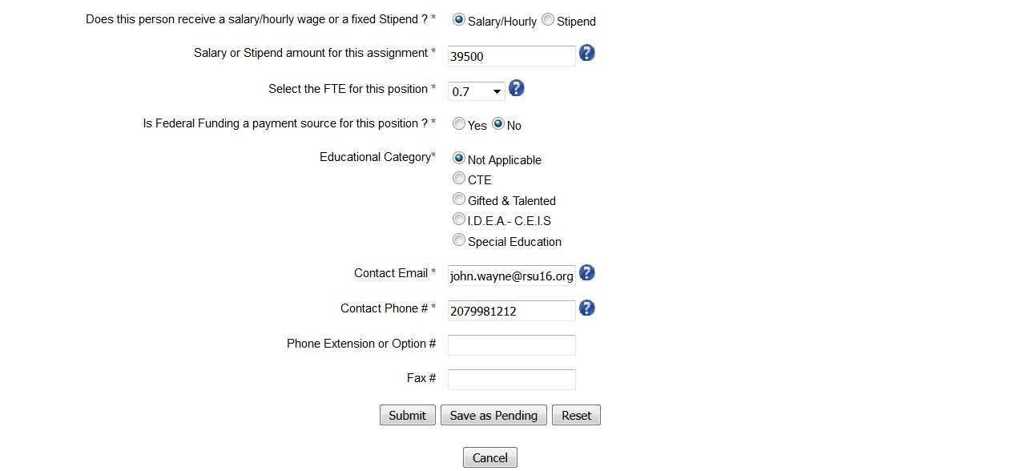
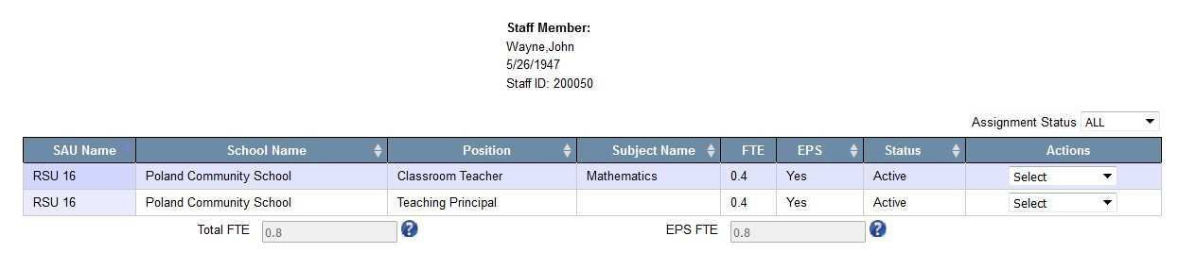
If a staff person’s salary is partially paid for with public funds, the assignment must be split and entered as two assignments; one for the public funds and one for the non-public funds. It is possible that depending on what is selected, one of the assignments counts for EPS while the other does not.

The remaining fields displayed above are an example of how a Classroom Teacher can be entered. A
description on these fields ca
n be found in the NEO Staff Help section.

Creating a Teaching Principal assignment

A Teaching Principal must split their time equally between a principal and a teacher. Therefore, you

would enter an assignment for a position called Teaching Principal. The FTE selected cannot be more
than 0.5 and it must equal the FTE used for the second assignment you must create called Classroom
Teacher. If you only select 0.4 for the Classroom Teacher you cannot select more than 0.4 for the
Teaching Principal position. If this is case, the staff person could still be available for up to 0.2 FTE for an
additional assignment.

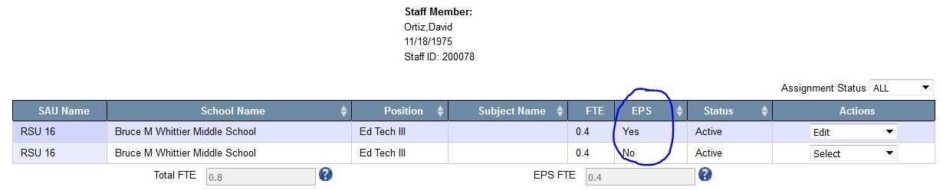
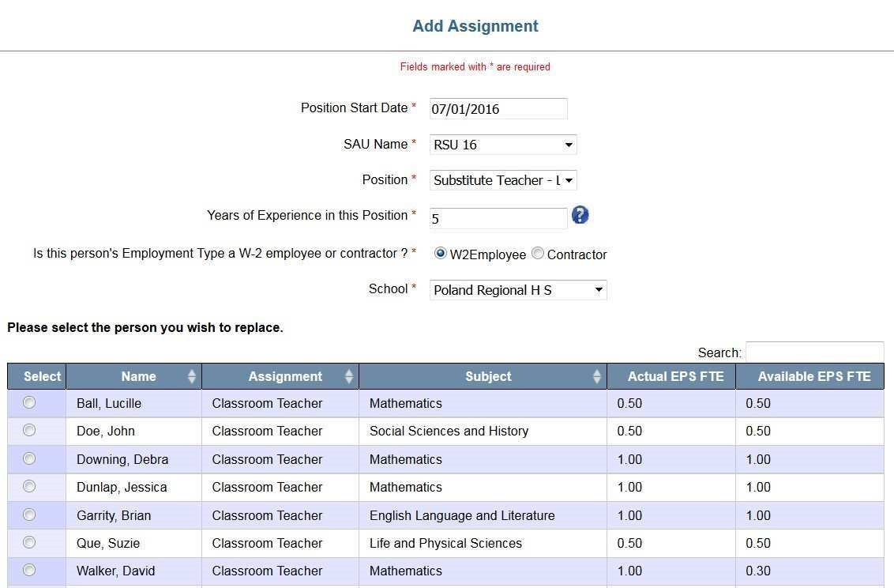
Note that once you select the school, additional information appears displaying all current Classroom Teachers in the school which you selected. You must select a name from this list in order to continue. This one-to-one relationship will continue until the teacher that went on leave returns. It is permissible to create more than one Long Term Sub position for each Classroom Teacher position going on a Leave of Absence as long as the cumulative totals of the EPS FTE for the Long-Term subs do not exceed the EPS FTE of the Classroom Teacher. The remainder of the assignment must be completed, and the record submitted. By entering the Long-Term Substitute before the Classroom Teacher, it will automatically put the Classroom Teacher on leave by saving the Long-Term Sub assignment.

Creating a Long-Term Sub & how do I return the original teacher?

In order to add a “Substitute Teacher
–

Long Term” assignment, you must designate a current active

Classroom Teacher and set the Classroom Teacher to be “On Leave”. When the Classroom
Teacher

returns from leave, the assignment is set to “Return from Leave” and the application will automatically

end the assignment of the Long
-
Term Sub.

Create the assignment for the Long
-
Term sub similar to the following:

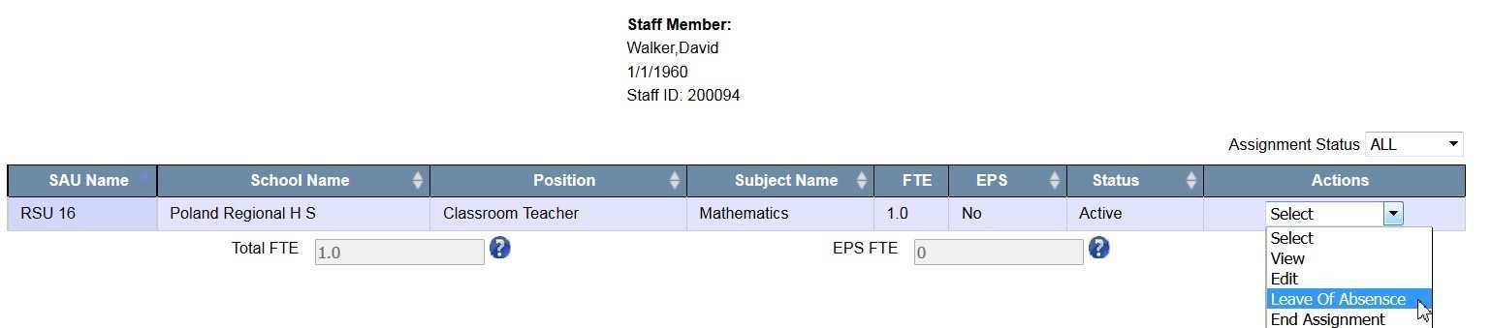
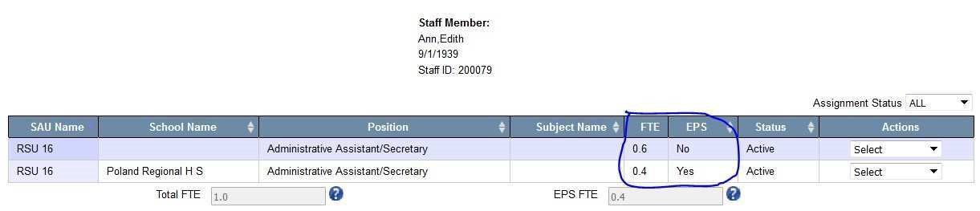
You may also put a person on leave without actually replacing them with a Long-Term Substitute. Find the teaching assignment in question then from the Actions menu, select “Leave of Absence”

Once this is selected, you will be asked to enter the Leave Date, check the confirmation box and click

Leave.

To return the Classroom Teacher from Leave of Absence, locate the staff person’s record, th
en from the

Actions Menu select “Return from Leave”. This will automatically end the assignment of the Long Term
Substitute and end the Leave of the Classroom Teacher. However, the original assignment of the
Classroom Teacher will not be re-created. You must complete the Add Assignment section for the
Classroom Teacher.

Creating an Administrative Assistant that is split between school and district level?

An Administrative Assistant is counted toward EPS if they are working at the school level however they

are not counted for EPS if they are working at the district level

Creating a CTE Teacher?
A CTE Teacher can be created at both CTE Regions and CTE Schools. The example below displays how a CTE Teacher might be entered. Education Level must be Career Technical Education. Subject Matter and Course options will be limited to the subject clusters and courses the school has been approved for.
Grades will be filtered to what your selected school is approved for.
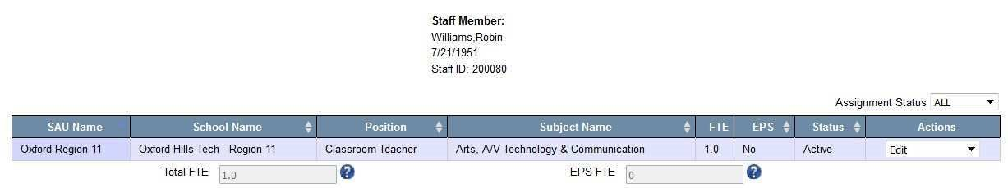
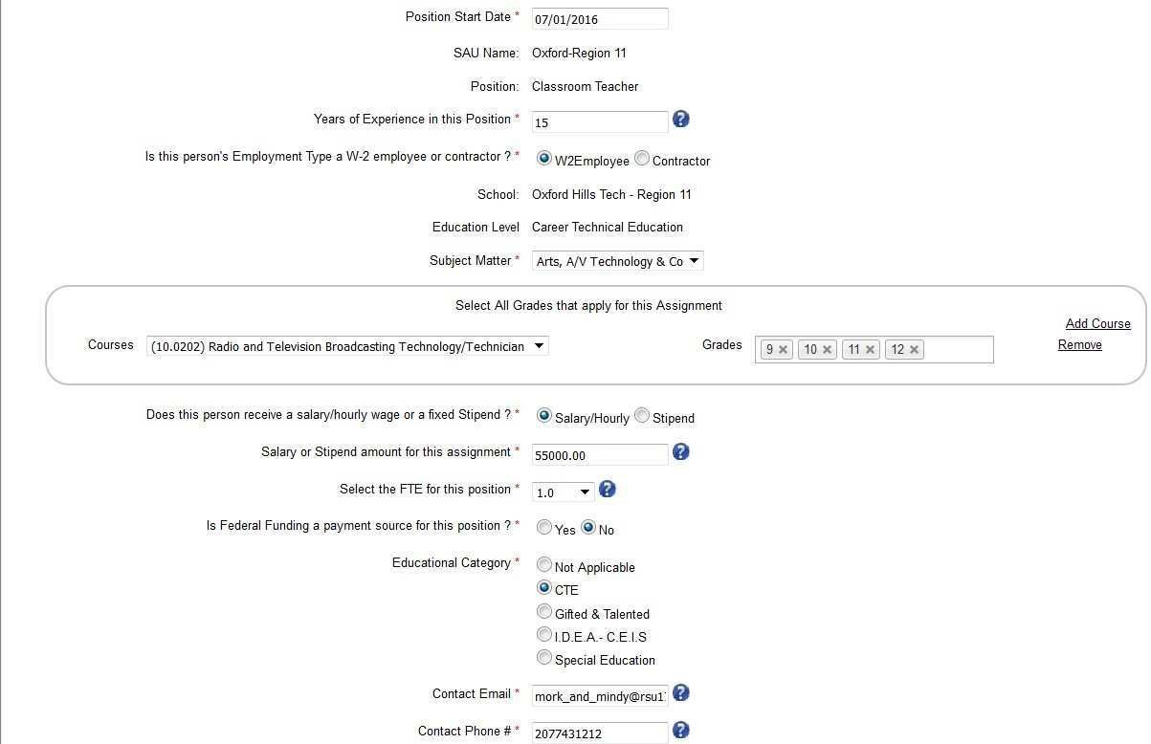

Creating assignments for Special Education Teacher, ELL Teacher, GT Teacher

There are multiple ways to create a Special Education teacher assignment. The example below displays a

Special Education Teacher working in an elementary school teaching mathematics courses. Because

Special Education Teacher was selected, you will notice disability types listed at the bottom of the form.
You only need to select one or more of these di
sabilities if you have students in your classroom with

these disabilities.
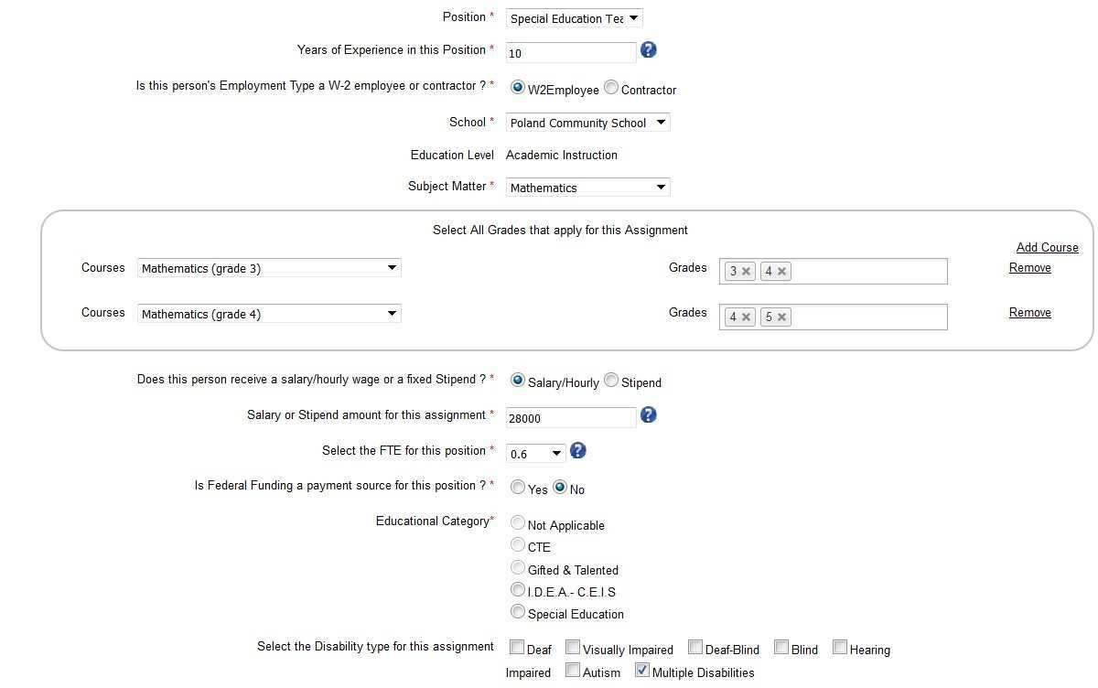

Another option to create a Special Education Teacher assignment would be for teachers that teach all

subjects to students in an alternative setting. In this case, the following example may be a scenario you
would use. In this example, the subject of “
Special Education

” is selected. This option is only available for
Special Education Teachers. Also, the course is Special Education and the grades are the grade levels of

the students the teacher is teaching. If this assignment is paid with federal funds (full or partially)

Federal Funding option is set to “yes”. Once “yes” is selected, another dropdown appears requesting
which specific federal fund is being used to pay this portion of the staff person’s assignment. Since

I.D.E.A. was selected, the only Educational Categories that can be selected are IDEA
–

CE
IS or Special

Education. You may need to contact your business manager to make sure these financial options are
entered correctly.

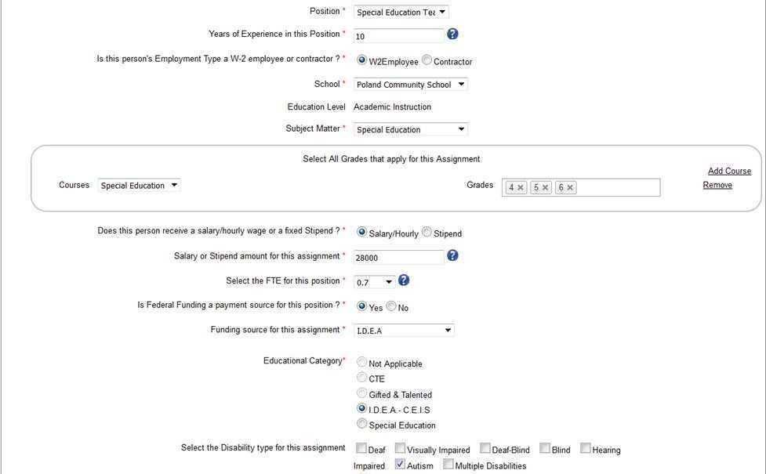
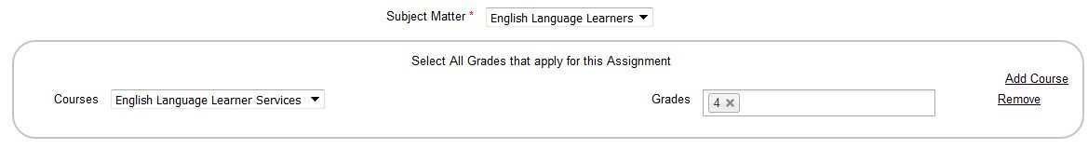
Gifted and Talented Teacher example:

Like the Special Education teacher, there are similar scenarios for an English Language Learner Teacher
and Gifted and Talented Teacher. When either of these are selected, in addition to the regular list of

subjects, you will also see “English Language Learners” when English Language Learner Teacher is

selected and also “Gifted and Talented” when Gifted and Talented Teacher is selected. Like in the

Special Education Teacher scenario above, these two add
itional Subject Matters are used when the

student is removed from the regular classroom and placed in an alternative setting specifically for these

purposes.

If these special topics Subject Matters are selected, the Courses list is still required but the list is limited
to only that topic oriented Subject Matter.

English Language Learner Teacher example:

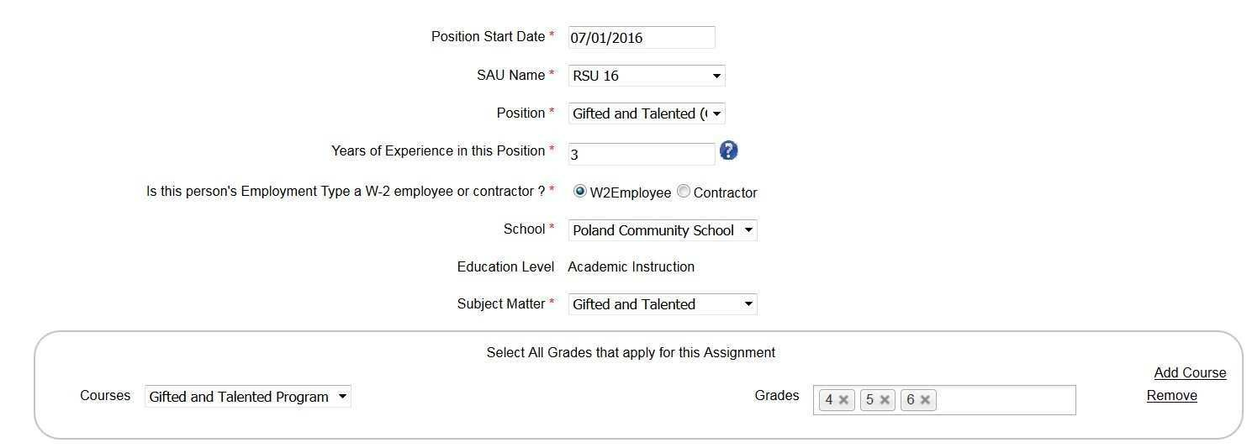

If the student is not removed from the regular setting for any of the above, then you would select the
subjects, courses and grades as you would for a regular Classroom Teacher assignment.

Certification Report

How to read position chart counts

There are five columns on the staff certification report.
1.

Number of Active Staff – the number of active staff members with this position.
2.

Number of Active Positions – the number of active positions with this position.
3.

Total FTE
–

this is the total FTE count for staff members in this position district wide. Total FTE

equals EPS FTE plus non-EPS FTE.
4.

Total EPS FTE
-

this is the total EPS FTE count for staff members in this position district wide. EPS

FTE is only listed if there are staff assigned to EPS Positions.
5.

Number of Pending Positions
–

the number of staff members in this positio
n that have pending

assignments within the district. If there are any staff assignments pending, the superintendent

will not be able to certify the staff data.
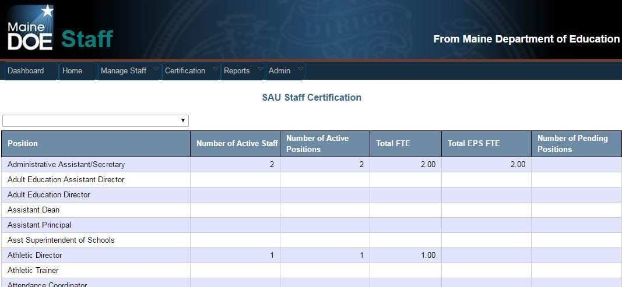

Explain the District Roles area. Changes this year in what you see

At the bottom of the staff certification report is the district roles section. The district roles section is
where you indicate which staff members perform critical roles within the
district. It is very important to

understand that these need to be accurate due to the fact that these will be public contacts and will
receive critical communications pertaining to those roles. It is also important to keep these roles current
and

up to date throughout the year.

New for school year 2016-17 you will no longer need to create a nurse or librarian assignment for the
superintendent in order to be able to select them for these roles in the case that your district does not
have

a nurse and/or a librarian.

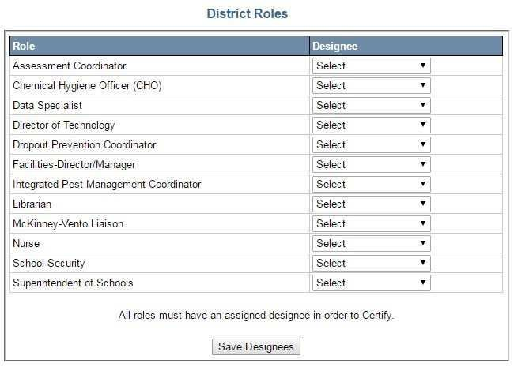

Explain process of updating District Roles throughout the year

Anyone with SAU admin access to the staff module within NEO can update the designated roles for their
district throughout the school year. It is important that this is done because the designee you list is the

one that is listed in all public reports
. It is not necessary for the superintendent to recertify if changes

are made after December 1

st

. When you update a district role or update a staff members contact

information you MUST save the Staff Certification report in order for those changes to be reflected going

forward.

Explain the EPS table

This table was added to the certification form in 2016/17. It gives you the ability to see the EPS FTE

amounts per EPS category for your SAU and is an additional place to view and certify this data other
than the ED 267 report.
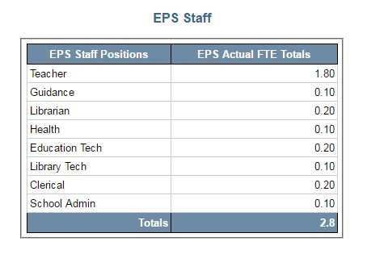
- Select Organization – Fiscal Year (FY 21 Staff are in Fiscal Year 2020) – Position – click View Report.

Explain the certification process

The staff certification is due October 31

st

. Prior to the superintendent’s certification all current staff must

be given an active assignment(s) for the current school year. The staff certification will not be accepted if
the certification repo
rt contains any pending records of if there is any missing data in the designated

roles section of the certification report. New for the 2016/17 school year; SAUs without a librarian or

nurse can select the superintendent as the district role without actually giving them an assignment as
such.
Reports

Staff Details Report – Courses

The staff courses details report contains all applicable data elements and is exportable to Excel which
allows you to sort and filter the data fields.
Staff Details Report – FTE

The staff FTE details report contains all applicable data elements

and is exportable to Excel which allows

you to sort and filter the data fields. The staff FTE details report is similar to the staff courses details
report yet contains FTE counts.
FTE By Person

This report groups staff by EPS Position Groups and displays the FTE hours reported for that position
group. It also allows you to export the report to a PDF or to Excel.
- Individual Staff information as entered into NEO Staff by the SAU is reported.
- Actual FTE for each Staff Position are entered into NEO staff by the SAU.
- The Actual FTE for EPS Positions is not to exceed 1.0.
- The ED 279 Actual FTE w Title I column is the FTE entered by the SAU for EPS positions held by a staff member – no staff member can work more than 1.0 FTE for EPS positions.
- The ED 279 Actual FTE w/out Title I column excludes the FTE amount if the staff member is identified as Title I staff – this is for information purposes only.
- Title I column – Indicates the staff member is paid out of Federal Title I funds.
- Multiple Positions column – indicates the staff member holds multiple positions.
- EPS Salary column is the EPS calculated salary based on the salary matrix, this is not available on this report until after the EPS subsidy calculation process has begun.
- The Total FTE w Title I amount at the end of the report is what will be used in the FTE EPS calculation for your SAU on page 1 of the ED 279 report when calculating subsidy.

Staff with Multiple Positions
This report shows all the staff positions that a specific staff member is listed as holding according to the NEO staff system. The report shows all the SAUs where a staff member is currently employed if they are employed at more than one SAU. The EPS FTE calculation for a staff person for all EPS positions held can never be more than 1.0 – therefore it is important to determine the FTE based on all positions; often those positions are in a different position category and are not seen on the individual reports.
The EPS Position notation refers to a position that is part of the FTE calculation used in the EPS funding calculation. Not all positions listed on the Multiple Positions report are considered EPS positions, but they should be used to determine the correct FTE to use in the EPS calculation.

Additional Help Documents
From within the NEO Staff module, click the Help menu for more helpful documentation. By clicking the Help menu, you will be brought to the following URL:
https://www.maine.gov/doe/sites/maine.gov.doe/files/inline-files/FY22_MaineSchoolsInstructions.pdf

