Maine Criminal Justice Academy

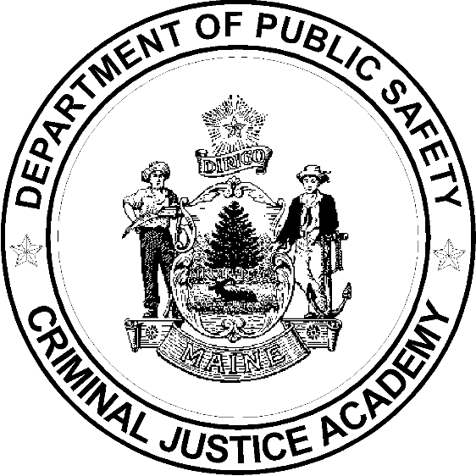

Basic Corrections Training Program
Curriculum

Updated December 2023

Curriculum Outline

1.0 Administrative, Foundations, Fitness & Drill
1.1 Administrative Details, Orientation, Testing,
Graduation 6.5 Hours
1.2 Foundations of an Effective Correctional Officer 3.5
1.3 Sociology of a Correctional Facility 4.0
1.4 Physical Fitness & Nutrition 19.5
1.5 Drill & Ceremony 12.0
Section Total: 45.5 Hours
2.0 Ethics and Professionalism
2.1 Professionalism, Ethics, & Administrative
Investigations 4.0 Hours
Section Total: 4.0 Hours
3.0 Criminal Justice System, Standards and Investigations
3.1 Law Enforcement, Courts, and Corrections 1.0 Hours
3.2 Constitutional & Civil Rights, and ADA 4.0
3.3 Correctional Standards 1.5
3.4 Prison Rape Elimination Act (PREA) 4.0
3.5 Investigations in Corrections 2.0
Section Total: 12.5 Hours
4.0 Communications
4.1 Report Writing 6.0 Hours
4.2 Log Books and Record Keeping 1.5
4.3 Interpersonal Communication Skills 24.0
4.4 Building an Inclusive Culture 4.0 Hours
Section Total: 35.5 Hours
5.0 Resident Management
5.1 Inmate Admitting and Release and Classification 2.0 Hours
5.2 Security and Count Procedures 2.0
5.3 Inmate Supervision 4.0
5.4 Women Offenders and Cross-Gender Supervision 2.0
5.5 Inmate Discipline and Inmate Grievances 2.0
5.6 Inmate Hygiene and Facility Sanitation 1.0
5.7 Inmate Programs and Services 1.0
Section Total: 14.0 Hours
6.0 Managing Vulnerable Populations
6.1 Sex Offenders 1.5 Hours
6.2 Homosexual, Bisexual, and Transgender Prisoners 2.0
6.3 Security Threat Groups 4.0
6.4 Mentally Ill Inmates and Crisis Intervention 6.0
6.5 Developmental Disabilities / Disabled Inmates 3.0
6.6 Effective Supervision of an Aging Population 2.0
6.7 Suicidal Inmates 4.0
6.8 Domestic Violence & Sexual Assault, Stalking 8.0
Section Total: 30.5 Hours
7.0 Safety, Security and Practical Skills

7.1 Basic Officer Safety and Security 3.0 Hours
7.2 Situational Use of Force 8.0
7.3 Mechanics of Restraint and Control 24.0 Hours
7.4 Contraband 2.0
7.5 Area, Cell and Body Searches 8.0
7.6 Key and Tool Control 1.0
7.7 Security in a Non-Secure Setting 3.0
7.8 Cell Extractions 8.0
Section Total: 57.0 Hours
8.0 Creating a Culture of Wellness

8.1 Communicable Diseases 1.5 Hours
8.2 Drugs and Drug Recognition 2.0
8.3 Substance Abuse Awareness 2.0 8.4 Correctional Officer Stress, Substance Use,
and Suicide 2.0
8.5 Mental Health First Aid 8.0
Section Total: 15.5 Hours
9.0 Critical Incident Prevention and Management
9.2 Assaults, Riots, and Other Disturbances 2.0 Hours
9.3 Hostage Situations 1.5
9.4 Fire and Fire Safety 2.5
9.5 Escapes 1.5
9.6 Unattended Death 1.0
9.7 Critical Incident Stress and Debriefing for Staff 1.0
Section Total: 9.5 Hours
BCTP Total Instructional Time 224 Hours

