BLETP Cadre

Maine Criminal Justice Academy

Opening Date: June 24, 2024

Closing Date: July 8, 2024

The Maine Criminal Justice Academy is looking for a talented, highly motivated and teamwork-oriented individual from one of our County Sheriff’s Offices to fill the position of Cadre for the upcoming Basic Law Enforcement Training Program(s). Applicants should have a strong desire to train and mentor future law enforcement officers and emulate the vision and values of the Maine Criminal Justice Academy.

Minimum Qualifications:

- Must have a minimum of (5) years of full-time law enforcement experience, or;
  - A minimum of (3) years of full-time law enforcement experience, with other applicable specialized law enforcement training.

- Must have an exemplary background, subject to further investigation and/or at the discretion of the Director.

- Must successfully pass an oral board interview with Academy staff.

- Must be able to pass the Maine Criminal Justice Academy entry PFT test at the 50th percentile.

- Preferably able to commit to (4) Basic Law Enforcement Training Program courses to maximize professional development and program integration but must be able to commit to no less than (2) consecutive courses.
  - Continual service will be dependent upon class-by-class evaluations conducted by Supervising Cadre and at the discretion of the Director.

- Must be able to commit to (8) full weeks of training out of (18).
  - To be determined by Supervising Cadre.

Primary Responsibilities:

- Supervision of cadets attending the BLETP, to include, but not limited to;
  - Ensuring adherence to Maine Criminal Justice Academy standards of conduct.
  - Investigating violations of codes of conduct, potentially resulting in disciplinary action.
  - Facilitation of day-to-day tasks, such as adherence to a predetermined schedule.
  - Maintenance of professionalism within the training environment.
  - Monitoring leave time/absences.
  - Conducting periodic assessments of cadet performance throughout the program.

- Continuous training and mentorship of cadets.
  - Modeling professional behavior.
  - Providing additional training beyond scheduled classes/blocks of instruction.
  - Participating in the BLETP fitness program.
  - Providing professional experiences in relation to course content daily.

- Assistance with scenario-based training.
  - Use of force scenarios.
  - Routine law enforcement activities scenarios.
  - Practical week scenarios.

- Working collaboratively with Academy staff.
  - Assisting in proctoring exams and quizzes.
  - Assisting with the facilitation and filing of paperwork.
  - Participating in Chief’s Day, Family Day and other BLETP related events.

- Other duties as assigned.
Application Instructions:

Interested applicants must submit a cover letter and resume to Director Jack Peck, Jr. via e-mail at (jack.d.peck@maine.gov), no later than July 8th.

Applicants should be prepared to complete the MCJA physical fitness test and oral board interview on July 11th. If selected, a time for each component will be communicated to you in advance.

Sincerely,

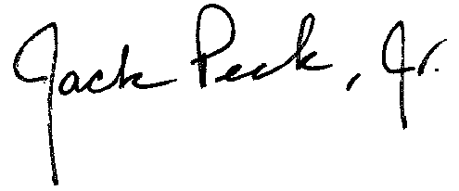
Jack D. Peck, Jr., Director
Maine Criminal Justice Academy

