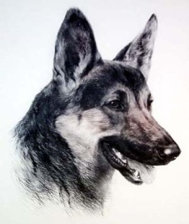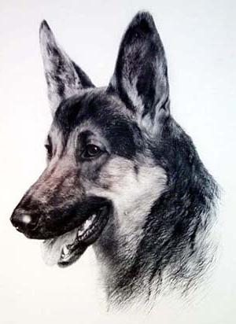
MCJA K-9 RETIREMENT FORM

K-9 Team Retirement
Name of officer_________________________________ Name of K-9_________________________________
Agency_______________________ Cell Phone ____________________email_______________________________
Retire from: Patrol _____ Detector_____ RETIREMENT DATE ________________________________
Note:_________________________________________________________________________________________

K-9 Trainer Retirement
Name of Officer________________________________ RETIREMENT DATE________________________________
Agency _______________________Cell Phone ________________________email___________________________

