Board of Trustees
MAINE CRIMINAL JUSTICEACADEMY

WAIVER OF THE LAW ENFORCEMENT PRESERVICE PROGRAM

Specification S-23

To establish the requirements for a Board of Trustee’s waiver of the Law Enforcement Preservice Program for law enforcement officers who have successfully completed training in another state or a United States government agency’s full-time Basic Law Enforcement Training Program.

Requirements:

- The applicant has received a conditional offer of employment as a part-time law enforcement officer in the State of Maine.

B. The applicant has met the Entrance Standards in Chapter 3 for admission to the Law Enforcement Preservice Program (LEPS), including the following:
1. MCJA Background form upon application.

2. MCJA Firearms Qualification form upon application.

3. MCJA Phase I On-line Course upon application.

4. Successful completion of the MCJA Law Enforcement Preservice Phase I Exam.

5. Successful completion of the MCJA Part-time Law Enforcement Certification Exam upon application, and:

6. Maine Mandatory Law Enforcement In-service Training for the 2 previous years.

- The applicant has met the Entrance Standards delineated in Chapter 3 for admission to the Law Enforcement Preservice Program, except the following:
- Alert Test.

- Medical Certificate.

- Physical Fitness Standards.

- The applicant has successfully completed a full-time Basic Law Enforcement Academy from another state, federal or United States military law enforcement academy.

- The analysis shall be conducted by academy staff on the applicant’s equivalent entry level law enforcement training program and a recommendation can only be made to the Board if the required training hours and testing, as required by this Specification have been met.

- Once the LEPS waiver process is completed with all requirements met and a MCJA Notice of Employment has been received, a provisional certificate as a part-time law enforcement officer will be issued, however the officer must complete 80 hours of supervised training (LEPS Phase III) within the first 12 months of employment.
- At the next available Board meeting, the waiver recommendation will be presented. Other reasonable recommendations can be made such as: the successful completion of the Maine hiring law enforcement agencies Field Training Program, if the applicant has less than 2 years of full-time law enforcement experience.

Procedures:

- The law enforcement agency having made a conditional offer of employment to the applicant shall apply for the part-time waiver on approved forms and is responsible for submitting to the Director all required and requested documentation, including:
- Transcripts from the full-time Basic Law Enforcement Training Academy the applicant attended.

- MCJA Background Form.

- MCJA Firearms Qualification Form.

- Documentation of the completion of the Phase I Program.

- Documentation of a passing score on the MCJA Law Enforcement Preservice Phase I Program Exam.

- Documentation of a passing score on the MCJA Law Enforcement Preservice Certification Exam.

- Documentation of the completion of the Maine Mandatory In-service Training for the 2 previous years.

- If the officer meets all requirements set forth in this Specification, the applicant can be hired and then a provisional certificate of eligibility will be issued as a part-time law enforcement officer once the academy received the MCJA Notice of Employment. The officer will be restricted to working no more than 1040 hours as a part-time law enforcement officer, unless employed as a Capitol Police Officer or as a Judicial Marshal.

- At the next available Board meeting, the waiver recommendation will be presented. Other reasonable conditions can be made such as: the successful completion of the Maine hiring law enforcement agencies Field Training Program, if the applicant has less than 2 years of full-time law enforcement experience.

- Once the Academy received the documentation of the Phase III completion, the officer will be issued a part-time law enforcement certificate of eligibility.

Adopted: 07/12/2013
Amended: 11/08/2019
Review Date: 11/08/2022
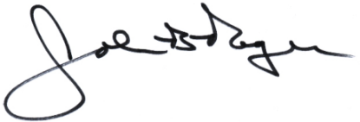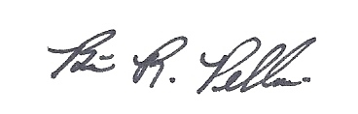
___________________________ __________________________
John B. Rogers, Director Brian R. Pellerin, Chair
Maine Criminal Justice Academy MCJA Board of Trustees

