October 2024
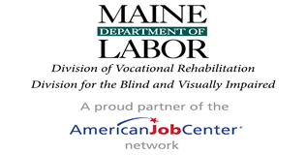
Bureau of Rehabilitation Services
National Disability Employment Awareness Month  Observed annually in October, National Disability Employment Awareness Month (NDEAM) celebrates the contributions of America’s workers with disabilities past and present and showcases supportive, inclusive employment policies and practices. This year’s theme for NDEAM 2024 is “Access to Good Jobs for All” https://www.dol.gov/agencies/odep/initiatives/ndeam | 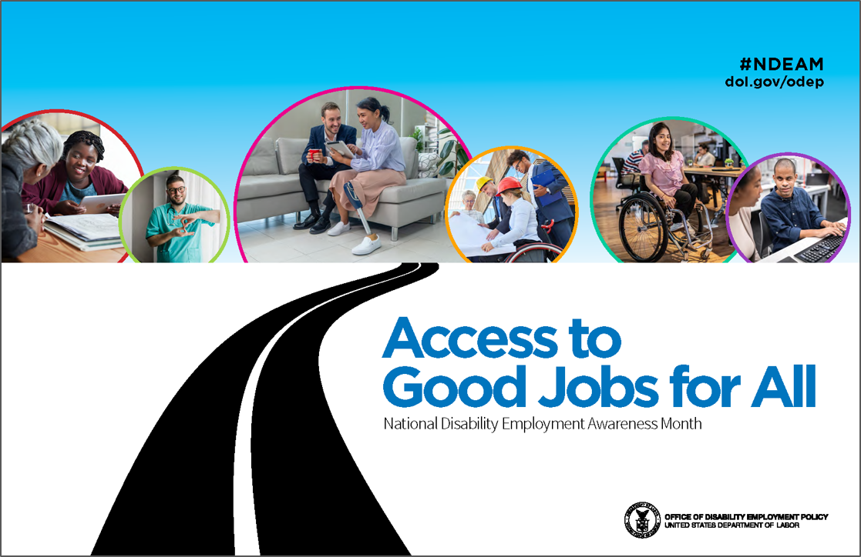
Date | Sponsor/Title | Description | How to access
10/01/2024 | Retail Career Pathways and Workforce Development | Join Corporate and Local Talent Acquisition teams for a deep discussion of Customer Service Careers in Maine featuring  Walgreens and Ocean State Job Lot. Businesses working closely together to develop local talent. | Zoom in at 9:00am https://mainestate.zoom.us/j/85730017552
10/04/2024 | Behind the Scenes at FedEx | Jobseekers enrolled with the Bureau of Rehabilitation Services will tour an early morning shift, experience the work that happens, meet the team, and learn about the career pathways at FedEx. | Bangor Area 7:00am Tour  Space is limited. Please contact your Vocational Rehabilitation Counselor to register.
10/07/2024 | Behind the Scenes at LL Bean | Jobseekers enrolled with the Bureau of Rehabilitation Services will tour LL Bean Headquarters, Order Fulfillment Center and the Flagship Retail Sore. Light Lunch and Refreshments will be provided at Headquarters. | Space is limited. Please contact your Vocational Rehabilitation Counselor to register.
10/08/2024 | DETAC Webinar: The Role of American Job Centers in Promoting Access to Good Jobs for All | 3:00-4:00 p.m. ET People with disabilities play a crucial role in strengthening America’s economy. In support of this year’s National Disability Employment Awareness Month (NDEAM) theme, Access to Good Jobs for All, we recognize the role of the American Job Center (AJC) network. As required by the Workforce Innovation and Opportunity Act, AJCs and their partners provide access and opportunities to all job seekers, including individuals with barriers to employment, to prepare for, obtain, retain, and advance in high-quality jobs.  This webinar will spotlight four AJCs located in New York and Colorado. Presenters will share insights on the services the AJCs provide, share a roadmap for accessing AJC services, discuss the critical role of partnerships in service delivery, and highlight the creative integration of universal design principles to ensure meaningful access to all customers using AJC services. | Register via Zoom: Register Here
10/8/24 | Diversity Hiring Coalition of Maine – Annual Meeting | DHC Annual Meeting: Strategies for Growing Maine’s Workforce and Economy through Diversity and Inclusion  This is our annual conference style event and we're excited to be with you all live and in person at Thomas College in Waterville. Our conference this year will focus on workforce development, featuring a State of Maine panel about the State Economic Development Strategic Plan, a working session to identify gaps in the plan and ways to overcome barriers, and strategic implementation breakout discussions. | https://dhcmaine.com/events/#!event/2024/10/8/dhc-annual-meeting  Thomas College  180 W River Rd  Waterville ME 04901 09:00am - 04:30pm
10/09/2024 | Full STEAM Ahead | An accomplished panel of professionals who are blind, DeafBlind, or have vision loss discuss their career journey in science, technology, engineering, arts, or mathematics (STEAM). They’ll also share the supportive, inclusive policies and practices that benefit employees and employers alike.  This webinar is inspired by National Disability Employment Awareness Month (NDEAM), which was created by the Office of Disability Employment Policy through the Department of Labor. | Zoom Webinar  2:00 pm –3:30pm  Register to attend:  https://www.helenkeller.org/events/ndeam2024/
10/10/24 | Commission for the Deaf, Hard of Hearing and Late-Deafened | Quarterly Commission meeting – ASL interpretation available  FMI: Nancy Winter – Nancy.A.Winter@maine.gov | In-person meeting  45 Commerce Drive  Augusta, ME  Department of Labor  Frances Perkins Room  4 pm – 7 pm
10/12/2024 | The Iris Network | 29th Annual White Cane Walk As an essential initiative of The Iris Network, the White Cane Walk raises awareness by promoting a safer environment for individuals with blindness or vision impairment who use a white cane or guide dog for travel and celebrates the capabilities of persons with vision impairment or blindness. | Register day of event at 9am 189 Park Avenue, Portland, Me.
10/15/2024 | Behind the Scenes at FedEx | Jobseekers enrolled with the Bureau of Rehabilitation Services will tour an early morning shift, experience the work that happens, meet the team, and learn about career pathways at FedEx. | Lewiston Area 7:30 am  Space is limited. Please contact your Vocational Rehabilitation Counselor to Register.
10/15/2024 | U.S. National Observance  P.L. 88-628 | National White Cane Awareness Day White Cane Safety Day is an annual observance dedicated to raising awareness about the importance of the white cane as a symbol of independence and mobility for individuals who are blind or visually impaired. This day also emphasizes the need for pedestrian safety and respect for the rights of people with visual disabilities. White Cane Safety Day serves as an opportunity to educate the public about the challenges faced by individuals with visual impairments and to promote inclusion and accessibility in society.
10/17/2024 | Division of Vocational Rehabilitation Virtual Orientation | Monthly recurring virtual opportunity to learn about Vocational Rehabilitation services. ASL interpretation available | No pre-registration required  9 a.m. – 10 a.m.  https://mainestate.zoom.us/j/85921692602?pwd=VUVDZFR1NWhHRHJHV0Jpc2dMZlllQT09#success  - Meeting ID: 859 2169 2602  Passcode: 48226391
10/22/24 | Accessing Democracy – Film and Panel  Disability Rights Maine | Film Summary:  Monica Wiley, a Black disabled woman, travels the East Coast interviewing voters with disabilities. She asks them about the barriers they face, from accessing the everyday conveniences that able-bodied people take as a given to the inability to receive the services they need to work and be a part of the community. This short documentary explores how politicians have left behind one of the largest minority groups in the United States, and what disabled voters want from their next commander in chief. Produced by the National Disability Rights Network in partnership with Disability Rights New York. Directed by Jack Rosen.  After the film, join a panel discussion about the importance of voting featuring Secretary of State Shenna Bellows, and disability advocates Eric McVay, Jenny McCarthy, and Molly Thompson.  The event is free, but registration is required! | The film includes ASL and captioning. The event space is ADA accessible and ASL and CART will be provided before the film begins and during the panel. DRM asks that attendees refrain from wearing scents. DRM provides masks at all agency-sponsored events and will make masks available to all attendees. Please indicate any additional accommodation requests when registering for the event.  https://www.eventbrite.com/e/accressing-democracy-film-screening-and-panel-discussion-tickets-1031530013037  6pm-7:30pm  Jewett Hall, University of Maine Augusta
10/23/2024 | Vertical Harvest | Meet the Human Potential team, learn more about job opportunities, ask questions about indoor vertical farming and hiring timelines. | Maine CareerCenter  8:00am – 5:00pm  151 Jetport Blvd, Portland, Maine

Maine Department of Labor provides Equal Opportunity in employment and programs. Auxiliary aids and services are available to individuals with disabilities upon request.
A Proud Partner of the American Job Center Network

