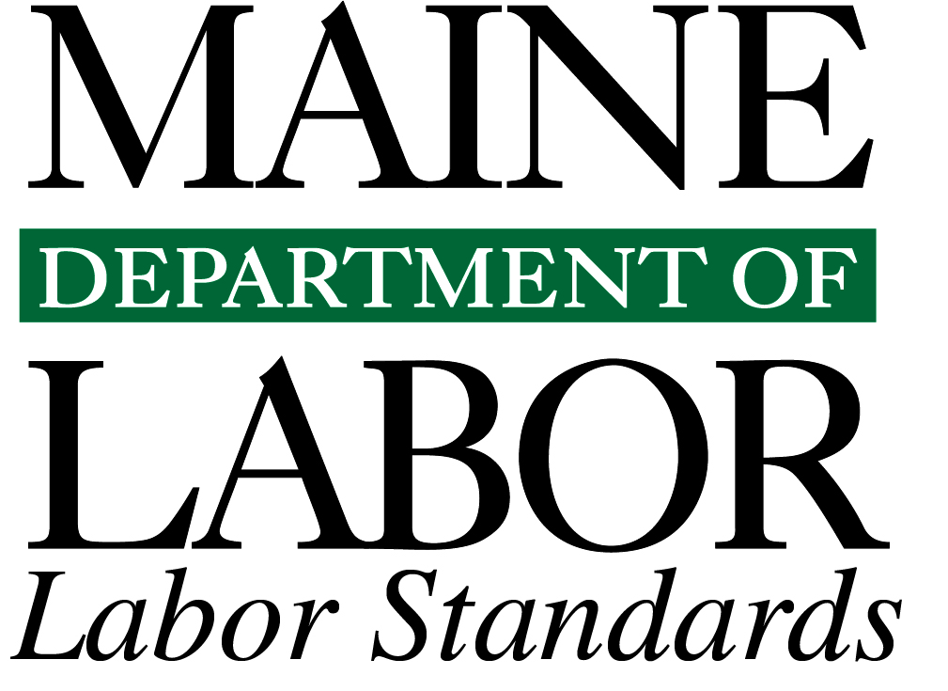
Roofing and Building Exterior Worker Falls in Maine, 2011- 2013
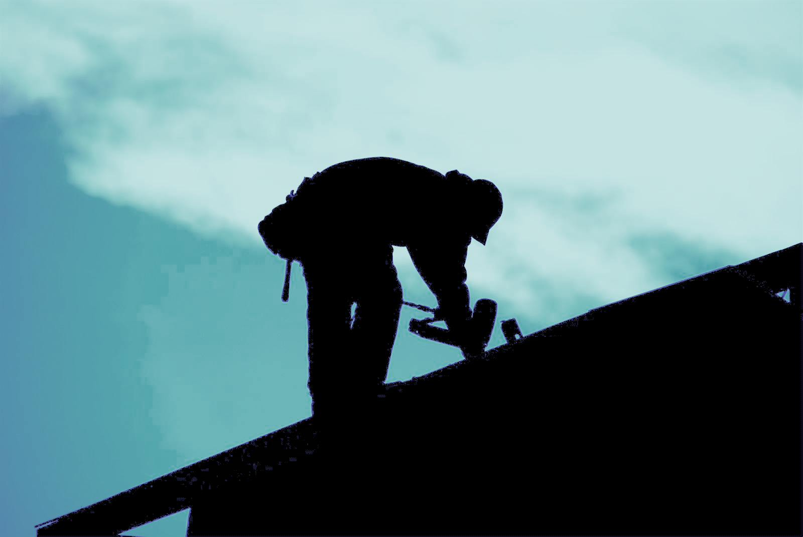

Roofing and Building Exterior Worker Falls in Maine
2011–2013
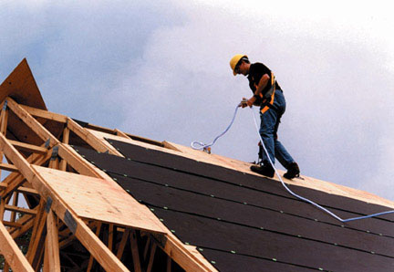
Figure 1. Roof worker adjusting safety line at rooftop
From 2011 through 2013, Maine insurance companies and employer establishments collectively paid over 1.5 million dollars for fall injuries to roofing and building exterior workers and for OSHA fall protection violations.

Introduction
The Occupational Safety & Health Administration (OSHA) states that: “Falls are the leading cause of fatalities in the construction industry. An average of 362 fatal falls occurred each year (in the United States) from 1995 to 1999, with the trend on the increase.”¹
This report, by the Research and Statistics Unit of the Maine Department Labor’s Bureau of Labor Standards, focuses on fall injuries among Maine’s roofing and building exterior construction workers, the factors that may have contributed to them and the regulatory/enforcement efforts to reduce them. From 2011 through 2013, 34 Maine workers were injured as a result of falls from roofs, falls onto roofs, and falls from ladders, scaffoldings, and staging. Four others died as a result of their falls.
The injured workers included roofers, construction laborers, construction managers and engineers, equipment operators, carpenters, structural steel workers, and sheet metal workers. This report provides data on the causes of these incidents, the kinds of injuries incurred by the workers, and associated Workers’ Compensation costs. It also provides information regarding federal regulations standards, enforced by OSHA, pertaining to fall-protection safety in the construction industry, and penalties levied against employers for violations of those standards.

The Roofing and Building Exterior Construction Industry
As shown in Table 1 below, a number of industry types in Maine may be associated with roofing and building exterior construction falls.²
TABLE 1.
Roofing and Building Exterior industry Types in Maine
NAICS Code | Private sector Industry Type | Number of Companies in Maine | Average Number of Employees
Primary roofing and building exterior contractors
238161 | Residential Roofing | 62 | 3.5
238162 | Nonresidential Roofing | 25 | 2.0
238171 | Residential Siding | 29 | 3.1
238172 | Nonresidential Siding | 3 | 1.3
238191 | Other Residential Building Exterior | 7 | 1.9
238192 | Other Nonresidential Building Exterior | 12 | 3.2
236115 | Single Family Housing Construction
236118 | Residential Remodelers
 | Subtotal | 138 | 3.0
Other contractors that at times do roofing/building exterior work
236210 | Industrial Building Construction | 2 | 14.0
236220 | Commercial and Industrial Building Construction | 51 | 12.5
238122 | Nonresidential Structural Steel Contractors | 6 | 6.8
238351 | Residential Finishing Contractors | 37 | 2.2
238352 | Nonresidential Finishing Contractors | 6 | 5.8
238391 | Other Residential Finishing Contractors | 6 | 5.5
238392 | Other Nonresidential Finishing Contractors | 5 | 11.8
238991 | Other Residential Trade Contractors | 28 | 4.1
 | Subtotal | 141 | 7.3
 | TOTAL Companies | 279 | 5.2

As shown by Table 1, many companies in Maine could have workers fall at building-exterior worksites. Based on average employment, most in the industry are likely to be small businesses.
While the industry classifications for the private sector are relatively intuitive, that is not the case for public sector industry classifications associated with roofing or building exterior falls, because public sector agencies are usually classified more broadly. For example, a person working for a public works department or a custodial/maintenance person in a school department, which would be coded under a general government classification, could at times do construction, repair, or maintenance work on a facility roof or building exterior that could result in a fall injury.
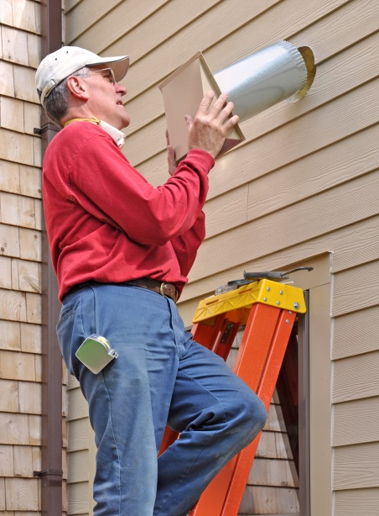
Figure 2. Carpenter on a ladder installing an exterior vent.

Methodology
Roof/construction-worker fall injuries were extracted from the 2011–2013 Workers’ Compensation claims database³ using the Standard Occupational Classification (SOC) code of 47, Construction and Extraction Occupations.⁴ Roofer/building-exterior construction-worker fall cases were then identified by conducting a review of the coded data elements, including the fall-related events causing injuries, the sources of the falls (roofs, ladders, scaffolding, and staging), and the claim severity level of “2” (injuries that resulted in employees having days away from work). In addition, a review of the descriptive narratives of the claims was conducted to acquire any additional information that could contribute to the data analyses. In order to protect the privacy of affected workers, the Workers’ Compensation board has requested that reporting be limited to aggregates of ten or more incidents. This data presented within this report reflect those limits. However, the number of worker fatal falls presented is lower because public media sources were used for that aggregation.^{5, 6 &7}

Injury and Fatality Data
Figure 3 presents data on the types and number of injuries resulting from roof/construction worker falls during 2011–2013. The most prevalent types of injuries sustained were Sprains, Strains or Tears and Bruises/Contusions, with a total of 17 incidents. The figure also shows that four additional falls resulted in worker fatalities. To protect the privacy of those workers, analytical data from the fatality incidents are not presented with the other injury data in this report 2011–2013.

As shown by Figure 4 below, injuries to Maine roofing and building exterior construction workers from 2011 through 2013 occurred from either falls off of roofs, falls onto roofs, or falls from ladders or scaffolds.

While the event information is not clear for some of the fall injuries, 20 of them resulted from workers slipping. Ice, snow or moisture on the roof was clearly the cause of 6 of those slips, and stepping on loose or other materials the cause of three falls. Three other falls resulted from collapsing or shifting structures or materials, and one fall resulted from tripping over a rope.

Workers’ Compensation, Lost Time and Social Costs
OSHA’s publication, “Workers’ Compensation Costs of Falls in Construction,” presents the results of its study on the costs associated with construction falls during the years 2005 through 2007. Cost data from 36 states were included in the study (states reporting injury data to the National Council of Compensation Insurance, Inc.). The study findings revealed that the average workers’ compensation costs for construction worker falls were $106,000, with 44 percent paid out for indemnity benefits (benefits paid to workers), and 66 percent paid out for medical care.⁸
Maine Workers’ Compensation claim costs for the 34 worker injuries resulting from roof, scaffolding, and ladder falls in 2011–2013 were approximately $1,051,655. More than 72 percent of that ($762,782) was for medical and rehabilitation care and about 25 percent ($259,124) for time away from work and claim settlements. The average cost per injury claim was $30,931.
Of course, the dollar costs fail to capture the accompanying human costs, including pain and suffering from physical injuries, the possibility of long-term or permanent disabilities, the stress of reduced or lost income, secondary effects on family members/caretakers, and, in the case of fatal falls, the loss of a life.
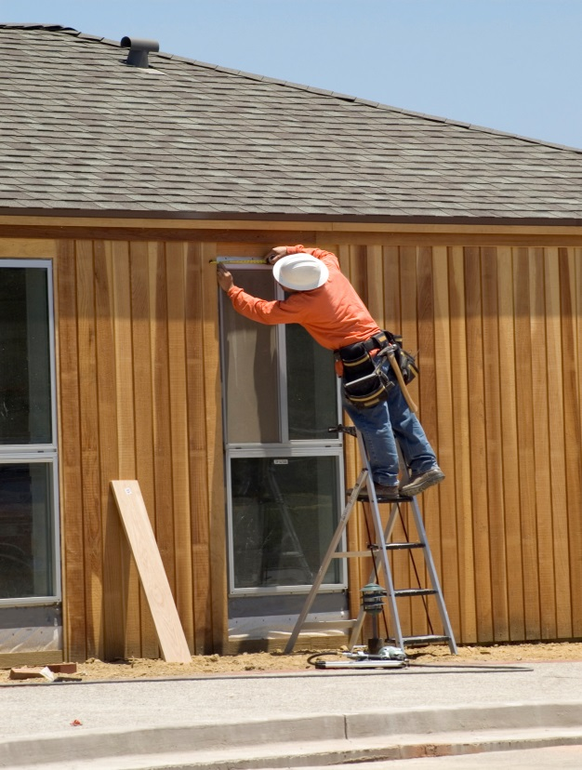
Figure 5. Carpenter measuring an exterior window from a ladder.

Regulations

In 2013, the most cited OSHA standard was 1926.501 (duty to have fall protection) with 8,174 violations and $20,488,609 in penalties — an average of $2,506 for each violation.

Under Title 29 of the Code of Federal Regulations, OSHA enforces Section 1926, “Safety and Health Regulations for Construction,” which includes a broad range of safety requirements for employers and workers in the construction industry. Below is a summary of OSHA’s requirements pertaining to roof workers. These regulations are designed to reduce the number of fall accidents and minimize fall injuries.⁹
I Employer Duty to Have Fall Protection — Regulation 1926.501
The employer has a duty under law to provide fall protection to its employees. This duty includes protection of workers from falls and from falling objects. A summary of this duty is provided below.
- Provide fall protection systems.
- Provide safe working surfaces with strength and structural integrity.
- Provide employee life-saving equipment and personal protective systems with respect to leading edges, hoist areas, surface holes, fascia formwork and reinforcing steel work, ramps, runways and other walkways, excavations, dangerous equipment, overhand bricklaying, low and steep slope roofs, precast concrete erection, residential construction, wall openings, and other walking/working surfaces not previously mentioned. Protection for these construction areas involves employing the use of safety equipment at surfaces, edges, or fascia heights of 6 feet or more.
- Provide protection from falling objects in the form of toe boards, screens, guardrail systems, canopies, and barricades. Require the use of hard hats.
III Employer Requirement for Personal Protective Systems and
Life Saving Equipment — Regulation 1926.502
- Guardrail systems
- Safety nets
- Personal fall arrest systems
- Positioning device systems
- Warning line systems
- Controlled access zones
- Safety monitoring systems
- Protection from falling objects
- Fall protection plan
II Employer Training Requirements — Regulation 1926.503
- The hazards of falling
- Erecting, maintaining, disassembling, and inspecting fall protection systems
- The use of guardrail systems, personal fall arrest systems, safety net systems, warning line systems, safety monitoring zones, and other protection to be used
- The role of each employee in the safety monitoring system

Enforcement
When employers are found to be in violation of fall safety regulations, they can be fined heavily by OSHA. The imposition of large fines is reflective of the high risks of injury associated with noncompliance to fall safety regulations. Repeat or willful violators of fall safety regulations may find themselves having penalties imposed in the many thousands of dollars. Moreover, OSHA places the responsibility on the employing company to ensure and enforce that workers use the required safety equipment and comply with required safety procedures.

A summary of Maine’s 2011–2013 employer violations of OSHA’s fall protection regulations, 19126.501, 1926.502 and 1926.503, is provided in Table 2.¹⁰
TABLE 2.
FALL PROTECTION VIOLATIONS AGAINST MAINE ESTABLISHMENTS DURING 2011-2013
REGULATION NUMBER | REGULATION TITLE | PRIVATE SECTOR VIOLATIONS FOUND | FINES IMPOSED FOR PRIVATE SECTOR VIOLATIONS | PUBLIC SECTOR VIOLATIONS FOUND | FINES IMPOSED FOR PUBLIC SECTOR VIOLATIONS
1926.501 | Duty to have fall protection | 153 | $509,484 | 5 | -
1926.502 | Fall protection systems criteria and practices | 4 | $13,560 | 11 | -
1926.503 | Fall protection training for employees | 3 | $4,160 | 6 | $2,400
TOTAL |  | 160 | $527,204 | 22 | $2,400

Contributing Factors to Roof/Construction Worker Falls
A. Employer-related factors that may contribute to roof/construction worker falls
- Some establishments may be focused on keeping costs down and on getting the job done ahead of schedule, possibly placing worker safety in jeopardy.
- Small establishments may not be fully aware of their legal responsibilities for providing fall protection and other safety training to their roof/construction workers and ensuring worker compliance with safety regulations.

B. Worker-related factors that may contribute to roof/construction worker falls
1. Some roof/construction workers may feel that using safety equipment is uncomfortable, cumbersome, and imposes restrictions on their physical movement.
2. Some workers do not wear appropriate footwear and clothing.
3. Some workers may try to carry too much material or travel to fast on roof surfaces, ladders, and scaffolds.
4. Some workers may come to work ill, tired, impaired by substances of abuse, or otherwise physically/emotionally unready or inadequately trained to do their tasks safely.
5. Some workers may have a false sense of personal infallibility, thinking that falling isn’t something that could happen to them.

C. Site-related conditions that may contribute to roof/construction worker falls
- It can be challenging for workers to retain their balance when maneuvering on surfaces that are sloped.
- When working on high surfaces, workers may experience dizziness, spontaneous vertigo, or other physical reactions, which can lead to falling more easily than at ground level.
- Weather hazards, including precipitation, wind, temperatures that affect reaction times and glare, can increase the risk of falling.
- Busier layouts that include many impediments like skylights, gables, HVAC and other equipment, chimneys and exhaust pipes.
- The type of surfaces being traveled upon; for example, an asphalt shingle surface is less slippery than a slate or metal surface.
- The structural integrity of the worksite; for example, an old facility may be less stable than new construction.
- Compromised working condition of equipment including improper set-up and support of scaffolding, ladders, and lifts.

Training Opportunities
Maine Department of Labor, Bureau of Labor Standards, through its Safetyworks! program, provides free and confidential training to help employers and employees prevent work-related injuries, illnesses, and deaths and reduce related costs. These classes identify and explain the relevant OSHA and other requirements, strategies for meeting those requirements, and best practices to help employers and workers provide and use proper safeguards to keep their worksites safe. At times each year, Safetyworks! offers free training in Scaffolding and Fall Protection, Ladder Safety, and General Construction Standards. The classes and schedules are found at: http://www.safetyworksmaine.com/ .

The OSHA Education Center also provides construction fall protection courses on-line to employers and workers at www.oshaeducationcenter.com.

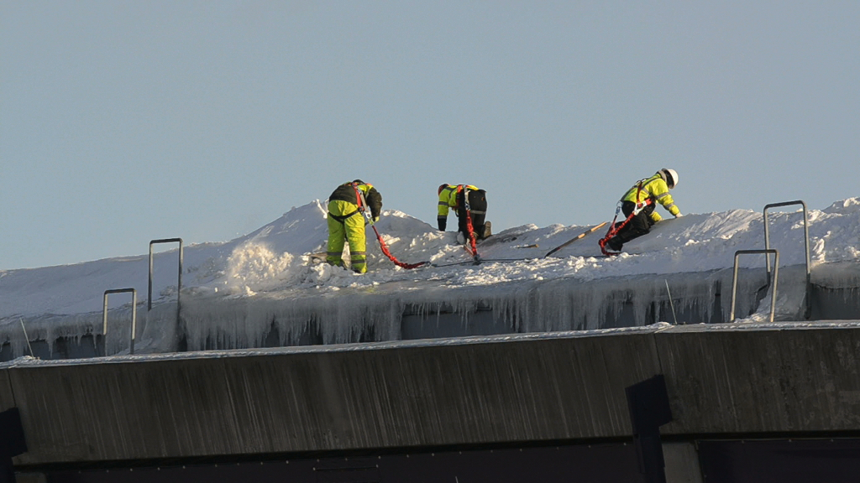
Figure 6. Workers, with life lines, safety belts and construction helmets, clearing the snow from the deflated Metradome roof in Minneapolis, Minnesota (still from video by David Brewster, StarTribune.com)

References
- OSHA Construction e-tool at www.osha.gov/SLTC/etools/construction/falls/mainpage.html.
- Maine Department of Labor, Center for Workforce Research and Information (for aggregate employer statistics).
- Maine Workers’ Compensation Board. Selected 2011, 2012 and 2013 Employer’s First Reports of Occupational Injury or Disease.
- Executive Office of the President, Office of Management and Budget, Standard Occupational Classification Manual, 2010, ISBN-978-1-935239-04-8
- Weekly Toll. June 2011.
- Bangor Daily News. December 2013 and June 2011.
- Portland Press Herald, October 2013.
- OSHA Publication: “Workers’ Compensation Costs of Falls in Construction. A study of claim counts and losses on policies effective 2005, 2006 and 2007.”
- OSHA Regulations. www.osha.gov/law-regs.html.
- OSHA Inspection Detail. www.osha.gov/oshstats/index.html.

This report was prepared by Barbara A. Spillane and Mark B. Dawson.
Research and Statistics Unit, Division of Technical Services
Bureau of Labor Standards Maine State Department of Labor
For more information regarding this report, contact
Mark Dawson, 207-623-7904.
TTY users call Maine Relay 711.

Maine Department of Labor provides equal opportunity in employment and programs.
Auxiliary aids and services are available to individuals with disabilities upon request.

